Shaneille Sash-Nicole Samuels
UPD82442QU91660
Post Doctorate in Quantitative Finance

COURSE NAME:
(Risk Financing and Treasury Management (RFI 772))

Assignment Title:
(Chapter 2: Risk Financing and Treasury Management)

Name of Book:
(Maximizing Economic Growth: A Holistic Approach to Financial and Risk Management)

ATLANTIC INTERNATIONAL UNIVERSITY
October/2023
Table of Contents

Introduction 4
1. Importance of Risk Financing and Treasury Management in Economic Stability 5
1.4. Sovereign Wealth Funds (SWFs) 14
2. Risk Identification, Assessment and Mitigation 17
2.1. Risk Identification 18
2.2. Risk Assessment 19
2.3. Risk Mitigation 21
3. Managing Risks Through Treasury Operations 28
3.1. Treasury Management 28
3.2. Cash Management and Liquidity Risk 29
4. Implications of Risk Financing Decisions 30
4.1. Cost Management 30
4.2. Liquidity and Cash Flow 30
4.3. Capital Allocation 31
4.4. Creditworthiness 31
4.5. Resilience and Sustainability 31
5. Summary 32
6. End of Chapter Questions 32
Bibliography 34

List of Figures
Figure 1 6
Figure 2 7
Figure 3 9
Figure 4 9
Figure 5 10
Figure 6 12
Figure 7 15
Figure 8 16
Figure 9 24
Figure 10 29
Figure 11 29

Introduction

As we delve into the intricate world of risk financing and treasury management, it is essential to recall the firm foundation laid in Chapter 1. In our earliest discussion, we explored the profound interplay between human capital development and growth. We unveiled how investments in education, health, and workforce developments are instrumental in fostering economic growth.
This chapter will build on that knowledge and take it a step further. We will navigate into the realm of risk financing and treasury management, recognizing that these financial strategies are not isolated concepts but integral components in the journey toward economic resilience and stability. Prudent risk management and sound treasury practices are crucial just as skilled and healthy workforce propels a nation forward in ensuring that the progress remains steadfast, even in the face of uncertainties.
In this exploration, we will draw upon the principles of risk financing and treasury management to fortify our understanding of their role in sustaining the symbiotic relationship between human capital and economic growth. The examples and insights you will encounter here will illuminate the intricate connections that underpin a thriving, resilient economy.

Importance of Risk Financing and Treasury Management in Economic Stability

Risk financing and treasury management play pivotal roles in maintaining economic stability in countries across the world, along with shielding these countries and organizations within from financial shocks and ensuring the efficient allocation of resources. These functions are dispensable, as they help to safeguard against unforeseen events, such as natural disasters or economic crises. This chapter will provide insight into the importance of risk financing and treasury management in economic stability.

  - Financial Crisis Resilience
The need for financial crisis resilience is paramount in maintaining economic stability, as history has shown that economic downturns and crises can have far-reaching and devastating effects on nations and their citizens. Ensuring financial crisis resilience is essential to safeguarding economic shocks and promoting sustained growth. This section will use real life examples and empirical evidence that underscore the significance of this need.
Financial crises, such as the Global Financial Crisis [or Great Depression] in 2008, can lead to severe economic recessions, financial instability, and unemployment. The need for financial crisis resilience is exemplified by the experience of Iceland during the global financial crisis. During that year, in October 2008 specifically, Iceland’s banking collapsed which resulted in a severe economic recession and a steep decline in living standards. It was uncovered that three banks that accounted for at least 80% of Iceland’s financial landscape collapsed few days apart from each other. Baudino et al (2020) shared that these banks had structural weaknesses such as the growth of their balance sheet was found to be excessive [asset growth within the banks kept exploding since 2003] which is about 10 times the country’s GDP at the time (see Figure 1). Consequently, when the crisis occurred the central bank was not able to lend them any money because the banks’ financial needs were too vast, and neither could the government. Moreover, these banks constantly borrowed funds from overseas to support their rapid growth rate, which over time signaled liquidity and funding worries.
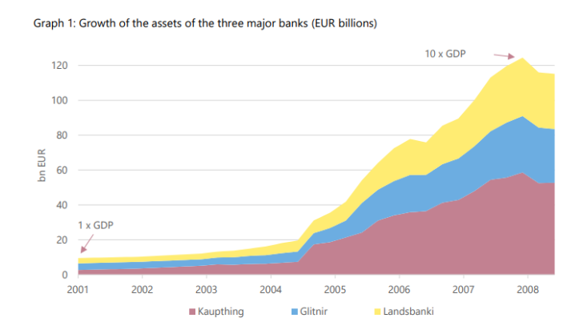
Figure 1
Assets that have grown for three Banks in Iceland (in EUR billions of dollars) (Baudino et al, 2020)

Countries like Canada, however, which implemented strong regulatory measures and prudent banking practices, weathered the crisis with significantly less damage. Therefore, the Bank Act prevented the banks in Canada from engaging in risky financial transactions and obliged to have an extremely low debt-to-equity ratios that majority of the banks overseas (Gordon, 2017). This is mainly because Canada has a well-educated and healthy population [workforce], so during the 2008 financial crisis, which was more likely to find new opportunities, and experienced shorter and less severe recessions, demonstrating the resilience fostered by human capital investments. So, Canada did not suffer from insolvency but rather was able in no time regain financial stability and provide liquidity to the financial markets.
In Chapter 1, we discussed how Singapore transformed into a knowledge-based economy through investments in education and health. Singapore, similarly, to Canada also had proactive risk financing strategies in place which included the Singapore Deposit Insurance Corporation, which provide stability during the 2008 Global Financial Crisis. Therefore, Singapore was able to bounce back from the 9% decline in GDP [as the country experienced downside risks] resulting in the central bank tightening policies like the foreign worker policy (International Monetary Fund, 2013). As part of Singapore’s Monetary Authority which established the Singapore Government Securities (SGS) market, Singapore has been able to efficiently manage its sovereign wealth fund, Temasek Holdings, which has provided Singapore to become financial resilient to continued investments in human capital development. This has ensured aa skilled and healthy workforce that supports ongoing economic development. Empirical studies across the world have demonstrated that countries with robust regulatory frameworks and financial institutions are more resilient to financial crises.
To ensure financial crisis resilience, financial institutions and governments must implement sound regulatory and risk management practices. For example, the Basel III framework introduced stricter capital and liquidity requirements for banks to enhance their resilience to economic shocks which was implemented following the Great Depression in 2008 (BIS, 2011). Additionally, countries can establish contingency funds, such as sovereign wealth funds (SWFs) or rainy-day funds, that can act as a financial cushion during financial crises. Norway’s sovereign wealth fund is a prime example of effective treasury management. According to Velculescu (2015), Norway’s Government Pension Fund Global [GPF] (the Norwegian Oil Fund) shields the nation’s finances from oil price fluctuations. By the end of 2007, the total assets of the GFP were $373 billion and have been one of the fastest-growing SWFs worldwide (Velculescu, 2015). By wisely investing its oil revenues, Norway has not only safeguarded its economic stability but also ensured resources for education and healthcare, contributing to its human development and long-term economic growth. Furthermore, the central bank of Norway uses GFP as a fiscal tool to limit government spending and ensure that any information on the GFP is transparent as seen in Figure 2 (Velculescu, 2015). Moreover, maintaining fiscal discipline and debt sustainability is crucial, as excessive debt can exacerbate the impact of financial crises.
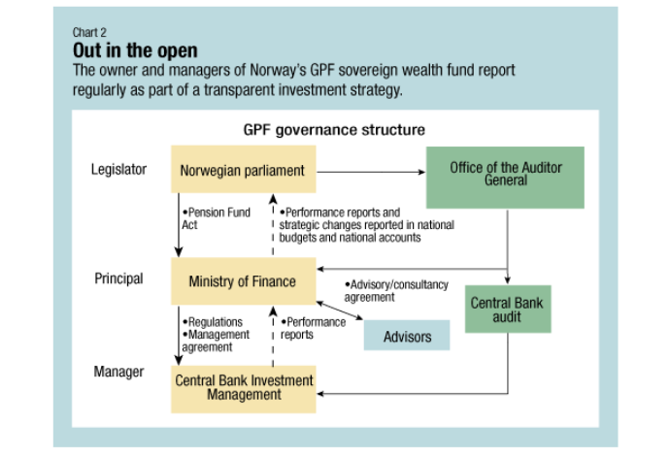
Figure 2
Transparency of the GFP (Velculescu, 2015)
Achieving financial crisis stability not only preserves economic stability but also fosters investor confidence, which is essential for long-term economic growth. Nations that demonstrate resilience during crises are more likely to attract foreign investments and maintain stable financial markets. For instance, during the Eurozone crisis, countries like Germany showcased resilience throughout their economic policies and strong financial institutions (Bulmer, 2022; Kenton, 2021). This contributed to their ability to bounce back quickly from the crisis and maintain robust economic stability.

  - Disaster Preparedness
Disaster preparedness in risk financing and treasury management is closely related to the concepts discussed in Chapter 1 and plays a crucial role in achieving and maintaining economic stability. The need for disaster preparedness is very pertinent, especially within the realm of risk financing and treasury management to maintain economic stability of nations. Disasters, whether economic or natural, can have devastating effects on a nation’s finances and its citizens’ well-being. Ensuring disaster preparation not only mitigates these impacts but also helps in the swift recovery of the economy. This chapter seeks to shed light on this need.

Mitigating the Economic Impact of Natural Disasters
Disaster preparedness involves government and financial institutions allocating financial resources and risk management strategies to mitigate the economic consequences of natural disasters such as floods, hurricanes, and earthquakes. Japan experienced a triple meltdown in 2011. During that period, an earthquake of magnitude 9.0 struck Japan off the east coast, which was immediately followed by a catastrophic tsunami having waves reaching 100 feet as seen in Figure 3 (Ferris & Solis, 2016).

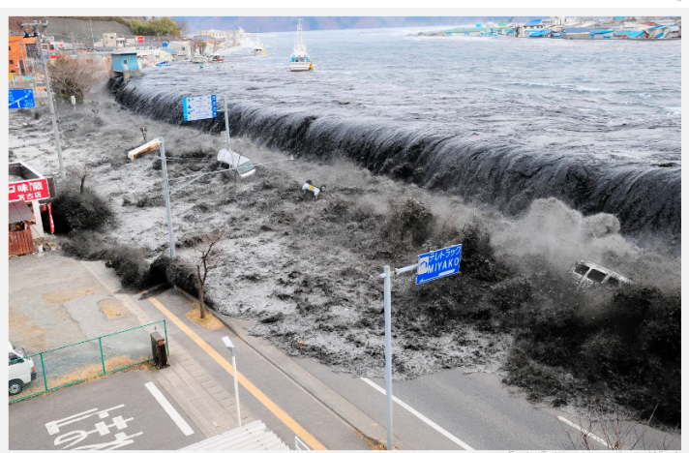
Figure 3
100 feet Wave of Massive Tsunami (Ferris & Solis, 2016)
Japan’s tsunami and earthquake triggered the Fukushima nuclear disaster, causing immense economic damage. The economic losses amounted to $360 billion and approximately 20,000 people died while 465,000 had to be evacuated [due to the uprooting of communities] (Ferris & Solis, 2016). This required the attention of the government and the people and thus closing nuclear reactors was done due to supply disruptions of electricity [sea water gravely affected the nuclear plants]; by the time operations resumed with only two of the reactors and Japan experienced trade deficits (Ferris & Solis, 2016). This was mostly because of the excessive oil importation into the country to address the loss of electricity.
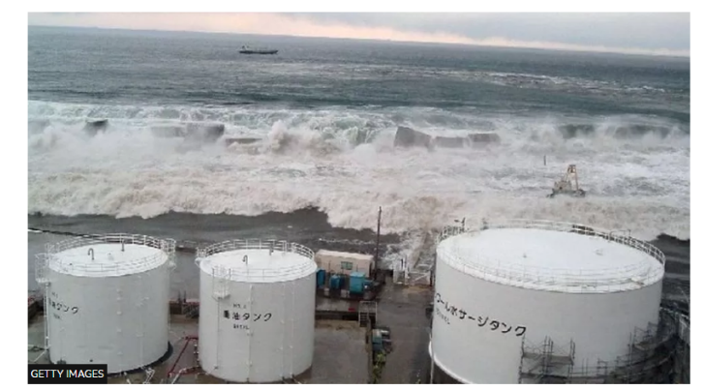
Figure 4
Catastrophic Impact of Nuclear Plant by the Influx of Sea Water (BBC News, 2021)


Figure 5
Checks were made to ensure people were not exposed to radiation (BBC, 2021)

People were also tested for radiation exposure to the plant to ensure they were fine as shown in Figure 5 (BBC News, 2021). However, Japan’s government had invested significantly in disaster preparedness and risk financing, including the issuance of catastrophe bonds. These measures helped to stabilize the country’s and expedite recovery efforts, preserving human capital.

Ensuring Financial Resilience against Economic Crises
Disaster preparedness encompasses financial resilience strategies that countries and institutions adopt to shield themselves from economic crises. Singapore’s robust treasury management and risk financing practices during the 2008 global financial crisis are illustrative. The country’s Monetary Authority took proactive measures, such as liquidity support to banks and prudent risk management, ensuring financial stability and minimizing the crisis’s impact on the economy.

Economic Stability through Contingency Funds
Chapter 1 discussed the role of education and health in human capital development which is fundamental for economic growth. Prudent treasury management practices, such as maintaining fiscal discipline and establishing contingency funds, are essential for economic crises. These strategies ensure that resources continue to be available for healthcare, education, and workforce development even during economic downturns. Contingency funds, a part of disaster preparedness, act as financial cushions during crises, ensuring the continuity of essential services and economic stability. The United Arab Emirates’ (UAE) establishment of the UAE Emergency Fund is an exemplary case. This fund, bolstered by treasury management practices, provides resources during economic or humanitarian crises. Glover (2023) wrote that following the COVID-19 pandemic at least 8 in every 10 UAE savers have indicated that emergency funding is very important to survive economic hardships. Having these savings resulted as a lesson they would have learnt based on the disruptions the pandemic caused in relation to the livelihood due to being ill as well as shutdowns. People struggled to survive the pandemic because they did not have sufficient funds to sustain them and their families. The availability of such funds supports economic stability and human capital development efforts.

  - Efficient Capital Deployment

Efficient capital deployment within risk financing and treasury management is a critical aspect of maintaining economic stability, as it ensures the optimal use of financial resources to support economic growth and resilience. Moreover, Chapter 1 underscores the importance of investments in human capital for long-term economic growth. This section will provide an explanation of the need for efficient capital deployment and how it can be ensured.

Enhancing Economic Stability through Optimal Resource Allocation
Efficient capital deployment involves the allocation of financial resources wisely, whether by individuals, businesses, or governments. It is essential for economic stability as it fosters innovation, prevents wastage of resources, ensures that investments in education, infrastructure, healthcare, and other critical sectors yield the maximum possible returns. Empirical evidence from the “Cash for Clunkers” programme developed in 2009 over the months of July and August by the federal government in the United States of America administered through the National Highway Traffic Safety Administration (NHTSA) following the 2008 financial crisis demonstrate the importance of efficient capital deployment (GAO, 2010). The programme offered incentives for trading in vehicles, as seen in Figure 6, that are old and fuel-inefficient for new, more fuel-efficient ones. The customers were offered credit in the amount of either US$3500 or US$4500 when they trade their cars which helped them to either purchase or lease a new vehicle as shown in Figure 6 (GAO, 2010). At the same time, both car dealers and the automobile manufacturers benefitted from the programme due to the increased sales of vehicles (GAO, 2010). Research indicates that this efficient use of resources not only supported the automobile industry but also contributed to economic stability by reducing emissions and fuel consumption.

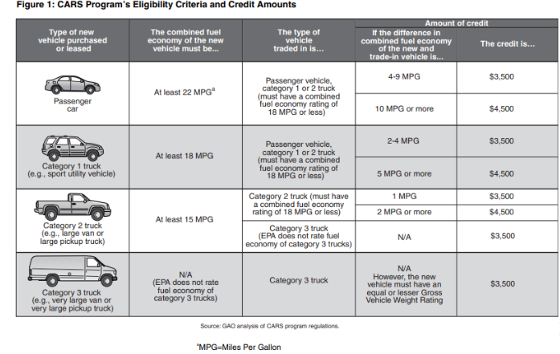
Figure 6
Eligibility Criteria to Participate in the 2009 Cash for Clunkers Programme and Monetary Benefits Derived (GAO, 2010)

Fostering Human Capital Development for Economic Resilience
Efficiently directing financial resources toward human capital development, including healthcare and education, is essential for economic stability. It ensures that individuals are equipped with the necessary skills and health to contribute productively to the workforce and adapt to changing economic conditions. Singapore’s strategic investments in its education system serve as a compelling real-life example as previously mentioned and discussed in Chapter 1. The city-state has consistently allocated a significant portion of its budget to education, emphasizing quality and relevance. For example, the International Trade Administration (2023) shared that for 2023 Singapore government allocated for budgeted expenditure $10.89 billion for the Ministry of education to provide training and manpower development, and education. The Ministry of education considered $5.53 billion of it for educators’ salaries, students’ subsidies including students needing special education; while the rest of the funds providing training of citizens in manpower development, provide technical and industry-relevant training as well as to support research at the universities based on the country’s economic plans (International Trade Administration, 2023). This efficient capital deployment over the years has resulted in a highly skilled workforce, which has contributed to Singapore’s economic resilience and stability, even in times of global uncertainty.
Effective capital deployment also includes strategies such as establishing contingency funds and prudent risk management. During the 2008 global financial crisis [caused by external factors to the country], Sweden’s National Debt office employed efficient treasury management practices, including issuing government bonds to ensure financial resilience [preventing a catastrophic financial meltdown] (Becker et al, 2016). This emergency action followed the collapse of the Lehman Brothers, where the financial authorities of Sweden adjusted the country’s traditional monetary policy to ensure that financial institutions could cope and avoid insolvency and ensure enough liquidity in the financial landscape (Becker et al, 2016). Becker et al (2016) explained that during 2008 and 2009 the adjusted monetary policy forced the reduction of the Riksbank’s repo rate from 4.25% to 0.25% at a slow pace. The main aim was to minimize both credit and term risks found to be associated with making direct purchases of [comparable-maturity] securities from banks (Becker et al, 2016). Consequently, financial resilience bolstered economic stability by preserving public services, including education and healthcare, which are vital components of human capital development.

Supporting Entrepreneurship and Innovation
Efficiently deployed capital is vital for supporting entrepreneurship and innovation, which are key drivers of economic growth and stability. Ensuring that financial resources are accessible to innovative individuals and businesses promotes economic dynamism and adaptability. Germany’s “Mittlestand” or mid-sized [small and medium-sized] companies (SMEs) serve as an example. This group of businesses accounts for at least 99% of all businesses in Germany that provides approximately 60% of the jobs in the country and more than 50% of the country’s economic output (BMWK – Federal Ministry for Economics Affairs and Climate Action, 2020). These firms have benefited from efficient capital deployment through access to well-structured financing mechanisms. This has allowed them to innovate and maintain economic stability, even in challenging economic environments.
Furthermore, Chapter 1 highlighted the impact of investments in education and healthcare on human capital development, which reflects that innovations in treasury management can enhance the effectiveness of human capital investments. In the Netherlands, the introduction or “studievoorschot”, or student loans [an administrative system setup to assist with payments of higher education], which has enabled efficient capital deployment for higher education. These loans are structured to provide financial support to students while ensuring responsible fiscal management (Netherlands Ministry of Education, Culture and Science, 2015). This approach safeguards human capital development, contributing to long-term economic stability.

Sovereign Wealth Funds (SWFs)

The establishment of Sovereign Wealth Funds (SWFs) is imperative to maintain economic stability, as they provide a financial cushion against economic volatility and enable nations to prudently manage their resources. This section explains the need for SWFs and how they can be ensured to support economic stability using real-life examples and empirical evidence.

Mitigating Economic Volatility through SWFs
Sovereign Wealth Funds (SWFs) are created to manage and invest in a country’s reserves, often generated from foreign exchange earnings or commodities. They serve to stabilize a nation’s economy during periods of economic uncertainty, external shocks, or commodity price fluctuations. The Norwegian Government Pension Fund Global (GPFG) established in 1990, funded by revenues from the petroleum sector, is a prime example. This happens because oil production being a finite source of revenue as well as can cause volatility (Centre for Public Impact A BCG Foundation, 2019). The GPFG has facilitated the management of oil assets and oil revenues and ensure that the country is able to save money and create wealth for future purposes (Centre for Public Impact A BCG Foundation, 2019). The fund’s prudent management and diversification have not only preserved Norway’s wealth but also contributed to economic stability. During the global financial crisis of 2008, the GPFG continues to generate returns, protecting Norway’s economy from severe shocks. In emphasizing the importance of investments in human capital, healthcare, and education for long-term economic growth and stability based on Chapter 1, this SWF becomes vital. SWFs, through their robust risk financing mechanisms, safeguard a nation’s wealth, ensuring that resources are available for essential services, including healthcare and education, even during economic crises.

Supporting Long-Term Economic Development
Sovereign Wealth Funds play a crucial role in supporting long-term economic development by investing in domestic infrastructure, education, and healthcare. They ensure that a nation’s resources are prudently deployed to drive sustainable growth. As previously mentioned, Singapore’s Temasek Holdings serve as an exemplar of how SWFs can contribute to economic stability through long-term investments. Tamasek Holdings revealed in their review 2023, that they had S$382 billion net portfolio value at the end of the year after investing S$31 billion during the year as seen in Figure 8 (Temasek Holdings, 2023). Temasek’s portfolio includes a wide range of assets, including strategic investments in healthcare, education, and technology. These investments [particularly due to its liquidity components as seen in Figure xx] have not only bolstered economic growth but also enhanced the resilience of Singapore’s economy during global economic challenges. 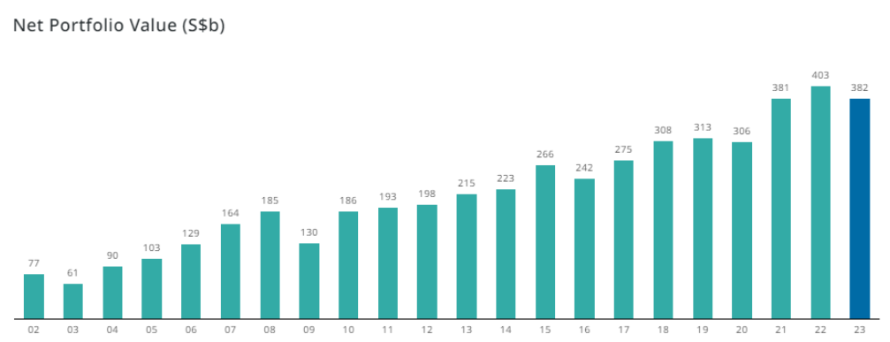
Figure 7
The Net Portfolio Value of Singapore's Assets (in S$ billions)
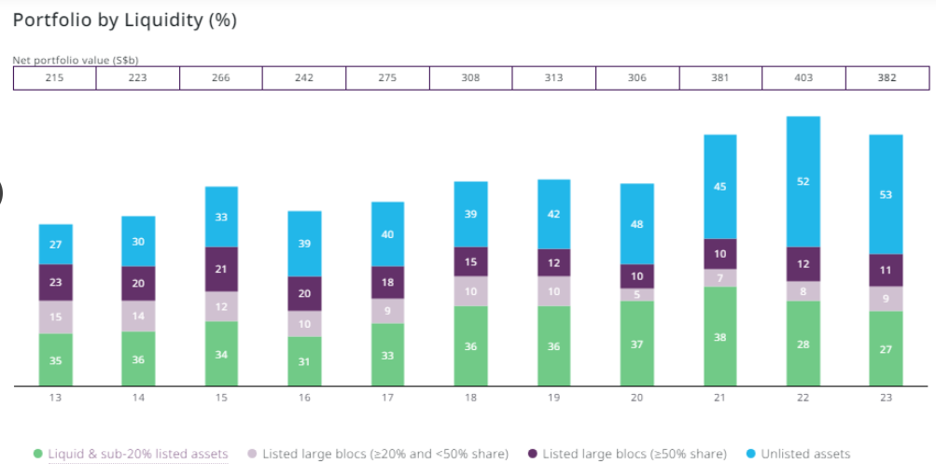
Figure 8
The Portfolio Value of Singapore's Assets that are Liquid (in %)

Also, SWFs often engage in strategic treasury management practices to maximize returns on investments. The Government of Singapore Investment Corporation (GIC) is an excellent illustration. GIC has been created to focus on building various asset classes within a portfolio along with suitable strategies that can obtain long-term real returns; in other words, it provides management of the Singapore’s foreign reserves (GIC, 2022). GIC’s prudent treasury management strategies have consistently generated returns, contributing to Singapore’s economic stability by ensuring the availability of resources for education and healthcare, thereby preserving human capital investments.
Moreover, SWFs often invest in sectors that support long-term human capital development. This is greatly aligned to Chapter 1 which highlighted the role of education, healthcare, and workforce development in human capital development. The Qatar Investment Authority (QIA) is a pertinent example that was established in 2005. The QIA purpose is to provide and generate returns through its developed sovereign wealth fund, in order to diversify Qatar’s economy while growing and protecting its financial assets (Qatar Investment Authority, 2023). QIA’s investments in research institutions, education, and healthcare aim to enhance human capital. By ensuring the availability of funds for these sectors, QIA contributes to Qatar’s economic stability and growth.

Ethical and Responsible Investment Practices
SWFs often adhere to ethical and responsible investment practices, ensuring that the wealth generated benefits the nation’s citizens and supports social and economic stability. The New Zealand Superannuation Fund (NZSF) is a testament to responsible SWF management. The NZSF has sought to manage environmental, social and governance (ESG) risk to provide sustainable finance for New Zealanders by ensuring that strong financial returns are obtained based on investments made over the years (New Zealand Superannuation Fund, 2023). With this in mind, the NZSF modified its approach in 2020 to ensure good practice remains forefront based on the country’s changing financial landscape (New Zealand Superannuation Fund, 2023). The NZSF incorporates ethical investment principles and actively engages with companies to improve their environmental, social, and governance practices. Such approaches not only generate returns but also align with the country’s values, contributing to economic stability and societal well-being.

Sovereign Wealth Funds are vital for maintaining economic stability, as they provide a means to mitigate economic volatility, support long-term development, and adhere to ethical investment practices. Real life examples, such as the Temasek Holdings, the Norwegian GPFG, and the New Zealand Superannuation Fund, demonstrate the benefits of effective SWF management in preserving a nation’s wealth and contributing to economic stability, even in the face of global economic challenges.

Risk Identification, Assessment and Mitigation

Strategies for risk identification, assessment, and mitigation are fundamental in managing financial and economic stability. Below, this section outlines these strategies using real-life examples.

Risk Identification
Risk identification is a crucial initial step in financing and treasury management, as it enables organizations to recognize potential threats and vulnerabilities. The importance of this process is underscored by real-life examples and empirical evidence, which highlight its necessity for financial stability and success.

Market Risk
Market risk can be identified as one’s exposure to market volatility by analyzing asset prices, interest rate changes, and currency fluctuations. For instance, during the 2008 financial crisis “The Great Depression”, banks like Lehman Brothers and institutions like American International Group (AIG) failed to identify their vulnerability to subprime mortgage risks, leading to substantial losses. These risks have caused a severe liquidity contraction of global financial markets in United States of America (Duignan, 2023). Empirical evidence from this crisis emphasizes that effective risk identification could have prevented or mitigated the catastrophic consequences that followed. Lehman Brothers filed for bankruptcy on September 15, 2008, having a debt of US$613 billion on assets of $639 billion (Rodini, 2023). As a result, AIG, the world’s largest insurance company, was threatened to collapse due to their holdings in credit swaps of $400 billion with Lehman Brothers. While AIG was trying to get a bailout, the stock market crashed on September 29, 2008, affecting Dow Jones Industrial Average (Duignan, 2023). Duignan (2023) stated that Lehman Brothers engaged in lack of transparency, risky lending, and excessive borrowing thus could not withstand the impact of the global financial crisis. Moreover, mortgages were defaulted by millions of Americans when the interest rates increased (Duignan, 2023). A comprehensive understanding of the risks associated with complex financial products, as seen in this crisis, is essential to safeguard the financial sector’s stability.

Operational Risk
Identify vulnerabilities in operational processes by conducting risk assessments and business impact analyses. The Fukushima Daiichi nuclear disaster in 2011 highlighted the need for better operational risk and mitigation within the energy sector. Following the two-phase disasters [tsunami and earthquake], a major accident [categorized as Level 7] happened at the Fukushima Daiichi. There were teams that constantly had to assess radiological levels and evaluate key nuclear safety elements (International Atomic Energy Agency, 2021). This allowed the International Nuclear and Radiological Event Scale (IAEA) to develop an action plan in September 2011 with the intention of ensuring nuclear safety is established as a response to the accident. The IAEA used the European Stress Test to help improve safety requirements.
The BP Deepwater Horizon oil spill served as a stark reminder of the importance of risk identification. BP failed to adequately identify the risks associated with deep-sea drilling, resulting in one the largest environmental disasters in history (National Commission on the BP Deepwater Horizon Oil Spill and Offshore Drilling, 2011). The aftermath had devastating financial repercussions for BP and its stakeholders, including shareholders and the affected communities. This real-life example underscores the need for thorough risk identification to protect not only an organization’s financial health but also the broader interests of stakeholders.

Beyond individual organizations, risk identification is vital for maintaining economic stability at the national level. The Great Depression, 2008 global financial risk, fueled by a lack of risk identification in various financial institutions, led to a severe global recession (Financial Crisis Inquiry Commission, 2011). This empirical evidence underscores that failures in risk identification can have far-reaching economic consequences, affecting not only individual businesses but entire economies. Robust risk identification practices are essential to ensure that financial systems remain resilient in the face of unexpected shocks.

In summary, risk identification is a critical element of risk financing and treasury management, with real-life examples and empirical evidence highlighting its indispensable role in preventing financial catastrophes, protecting stakeholders’ interests, and maintaining economic stability. These examples emphasize that comprehensive risk identification practices are important for organizations and economies to thrive in an increasingly complex and uncertain world.

Risk Assessment
The need for risk assessment in risk financing and treasury management, encompassing quantitative analysis and scenario analysis, is paramount for ensuring financial stability and mitigating potential threats. Real-life examples and empirical evidence underscore the significance of these methodologies in effective risk management. For instance, the collapse of Enron in 2001 provides an example of the consequences of inadequate risk assessment. Enron’s failure was due, in part, to a lack of proper risk assessment and financial transparency (Segal, 2023). This real-life case demonstrates that failing to conduct comprehensive risk analysis can lead to catastrophic consequences for organizations and their stakeholders. Empirical evidence from Enron’s downfall emphasizes the need for rigorous risk assessment as a foundation for effective risk mitigation.

Quantitative Analysis
Quantitative analysis employs statistical models and data analysis to assess risks quantitatively. For instance, Value at Risk (VaR) models were widely used in the financial industry to assess potential losses during the 2008 global financial crisis. The VaR is a statistical metric used by commercial and investment banks to quantify the extent of potential losses in their institutional portfolios and provide their probabilities (Kenton, 2023). Kenton (2023) explained that these models are used to provide a measurement of the level of risk exposure and ensure that it is controlled.
The formula used [historical method] to calculate VaR is $VaR=v_{n}\left(\frac{v_{p}}{v_{p-1}}\right);$where n is number days reflecting the historical timeframe the data was obtained for, and $v_{p}$is the number of variables on day p (Jassy, 2023). This formula provides the calculate the change in percent for the past 252 trading days [in a year] associated with each risk factor corresponding to 252 scenarios for the security’s future value (Jassy, 2023). This model indicates the likely loss to be experienced on an investment at various confidence intervals. When a calculated VaR is high it implies that investors are more likely to be confident in the projected outcome for their investments. Conversely, a high projected outcome according to Jassy (2023) implies avoid investments because the possible dollar loss is higher.
The internal VaR estimates for seven large international banks when examined during 2007-2009 financial crisis were found to have inaccuracies (Ha Tran & Mai Tran, 2023). These values were mostly overstated and indicated mixed performance and expected outcomes. Consequently, these banks performed very poorly due to their choice of faulty VaR models.

Scenario Analysis
Scenario analysis creates scenarios to understand how different events may impact your organization. A notable example is the “Black Swan” scenario, where unforeseen events have a significant impact, as seen in the COVID-19 pandemic. Taleb (2010) a well-known finance professor shared that the 2008 global financial crisis is categorized as a Black Swan event because it is rare and impossible to predict but usually has a catastrophic impact when it occurs. This crisis gravely impacted the global financial landscape including JP Morgan Chase investment and Lehman brothers’ which crashed. The Investopedia Team (2022) also shared that Zimbabwe saw its worst case of hyperinflation in 2008 resulting from the Great Depression where the rate peaked at al least 79.6 billion percent.
The most recent Black Swan event experienced globally was the COVID-19 in 2020 which turned the whole world upside down causing governments to restrict travelling and shutdown various activities in their countries as a risk mitigation mechanism to curtail the spread of the virus. Thus, causing disruptions of various economies and financial markets across the world. This pandemic serves as a compelling illustration for scenario analysis in risk assessment. Organizations that had conducted scenario planning for pandemics were better equipped to respond swiftly and effectively to the crisis. For instance, the U.S. Centers for Disease Control and Prevention (CDC) had developed pandemic response scenarios, enabling a coordinated and data-driven response (Centers for Disease Control and Prevention, 2022). This evidence underscores the critical role of scenario analysis in anticipating and preparing for unforeseen events.

Risk Mitigation
The need for risk mitigation in risk financing and treasury management is essential for safeguarding financial stability and protecting organizations and economies from potential harm. Risk mitigation is known to prevent catastrophic financial losses. For example, during the 2008 financial crisis the collapse of Lehman Brothers serves as a sheer reminder of the importance of risk mitigation. Lehman Brother’s failure and far-reaching consequences, contributing to the global financial meltdown. This real-life scenario illustrates that inadequate risk mitigation can lead to catastrophic financial losses not only for the organization itself but also for the broader financial system. Empirical evidence from this crisis underscores the need for proactive risk mitigation to prevent such severe repercussions.
Risk mitigation strategies have also been known to facilitate a safeguard of stakeholder interests. For example, the 2010 BP Deepwater Horizon oil spill is a powerful illustration of the need for risk mitigation in protecting stakeholder interests. BP’s failure to adequately mitigate the risks of deep-sea drilling led to one the largest environmental disasters in history. The financial and reputational damage inflicted on BP emphasized the importance of robust risk mitigation strategies to safeguard not only shareholder value but also the well-being of the communities affected. Empirical evidence from this incident underscores that the consequences of inadequate risk mitigation can extend far beyond financial losses.
Moreover, risk mitigation is needed to enhance economic stability. The COVID-19 pandemic demonstrated the critical role of risk mitigation in maintaining economic stability. Countries that implemented effective risk mitigation measures, such as lockdowns and vaccination campaigns, were better able to limit the economic impact of the pandemic. Empirical evidence from various nations’ responses highlights risk mitigation is essential for preserving economic stability and ensuring that economies can withstand unexpected shocks.
Other real-life examples and empirical evidence below emphasize the significance of robust risk mitigation strategies in financial management.

Diversification
Diversification involves the spread of investments across different industries [sectors], geographical regions, or assets to reduce risk concentration [overall risk exposure].

Investment Diversification in Portfolio Management
A well-diversified investment portfolio can mitigate the impact of a downturn in a specific sector. For instance, the California Public Employees’ Retirement System (CalPERS) is one of the largest pension funds globally. CalPERS employs diversification as a core risk mitigation strategy. By investing in a broad array of asset classes, including real estate, bonds, stocks, and private equity, CalPERS aims to reduce its portfolio’s risk while pursuing long-term returns for the next 80 years (CalPERS, 2021). Empirical evidence shows that diversified portfolios like CalPERS have historically demonstrated more stable returns over time. CalPERS has been known to have over millions of members and was found to be in value of US$485.2 million by December 2021 (CalPERS, 2021).

Geographic Diversification in the International Business
Multinational corporations often utilize geographic diversification to mitigate business risks. They seek diversification in order to generate more revenues while being exposed to less economic risk, avoiding business decline and exploiting potential synergies (Williams, 2023). Apple Inc. is an exemplar of this strategy. By manufacturing products in various countries, Apple mitigates supply chain risks associated with localized disruptions. In the 1990s, Apple struggled to stay afloat due to Microsoft software flooding the market providing cheaper and easier to use PC models (Williams, 2023). However, during the early years of 2000s, Apple’s development of diversified supply chain [which included iPod and iTunes software in 2003 followed by the emergence of the iPhone in 2007] helped it navigate challenges, ensuring product availability and mitigating financial losses (Williams, 2023). Presently, Apple has become even more diversified with assets such as watchers, electric vehicles, tables, and smart-audio. Therefore, Apple is known as one the world’s biggest corporations.

Sectoral Diversification in Investment Funds
Exchange-Traded Funds (ETFs) are an accessible way to retail investors to employ sectoral diversification. The Vanguard Information Technology EFT (VGT) is an ETF that focuses on the technology sector. By investing in a diversified basket of tech-related companies, VGT offers investors exposure to the sector while spreading risk (Vanguard, 2023). As of Friday, September 22, 2023, VGT’s YTD returns (MP) is 30.53% and its YTD returns (NAV) is 30.51% and having a fund total net assets of $62.4 billion [seen in Figure 9] (Vanguard, 2023). This example illustrates how sectoral diversification within investment funds can help retail investors reduce risk while participating in specific industry growth.
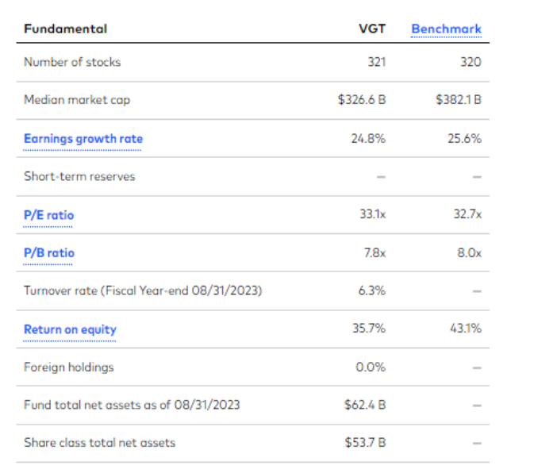
Figure 9
VGT Portfolio Composition Characteristics as of August 31, 2023 (Vanguard, 2023)

Diversification is a well-established risk mitigation strategy, supported by empirical evidence and real-life examples. It demonstrates how spreading risk across various assets, geographies, or sectors can reduce overall risk exposure, enhance financial stability, and potentially lead to more consistent returns. Whether in pension fund management, international business, or individual investments, diversification remains a key approach for risk mitigation in risk financing and treasury management. Diversification not only contributes to financial stability, but human capital development and economic growth based on the principles discussed in Chapter 1: Introduction to Human Capital and Economic Growth. Just as diversification spreads risk across various assets to safeguard financial resources, investments in education, healthcare, and workforce development diversify human capital, enhancing skills and capabilities. This parallels the idea that a well-rounded and diversified workforce is essential for driving economic growth. By managing risk effectively through diversification, organizations and economies can allocate resources consistently to human capital investments, fostering the development of a skilled and healthy workforce, which is fundamental to sustainable economic growth.

Hedging
Hedging is a widely used risk mitigation strategy in risk financing and treasuring management, which requires the use of financial instruments like derivatives to protect against adverse price movements. In other words, it aims to reduce exposure to price fluctuations or adverse events. For instance, Airlines often use fuel price hedges to mitigate the risk of rising fuel costs. Harbourfront Technologies (2023) shared that this is done to “counter the impact of fuel price volatility”. This involves airlines entering financial contracts such as futures contracts where the fuel cost is calculated at predetermined prices thereby addressing [mitigating] the vulnerability associated with any sudden spikes in fuel costs (Harbourfront Technologies, 2023). Therefore, the airlines can better manage economic challenges that are likely to arise because of the fluctuation of fuel costs while ensuring stability in their operational planning and budgeting (Harbourfront Technologies, 2023). Below are other real-life examples that illustrate how hedging has been effectively employed.

Currency hedging in International Business
Toyota Motor Corporation, a Japanese automaker with substantial international operations, employs currency hedging to mitigate exchange rate risks. Toyota produces vehicles in various countries and sells them globally, which exposes it to fluctuations in exchange rates. To minimize the impact of currency movements on its financial results, Toyota engages in forward contracts and options to hedge against unfavourable exchange rate shifts (Pan, 2023; US Securities and Exchange Commission, 2010). This strategy helps stabilize earnings and supports consistent investments in development, research, and workforce development.

Commodity Hedging in Agriculture
Archer Daniels Midland Company (ADM), a major player in the agricultural industry, utilizes commodity hedging to manage price volatility. ADM processes and trades agricultural commodities to factors like weather and supply-demand dynamics, ADM employs futures and options contracts to hedge against unfavourable price movements (US Securities and Exchange Commission, 2021). Effective hedging ensures stable revenues, enabling ADM to sustain investments in technology and employee training.

Interest Rate Hedging in Financial Institutions
Wells Fargo, one of the largest US banks, uses interest rate hedging to manage the impact of fluctuating interest rates on its balance sheet. Wells Fargo offers a variety of financial products and services, making it sensitive to changes in interest rates (Wells Fargo corporate & investment banking, 2023). To mitigate this risk, the bank engages in interest rate swaps and options to offset potential losses due to interest rate fluctuations. Effective interest rate hedging supports Wells Fargo’s financial stability, enabling it to continue lending and supporting economic activities.

Heding in risk financing and treasury management is a prudent strategy that reduces the impact of adverse events or market fluctuations. By mitigating financial risks, such as commodity price volatility, or interest rate shifts, or currency fluctuations, organizations ensure a stable financial foundation. This stability enables them to allocate resources consistently to human capital development, including healthcare, education, and workforce training and innovation. Just as hedging safeguards financial assets, it directly supports the development of a skilled workforce -essential elements for sustained economic growth. The ability to manage financial risks through hedging aligns with the broader goal of fostering a resilient economy driven by a robust human capital base, as explored in Chapter 1.

Insurance
Insurance is a well-established risk mitigation strategy in risk financing and treasury management, offering protection against various types of risks. Insurance facilitates the transfer of risks to insurance companies across the world. For instance, property owners purchase insurance to mitigate the financial impact of events like natural disasters.

Property and Casualty Insurance for Businesses
General Electric (GE), a multinational conglomerate, utilizes property and casualty insurance to manage risks associated with its vast global operations. GE’s diverse business units, including aviation, healthcare, and renewable energy, are exposed to various risks, such as property damage, liability claims, and supply chain disruptions (General Electric Company, 2022). By maintaining comprehensive insurance coverage, GE mitigates these risks and protects its financial resources. This enables the company to focus on investments in innovation, employee development, and research.

Health Insurance for Workforce Well-being
Google, a global technology company, offers comprehensive health insurance benefits to its employees (Google LLC, 2023). This commitment to employee health mitigates the risk of workforce health-related issues disrupting operations. Google’s health insurance coverage not only supports the well-being of its workforce but also helps retain and attract top talent. This real-life example demonstrates how health insurance contributes to a healthy and productive workforce, indirectly supporting the company’s growth and innovation.

Trade Credit Insurance for Exporters
The Export-Import Bank of the United States of America provides trade credit insurance to U.S. exporters. This insurance mitigates the risk of non-payment by foreign buyers, enabling American businesses to expand their export activities (International Trade Administration, 2023). By offering this coverage, the government supports economic growth by encouraging international trade and empowering businesses to invest in product development and market expansion.

Insurance in risk financing and treasury management aligns with the principles discussed in Chapter 1: Introduction to Human Capital and Economic Growth by providing financial security. It ensures that organizations have a safety net to manage any unexpected events and losses, enabling them to allocate resources to areas like healthcare, education, and workforce development, which are pivotal for sustained economic growth. By mitigating various risks through insurance, organizations safeguard their financial stability, reinforcing their capacity to invest in human capital and drive economic prosperity.

Managing Risks Through Treasury Operations

Managing risks through treasury operations is a critical pillar in the field of risk financing and treasury management, serving as the financial guardian of organizations in a dynamic and unpredictable world. This strategic discipline involves a spectrum of tactics, from hedging against currency fluctuations to optimizing liquidity and cash management. In an era where economic and financial landscapes are increasingly intricate, an adept treasury function becomes indispensable. This introductory paragraph delves into the realm of treasury operations, emphasizing its pivotal role in safeguarding an organization’s financial health, thereby fortifying its ability to invest in human capital development and stimulate enduring economic growth.

Treasury Management

The Proctor and Gamble Company (P&G) between 2020 and 2021 was criticized for its non-proactive approach to treasury risk management. P&G strongly opted to not consider hedging policy while expecting their customers to pay $2.3 billion because of not hedging against inflation risk associated with commodity (Karwal, 2021). This cost resulted because of an increase in FX, freight, and raw material costs in the third quarter after P&G promised that they would be alright by not hedging. At that time raw material prices seemed to be surging greatly as seen in Figure 10.
Coca Cola, on the other hand, US beverage giant, is known for its proactive approach to treasury risk management. The company employs various hedging strategies to mitigate currency risk, given its extensive international operations. Coca Cola’s treasury options include the use of financial derivatives such as forward contracts and options to protect against fluctuations in exchange rates. This approach has contributed to the stability of Coca Cola’s earnings and financial results. Karwal (2021) shared that Coca Cola was able to benefit vastly from very low prices of raw materials after almost doubling its notional commodity hedges in 2021. Karwal (2021) also explained that PepsiCo also benefited from its notional commodity hedges being able to counter the “2% rise in its cost of goods sold”. Figure 11 shows that in 2021, Coca Cola in comparison to Pepsi benefited more from commodity hedging using derivatives (Karwal, 2021).
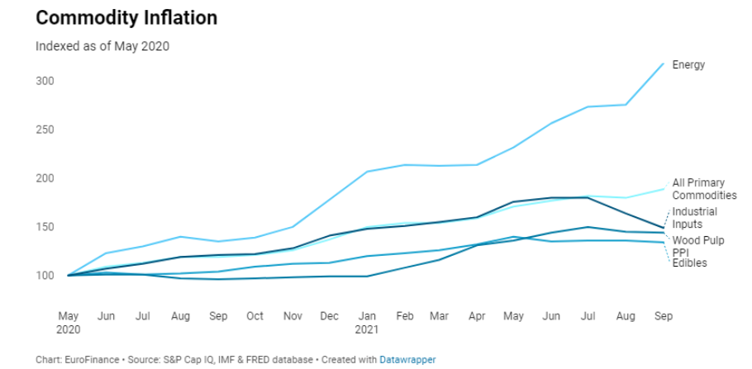
Figure 10
Commodity Inflation Indexed as of May 2020 - Proctor & Gamble (Karwal, 2021)

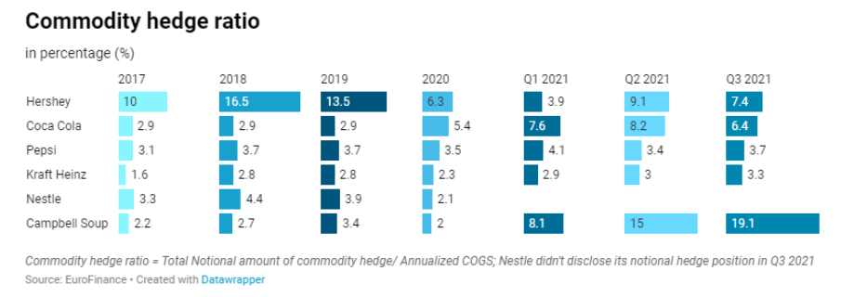
Figure 11
Commodity Hedge Ratio for Some Companies (in %) from 2017 to 2021 (Karwal, 2021)

Cash Management and Liquidity Risk

Apple’s treasury operations are renowned for their efficiency in managing cash and liquidity risk. The company holds substantial cash reserves and invests them prudently. Apple utilizes a diversified portfolio of short-term and long-term investments to optimize returns while ensuring sufficient liquidity for its operations and strategic investments (Apple Inc, 2022).

These examples demonstrate how businesses with global operations manage risks through treasury operations, aligning with principles discussed in risk financing and treasury management. Effective treasury practices ensure financial stability, support innovation and workforce development, and contribute to long-term economic growth.

Implications of Risk Financing Decisions

Risk financing decisions bear substantial implications on the overall financial health of an organization. These decisions encompass a range of strategies, including insurance, self-insurance, diversification, and hedging, each with distinct ramifications for financial well-being.

Cost Management
The choice of risk financing method directly influences cost structures. For instance, opting for comprehensive insurance coverage may lead to higher premium expenses, while self-insurance can entail setting aside significant reserves. The financial health of an organization is impacted by these costs, as they affect cash flows, capital allocation, and profit margins. Prudent risk financing decisions aim to strike a balance between managing expenditure to sustain profitability while protecting against potential losses.

Liquidity and Cash Flow
Risk financing strategies can tie up significant amounts of capital. For instance, self-insurance necessitates maintaining reserves to cover potential losses. This allocation of resources can impact cash flow and liquidity, potentially limiting the organization’s ability to invest in growth initiatives, including human capital development. Therefore, the choice of risk financing method should align with an organization’s liquidity needs to ensure financial stability.

Capital Allocation
The allocation of capital for risk financing affects the availability of funds for other critical purposes, such as expansion, workforce training, and research and development. Misaligned risk financing decisions can divert resources away from these areas, potentially hindering an organization’s long-term growth prospects. Therefore, careful consideration of how risk financing impacts capital allocation is vital for preserving overall financial health.

Creditworthiness
Risk financing decisions can influence an organization’s creditworthiness. Overreliance on debt to cover potential losses, rather than adequate risk financing measures, can increase leverage rations, affecting the organization’s ability to secure favourable financing terms. This, in turn, can impact financial health by raising borrowing costs and limiting access to capital.

Resilience and Sustainability
Effective risk financing decisions contribute to an organization’s resilience in the face of adversity. By adequately protecting against potential losses, organizations can better weather unexpected events or economic downturns [shocks], preserving their financial health and long-term sustainability.

Risk financing decisions are integral to an organization’s financial health. The selected approach must strike a balance between preserving liquidity, managing costs, maintaining creditworthiness, allocating capital wisely, and ensuring long-term resilience. A well-thought-out risk financing strategy enhances an organization’s ability to invest in human capital development and fosters sustained economic growth.

Summary

Chapter 2: Risk Financing and Treasury Management delves into the essential domain of mitigating financial uncertainties, showcasing how effective risk management supports the overarching objectives introduced in Chapter 1: Introduction to Human Capital and Economic Growth. In this chapter, we explored the prudent financial practices, such as insurance, hedging, and efficient cash management, are fundamental to maintaining financial stability and ensuring that resources are consistently available for investments in human capital. By guarding against potential financial shocks, organizations can sustain their commitments to education, healthcare, and workforce development, which are foundational elements for economic growth.
As we progress to Chapter 3: Market Microstructure and Quantitative Methods, it is critical to recognize that the strategies and financial prudence discussed in Chapter 2 serve as the basis for informed decision-making in financial markets. These risk management practices not only shield organizations but also empower them to engage confidently in financial markets, where they can optimize returns and bolster their financial resources further. We will delve into the intricacies of market microstructure and quantitative methods, exploring how these tools amplify financial efficiency, further reinforcing our understanding of how human capital development and economic growth intertwine with sound practices.
In Chapter 3, we will witness how well-structured financial markets and quantitative analysis serve as enablers for organizations to make informed investment decisions, allocating resources effectively to sustain and enhance their human capital. Let’s consider the following, “How does the effective management of financial risks directly impact an organization’s capacity to engage in financial markets and generate funds? How might these returns contribute to broader economic growth and development, as we will explore further in Chapter 3?” By understanding market dynamics and employing data-driven approaches, we will unveil how these financial intricacies underpin the growth and prosperity envisioned in Chapter 1, reinforcing the essential connection between finance, human capital, and economic development.

End of Chapter Questions

Here are some end-of-chapter questions for Chapter 2: Risk Financing and Treasury Management:

- How do risk management strategies, such as insurance and hedging, align with the goal of sustaining investments in education and healthcare?

- Can you provide examples of organizations that have effectively managed risks to secure resources for human capital development?

- Analyze the significance of foreign exchange risk in today’s global business landscape. How do multinational corporations use hedging strategies to mitigate currency risk? Discuss how managing currency risk aligns with the goal of sustaining and enhancing human capital.

- Explain the importance of liquidity management in treasury operations. How can efficient cash and liquidity management directly impact an organization’s ability to invest in education, healthcare, and workforce development? Provide examples of how organizations balance liquidity with long-term investments in human capital.

- How might a stable treasury operation indirectly support employee training and skills development?

- Consider the implications of efficient cash management and liquidity risk reduction for workforce productivity.

- Reflect on how a well-structured treasury operation can serve as a foundation for informed market participation. Can you envision how financial prudence links the themes of Chapters 2 and 3, reinforcing the connection between financial acumen, human capital development, and economic prosperity?

Bibliography

Apple Inc. (2022). Form 10-K for the Fiscal Year Ended September 27, 2022. Apple
Inc. https://s2.q4cdn.com/470004039/files/doc_financials/2022/q4/_10-K-2022-(As-Filed).pdf.
Baudino, P., Thor Sturluson, J., & Svoronos, J. (2020, March). The banking crisis in Iceland. Bank
for International Settlements. FSI Crisis Management Series No 1. https://www.bis.org/fsi/fsicms1.pdf.
BBC News. (2021, March 10). Fukushima disaster: What happened at the nuclear
plant? Retrieved September 18, 2023, from https://www.bbc.com/news/world-asia-
56252695.
Becker, T., Bryant, R., & Henderson, D. (2016, July 29). Maintaining financial stability in an
open economy: Sweden in the global crisis and beyond. Brookings.
Retrieved September 22, 2023, from https://www.brookings.edu/articles/maintaining-
financial-stability-in-an-open-economy-sweden-in-the-global-crisis-and-beyond/.
BIS. (2011). Basel III: A global regulatory framework for more resilient banks and banking
systems. Bank for International Settlements. https://www.bis.org/publ/bcbs189.pdf.
BMWK - Federal Ministry for Economics Affairs and Climate Action. (2020). The German
Mittelstand as a model for success. BMWK - Bundesministerium für Wirtschaft und Klimaschutz. https://www.bmwk.de/Redaktion/EN/Dossier/sme-policy.html.
Bulmer, S. (2022, March 23). Germany, the Eurozone crisis and the COVID-19 pandemic: Failing
forward or moving on? PubMed Central (PMC). https://www.ncbi.nlm.nih.gov/pmc/articles/PMC8942386/.
CalPERS. (2021, June). CalPERS for California 2021: For the Fiscal Year Ended June 30,
2021. California Public Employees' Retirement System -
CalPERS. https://www.calpers.ca.gov/docs/board-agendas/202211/invest/item04i-
01_a.pdf.
Centers for Disease Control and Prevention. (2022, April 2). National Pandemic Strategy. U.S.
Department of Health & Human Services. Retrieved September 23, 2023, from https://www.cdc.gov/flu/pandemic-resources/national-strategy/index.html.
Centre For Public Impact A BCG Foundation. (2019, September 2). The government pension fund
global (GPFG) in Norway. Centre For Public Impact
(CPI). https://www.centreforpublicimpact.org/case-study/government-pension-fund-
global-gpfg-norway.
Duignan, B. (2023, August 14). Financial crisis of 2007–08 | Definition, causes, effects, & facts.
Encyclopedia Britannica. Retrieved September 23, 2023,
from https://www.britannica.com/money/topic/financial-crisis-of-2007-2008.
Ferris, E., & Solis, M. (2016, July 29). Earthquake, tsunami, meltdown - The triple disaster's
impact on Japan, impact on the world | Brookings. Brookings. Retrieved September 18, 2023, from https://www.brookings.edu/articles/earthquake-tsunami-meltdown-the-triple-disasters-impact-on-japan-impact-on-the-world/.
Financial Crisis Inquiry Commission. (2011, February 25). The Financial Crisis Inquiry
Report. Final report of the national commission on the causes of the financial and economic crisis in the united states. U.S. Government Printing Office. https://www.govinfo.gov/content/pkg/GPO-FCIC/pdf/GPO-FCIC.pdf.
GAO. (2010, April). Lessons Learned from Cash for Clunkers Program. Highlights of GAO-10-
486, a report to congressional committees. Auto industry. U.S. Government Accountability Office (U.S. GAO). https://www.gao.gov/assets/gao-10-486.pdf.
General Electric Company. (2022, December). GE 2022 Company Overview. GE | Building a
world that works | General Electric. https://www.ge.com/sites/default/files/ge-company-overview.pdf.
GIC. (2022). Report on the management of the government’s
Portfolio 2021/2022. https://www.gic.com.sg/wp-content/uploads/2022/07/GIC_AR_2021-22_PRINT.pdf.
Glover, F. (2023, July 19). Emergency fund a top financial goal for UAE savers, survey finds. The
National. https://www.thenationalnews.com/business/money/2023/07/19/emergency-fund-a-top-financial-goal-for-uae-savers-survey-finds/.
Google LLC. (2023). Benefits Overview: United States. Google
Careers. https://careers.google.com/benefits/.
Gordon, S. (2017, October). Recession of 2008–09 in Canada. The Canadian
Encyclopedia. https://www.thecanadianencyclopedia.ca/en/article/recession-of-200809-in-canada#:~:text=Partly%20because%20of%20this%20stronger,see%20Stock%20and%20Bond%20Markets).
Harbourfront Technologies. (2023, September 5). How the airlines hedge fuel costs. Risk
Management. Retrieved September 24, 2023, from https://harbourfronts.com/how-the-airlines-hedge-fuel-costs/#:~:text=To%20counter%20the%20adverse%20impact,sudden%20spikes%20in%20fuel%20costs.
Ha Tran, M., & Mai Tran, N. (2023, March 1). Value-at-risk and the global financial crisis –
Journal of risk model validation. Risk.net. https://www.risk.net/journal-of-risk-model-validation/7956141/value-at-risk-and-the-global-financial-crisis.
Hui Ting, Y. (2023, June 30). Temasek tops 200 sovereign and pension funds in governance,
sustainability and resilience practices. https://www.businesstimes.com.sg/singapore/temasek-tops-200-sovereign-and-pension-funds-governance-sustainability-and-resilience.
International Trade Administration. (2023). Export credit insurance. International Trade
Administration | Trade.gov. https://www.trade.gov/export-credit-insurance.
International Atomic Energy Agency. (2021). Fukushima Daiichi nuclear accident. International
Atomic Energy Agency | Atoms for Peace and Development. https://www.iaea.org/topics/response/fukushima-daiichi-nuclear-accident.
International Monetary Fund. (2013, November). Singapore financial system stability
assessment. https://www.imf.org/external/pubs/ft/scr/2013/cr13325.pdf.
International Trade Administration. (2023). Singapore budget 2023. International Trade
Administration | Trade.gov. https://www.trade.gov/market-intelligence/singapore-budget-2023#:~:text=In%20the%20area%20of%20education,students%20and%20salaries%20for%20educators.
Jassy, D. (2023, August 29). How to calculate value at risk (Var) in Excel. Investopedia.
Retrieved September 23, 2023, from https://www.investopedia.com/ask/answers/033115/how-can-you-calculate-value-risk-var-excel.asp.
Karwal, A. (2021, November 16). P&G defends no-hedging policy, insists customers will pay for
$2.3bn commodity hit. EuroFinance | The global treasury community.
Retrieved September 24, 2023, from https://www.eurofinance.com/news/pg-defends-no-
hedging-policy-insists-customers-will-pay-for-2-3bn-commodity-hit/.
Kenton, W. (2021, October 28). Learn about the European sovereign debt crisis. Investopedia.
Retrieved September 18, 2023, from https://www.investopedia.com/terms/e/european-sovereign-debt-crisis.asp.
Kenton, W. (2023, March 23). Understanding value at risk (Var) and how it's computed.
Investopedia. Retrieved September 23, 2023, from https://www.investopedia.com/terms/v/var.asp.
National Commission on the BP Deepwater Horizon Oil Spill and Offshore Drilling. (2011,
January). Deep Water: The Gulf Oil Disaster and the Future of Offshore Drilling. U.S.
Government Printing Office. Report to the
President. https://www.govinfo.gov/content/pkg/GPO-OILCOMMISSION/pdf/GPO-
OILCOMMISSION.pdf.
Netherlands Ministry of Education, Culture and Science. (2015, July). Strategic Agenda for
Higher Education and Research 2015-2025. European Higher Education Area and Bologna Process. https://ehea.info/Upload/the_value_of_knowledge.pdf.
New Zealand Superannuation Fund. (2023, July 20). Sustainable finance. NZ Super
Fund. https://nzsuperfund.nz/how-we-invest/sustainable-finance/.
Pan, G. (2023, March). The Impact of Exchange Rate Fluctuation on Toyota Financial
Performance and Its Hedging Strategy. ResearchGate | Find and share research. https://www.researchgate.net/publication/369525380_The_Impact_of_Exchange_Rate_Fluctuation_on_Toyota_Financial_Performance_and_Its_Hedging_Strategy.
Qatar Investment Authority. (2023). About Qatar Investment
Authority. https://www.qia.qa/en/About/Pages/default.aspx.
Rodini, L. (2023, July 14). What Happened to Lehman Brothers? Why Did It
Fail? thestreet.com. https://www.thestreet.com/banking/what-happened-to-lehman-
brothers#:~:text=On%20September%2015%2C%202008%2C%20Lehman,11%2C%202
001%2C%20terrorist%20attacks.
Segal, T. (2023, April 5). Enron scandal: The fall of a Wall Street darling. Investopedia. Retrieved August 11, 2023, from https://www.investopedia.com/updates/enron-scandal-summary/.
Taleb, N. N. (2010, May 11). The Black swan: Second edition: The impact of the highly
improbable: With a new section: "On robustness and fragility" (Incerto): Taleb, Nassim
Nicholas: 8601404990557: Amazon.com: Books. Amazon.com. Spend less. Smile
more. https://www.amazon.com/Black-Swan-Improbable-Robustness-
Fragility/dp/081297381X.
Temasek Holdings. (2023). Temasek review 2023: Our compass in a complex world. Temasek
Review 2023. https://www.temasekreview.com.sg/#performance-overview.
The Investopedia Team. (2022, June 7). Black swan in the stock market: What is it, with examples
and history. Investopedia. Retrieved September 23, 2023, from https://www.investopedia.com/terms/b/blackswan.asp.
Us Securities and Exchange Commission. (2010, June 25). Request rate threshold
exceeded. SEC.gov. https://www.sec.gov/Archives/edgar/data/1094517/000119312510146673/d20f.htm.
Us Securities and Exchange Commission. (2021, September 20). Request rate
threshold exceeded. SEC.gov. https://www.sec.gov/Archives/edgar/data/7084/000000708421000039/adm-20210930.htm.
Vanguard. (2023). Vanguard Information Technology ETF
(VGT). Vanguard. https://investor.vanguard.com/investment-products/etfs/profile/vgt.
Velculescu, D. (2015, September 28). IMF survey: Norway's oil fund shows the way for wealth
funds. IMF. IMF European Department. Retrieved September 18, 2023, from https://www.imf.org/en/News/Articles/2015/09/28/04/53/sopol070908a.
Wells Fargo corporate & investment banking. (2023). Market risk management and foreign
exchange - Wells Fargo corporate & investment banking. Wells Fargo Bank | Financial Services & Online Banking. https://www.wellsfargo.com/cib/institutional-investing/market-risk-management/.
Williams, A. (2023, January 20). Business diversification – How it works and examples. Latest
News & Blog | Shorts Accountants. https://blog.shorts.uk.com/genus/business-diversification-strategy-examples.

