REETA JACKS
ID: UM95245BU104466
MASTERS IN BUSINESS ADMINSTRATION
ATLANTIC INTERNATIONAL UNIVERSITY

STRATEGIC LEADERSHIP AND CHANGE MANAGEMENT

CONTENT
Abstract……………………………………………………………………………………….2
Introduction…………………………………………………………………………………..2
Theoretical Frameworks of Change Management…………………………………………2
The Concept of "Psychological Safety" in Change……………………………...…………3
Ethical Leadership and the "Social Contract"………………………………….…………3
The "Change Curve" (Kübler-Ross Integration) ………………………………………….3
Digital Transformation as a Strategic Driver………………………………………………4
Summary Table: Management vs. Strategic Leadership………………………………….4
Governance and Public Policy Alignment………………………………………………….4
Analysis of Pros and Cons……………………………………………………………...........5
Career Benefits and Professional Trajectory………………………………………………5
Filling the Gaps: The Role of "Internal Communication"……………………………….6
Conclusion…………………………………………………………………………………...6
Bibliography…………………………………………………………………………………6

The Strategic Architect: Navigating Organizational Evolution through Leadership and Change Management
Major: Business Administration / Strategic Management
Focus Area: Business Transformation & Public Policy
Core Concepts: Vision Alignment, Adaptive Leadership, Corporate Communication, Stakeholder Engagement

Abstract
Strategic Leadership is the ability to influence others to voluntarily make decisions that enhance the long-term viability of the organization while maintaining short-term financial stability. When paired with Change Management, it forms the "engine" of organizational transformation. This paper explores the symbiotic relationship between visionary leadership and the structured processes required to transition individuals, teams, and organizations from a current state to a desired future state.
Introduction: The Mandate for Strategic Leadership
In an era defined by "VUCA" (Volatility, Uncertainty, Complexity, and Ambiguity), traditional management is no longer sufficient. Strategic Leadership transcends day-to-day operations to focus on Business Transformation. It involves not only deciding what to do but also how to foster an organizational culture that accepts and sustains change.
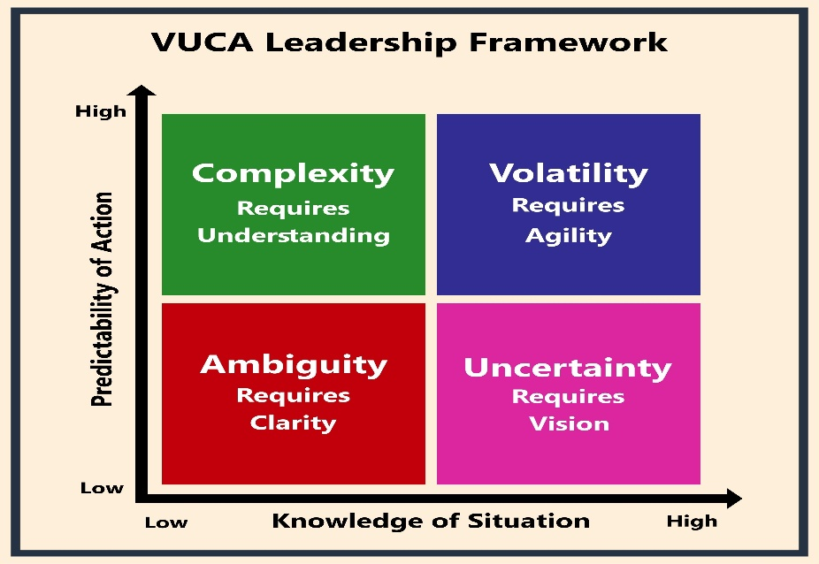

Theoretical Frameworks of Change Management
To manage change effectively, a leader must utilize proven models to mitigate resistance:
- Kotter’s Eight-Step Process: Focuses on creating a "Sense of Urgency" and building a "Guiding Coalition." This is particularly effective in large-scale institutional shifts (such as those in public policy or national training trusts).
- The ADKAR Model: (Awareness, Desire, Knowledge, Ability, and Reinforcement). This individual-focused model ensures that every team member is psychologically prepared for the transition.
- Lewin’s Three-Step Model: Unfreeze (preparing for change), Change (the transition), and Refreeze (stabilizing the new state).

The Concept of "Psychological Safety" in Change
While models like Kotter’s focus on the process, a unique view in modern leadership is the focus on the environment.
- The Insight: Based on research by Amy Edmondson (Harvard), Strategic Leadership is ineffective if team members are afraid to speak up during a transition.
- The "Gap" Filled: Most change management plans fail because they are "top-down." Adding Psychological Safety ensures that “ Change Management" becomes a collaborative effort where feedback is used to fix the strategy in real-time.

Ethical Leadership and the "Social Contract"
Since your subjects include Public Policy, you should address how strategic change affects the "Social Contract" between an employer and the workforce.
- The Insight: Change often involves "skilling up" or "skilling out." Ethical leaders prioritize Transparency and Reskilling Pathways.
- Career Benefit: In a national training environment (like HEART/NSTA), this demonstrates that you aren't just managing profit, but for national human capital development. This positions you as a leader capable of handling public-sector responsibilities.

The "Change Curve" (Kübler-Ross Integration)
A common gap in "Strategic Management" papers is the neglect of the emotional journey.
- The Insight: Individuals go through a process similar to grief when a workplace change occurs (Shock $\rightarrow$ Denial $\rightarrow$ Anger $\rightarrow$ Bargaining $\rightarrow$ Depression $\rightarrow$ Testing $\rightarrow$ Acceptance).
- Leadership Application: A Strategic Leader recognizes where their team is on this curve and adjusts their Corporate Communication style accordingly using "Empathy" during the depression stage and "Motivation" during the testing stage.

Digital Transformation as a Strategic Driver
In the modern field, you cannot discuss Strategic Leadership without mentioning Technology.
- The Insight: "Digital Transformation" is not about buying new computers; it is about changing the business model to leverage data.
- Vocational Context: For your work, this might involve moving from physical classroom supervision to Data-Driven Performance Monitoring, where you use analytics to predict student success rates.

Summary Table: Management vs. Strategic Leadership
Included is a comparison table in my paper provides a quick "at-a-glance" value for the AIU evaluator.
Feature | Operational Management | Strategic Leadership (Change-Focused)
Primary Goal | Efficiency and Stability | Innovation and Evolution
Time Horizon | Short-term (Weeks/Months) | Long-term (Years/Decades)
Approach | Problem Solving | Sense-Making and Visioning
Communication | Top-Down Instruction | Dialectical/Two-Way Engagement
Risk Profile | Risk Aversion | Calculated Risk-Taking

Governance and Public Policy Alignment
Since you mentioned Public Policy, add a section on Institutional Governance.
- Unique View: Strategic leaders in the public sector must manage "Dual Accountability” they are accountable to the board/government (upward) and the community/students (downward).
- The Gap: Most corporate change models ignore the "Red Tape" of public policy. You can discuss the "Strategic Management of Stakeholder Interests" to navigate bureaucracy while still achieving transformation.

Analysis of Pros and Cons
The Advantages (Pros)
- Organizational Agility: Strategic leadership creates a "fail-fast, learn-fast" culture, allowing the organization to pivot before market or policy shifts become catastrophic.
- Alignment of Vision and Action: It ensures that every departmental goal contributes directly to the high-level corporate mission.
- Stakeholder Buy-in: Effective Corporate Communication reduces the "fear of the unknown," leading to higher employee retention during turbulent times.
The Challenges (Cons)
- Change Fatigue: Constant transformation can exhaust a workforce, leading to burnout and decreased productivity.
- Resistance to Change: Natural human psychology leans toward the status quo; leaders often underestimate the emotional labor required to move a team forward.
- Resource Intensity: Transformation requires significant time, capital, and "emotional intelligence" which may distract from immediate operational targets.

Career Benefits and Professional Trajectory
Integrating Strategic Leadership into one's career profile, particularly for those in Business Technology or Public Sector Management—offers significant advantages:
- Transition from Manager to Executive: You move from supervising "tasks" to orchestrating "systems."
- Conflict Resolution Expertise: Change management provides the tools to navigate the grievances that inevitably arise during restructuring.
- Policy Influence: For those in national organizations like HEART/NSTA, these skills allow you to translate national Public Policy into actionable training standards.

Filling the Gaps: The Role of "Internal Communication"
A common gap in Strategic Leadership studies is the neglect of Internal Marketing.
- Strategy as a Product: Leaders must "sell" the change to their employees as if they were customers.
- Feedback Loops: A unique view in this field is that change is not "Top-Down" but "Circular." The most successful leaders use Social Listening within their organizations to adjust the strategy in real-time based on the feedback from the frontline.
Conclusion
Strategic Leadership and Change Management are not merely "soft skills” they are the hard requirements for survival in a globalized economy. For a professional, the goal is to become an Adaptive Leader: one who provides direction and protection while simultaneously challenging the organization to grow beyond its comfort zone.

Bibliography
- Edmondson, A. C. (2018). The Fearless Organization: Creating Psychological Safety in the Workplace for Learning, Innovation, and Growth. Wiley.
- Westerman, G., et al. (2014). Leading Digital: Turning Technology into Business Transformation. Harvard Business Review Press.
- Christensen, C. M. (2016). The Innovator's Dilemma. Harvard Business Review Press (for a view on why large institutions struggle with change).
- Kotter, J. P. (2012). Leading Change. Harvard Business Review Press.
- Heifetz, R. A., & Linsky, M. (2017). Leadership on the Line: Staying Alive through the Dangers of Change. Harvard Business Review Press.
- Hiatt, J. M. (2006). ADKAR: A Model for Change in Business, Government, and our Community. Prosci Learning Center Publications.
- Senge, P. M. (2006). The Fifth Discipline: The Art & Practice of The Learning Organization. Doubleday.

