KENGNE DJEUTANE GEORGINE
D95499EC104721

COURSE NAME:
Advanced Macroeconomics

Assignment Title:
(Introduction to the Advanced Macroeconomic Analysis)

ATLANTIC INTERNATIONAL UNIVERSITY
April/2026

Contents
Introduction 2
Understanding macroeconomics 3
The neoclassical growth theory: Solow-Swan Growth model (1956) 4
Definition of the model 4
The main assumptions of the model 5
Key Components and Simplified Formula Details 5
Implications of The Solow Growth Model 10
Limitation of the Solow- Swan Growth Model 11
Personal analysis of the course concepts 12
How I will apply the knowledge to my life, work and community. 12
Case example to demonstrate the concept 13
Conclusion 14
Bibliography 15

Introduction
This paper introduces various methods of macroeconomic analysis, viewing the field as a framework for understanding long-term growth and short-term fluctuations in aggregate variables. We begin with a general overview of macroeconomics, followed by a simplified examination of the neoclassical model of economic growth known as Solow – Swan (1956)growth model which is the workhorse of modern macroeconomics. It is equally the foundation for more advanced understanding of the evolution of production potential of economics, its explains how a country’s economy grows over time by using capital, labour, technology, and savings; showing that long-run economic growth does not come only from machines and workers, but mainly from technological progress and better skills. By critically analyzing these concepts and addressing their inherent limitations, I argue that an economy may employ multiple models to better understand growth, fluctuations, and specific national objectives. As Milton Friedman famously posited, models need not be entirely realistic to be useful; rather, when presented with two models of equal predictive power, the choice should favor the more realistic framework or a strategic combination of both. Existing literature suggests that the Solow Model partially explains the economic growth of the four East Asian 'Tigers' a theme further elaborated upon in this paper. Exploring these dynamics reinforces my professional ambition to serve as a policy analyst within an African think tank, where I hope to provide data-driven insights for future policymakers.

Understanding macroeconomics

Macroeconomics is a branch of economics that studies how an overall economy behaves. Macroeconomics is about explaining two (2) things: growth and fluctuations and business cycles – fluctuations around the trend. It is different to microeconomics even though its foundations are essential to macroeconomics.

Macroeconomics is about aggregate activity over some period. We are interested in Gross Domestic Product (GDP) at constant prices, inflation (rate of change in the price level), interest rates (financial variables), unemployment rate, exchange rate. In thinking about the overall health of the macroeconomy, three primary goals are considered: economic growth, full employment or low unemployment, and stable prices (or low inflation). Economic growth ultimately determines the prevailing standard of living in a country. Some of the macroeconomic goals of countries are: economic growth, maximum employment, price stability (controlling inflation which many say 2% is the acceptable level), external balance (exportation minus importation).

Why do we care about growth? It is hard to put it better than Nobel laureate Robert Lucas did as he mused on the importance of the study of economic growth for macroeconomists and for anyone interested in economic development.1 ‘The diversity across countries in measured per capita income levels is literally too great to be believed. (...) Rates of growth of real per capita GNP are also diverse, even over sustained periods. For 1960–80 we observe, for example: India, 1.4% per year; Egypt, 3.4%; South Korea, 7.0%; Japan, 7.1%; the United States, 2.3%; the industrial economies averaged 3.6%. (..) An Indian will, on average, be twice as well off as his grandfather; a Korean 32 times. (...) I do not see how one can look at figures like these without seeing them as representing possibilities. Is there some action a government of India could take that would lead the Indian economy to grow like Indonesia’s or Egypt’s? If so, what, exactly? If not, what is it about the ‘nature of India’ that makes it so? The consequences for human welfare involved in questions like these are simply staggering: Once one starts to think about them, it is hard to think about anything else.’ Lucas Jr. (1988) (emphasis added).
Macroeconomics is a positive science when examining how the economy functions, but it informs normative economics when prescribing how it should behave.
Macroeconomists want to understand aggregate facts as they are. They used theories to do so. According to Robert King (1996) a theory is a set of structures and principles which translate economic causes to economic consequences, in other words how do we translate causes to consequences (causal relationships). A mathematical easy way to communicate that causation. J.M. Keynes (1922) says it is a method than a doctrine, and apparatus of the mind, a technique of thinking which helps its possession to draw correct conclusions. For instance, if a certain policy is applied for instance and the interest rate is raised, my question should be what happened?

The theories should be then presented in a model which is a way of organizing your thoughts, of abstracting. The following metaphor helps define a model. The model is a lens, a map (where to look), a window. A good model should be falsifiable (Kuhn, Popper), make sure predictions are validated by empirical observation (for instance in an economy, it is possible to predict inflation). The model should be logically consistent, simple (Occam’s Razor), as simple as possible but not simpler (Einstein), need not to be realistic (Milton Friedman) but given the choice between two equally predictive theories to choose the more realistic one.

Models are economists’ best laboratories. They can be deductive: examining the logical consequences of certain unchallenged axiomatic assumptions (bottom-up approach); or can be inductive: to compress regularities in the data in a robust fashion (top-down approach).

The neoclassical growth theory: Solow-Swan Growth model (1956)

Definition of the model

Robert Solow & Trevor Swan Model is a finger exercise, a warmup exercise for Overlapping Generations (OLG). It combines inductive and deductive approaches to economic reasoning.

The Solow-Swan model is a neoclassical framework analyzing long-term economic growth through capital accumulation, population growth, and technological progress. It posits that while investment drives short-term growth, diminishing returns ensure that long-term, sustained growth in per capita income is only achieved through technological progress. The Solow-Swan model is an economic growth model that uses a production function (often Cobb-Douglas) to determine the long-term growth path of an economy.

Let’s understand through this example. You have two countries. Country X saves money and invests in construction or factories while Country Y does not invest and only depends on what they have already as investments. In the beginning, Country X will grow faster. But after some years, machines become old and productivity slows. If Country X does not improve technology, research, growth will stop. This is exactly what the Solow model explains.

What is track in the Solow model? The Gross Domestic Product (GDP) which is the final sales that occur in a geographic area, region or nation, the income accruing to factors of production put to work withing a geographic region all at the value market prices (including taxes net of subsidies). Why real GDP? The measure of happiness, life satisfaction. The assumption is that people are happier and healthy when they are rich.

The main assumptions of the model

The Solow-Swan model works on some basic assumptions

- The two (2) main factors of production: Capital (K) which might be Machines, buildings, roads. Labor (L) which are workers.
- The economy is assumed to be a closed economy without Government
- The economy produces a single good using capital and labor as inputs.
- The population grows at a constant rate n, which determines the growth rate of labor
- A fraction s (0$≤s≤1)$of output is saved and invested in new capital
- Capital depreciates at a constant rate $δ$
- Technology improves at a constant rate …. which increases the productivity of both capital and labor
- Aggregate production function is linearly homogeneous i.e. has constant return to scale (CRS).

Key Components and Simplified Formula Details

Production function: The model assumes Y = F (K, L) if we introduced time (t) and A Exogenous, Harrod – neutral technical progress we have

Y(t) = F[K(t), A(t)L(t)]

- Y(t): Output at time t
- K(t): Capital stock at time t
- L(t): Labor supply at time t
- A(t): “effectiveness of labor” at time t (aka “productivity”)

The model is dynamic, time is continuous, time only enters production function through inputs, productivity is “labor augmenting” (Harrod neutral).

We assume that the production function is constant returns to scale:
F(cK,cAL) = cF(k,AL)

We can write production function in intensive form:

$\frac{Y}{AL}$ = $\frac{K1 }{AL }$F (K, AL) = F${\left.\left( \frac{K}{AL}, 1\right.\right)}^{}$

Define k =K/AL: Capital per effective worker y =Y/AL: Output per effective worker
Also define f(k) = F(k,1) Then we have: y =f(k)

What happens to output

Output is divided between consumption and investment: Y(t) = C(t)+I(t) How much is invested? Simplifying assumption: Constant savings rate I(t) = sY(t)

Y is a flow of output produced. Since Solow assumes constant returns to scale (CRS).
Consumption at time t is denoted by C(t). The capital stock K(t) is assumed to depreciate at a constant nonnegative rate $δ$, so that gross investment I(t) at time t is given by:

I(t) = D₊ K(t) + $δ$ K(t)

The time t output Y(t) is assumed to be divided between consumption and (gross) investment, the usual national income accounting identity for an economy without a government or foreign sector. Finally, the labor supply L(t) is assumed to grow at a constant positive rate g.

Evolution of capital

K* (t) = I(t) - $δ$ K(t)
= sY(t) - $δ$ K(t)
K*(t) = dk(t)/dt

Each instant: New investment adds to capital stock Existing capital depreciates by some fraction (per unit time)

Capital Accumulation Equation: The fundamental equation for the change in capital per worker over time is$∆k$ = sf($k$) – (n+ $δ)k$
- $∆k$: Change in capital stock per worker over time
- (n+ $δ)k$: Break-even investment (investment needed to keep k constant)
- sf($k$) Actual investment per worker

- Components of the Equation

Investment (sf($k$)) Capital grows based on the share of output saved and invested.
Depreciation $(δk)$ Capital reduces as existing machines break down or become obsolete
Capital dilution $(nk)$ As the population grows, existing capital is spread thinner among more workers, requiring new investment to maintain the same capital per worker

- Dynamics and Steady State
If sf($k$) $>$ (n+ $δ)k$ capital per worker increases. This is capital deepening.
If sf($k$) $<$ $(n+ δ)k$ capital per worker decreases, this is capital shallowing

“Steady State” ( $k$ *)
The economy reaches equilibrium when sf($k$ *) = (n + $δ$ ) $k$ *, meaning k* = 0. At this point, capital per worker is constant.

Remember the model predicts that in the absence of technological progress, sustained growth in per capita income is impossible due to diminishing returns to capital

Further and explicit mathematical/econometric development can be found in (Campante, F., Sturzenegger, F. and Velasco, A. 2021) a must read book .

Summary of Key Variables
- Y: Total Output
- K: Physical Capital (Endogenous growth in capital in continuous time)
- L: Labor Force (Exogenous growth input)
- A: Technology (Total Factor Productivity) (exogenous technical change)
- k: Capital Intensity (K/L)
- y: Output per worker (Y/L)
- s: Saving Rate
- $δ$: Depreciation Rate
- α: Capital share of income
- C: Consumption (output consumed)
- I: Investment (output invest)
- A: Exogenous (Harrod-neutral technical progress).
- $∆k$: Change in capital stock per worker over time
- (n+ $δ)k$: Break-even investment (investment needed to keep k constant)

The Simplified Solow-Swan Model

Y(t) = F[K(t), A(t)L(t)]

Y(t) = C(t)+I(t)
I(t) = sY(t)

K*(t) = I(t) − $δ$ K(t)
L*(t) = nL(t)
A* (t) = gA(t)
Initial Conditions : K(0), A(0), L(0) given
Goal : Solve for evolution of K(t), Y(t), C(t), I(t), L(t), A(t)

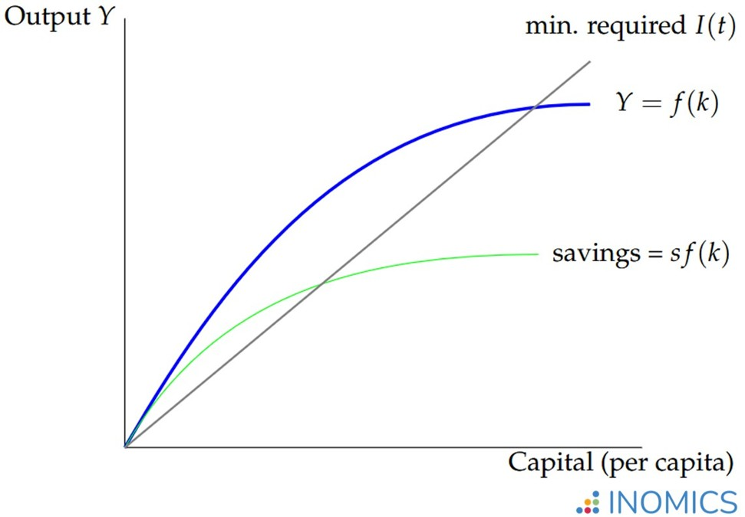
Figure 1 Basic Solow-Swan model graphically.

- The red line represents how much capital depreciates every year. It’s a straight line because depreciation just depends on how much capital you have. If you have 10 times as much capital, then 10 times as much is depreciating every year.

- The blue line is how much total economic output gets produced. When the number of people is fixed, building more physical capital has diminishing returns. That’s why the curve is concave — each piece of capital you add gives you a little less additional output than the previous one.

- The green line is just the fraction of output that gets invested. The green line is how much production goes into building new capital. The Solow model assumes that a country saves and invests a constant fraction of its output.

- The place where the green line crosses the red line — which is marked with a star — is an equilibrium of sorts. That’s the point where the amount of new capital coming into the economy via investment is the same as the amount of old capital going out of the economy via depreciation.

As specified earlier in Solow model Capital accumulation is endogenous. It then comes from differ consumption over time, decades. Saving and non-consuming means investment = more net capital formation = more capital per capita = more output per capita. This is the causation the Solow models established. All about savings. Solow concept is to teach us what makes countries rich or poor.

The model analyzes long-term resource employment and growth driven by net investment. It uses a neoclassical production function with constant returns to scale, differentiability, and concavity, exemplified by Cobb-Douglas. Assumes full employment, capital utilization, and a growing labor force at rate g. Consumption is modeled as a fixed proportion of net income, influencing investment and capital accumulation.
Generally, the more savings an economy has, the more capital stock and therefore economic output it can support. However, with more capital stock comes more depreciation. In per capita terms, there is a limit to how much growth the economy can sustain given its savings rate.

The model predicts that the economy will trend towards a “steady-state” where the savings rate and the rate of depreciation offset one another such that the per capita amount of capital remains unchanged. In other words, while the overall economy can be growing, the population, depreciation, and (per capita) capital stock grow alongside it such that all individuals have a consistent amount of income in perpetuity.

Still, if s increases too much, current generations will suffer as their consumption plummets. The Golden Rule, then, is the rate of savings that maximizes the steady-state level of consumption per capita k* for all generations. It’s called the “Golden Rule” because each generation does to others what they would have wanted done to themselves – they save enough to make sure everyone else can consume the optimal amount in perpetuity.

Implications of The Solow Growth Model

Diminishing Returns: Increased investment temporarily boosts growth but eventually faces diminishing returns, preventing capital accumulation alone from causing permanent growth.

Role of Technology: Exogenous technological progress is the only mechanism for sustained long-term growth in per-capita income.

Convergence: Poor countries with lower capital stocks are expected to grow faster than rich countries, eventually catching up (conditional convergence).

Savings Rate: A higher saving rate increases the steady-state level of capital and income but does not affect the long-term growth rate of output per person

In Solow model (and others), the equilibrium growth path is a steady state in which “level variables” such as K and Y grow at constant rates and the ratios among key variables are stable.
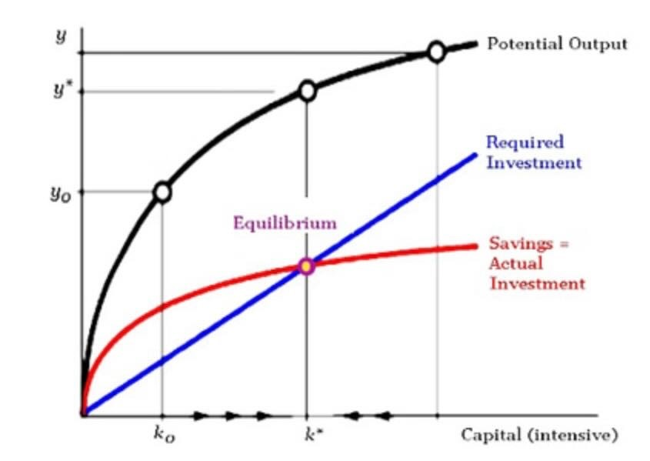

Figure 2: The basic Solow model showing transition dynamics. High investment (s₂)
moves the economy from k₁ to k₂ causing rapid growth. (Source: INOMICS)

Limitation of the Solow- Swan Growth Model

The key limitations of the Solow-Swan model are as follow:

- Solow-Swan growth model lacks macroeconomic foundations even though it can address many questions. The convergence rule is also a weak part of the Solow model. Solow model is versatile and can account for growth in advanced countries rather well. It is limited by the lack of micro-foundations, especially the savings decision. People are told what to do. An extended notion of convergence is necessary to account for country specific factors (rules of law, education, human capital, infrastructure).

- The model does not explain the sources of technological progress (it is exogenous) nor account for human capital development, which influences long-term growth. The model suggests that policies designed to increase the savings rate or investment in capital only provide temporary growth boosts, while investments in technology and innovation create sustainable, permanent growth.

Personal analysis of the course concepts

We all agreed that the model points at the directions we can take to try and understand long-term growth, based on two main factors of production: Labor (L) and Capital (K). By doing so, the model overlooks the role of State, even if we are still thinking as (A. Smith), that the State will only play its sovereign role /duties including security, they are influencing today economy so as the strong or weak legal system in place to facilitate transactions.

The model then assumes perfect competition which is not generally the case. Many country policies are intervening to address some crises or to prevent them. Those crises are so recurrent in this century so as the climate crises.

In today’s world, capital can’t be a single homogeneous good. The multifaced crisis including the climate crisis which is pushing state to compete for “critical mineral” is making “land” and those “critical resources” undoubtfully a capital. Land goes with natural resources beneath. The real-world market has today many complexities.

Having say this, it is important to note that despite some of the limitations and complexities of economies today; the model provides a framework for policy analysis, highlighting the roles of saving, investment, population growth, and technological progress in determining living standards. Still very valid today as growth determinants for countries. The model is simple compared to some sophisticated models developed. An economy may employ multiple models to better understand growth, fluctuations, and specific national objectives. As Milton Friedman famously posited, models need not be entirely realistic to be useful; rather, when presented with two models of equal predictive power, the choice should favor the more realistic framework or a strategic combination of both.

How I will apply the knowledge to my life, work and community.

My current role programme coordinator is in an NGO (Non-governmental Organisation), but planning in the future to transitioning toward launching a Think Tank and a Consulting Firm dedicated to African economic policy. We will focus on researching poverty and unemployment to influence government decision-making and improve societal well-being. Recognizing the lack of accessible economic analysis in the media, my firm will prioritize translating complex global trends into clear, public-facing insights. My ultimate ambition is to serve as a high-level policy advisor for African governments, supported by a rigorous track record of presenting original research at international scientific conferences.
I may gain recognition and may be co-opted by my government or any other Government in Africa to advise on policies or be an economist advisor. I am not neglecting participation at the international scientific conferences presenting scientific paper produce on economic trends in Africa.

Case example to demonstrate the concept

The application of the Solow Growth Model in the four (4) selected countries in Asian named the Asian Tigers. The rapid economic growth of East Asian economies (South Korea, Taiwan, Singapore, and Hong Kong) in the late 20th century can be partly explained by the Solow model. These economies saw massive capital investment and improvements in education and technology. The key aspect to the Solow-Swan model applied to these countries are:
- High capital accumulation. The "Four Tigers" maintained high savings rates, which, according to the Solow model, enabled massive investments in machinery, infrastructure, and factories (physical capital).
- Human capital investment: Beyond physical machinery, these economies invested significantly in education, increasing the skills of the labour force.
- Technological progress: The model shows that sustained growth requires technological progress. The Asian Tigers successfully adopted and later innovated new technologies to shift their production functions upward.

Figure 3: Jones 2013

Conclusion
As a foundational pillar of neoclassical economics, the Solow-Swan model illustrates how diminishing returns eventually stall growth unless fuelled by innovation. However, its simplicity is a double-edged sword; by focusing strictly on technical inputs, it neglects the institutional environment necessary for investment to thrive. To address the complexities of modern development, we must move past the limitations of this basic framework. Strengthening institutions and the business climate is essential to fostering the human capital and innovation described in more advanced models. Ultimately, the Solow-Swan model serves as a necessary analytical starting point, preparing the way for more sophisticated tools like the Overlapping Generations (OLG) model.

Bibliography
Barro, R. (1991). Economic Growth in a Cross Section of countries. Quarterly Journal of Economics, 407-443.
Campante, F. S. (2021). Advanced Macroeconomics: An Easy Guide. London: LSE Press.
Clark, J. (2021, March 25). Cooperatives in Australia. (W. Mora, Interviewer)
Cooperatives, A. (2018, July 15). Savings Groups. Retrieved from youtube: http://www.youtube.com/2827565dj3h58
D, R. (2019). Advanced Macroeconomics. New York, NY: McGraw Hill.
Grandmother, M. (2021, March 28). Inspiration. (W. Mora, Interviewer)
Grandmother, M. (2021, March 25). My assignment. (Me, Interviewer)
Hendricks, L. (2023, April 11). Applying the Solow Model, . Econ 520.
Idehen, S. (2019). Cost Accounting in a Family Business. Anywhere: Galaxy Press.
IMF. (2018, Mayo 18). IMF Financial Operations: Overview. (Youtube, Editor) Retrieved from https://www.youtube.com/watch?v=WQdLDMLrYIA
Loisel, O. (September - December 2025). The Growth Model With An Exogenous Saving Rate (Solow-Swan). ENSOE.
Rodriguez, D. S. (2021, Febrero 22). Trabajo Social y la Salud Mental. (E. L. Dr, Interviewer)
Steinsson, J. (Fall 2025). Capital Accumulation and Growth: The Solow Model. California: University of California, Berkely.

Robert Solow (1925–2023) and Trevor Swan (1918–1989).
Nobel Prize in Economy in 1987
Campante, F., Sturzenegger, F. and Velasco, A. 2021. Advanced Macroeconomics: An Easy Guide. London: LSE Press. DOI: https://doi.org/10.31389/lsepress.ame. License: CC-BY-NC 4.0.
Macroeconomics can be both positive (describing "what is" using data) and normative (recommending "what should be" based on value judgments). While it predominantly functions as a positive science to analyze aggregate data like inflation and GDP, it often shifts to normative economics when economists suggest policies, such as "the government should reduce taxes"
Leigh Tesfatsion, Department of Economics, Iowa State University, Ames, IA 50011 Last Updated: 28 February 2024 Course Site for Econ 502 (M.S. Macroeconomic Theory:) https://www2.econ.iastate.edu/tesfatsi/Syl502.htm Elements of Dynamic Economic Modeling: https://www2.econ.iastate.edu/tesfatsi/DynamicEconomicModelingBasics.WPVersion.pdf The Basic Solow-Swan Descriptive Growth Model: https://www2.econ.iastate.edu/tesfatsi/SolowMod.pdf The Basic Optimal Growth Model: https://www2.econ.iastate.edu/tesfatsi/OptGrow.pdf
chrome-extension://efaidnbmnnnibpcajpcglclefindmkaj/https://eml.berkeley.edu/~jsteinsson/teaching/Solow.pdf
Campante, F., Sturzenegger, F. and Velasco, A. 2021. Advanced Macroeconomics: An Easy Guide. London: LSE Press. DOI: https://doi.org/10.31389/lsepress.ame. License: CC-BY-NC 4.0.
chrome-extension://efaidnbmnnnibpcajpcglclefindmkaj/https://eml.berkeley.edu/~jsteinsson/teaching/Solow.pdf
https://inomics.com/
All development made in this assignment are from the video (YouTube) live classes of Professor Michael Burda, 1st Lecture: Economic Growth Introduction; Professor Ricardo Caballero, MIT 14.02: Principles of Macroeconomics (spring 2023) and Professor Robert Townsend, Development Economic: Macroeconomics (MIT).
https://etonomics.com/2025/10/07/the-solow-swan-growth-model/
Critical minerals are metallic or non-metallic elements—such as lithium, cobalt, nickel, and rare earth elements—essential to modern technology, economies, and national security. Some of them are lithium, cobalt and nickel, earth rare elements, copper, graphite.

