MUMTAZ MOHAMEDSHAFI
ID UD92359NE101580UUD92359NE101580

Doctorate in Neuropsychology (PSY.D)

Cognitive and Affective Neuroscience

ATLANTIC INTERNATIONAL UNIVERSITY
HONOLULU, HAWAII
11th October , 2025
INTRODUCTION TO COGNITIVE NEUROSCIENCE
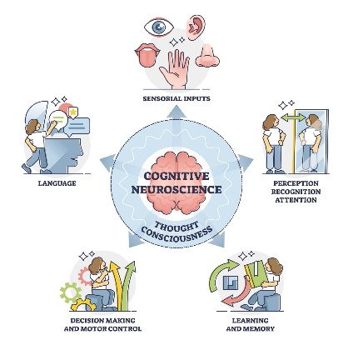
Scope of Cognitive and Affective Neuroscience
Cognitive and affective neuroscience is a specialized branch of cognitive psychology that investigates how specific brain regions contribute to cognition, emotion, and behavior. Cognitive neuroscience, positioned at the intersection of psychology and neurobiology, focuses on understanding the neural mechanisms underlying higher-order processes such as attention, memory, language, reasoning, and emotion (Gazzaniga, Ivry, & Mangun, 2019). This field examines how different areas of the brain interact to produce thought and behavior and how these processes are influenced by physiological and environmental factors.
Cognitive Neuroscience of Language
Language is a fundamental aspect of human cognition, and cognitive neuroscience provides insights into how the brain processes linguistic information. The field explores topics such as speech perception, speech production, sentence formation, comprehension, and the meaning of words, both concrete and abstract. Studies also cover bilingualism, sign language, and reading and writing processes. Empirical research, guided by influential theoretical models, shows how these cognitive functions are linked to specific brain regions, sometimes confirming and at other times challenging existing models (Kemmerer, 2022).
Integration of Cognitive and Affective Neuroscience
Cognitive and affective neuroscience together help explain both thought and emotion. While cognitive neuroscience primarily focuses on memory, attention, and decision-making, affective neuroscience examines the biological foundations of emotion, motivation, and empathy. Together, these fields illuminate how emotional states influence cognitive processing and vice versa. Researchers employ diverse methods, ranging from animal studies and electrophysiology to advanced neuroimaging techniques, to explore brain function across lifespan, in health and disease, and in special contexts such as criminality and bilingualism.
Synaptic Plasticity and Memory
Studies on memory consolidation have highlighted the hippocampus as a critical structure. Long-term potentiation (LTP), the strengthening of synaptic connections after stimulation, is central to understanding how memories are formed and retained. Research employs electrophysiological, biochemical, and molecular techniques to study LTP, and findings indicate that synaptic plasticity may be altered in neurological disorders, offering potential therapeutic targets (Sateesh & Abraham, 2021; Kirk et al., 2021).
Neuroscience and Behavior
Forensic neuroscience demonstrates how brain research can inform our understanding of human behavior, including violent and criminal behavior. Techniques from neurophysiology and neuroimaging allow researchers to explore the link between cognitive empathy and violent tendencies, offering insights for potential behavioral interventions (Eisenbarth, 2021). Similarly, studies on bilingualism, cognitive flexibility, and aging show how brain function can adapt to experience, environmental changes, and lifestyle factors (Waldie et al., 2021; Highgate & Schenk, 2021; Machado, 2021).
Consciousness and Brain Function
Research using transcranial magnetic stimulation (TMS) and near-infrared spectroscopy (NIRS) has advanced our understanding of consciousness and higher-order cognitive functions. These methods provide causal evidence about how brain networks generate conscious experience and adapt during aging or neurological disease (Bareham et al., 2021). Additionally, examining peripheral nervous system activity offers insights into social and affective processes, revealing how emotion regulation and social behaviors are linked to brain-body interactions (Grimshaw & Philipp, 2021).
Advances in Neuroimaging
Modern neuroimaging techniques, such as functional magnetic resonance imaging (fMRI), electroencephalography (EEG), and positron emission tomography (PET), have revolutionized neuroscience by allowing scientists to observe live brain activity. These tools provide detailed accounts of attention, working memory, and executive control, showing how information is integrated to guide behavior (Ward, 2022).
Affective Neuroscience
Affective neuroscience emphasizes the evolutionary and biological bases of emotions, focusing on structures such as the amygdala, which evaluates environmental stimuli for safety, danger, or reward. Emotional processes interact with cognition to shape decision-making, learning, and behavior (Šimić et al., 2021; Panksepp, 1998). Contrary to earlier models that separated “cold” cognition from “hot” emotion, recent evidence suggests that cognitive and affective processes are deeply intertwined, sharing common neural pathways (Damasio, 2005; Pessoa, 2017).
Clinical and Psychological Implications
Early life experiences and personality traits influence cognitive and emotional patterns, which can predispose individuals to psychiatric conditions. Cognitive distortions and maladaptive emotional regulation are central to mood disorders such as depression and bipolar disorder (Beck, 1967; Kennedy et al., 1998; Harkness & Lumley, 2008; Yenilmez et al., 2021). Understanding these mechanisms through the lens of cognitive and affective neuroscience provides insights for therapeutic strategies, educational interventions, and technological applications.
The Brain and Its Neural Systems
Cognitive and affective neuroscience can only be understood by examining the brain and the neural systems that underlie thought and emotion. While the brain itself weighs a little over 1.3 kilograms, it contains nearly 86 billion neurons, and each one of those neurons forms thousands of synaptic connections (Herculano-Houzel, 2009). It is these connections, as they occur in complicated networks, that underlie the whole gamut of mental function, from remembering a telephone number through to experiencing happiness or horror. While the ultimate objective of neuroscience research is a more refined understanding of the brain, its structures and how its functions are related to the mind and nervous system of the subject, most of the work that is being undertaken presently deals with the resolution of lesser issues with more specific information on internal structures, physiology, and clinical applications within the central nervous system (CNS). (Bhushan, R., Ravichandiran, V., & Kumar, N. (2022). An overview of the anatomy and physiology of the brain. Nanocarriers for Drug-Targeting Brain Tumors, 3-29.) Brain and other central nervous system (CNS) tumors remain a significant health problem, with broad differences in their incidence and effect on survival by age and tumor type. The report states that some tumors, like glioblastoma, are both most common and most malignant, having dismal survival rates. Conversely, some children's tumors vary both in type and outcome, signifying the requirement for age-specific statistics. The report also emphasizes that up-to-date statistics are required to guide treatment, investigative direction, and public health planning (Miller et al., 2021). make sure it's not caught by ai or turntin or plagarism and avoid repetationMajor Brain Structures in Cognition and Emotion
Brain Anatomy and How the Brain Works
Brain, Nerves and Spine
What is the brain?
The brain is a complex organ that is answerable for thought, memory, emotion, touch, motor function, vision, respiration, temperature, hunger and every process that regulates our body. The brain and spinal cord that extends from it together make up the central nervous system, or CNS.
What is the brain made of?
Weighing in at about 3 pounds in the average adult, the brain is about 60% fat. The remaining 40% is a combination of water, protein, carbohydrates and salts. The brain is not a muscle itself. It does, however, contain blood vessels and nerves, including neurons and glial cells.
What is the gray matter and white matter?
Gray matter and white matter are two different regions of the central nervous system. In the brain, gray matter is the darker outer portion, while white matter is the lighter inner portion beneath. In the spinal cord, this is reversed: The white matter is outer, and the gray matter is inner.
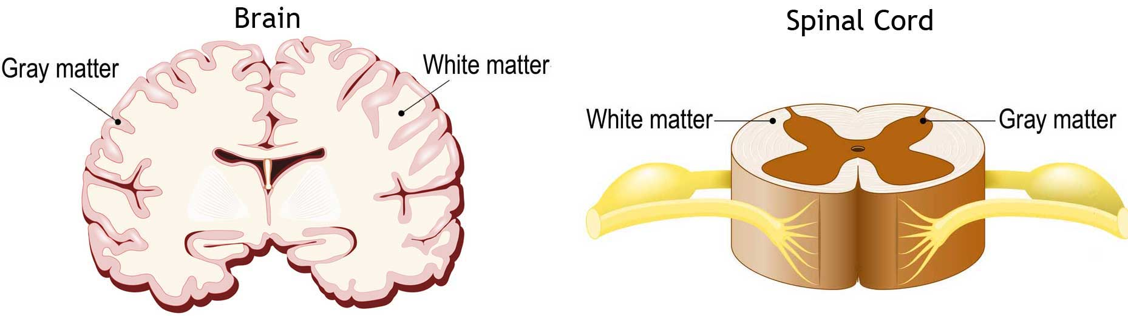
Gray matter is mainly made up of the cell bodies of neurons, which are the round central parts of the cells. White matter, on the other hand, is mostly formed by the long extensions of neurons called axons, which are covered in a fatty layer called myelin that protects them. Because gray matter and white matter are made of different parts of neurons, they look like different shades on brain scans.

Neuron Anatomy
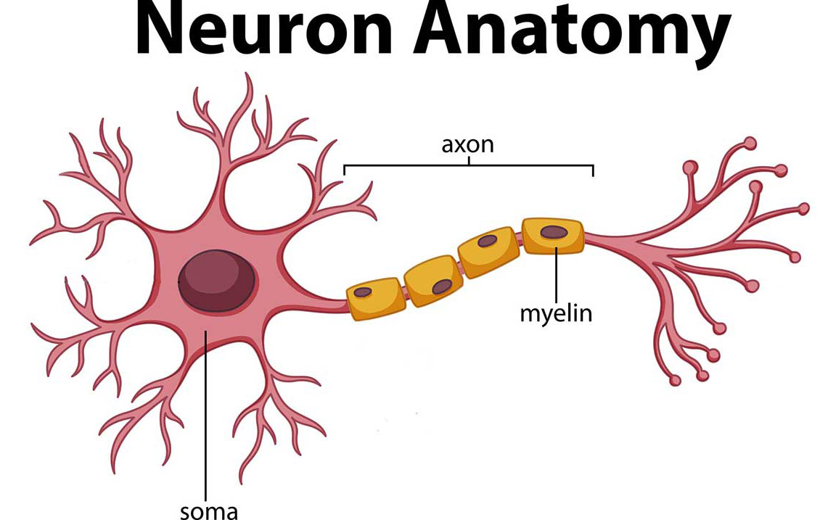
Each part of the brain has a unique role. Gray matter mainly handles processing and interpreting information, while white matter acts like a network of highways, sending that information to other areas of the nervous system. The brain communicates with the body using chemical and electrical signals, which control everything from how tired or alert you feel to how you sense pain. Some messages stay within the brain, while others travel through the spinal cord and the body’s vast network of nerves to reach muscles and organs. This communication depends on billions of neurons, the brain’s nerve cells. Broadly, the brain is divided into three main parts: the cerebrum, which manages thinking and memory; the brainstem, which controls vital functions; and the cerebellum, which coordinates movement and balance.
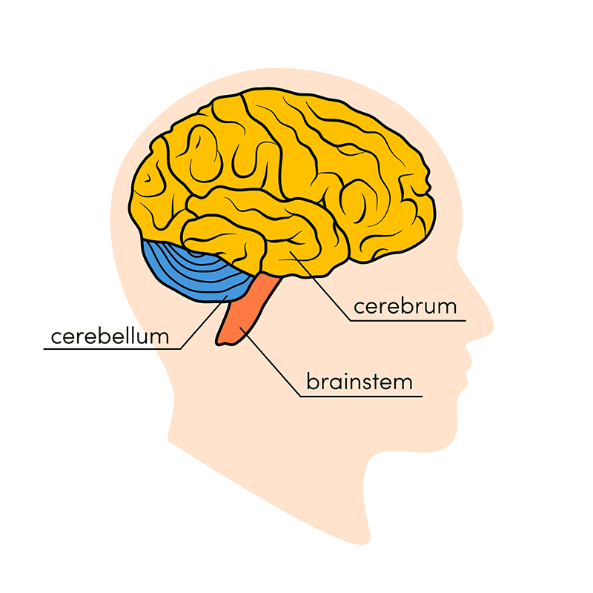
Cerebrum
The cerebrum is the largest part of the brain and is located at the front. It is made up of gray matter, known as the cerebral cortex, on the outside, and white matter in the center. The cerebrum controls movement, regulates body temperature, and manages many higher functions like thinking, reasoning, judgment, problem-solving, emotions, learning, and speech. It also processes sensory information such as sight, hearing, and touch.

Cerebral Cortex
The word “cortex” means “bark” in Latin, reflecting its outer layer of gray matter that covers the cerebrum. Its many folds increase the surface area and make up about half of the brain’s weight. The cortex is divided into two hemispheres—left and right—which control opposite sides of the body. The hemispheres communicate through the corpus callosum, a thick band of white matter in the center of the cerebrum. The surface is covered with ridges called gyri and grooves called sulci.

Brainstem
The brainstem connects the cerebrum with the spinal cord and consists of the midbrain, pons, and medulla.
- Midbrain: Handles hearing, movement, and responses to the environment. It contains the substantia nigra, important for movement and affected in Parkinson’s disease.
- Pons: Acts as a bridge between brain regions and controls activities like chewing, blinking, balance, facial expressions, and some eye movements.
- Medulla: Controls vital functions like heart rate, breathing, blood flow, and reflexes such as coughing, sneezing, swallowing, and vomiting.
The spinal cord extends from the medulla, running through the vertebrae, and carries messages between the brain and the body.

Cerebellum
The cerebellum, or “little brain,” sits at the back of the head, below the cerebrum and above the brainstem. It has two hemispheres and helps coordinate voluntary movements, balance, posture, and muscle control. Recent research also suggests it may play a role in thinking, emotions, social behavior, and even conditions like addiction, autism, and schizophrenia.

Brain Coverings: Meninges
The brain and spinal cord are protected by three layers of tissue called meninges:
- Dura mater: The thick, tough outer layer with two parts. The periosteal layer lines the skull, while the meningeal layer lies beneath. Spaces between these layers carry blood vessels.
- Arachnoid mater: A thin, web-like layer with no nerves or blood vessels. Beneath it flows cerebrospinal fluid (CSF), which cushions the brain and removes waste.
- Pia mater: A delicate layer that closely follows the contours of the brain, rich in blood vessels to supply oxygen and nutrients.

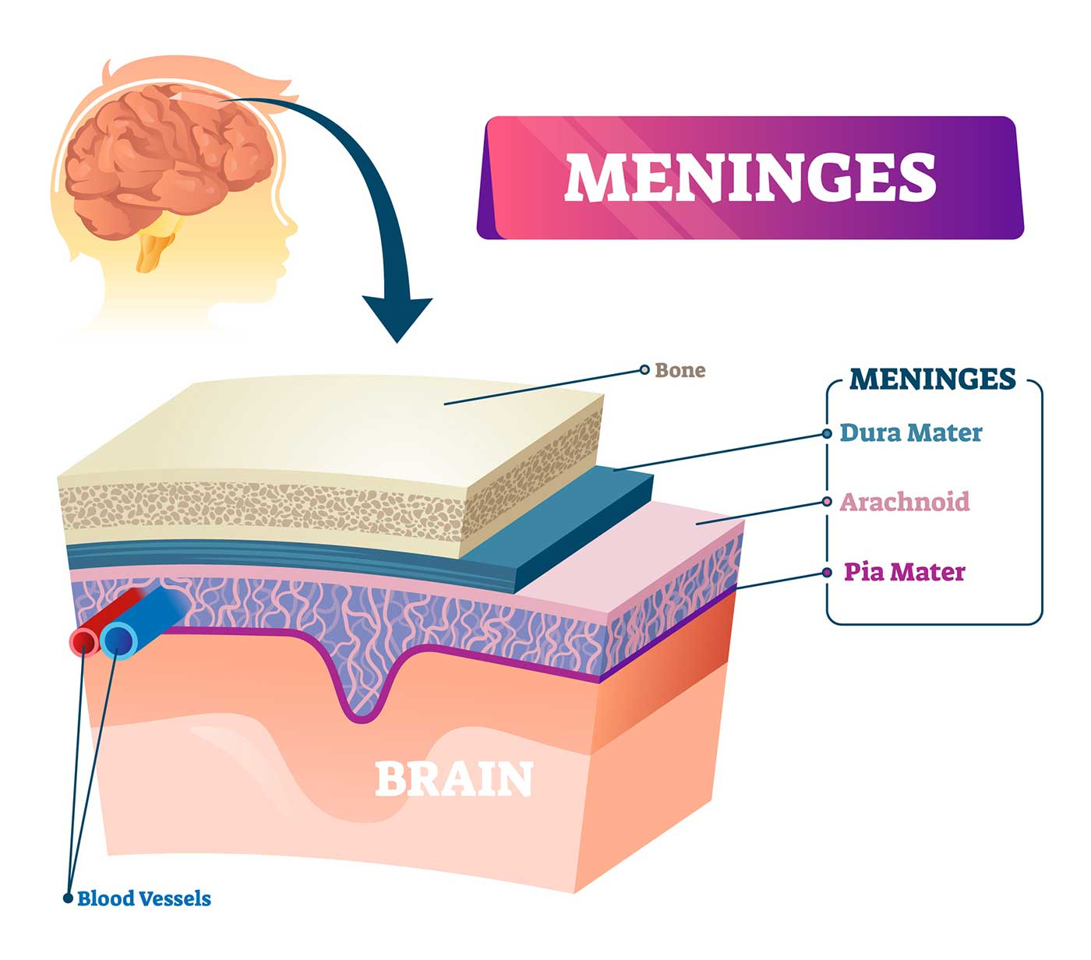
Lobes of the Brain and What They Control
Each brain hemisphere (parts of the cerebrum) has four sections, called lobes: frontal, parietal, temporal and occipital. Each lobe controls specific functions.
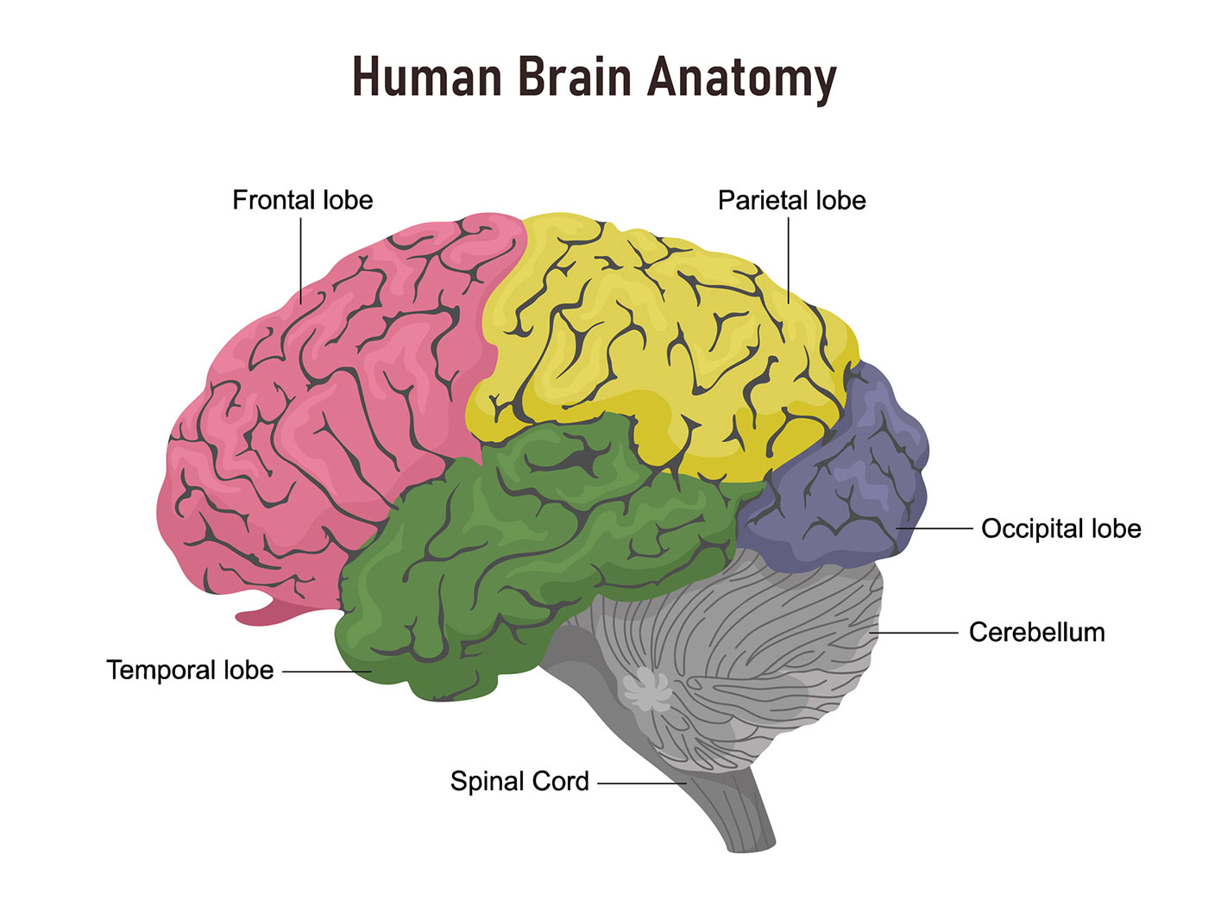
- Frontal Lobe: The largest lobe, located at the front of the brain, controls personality, decision-making, and voluntary movement. It also plays a role in recognizing smells. Broca’s area, found in the frontal lobe, is essential for producing speech.
- Parietal Lobe: Situated in the middle of the brain, the parietal lobe helps us understand where our body is in space and recognize objects. It also processes sensations like touch and pain. Wernicke’s area, located here, allows us to understand spoken language.
- Occipital Lobe: Found at the back of the brain, the occipital lobe is mainly responsible for vision.
- Temporal Lobe: Located on the sides of the brain, the temporal lobes handle short-term memory, speech, music perception, and some sense of smell.

Deeper Brain Structures
- Pituitary Gland: Often called the “master gland,” this pea-sized gland sits deep in the brain behind the nose. It controls other glands in the body, regulating hormones from the thyroid, adrenal glands, ovaries, and testicles. It receives chemical instructions from the hypothalamus.
- Hypothalamus: Above the pituitary gland, the hypothalamus sends signals that control body temperature, hunger, thirst, sleep patterns, and even some memory and emotional responses.
- Amygdala: Almond-shaped structures under each hemisphere, the amygdalae are part of the limbic system. They regulate emotions, memory, stress responses, and the body’s “fight or flight” reaction to danger.
- Hippocampus: Shaped like a curved seahorse and located under each temporal lobe, the hippocampus helps with memory, learning, navigation, and understanding space. It communicates with the cerebral cortex and is involved in conditions like Alzheimer’s disease.
- Pineal Gland: Deep in the brain, connected to the third ventricle, the pineal gland senses light and dark and releases melatonin, which regulates sleep-wake cycles.
- Ventricles and Cerebrospinal Fluid (CSF): The brain has four fluid-filled spaces called ventricles, which are connected to the spinal canal and surrounding meninges. They produce CSF, a watery fluid that cushions the brain and spinal cord, removes waste, and delivers nutrients.

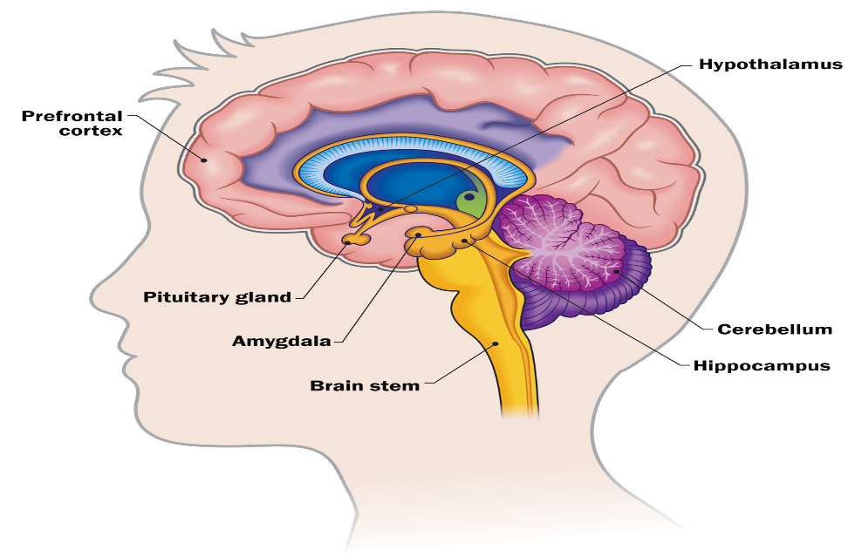
Blood Supply to the Brain
The brain gets its blood and oxygen from two main sets of arteries: the carotid arteries and the vertebral arteries.
The external carotid arteries run along the sides of the neck, and you can feel your pulse there with your fingertips. The internal carotid arteries branch off and enter the skull, supplying blood to the front areas of the brain.
The vertebral arteries travel up along the spinal column and join at the brainstem to form the basilar artery, which provides blood to the back parts of the brain.
At the base of the brain is a loop of blood vessels called the circle of Willis. This circle connects the main arteries, allowing blood to flow between the front and back of the brain and ensuring the brain continues to get oxygen even if one pathway is blocked.

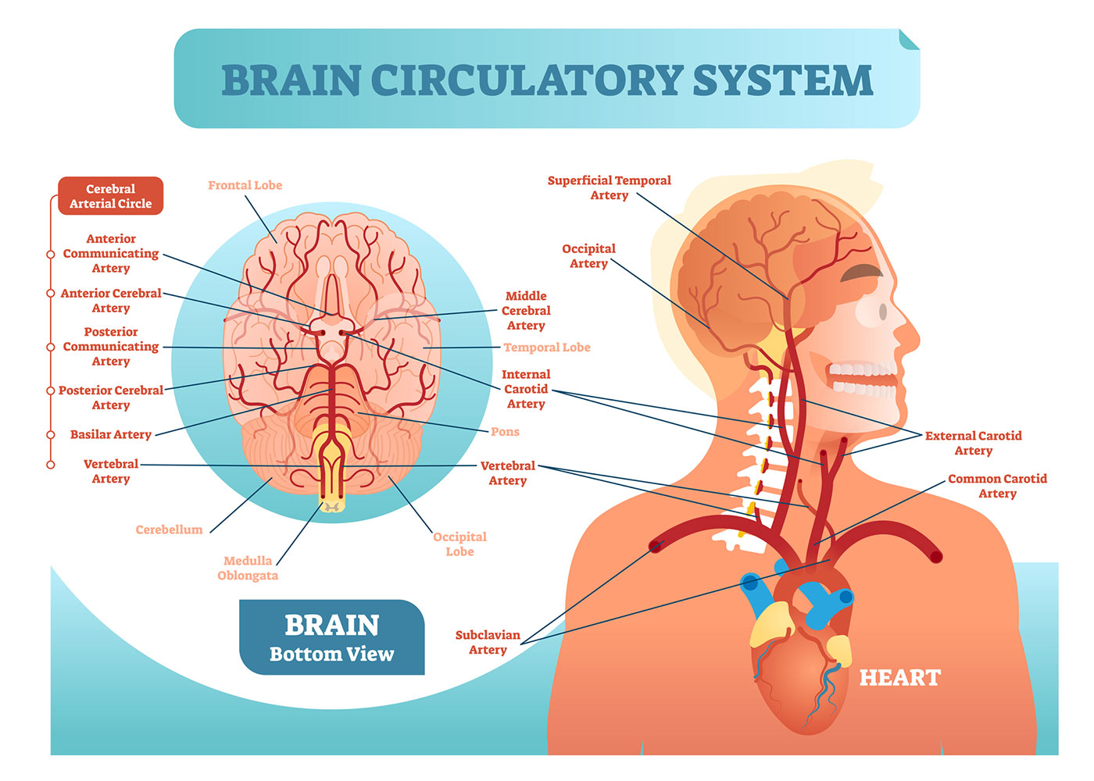
Cranial Nerves
There are 12 nerves in the cranium (the dome of the skull), which are known as cranial nerves:
• Cranial nerve 1: The first is the olfactory nerve, responsible for the sense of smell.
• Cranial nerve 2: The optic nerve is responsible for eyesight.
• Cranial nerve 3: The oculomotor nerve is responsible for pupil response and other movements of the eye and arises from the area in the brainstem where the midbrain and the pons meet.
• Cranial nerve 4: Trochlear nerve innervates muscles of the eye. It originates from the back of the midbrain part of the brainstem.
• Cranial nerve 5: The trigeminal nerve is the largest and most complex cranial nerve that has sensory and motor function. It originates from the pons and carries sensation from the scalp, teeth, jaw, sinuses, parts of the mouth and face to the brain, facilitates the working of chewing muscles, and many more.
• Cranial nerve 6: The abducens nerve innervates some of the muscles of the eye.
• Cranial nerve 7: The facial nerve facilitates face movement, taste, glandular and other functions.
• Cranial nerve 8: The vestibulocochlear nerve facilitates balance and hearing.
• Cranial nerve 9: The glossopharyngeal nerve facilitates taste, ear and throat movement, and has many other functions.
• Cranial nerve 10: The vagus nerve facilitates sensation around the ear and the digestive system and controls motor activity in the heart, throat and digestive system.
• Cranial nerve 11: The accessory nerve innervates some muscles of the head, neck and shoulder.
• Cranial nerve 12: The hypoglossal nerve gives motor supply to the tongue.
The first two nerves originate from the cerebrum, while the remaining 10 cranial nerves originate from the brainstem, which has three parts: the midbrain, the pons and the medulla.

1. The Prefrontal Cortex (PFC).
The PFC, located at the front portion of the brain, is chiefly accountable for advanced cognitive processes, typically referred to as executive processes. These include decision-making, planning, impulse control, along with flexible thinking (Miller & Cummings, 2017). Different regions of the PFC participate in distinct tasks: the dorsolateral PFC assists with cognitive control and working memory, and the ventromedial PFC participates in social decision-making and emotional regulation (Ochsner et al., 2012). Damage to the PFC, as demonstrated in a classic case involving Phineas Gage, generally causes extreme changes in personality, judgment, and emotional regulation.
2. The Amygdala.
The amygdala, an almond-shaped structure in the medial temporal lobe, is a hub for the processing of emotionally salient stimuli, particularly threat and fear (LeDoux, 2015). It rapidly evaluates sensory input and triggers physiological and behavioral responses to threat. However, the function of the amygdala is not solely fear; it has a role in reward learning, social emotions, and memory consolidation, especially for emotionally arousing events (Pessoa, 2017). Its hyperactivity is commonly found in anxiety disorders, and amygdala dysfunction plays a role in blunted affect in certain psychiatric disorders.
3. The Hippocampus.
The hippocampus plays a critical role in the formation and retrieval of episodic memories—memories for specific events and experiences (Squire & Wixted, 2011). It acts in concert with the amygdala, which is one reason why emotionally significant experiences are remembered well. Aside from memory, the hippocampus is also implicated in spatial navigation and learning of context. Damage to this structure, as in the case of patient H.M., results in severe anterograde amnesia but does not affect other aspects of cognition.
4. The Basal Ganglia.
Classically associated with motor control, the basal ganglia are also implicated in the control of motivation and reward processing. The striatum, in particular, is critical for reinforcement learning and habit formation (Graybiel & Grafton, 2015). Disruptions in this system play a role in diseases such as Parkinson's disease, where dopaminergic losses impair both motor and cognitive function, and in addiction, where aberrant reward learning dictates behavior.
5. The Insula.
The insula is engaged in interoception—the perception of internal bodily states. It integrates pain, hunger, and visceral sensation information with emotional experience (Craig, 2009). This puts the insula at the center of emotions like disgust and empathy, which entail sensitivity to internal states and simulation of others' experience.
6. The Anterior Cingulate Cortex (ACC).
The ACC incorporates cognition and emotion in that it conflict monitors, controls attention, and modulates emotional arousal (Bush et al., 2000). It is also activated when individuals are experiencing pain, both physical and social, showing its role in the integration of cognitive and affective information.
Neurotransmitters and Neural Communication
Neural systems communicate via chemical messengers—neurotransmitters—across synapses. Some of the most significant ones for cognition and affect are:
• Dopamine, implicated in reward processing, motivation, and reinforcement learning (Schultz, 2016).
• Serotonin, linked to mood control, emotional stability, and impulse control (Cools et al., 2008).
• Norepinephrine, essential for arousal, attention, and stress responses.
• Gamma-aminobutyric acid (GABA), the chief inhibitory neurotransmitter, offsetting excitatory activity in neural circuits.
• Glutamate, the major excitatory neurotransmitter, important for learning and memory.
Disorders of neurotransmitter systems often underlie neurological and psychiatric diseases. For instance, depression involves imbalances of serotonin, and schizophrenia and addictive disorders involve dysregulation of dopamine.
Methods for Studying Brain-Behavior Relationships
Advances in methodology have revolutionized our ability to link neural activity and cognitive and emotional processes.
• Functional magnetic resonance imaging (fMRI): Measures blood oxygenation to infer neural activity, widely used to examine networks underlying attention, decision-making, and emotion regulation (Ward, 2022). MRI exploits the fact that one of the characteristics of atomic nuclei, their spins, can be manipulated by exposing them to a strong magnetic force. While the patient lies with his/her head in a powerful magnet (1.5 to 5 Teslas in power), a short-wave radio wave antenna alters the magnetic field in a way much weaker than the main magnet. The varying pulse makes the nuclei produce a resonance signal that can be quantified in 3D and digitized.5
• Electroencephalography (EEG): EEG, a recording of electrical activity of the brain, is obtained by placing electrodes on the EAHB Bulletin 37 Vol. 18 scalp at various landmarks and amplifying immensely the recorded brain activity. Both in research and clinical settings, EEG has been correlated with verbal and nonverbal body state cues. For example, alpha activity (7-12 Hz) is an indication of relaxation, whereas beta activity (13-30 Hz) is an indication of alertness. Power spectral analysis (PSA), which examines single frequency bands (e.g., alpha, beta, delta), has revealed clinical and nonclinical population differences. For example, in studies with mentally retarded children, PSA has established correlations between therapeutic intervention, heightened alpha, and improvement in intellectual task performance (Psatta, Goldstein & Matei, 1991)
• Positron emission tomography (PET): Allows for the measurement of neurotransmitter systems and metabolic activity. PET has widescale use throughout the fields of medicine. One may utilize it both as a research and a diagnostic technique. Clinical applications of PET include the identification of head tumours, cancer of the breast and prostate, neurodegenerative disorders amongst others [44- 47]. Figure 3 shows the PET scanner images of both a normal brain and a Parkinson disease-affected brain.( (Al-Sharify, Al-Sharify, & Al-Sharify, 2020) PET has been used very widely in cognitive neuroscience over the last 15 years, and an extremely good introduction to this research is Drs. Michael Posner's and Marcus Raichle's Images of the Mind (1997).
•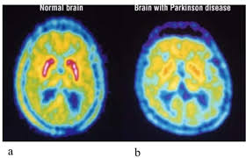
• Lesion studies: Classic neuropsychological method, where natural or accidental brain damage reveals functional characteristics of discrete areas (Kolb & Whishaw, 2021).
• Transcranial magnetic stimulation (TMS): Non-invasive means to temporarily disrupt brain activity, yielding causal data regarding brain-behavior relationships.
Each method has limitations—fMRI offers good spatial resolution but poor temporal resolution, while EEG is excellent for timing but cannot specify the localization of activity. A convergence of methods generally offers the most valid results. The study proved that BPGAN synthetic PET images from MRI scans are stable and of high quality with additional information that can aid in enhancing the diagnosis of Alzheimer's disease. The approach is a valuable reference for the development of multi-modal medical image analysis (Zhang et al., 2022). Both fMRI and PET are indirect measures of brain activity that rely on correlated metabolic measures that are presumed to reflect true activity in a region of interest. This renders temporal activation less interpretable, as neuronal activity can occur before changes in blood flow. More direct reflections of activity are provided by EEG and MEG. As these techniques offer far greater temporal resolution, several laboratories are now combining these techniques with fMRI to gain a more precise snapshot of neural activity (below). Invasiveness and safety. MRI methods appear to be far less invasive than PET or SPECT. Because there is no exposure to radiation in MRI, as in these other techniques with radioactive tracers. As far as we know, exposure to the strong magnetic fields currently in use in clinical studies are without risk. That being said, there are some key considerations (Solomon, P. R. (1986).
Cognitive Neuroscience
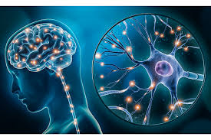
Cognitive neuroscience addresses the question of how brain activity gives rise to mental processes. It examines mundane faculties—like the ability to pay attention, recall events, talk, or decide—and inquires about how those activities are enabled by neural mechanisms. Unlike previous psychological methods of isolating the study of behavior, cognitive neuroscience combines psychology, biology, and neuroscience to illustrate how the "mind" is based on the brain (Gazzaniga, Ivry, & Mangun, 2019). Cognitive neuroscience has emerged as a major discipline during the latter part of the 20th century as an attempt to comprehend how the brain constructs mental events. We scan the areas of emotional and motor memory, vision, and higher mental function as examples of this new knowledge. Progress in each of these areas has been lightning-fast and breathtaking, but there is still much to be learned to reveal the mechanisms of cognition at the level of the local circuit and the molecule. This effort will require new techniques for the regulation of gene expression in higher animals and the study of interactions between neurons at multiple levels.(Albright, T.D. 2000)
Neisser, and other earlier cognitive psychology founders, pointed out that in trying to study mental processes, cognitive psychologists are required to notice the flow of sensory information, from its transduction by pertinent sensory receptors to its ultimate use in memory and action. This would imply that each motor or percept act is internally represented in the brain, as indicated by a pattern of activity in a specific set of connected cells. The pattern of connections also conveys information, in memory, with regard to the motor act and the perception. Attention and its Neural basis
Attention is a balance between activation, selection, and control—processes that allow us to attend to what matters and distribute our mental resources most efficiently.
Cognitive neuroscience research suggests that these aspects of attention are supported by networks connecting the frontal and parietal lobes, and lower brain areas like the thalamus (Rueda, Pozuelos, & Cómbita, 2015). When such systems fail, as with disorders like ADHD, individuals struggle with distractibility and sustained attention. Attention is also affectively sensitive—stress or anxiety can hijack attentional systems, directing attention to threat-related stimuli at the expense of other information.These networks dynamically converse to modulate how and when we respond to stimuli. Neurotransmitters such as norepinephrine and dopamine also play a crucial function in keeping these systems flexible and targeted. Understanding how these neural networks operate not only explains why people differ in attentional efficacy but also makes clear the directions to improve attention through training and growth (Rueda et al., 2015). People with ADHD often have differences in how parts of their brain function, especially areas that help with attention, self-regulation, and timing, like the prefrontal cortex (Rubia, 2018). Because of this, they may have trouble keeping their attention focused or regulating impulsive actions. What is understood about how these brain systems function has helped doctors create better ways to help attention and behavior, such as through training or medication (Rubia, 2018). Memory Systems
Memory is a complex process which allows us to perceive, store, and use information, covering a variety of stages such as encoding, consolidation, and retrieval.
From the cognitive neuroscience perspective, memory is dependent on the synchronized activity of different brain regions, not one region (Sridhar, Khamaj, & Asthana, 2023). The prefrontal and parietal regions are the ones that take center stage in working memory, allowing us to store and manipulate information in the short term. The central executive system, with the help of the cingulo-opercular and frontoparietal networks, takes charge of regulating attention and managing how information is processed and stored (Yu et al., 2023). Language regions like Broca's and Wernicke's areas support verbal memory, with the supramarginal gyrus supporting retention of short-term sound-based information (Perrachione et al., 2017; Graves et al., 2008). Recent neuroimaging studies suggest that such networks are constantly in dialogue to achieve a balance between attention, organization, and recall, suggesting that memory is a matter of utilizing stable brain structures as well as adaptive experience-dependent neural connections (Sridhar et al., 2023). Language and the Brain Language is likely to be the most important ability that shapes human thinking and communication.
Research suggests that it is not just talking or understanding words—it's a complex mental mechanism that allows us to compose and interpret unlimited combinations of thought (Friederici et al., 2017).
Brain imaging studies show that language is obtained through coordination between different parts of the brain, specifically the inferior frontal cortex and the superior temporal cortex, which are linked to strong neural connectivity. Both regions help control the syntax of sentences and the semantics of words, showing that language is based on the brain's ability to coordinate syntax and semantics in real time. This perspective sets language as a unique, biologically based skill that reflects the structure of our brains for complex thought and communication (Friederici et al., 2017).
Executive Functions Executive functions are higher-order capacities of the brain that allow us to plan, stay focused, solve problems, and adapt to new situations.
They include abilities like working memory, self-control, and adaptive thinking, all needed for everyday decision-making and social behavior (Cristofori, Cohen-Zimerman, & Grafman, 2019).
Though in the past it was thought these abilities hinged mainly on the frontal lobes, more recent research shows that other brain areas—the posterior and subcortical areas—have equally important roles to play by helping in processing sensory stimuli as well as emotions.One of the earliest indications of the relationship between the brain and executive functions was that of Phineas Gage, whose frontal lobe injury produced dramatic changes in personality and behavior (Ratiu et al., 2004). This and further research stresses that executive functions rely on an integrated network of brain regions working together to provide goal-directed and adaptive behavior (Cristofori et al., 2019). Decision-Making and the Role of Emotion Neuroscientific and psychological methods are used to investigate and explain the active neurons of the brain response of an individual towards being exposed to external stimuli. This study investigates the applicability literature and inquires into the neural basis of emotion, rewards, and motivation during decision-making, emotional transactions between children, adolescents, and aging. It was the literature that was reviewed to assess if neuroscientific methods provide the appropriate information about the role of emotion, reward, and motivation in decision-making processes.
The findings revealed the engagement of amygdala, medial prefrontal cortex, and ventromedial prefrontal cortex in the process of emotion that further influence decision-making process.
Though individuals with lesion in the ventromedial prefrontal cortex associated with emotional responses to risk, reward, and decision-making are poor decision-makers. Moreover, the prefrontal cortex plays a critical function in approach and withdrawal motivational, where right prefrontal cortex is associated with withdrawal behavior and left prefrontal cortex associated with approach behavior. (Alsharif, A. H., Salleh, N. Z. M., & Baharun, R. (2021). The neural roots of emotion in decision-making. International journal of academic research in business and social sciences, 11(7), 64-77). Interactions Across Cognitive Domains Even though it is helpful to consider each of these cognitive processes separately, in reality they are not usually independent of each other. Attention supports memory encoding, emotion influences memory and decision-making, and executive functions coordinate across all these processes. For example, attention screens out distractions when preparing for an exam, working memory retains pertinent information, and executive functions look ahead to plan revision. If anxiety mounts, the amygdala can skew attention towards concerns rather than the material, affecting performance.
Cognitive neuroscience therefore increasingly emphasizes the importance of networks and interactions over isolated brain regions (Pessoa, 2017).
Disorders of Cognition The examination of disorders has provided specific insight into cognitive system vulnerability. Alzheimer's disease, for instance, is marked by hippocampal atrophy and diffuse cortical atrophy and leads to memory loss and confusion (Hardy & Selkoe, 2002). Schizophrenia involves deficits in executive function and working memory, linked with prefrontal dysfunction and dopamine dysregulation (Millan et al., 2012). Even mild traumatic brain injuries can be able to disrupt attentional control and decision-making, validating the vulnerability of these processes to chemical and structural imbalances.
These clinical perspectives strengthen why cognitive neuroscience is just as theoretical an endeavor as it is a discipline of concrete application to diagnosis and rehabilitation.
Affective Neuroscience Foundations
While cognitive neuroscience accounts for the way we think, reason, and recall, affective neuroscience focuses on emotions—how we feel and the reason that feelings are central to human existence. Feelings are not superficial overlays on cognition; they drive our decisions, dictate our memories, and enable us to quickly respond to threats or opportunities. Feelings, Panksepp (1998) maintains, are evolutionary, i.e., they are biological processes shared with other mammals and not simply psychological processes.
Defining Emotions
Emotions are distinct psychological states resulting from neurophysiological alterations, which affect thoughts, feelings, and actions. Traditionally, emotions were perceived as illogical, discrete from rational thought. This has been developed with theories such as the James-Lange and Cannon-Bard models, Schachter-Singer two-factor theory, and Lazarus' cognitive appraisal theory explaining how emotions occur. Four primary components make up emotional experience: physiological changes (like increased heart rate), body language (gestural and facial cues), cognition (thinking and regulation), and felt feelings (subjective emotional experience). Emotions can be generated automatically by bodily inputs (bottom-up) or higher-order cognitive appraisal (top-down). The amygdala, for example, is a "neural alarm" that habituates fear responses, while the medial prefrontal cortex helps with emotion regulation and decision making.
Appraisal and Personality Systems
Current theory suggests that emotions are influenced by how we assess events in relation to our goals. Being fired may provoke anger if it's perceived as unfair, depression if perceived as failure on our part, or relief if unwanted. Davis and Panksepp (2011) labeled basic emotional systems—SEEKING, FEAR, RAGE, CARE, and PLAY—based on subcortical parts of the brain. They are the biological underpinnings of personality, motivation, and emotional behavior. Techniques like the Affective Neuroscience Personality Scales (ANPS) measure these systems in humans and show that personality is based on evolved brain circuits, not higher cognition.
Neural Emotion Circuits
Affect is sustained by interconnected brain circuits. The amygdala processes emotional stimuli, such as fear and reward, and pairs them with memory and perception, preparing adaptive responses (Šimić et al., 2021). The orbitofrontal cortex (OFC) evaluates rewards and penalties in order to adjust behavior. The insula associates body states with emotion like empathy and disgust, and the anterior cingulate cortex (ACC) monitors emotional conflict and guides responses (Rolls, 2023). Dopamine, which is produced in midbrain areas like the ventral tegmental area (VTA), drives by signaling predicted reward and learning from the outcome (Costa & Schoenbaum, 2022).
Emotion Regulation
Emotion regulation is an active process that is guided by intrinsic goal and motivation. The prefrontal cortex formulates strategies, the amygdala controls intensity, and the ACC monitors conflict and guides action (Tamir et al., 2020). Effective regulation is based on the smooth coordination of these regions, demonstrating how neural coordination and motivation cooperate.
Social Emotions and Empathy
Social emotions, such as nostalgia, unify people and enhance empathy. Recalling significant memories makes individuals feel at ease, intimate, and empathetic, which helps prosocial behavior and emotional well-being (Juhl & Biskas, 2023).
Clinical Perspectives
Knowledge of affect circuits can explain psychiatric illness:
Anxiety: Overactive amygdala with poor prefrontal regulation leads to enduring fear and apprehension.
Depression: Reduced activity in reward circuits and compromised serotonin signaling affect mood and motivation.
PTSD: Hyperactive amygdala response, impaired hippocampal processing, and inadequate prefrontal control disrupt emotion regulation.
Neuroscience increasingly understands cognition and emotion to be deeply interactive, working together to direct adaptive behavior (Pessoa, 2008).
Brain Injury and Disease
Lesions in particular brain regions illustrate the neural system dependence of cognition and emotion: Traumatic Brain Injury (TBI): May reduce attention, slow processing speed, impair memory, and lead to irritability or impulsivity, especially if frontal or temporal lobes are damaged (McAllister, 2011; Kim et al., 2019).
Stroke: Varies according to hemisphere affected. Left hemisphere strokes result in impairments of language and depression, whereas right hemisphere strokes yield neglect or emotional blunting (Adolphs et al., 2000). Post-stroke depression is common, illustrating the intersection of mood and cognition (Robinson & Jorge, 2016).
Dementia: Neurodegenerative diseases like Alzheimer's and frontotemporal dementia steadily impair memory, logic, and emotion regulation. In frontotemporal dementia, emotional alterations like apathy or disinhibition can be the first manifestations (Rascovsky et al., 2011).
Psychotic disorders such as depression, anxiety, and schizophrenia also reflect abnormalities in neural circuits that govern emotion and cognition. Depression, for instance, affects planning and attention while overactive amygdala in anxiety amplifies fear. Schizophrenia both affects memory and emotional expression by disabling the prefrontal-dopamine networks (Disner et al., 2011; Millan et al., 2016).
Case Studies
Phineas Gage: A railroad worker who, following a head injury to the frontal lobe in 1848, lived but experienced radical shifts in his personality, which suggested frontal lobe functions in controlling emotions (Harlow, 1848).
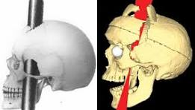
Henry Molaison (H.M.): Temporal lobe structures such as the hippocampus were excised by surgery, leaving him incapable of forming new memories, although he could retain old memories and emotions (Scoville & Milner, 1957).
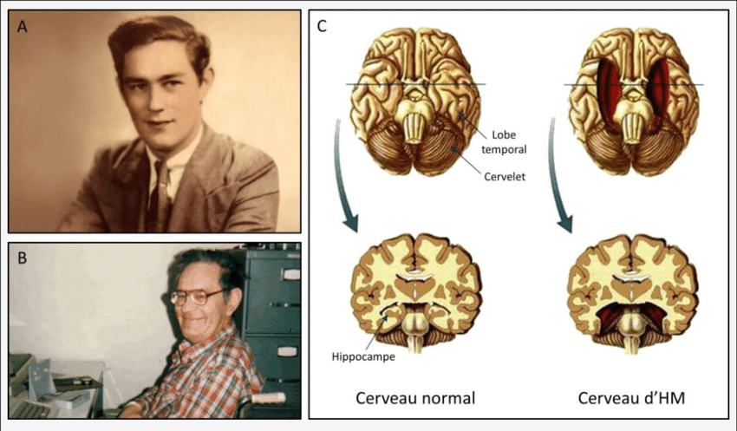
Clive Wearing: Lost all ability to create new memories due to viral encephalitis but was able to maintain emotional feelings and musical abilities, showing memory and emotion are within distinct brain networks (Wilson et al., 2008).
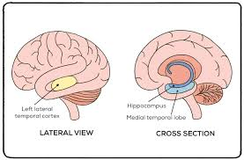
These examples demonstrate how closely emotion and cognition are tied to the brain and how injury can reorganize personality, memory, and emotional feeling.

Applications of Cognitive and Affective Neuroscience
Cognitive and affective neuroscience are not merely intellectual curiosities—these have very tangible impacts on our everyday lives. Understanding how the brain facilitates thinking and feeling makes it possible for us to improve education, mental health care, legal proceedings, workplace protocols, and even technology.
Mental Health and Rehabilitation
Research illustrates that understanding how emotions and cognition work together in the brain allows therapists to develop more efficient treatments. Schenk, Waldie, and Grimshaw (2021) explain how imaging of the brain and tests of cognition allow clinicians to identify specific patterns of malfunction in conditions like depression, anxiety, or head injury. This allows for the customization of therapy in thinking and emotional functioning. For patients recovering from neurotrauma, knowledge of how the brain compensates following damage allows clinicians to create personalized programs that stimulate memory, attention, and regulation of emotions. Interventions such as cognitive-behavioral therapy (CBT) and mindfulness capitalize on these results to allow individuals to more effectively regulate negative emotions and form adaptive thought. Drugs like SSRIs can regulate serotonin pathways to reduce anxiety, while dopaminergic agents sustain motivation for depression or Parkinson's disease.
Forensic and Legal Applications
Cognitive and affective neuroscience is beginning to influence law and forensics. Meixner (2015) observes that an understanding of how the brain functions when it comes to emotion, impulse, and decision-making can be applied to enhance legal judgment. Brain imaging is one method that can reveal if a defendant's conduct was due to impaired cognitive control or emotion dysregulation, such as in cases of mental illness or brain damage. Neuroscience can further inform knowledge of memory reliability, dishonesty, and reoffending risk. Though such tools are helpful, Meixner stresses that they should guide legal decision-making but not replace it. As a whole, neuroscience is to humanize the legal process by uncovering the biological and emotional underpinnings of behavior and pushing for equity and compassion alongside justice.
Workplace and Organizational Environments
In the workplace, neuroscience helps to describe how people think, feel, and decide. Butler, O'Broin, Lee, and Senior (2016) note that traditional management generally overlooks the role of the brain in behavior but neuroscience uncovers how performance is affected by attention, emotion, and judgment. Emotional stress and pressure disintegrate decision-making, while positive emotions and trust fuel collaboration and motivation. Brain studies also illustrate how leaders dissect complex information, navigate uncertainty, and respond to ethical challenges. Brain empathy, reward circuits, and fairness are all critical to understanding how to train leaders, improve engagement, and establish healthier, more productive workplaces. Emotional intelligence, as it turns out, is innately hardwired into neural circuits that govern social behavior and emotion regulation.
Technology and Artificial Intelligence
Neuroscience is transforming technology, especially AI and brain-computer interfaces (BCIs). Zaib (2022) explains how machine learning and AI allow scientists to study large, complex brain data sets to identify patterns within neural activity and predict outcomes in emotion and cognition. AI is capable of detecting subtle changes in the brain in mental health disorders, aiding in early diagnosis and personalized treatment. AI also allows for modeling of brain function, neural connection knowledge, and simulation of cognition. Techniques like fMRI, EEG, and neural network simulations, in combination with AI, allow researchers to map how brain regions work together on decision-making, memory, and emotion processing. These are not only research tools—those have clinical applications too, to monitor disease, predict responses to treatment, and develop interfaces that connect the brain with machinery.
Integrated Perspective
From education to law, medicine, workplace management, and technology, there's one principle evident: thinking and feeling are intertwined. Interventions that treat both cognition and emotion are more effective and humane. By understanding the emotional and cognitive functioning of the brain, we can build smarter learning, more just justice, better therapies, effective workplaces, and robust technologies responsive to human needs.
Conclusion
Affective and cognitive neuroscience provides us with a robust basis for appreciating the way thinking and feeling are bound together in the brain. Our feelings, our decisions, our thoughts do not exist independently of one another—there are complex networks of brain regions operating together to produce them. Classic cases like Phineas Gage, H.M., and Clive Wearing show the way damage to specific areas will obstruct memory, decision-making, and emotional reaction simultaneously, proving the inseparability of cognition and emotion. Neurological studies also prove that illnesses like depression, anxiety, and schizophrenia are manifestations of impairment in these networks, and it shows the need for a combined approach in therapy and rehabilitation.
Even slight brain injuries, as exposed by Theadom et al. (2018), have long-term effects on attention, mood, and daily function, which only underscore the necessity of continued support and follow-up treatment. New technology, including brain imaging, AI, and machine learning, now allows scientists and clinicians to study these networks more specifically. This has allowed for more precise diagnostics, specific treatments, and better rehabilitation options, which allow individuals to recover cognitive and emotional functions more effectively.
Also, the interaction between cognition and emotion has significant effects in everyday life. It informs education, workplace performance, legal evaluation, and social relationships, fostering mental health, decision-making, and well-being environments. The concept of brain plasticity further highlights the fact that, by specific interventions, the brain is able to modify and reorganize itself, offering a hope for recovery after injury or malfunction.
Briefly, the integration of cognition and affective neuroscience not only enlightens us about human behavior but also provides useful resources for enhancing health, learning, and social functioning. It reminds us that the brain is at the heart of our experiences and that feeding its well-being is a precondition for a fulfilling life.

References

Al-Sharify, Z. T., Al-Sharify, T. A., & Al-Sharify, N. T. (2020, June). A critical review on medical imaging techniques (CT and PET scans) in the medical field. IOP Conference Series: Materials Science and Engineering, 870(1), 012043. https://doi.org/10.1088/1757-899X/870/1/012043
Alsharif, A. H., Salleh, N. Z. M., & Baharun, R. (2021). The neural correlates of emotion in decision-making. International Journal of Academic Research in Business and Social Sciences, 11(7), 64–77.
Albright, T. D., Kandel, E. R., & Posner, M. I. (2000). Cognitive neuroscience. Current Opinion in Neurobiology, 10(5), 612–624. https://doi.org/10.1016/S0959-4388(00)00136-3
Bear, M. F., Connors, B. W., & Paradiso, M. A. (2020). Neuroscience: Exploring the brain (4th ed.). Wolters Kluwer.
Bhushan, R., Ravichandiran, V., & Kumar, N. (2022). An overview of the anatomy and physiology of the brain. In Nanocarriers for drug-targeting brain tumors (pp. 3–29).
Butler, M. J., O’Broin, H. L., Lee, N., & Senior, C. (2016). How organizational cognitive neuroscience can deepen understanding of managerial decision‐making: A review of the recent literature and future directions. International Journal of Management Reviews, 18(4), 542–559. https://doi.org/10.1111/ijmr.12103
Costa, K. M., & Schoenbaum, G. (2022). Dopamine. Current Biology, 32(15), R817–R824. https://doi.org/10.1016/j.cub.2022.06.056
Cristofori, I., Cohen-Zimerman, S., & Grafman, J. (2019). Executive functions. In Handbook of clinical neurology (Vol. 163, pp. 197–219). Elsevier.
Davis, K. L., & Panksepp, J. (2011). The brain's emotional foundations of human personality and the Affective Neuroscience Personality Scales. Neuroscience & Biobehavioral Reviews, 35(9), 1946–1958. https://doi.org/10.1016/j.neubiorev.2011.05.004
Disner, S. G., Beevers, C. G., Haigh, E. A. P., & Beck, A. T. (2011). Neural mechanisms of the cognitive model of depression. Nature Reviews Neuroscience, 12(8), 467–477. https://doi.org/10.1038/nrn3027
Friederici, A. D., Chomsky, N., Berwick, R. C., Moro, A., & Bolhuis, J. J. (2017). Language, mind and brain. Nature Human Behaviour, 1(10), 713–722. https://doi.org/10.1038/s41562-017-0189-1
Gazzaniga, M. S., Ivry, R. B., & Mangun, G. R. (2019). Cognitive neuroscience: The biology of the mind (5th ed.). W. W. Norton & Company.
Haines, D. E. (2022). Fundamental neuroscience for basic and clinical applications (5th ed.). Elsevier.
Harlow, J. M. (1848). Passage of an iron rod through the head. Boston Medical and Surgical Journal, 39(20), 389–393. https://doi.org/10.1056/NEJM184809020390901
Juhl, J., & Biskas, M. (2023). Nostalgia: An impactful social emotion. Current Opinion in Psychology, 49, 101545. https://doi.org/10.1016/j.copsyc.2023.101545
Kandel, E. R., Schwartz, J. H., Jessell, T. M., Siegelbaum, S. A., & Hudspeth, A. J. (2021). Principles of neural science (6th ed.). McGraw Hill.
Kolb, B., & Whishaw, I. Q. (2021). Fundamentals of human neuropsychology (8th ed.). Worth Publishers.
Meixner, J. B., Jr. (2015). Applications of neuroscience in criminal law: Legal and methodological issues. Current Neurology and Neuroscience Reports, 15(2), 513. https://doi.org/10.1007/s11910-014-0513-x
Miller, K. D., Ostrom, Q. T., Kruchko, C., Patil, N., Tihan, T., Cioffi, G., ... & Barnholtz‐Sloan, J. S. (2021). Brain and other central nervous system tumor statistics, 2021. CA: A Cancer Journal for Clinicians, 71(5), 381–406. https://doi.org/10.3322/caac.21693
Millan, M. J., Fone, K., Steckler, T., & Horan, W. P. (2016). Negative symptoms of schizophrenia: Clinical characteristics, pathophysiological substrates, experimental models, and prospects for improved treatment. European Neuropsychopharmacology, 26(5), 645–692. https://doi.org/10.1016/j.euroneuro.2015.12.017
Oymak Yenilmez, D., Atagün, M. İ., Keleş Altun, İ., Tunç, S., Uzgel, M., Altinbaş, K., ... & Oral, E. T. (2021). Relationship between childhood adversities, emotion dysregulation and cognitive processes in bipolar disorder and recurrent depressive disorder. Turk Psikiyatri Dergisi, 32(1), 1–12. https://doi.org/10.5080/u24495
Rueda, M. R., Pozuelos, J. P., & Cómbita, L. M. (2015). Cognitive neuroscience of attention from brain mechanisms to individual differences in efficiency. AIMS Neuroscience, 2(4), 183–202. https://doi.org/10.3934/Neuroscience.2015.4.183
Rolls, E. T. (2023). Emotion, motivation, decision-making, the orbitofrontal cortex, anterior cingulate cortex, and the amygdala. Brain Structure and Function, 228(5), 1201–1257. https://doi.org/10.1007/s00429-023-02632-1
Schenk, S., Waldie, K., & Grimshaw, G. (2021). Cognitive and affective neuroscience: Approaches and applications. Journal of the Royal Society of New Zealand, 51(1), 1–3. https://doi.org/10.1080/03036758.2021.1877208
Sridhar, S., Khamaj, A., & Asthana, M. K. (2023). Cognitive neuroscience perspective on memory: Overview and summary. Frontiers in Human Neuroscience, 17, 1217093. https://doi.org/10.3389/fnhum.2023.1217093
Stanojlović, O., Šutulović, N., Hrnčić, D., Mladenović, D., Rašić-Marković, A., Radunović, N., & Vesković, M. (2021). Neural pathways underlying the interplay between emotional experience and behavior, from old theories to modern insight. Archives of Biological Sciences, 73(3), 361–370. https://doi.org/10.2298/ABS2103361S
Šimić, G., Tkalčić, M., Vukić, V., Mulc, D., Španić, E., Šagud, M., ... & Hof, P. R. (2021). Understanding emotions: Origins and roles of the amygdala. Biomolecules, 11(6), 823. https://doi.org/10.3390/biom11060823
Tamir, M., Vishkin, A., & Gutentag, T. (2020). Emotion regulation is motivated. Emotion, 20(1), 115–127. https://doi.org/10.1037/emo0000661
Taylor, K., & Marienau, C. (2022). Emotions, affective neuroscience, and changing one’s mind. In The Palgrave Handbook of Learning for Transformation (pp. 717–731). Springer. https://doi.org/10.1007/978-3-030-80603-9_36
Theadom, A., Starkey, N., Barker-Collo, S., Jones, K., Ameratunga, S., Feigin, V., & BIONIC4you Research Group. (2018). Population-based cohort study of the impacts of mild traumatic brain injury in adults four years post-injury. PLOS ONE, 13(1), e0191655. https://doi.org/10.1371/journal.pone.0191655
Van de Cruys, S., & Latham, P. (2023). The brain: Structure and functions. OpenStax. https://openstax.org/books/biology/pages/

