MUMTAZ MOHAMEDSHAFI
ID UD92359NE101580UUD92359NE101580

Doctorate in Neuropsychology (PSY.D)

Clinical Neuropsychology and Psychopathology

ATLANTIC INTERNATIONAL UNIVERSITY
HONOLULU, HAWAII
October 21st , 2025 , 2025
Introduction
Clinical neuropsychology is a specialized field of psychology that is interested in understanding how structure and function of the brain influence cognitive processes, behavior, and the control of emotion. It is trying to understand how disruptions in neural networks, resulting from injury, developmental disorders, or degenerative disease, can disrupt an individual's ability to think, to recall, to plan, and to interact with the environment. Psychopathology, however, is concerned with the study of mental disorders, causes, symptoms, course, and treatment. While neuropsychology is an investigation of how the brain functions and how that is reflected in behavior, psychopathology is concerned with the understanding of patterns of thought, feelings, and behavior that are not considered healthy or normal. Together, these two fields give a broad picture of how to understand mental health, connecting observable behavior with the underlying brain processes.
The intersection of psychopathology and clinical neuropsychology is particularly pertinent because the majority of mental illness entails complex interaction among brain malfunction and psychological processes. For example, consider the patient who has been diagnosed with depression following a stroke. Neuropsychological evaluation can uncover attentional, memory, and executive function impairments resulting from damage to certain brain areas, say the prefrontal cortex. Psychopathologically, the patient can present with low mood, hopelessness, and reduced motivation. With both the neurological and the psychological components, practitioners are able to formulate a more specific treatment plan that addresses both the cognitive impairments as well as the affective impact of the disorder. In daily life, this appears as planning techniques that facilitate the individual to accomplish daily tasks, for example, making a shopping list, remembering schedules, or handling personal finances, as well as in favoring mood stabilization and coping strategies.

The practical implications of this integration spread into many settings. In educational environments, children with learning disabilities can be provided with neuropsychological evaluation to determine whether deficiencies in reading, attention, or memory are linked with developmental disorders like dyslexia or attention-deficit/hyperactivity disorder (ADHD). Psychopathological evaluation can then identify the co-morbid disorders of depression or anxiety that can be induced by the stress of academic failure or school-based social issues. By understanding both the brain-based and psychological aspects, the therapist and teacher can develop personalized learning plans, classroom modifications, and behavior interventions that lead to academic achievement and emotional well-being. For instance, a student struggling with working memory challenges can be supported with visual aids and embedded sequences of instructions, and counseling interventions can aid in frustration setting and building confidence.

Similarly in the workplace, adults with cognitive impairment due to neurodegenerative disease such as Alzheimer's disease can be functionally impaired as well as emotionally disordered. Neuropsychological testing can assess some impairment of cognition, such as poor planning or problem-solving capacity, that may affect work performance or activities of daily living. Psychopathological evaluation can ascertain the emotional and behavioral consequence, e.g., anxiety, depression, or irritability, typically triggered by cognitive decline. Integrated care can lead to everyday practical interventions like organizational everyday routines, memory aids, environment modifications, and counseling support. For example, a person with early dementia can be helped to use a calendar or cell phone reminders for arranging appointments with cognitive rehabilitation exercises in order to maintain performance on memory tasks. At the same time, psychotherapy can provide an individual stress coping strategies against frustration or worry associated with cognitive impairment, improving quality of life.

The neuropsychological interface with psychopathology is equally essential in both clinical and forensic contexts. Patients exposed to traumatic brain injury (TBI) from attack or trauma may exhibit a behavior change, impulsivity, or mood disturbance. Neuropsychological testing helps identify what parts of the brain are affected and how that impacts decision-making, memory, or attention. Psychopathological examination can identify post-traumatic stress, depression, or anxiety that follows the injury or stress of life that follows, such as loss of employment or social isolation. This two-systems model becomes not only essential to treatment but to legal and rehabilitation settings, where cognitive and affective injury outcomes inform competency, responsibility, and vocational rehabilitation outcomes.

Additionally, integration of these domains is essential to the therapy and conceptualization of severe psychiatric illness, such as bipolar disorder, schizophrenia, and psychotic major depression. These disorders always involve cognitive and affective impairment. For instance, a person with schizophrenia would be impaired on executive function, working memory, or attention depending upon neurobiologic alterations in the hippocampus and prefrontal cortex. Psychopathologically, the patient would present with hallucinations, delusions, and even with impairment in handling social relationships. Clinical interventions that combine neuropsychological procedures, including cognitive remediation, into psychotherapeutic strategies, like cognitive-behavioral therapy (CBT), allow patients to improve cognitive capacity while symptom management is being achieved, consequently leading to better everyday functioning. Practically, it could allow one to arrange routine independently, remember medication habits, or work, with treatment allowing movement towards socialization and reality testing.

Day-to-day, the input of neuropsychology and psychopathology integration is seen in everyday life such as stress management, learning new skills, or recovering from trauma. For example, someone recovering from a mild concussion would find memory or slowed processing speed. Neuropsychological assessment determines the most affected areas and psychological treatment addresses emotional reactions such as frustration or concern about functioning in work or school. Cognitive rehabilitation tasks and coping strategies can enable the person to adjust better and more effectively to everyday life. In the same way, old patients with age-related cognitive impairments can be assisted through treatment using brain training techniques with lifestyle modification and psychologic counseling for independence and emotional well-being.

Technological innovations have also increased the utilitarian value for integrating neuropsychology and psychopathology. Functional magnetic resonance imaging (fMRI), electroencephalography (EEG), and virtual reality cognitive testing allow clinicians to observe real-time brain function and behavior and open doors to personalized interventions. A disordered spatial navigation patient typically can utilize virtual reality training simulations that condition the brain and minimize distress regarding becoming lost in actual environments. At the same time, psychological counseling will increase confidence and adaptive coping, thereby increasing the effectiveness of interventions and their transfer to everyday life.

In the end, the unification of these fields is necessary in order to advance mental health studies and public health outcomes. Interdisciplinarity is revolutionizing healthcare. Knowledge of how brain dysfunction leads to psychiatric symptoms guides the creation of new treatments, ranging from drugs to cognitive training programs and psychotherapy methods. It also supports the patient-centered, integrative model of care that recognizes mental health as guided not just by biology but by history, social context, and environment as well. By blending neuropsychological knowledge with psychopathological experience, clinicians, scientists, and policymakers can devise more effective, individualized, and relevant solutions for the common problems. Clinical neuropsychology and psychopathology together constitute an integrated system for understanding the intricate interwoven nature of brain, behavior, and mental health.

Through the integration of cognitive understanding of neural mechanisms and psychologic, emotional, and social sensitivity, these sciences enhance diagnosis, inform treatment planning, and enable recovery of function in everyday life. From learning-disabled children to psychiatric and neurological disorders in adults, this integrated approach enables science-based interventions of use in everyday life. Regardless of whether applied in clinics, schools, the workplace, or in rehabilitation centers, the intermarriage of neuropsychology and psychopathology ensures that mental health care is effective, individualized, and integrative—fostering the ability of the individual to deal with the ups and downs of life, better, more competently, resiliently, and wholesomely.
1. CLINICAL NEUROPSYCHOLOGY: A BRIEF HISTORY (BENTON & SIVAN, 2007)
Clinical Neuropsychology as an established discipline seeks to understand how human brain function and structure correlate with thought and action, particularly when those functions are disrupted by disease or injury. While its foundations reach back thousands of years, the development of the discipline in its current form is comparatively recent and follows centuries of advancement in anatomy, physiology, and clinical observation.
The earliest ideas regarding brain, mind, and behavior were during antiquity. The fact that ancient medical practices such as trephination have been found shows that ancient humans were aware that head wounds have the potential to induce disturbances of the mind. Early Greek philosophers such as Nemesius in 400 A.D. proposed theories relating different mental activities (sensation, perception, memory, reasoning) with the brain ventricles. Sensation and perception were said to be found in the lateral ventricles; thought or reflection in the third; and memory in the fourth. This "ventricular doctrine" though a crude and imprecise system by present-day standards is an early attempt at localizing mental activities in areas of the brain. Aristotle, however, was convinced that the heart was the seat of emotion and cognition and had a conception of the brain as a cooler. This cardiocentric view held some manner of sway throughout the Middle Ages, the Renaissance, and even the early modern period, influencing how people thought about the mind and its relationship to the body.
A shift to embracing the brain (rather than the heart or ventricles) as the thinking organ began in earnest in the 17th and 18th centuries. Scientists such as Thomas Willis, Swedenborg, and others started assigning particular mental functions to regions of the brain, such as the cerebral cortex, basal ganglia, and other structures. They did all this with limited tools: dissections, gross anatomy, and physiological observation rather than imaging.
By the 19th century, cerebral localization was the prevailing notion.
Franz Joseph Gall and his followers (phrenologists) posited that the brain is composed of distinct modules which are each dedicated to particular traits or abilities. Phrenology can now be discounted, but its influence was significant in making scientists think of the brain as being compartmentalized into functional areas. Simultaneously, more accurate anatomical and clinical observations, including those of Broca, more sharply defined the concept of localization: Broca demonstrated that lesions to one area in the left hemisphere disrupt speech production. At the same time, research by Fritsch and Hitzig (cortex stimulation by electricity and recording motor responses) further developed knowledge of how particular areas of the cortex relate to particular functions. The "golden age" of localization was the step-by-step mapping of cortical gyri and sulci, correlating brain lesions found after death with behavioral dysfunction noted before death.
This laid the foundation for clinical neuropsychology: the scientific study of the impact of brain lesions on cognition, perception, memory, language, and behavior. There were also major voices against oversimplification. Hughlings Jackson, for example, emphasized that brain activities are not strictly localized to centers but are networks and communications; that damage in one site could affect many functions. Kurt Goldstein, Henry Head, and others envisioned a holistic view. These notions provided the foundation for learning about brain plasticity and reorganization: after damage, other parts of the brain can compensate or reorganize functions. In later centuries, as scientific and technological advancements were made, clinical neuropsychology grew more codified. The development of neuroanatomy, histology, microscopy, and imaging gave foundations for modern devices like MRI, CT scan, PET scan, and functional imaging. Together with behavioral testing, these enabled clinicians to map more precisely brain-behavior correlations, discover neurodevelopmental disorders, and correct cognitive impairments. Last, Benton and Sivan consider how even with the progress, much of our understanding of brain function carries the signature of the technologies and metaphors of their day: "telephone networks," "computer," etc.
They contend that figuring out brain-behavior relationships has always been limited and controlled by the prevailing tools and metaphors of the day.
Yet, with recent neuroimaging, computational modeling, theory, and interdisciplinarity, the discipline is well positioned than ever to increase its wisdom.
They conclude by being upbeat about clinical neuropsychology's future, noting that new methods of investigation and new techniques should lead to richer, more nuanced understanding of how the brain facilitates behavior and cognition. 2. THEORETICAL PERSPECTIVES OF PSYCHOPATHOLOGY Psychopathology is the scientific study of mental illness, such as their etiology, symptoms, and treatment. Over the centuries, scholars and practitioners have attempted to explain the complexities of abnormal behavior with various theoretical perspectives, each offering distinctive explanatory paradigms. The evolution of these theories follows the evolution of psychology, psychiatry, neuroscience, and social sciences.

In modern practice, psychopathology is understood as multifactorial and with biological, psychological, and social determinants that interact in complex and dynamic processes (Kring & Johnson, 2022).
However, analysis of the individual theoretical models provides essential insights into understanding how mental disorders are formulated and managed in clinical practice. The Biological Perspective The biological or medical model has been among the dominant paradigms of research in psychopathology from the mid-twentieth century. It is rooted in the assumption that psychological illnesses are caused by physiological or genetic pathology of the brain and nervous system. The model has been closely in step with developments in neuroscience, psychopharmacology, and behavioral genetics.

Early findings of the relationship between neurotransmitter imbalance and disease such as depression (serotonin and norepinephrine) and schizophrenia (dopamine) revolutionized psychiatric diagnosis and treatment (Carlson, 2019).
Similarly, brain imaging techniques such as fMRI and PET scans have provided visual evidence of interrupted brain activity patterns among psychiatric patients that lends support to the hypothesis of a neurobiological basis of psychopathology. The biological model also incorporates the role of genetics in mental illness. Twin and adoption research all indicate that conditions such as bipolar disease, schizophrenia, and autism spectrum disorders are significantly heritable (Gottesman & Gould, 2003). Also, molecular genetics has identified candidate genes and gene–environment interactions that influence risk for psychopathology. Epigenetic process has expanded on this model in that it has suggested that exposure to environments such as trauma or chronic stress has the ability to modify gene expression to influence neurodevelopment and behavior throughout life (Meaney, 2010).
Despite its empirical strengths, the biological model is not without shortcomings. It has been criticized on reductionism—its ability to explain complex psychological occurrences only in biological language. It can have the consequence of eliminating the subjective experience of suffering, social causes, and cultural construction of mental illness. Moreover, not all individuals with biological vulnerabilities go on to develop psychopathology, and this emphasizes the moderating role of environment, personality, and coping style.
But the biological model is still needed to account for the neurocognitive substrates of mental disorders and for the development of pharmacological interventions. 2.2. The Psychodynamic Perspective The psychodynamic model, founded on the work of Sigmund Freud, has a very different conceptualization of psychopathology. According to the psychodynamic model, mental disorders are due to unconscious conflicts, repressed affect, and unresolved early childhood experiences. According to Freud's theory, the psyche is composed of the id, ego, and superego whose conflict gives rise to intrapsychic tension.

In cases where the ego cannot step in to mediate between primitive impulses and moral restrictions, anxiety and defensive processes manifest, maybe in terms of neurotic or maladaptive behavior (Freud, 1923/1961).
Contemporary psychodynamic theory has expanded upon Freud's ideas to incorporate object relations and attachment theory, which centers on early relationships and their internalization as crucial determinants of personality and pathology (Fonagy & Target, 2007). For instance, insecure or disorganized attachment in early childhood might predispose an individual to emotion regulation, self-concept, and interpersonal problems later in life. This theory provides a rich framework for the explanation of complex personality disorders, trauma-related conditions, and treatment resistance. Psychodynamic theory intersects with neurobiological findings in clinical neuropsychology, particularly in the description of the effects of early relational trauma on the brain and stress regulation systems. Structural imaging findings have mapped alterations in limbic structures such as the amygdala and hippocampus in subjects with a background of early trauma, lending biological grounding to psychodynamic hypotheses (Teicher & Samson, 2016). The psychodynamic methodology remains valid in mediating the link between subjective experience and neurobiological knowledge. 2.3. The Behavioral and Cognitive Perspectives The behavioral model of psychopathology emerged as a reaction to the introspective and speculative nature of psychoanalysis. Drawing from the principles of classical and operant conditioning, behavioral theory assumes that adaptive behavior is learned through environmental contingencies and reinforcement histories. For instance, phobias may develop when neutral stimuli are associated with fear through conditioning, and anxiety may be maintained by avoidance behaviors reinforced through removal of the aversive stimulus (Skinner, 1953).
Later cognitive theory, developed by Aaron Beck and Albert Ellis, introduced the idea that adaptive cognitions—distorted thinking, assumptions, and cognitive operations—are responsible for emotional and behavioral disorders.
Beck's cognitive model of depression proposed that dysfunctional schemas and negative automatic thoughts cause hopelessness and feelings of worthlessness, which reinstate depressive symptoms (Beck, 1967).
Cognitive-behavioral therapy (CBT), with these behavioral and cognitive principles built in, is presently one of the most empirically validated treatments within modern psychopathology (Hofmann et al., 2012).
Current research has advanced cognitive-behavioral theory into the field of neuropsychology. Cognitive neuroscience has identified neural correlates of distorted cognitive operations, such as hyperactivation of the amygdala in fear and hypocactivation of prefrontal regions in depression. This convergence of cognitive theory and neurobiological data emphasizes the multifaceted nature of psychopathology, integrating psychological models with measurable brain processes.
2.4. The Humanistic and Existential Perspectives The humanistic movement arose in the mid-twentieth century as a response to psychoanalysis and behaviorism, both of which were deemed deterministic and mechanistic in their views of human beings. Carl Rogers and Abraham Maslow led the way for the humanistic movement, emphasizing self-actualization, authenticity, and personal meaning as central to psychological health (Rogers, 1951; Maslow, 1968).
Psychopathology, therefore, in this theoretical context emerges out of incongruence between lived experience and self-concept—when individuals are compelled to live according to other people's expectations and not their own intrinsic values.

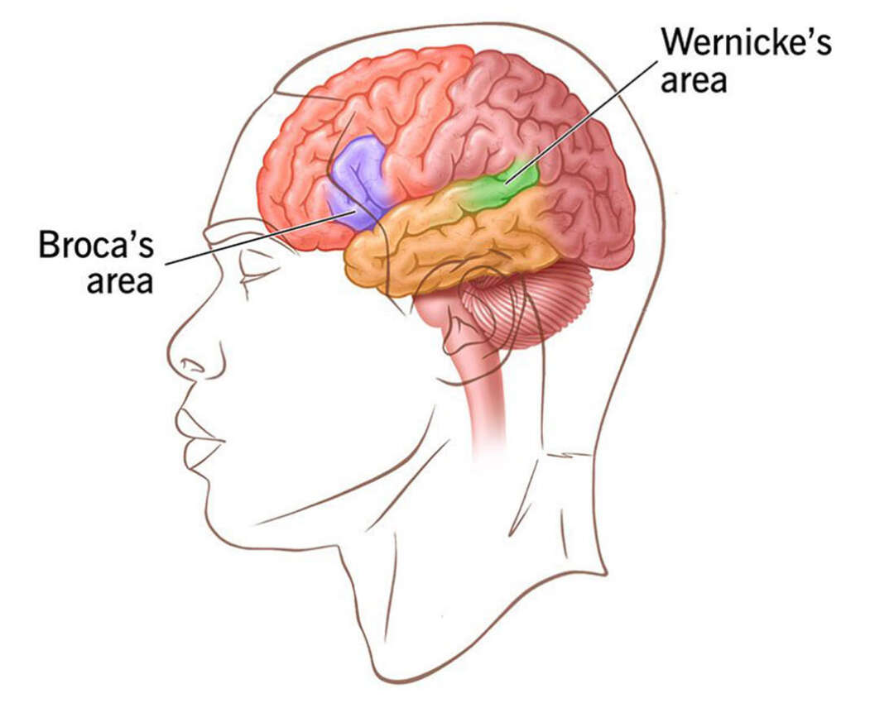
Figure 1: Major Brain regions identified by early neuropsychologists Broca and Wernicke

Existential theorists like Rollo May and Viktor Frankl built on the ideas of humanistic psychology but looked more deeply into the challenges that come with simply being human. They believed that feelings such as anxiety, emptiness, and the fear of death are a natural part of life, not just signs of mental illness. According to Frankl (1963), the biggest source of human suffering is not always the difficult events we face, but rather the loss of meaning and purpose in life. When people cannot find meaning in what they do or what happens to them, they may feel lost, hopeless, or disconnected.
From this view, therapy is about helping people face the deeper questions of life. A therapist works with the person to explore what truly matters to them and how they can create a sense of direction, even in the face of pain or uncertainty. The goal is to help the person find purpose, value, and personal freedom, so they can live in a more genuine and fulfilling way. In simple terms, existential therapy helps people make sense of their lives. It supports them in accepting life’s challenges and choosing how to respond with courage and honesty. Instead of trying to escape anxiety or sadness, people learn to use these feelings as signals to grow, change, and live more meaningfully.
Although the humanistic and existential perspectives are not as focused on scientific measurement as cognitive or biological models, they still offer deep and meaningful insights into what it means to be human. These approaches value the individual’s personal experience, the therapeutic relationship, and the importance of empathy in healing. They also connect well with modern models of care, such as recovery-oriented and trauma-informed approaches, which focus on respect, compassion, empowerment, and overall well-being rather than just symptom control.
2.5 The Sociocultural Perspective
The sociocultural perspective looks at mental health problems through the lens of society, culture, and environment. It reminds us that people do not live in isolation. our thoughts, feelings, and behaviors are shaped by the world around us. Factors such as poverty, discrimination, social pressure, and lack of support can increase a person’s risk of developing psychological difficulties. For example, studies have found that people who face racism, inequality, or loneliness are much more likely to experience depression or anxiety (Marmot, 2005).
This perspective also highlights that mental health cannot be fully understood without considering cultural differences. What one culture may view as unusual or unhealthy might be seen as completely normal in another. For instance, culture-bound syndromes such as ataque de nervios (common in Latin American cultures) or koro (found in some Asian cultures) show how mental distress can take very different forms depending on cultural beliefs and traditions.
In today’s globalized and multicultural world, understanding these differences has become essential. Professionals in psychology and neuropsychology are now trained to develop cultural competence. It is the ability to recognize their own biases, respect diversity, and adapt their approach based on a person’s cultural background (Sue et al., 2019). Moreover, this perspective connects with brain-based models by showing how chronic stress, poverty, and trauma can actually change brain development and cognitive functioning over time. This helps explain how social and environmental hardships can literally affect both the mind and the brain.
3. Neurobiological Mechanisms in Psychopathy: Implications for Psychopathology
Psychopathy provides a powerful example of how the brain and behavior are connected. It is a condition marked by a lack of empathy, emotional coldness, and antisocial behavior. People with psychopathic traits often struggle to understand or care about other people’s feelings, which can lead to manipulative or harmful behavior. Studying psychopathy helps scientists understand how abnormal brain structures and functions can lead to serious emotional and moral problems.
Researchers in fields like neuropsychology and neuroscience have found that psychopathy involves differences in brain regions linked to emotion regulation, empathy, and decision-making. These findings are not only useful for understanding psychopathy itself but also help us see how brain dysfunction might play a role in other mental and personality disorders.
3.1 Neural Systems and Structural Abnormalities
Brain imaging and lesion studies have shown that people with psychopathy are mainly affected in two key brain areas: the amygdala and the prefrontal cortex
The amygdala is a small structure deep in the brain that helps us recognize danger, learn from fear, and respond to emotional cues. In individuals with psychopathic traits, the amygdala tends to be less active when they are shown emotional faces or when they are asked to make moral judgments. That’s why they often show little fear, guilt, or empathy.
The prefrontal cortex, especially the ventromedial prefrontal cortex (vmPFC), helps control impulses, make ethical decisions, and consider the consequences of actions. Studies using MRI scans have found that this region tends to have less gray matter in psychopathic individuals, suggesting weaker connections between emotion and reasoning. When the communication between the amygdala and the prefrontal cortex is disrupted, people may understand what is “right” or “wrong” in theory but fail to feel the emotional weight of their actions.
In simpler terms, psychopathy shows what can happen when the parts of the brain that handle emotion, empathy, and moral judgment do not work together properly. These brain differences help explain why some individuals behave in ways that seem cold, impulsive, or remorseless, even when they know their actions are harmful.

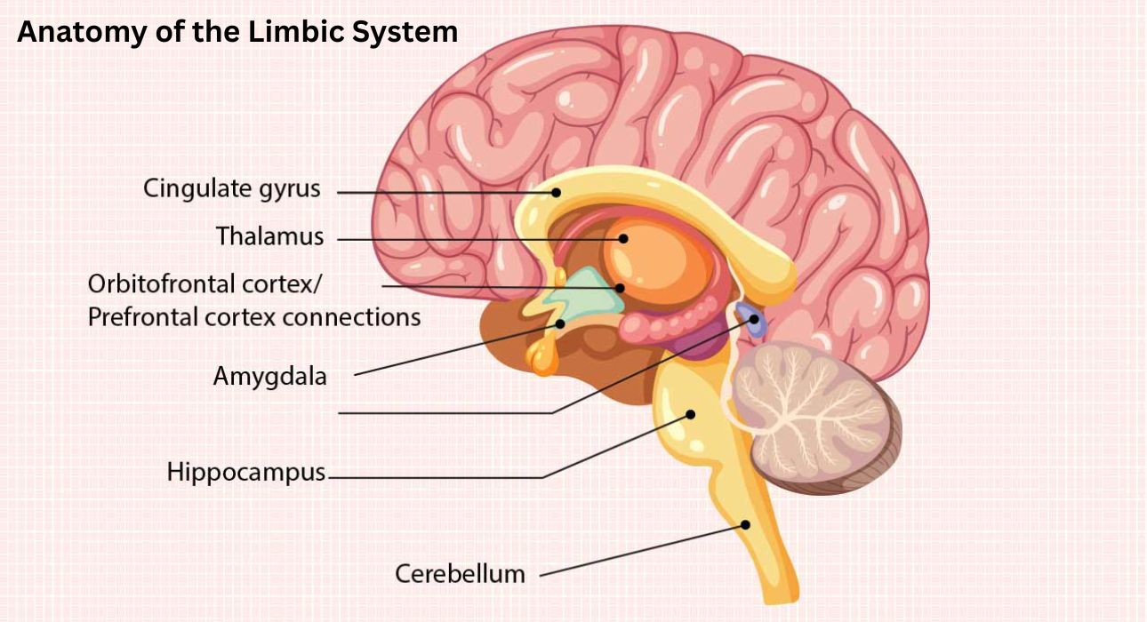
Figure 2. Components of the limbic system including the amygdala and hippocampus, key to emotion regulation.

The prefrontal cortex especially the orbitofrontal and dorsolateral region (the brain’s control center) for making decisions, managing impulses, and understanding right from wrong. When these areas don’t function properly, a person may struggle to think ahead, control their behavior, or consider how their actions affect others. This lack of self-control and foresight is often seen in people with psychopathic traits.
Today’s brain imaging studies strongly support the idea of Benton and Sivan (2007) that early psychologists already believed the frontal lobes were key to moral and social behavior . When these parts of the brain are damaged or underdeveloped, the brain has trouble linking emotions with thoughts and decisions. As a result, emotional signals like guilt, empathy, or fear don’t guide behavior as they should. This breakdown makes it harder for a person to regulate their actions, understand others’ feelings, or behave in socially acceptable ways.
In simple terms, when the front part of the brain doesn’t communicate well with the emotional centers, a person may know what’s right or wrong intellectually, but they don’t feel it in the same way most people do. This emotional disconnect can lead to impulsive, risky, or insensitive behavior, which is often seen in psychopathy.

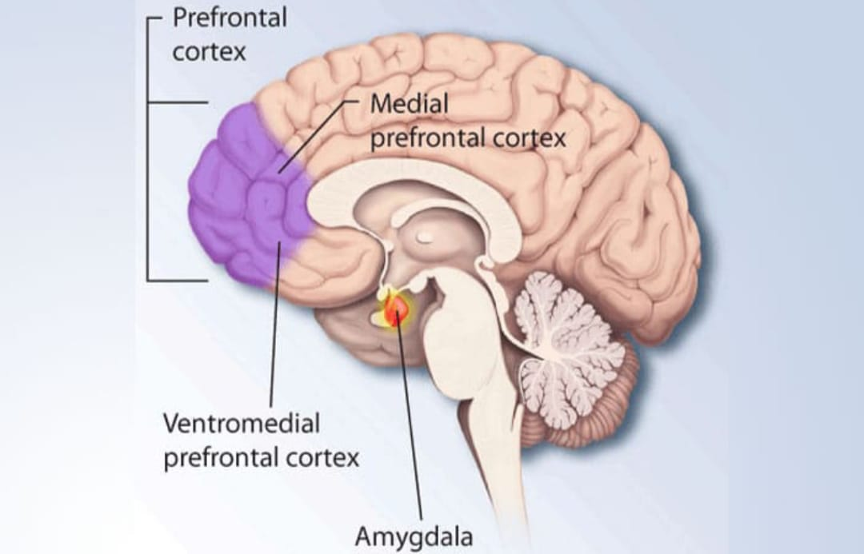
Figure 3. The prefrontal cortex regions (dorsolateral and orbitofrontal) involved in executive control.

3.2 Neurochemical and Physiological Correlates
Psychopathy is not only linked to brain structure but also to imbalances in the body’s chemical systems that control mood and stress. When these systems don’t work properly, emotions and impulses become harder to manage. For example, low levels of serotonin have been connected to aggressive and impulsive behavior, while an overactive dopamine system makes a person more driven by rewards and excitement.
The hypothalamic–pituitary–adrenal (HPA) axis, which helps the body respond to stress, also behaves differently in people with psychopathic traits. They often have lower levels of cortisol, the hormone that rises when we are stressed. This means their bodies are less reactive to pressure or threat(hypoarousal). This underactive stress system can explain why many psychopathic individuals appear calm, detached, and fearless, even in dangerous or emotional situations.
Research on the autonomic nervous system supports this idea. When shown unpleasant or threatening images, people with psychopathy show smaller changes in skin conductance, meaning their bodies don’t react as strongly as others would. This shows that their amygdala and limbic system, the emotional centers of the brain, are not generating normal emotional arousal. Because of this lack of response, they may not learn from punishment or negative experiences, which helps explain why consequences often fail to change their behavior.
3.3. Functional Connectivity and Network Dysregulation
Modern brain imaging research shows that psychopathy is also connected to poor communication between different brain regions. In particular, the amygdala and the ventromedial prefrontal cortex (vmPFC)—two areas that normally work together to connect emotion and moral judgment : don’t communicate effectively. When this link is weak, emotional signals fail to guide reasoning, leading to the cold, calculating behavior often seen in psychopathy.There are also problems in other large brain networks, such as the default mode network (involved in self-reflection) and the salience network (which helps detect important emotional or social cues). When these networks are disrupted, people become less responsive to emotional or moral information, showing less empathy or concern for others.
In simple terms, psychopathy can be seen as a breakdown in the brain’s teamwork. The emotional, thinking, and moral systems don’t coordinate properly, resulting in a person who can think clearly but feels emotionally disconnected from their actions and the people around them.
3.4. Developmental and Genetic Considerations
The roots of psychopathy are shaped by both genetic makeup and life experiences. Research on twins and genes shows that traits such as emotional coldness and lack of empathy are partly inherited. However, the environment also plays a huge role. Childhood neglect, abuse, or unstable parenting can strongly influence how these traits develop. Such experiences can affect the growth of the frontal and limbic brain regions, which are vital for emotion and self-control. Recent studies in epigenetics show that early life stress can even change how certain genes work. This means that trauma can literally leave a biological mark, increasing the likelihood of developing psychopathic traits later in life. Together, these findings highlight that psychopathy is not just a matter of biology or upbringing alone, but a combination of both. They also point to the importance of early intervention—supporting at-risk children and families before these patterns become deeply ingrained.
3.5. Implications for Broader Psychopathology
Studying psychopathy helps us understand many other mental health conditions as well. The same brain circuits that malfunction in psychopathy(especially the amygdala and prefrontal cortex) are also involved in mood, anxiety, and personality disorders. For instance, reduced amygdala activity is seen in severe depression, while overactivity occurs in PTSD and generalized anxiety. Psychopathy can therefore be viewed as one extreme form of imbalance between the emotional and rational parts of the brain. When emotion overwhelms control, anxiety or depression may result; when control suppresses emotion completely, we see the emotional coldness and impulsivity of psychopathy. From a neuropsychological point of view, psychopathy shows what happens when the balance between feeling and thinking breaks down.
3.6. Clinical and Theoretical Implications
Looking at psychopathy from a neurobiological perspective helps bridge the gap between psychology and brain science. It moves the discussion away from moral judgment of seeing people as “bad” and toward understanding the brain systems that shape behavior. This approach encourages more empathy and less stigma. In practice, neuropsychological assessments now include tools that test emotional processing and executive function to detect problems in the frontal-limbic systems. However, treating psychopathy remains difficult. Traditional therapy methods that rely on empathy and emotional insight are usually not effective. Instead, structured cognitive-behavioral programs and reward-based approaches show more promise, though results are modest. Newer treatments being explored include neuromodulation techniques, such as transcranial magnetic stimulation (TMS), which aim to strengthen prefrontal control and improve emotional regulation. These future-oriented methods reflect a growing hope that brain-based treatments can support rehabilitation alongside psychological and social interventions.
4. METHODS OF ASSESSMENT IN CLINICAL NEUROPSYCHOLOGY
Clinical neuropsychological assessment is a key process for understanding how brain problems affect thinking, emotions, and behavior. It connects the world of neuroscience with real-life clinical practice. The goal is not only to identify what is wrong but also to understand how the person’s brain, mind, and environment interact. Through a combination of standardized tests, careful observation, and brain imaging data, neuropsychologists build a detailed picture of each person’s strengths and weaknesses. This helps guide diagnosis, treatment planning, and rehabilitation (Lezak et al., 2012). The DSM-5 (American Psychiatric Association, 2022) lists various psychiatric disorders, each involving unique patterns of cognitive and emotional symptoms. For example, people with schizophrenia often have problems with working memory and executive functioning, which are linked to changes in the frontal and temporal lobes. Those with depression tend to show slowed thinking, attention difficulties, and lower activity in the anterior cingulate cortex, while anxiety disorders involve overactivation of the amygdala and poor communication between emotion and reasoning areas. Combining DSM-5 criteria with neuropsychological testing gives a fuller, brain-based understanding of these disorders.

Foundations and Rationale
The history of neuropsychological assessment dates back to early neurologists like Broca and Wernicke, who first linked specific brain areas to speech and language. Over time, their work evolved into more systematic and reliable testing methods.
Today, neuropsychological assessment serves several important purposes:
- identifying cognitive impairments,
- distinguishing between neurological and psychological causes,
- tracking recovery or decline, and
- guiding therapy and rehabilitation (Tranel, 2019).
For example, if someone develops memory loss or behavioral changes after a head injury, a neuropsychologist can use tests to determine whether the cause is physical brain damage, emotional distress, or both. In this way, assessment connects the science of the brain with the reality of human experience.
5. STRUCTURE OF THE NEUROPSYCHOLOGICAL EVALUATION
A complete neuropsychological evaluation usually begins with a detailed interview and a review of the person’s medical, developmental, and social history. This is followed by a series of standardized tests designed to measure different areas of thinking, such as attention, language, memory, visual-spatial skills, and problem-solving.
Commonly used tests include:
- Wechsler Adult Intelligence Scale (WAIS-IV) measures overall intelligence, memory, and processing speed.
- Wechsler Memory Scale (WMS-IV) evaluates short-term and long-term memory.
- Wisconsin Card Sorting Test (WCST) tests problem-solving and flexibility, often linked to frontal-lobe function.
- Trail Making Test, Stroop Test, and Rey–Osterrieth Complex Figure Test assess attention, inhibition, and spatial organization.
Test selection depends on the reason for referral and the individual’s background. In addition to scores, the way a person behaves during testing such as their motivation, frustration, or emotional reactions provides valuable clues. The neuropsychologist then combines all this information to understand which brain systems may be affected.
4.1. Integration of Neuroimaging and Electrophysiological Methods
Modern technology has added powerful tools to neuropsychological assessment. MRI and CT scans can reveal structural brain problems like tumors or injury. Functional MRI (fMRI) and PET scans go a step further, showing how different brain areas activate during specific tasks (Bigler & Maxwell, 2012). These imaging methods do not replace behavioral testing but complement it. They help link brain structure and activity with real-life cognitive performance. Electroencephalography (EEG) and event-related potentials (ERPs) measure the brain’s electrical activity in real time, helping detect subtle dysfunctions that may not yet affect behavior. This is particularly useful in conditions like mild brain injury or early dementia, where symptoms can be difficult to spot. By combining imaging, electrophysiology, and standardized testing, clinicians can build a rich, multidimensional picture of how the brain supports thinking, feeling, and behavior.

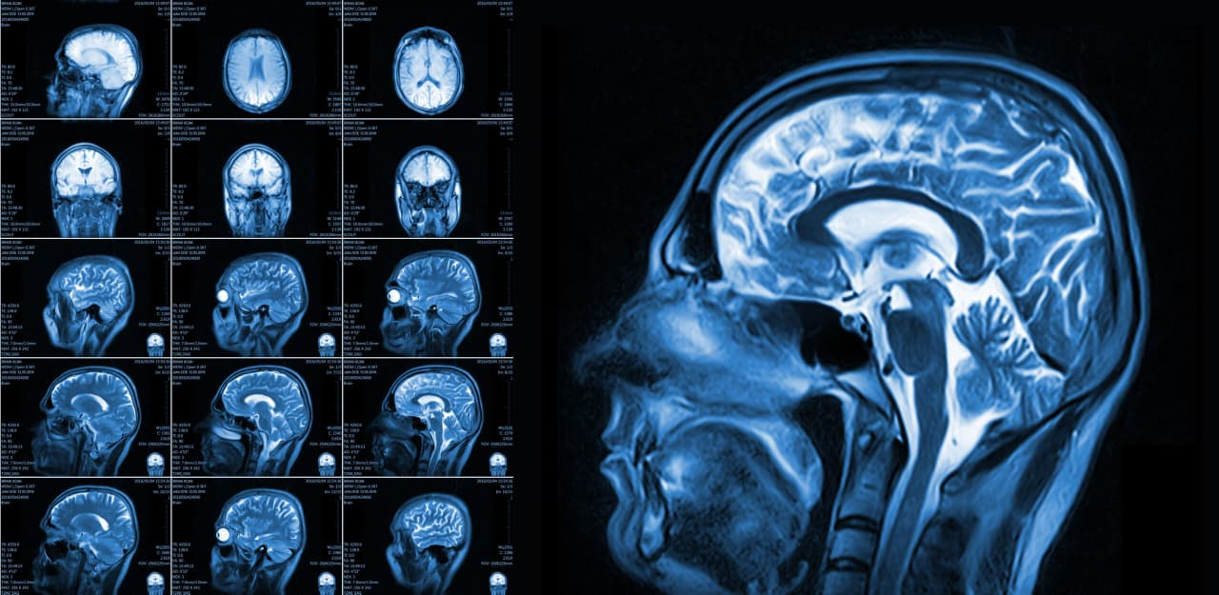
Figure 4. Functional MRI (fMRI) image showing activation patterns used in neuropsychological assessment.

Evidence-Based Assessment in Neuropsychology
In recent years, clinical neuropsychology has increasingly adopted what is known as Evidence-Based Assessment (EBA). This approach, explained by Chelune (2002, 2008), focuses on using reliable and scientifically tested methods when assessing patients. Instead of depending on personal intuition or tradition, EBA encourages clinicians to use tools that are supported by solid research and standardized data. EBA promotes fairness, accuracy, and accountability in how professionals make clinical decisions. Chelune emphasized that the choice of psychological tests should be based on how consistent and valid they are, and how well they compare to results from healthy people. For example, when a person performs poorly on a memory or attention test, EBA helps clinicians decide whether that score truly indicates a problem or if it could still fall within the normal range. Another important part of EBA is combining test results with other information, such as brain imaging findings and social or emotional factors. This creates a complete picture of the person’s functioning instead of relying on test scores alone. Overall, this approach represents a major shift from the older, more “artistic” style of assessment—where intuition often guided interpretation—to one that is systematic, transparent, and based on evidence.

Case Example
Take the case of a 35-year-old man who experienced a mild traumatic brain injury after a car accident. He complains of trouble focusing, forgetfulness, and irritability. When tested, he performs below average on attention and executive function tasks (like the Stroop or Wisconsin Card Sorting Test), but his memory and language skills are normal. An MRI scan shows mild injury to the frontal parts of his brain.
By connecting the test results with the imaging findings, the clinician concludes that his difficulties likely stem from damage to the brain’s frontal networks. This case clearly shows how assessment is not only diagnostic but also a guide for treatment and rehabilitation. It identifies which mental abilities are affected, helps plan specific interventions such as attention training, and gives a baseline for tracking progress over time.
Emerging Trends and Innovations
The field of neuropsychological assessment is changing rapidly thanks to new technologies and collaborations with other sciences. Computer-based tests like the Cambridge Neuropsychological Test Automated Battery (CANTAB) allow for faster, more objective, and standardized assessments, reducing possible examiner bias. Artificial intelligence (AI) and machine learning are also being used to study large sets of neuropsychological data. These systems can spot subtle patterns, help predict recovery outcomes, and guide personalized treatment plans (Spooner & Pachana, 2020). Similarly, virtual reality (VR) is being explored as a way to test people in realistic, everyday-like settings. For example, VR memory and navigation tasks can reveal problems with spatial orientation that paper tests might miss. Even with these technological advances, the human element remains central. Machines can analyze data, but only a skilled clinician can understand the full context of a person’s life, emotions, and motivations. The future of neuropsychological assessment will therefore rely on a balance between technology and human empathy combining precision with compassion.
Transition to Interventions
Once assessment identifies where the problems lie, treatment must build on those findings. In other words, therapy should match each person’s specific brain and cognitive profile. Understanding how the brain and mind interact helps clinicians design interventions that address both biological and psychological aspects of mental health.
Interventions and Treatment Approaches
In conditions such as schizophrenia and other psychotic disorders, cognitive difficulties like poor memory, attention, and planning. It can make both diagnosis and treatment more complicated. According to Gkintoni, Skokou, and Gourzis (2024), traditional medications often do not fully correct these problems, so there is a growing need for integrated, multi-method treatments. Similarly, Theodoratou (2024) highlights that combining insights from both clinical psychology and neuropsychology creates more complete and effective care.
Cognitive Remediation and Rehabilitation
Cognitive remediation (CR) and cognitive rehabilitation (CRb) involve structured exercises aimed at improving thinking skills such as memory, attention, and problem-solving. These programs are designed to stimulate brain plasticity , the brain’s ability to rewire and strengthen itself through practice. For example, a person might do targeted activities that challenge working memory or decision-making. Over time, this can lead to improvements not only in test performance but also in everyday functioning. Studies reviewed by Gkintoni et al. (2024) show that when CR or CRb are combined with other therapies, people often experience noticeable improvements in real-world abilities like social interaction or job performance.
Non-Invasive Brain Stimulation
Techniques like transcranial direct current stimulation (tDCS) and transcranial magnetic stimulation (TMS) are also being explored. These methods gently stimulate specific brain regions using electrical or magnetic fields to improve brain activity. For example, stimulating the dorsolateral prefrontal cortex can boost attention and working memory. While early studies show promise, results can vary depending on the person and the method used, so more research is still needed before these treatments become mainstream.
Psychological and Psychosocial Therapies
Psychological therapies such as cognitive-behavioral therapy (CBT) and metacognitive training (MCT) are essential in helping people manage their thoughts, emotions, and social functioning. CBT helps individuals identify and challenge unhelpful thinking patterns, while MCT helps them understand and regulate how they think about their own thoughts. These therapies can reduce symptoms, improve coping strategies, and enhance self-awareness, allowing patients to regain a sense of control over their mental processes.
Integrated, Multimodal Approaches
The most promising results come from combining these methods. For example, pairing brain stimulation (TMS or tDCS) with cognitive therapy can reinforce both neural and psychological improvements. This integrated model acknowledges that psychotic disorders affect multiple systems like cognitive, emotional, and biological and therefore require equally multi-layered treatments. Gkintoni et al. (2024) found that these combined approaches often produce more lasting improvements in thinking, motivation, and daily functioning.
The Role of Clinical Psychology
Theodoratou (2024) emphasizes how clinical psychology strengthens neuropsychological treatments. While neuropsychology focuses on repairing cognitive functions, clinical psychology helps address emotional struggles, motivation, and self-esteem .factors that are crucial for long-term progress. For instance, a patient might regain better attention through cognitive training but still need emotional support and coping strategies to apply those skills in real life. The partnership between these two fields ensures that treatment addresses both the mind and the brain, leading to more complete recovery.
How These Interventions Work in the Brain
Each of these therapies influences brain function in different but complementary ways.
- Cognitive remediation strengthens neural pathways through repeated practice, improving communication within brain networks responsible for attention and planning. Imaging studies show that improvements in these abilities often correspond with greater activity in the prefrontal cortex.
- Non-invasive stimulation helps “prime” brain areas for learning, making cognitive training more effective. For example, applying tDCS to the frontal regions before therapy can enhance neural readiness and learning efficiency.
By combining brain-based and psychological interventions, clinicians can support recovery at both the biological and emotional levels—helping patients rebuild not just cognitive skills but also confidence, motivation, and independence.

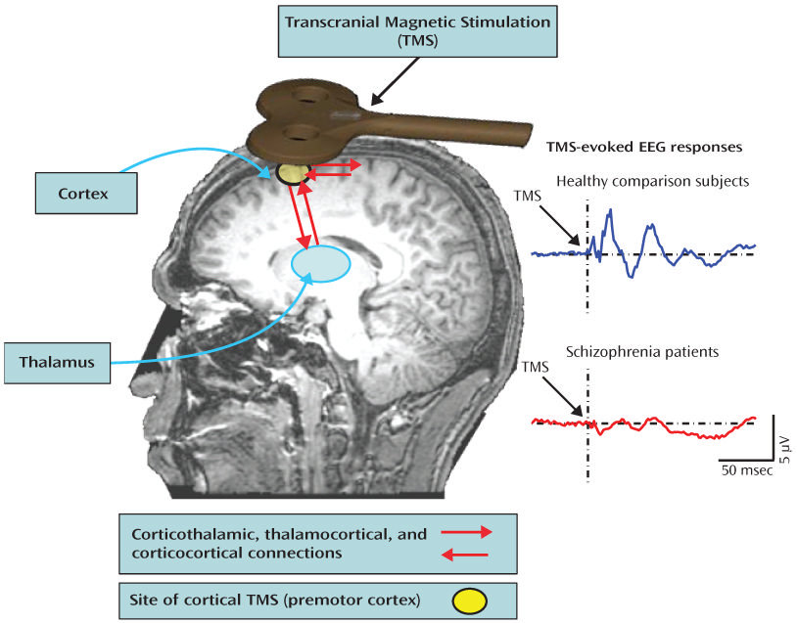
Figure 5. Transcranial magnetic stimulation (TMS) targeting prefrontal cortical regions involved in mood regulation.

Psychological Therapies and Integrative Interventions
Psychological therapies such as Cognitive Behavioural Therapy (CBT) and Metacognitive Training (MCT) help people with psychosis understand and challenge the way they think. These approaches aim to correct distorted beliefs, improve self-awareness, and manage thinking habits that might worsen symptoms—like the tendency to “jump to conclusions.” MCT, in particular, has been shown to help patients question rigid beliefs, reduce the intensity of delusional thoughts, and build insight into their own thinking patterns (Moritz & Woodward, 2014).
In recent years, integrative or combined approaches have received growing attention. Theodoratou (2024) highlights that blending psychological tools such as emotional regulation techniques or motivational interviewing with neuropsychological interventions like cognitive training or neurofeedback can create stronger and longer-lasting results. For example, when patients see how changes in their brain activity (through neurofeedback or imaging) connect to improvements in behavior, they often become more engaged and motivated in therapy.
Evidence of Effectiveness and Key Influencing Factors
Research reviewed by Gkintoni and colleagues (2024) shows that cognitive remediation therapy produces moderate to strong improvements in attention, memory, and problem-solving for people with psychosis. These cognitive gains often lead to better everyday functioning, such as improved social relationships or job performance. However, results differ between studies some show large benefits while others report smaller effects, especially when follow-up is limited.
Several factors can influence how well these treatments work:
- Stage of illness: Interventions introduced early, during the first episode or even before full symptoms develop tend to produce stronger and longer-lasting improvements.
- Severity and variability: People with very severe cognitive impairments may progress more slowly, so sessions must be carefully adjusted to their pace and ability level.
- Medication and support: The best results often occur when treatment is supported by stable medication, good family support, and a positive rehabilitation environment.
- Motivation and engagement: Because cognitive training is repetitive and effortful, patients’ motivation plays a huge role. Strategies from clinical psychology, like motivational interviewing, can help sustain participation and commitment.
- Strengths, Challenges, and Limitations
Strengths
- These interventions focus on the root causes of dysfunction(cognitive and neural deficits) rather than only reducing visible symptoms.
- They are grounded in the science of neuroplasticity, showing how repeated practice can rewire and strengthen brain networks.
- Integrating psychological and neuropsychological techniques brings together emotion, motivation, and cognition, creating treatments that are both effective and personally meaningful for patients.
Challenges and Limitations
- Small study sizes and generalizability: Many research studies are done with small, specific samples, making it difficult to apply findings widely.
- Durability: Without follow-up or refresher sessions, the benefits may fade over time.
- Resource constraints: Advanced tools like neurostimulation or specialized software may not be available in low-resource clinics.
- Cause versus correlation: It’s still difficult to prove that brain changes directly cause behavioral improvements rather than simply occurring alongside them.
- Integration difficulties: Combining techniques from psychology and neuroscience requires collaboration, training, and a shared understanding among professionals. something that is not always easy to achieve.
Conclusion
Clinical neuropsychology and psychopathology are two closely connected fields that work together to explain how brain function relates to thought, emotion, and behavior. Clinical neuropsychology began with early scientists studying brain injuries and has now grown into a discipline that links brain structure, function, and behavior using modern tools like MRI and EEG. Psychopathology, on the other hand, focuses on understanding and treating mental disorders from biological, psychological, and social perspectives. When combined, these fields provide a fuller picture of how brain changes lead to psychological symptoms and how both can be treated together.
Historically, this integration can be traced back to early thinkers like Broca and Wernicke, who connected specific brain regions with language, and Hughlings Jackson and Kurt Goldstein, who emphasized that brain functions work together in networks. Today, technologies such as MRI, fMRI, EEG, and other imaging methods help clinicians map brain-behavior links more precisely. This progress allows assessments to be not only diagnostic but also practical. Its helping us to guide treatment and rehabilitation plans.
Psychopathology adds another layer by helping us interpret these findings through different lenses:
- Biological models explain how genes and brain chemistry influence mental disorders.
- Psychodynamic, cognitive, behavioral, and humanistic approaches explore how life experiences, learning, and emotions shape mental health.
- Sociocultural theories remind us that culture and environment also play crucial roles in shaping mental illness and recovery.
Together, these perspectives show that mental disorders are not caused by just one factor but are the result of a complex mix of brain, mind, and environment.
This connection is especially clear in conditions like psychopathy, where brain scans reveal abnormalities in the prefrontal cortex and amygdala. These areas responsible for moral reasoning and emotion regulation. Similar patterns are seen in schizophrenia, bipolar disorder, depression, and anxiety, where disruptions in brain networks and neurotransmitters contribute to symptoms. Understanding these biological underpinnings helps clinicians move beyond simply describing symptoms and toward designing interventions that target specific mechanisms. One of the most important applications of this integration is the treatment of psychotic disorders. Cognitive impairment(memory, attention, and executive function) are key barriers to recovery in conditions like schizophrenia or bipolar disorder with psychotic features. While medication is vital for controlling hallucinations and delusions, it often does little to improve these cognitive weaknesses. Modern treatments therefore combine cognitive exercises, brain stimulation, and psychological therapy to create a more complete and effective plan.
Cognitive remediation helps retrain the brain through structured exercises, while non-invasive brain stimulation (like tDCS or TMS) helps “activate” certain brain areas, making them more responsive to training. When these are paired with psychological therapies such as CBT or MCT, patients not only gain better thinking skills but also improve emotional regulation, motivation, and insight.
For example, MCT helps people recognize and question their thought patterns, while CBT helps them manage emotions and develop healthier coping strategies. This combination creates a synergistic effect and cognitive gains are reinforced emotionally and behaviorally, helping patients apply what they learn to daily life.
Clinical psychology adds tremendous value by supporting motivation and emotional stability throughout treatment. Patients often need help staying engaged in repetitive cognitive exercises, and addressing emotional distress makes it easier to keep improving. By treating both the “hardware” of the brain and the “software” of thoughts and emotions, clinicians can achieve more complete and lasting recovery.
Evidence shows that these integrated interventions work best when started early, especially during the first signs of illness. However, challenges remain such as sustaining long-term benefits and ensuring access to advanced therapies in all clinical settings.
Looking ahead, the future of neuropsychology will likely involve greater use of computerized assessments, artificial intelligence, virtual reality, and other emerging technologies. These tools can make testing more accurate and treatment more personalized. But even with all this innovation, the human element like understanding each person’s story, motivation, and emotional world—will always be central.
In essence, integrating neuropsychology and psychopathology gives clinicians a holistic way to understand and treat mental illness. It unites science and empathy, evidence and experience, to not only reduce symptoms but also help people rebuild meaningful, functional lives.

References
Barr, W. B., & Bieliauskas, L. A. (2024). The Oxford handbook of the history of clinical neuropsychology. Oxford University Press.
Bigler, E. D., & Maxwell, W. L. (2012). Neuropathology of mild traumatic brain injury: Relationship to neuroimaging findings. Brain Imaging and Behavior, 6(2), 108–136. https://doi.org/10.1007/s11682-011-9145-0
Gkintoni, E., Skokou, M., & Gourzis, P. (2024). Integrating clinical neuropsychology and psychotic spectrum disorders: A systematic analysis of cognitive dynamics, interventions, and underlying mechanisms. Medicina, 60(4), 645. https://doi.org/10.3390/medicina60040645
Lezak, M. D., Howieson, D. B., Bigler, E. D., & Tranel, D. (2012). Neuropsychological assessment (5th ed.). Oxford University Press.
Spooner, D. M., & Pachana, N. A. (2020). Emerging technologies in neuropsychological assessment: A review. The Clinical Neuropsychologist, 34(3), 473–489.
Theodoratou, M. (2024). Integrating clinical psychology and neuropsychology: Advancing insights and interventions in mind–brain disorders. European Journal of Environment and Public Health, 8(1), em0150. https://doi.org/10.29333/ejeph/14126
Tranel, D. (2019). Clinical neuropsychology: A foundational framework for understanding brain–behavior relationships. Journal of Clinical and Experimental Neuropsychology, 41(9), 841–853.
American Psychological Association. (n.d.). APA PsycNet. https://psycnet.apa.org/record/2015-47050-011

