Rhea Cumberbatch-Grant
ID a9UD91524

Course Name: SBU 671 Strategy in Business
Assignment: Research Paper -The Importance of Strategy in Business

Friday 1st August, 2025

Atlantic International University

Table of Contents
Page number
Introduction ,………………………………………………………………………………..…..3
Evolution of Strategic Thinking…,………………………,……………………….……..….....4
Globalization and Strategic Positioning,…………………………………………………..….11
Digital Transformation Strategy,…………………………...................…………………….…15
Sustainable Competitive Advantage in Fast-Changing Markets..…………….…… ..……..18
Sustainability as Core Strategy……,…………………………………………………..………23
Strategy Execution Gaps: Why Strategies Fail in Implementation.…..….……………..……27
AI-Powered Strategic Decision-Making…………….…………………………………...…….31
Real-Life Application Plan for an Educational Institution…,………………………………..37 Conclusion..………………………………………………………………………..………...….39
References ,………………………………………………………………………………..……40

Introduction
In today's rapidly evolving business landscape, strategic management has become increasingly complex and multifaceted. Organizations must navigate a myriad of challenges, including technological advancements, globalization, shifting workforce dynamics, and heightened ethical expectations. To remain competitive and sustainable, businesses must adopt comprehensive strategies that encompass innovation, adaptability, ethical considerations, and effective leadership.
This research paper explores critical areas of business strategy, focusing on strategic thinking, digital transformation, strategic positioning and competitive advantage for sustainability in business. A section of the paper also looks at key concepts which are examined under emerging and future artificial intelligence-powered strategic decision-making, such as scenario planning for extreme uncertainty, gig economy and workforce strategy, resilience strategy, data strategy as core business strategy, and ethical implementation of AI. Each concept is analyzed for its theoretical underpinnings and practical applications, culminating in a practical real-life application plan that can be tailored for business; specifically in an educational institution.

Evolution of Strategic Thinking
  - 1.1 Classical Strategic Thinking
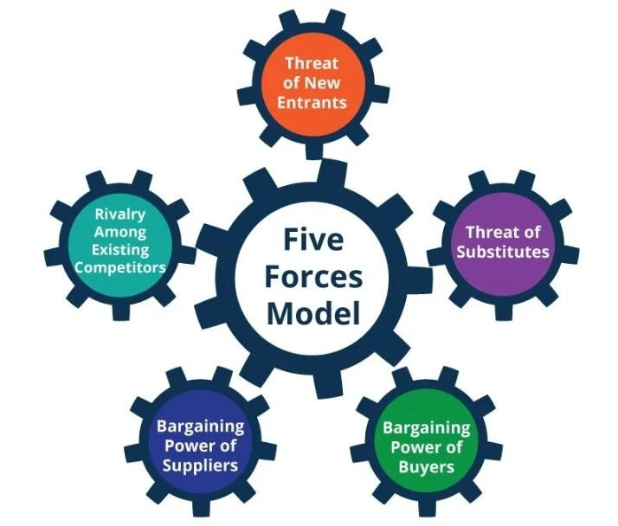
Classical strategic thinking, epitomized by Michael Porter's frameworks, emphasizes industry structure and competitive positioning. Porter's Five Forces model provides a systematic approach to analyzing competitive forces within an industry, guiding firms to position themselves advantageously (Porter, 1980). This approach assumes relatively stable market conditions, where long-term planning and analytical rigor can yield sustainable competitive advantages.
Fig 1.1 Porter’s Five Forces Model
Porter’s framework provides structured, widely respected and time tested tools for Strategy formulation. However, I’ve found that they can be too rigid or static, for today’s fast moving, tech- driven markets. It doesn’t provide the know-how of implementing the chosen strategy, although this strategy is applicable to all business scales and helps to build sustainability and competitive advantage.
  - 1.2. Emergence of Adaptive and Agile Strategies
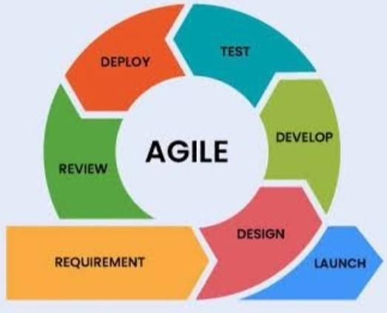
In contrast, the dynamic nature of modern markets necessitates more flexible strategic approaches. Adaptive strategies focus on continuous learning and responsiveness to environmental changes. Agile strategies, often associated with the technology sector, emphasize iterative development, cross-functional teams, and customer feedback loops (Rigby, Sutherland, & Takeuchi, 2016). These approaches allow firms to pivot quickly in response to market shifts, technological advancements, and evolving customer preferences.
Fig 1.2 Agile Strategies
  - 1.3. Integration of Dynamic Capabilities
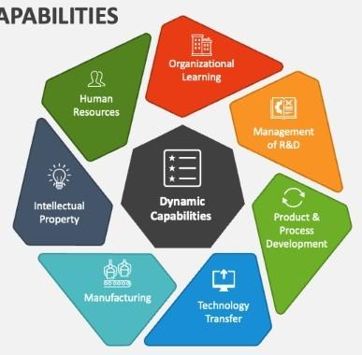
The concept of dynamic capabilities further enriches adaptive strategic thinking. Teece, Pisano, and Shuen (1997) define dynamic capabilities as the firm's ability to integrate, build, and reconfigure internal and external competencies to address rapidly changing environments.
Fig 1.3 Dynamic Capabilities
This perspective underscores the importance of organizational learning, innovation, and the capacity to adapt resources and processes in pursuit of sustained competitive advantage.
2. Corporate Strategy vs. Business Unit Strategy
  - 2.1. Distinction Between Corporate and Business Unit Strategies
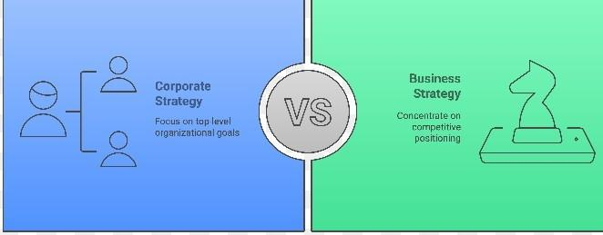
Corporate strategy pertains to the overall scope and direction of a corporation, encompassing decisions about which industries or markets to compete in and how to allocate resources among business units. Business unit strategy, on the other hand, focuses on how a specific business competes within its particular market.
Fig 1.4 Corporate vs Business Strategy
The alignment between these two levels of strategy is crucial for organizational coherence and performance (Collis & Montgomery, 2008)
  - 2.2. Challenges in Strategic Alignment
Achieving alignment between corporate and business unit strategies can be challenging, especially in diversified firms. Tensions may arise when business units pursue objectives that conflict with corporate-level goals or when resource allocation decisions favor certain units over others. Effective governance structures, clear communication channels, and a shared strategic vision are essential to mitigate these tensions and ensure cohesive strategic execution (Goold & Campbell, 2002).
3. Core Competencies and Competitive Advantage: Identification, Sustenance, and Evolution
  - 3.1. Defining Core Competencies
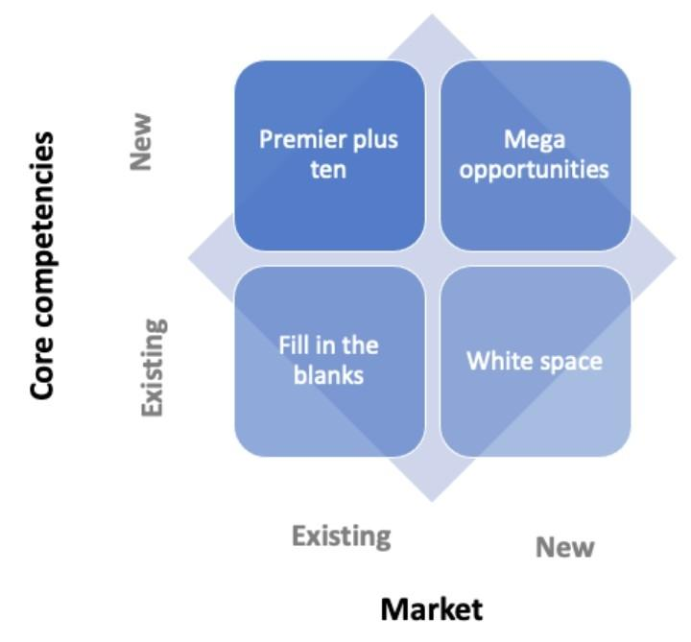
Core competencies are the unique capabilities that provide a firm with a competitive advantage. Prahalad and Hamel (1990) identify three criteria for core competencies: they provide access to a wide variety of markets, contribute significantly to customer benefits, and are difficult for competitors to imitate. These competencies are often rooted in the firm's collective learning and coordination of diverse production skills and technologies.
Fig 1.3 Core Competencies
This theory supports a strategic focus on strengths and builds strategy around that, as well as investing in creating a niche that competitors can’t imitate but it goes beyond competing for price, rather in creating an advantage and innovation with a holistic organizational view. On the other hand, you don’t want to focus too narrowly on core competencies and then innovation becomes outside of the core as neglected, or the company is locked into outdated strengths.
  - 3.2. Sustaining and Evolving Core Competencies
To sustain competitive advantage, firms must continuously nurture and evolve their core competencies. This involves investing in employee development, fostering innovation, and adapting to technological changes. Failure to evolve can render competencies obsolete, eroding the firm's market position. Therefore, strategic management must balance the exploitation of existing competencies with the exploration of new capabilities (Leonard-Barton, 1992).
4. The Role of Strategic Planning in Volatile Environments
  - 4.1. Limitations of Traditional Strategic Planning
Traditional strategic planning often relies on long-term forecasts and assumes a relatively stable environment. However, in volatile and uncertain contexts, such as those characterized by rapid technological change or geopolitical instability, these assumptions may not hold. Rigid plans can become obsolete quickly, leading to strategic misalignment and missed opportunities (Mintzberg, 1994).
  - 4.2. Adaptive Strategic Planning
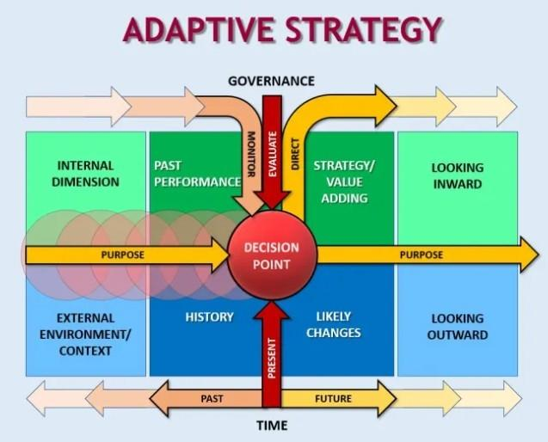
In response to environmental volatility, organizations are adopting more adaptive strategic planning processes. This involves iterative planning cycles, scenario analysis, and real-time data monitoring to inform decision-making.
Fig 1.5 Adaptive Strategies
Such approaches enhance organizational agility, allowing firms to respond promptly to emerging threats and opportunities (Johnsen, 2023).
5. Strategic Fit: Aligning Internal Resources with External Opportunities
  - 5.1. Resource-Based View (RBV) vs. Market-Based View (MBV)
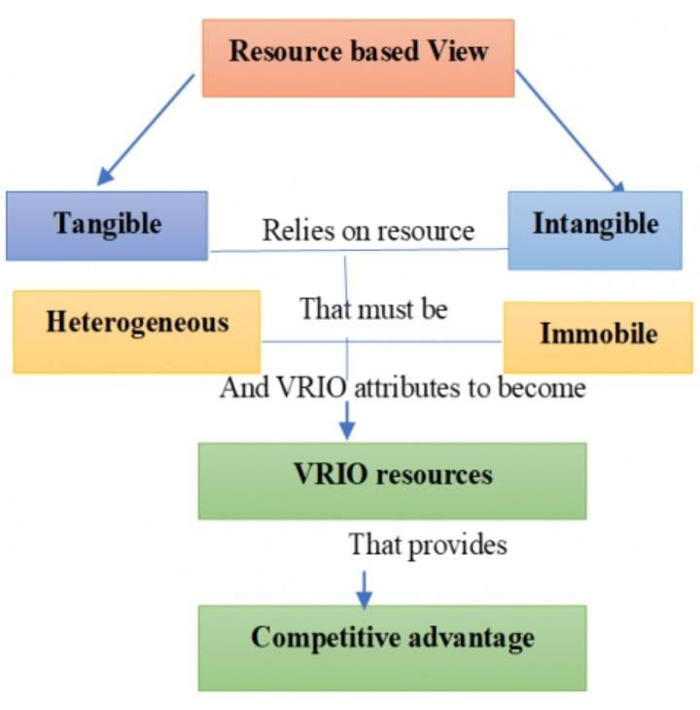
The concept of strategic fit involves aligning a firm's internal resources and capabilities with external market opportunities. The Resource-Based View (RBV) posits that sustainable competitive advantage arises from unique, valuable, and inimitable internal resources (Barney, 1991).
Fig 1.6 Resource- Based View
Conversely, the Market-Based View (MBV) emphasizes the importance of external market positioning and industry structure in determining firm performance (Porter, 1980).
  - 5.2. Integrative Approaches to Strategic Fit
Modern strategic management recognizes the need to integrate RBV and MBV perspectives. Firms must not only develop distinctive internal capabilities but also ensure these align with market demands and opportunities. This integrative approach enables firms to leverage their strengths effectively in the marketplace, enhancing competitiveness and adaptability (Dahle et al., 2018).
6. Blue Ocean vs. Red Ocean Strategies: Evaluating Sustainable Growth Approaches
  - 6.1. Red Ocean Strategy
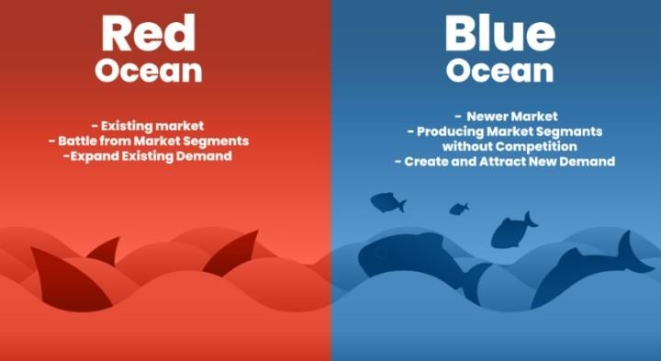
Red Ocean Strategy involves competing in existing markets, striving to outperform rivals through cost leadership or differentiation. This often leads to intense competition, commoditization, and shrinking profit margins. Firms operating in red oceans focus on capturing a larger share of existing demand, which can result in zero-sum games (Kim & Mauborgne, 2005).
Fig 1.7 Red vs Blue Ocean Strategy
  - 6.2. Blue Ocean Strategy
In contrast, Blue Ocean Strategy advocates for creating new market spaces, rendering competition irrelevant. This approach emphasizes value innovation, where firms simultaneously pursue differentiation and low cost to open up new demand and achieve sustainable growth. By breaking away from traditional competitive boundaries, firms can unlock untapped markets and create unique value propositions (Kim & Mauborgne, 2005).
  - 6.3. Assessing Sustainability
While Blue Ocean Strategy offers the potential for uncontested market space and high growth, sustaining this advantage requires continuous innovation and adaptability. Competitors may eventually enter the new market space, eroding the initial advantage. Therefore, firms must invest in ongoing value creation and strategic renewal to maintain their blue ocean position (Kim & Mauborgne, 2005).
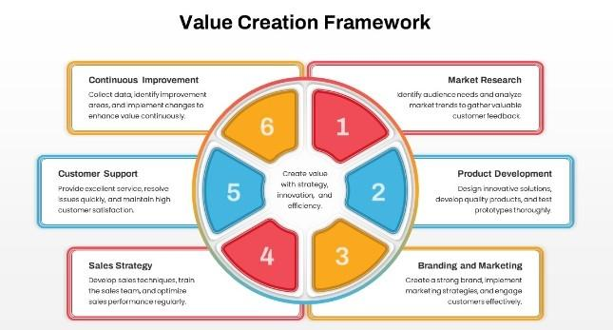
Fig 1.8 Value Creation Framework
A great value creation framework ensures consistency in quality for stakeholders; employees, investors and customers while maintaining market positioning and competitive advantage.

Globalization and Strategic Positioning
Navigating the complexities of global and international business strategy necessitates a nuanced understanding of various strategic approaches and their practical applications. From adapting strategies for multi-country operations to managing cross-cultural differences, firms must be agile and culturally intelligent. Building resilient supply chains and executing successful international mergers further underscore the importance of strategic foresight and adaptability in the global business arena.
  - The Dynamics of Globalization
Globalization has transformed the business landscape, compelling firms to adapt their strategies to operate effectively across multiple countries. This involves understanding diverse market dynamics, regulatory environments, and cultural nuances. Strategic positioning in a global context requires firms to balance global integration with local responsiveness (Ghemawat, 2007).
  - 1.2. Strategic Positioning in Practice
Companies like McDonald's exemplify effective global strategic positioning by maintaining a consistent brand image while adapting menus to local tastes. Similarly, Unilever operates with a decentralized structure, allowing regional units to tailor products and marketing strategies to local markets, thereby enhancing relevance and competitiveness (Bartlett & Beamish, 2018).
2. Transnational Strategies: Balancing Global Efficiency with Local Responsiveness
  - 2.1. Understanding Transnational Strategy
Transnational strategy seeks to achieve global efficiency and local responsiveness simultaneously. This complex approach requires firms to integrate global operations while being sensitive to local market conditions (Bartlett & Ghoshal, 1989).
  - 2.2. Implementation Challenges and Solutions
Implementing a transnational strategy involves organizational complexity, requiring robust coordination mechanisms and knowledge-sharing systems. Companies like Nestlé have successfully adopted this approach by decentralizing decision-making and fostering a culture of collaboration across subsidiaries (Doz & Prahalad, 1991).
3. Emerging Markets Strategy: Approaches for High-Growth Economies
  - 3.1. The Appeal of Emerging Markets
Emerging markets offer substantial growth opportunities due to expanding middle classes and increasing consumption. However, they also present challenges such as political instability and infrastructural deficits (Khanna & Palepu, 2010).
  - 3.2. Strategic Approaches
Firms entering emerging markets often adopt strategies like joint ventures to mitigate risks and leverage local knowledge. For instance, Starbucks partnered with Tata in India to navigate the complex market environment. Additionally, companies may tailor products to meet local needs, as seen with Unilever's development of low-cost products for rural markets (London & Hart, 2004).
4. Cross-Cultural Strategic Management: The Impact of Cultural Differences
  - 4.1. Cultural Dimensions and Business Strategy
Cultural differences significantly influence strategic decisions, affecting communication, leadership styles, and negotiation practices. Hofstede's cultural dimensions provide a framework for understanding these differences and their implications for international business (Hofstede, Hofstede, & Minkov, 2010).
  - 4.2. Managing Cultural Diversity
Effective cross-cultural management involves cultural intelligence and adaptability. Companies like IBM have implemented cross-cultural training programs to enhance employees' cultural awareness and competence, facilitating smoother international operations (Earley & Mosakowski, 2004).
5. Global Supply Chain Strategy: Building Resilience Post-COVID and Amid Geopolitical Conflicts
  - 5.1. Supply Chain Vulnerabilities
The COVID-19 pandemic and geopolitical tensions have exposed vulnerabilities in global supply chains, prompting firms to reassess their strategies. Disruptions have highlighted the need for greater resilience and flexibility (Ivanov & Das, 2020).
  - 5.2. Strategies for Resilience
Companies are adopting strategies such as diversifying suppliers, increasing inventory buffers, and investing in digital technologies for real-time monitoring. For example, Toyota's just-in-time system has been complemented with just-in-case strategies to balance efficiency with resilience (Choi, Rogers, & Vakil, 2020).
6. International Mergers & Acquisitions: Strategic Intent and Integration Challenges
  - 6.1. The Strategic Rationale for M&As
International mergers and acquisitions (M&As) are pursued for various strategic reasons, including market expansion, resource acquisition, and synergy realization. However, cross-border M&As often face integration challenges due to cultural differences and regulatory complexities (Weber, Tarba, & Reichel, 2011).
  - 6.2. Integration Strategies
Successful integration requires careful planning and cultural due diligence. The merger between Daimler-Benz and Chrysler serves as a cautionary tale, where cultural clashes undermined potential synergies. Conversely, the acquisition of Jaguar Land Rover by Tata Motors succeeded due to respect for organizational cultures and autonomy (Rottig, 2013)

Digital Transformation Strategy
  - The Imperative of Digital Transformation
Digital transformation involves integrating digital technologies into all areas of a business, fundamentally changing how organizations operate and deliver value to customers. The adoption of AI, cloud computing, and automation has become crucial for businesses seeking to enhance efficiency, agility, and competitiveness (Vial, 2019).
  - 1.2. Strategic Implementation
Companies like Microsoft have successfully transformed by investing heavily in AI and cloud capabilities, leading to substantial growth in cloud revenue and the development of AI-driven solutions across their product portfolio (Khajeh-Hosseini et al., 2010). This strategic shift has enabled Microsoft to transition from a desktop software company to a leading provider of cloud-based, AI-powered enterprise solutions.
2. Platform and Ecosystem Strategies: The Rise of Network-Based Business Models
  - 2.1. Understanding Platform Ecosystems
Platform ecosystems are business models that create value by facilitating exchanges between two or more interdependent groups, usually consumers and producers. Companies like Amazon and Apple have leveraged platform strategies to build extensive ecosystems that drive network effects and innovation (Gawer & Cusumano, 2014).
  - 2.2. Strategic Management of Platforms
Apple's platform ecosystem, for instance, relies on a global network of third-party developers who contribute to the App Store. Apple manages this ecosystem through quality-control standards, shared values, and programming resources, ensuring that the platform evolves in a coherent and strategic direction (Tiwana, 2014).
3. Open Innovation and Co-Creation Strategies: Leveraging External Collaboration
  - 3.1. The Concept of Open Innovation
Open innovation involves the use of purposive inflows and outflows of knowledge to accelerate internal innovation and expand the markets for external use of innovation. Companies engage in open innovation by collaborating with customers, partners, and startups to co-create value (Chesbrough, 2011).
  - 3.2. Real-World Applications
Several companies have successfully implemented co-creation strategies:
- LEGO Ideas Platform: An online community where fans submit and vote on new LEGO set ideas, with winning designs becoming commercial products.
- Starbucks' My Starbucks Idea: A platform allowing customers to suggest and vote on new products and improvements, leading to innovations like mobile payment and free Wi-Fi .
- Nike's NIKEiD: A customization service enabling consumers to design their own Nike shoes, enhancing customer engagement and brand loyalty.
- Dell's IdeaStorm: A platform for customers to suggest product improvements, leading to several enhancements and new initiatives .
-Unilever's Open Innovation Portal: An initiative inviting customers, suppliers, and researchers to contribute ideas and technologies to meet innovation and sustainability goals .
4. Disruptive Innovation Management: Strategies for Incumbents
  - 4.1. Understanding Disruptive Innovation
Disruptive innovation refers to innovations that create new markets by discovering new categories of customers. These innovations eventually disrupt existing markets and displace established market-leading firms, products, and alliances (Christensen, 1997).
  - 4.2. Strategies for Incumbents
Incumbent firms can respond to disruptive innovation by:
- Creating Autonomous Units: Establishing separate divisions to explore disruptive technologies without the constraints of the existing business model.
- Investing in R&D: Allocating resources to research and development to innovate and stay ahead of potential disruptors.
- Acquiring Startups: Acquiring innovative startups to integrate new technologies and business models.
For example, traditional taxi companies have responded to the disruption caused by ride-sharing platforms like Uber by developing their own apps and improving service quality.
5. First-Mover vs. Fast-Follower Strategies
  - 5.1. First-Mover Advantages and Disadvantages
First movers can gain advantages such as technology leadership, control of resources, and buyer switching costs. However, they also face risks like high Research and Development costs and uncertainty about market acceptance (Lieberman & Montgomery, 1988).
  - 5.2. Fast-Follower Strategies
Fast followers can capitalize on the first mover's investments by learning from their successes and failures. They can avoid the high costs and risks associated with pioneering new markets. For instance, Facebook was not the first social network but succeeded by improving upon the models of predecessors like Friendster and MySpace.
6. Strategic Agility: Pivoting Rapidly Under Uncertainty
  - 6.1. The Need for Strategic Agility
In today's volatile business environment, strategic agility as the ability to quickly adapt to changes is essential. Organizations must be able to pivot strategies, reconfigure resources, and innovate rapidly to remain competitive (Doz & Kosonen, 2010).
  - 6.2. Building Strategic Agility
Companies can enhance strategic agility by:
- Developing Dynamic Capabilities: Building the capacity to integrate, build, and reconfigure internal and external competencies to address rapidly changing environments (Teece, 2007).
- Fostering an Ambidextrous Organization: Balancing exploitation of existing competencies with the exploration of new opportunities.

Sustainable Competitive Advantage in Fast-Changing Markets
In the contemporary business landscape, firms must navigate complex and rapidly changing environments. Achieving and sustaining competitive advantage requires a multifaceted approach that includes understanding the dynamics of market competition, strategic positioning, collaboration, and organizational adaptability. By integrating insights from sustainable competitive advantage, hybrid strategies, strategic rivalry, coopetition, and dynamic capabilities, firms can develop robust strategies to thrive in competitive markets.
  - 1.1 The Concept of Sustainable Competitive Advantage
Sustainable competitive advantage refers to a firm's ability to maintain superior performance relative to competitors over an extended period. Traditionally, this advantage stems from unique resources, capabilities, or positioning that are difficult for competitors to replicate (Barney, 1991).
  - 1.2. Challenges in Dynamic Environments
In rapidly changing markets, sustaining a competitive advantage becomes increasingly challenging. Technological advancements, shifting consumer preferences, and globalization contribute to shorter product life cycles and increased competition (D'Aveni, 1994). Firms must continuously innovate and adapt to maintain their competitive edge.
  - 1.3. Strategic Implications
To achieve sustainable competitive advantage in dynamic markets, firms should focus on developing dynamic capabilities of organizational processes that enable adaptation and innovation in response to environmental changes (Teece, Pisano, & Shuen, 1997). This includes investing in research and development, fostering a culture of continuous learning, and maintaining strategic flexibility.
2. Cost Leadership vs. Differentiation Trade-Offs: When Hybrid Strategies Work (or Fail)
  - 2.1. Porter's Generic Strategies
Michael Porter (1980) identified three generic strategies for achieving competitive advantage: cost leadership, differentiation, and focus. He cautioned against pursuing both cost leadership and differentiation simultaneously, as this could result in a firm being "stuck in the middle," lacking clear strategic direction.
  - 2.2. The Viability of Hybrid Strategies
Despite Porter's warning, some firms have successfully implemented hybrid strategies that combine elements of cost leadership and differentiation. For example, Toyota has achieved cost efficiency through lean manufacturing while offering differentiated products with high quality and innovation (Surowiecki, 2010).
  - 2.3. Conditions for Success
Hybrid strategies can be effective when firms possess the necessary resources and capabilities to manage the complexities of both cost efficiency and differentiation. Organizational structure, culture, and processes must align to support this dual focus (Hill, 1988). However, without careful management, hybrid strategies can lead to strategic confusion and diluted brand identity.
3. Strategic Rivalry Analysis: Case Studies of Head-to-Head Corporate Battles
  - 3.1. Understanding Strategic Rivalry
Strategic rivalry involves direct competition between firms seeking to outperform each other in the same market. Analyzing such rivalries provides insights into competitive behaviors, market dynamics, and strategic decision-making.
  - 3.2. Case Study: Coca-Cola vs. PepsiCo
The long-standing rivalry between Coca-Cola and PepsiCo exemplifies strategic competition in the beverage industry. Both companies have engaged in aggressive marketing campaigns, product diversification, and global expansion to capture market share. Their strategies include brand positioning, pricing tactics, and distribution channel optimization.
  - 3.3. Case Study: Airbus vs. Boeing
In the aerospace industry, Airbus and Boeing compete fiercely in the commercial aircraft market. Their rivalry encompasses technological innovation, production efficiency, and customer relationships. Both firms invest heavily in research and development to introduce new aircraft models with improved performance and fuel efficiency.
4. Coopetition Strategies: Competing and Cooperating Simultaneously
  - 4.1. The Concept of Coopetition

Coopetition refers to the strategic collaboration between competing firms to achieve mutual benefits while maintaining competition in other areas.
Fig 1.9 Coopetition Strategy
This approach allows firms to leverage shared resources, knowledge, and capabilities to enhance innovation and market reach (Brandenburger & Nalebuff, 1996).
  - 4.2. Tesla's Patent Licensing
Tesla's decision to open its electric vehicle patents to competitors illustrates coopetition. By sharing its technology, Tesla aims to accelerate the adoption of electric vehicles and expand the market, benefiting all participants, including itself (Cheong, 2016).
  - 4.3. Strategic Considerations
Successful coopetition requires clear agreements, trust, and alignment of goals between partners. Firms must carefully manage the balance between collaboration and competition to avoid conflicts and protect proprietary information.
5. Dynamic Capabilities: How Firms Renew Themselves Strategically Over Time
  - 5.1. Defining Dynamic Capabilities
Dynamic capabilities are the firm's abilities to integrate, build, and reconfigure internal and external competencies to address rapidly changing environments (Teece, Pisano, & Shuen, 1997). They enable firms to adapt, innovate, and renew their strategies to maintain competitiveness.
  - 5.2. Components of Dynamic Capabilities
Dynamic capabilities encompass three main activities:
- Sensing: Identifying and assessing opportunities and threats in the environment.
- Seizing: Mobilizing resources to capture opportunities and mitigate threats.
- Transforming: Continuously renewing and reconfiguring organizational assets and structures to adapt to changes.
  - 5.3. Strategic Importance
Developing dynamic capabilities is crucial for firms operating in volatile markets. They facilitate strategic agility, enabling firms to pivot and innovate in response to disruptions and evolving customer needs (Eisenhardt & Martin, 2000).

Sustainability as Core Strategy
Integrating sustainability and ethics into business strategy is no longer optional but essential for long-term success. Organizations that embed ESG considerations, align with faith-based or values-driven models, implement genuine CSR initiatives, and adopt circular economy principles can achieve competitive advantages while contributing positively to society and the environment. As stakeholders increasingly demand responsible business practices, companies must evolve their strategies to meet these expectations and drive sustainable growth.
  - 1.1 The Emergence of ESG in Strategic Planning
Environmental, Social, and Governance (ESG) factors have become integral to strategic business planning. Companies are increasingly recognizing that ESG considerations can drive long-term value creation rather than merely serving as compliance measures. Integrating ESG into core strategy can enhance risk management, foster innovation, and improve stakeholder relationships (Eccles, Ioannou, & Serafeim, 2014).
  - 1.2. ESG as a Value Driver
Firms that proactively incorporate ESG factors into their strategies often experience improved financial performance. For instance, companies with strong ESG practices may benefit from increased investor interest, customer loyalty, and operational efficiencies (Friede, Busch, & Bassen, 2015). Moreover, ESG integration can lead to better access to capital and reduced cost of capital due to enhanced risk profiles.
  - 1.3. ESG as a Compliance Measure
Conversely, some organizations approach ESG primarily as a compliance requirement, focusing on meeting regulatory standards without embedding these considerations into their strategic frameworks. This peripheral approach may result in fragmented initiatives that lack coherence and fail to deliver substantial value (Aguinis & Glavas, 2012). Such companies risk falling behind in a market where stakeholders increasingly demand genuine commitment to sustainability.
2. Faith-Based or Values-Driven Strategic Models: SDA or Christian-Based Strategic Principles in Business
  - 2.1. Integrating Faith and Business Strategy
Faith-based organizations often align their strategic models with religious principles, emphasizing ethical conduct, stewardship, and community service. For example, Seventh-day Adventist (SDA) institutions incorporate values such as health, education, and humanitarian service into their operational strategies (Stead & Stead, 2014). This integration fosters a holistic approach to business that balances profit with purpose.
  - 2.2. Spiritual Capital and Strategic Advantage
The concept of spiritual capital refers to the intangible assets derived from an organization's faith-based values, which can contribute to a sustainable competitive advantage. By cultivating spiritual capabilities, organizations can enhance employee engagement, ethical decision-making, and stakeholder trust (Stead & Stead, 2014). These factors can lead to improved organizational performance and resilience.
  - 2.3. Challenges and Considerations
While integrating faith-based principles into business strategy can offer benefits, it also presents challenges, such as navigating diverse stakeholder beliefs and ensuring inclusivity. Organizations must balance their religious values with broader societal expectations to maintain relevance and avoid alienating stakeholders.
3. Corporate Social Responsibility Strategy: Tokenism vs. True Strategic Integration
  - 3.1. Peripheral vs. Integrated CSR Approaches
Corporate Social Responsibility (CSR) strategies can range from peripheral initiatives, such as charitable donations, to fully integrated approaches that embed social and environmental considerations into core business operations. Peripheral CSR often serves as a means to enhance corporate image without substantial impact, while integrated CSR aligns with the company's mission and strategic objectives (Aguinis & Glavas, 2012).
  - 3.2. Strategic CSR Integration
Integrating CSR into business strategy involves setting measurable objectives, engaging stakeholders, and aligning CSR initiatives with core competencies. This approach can lead to improved financial performance, innovation, and competitive advantage (Porter & Kramer, 2011). For example, companies that address social issues relevant to their operations can create shared value for both society and shareholders.
  - 3.3. Managing Tensions in CSR Integration
Implementing strategic CSR can generate tensions between social and economic goals. Organizations must navigate trade-offs and align internal processes to balance these objectives effectively. Developing a culture that supports ethical behavior and stakeholder engagement is crucial for successful CSR integration (Hahn et al., 2015).
4. Circular Economy Strategies: Designing Strategies for Waste-Free Production Cycles
  - 4.1. Principles of the Circular Economy
The circular economy model emphasizes designing out waste and pollution, keeping products and materials in use, and regenerating natural systems. This approach contrasts with the traditional linear economy, which follows a take-make-dispose pattern. By adopting circular principles, businesses can enhance sustainability and resource efficiency (Geissdoerfer et al., 2017).
  - 4.2. Implementing Circular Strategies
Companies can implement circular strategies through various practices:
- Product Design: Creating products that are durable, repairable, and recyclable.
- Resource Recovery: Developing systems to reclaim materials at the end of product life cycles.
- Business Models: Shifting from product ownership to service-based models, such as leasing or product-as-a-service.
For example, the "cradle-to-cradle" design philosophy advocates for products that can be fully reclaimed or re-used, promoting a closed-loop system (McDonough & Braungart, 2002).
  - 4.3. Policy and Regulation
Governments play a vital role in facilitating the transition to a circular economy through policies and regulations. France's Anti-Waste and Circular Economy Law, for instance, aims to reduce waste and promote recycling by banning the destruction of unsold goods and encouraging product repairability (French Ministry for the Ecological Transition, 2020).

Strategy Execution Gaps: Why Strategies Fail in Implementation
  - The Prevalence of Execution Failures
While formulating a robust strategy is crucial, the execution phase often determines success. Studies indicate that up to 67% of well-formulated strategies fail due to poor execution. This gap between strategy development and implementation can lead to significant financial losses and diminished competitive advantage.
  - 1.2. Barriers to Effective Execution
Several factors contribute to execution failures:
- Leadership Fragmentation: Misalignment between executives and middle management can result in miscommunication and conflicting priorities.
- Rigid Organizational Structures: Hierarchical and inflexible structures hinder rapid decision-making and adaptability.
- Cultural Resistance: Employees may resist changes due to entrenched organizational cultures that are not aligned with new strategic directions.
- Technological Limitations: Outdated systems can impede the effective monitoring and execution of strategies.
- Outdated Performance Metrics: Relying solely on financial indicators may not provide a comprehensive view of strategic progress.
  - 1.3. Enablers of Successful Execution
To bridge the execution gap, organizations can leverage:
- Integrated Leadership Frameworks: Aligning executives and middle management ensures cohesive strategy implementation.
-Agile Organizational Structures: Promoting flexibility and rapid decision-making enhances responsiveness to strategic needs.
- Cultural Engagement Strategies: Fostering a culture that embraces change facilitates smoother execution.
- Modern Performance Metrics: Implementing dynamic and predictive measurements provides real-time insights into strategic progress.
2. Strategic Leadership: How Leaders Shape and Communicate Strategy
  - 2.1. The Role of Leadership in Strategy
Strategic leaders are pivotal in articulating vision, aligning organizational goals, and motivating employees. Their ability to communicate effectively influences knowledge sharing, team commitment, and overall performance.
  - 2.2. Communication Styles and Leadership Outcomes
Leaders' communication styles of supportiveness, assuredness, and preciseness significantly impact leadership effectiveness. Charismatic and human-oriented leaders tend to be more communicative, fostering better knowledge sharing and team cohesion .
  - 2.3. Ambidextrous Leadership
Ambidextrous leaders balance exploration (innovation) and exploitation (efficiency) by adapting their leadership styles as needed. This flexibility enables organizations to innovate while maintaining operational excellence.
3.. Balanced Scorecard & OKRs
  - 3.1. Balanced Scorecard (BSC)
The BSC is a strategic performance management system that translates organizational goals into measurable objectives across four perspectives: financial, customer, internal processes, and learning and growth. It facilitates alignment between strategic objectives and performance metrics, enhancing accountability and strategic focus.
  - 3.2. Objectives and Key Results (OKRs)
OKRs are a goal-setting framework comprising specific objectives and measurable key results. They promote transparency, focus, and alignment within organizations by clearly defining goals and tracking progress.
  - 3.3. Effectiveness in Driving Alignment
Both BSC and OKRs can drive strategic alignment when implemented effectively. Their success depends on organizational commitment, clarity of objectives, and regular performance reviews. However, without proper integration into the organizational culture and processes, these tools may fail to deliver the desired outcomes.
4. Organizational Culture & Strategy Fit: Does Culture Really “Eat Strategy for Breakfast”?
  - 4.1. The Importance of Culture-Strategy Alignment
Organizational culture significantly influences the success of strategic initiatives. A misalignment between culture and strategy can lead to resistance, reduced employee engagement, and implementation failures.
  - 4.2. Culture as a Driver of Innovation
Studies indicate that a strong fit between organizational culture and innovation strategy enhances innovation performance. Organizations that align their cultural attributes with their strategic objectives are more likely to achieve superior innovation outcomes.
  - 4.3. Models of Culture and Effectiveness
The Model of Organizational Culture and Effectiveness identifies four key dimensions: involvement, consistency, adaptability, and mission. These dimensions collectively influence an organization's ability to achieve its goals .
5. Strategic Change Management: Leading Strategy Shifts Without Organizational Collapse
  - 5.1. The Necessity of Change Management
Strategic shifts are inevitable in dynamic business environments. Effective change management ensures that organizations adapt without compromising stability.
  - 5.2. Leadership in Change Initiatives
Leaders play a critical role in guiding organizations through change. Their ability to communicate vision, manage resistance, and foster a culture of adaptability determines the success of strategic transformations.
  - 5.3. Avoiding Organizational Collapse
To prevent collapse during strategic shifts, organizations should:
- Engage Stakeholders: Involve employees at all levels to build commitment and reduce resistance.
- Communicate Transparently: Provide clear and consistent information about the change process.

AI-Powered Strategic Decision-Making
  - 1.1 The Emergence of AI in Strategic Decision-Making
Artificial Intelligence (AI) has increasingly become integral to strategic decision-making processes within organizations. AI's capabilities in data analysis, pattern recognition, and predictive analytics enable firms to make more informed and timely decisions. The concept of the "AI Factory" exemplifies this integration, where companies like Uber and Netflix utilize AI to optimize operations and enhance customer experiences.
  - 1.2. Enhancing Strategic Processes with AI
AI augments strategic decision-making by improving the speed, quality, and scale of analysis. For instance, AI can assist in scenario simulations, risk assessments, and market trend analyses, providing executives with deeper insights . However, the effectiveness of AI in strategy depends on the quality of data and the alignment of AI tools with organizational goals.
  - 1.3. Challenges and Considerations
Despite its benefits, AI integration poses challenges, including data privacy concerns, algorithmic biases, and the need for robust governance frameworks. Organizations must ensure that AI-driven decisions align with ethical standards and do not compromise stakeholder trust.
Artificial Intelligence (AI) has emerged as a transformative force in strategic decision-making. By leveraging machine learning algorithms and data analytics, organizations can enhance their decision-making processes, leading to improved efficiency and competitiveness. Csaszar et al. (2024) highlights that AI can augment strategic decision-making by providing insights that are comparable to those generated by experienced entrepreneurs and investors. However, the integration of AI into strategic processes necessitates careful consideration of ethical implications, data quality, and organizational readiness (Mökander et al., 2024).
2. Scenario Planning for Extreme Uncertainty
  - 2.1. Understanding Scenario Planning
Scenario planning is a strategic tool that enables organizations to anticipate and prepare for potential future events, especially under conditions of uncertainty. Originating from military applications, it has been adapted for business use to navigate complex and unpredictable environments.
  - 2.2. Applications in Recent Crises
The COVID-19 pandemic highlighted the importance of scenario planning. Companies that had contingency plans were better positioned to adapt to disruptions. Similarly, climate change and geopolitical tensions necessitate proactive scenario analyses to mitigate risks and capitalize on emerging opportunities.
  - 2.3. Implementing Effective Scenario Planning
Effective scenario planning involves identifying key drivers of change, developing plausible scenarios, and formulating strategic responses. Organizations must foster a culture of adaptability and continuous learning to respond effectively to unforeseen events.
The contemporary business environment is characterized by unprecedented levels of uncertainty, driven by factors such as pandemics, climate change, and geopolitical tensions. Scenario planning has become an essential tool for organizations to anticipate and prepare for various future contingencies. According to the MIT Sloan Management Review, scenario planning enables companies to explore multiple plausible futures, thereby enhancing strategic flexibility and resilience (MIT Sloan Management Review, n.d.). By engaging in scenario planning, organizations can identify potential risks and opportunities, allowing for more informed and adaptive strategies.
3. Gig Economy & Workforce Strategy: Adapting Strategy to Flexible, Non-Traditional Workforces
  - 3.1. The Rise of the Gig Economy
The gig economy, characterized by short-term contracts and freelance work, has transformed traditional employment models. Platforms like Upwork and Deliveroo exemplify this shift, offering flexibility to workers and scalability to businesses.
  - 3.2. Strategic Implications for Organizations
Adapting to the gig economy requires organizations to rethink workforce strategies, including talent acquisition, performance management, and employee engagement. Companies must balance cost efficiencies with maintaining organizational culture and ensuring quality standards.
  - 3.3. Challenges and Opportunities
While the gig economy offers flexibility, it also presents challenges such as reduced employee loyalty and potential legal implications regarding worker classification. Organizations must navigate these complexities to harness the benefits of a flexible workforce effectively.
The rise of the gig economy has fundamentally altered traditional employment models, presenting both opportunities and challenges for organizations. Gig work offers flexibility and cost savings but also raises concerns regarding worker rights, job security, and organizational commitment. Research indicates that gig workers often face power imbalances and algorithmic control, leading to reduced autonomy and job insecurity (MDPI, 2024). Organizations must develop workforce strategies that balance the benefits of gig work with the need for fair labor practices and employee engagement
4. Resilience Strategy: How Businesses Prepare for Black Swan Events
  - 4.1. Defining Resilience in Business
Business resilience refers to an organization's ability to withstand and recover from unforeseen disruptions. Black swan events, such as pandemics or financial crises, underscore the need for robust resilience strategies.
  - 4.2. Strategic Approaches to Building Resilience
Organizations can enhance resilience by diversifying supply chains, investing in technology, and fostering agile cultures. For example, during the COVID-19 pandemic, firms that quickly adapted their operations and embraced digital transformation fared better..
  - 4.3. Balancing Fiscal Conservatism and Social Responsibility
In response to crises, firms often face the dilemma of choosing between cost-cutting measures and maintaining social responsibilities. Research indicates that while investors may favor fiscally conservative strategies during downturns, socially responsible actions can enhance long-term brand value ..
Resilience has become a critical strategic imperative, particularly in the face of "black swan" events that are rare and unpredictable occurrences with significant impact. Developing a resilience strategy involves building organizational capabilities to absorb shocks, adapt to changing conditions, and recover swiftly from disruptions. Enz et al. (2024) emphasize the importance of supply chain resilience and the need for cross-functional collaboration to navigate crises effectively. By fostering a culture of resilience, organizations can enhance their long-term sustainability and performance.
5. Data Strategy as Core Business Strategy
  - 5.1. The Value of Data in Modern Business
Data has become a critical asset, driving decision-making, innovation, and competitive advantage. Companies leverage data analytics to understand customer behavior, optimize operations, and develop new products.
  - 5.2. Risks and Ethical Considerations
While data offers immense value, it also poses risks, including privacy breaches and ethical concerns. Organizations must implement robust data governance frameworks to ensure compliance with regulations and maintain stakeholder trust.
  - 5.3. Strategic Integration of Data Management
Integrating data strategy into core business strategy involves aligning data initiatives with organizational goals, investing in infrastructure, and fostering a data-driven culture. This holistic approach ensures that data serves as a strategic asset rather than a liability.
Data has become a central asset in the digital economy, driving innovation, customer insights, and operational efficiency. A robust data strategy involves the systematic collection, analysis, and utilization of data to inform strategic decisions. However, the proliferation of data also introduces challenges related to privacy, security, and ethical use. Organizations must implement comprehensive data governance frameworks to ensure responsible data management and compliance with regulatory standards (ResearchGate, n.d.).
6. Ethical AI in Corporate Strategy
  - 6.1. The Importance of Ethical AI
As AI technologies become pervasive, ethical considerations in their development and deployment are paramount. Issues such as algorithmic bias, transparency, and accountability must be addressed to prevent harm and ensure fairness.
  - 6.2. Implementing AI Governance Frameworks
Organizations are adopting AI governance models to guide ethical AI practices. The "Hourglass Model," is used for guiding implementation of artificial intelligence.
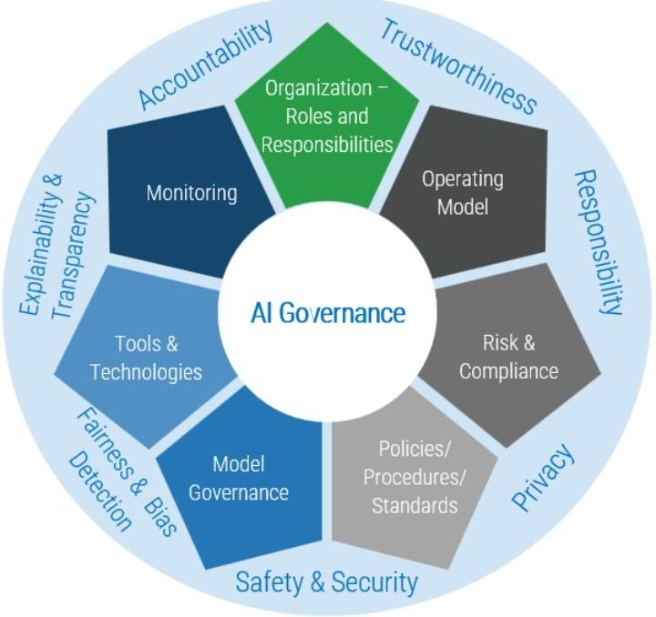
Fig 1.10 AI Ethical Framework
As AI technologies become increasingly integrated into business operations, ethical considerations have come to the forefront. Organizations must navigate complex issues related to algorithmic bias, transparency, and accountability. The Hourglass Model of Organizational AI Governance provides a framework for aligning AI systems with ethical principles and regulatory requirements (Mäntymäki et al., 2022). By embedding ethical considerations into AI governance, companies can foster trust and mitigate potential risks associated with AI deployment.

Real-Life Application Plan for an Educational Institution
Applying these strategic concepts to an educational institution involves a comprehensive approach to innovation, adaptability, and ethical leadership. The following plan outlines how a Principal of an educational institution can integrate these strategies to enhance its operations and educational outcomes:
1. AI-Powered Decision-Making: Implement AI tools to analyze student performance data, predict enrollment trends, and optimize resource allocation. This data-driven approach can inform curriculum development and personalized learning pathways.
2.. Scenario Planning: Engage in scenario planning exercises to prepare for potential disruptions, such as shifts in educational technology, changes in funding models, or public health crises. This proactive approach enables the institution to adapt swiftly to changing circumstances.
3. Gig Economy Workforce Strategy: Develop flexible staffing models that incorporate adjunct faculty and industry professionals, providing students with diverse perspectives while maintaining cost-effectiveness. Ensure fair labor practices and opportunities for professional development.
4. Resilience Strategy: Build organizational resilience by diversifying revenue streams, investing in digital infrastructure, and fostering a culture of continuous improvement. Establish contingency plans for various crisis scenarios to ensure operational continuity.
5.Data Strategy: Establish a centralized data governance framework to manage student information, research data, and administrative records. Prioritize data privacy and security while leveraging analytics to inform strategic decisions.
6. Ethical AI and Tech Governance: Develop policies and oversight mechanisms to guide the ethical use of AI and technology in educational settings. Engage stakeholders in discussions about the implications of AI on teaching, learning, and institutional values.

Conclusion
In an era marked by rapid technological advancements and complex global challenges, strategic management must evolve to address emerging themes and uncertainties. By embracing knowledge of strategy theories with an, AI-powered decision-making, engaging in scenario planning, adapting to the gig economy, building resilience, developing robust data strategies, and ensuring ethical governance of technology, organizations can navigate the complexities of the modern business environment. For educational institutions, integrating these strategic concepts is essential to remain relevant and effective in fulfilling their mission. By adopting a comprehensive and ethically grounded approach to strategy, educational institutions can enhance their adaptability, innovation, and impact in a rapidly changing world.

References
Barney, J. (1991). Firm resources and sustained competitive advantage. Journal of Management,
Bartlett, C. A., & Beamish, P. W. (2018). Transnational Management: Text, Cases & Readings in Cross-Border Management (8th ed.). Cambridge University Press.
Bartlett, C. A., & Ghoshal, S. (1989). Managing Across Borders: The Transnational Solution. Harvard Business School Press.
Choi, T. Y., Rogers, D., & Vakil, B. (2020). Coronavirus Is a Wake-Up Call for Supply Chain Management. Harvard Business Review. https://hbr.org/2020/03/coronavirus-is-a-wake-up-call-for-supply-chain-management
Csaszar, F. A., Ketkar, H., & Kim, H. (2024). Artificial intelligence and strategic decision-making: Evidence from entrepreneurs and investors. arXiv preprint arXiv:2408.08811. https://arxiv.org/abs/2408.08811
Doz, Y . L., & Prahalad, C. K. (1991). Managing DMNCs: A Search for a New Paradigm. Strategic Management Journal, 12(S1), 145–164.
Earley, P. C., & Mosakowski, E. (2004). Cultural Intelligence. Harvard Business Review, 82(10), 139–146.
Ghemawat, P. (2007). Redefining Global Strategy: Crossing Borders
Enz, M. G., Ruel, S., Zsidisin, G. A., Penagos, P., Bernard Bracy, J., & Jarzębowski, S. (2024). Supply chain strategies in response to a black-swan event: A comparison of USA, French and Polish firms. The International Journal of Logistics Management, 35(7), 1–32. https://doi.org/10.1108/IJLM-07-2023-0288
Mäntymäki, M., Minkkinen, M., Birkstedt, T., & Viljanen, M. (2022). Putting AI ethics into practice: The hourglass model of organizational AI governance. arXiv preprint arXiv:2206.00335. https://arxiv.org/abs/2206.00335
MDPI. (2024). Systematic literature review on gig economy: Power dynamics, worker
1.ResearchGate: http://www.researchgate.net/publication/389174164_Closing_the_Strategy-Execution_Gap_A_Systematic_Review_of_Barriers_and_Enablers?.com
2. SpringerLink: http://link.springer.com/article/10.1007/s10869-009-9140-2?.com
3. Wikipedia: http://en.wikipedia.org/wiki/Ambidextrous_organization?.com
4. Wiley Online Library: http://onlinelibrary.wiley.com/doi/10.1002/pfi.20240?.com
5. Wikipedia: http://en.wikipedia.org/wiki/Objectives_and_key_results?.com
6. MDPI: http://www.mdpi.com/2071-1050/10/10/3378?utm.com
7. Taylor & Francis Online: http://www.tandfonline.com/doi/full/10.1080/23311975.2024.2340129?.com

