Rhea Cumberbatch-Grant
ID a9UD91524

Course Name: SCPMA 675 Performance Management and Feedback Cultures
Assignment: Research Paper -The Impact of Feedback Cultures on Performance Management

Friday 11th July, 2025

Atlantic International University

Table of Contents
Page number
Introduction ,…………………………………………………………………………….……3
Performance, Potential, and Readiness in Performance Management ………………...…4
Performance Management and Feedback Cultures:,…….…………………………………5
Understanding Feedback Cultures in Organizations……….…………………………….…6
Theoretical Frameworks for Performance Management and Feedback Cultures ..………7
The Impact of Leadership Style on Feedback Cultures……….…………………………… 9
Cross-Cultural Challenges ,…………………………………………………………….…….10
Employee Engagement and Motivation ,…………………...…..,……………………….…..11
Effective Feedback Delivery and Reception …………………..……………………………13
Challenges and Barriers to Feedback ……………………………………………………….14
Coaching and Mentoring in Feedback within Business Cultures.………………….…….15
Pros and Cons of Performance Ratings in Performance Management……………………16
Factors That Produce a Culture of High-Performance Teams..…………………….…….17
Factors That Produce High Feedback Cultures……………………………………….……17
The Law of Diffusion……………………………..……………………………….……………18
Conclusion, ,………………………………………………………………………..………..…19
References ,………………………………………………………………………………..……20

Introduction
Performance management and feedback cultures are pivotal in driving organizational effectiveness and employee development. Performance management encompasses systematic processes such as setting objectives, monitoring progress, and evaluating outcomes to align individual contributions with organizational goals (Aguinis, 2019). Central to this process is the cultivation of a feedback culture, where an environment of continuous, constructive feedback is normalized, fostering open communication, trust, and learning (London & Smither, 2020). Key concepts in this area include performance appraisals, Key Performance Indicators (KPIs), and the distinction between continuous versus periodic feedback, all of which shape how performance is assessed and improved (Pulakos et al., 2015).
Additionally, a robust feedback culture not only enhances individual growth but also strengthens team cohesion and adaptability, crucial in today’s dynamic business environment (Edmondson, 2018). Organizations that embed timely, honest feedback practices encourage transparency and responsiveness, thereby supporting sustained performance improvements and innovation. In this research paper, we would delve into how organizations can integrate effective performance management with a strong feedback culture which is essential for organizational success. This research will explain some areas that prioritize ongoing communication and development for leaders to foster environments that motivate employees, enhance accountability, and drive continuous improvement, ultimately contributing to competitive advantage.

Performance, Potential, and Readiness in Performance Management
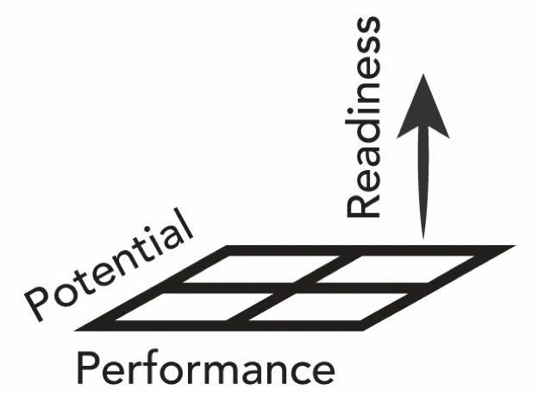
Effective performance management systems depend on understanding the interplay between performance, potential, and readiness. Performance reflects an employee’s ability to meet the current job demands, while potential indicates the capability of employees to take on greater responsibilities in the future (Silzer & Church, 2009). Readiness bridges the two by assessing whether an individual is prepared to transition into a higher role or adapt to evolving organizational needs. Leaders must accurately evaluate all three factors to tailor development plans and drive employee engagement. ( Fig 1.1)
Fig 1.1 The difference of terms in performance management
In high-performing organizations, a culture of feedback supports continuous performance improvement. With constructive, timely feedback expectations are reinforced, misalignments are corrected and growth is encouraged (London & Smither, 2002). For such cultures to thrive, psychological safety, trust, and leadership support are crucial (Edmondson, 1999). Moreover, aligning feedback with strategic goals and developmental assessments, ensures that both performance and potential are nurtured sustainably.
Readiness for feedback itself is influenced by mindset, motivation, and previous feedback experiences. Employees who perceive feedback as developmental rather than punitive are more likely to engage with it and improve (Bakker & Demerouti, 2007). Therefore, organizations must cultivate feedback cultures that not only assess performance but also promote learning, self-efficacy, and strategic talent growth.

Performance Management and Feedback Cultures: Appraisals, KPIs, and Feedback Cycles
Performance management systems aim to align individual performance with organizational goals through structured feedback, assessment, and development mechanisms. Performance appraisals which are traditionally conducted annually serve to evaluate employee contributions, set goals, and identify areas for improvement (Aguinis, 2019). However, such periodic evaluations are increasingly being supplemented or replaced by continuous feedback models, which provide more timely, real-time guidance and support performance for improvement and more effectiveness (Pulakos et al., 2015).
Key Performance Indicators (KPIs) and performance metrics play a central role in measuring job effectiveness. KPIs help quantify progress toward strategic objectives, offering a data-driven basis for assessing performance (Kaplan & Norton, 2007). Metrics, when used, must be specific, relevant, and aligned with the organizational goals to ensure meaningful evaluation and accountability. Misaligned or overly rigid metrics, however, may hinder creativity or lead to unintended behaviors.
In modern feedback cultures, the shift toward continuous feedback enhances employee engagement and development. Unlike periodic feedback, which can feel reactive and disconnected, ongoing conversations foster learning, agility, and trust for growth (Anseel et al., 2015). Continuous models also support performance agility, enabling quick adjustments in response to dynamic business needs. Effective feedback cultures rely on leadership commitment, communication training, and psychological safety, encouraging open dialogue and shared accountability.
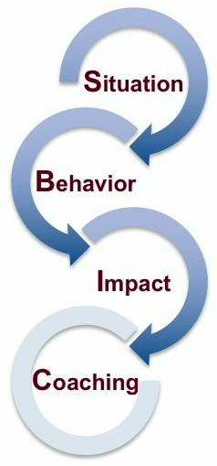
Integrating robust appraisal systems, aligned KPIs, and continuous feedback fosters a high-performance culture. When strategically implemented, these elements drive both individual growth and organizational success.
(Fig 1.2) Process of analysis for Coaching
Understanding Feedback Cultures in Organizations
A feedback culture refers to an organizational environment where continuous, constructive feedback is expected, valued, and used to improve performance and relationships (London & Smither, 2002). In strong feedback cultures, feedback is not limited to formal evaluations but is embedded in everyday interactions, consistency in communication, promoting ongoing development and accountability.
Feedback can be categorized into several types: positive (reinforcing effective behaviors), negative (corrective or developmental), and feedforward (focused on future actions) (Goldsmith, 2002). Each type serves a purpose and while positive feedback boosts morale and motivation, developmental feedback supports growth by identifying areas for improvement.
Employee feedback behaviors such as seeking, receiving, and using feedback are influenced by psychological safety and organizational norms (Anseel et al., 2015). When employees feel safe and supported, they are more likely to engage with and act upon feedback. Conversely, environments where feedback is perceived as punitive may suppress open communication and reduce effectiveness.
Timeliness is another essential dimension. Prompt and valid feedback allows for immediate course correction and reinforces learning (Hattie & Timperley, 2007). Delayed feedback, however, often loses relevance and impact. Therefore, leaders must prioritize real-time or near-time responses.
Trust in addition, plays a foundational role in feedback cultures. Trust in the source of feedback, whether a supervisor, peer, or subordinate influences how feedback is interpreted and applied (Atwater et al., 2015). Without trust, even well-intentioned feedback can be dismissed or misinterpreted.
Therefore building an effective feedback culture requires intentional leadership, structured opportunities for dialogue, and a shared understanding of feedback as a developmental tool. When trust, timeliness, and psychological safety are present, feedback becomes a strategic lever for continuous improvement and organizational excellence.

Theoretical Frameworks for Performance Management and Feedback Cultures
Performance management and feedback cultures are grounded in several interrelated theoretical frameworks that guide how organizations structure performance systems and foster feedback-rich environments. Among the most prominent are Goal-Setting Theory, Expectancy Theory, Social Exchange Theory and Feedback Intervention Theory.
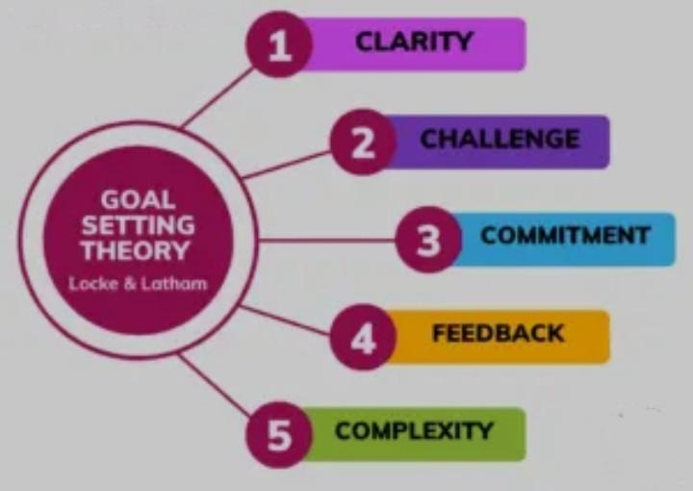
Firstly, Goal-Setting Theory (Locke & Latham, 2002) posits that specific and challenging goals lead to higher performance than vague or easy goals. Performance management systems that incorporate clear KPIs and developmental goals are often more effective because they enhance focus, persistence, and motivation. Feedback in this context serves to align employee behavior with organizational expectations.
(Fig 1.3) Locke’s Goal Setting Theory
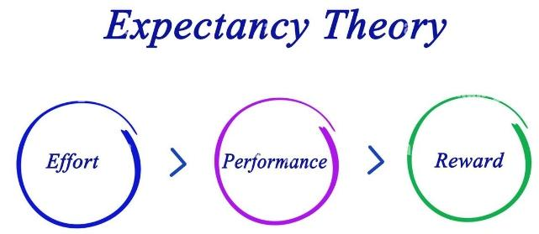
Secondly, Expectancy Theory (Vroom, 1964) explains employee motivation through three core beliefs: expectancy (effort will lead to performance), instrumentality (performance will lead to outcomes), and valence (value of those outcomes). Performance management frameworks built on this theory emphasize fair appraisal systems and meaningful rewards, ensuring that feedback is perceived as instrumental in achieving desired outcomes.
(Fig 1.4) Expectancy Theory
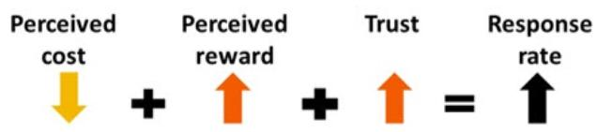
Thirdly, Social Exchange Theory (Blau, 1964) underpins the trust and reciprocity essential for a feedback culture. Employees are more receptive to feedback and performance evaluations when they perceive the organization as supportive and fair. This theory helps explain why and when benefits outweigh costs, consistent, two-way feedback strengthens relationships and promotes engagement.
Fig 1.5 Social Exchange Theory
Fourthly, Feedback Intervention Theory (Kluger & DeNisi, 1996) examines how feedback influences performance by directing attention. Feedback that focuses on task-level processes is more effective than feedback targeting the self. This insight informs how feedback should be framed constructively and with an emphasis on behaviors and not on traits.
Integrating these theories supports the design of comprehensive performance systems that are motivational, behavior-focused, and development-oriented. When feedback processes are underpinned by theory, they are more likely to build trust, ensure alignment, and promote continuous improvement. Organizations benefit from aligning theoretical insights with practical mechanisms such as regular check-ins, coaching, and transparent metrics which help to create sustainable high-performance cultures.

The Impact of Leadership Style on Feedback Cultures
Leadership style plays a pivotal role in shaping and sustaining effective feedback cultures within organizations. Furthermore, transformational leaders, who inspire, support, and intellectually stimulate followers, foster open communication and psychological safety which are critical components of a healthy feedback culture (Bass & Riggio, 2006). Such leaders model receptivity to feedback, encouraging a two-way exchange that promotes continuous learning and trust.
In contrast, autocratic or transactional leadership styles, which emphasize control, performance-based rewards, and limited dialogue, often suppress open feedback and discourage upward communication (Eisenbeiss et al., 2008). These environments may lead to fear of reprisal, reduced engagement, and lower feedback utilization.
Servant leadership, however, which emphasizes empathy, listening, and development of others, has been linked to strong feedback cultures, as employees feel valued and safe to share and receive feedback (Eva et al., 2019). Leadership behavior that encourages inquiry, values diverse perspectives, and supports learning contributes directly to how feedback is exchanged, perceived, and acted upon. Summatively, leadership style sets the tone for whether feedback is viewed as a developmental tool or a performance judgment. Cultivating feedback-rich cultures requires leaders who are approachable, emotionally intelligent, and committed to growth.

Cross-Cultural Challenges
In global organizations, performance management and feedback cultures are significantly influenced by cultural differences, which shape how feedback is given, received, and interpreted. The effectiveness of performance systems depends not only on metrics and processes but also on cultural sensitivity and alignment (Hofstede, 2001). Leaders managing across borders must navigate varying attitudes and personalities toward authority, communication, and individualism, which directly impact feedback effectiveness and employee engagement.
One of the primary cross-cultural challenges lies in power distance which is the extent to which less powerful members expect and accept unequal power distribution. In high power distance cultures such as sometimes in Caribbean contexts, subordinates may hesitate to offer upward feedback or question authority (Hofstede, 2001). Conversely, in low power distance cultures, open dialogue may be more accepted, and feedback may be expected as a norm.
In addition , communication style is another barrier. Cultures vary between high-context (implicit communication) and low-context (explicit communication). For instance, some cultures may prefer subtle, indirect feedback, while other cultures often value directness (Hall, 1976). This divergence can lead to misinterpretation or resistance if not managed timely and carefully.
Face-saving and collectivist values in certain cultures reduce the receptivity to negative feedback. In collectivist societies, preserving harmony is prioritized, so leaders may need to adjust their feedback approach to ensure it does not embarrass or alienate the recipient (Earley & Mosakowski, 2000).
To manage these challenges, global organizations must adopt culturally adaptive performance systems. This includes training managers in cross-cultural communication, encouraging localized feedback strategies, and integrating cultural intelligence into leadership development (Ang & Van Dyne, 2015). Performance appraisal systems must also be flexible enough to accommodate different cultural norms without compromising fairness and clarity. Cross-cultural understanding is essential for building effective performance and feedback cultures in global organizations. Tailoring systems and leadership behavior to fit cultural expectations enhances trust, learning, and organizational alignment.

Employee Engagement and Motivation
Employee engagement and motivation are central to effective performance management and feedback cultures. Engaged employees exhibit higher levels of commitment, productivity, and innovation, and these outcomes are strongly influenced by how performance and feedback systems are structured and delivered (Mone et al., 2011). A transparent and development-focused performance management system reinforces employee motivation by aligning individual contributions with organizational goals.
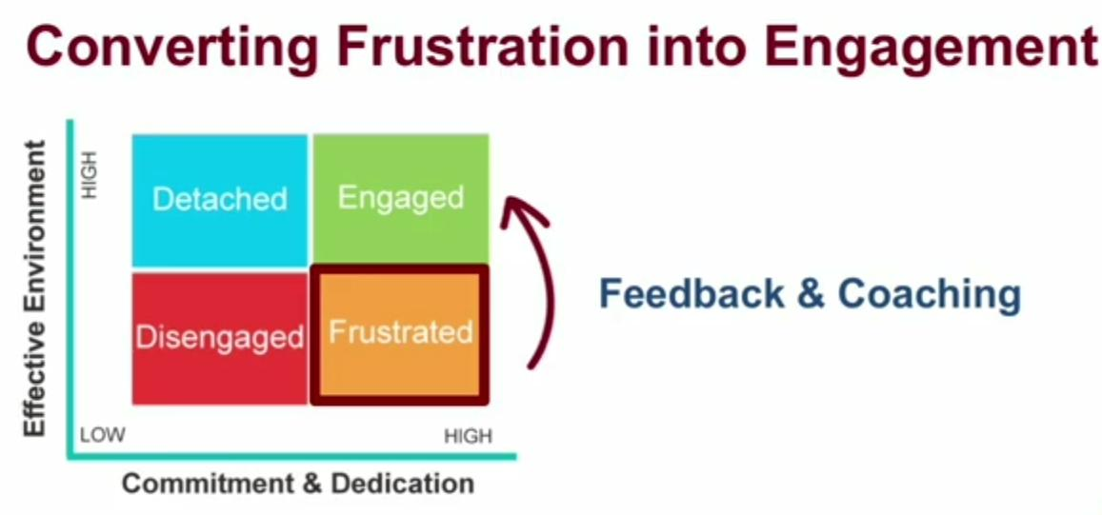
Motivation is further enhanced when feedback is continuous, specific, and supportive. According to Deci and Ryan’s (2000) Self-Determination Theory, intrinsic motivation thrives in environments that promote autonomy, competence, and relatedness; all of which can be fostered through well-designed feedback mechanisms. Employees who regularly receive constructive feedback feel more valued and are more likely to engage meaningfully in their roles. Frustrated employees can develop into engaged employees.
Fig 1.6 Converting employee frustration to Engagement
Moreover, recognition and goal alignment through performance metrics and feedback strengthen psychological commitment to the organization (Bakker & Demerouti, 2008). When feedback is timely and linked to personal growth, it encourages ownership and sustained performance. Cultivating a culture of frequent, developmental feedback within performance management practices significantly boosts employee engagement and motivation, leading to enhanced organizational performance.

Effective Feedback Delivery and Reception
In performance management and feedback cultures, the ability to give, receive, and apply feedback effectively is critical for individual and organizational development. Constructive feedback promotes learning, motivation, and behavior change when delivered clearly, respectfully, and with a focus on improvement (London & Smither, 2002). Effective feedback is timely, specific, and aligned with goals, allowing employees to understand expectations and adjust performance accordingly.
Receiving feedback, however, effectively requires openness and a growth mindset. Employees must be willing to reflect, manage defensiveness, and seek clarification when necessary. According to Anseel et al. (2015), feedback-seeking behavior is positively associated with performance improvement, especially in psychologically safe environments.
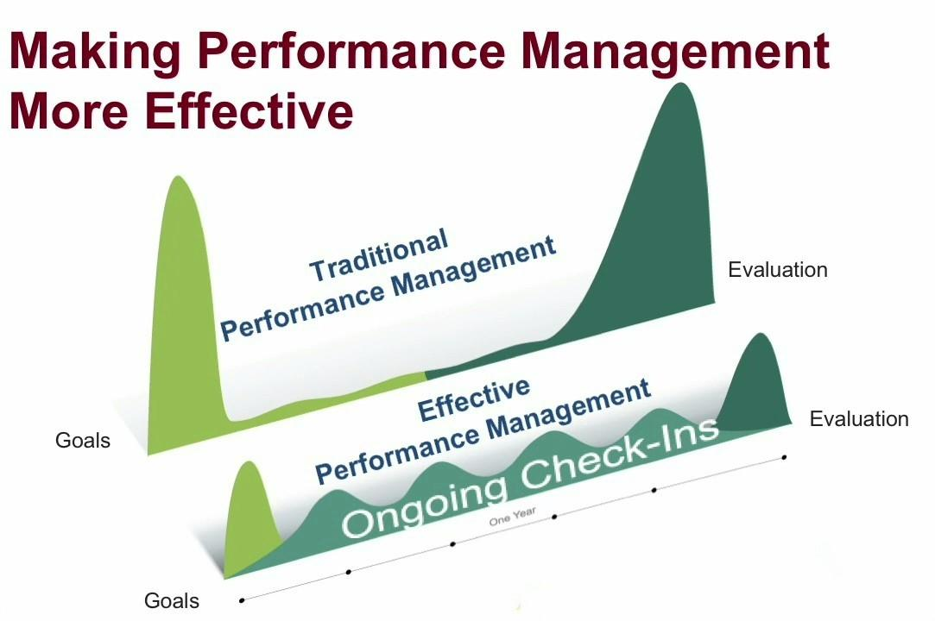
(Fig 1.6)
Equally important is using feedback that translates insights into action. Feedback only drives value when recipients willingly engage in reflection and behavioral change (Kluger & DeNisi, 1996). Leaders can foster this by providing support, setting follow-up goals, and modeling feedback receptivity themselves. Therefore, the effectiveness of performance management systems depends on feedback being a two-way, ongoing and developmental process. When giving, receiving, and using feedback is embedded in the organizational culture, it strengthens engagement, accountability, and continuous improvement.

Challenges and Barriers to Feedback
We have determined that feedback is essential for growth, development, and continuous improvement in organizations. However, various challenges and barriers often impede the effectiveness of feedback processes, ultimately shaping and sometimes undermining organizational culture. A lack of trust, fear of reprisal, poor communication skills, and hierarchical barriers are some of the most common impediments to a feedback-rich culture (London & Smither, 2002).
In many business settings, employees may hesitate to give or receive feedback due to fear of damaging relationships or being perceived negatively, especially in high power distance or hierarchical cultures (Hofstede, 2001). When leadership fails to foster psychological safety—a climate where individuals feel safe to speak up—feedback becomes infrequent, superficial, or avoided altogether (Edmondson, 1999). This stifles innovation, transparency, and accountability, eroding the integrity of the organizational culture.
Communication style and feedback delivery skills are also critical barriers. Feedback that is overly critical, vague, or poorly timed can lead to resistance, defensiveness, and disengagement (Stone & Heen, 2014). Similarly, managers who are not trained to offer developmental, actionable feedback risk perpetuating a culture of ambiguity or fear.
Moreover, cultural norms may influence perceptions of feedback. In collectivist or high-context cultures, direct feedback may be seen as rude or confrontational, leading to passive communication and misunderstandings (Hall, 1976). Failure to adapt feedback styles to cultural expectations can alienate employees and foster disengagement.
When feedback barriers persist, the organizational culture suffers. A lack of open dialogue discourages collaboration and weakens performance accountability. Conversely, businesses that identify and overcome these barriers through leadership modeling, feedback training, and creating safe feedback channels can transform their culture into one that embraces continuous improvement and mutual respect.

Coaching and Mentoring in Feedback within Business Culture
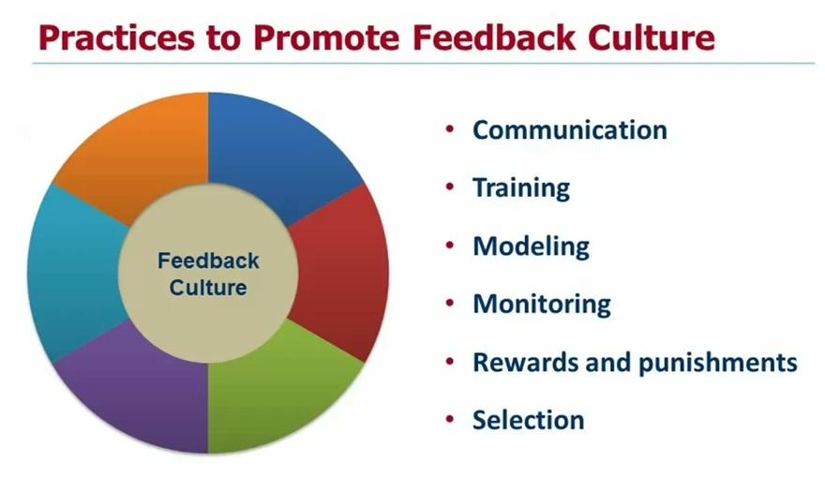
Coaching and mentoring are integral components of effective feedback cultures in modern business environments. Both practices among others, provide structured, developmental relationships that support ongoing learning, performance improvement, and career growth (Ely et al., 2010). Unlike traditional performance reviews, communication , modelling, monitoring, training, coaching and mentoring foster continuous dialogue, encourage self-reflection, and create psychologically safe spaces for honest, two-way feedback.
(Fig 1.7)
Coaching emphasizes goal-setting, skill enhancement, and personal accountability through active listening and tailored feedback (Grant, 2014). When embedded into organizational culture, coaching strengthens individual performance and supports a feedback-rich environment. Similarly, mentoring leverages experienced professionals to guide less experienced employees, enhancing engagement and retention while promoting feedback that is developmental rather than evaluative (Allen & Eby, 2007).
These practices also help normalize feedback as a growth tool, reducing defensiveness and increasing trust. As such, coaching and mentoring align with inclusive leadership values and are essential for fostering a supportive feedback culture where individuals feel empowered to learn and improve continuously.

Pros and Cons of Performance Ratings in Performance Management
Performance ratings have long been a central element in performance management systems, offering a structured approach to evaluate employee contributions. One major advantage of performance ratings is their ability to provide clear, quantifiable metrics that aid in decision-making regarding promotions, compensation, and developmental needs (Aguinis, 2013). Ratings facilitate standardized comparisons across employees, fostering transparency and fairness when implemented correctly (Pulakos, 2009). Additionally, they can motivate employees by setting clear expectations and benchmarks for success.
However, performance ratings also present significant drawbacks. Critics argue that they can oversimplify complex employee behaviors, reducing nuanced performance into arbitrary scores that may not fully capture an individual’s contributions or potential (Cascio & Aguinis, 2019). Ratings can promote unhealthy competition, reduce collaboration, and provoke anxiety or dissatisfaction, especially if perceived as unfair or biased (Smither, London, & Reilly, 2005). Furthermore, reliance on ratings may discourage ongoing dialogue, turning performance management into an annual “check-box” exercise rather than a continuous developmental process. While performance ratings provide a useful framework for assessment, organizations must balance their use with developmental feedback and a culture that values growth to avoid the pitfalls of rigid evaluation systems.

Factors That Produce a Culture of High-Performance Teams
A culture of high-performance teams is cultivated through trust, clear communication, shared goals, and strong leadership (Edmondson, 2012). Psychological safety allows team members to take risks and innovate without fear of negative consequences (Kahn, 1990). Additionally, effective conflict resolution and mutual accountability reinforce commitment and cohesion (Salas et al., 2015). Leaders who foster inclusivity and provide continuous feedback further enhance team dynamics and performance (Zaccaro et al., 2001). These factors collectively create an environment that motivates and sustains high levels of productivity and collaboration.

Factors That Produce High Feedback Cultures
High feedback cultures are vital for organizational learning, continuous improvement, and employee engagement. Key factors that foster such cultures include psychological safety, leadership support, and open communication (Edmondson, 2018). Psychological safety encourages employees to share candid feedback without fear of retribution, which enhances trust and transparency (Frazier et al., 2017). Leaders play a pivotal role by modeling receptive feedback behaviors and creating environments where feedback is normalized and valued (London & Smither, 2020).
Another crucial factor is the timeliness and frequency of feedback. Continuous, real-time feedback helps address issues promptly and reinforces positive behaviors, contrasting with traditional annual reviews that may delay performance improvement (Pulakos et al., 2015). Additionally, training employees on how to give and receive feedback effectively cultivates a culture of constructive dialogue and mutual respect (Ashford & DeRue, 2012).
Moreover, organizational systems and processes must align to support feedback practices, including the use of technology platforms that facilitate ongoing feedback exchange (Zhao et al., 2020). When these factors converge, organizations can develop robust feedback cultures that drive performance, innovation, and employee satisfaction.

Law of Diffusion
The Law of Diffusion explains how innovations, ideas, or behaviors spread through populations over time, typically following an S-curve pattern (Rogers, 2003). Early adopters play a critical role in influencing the majority, accelerating acceptance and implementation (Bass, 1969). Diffusion is affected by factors such as communication channels, social systems, and perceived attributes of the innovation, including relative advantage and compatibility (Rogers, 2003). Understanding this law enables leaders to strategically manage change and innovation adoption within organizations to maximize success and reduce resistance.

Conclusion
This research paper in the area of performance management and feedback cultures highlighted the critical role and impact of continuous, transparent, and developmental feedback in enhancing employee performance and organizational success. Key areas explored included performance appraisal systems, KPIs, feedback frequency, leadership influence, coaching, and cultural considerations. A strong feedback culture fosters psychological safety, employee engagement, and accountability, while effective performance management aligns individual goals with strategic outcomes. Emphasizing communication, trust, and adaptability, organizations can overcome barriers to feedback and cultivate high-performing teams. Ultimately, integrating these practices creates a resilient culture of excellence that drives sustained growth and innovation in dynamic work environments.

References
Aguinis, H. (2019). Performance management (4th ed.). Pearson.
Allen, T. D., & Eby, L. T. (2007). The Blackwell handbook of mentoring: A multiple perspectives approach. Blackwell Publishing.
Ang, S., & Van Dyne, L. (2015). Handbook of cultural intelligence. Routledge.
Anseel, F., Beatty, A. S., Shen, W., Lievens, F., & Sackett, P. R. (2015). How are we doing after 30 years? A meta-analytic review of feedback-seeking behavior. Journal of Management, 41(1), 318–348.
Ashford, S. J., & DeRue, D. S. (2012). Developing as a leader: The power of mindful engagement. Organizational Dynamics, 41(2), 146–154.
Atwater, L. E., Brett, J. F., & Charles, A. C. (2015). Feedback format: Does it influence manager feedback use? Journal of Occupational and Organizational Psychology, 88(2), 365–379.
Bakker, A. B., & Demerouti, E. (2007). The job demands-resources model: State of the art. Journal of Managerial Psychology, 22(3), 309–328.
Bakker, A. B., & Demerouti, E. (2008). Towards a model of work engagement. Career Development International, 13(3), 209–223.
Bass, F. M. (1969). A new product growth for model consumer durables. Management Science, 15(5), 215–227.
Bass, B. M., & Riggio, R. E. (2006). Transformational leadership (2nd ed.). Psychology Press
Blau, P. M. (1964). Exchange and power in social life. Wiley
Cascio, W. F., & Aguinis, H. (2019). Applied psychology in human resource management (8th ed.). Pearson.
Deci, E. L., & Ryan, R. M. (2000). The “what” and “why” of goal pursuits: Human needs and the self-determination of behavior. Psychological Inquiry, 11(4), 227–268.
Earley, P. C., & Mosakowski, E. (2000). Creating hybrid team cultures: An empirical test of transnational team functioning. Academy of Management Journal, 43(1), 26–49.
Edmondson, A. C. (2012). Teaming: How organizations learn, innovate, and compete in the knowledge economy. Jossey-Bass.
Edmondson, A. C. (1999). Psychological safety and learning behavior in work teams. Administrative Science Quarterly, 44(2), 350–383.
Edmondson, A. C. (2018). The fearless organization: Creating psychological safety in the workplace for learning, innovation, and growth. Wiley.
Eisenbeiss, S. A., van Knippenberg, D., & Boerner, S. (2008). Transformational leadership and team innovation. Journal of Applied Psychology, 93(6), 1438–1446.
Ely, K., Boyce, L. A., Nelson, J. K., Zaccaro, S. J., & Hernez-Broome, G. (2010). Evaluating leadership coaching. Consulting Psychology Journal: Practice and Research, 62(4), 251–267.
Eva, N., Robin, M., Sendjaya, S., van Dierendonck, D., & Liden, R. C. (2019). Servant leadership: A systematic
Frazier, M. L., Fainshmidt, S., Klinger, R. L., Pezeshkan, A., & Vracheva, V. (2017). Psychological safety: A meta-analytic review and extension. Personnel Psychology, 70(1), 113–165.
Goldsmith, M. (2002). The power of feedforward. Leader to Leader, 25, 56–61.
Grant, A. M. (2014). Autonomy support, relationship satisfaction and goal focus in the coach–coachee relationship. International Journal of Evidence Based Coaching and Mentoring, 12(2), 18–29.
Hall, E. T. (1976). Beyond culture. Anchor Books.
Hattie, J., & Timperley, H. (2007). The power of feedback. Review of Educational Research, 77(1), 81–112.
Hofstede, G. (2001). Culture's consequences: Comparing values, behaviors, institutions and organizations across nations (2nd ed.). Sage Publications
Kahn, W. A. (1990). Psychological conditions of personal engagement and disengagement at work. Academy of Management Journal, 33(4), 692–724.
Kaplan, R. S., & Norton, D. P. (2007). Using the balanced scorecard as a strategic management system. Harvard Business Review.
Kluger, A. N., & DeNisi, A. (1996). The effects of feedback interventions on performance: A historical review, a meta-analysis, and a preliminary feedback intervention theory. Psychological Bulletin, 119(2), 254–284.
Locke, E. A., & Latham, G. P. (2002). Building a practically useful theory of goal setting and task motivation. American Psychologist, 57(9), 705–717.
London, M., & Smither, J. W. (2002). Feedback orientation, feedback culture, and the longitudinal performance management process. Human Resource Management Review, 12(1), 81–100.
London, M., & Smither, J. W. (2020). Feedback orientation, feedback culture, and the feedback environment. Annual Review of Organizational Psychology and Organizational Behavior, 7, 199–220.
Mone, E. M., Eisinger, C. F., Guggenheim, K., Price, B., & Stine, C. (2011). Performance management at the wheel: Driving employee engagement in organizations. Journal of Business and Psychology, 26(2), 205–212.
Pulakos, E. D. (2009). Performance management: A new approach for driving business results. Wiley-Blackwell.
Pulakos, E. D., Hanson, R. M., Arad, S., & Moye, N. (2015). Performance management can be fixed: An on-the-job experiential learning approach for complex behavior change. Industrial and Organizational Psychology, 8(1), 51–76.
Rogers, E. M. (2003). Diffusion of innovations (5th ed.). Free Press.
Salas, E., Shuffler, M. L., Thayer, A. L., Bedwell, W. L., & Lazzara, E. H. (2015). Understanding and improving teamwork in organizations: A scientifically based practical guide. Human Resource Management, 54(4), 599–622.
Silzer, R., & Church, A. H. (2009). The pearls and perils of identifying potential. Industrial and Organizational Psychology, 2(4), 377–412.
Smither, J. W., London, M., & Reilly, R. R. (2005). Does performance improve following multisource feedback? Personnel Psychology, 58(1), 33–66.
Stone, D., & Heen, S. (2014). Thanks for the feedback: The science and art of receiving feedback well. Viking.
Vroom, V. H. (1964). Work and motivation. Wiley.
Zaccaro, S. J., Rittman, A. L., & Marks, M. A. (2001). Team leadership. The Leadership Quarterly, 12(4), 451–483.
Zhao, H., Seibert, S. E., & Hills, G. E. (2020). The mediating role of psychological safety in feedback cultures. Journal of Business Research, 112, 97–107.

