**Loai Al-Adim  
ID: UD86217EL95438**

COURSE NAME:

**Fundamentals of Applied Electromagnetics**

ATLANTIC INTERNATIONAL UNIVERSITY

**Aug/2024**

**Table of Contents**

1. Introduction 5

1.1. Maxwell’s equations 6

1.2. Electric charge 7

2. Electrostatics 9

2.1 Electrostatic Fields 10

2.1.1 Coulomb’s Law and Electric Field Intensity 10

2.1.2 ELECTRIC FIELDS DUE TO CONTINUOUS CHARGE DISTRIBUTIONS 14

2.1.2.1 A line Charge 15

2.1.2.2 A Circular Ring Charge 19

2.1.2.3 A Surface Charge 22

2.1.2.4 A Volume Charge 25

2.1.3 ELECTRIC FLUX DENSITY 29

2.1.3.1 The flux density for point charge 29

2.1.3.2 The flux density for continuous charge distribution 29

2.1.4 GAUSS'S LAW - MAXWELL'S EQUATION 29

2.1.5 APPLICATIONS OF GAUSS'S LAW 31

2.1.5.1 A Point charge 31

2.1.5.2 An Infinite Line charge 33

2.1.5.3 Infinite Sheet of Charge 35

2.1.5.4 Charged Sphere 37

2.1.5.5 Charged Cylinder 41

2.1.6 ELECTRIC POTENTIAL 45

2.1.7 Relationship Between E and V— Maxwell's Equation 47

2.1.8 AN ELECTRIC DIPOLE AND FLUX LINES 49

2.1.9 ENERGY DENSITY IN ELECTROSTATIC FIELDS 52

2.2 ELECTRIC FIELDS IN MATERIAL SPACE 55

2.2.1 CONVECTION AND CONDUCTION CURRENTS 55

2.2.2 Conductors and Ohm’s Law 58

2.2.3 POLARIZATION IN DIELECTRICS 62

2.2.4 CONTINUITY EQUATION AND RELAXATION TIME 68

2.2.5 BOUNDARY CONDITIONS 71

2.2.5.1 Dielectric-Dielectric Boundary Conditions 72

2.3 ELECTROSTATIC BOUNDARY-VALUE PROBLEMS 76

2.3.1 POISSON'S AND LAPLACE'S EQUATIONS 76

2.3.2 GENERAL PROCEDURE FOR SOLVING POISSON'S OR LAPLACE'S EQUATION 76

2.3.2.1 Solving Poisson’s Equation for Cartesian Coordinate System 77

2.3.2.1 Solving Poisson’s Equation for Cylindrical Coordinate System 80

2.3.2.2 Solving Poisson’s Equation for Spherical Coordinate System 82

2.3.3 Resistance Evaluation using Boundary Value Problems 85

2.3.4 Capacitance Evaluation using Boundary Value Problems 92

2.3.4.1 Parallel Plate Capacitor 94

2.3.4.2 Cylindrical Capacitor 95

2.3.4.3 Spherical Capacitor 99

3. Magnetostatics 103

3.1 Magnetostatics 103

3.1.1 BIOT-SAVART'S LAW 103

3.1.2 Magnetic Field Strength due to Current Carrying Conductors 106

3.1.2.1 Magnetic Field Strength due to Current Carrying Straight Conductor 106

3.1.2.2 Magnetic Field Strength due to Current Carrying Circular Loop (Ring) 110

3.1.2.3 Magnetic Field Strength due to Current Carrying Solenoid 112

3.1.3 Ampere's Circuit Law—Maxwell's Equation 115

3.1.4 APPLICATIONS OF AMPERE'S LAW 116

3.1.4.1 Infinite Line Current 116

3.1.4.2 Infinite Sheet of Current 117

3.1.4.3 Infinitely Long Coaxial Transmission Line 118

3.1.4.4 Toroid 123

3.1.5 MAGNETIC FLUX DENSITY—MAXWELL'S EQUATION 125

3.1.6 MAXWELL'S EQUATIONS FOR STATIC EM FIELDS 128

3.1.7 MAGNETIC SCALAR AND VECTOR POTENTIALS 128

3.1.8 MAGNETIC VECTOR POTENTIALS ON INFINIT CURRENT SHEET 133

3.1.9 DERIVATION OF BIOT-SAVART'S LAW AND AMPERE'S LAW 136

3.2 MAGNETIC FORCES, MATERIALS, AND DEVICES 138

3.2.1 Force on a Charged Particle 139

3.2.2 Force on a Current Element 140

3.2.3 Force between Two Current Elements 141

3.3 MAGNETIC TORQUE AND MOMENT 143

3.4 A MAGNETIC DIPOLE 145

3.5 MAGNETIZATION IN MATERIALS 148

3.6 MAGNETIC BOUNDARY CONDITIONS 152

3.7 INDUCTORS AND INDUCTANCES 153

3.7.1.1 Inductance for Toroid 156

3.7.1.2 Inductance for Solenoid 157

3.7.1.3 Inductance for Coaxial Cable 160

3.8 MAGNETIC ENERGY 164

3.9 MAGNETIC CIRCUITS 168

3.10 FARADAY'S LAW 170

3.11 TRANSFORMER AND MOTIONAL EMFs 171

4. Conclusion 178

# Introduction

Electromagnetics (EM) is a branch of electrical engineering or physics in which electric and magnetic phenomena are thoroughly studied by the analyzing of the interactions between electric charges at rest which is the “electricity” and electric charge at motion which is the “magnetism”. Electricity and magnetism are fundamental concepts that are widely used in our everyday lives in the field of electrical engineering. They have a strong correlation and rely heavily on one another. The existence of one is inseparable on the existence of the other. The terms electrostatic and electromagnetic are derived from the interplay between electricity and magnetism.

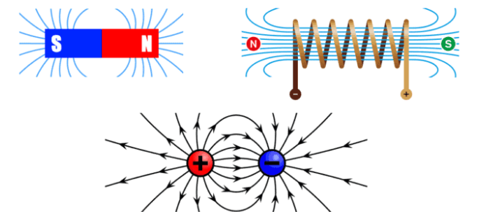

**Figure ‎1‑1:** Electricity and Magnetism

Electromagnetics principles find applications in diverse fields including electric machines (generators, transformers, and motors), antennas, microwaves, satellite communications, bioelectromagnetic, plasmas, nuclear research, fiber optics, electromagnetic interference and compatibility, electromechanical energy conversion, radar meteorology, and remote sensing. Electromagnetic devices include a wide range of equipment such as transformers, electric relays, radio and television systems, telephones, electric motors, transmission lines, waveguides, antennas, optical fibers, radars, and lasers. A comprehensive understanding of the laws and principles of electromagnetism is essential for designing these devices.

## Maxwell’s equations

The subject of electromagnetics can be summarized in Maxwell’s equations below:

$$ψ_{e}=\oint_{s}{D.ds}=\int_{v}{\left(∇.D\right) dv}=\int_{v}{ρ_{v} dv}=Q$$

$$ψ_{m}=\oint_{s}{B.ds}=\int_{v}{\left(∇.B\right) dv}=0$$

$$\oint_{L}{H.dl}=\int_{S}{\left(∇×H\right) .ds}=\int_{S}{J .ds}=I$$

$$\oint_{L}{E.dl}=\int_{S}{\left(∇×E\right) .ds}=\int_{S}{-\frac{∂B}{∂t} .ds}=-\frac{dλ}{dt}$$

It is typical to indicate a vector by using a letter with an arrow on top, such as A ⃑ and B ⃑, or by using a letter in boldface type, such as A and B, in order to differentiate between a scalar and a vector in this assignment.

A scalar is customary represented by a letter e.g., *A, B, U*, and *V or $\left|A\right|$* .

## Electric charge

It was found that there are two kinds of electric changes, positive charge which is the charge as that possessed by proton, and negative charge which is the charge as that possessed by electron and it was found that same kind of charge repel each other, while different kind of charges attract each other

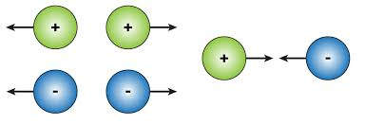

**Figure ‎1‑2:** Attraction and Repulsion of Electric Charges

Conservation principle of electric charge states that the charge on an isolated objects is conserved

$$\sum_{i=1}^{n}{Q_{i, before}}=\sum_{i=1}^{n}{Q_{i, after}}$$

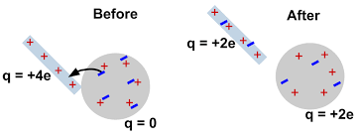

**Figure ‎1‑3:** Conservation Principles of Electric Charge

Quantization principle of electric charge states that the charge is quantized, and its quantity equals an integer number multiplied by the basic charge which is the charge of electron

$$Q=N × e^{-}$$

$$e^{-}=- 1.6 ×{10}^{-19}C$$

# Electrostatics



Electrostatics is the examination of electromagnetic occurrences that happen when there are no charges in motion, specifically when a state of static equilibrium has been achieved. In other words, Electrostatics is a field of physics that focuses on the examination of stationary electric charges. The phrase "electrostatic" is derived from the combination of the terms "electro" and "static". "Electro" pertains to charges, while "static" refers to a motionless or resting condition. The electrostatic word is derived from the phenomena that two stationary charges experience either an attractive or repulsive force.

To start our examination of electrostatics, we will explore the two basic principles that regulate electrostatic fields: (1) Coulomb's law and (2) Gauss's law.

# Electrostatic Fields

The electrostatic field refers to the area that surrounds a stationary electric charge and where the influence of the charge may be detected. A stationary charge, whether positive or negative, exerts an electric field in its surroundings. When another charge is introduced into this field, it will either be attracted towards or repelled away from the stationary charge.

## Coulomb’s Law and Electric Field Intensity

Coulomb's law says that the force between two-point charges, $Q_{1}$ and $Q_{2}$, is directed down the line connecting them the relationship is directly proportional to the product of the charges, $Q_{1}$ and $Q_{2}$ and varies inversely with the square of the distance R

$$F=\frac{k Q_{1}Q_{2}}{R^{2}}$$

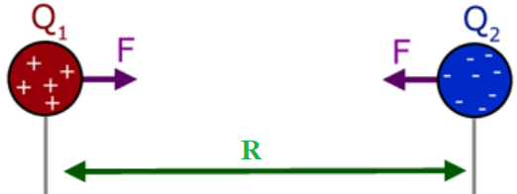

**Figure ‎2.1‑1:** Coulombs Electrostatic Force between two-point charges

Where $k$ is the proportionality constant

$$k=\frac{1}{4πϵ_{o}}=\frac{1}{4π×\frac{{10}^{-9}}{36π}}=9×{10}^{9}$$

However, if we have these two-point charges $Q_{1}$ and $Q_{2}$ in the xyz-space having position vectors $r_{1}$ and $r_{2}$ respectively

$$r_{1}=x_{1}a_{x}+y_{1}a_{y}+z_{1}a_{z}$$

$$r_{2}=x_{2}a_{x}+y_{2}a_{y}+z_{2}a_{z}$$

$$R_{12}=r_{2}-r_{1}=\left(x_{2}-x_{1}\right)a_{x}+\left(y_{2}-y_{1}\right)a_{y}+\left(z_{2}-z_{1}\right)a_{z}$$

$$\left|R\right|=\sqrt{{\left(x_{2}-x_{1}\right)}^{2}+{\left(y_{2}-y_{1}\right)}^{2}+{\left(z_{2}-z_{1}\right)}^{2}}$$

$$F=\frac{k Q_{1}Q_{2}}{R^{2}}a_{R}=\frac{1}{4πϵ_{o}}\frac{ Q_{1}Q_{2}}{R^{2}}a_{R}=\frac{1}{4πϵ_{o}}\frac{ Q_{1}Q_{2}}{R^{2}}\frac{R}{R}=\frac{1}{4πϵ_{o}}\frac{ Q_{1}Q_{2}}{R^{3}}R$$

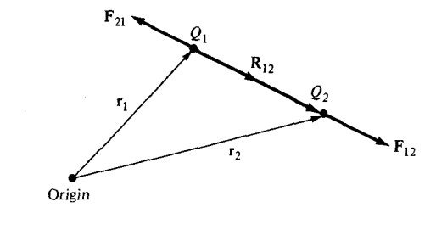

**Figure ‎2.1‑2:** Two Point Charges in xyz-space

If we have more than two-point charges, we can use the principle of superposition to determine the force on a particular charge from the other charges. The concept asserts that the resultant force F on a charge Q situated at point r, due to N charges Q1, Q2, …QN placed at locations with position vectors r1, r2, …, rn, is obtained by summing up the vector forces imposed on Q by each of the charges Q1, Q2, …QN. Therefore:

$$F=\frac{Q}{4πϵ_{o}}\sum_{k=1}^{n}{\frac{ Q_{k}}{{\left|r-r_{k}\right|}^{3}}\left(r-r_{k}\right)}$$

To explain the effect of the electrostatic repulsive force, we shall assume two-point charges of equal mass **m**, charge **Q** are suspended at a common point by two threads of negligible mass and length $l$. As shown below

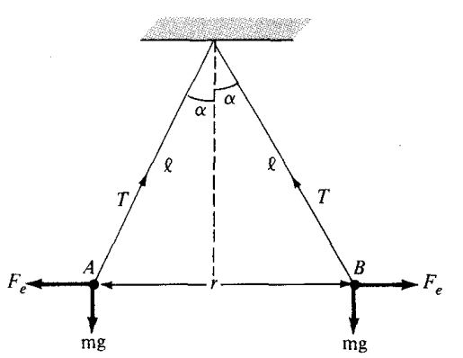

**Figure ‎2.1‑3:** Equilibrium State for two-point charges suspended from one common point

At equilibrium, the total result force at each charge will be zero

$$\sum{F_{x}=0}$$

$$F_{e}=T\sin{α}$$

$$\frac{1}{4πϵ_{o}}\frac{ Q×Q}{r^{2}}=T\sin{α}$$

$$\frac{1}{4πϵ_{o}}\frac{ Q^{2}}{r^{2}}=T\sin{α}------\left(1\right)$$

$$\sum{F_{y}=0}$$

$$W=T\cos{α}$$

$$mg=T\cos{α}------(2_{}_$$

$$Dividing equ \left(1\right)by \left(2\right)$$

$$\frac{\left\{\frac{1}{4πϵ_{o}}\frac{ Q^{2}}{r^{2}}\right\}}{mg}=\frac{T\sin{α}}{T\cos{α}}$$

$$\frac{Q^{2}}{4πϵ_{o}mgr^{2}}=\tan{α}$$

$$Q^{2}=4πϵ_{o}mgr^{2}\tan{α}$$

From the right triangle in red

|  |  |
| --- | --- |
|  | $$\sin{α}=\frac{\frac{r}{2}}{l}$$ $$r=2l\sin{α}$$ |

$$Q^{2}=4πϵ_{o}mg{\left(2l\sin{α}\right)}^{2}\tan{α}=16πϵ_{o}mgl^{2}\sin^{2}{α}\tan{α}$$

$$Q^{2}=If α is very small, then\sin{α}≈α and\tan{α}≈ α$$

$$Q^{2}=16πϵ_{o}mgl^{2}α^{3}⇒α=\sqrt[3]{\frac{Q^{2}}{16πϵ_{o}mgl^{2}}}$$

The electric field intensity, represented by $E$, is the magnitude of the electrostatic force exerted on a unit charge when put in an electric field. It is aligned with the direction of the force $F$ and is measured in newtons per coulomb or volts per meter. The electric field strength at point r, caused by a point charge placed at r', is expressed as

$$E=\frac{F}{Q}=\frac{1}{Q}×F=\frac{1}{Q}×\left\{\frac{1}{4πϵ_{o}}\frac{ Q{ Q}_{eff}}{R^{2}}a_{R}\right\}=\frac{1}{4πϵ_{o}}\frac{Q_{eff}}{R^{2}}a_{R}=\frac{1}{4πϵ_{o}}\frac{Q_{eff}}{R^{3}}R$$

The concept of superposition allows us to calculate the total force acting on a specific charge when there are several point charges present. The concept asserts that if there are N charges denoted as Q1, Q2, ...The electric field intensity, denoted as E, acting on a charge Q positioned at position vector r, is the vector sum of the forces exerted on Q by each of the charges Q1, Q2, ..., QN, which are placed at places with position vectors r1, r2, ..., rn, respectively. Therefore:

$$E=\frac{1}{4πϵ_{o}}\sum_{k=1}^{n}{\frac{ Q_{eff-k}}{{\left|r-r_{k}\right|}^{3}}\left(r-r_{k}\right)}$$

## ELECTRIC FIELDS DUE TO CONTINUOUS CHARGE DISTRIBUTIONS

In addition to the point charge $Q$ which is a dimensionless charge, it is also possible to have continuous charge distribution and this distribution could be along a line, on a surface, or in a volume as illustrated in Figure below.



Figure ‎2.1‑4:continuous charge distribution along a line, on a surface, and in a volume

It is customary to denote the line charge density $ρ_{L}$ (in C/m), surface charge density (in C/m2), and volume charge density (in C/m3). These must not be confused with $ρ$ (without subscript) used for radial distance in cylindrical coordinates system.

The charge element $dQ$ and the total charge $Q$ due to above charge distributions are obtained using the integration principle

$$dQ=ρ_{L} dl ⟶Q=\int_{L}{ρ_{L} dl}$$

$$dQ=ρ_{S} dS ⟶Q=\int_{S}{ρ_{S} dS}$$

$$dQ=ρ_{v} dv ⟶Q=\int_{v}{ρ_{v} dv}$$

The electric field intensity due to each of the charge distributions $ρ_{L}$, $ρ_{s}$, and $ρ_{v}$ may be regarded as the summation of the field contributed by the numerous point charges making up the charge distribution. Thus, by replacing $Q$ in eq. (4.11) with charge element $dQ$ = $ρ_{L} dl$, $ρ_{S} dS$, or $ρ_{v} dv$ and integrating, we get

$$E=\int{\frac{1}{4πϵ_{o}}\frac{dQ}{R^{2}}a_{R}}=\int_{L}{\frac{1}{4πϵ_{o}}\frac{ρ_{L} dl}{R^{2}}a_{R}}$$

$$E=\int{\frac{1}{4πϵ_{o}}\frac{dQ}{R^{2}}a_{R}}=\int_{S}{\frac{1}{4πϵ_{o}}\frac{ρ_{S} dS }{R^{2}}a_{R}}$$

$$E=\int{\frac{1}{4πϵ_{o}}\frac{dQ}{R^{2}}a_{R}}=\int_{v}{\frac{1}{4πϵ_{o}}\frac{ρ_{v} dv}{R^{2}}a_{R}}$$

## A line Charge

Considering a line charge with uniform charge density $ρ_{L}$ extending from point A to B along the z-axis as shown in Figure below.

|  |  |
| --- | --- |
|  |  |

**Figure ‎2.1‑5:** Electric Field Intensity due to line charge

The charge element $dQ$ associated with element $dl= dz$ of the line is $dQ=ρ_{L} dl$

The total electric filed intensity $E$ at observation point P which has a cartesian coordinate (x,y,z) due to the linearly charged line can be found by the integration of the differential electric filed $dE$

$$E=\int{dE}$$

$$E=\int{\frac{1}{4πϵ_{o}}\frac{dQ}{R^{2}}a_{R}}=\int{\frac{1}{4πϵ_{o}}\frac{dQ}{R^{3}}R}$$

$$dQ=ρ_{L} dl=ρ_{L} dz^{'}$$

$$R=\left(x-0\right)a_{x}+\left(y-0\right)a_{y}+\left(z-z^{'}\right)a_{z}$$

$$R=xa_{x}+ya_{y}+\left(z-z^{'}\right)a_{z}$$

It is recommended that we transfer from cartesian coordinate to cylindrical coordinate as per transformation matrix

$$\left[\begin{matrix}R_{ρ} \\ R_{ϕ} \\ R_{Z}\end{matrix}\right]=\left[\begin{matrix}cosϕ & sinϕ & 0 \\ -sinϕ & cosϕ & 0 \\ 0 & 0 & 1\end{matrix}\right]\left[\begin{matrix}x \\ y \\ z-z^{'}\end{matrix}\right]$$

$R_{ρ}=x cosϕ+y sinϕ=\left(ρ\cos{ϕ}\right)cosϕ+\left(ρ\sin{ϕ}\right)sinϕ=ρ \left[ \sin^{2}ϕ+\cos^{2}ϕ\right]=ρ$

$$R_{ϕ}=-x sinϕ+y cosϕ=-\left(ρ\cos{ϕ}\right)sinϕ+\left(ρ\sin{ϕ}\right)cosϕ=0$$

$$R_{Z}=z-z^{'}$$

$$R_{ρ,ϕ,Z}=ρ a_{ρ}+\left(z-z^{'}\right)a_{z}$$

$$\left|R\right|=\sqrt{ρ^{2}+{\left(z-z^{'}\right)}^{2}}$$

Substituting above equations in E

$$E=\int{\frac{1}{4πϵ_{o}}\frac{dQ}{R^{2}}a_{R}}=\int{\frac{1}{4πϵ_{o}}\frac{ρ_{L} dz^{'}}{R^{3}}R}$$

$$E=\int{\frac{1}{4πϵ_{o}}\frac{ρ_{L} dz^{'}}{R^{2}}a_{R}}=\int{\frac{1}{4πϵ_{o}}\frac{ρ_{L} dz^{'}}{{\left[\sqrt{ρ^{2}+{\left(z-z^{'}\right)}^{2}}\right]}^{3}}\left[ρ a_{ρ}+\left(z-z^{'}\right)a_{z}\right]}$$

$$E=\int{\frac{1}{4πϵ_{o}}\frac{ρ_{L} dz^{'}}{{\left\{ρ^{2}+{\left(z-z^{'}\right)}^{2}\right\}}^{3/2}}\left[ρ a_{ρ}+\left(z-z^{'}\right)a_{z}\right]}$$

From the red triangle

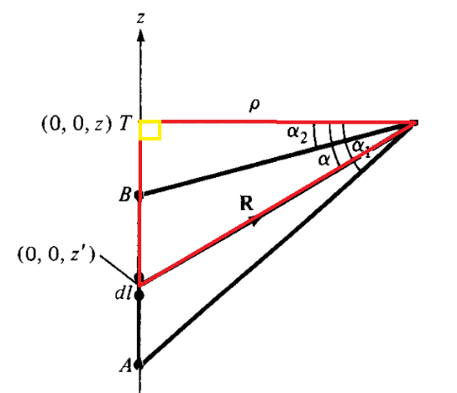

$$\tan{α}=\frac{z-z^{'}}{ρ} ⇒z-z^{'}=ρ \tan{α}$$

Differentiating both sides

$$-dz^{'}=ρ \sec^{2}{α} dα⇒dz^{'}=-ρ \sec^{2}{α} dα$$

$$E=\int{\frac{-1}{4πϵ_{o}}\frac{ρ_{L} ρ \sec^{2}{α} dα}{{\left\{ρ^{2}+{\left(ρ \tan{α}\right)}^{2}\right\}}^{\frac{3}{2}}}\left[ρ a_{ρ}+\left(ρ \tan{α}\right)a_{z}\right]}$$

$$E=\frac{-ρ_{L}}{4πϵ_{o}}\int{\frac{ ρ \sec^{2}{α} dα}{{\left\{ρ^{2}+ρ^{2} \tan^{2}{α}\right\}}^{\frac{3}{2}}}\left[ρ a_{ρ}+\left(ρ \tan{α}\right)a_{z}\right]}$$

$$E=\frac{-ρ_{L}}{4πϵ_{o}}\int{\frac{ \left[ρ^{2} \sec^{2}{α} dα{ a}_{ρ}+ρ^{2} \sec^{2}{α} \tan{α}dα a_{z}\right]}{{ρ^{3}\left\{1+ \tan^{2}{α}\right\}}^{\frac{3}{2}}}}$$

$$E=\frac{-ρ_{L}}{4πϵ_{o}}\int{\frac{ \left[ρ^{2} \sec^{2}{α} dα{ a}_{ρ}+ρ^{2} \sec^{2}{α} \tan{α}dα a_{z}\right]}{{ρ^{3}\left\{\sec^{2}{α}\right\}}^{\frac{3}{2}}}}$$

$$E=\frac{-ρ_{L}}{4πϵ_{o}}\left\{\int{\frac{ ρ^{2} \sec^{2}{α} dα}{ρ^{3}\sec^{3}{α}}{ a}_{ρ}}+\int{\frac{ ρ^{2} \sec^{2}{α} \tan{α}dα}{ρ^{3}\sec^{3}{α}}}a_{z}\right\}$$

$$E=\frac{-ρ_{L}}{4πϵ_{o}}\left\{\int{\frac{ dα}{ρ\sec{α}}{ a}_{ρ}}+\int{\frac{ \tan{α}dα}{ρ\sec{α}}}a_{z}\right\}$$

$$E=\frac{-ρ_{L}}{4πϵ_{o}ρ}\left\{\int{\cos{α} dα{ a}_{ρ}}+\int{\sin{α}dα}a_{z}\right\}$$

Considering limits of integration

$$E=\frac{-ρ_{L}}{4πϵ_{o}ρ}\left\{\int_{α_{1}}^{α_{2}}{\cos{α} dα{ a}_{ρ}}+\int_{α_{1}}^{α_{2}}{\sin{α} dα{ a}_{z}}\right\}$$

$$E=\frac{-ρ_{L}}{4πϵ_{o}ρ}\left\{\sin{α} \left|\begin{matrix}α_{2} \\ \\ α_{1}\end{matrix}\right.{ a}_{ρ}-\cos{α} \left|\begin{matrix}α_{2} \\ \\ α_{1}\end{matrix}\right. { a}_{z}\right\}$$

$$E=\frac{-ρ_{L}}{4πϵ_{o}ρ}\left\{\left(\sin{α_{2}}- \sin{α_{1}}\right){ a}_{ρ}-(cos{α_{2}}-\cos{α_{1}}) { a}_{z}\right\}$$

$$E=\frac{ρ_{L}}{4πϵ_{o}ρ}\left\{\left(\sin{α_{1}}- \sin{α_{2}}\right){ a}_{ρ}+(cos{α_{2}}-\cos{α_{1}}) { a}_{z}\right\}$$

As a special case, for an *infinite line charge,* point *B* is at (0, 0, $∞$) and *A* at (0, 0, - $∞$) so

That ${ α}_{1}=\frac{π}{2}$, $α_{2}=-\frac{π}{2}$*;* then the z-component vanishes, and eq. (4.20) becomes

$$E=\frac{ρ_{L}}{4πϵ_{o}ρ}\left\{\left(\sin{{(90}^{o})}- \sin\left(-{90}^{o}\right)\right){ a}_{ρ}+(cos{{(90}^{o})}-\cos\left(-{90}^{o}\right)) { a}_{z}\right\}$$

$$E=\frac{ρ_{L}}{2πϵ_{o}ρ}{ a}_{ρ}$$

## A Circular Ring Charge

A circular ring of radius **a** carry a uniform linear charge density $ρ_{L}$ C/m and is placed on the xy-plane ( or Z=0 plane ) with axis the same as the z-axis as shown below

|  |  |
| --- | --- |
|  |  |

Figure ‎2.1‑6: Electric Field Intensity due to Circular Ring Charge

The total electric filed intensity $E$ at observation point **P** (0,0,h) due to the linearly charged line can be found by the integration of the differential electric filed $dE$

$$E=\int{dE}$$

$$E=\int{\frac{1}{4πϵ_{o}}\frac{dQ}{R^{2}}a_{R}}=\int{\frac{1}{4πϵ_{o}}\frac{dQ}{R^{3}}R}$$

$$dQ=ρ_{L} dl$$

For cylindrical coordinate system

$dl=dρ a_{ρ}+ρdϕ{ a}_{ϕ}+dz a_{z}$

Since the differential displacement vector is along ${ a}_{ϕ}$

$$dl=ρdϕ{ a}_{ϕ}$$

$$dQ=ρ_{L} dl=ρ_{L} ρdϕ{ a}_{ϕ}$$

$$R=\left(0-x\right)a_{x}+\left(0-y\right)a_{y}+\left(h-0\right)a_{z}$$

$$R=-x a_{x}-y a_{y}+h a_{z}$$

It is recommended that we transfer from cartesian coordinate to cylindrical coordinate as per transformation matrix

$$\left[\begin{matrix}R_{ρ} \\ R_{ϕ} \\ R_{Z}\end{matrix}\right]=\left[\begin{matrix}cosϕ & sinϕ & 0 \\ -sinϕ & cosϕ & 0 \\ 0 & 0 & 1\end{matrix}\right]\left[\begin{matrix}-x \\ -y \\ h\end{matrix}\right]$$

$R_{ρ}=-x cosϕ-y sinϕ=-\left(ρ\cos{ϕ}\right)cosϕ-\left(ρ\sin{ϕ}\right)sinϕ=-ρ \left[ \sin^{2}ϕ+\cos^{2}ϕ\right]=-ρ$

$$R_{ϕ}=x sinϕ-y cosϕ=\left(ρ\cos{ϕ}\right)sinϕ-\left(ρ\sin{ϕ}\right)cosϕ=0$$

$$R_{Z}=h$$

$$R_{ρ,ϕ,Z}=-ρ a_{ρ}+h a_{z}$$

$$\left|R\right|=\sqrt{ρ^{2}+h^{2}}$$

Substituting above equations in **E**

$$E=\int{\frac{1}{4πϵ_{o}}\frac{dQ}{R^{2}}a_{R}}=\int{\frac{1}{4πϵ_{o}}\frac{ρ_{L} ρdϕ{ a}_{ϕ}}{R^{3}}R}$$

$$E=\int{\frac{1}{4πϵ_{o}}\frac{ρ_{L} ρdϕ{ a}_{ϕ}}{{\left[\sqrt{ρ^{2}+h^{2}}\right]}^{3}}\left[-ρ a_{ρ}+h a_{z}\right]}$$

$$E=\int{\frac{1}{4πϵ_{o}}\frac{ρ_{L} ρdϕ{ a}_{ϕ}}{{\left[ρ^{2}+h^{2}\right]}^{3/2}}\left[-ρ a_{ρ}+h a_{z}\right]}$$

Because of the symmetrical charge distribution, there exists a corresponding element 2 for every element 1. The contribution of element 2 along $a_{ρ}$ counteracts that of element 1, as seen in the above Figure. Thus, the contributions to E $ρ$ add up to zero so that $E$ has only z-component

$$E=\int{\frac{1}{4πϵ_{o}}\frac{ρ_{L} ρdϕ}{{\left[ρ^{2}+h^{2}\right]}^{3/2}}\left[h a_{z}\right]}$$

$$E=\frac{1}{4πϵ_{o}}\frac{ρ_{L} ρh}{{\left[ρ^{2}+h^{2}\right]}^{3/2}}\int_{0}^{2π}{dϕ}a_{z}$$

But $ρ=a$

$$E=\frac{1}{4πϵ_{o}}\frac{ρ_{L} ah}{{\left[a^{2}+h^{2}\right]}^{3/2}}×2π a_{z}$$

$$E=\frac{1}{2ϵ_{o}}\frac{ρ_{L} ah}{{\left[a^{2}+h^{2}\right]}^{3/2}} a_{z}$$

However, $2πh is the priemeter of the ring with total length l$

$$E=\frac{1}{4πϵ_{o}}\frac{ρ_{L} 2πa h}{{\left[a^{2}+h^{2}\right]}^{3/2}}=\frac{1}{4πϵ_{o}}\frac{ρ_{L} l h}{{\left[a^{2}+h^{2}\right]}^{3/2}}=\frac{1}{4πϵ_{o}}\frac{Q h}{{\left[a^{2}+h^{2}\right]}^{3/2}}$$

As $a→0$

$$E=\frac{1}{4πϵ_{o}}\frac{Q h}{{\left[h^{2}\right]}^{3/2}}=\frac{1}{4πϵ_{o}}\frac{Q h }{h^{3}}=\frac{1}{4πϵ_{o}}\frac{Q }{h^{2}}$$

What values of *h* gives the maximum value of E ?

To get this, we should apply the Extrema problems

$$\frac{dE}{dh}=0⇒$$

$$E=\left|E\right|=\frac{ρ_{L} a}{2ϵ_{o}}\frac{ h}{{\left[a^{2}+h^{2}\right]}^{3/2}}$$

$$\frac{dE}{dh}=\frac{ρ_{L} a}{2ϵ_{o}}×\frac{\left\{{\left[a^{2}+h^{2}\right]}^{3/2}\right\}×\left\{1\right\}-\left\{h\right\}×\left\{\frac{3}{2}{\left[a^{2}+h^{2}\right]}^{1/2}×2h\right\}}{{\left[a^{2}+h^{2}\right]}^{3}}=0$$

$${\left[a^{2}+h^{2}\right]}^{3/2}-3h^{2}{\left[a^{2}+h^{2}\right]}^{1/2}=0$$

$${\left[a^{2}+h^{2}\right]}^{1/2}×\left\{a^{2}+h^{2}-3h^{2}\right\}=0$$

$$a^{2}-2h^{2}=0⇒h=±\frac{a}{\sqrt{2}}$$

## A Surface Charge

Consider an infinite charged sheet with total charge $Q$ laid on the xy-plane with uniform charge density $ρ_{s}$.

|  |  |
| --- | --- |
|  |  |

**Figure ‎2.1‑7:** Electric Field Intensity due to Surface Charged Sheet

The total electric filed intensity $E$ at observation point P (0,0,h) due to the surface charged infinite sheet can be found by the integration of the differential electric filed $dE$

$$E=\int{dE}$$

$$E=\int{\frac{1}{4πϵ_{o}}\frac{dQ}{R^{2}}a_{R}}=\int{\frac{1}{4πϵ_{o}}\frac{dQ}{R^{3}}R}$$

The charge associated with an elemental area *d****S*** is

$$dQ=ρ_{s} ds$$

For Cylindrical coordinate system

$dl=dρ a_{ρ}+ρdϕ{ a}_{ϕ}+dz a_{z}$

Since the differential area’s normal vector is along $a_{z}$

$ds= ρdρdϕa_{z}$

$dQ=ρ_{s} ρdρdϕa_{z}$

$$R=\left(0-x\right)a_{x}+\left(0-y\right)a_{y}+\left(h-0\right)a_{z}$$

$$R=-x a_{x}-y a_{y}+h a_{z}$$

It is recommended that we transfer from cartesian coordinate to cylindrical coordinate as per transformation matrix

$$\left[\begin{matrix}R_{ρ} \\ R_{ϕ} \\ R_{Z}\end{matrix}\right]=\left[\begin{matrix}cosϕ & sinϕ & 0 \\ -sinϕ & cosϕ & 0 \\ 0 & 0 & 1\end{matrix}\right]\left[\begin{matrix}-x \\ -y \\ h\end{matrix}\right]$$

$R_{ρ}=-x cosϕ-y sinϕ=-\left(ρ\cos{ϕ}\right)cosϕ-\left(ρ\sin{ϕ}\right)sinϕ=-ρ \left[ \sin^{2}ϕ+\cos^{2}ϕ\right]=-ρ$

$$R_{ϕ}=x sinϕ-y cosϕ=\left(ρ\cos{ϕ}\right)sinϕ-\left(ρ\sin{ϕ}\right)cosϕ=0$$

$$R_{Z}=h$$

$$R_{ρ,ϕ,Z}=-ρ a_{ρ}+h a_{z}$$

$$\left|R\right|=\sqrt{ρ^{2}+h^{2}}$$

Substituting above equations in $E$

$$E=\int{\frac{1}{4πϵ_{o}}\frac{dQ}{R^{2}}a_{R}}=\int{\frac{1}{4πϵ_{o}}\frac{ρ_{s} ρdρdϕa_{z} }{R^{3}}R}$$

$$E=\int{\frac{1}{4πϵ_{o}}\frac{ρ_{s} ρdρdϕa_{z}}{{\left[\sqrt{ρ^{2}+h^{2}}\right]}^{3}}\left[-ρ a_{ρ}+h a_{z}\right]}$$

Due to the symmetry of the charge distribution, for every element 1, there is a corresponding element 2 whose contribution along $a_{ρ}$ cancels that of element 1, as illustrated in Figure above. Thus, the contributions to E $ρ$ add up to zero so that $E$ has only z-component

$$E=\int{\frac{1}{4πϵ_{o}}\frac{ρ_{s} ρdρdϕa_{z}}{{\left[\sqrt{ρ^{2}+h^{2}}\right]}^{3}}\left[h a_{z}\right]}$$

$$E=\frac{ρ_{s}h}{4πϵ_{o}}\int{\frac{ ρdρdϕa_{z}}{{\left[ρ^{2}+h^{2}\right]}^{3/2}}a_{z}}$$

$$E=\frac{ρ_{s}h}{4πϵ_{o}}\int{ρ({ρ^{2}+h^{2})}^{{-3}/2} dρdϕ a_{z}}$$

$$E=\frac{ρ_{s}h}{4πϵ_{o}}\int_{0}^{2π}{dϕ}\int_{0}^{∞}{ρ({ρ^{2}+h^{2})}^{{-3}/2} dρ}$$

$$E=\frac{ρ_{s}h}{4πϵ_{o}}2π \int_{0}^{∞}{ρ({ρ^{2}+h^{2})}^{{-3}/2} dρ}$$

This integration requires integration by substitution

|  |  |
| --- | --- |
| Let |  |

## A Volume Charge

Let the volume charge distribution with uniform charge density $ρ_{v}$ be as shown in Figure

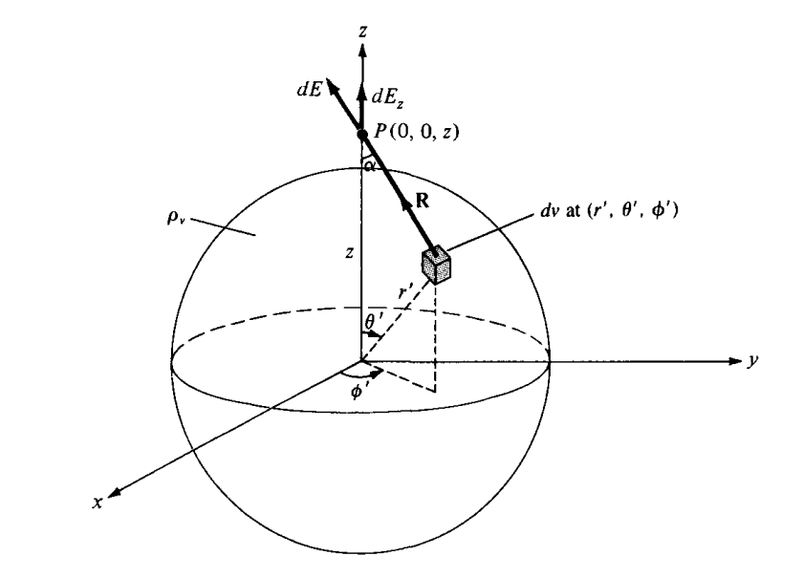

**Figure ‎2.1‑8:** Electric Field Intensity due to charged sphere

The electric field $dE$ at P(0, 0, z) due to the differentially volume charge is

$$dE=\frac{1}{4πϵ_{o}}\frac{dQ}{R^{2}}a_{R}=\frac{ρ_{v} dv}{{4πϵ_{o}R}^{2}}a_{R}$$

where $a_{R}=\cos{α} a_{z}+\sin{α} a_{ρ}$. Due to the symmetry of the charge distribution, the contributions to $E_{x}$ or $E_{y}$ add up to zero. We are left with only $E_{z}$, given by

$$E_{z}=E.a_{z}=\int{dE\cos{α}}=\int{\frac{ρ_{v} dv}{{4πϵ_{o}R}^{2}}\cos{α}}=\frac{ρ_{v} }{4πϵ_{o}}\int{\frac{ dv}{R^{2}}\cos{α}}$$

However, we need to find an expression for $dv,R^{2}, and\cos{α}$

For the $dv$ it will be simply derived from the differential displacement for the spherical coordinate system

$dl=dr a_{r}+rdθ{ a}_{θ}+r\sin{θ}dϕ a_{ϕ}$

$dv$ can be found by multiplying the differential displacement of the individual components of $dl$

$$dv=r^{2}sinθ drdθdϕ$$

However, for the differential volume within the spherical charged object

$$dv^{'}={r^{'}}^{2}sinθ^{'} dr^{'}dθ^{'}dϕ^{'}$$

$$E_{z}=\frac{ρ_{v} }{4πϵ_{o}}\int{\frac{ dv^{'}}{R^{2}}\cos{α}}=\frac{ρ_{v} }{4πϵ_{o}}\int{\frac{ {r^{'}}^{2}sinθ^{'} dr^{'}dθ^{'}dϕ^{'}}{R^{2}}\cos{α}}$$

Rearranging above equation to get a better view about the necessary simplifications

$$E_{z}=\frac{ρ_{v} }{4πϵ_{o}}\int{\frac{ dv^{'}}{R^{2}}\cos{α}}=\frac{ρ_{v} }{4πϵ_{o}}\int{\frac{ 1}{R^{2}}{r^{'}}^{2}(sinθ^{'} dθ^{'})dr^{'}dϕ^{'}(\cos{α})}$$

As for $sinθ^{'} dθ^{'} and\cos{α}$ we will make use of the cosine law

|  |  |
| --- | --- |
| $$R^{2}={r^{'}}^{2}+z^{2}-2r^{'}z cosθ^{'}$$ $$2r^{'}z cosθ^{'}={r^{'}}^{2}+z^{2}-R^{2}$$ $$cosθ^{'}=\frac{{r^{'}}^{2}+z^{2}-R^{2}}{2r^{'}z }$$ $$-sinθ^{'}dθ^{'}=\frac{-2R dR}{2r^{'}z }$$ $$sinθ^{'}dθ^{'}=\frac{R dR}{r^{'}z }$$ |  |
| $${r^{'}}^{2}=R^{2}+z^{2}-2Rz cosα$$ $$2Rz cosα=R^{2}+z^{2}-{r^{'}}^{2}$$ $$cosα=\frac{R^{2}+z^{2}-{r^{'}}^{2}}{2Rz }$$ |

$$E_{z}=\frac{ρ_{v} }{4πϵ_{o}}\int{\frac{ dv^{'}}{R^{2}}\cos{α}}=\frac{ρ_{v} }{4πϵ_{o}}\int{\frac{ 1}{R^{2}}{r^{'}}^{2}(sinθ^{'} dθ^{'})dr^{'}dϕ^{'}(\cos{α})}$$

$$E_{z}=\frac{ρ_{v} }{4πϵ_{o}}\int{\frac{ 1}{R^{2}}{r^{'}}^{2}\left(\frac{R dR}{r^{'}z }\right)dr^{'}dϕ^{'}\left(\frac{R^{2}+z^{2}-{r^{'}}^{2}}{2Rz }\right)}$$

To find the limits of integration for R, we make use of the limits of integration in $θ$

$$R^{2}={r^{'}}^{2}+z^{2}-2r^{'}z cosθ^{'}$$

**When $θ=0 ⇒R^{2}={r^{'}}^{2}+z^{2}-2r^{'}z\cos\left(0^{o}\right)={r^{'}}^{2}+z^{2}-2r^{'}z=z-r^{'}$**

**When $θ=180 ⇒R^{2}={r^{'}}^{2}+z^{2}-2r^{'}z\cos\left({180}^{o}\right)={r^{'}}^{2}+z^{2}-2r^{'}z=z+r^{'}$**

$$E_{z}=\frac{ρ_{v} }{4πϵ_{o}z^{2}}\int_{ϕ^{'}=0}^{ϕ^{'}=2π}{dϕ^{'}}\int_{r^{'}=0}^{r^{'}=a}{r^{'}dr^{'}}\int_{R=z-r^{'}}^{R=z+r^{'}}{\frac{ 1}{R^{2}}\left(\frac{R^{2}+z^{2}-{r^{'}}^{2}}{2 }\right)dR}$$

$$E_{z}=\frac{ρ_{v} }{4πϵ_{o}z^{2}}×2π ×\int_{r^{'}=0}^{r^{'}=a}{r^{'}dr^{'}}\int_{R=z-r^{'}}^{R=z+r^{'}}{\frac{ 1}{2}\left(1+\frac{z^{2}-{r^{'}}^{2}}{R^{2} }\right)dR}$$

$$E_{z}=\frac{ρ_{v} }{4πϵ_{o}z^{2}}×π ×\int_{r^{'}=0}^{r^{'}=a}{r^{'}dr^{'}}×\left(\left(z+r^{'}\right)-\left(z-r^{'}\right)+z^{2}-{r^{'}}^{2}×\int_{R=z-r^{'}}^{R=z+r^{'}}{\frac{1}{R^{2} }dR}\right)$$

$$E_{z}=\frac{ρ_{v} }{4πϵ_{o}z^{2}}×π ×\int_{r^{'}=0}^{r^{'}=a}{r^{'}dr^{'}}×\left(\left(2r^{'}\right)+\left(z^{2}-{r^{'}}^{2}\right)×\left(\frac{R^{-1}}{-1}\left|\begin{matrix}z+r^{'} \\ \\ z-r^{'}\end{matrix}\right.\right)\right)$$

$$E_{z}=\frac{ρ_{v} }{4πϵ_{o}z^{2}}×π ×\int_{r^{'}=0}^{r^{'}=a}{r^{'}dr^{'}}×\left(\left(2r^{'}\right)+\left(z^{2}-{r^{'}}^{2}\right)×\left(\frac{-1}{z+r^{'}}-\frac{-1}{z-r^{'}}\right)\right)$$

$$E_{z}=\frac{ρ_{v} }{4πϵ_{o}z^{2}}×π ×\int_{r^{'}=0}^{r^{'}=a}{r^{'}dr^{'}}×\left(\left(2r^{'}\right)+\left(z^{2}-{r^{'}}^{2}\right)×\left(\frac{1}{z-r^{'}}-\frac{1}{z+r^{'}}\right)\right)$$

$$E_{z}=\frac{ρ_{v} }{4πϵ_{o}z^{2}}×π ×\int_{r^{'}=0}^{r^{'}=a}{r^{'}dr^{'}}×\left(\left(2r^{'}\right)+\left(z^{2}-{r^{'}}^{2}\right)×\left(\frac{z+r^{'}}{\left(z^{2}-{r^{'}}^{2}\right)}-\frac{z-r^{'}}{\left(z^{2}-{r^{'}}^{2}\right)}\right)\right)$$

$$E_{z}=\frac{ρ_{v} }{4πϵ_{o}z^{2}}×π ×\int_{r^{'}=0}^{r^{'}=a}{r^{'}dr^{'}}×\left(\left(2r^{'}\right)+\left(z^{2}-{r^{'}}^{2}\right)×\left(\frac{z+r^{'}-\left(z-r^{'}\right)}{\left(z^{2}-{r^{'}}^{2}\right)}\right)\right)$$

$$E_{z}=\frac{ρ_{v} }{4πϵ_{o}z^{2}}×π ×\int_{r^{'}=0}^{r^{'}=a}{r^{'}dr^{'}}×\left(\left(2r^{'}\right)+\left(2r^{'}\right)\right)=\frac{ρ_{v} }{4πϵ_{o}z^{2}}×π ×\int_{r^{'}=0}^{r^{'}=a}{{{4r}^{'}}^{2}dr^{'}}$$

$$E_{z}=\frac{ρ_{v} }{4πϵ_{o}z^{2}}×π ×\int_{r^{'}=0}^{r^{'}=a}{{{4r}^{'}}^{2}dr^{'}}=\frac{ρ_{v} }{4πϵ_{o}z^{2}}×π ×\frac{{{4r}^{'}}^{3}}{3}\left|\begin{matrix}a \\ \\ 0\end{matrix}\right.$$

$$E_{z}=\frac{ρ_{v} }{4πϵ_{o}z^{2}} ×\frac{4}{3}{πa}^{3}=\frac{ρ_{v} }{4πϵ_{o}z^{2}} ×v=\frac{Q }{4πϵ_{o}z^{2}}$$

$$E=\frac{Q }{4πϵ_{o}z^{2}}a_{z}$$

This result is obtained for $E$ at P(0, 0, z). Due to the symmetry of the charge distribution, the electric field at *P(r, θ, Φ)* is readily obtained from eq. (4.33) as

$$E=\frac{Q}{4πϵ_{o}r^{2}}a_{r}$$

which is identical to the electric field at the same point as a result of a point charge Q situated at the origin or the center of the spherical charge distribution

## ELECTRIC FLUX DENSITY

The flux due to the electric field intensity $E$ can be calculated using the general definition of flux below.

$$ψ=\int_{s}{D.ds}$$

For practical reasons, however, this quantity is not usually considered as the most useful flux in electrostatics. Also, the electric field intensity is dependent on the medium in which the charge is placed (free space in this section). Let’s Suppose a new vector field D independent of the medium is defined by

$$D=ϵ_{o}E$$

## The flux density for point charge

$$D=ϵ_{o}E=ϵ_{o}×\left(\frac{1}{4πϵ_{o}}\frac{Q_{eff}}{R^{2}}a_{R}\right)=\frac{1}{4π}\frac{Q_{eff}}{R^{2}}a_{R}$$

## The flux density for continuous charge distribution

$$D=ϵ_{o}E=ϵ_{o}×\int{\frac{1}{4πϵ_{o}}\frac{dQ}{R^{2}}a_{R}}=\int{\frac{1}{4π}\frac{ρ_{L} dl}{R^{2}}a_{R}} line charge$$

$$D=ϵ_{o}E=ϵ_{o}×\int{\frac{1}{4πϵ_{o}}\frac{dQ}{R^{2}}a_{R}}=\int{\frac{1}{4π}\frac{ρ_{S} dS }{R^{2}}a_{R} } surface charge$$

$$D=ϵ_{o}E=ϵ_{o}×\int{\frac{1}{4πϵ_{o}}\frac{dQ}{R^{2}}a_{R}}=\int{\frac{1}{4π}\frac{ρ_{v} dv}{R^{2}}a_{R}} volume charge$$

## GAUSS'S LAW - MAXWELL'S EQUATION

Gauss's law states that the total electric flux denoted by $ψ$ through any given closed surface S is equal to the total electric charge enclosed by that surface.

$$ψ=Q_{enc}$$

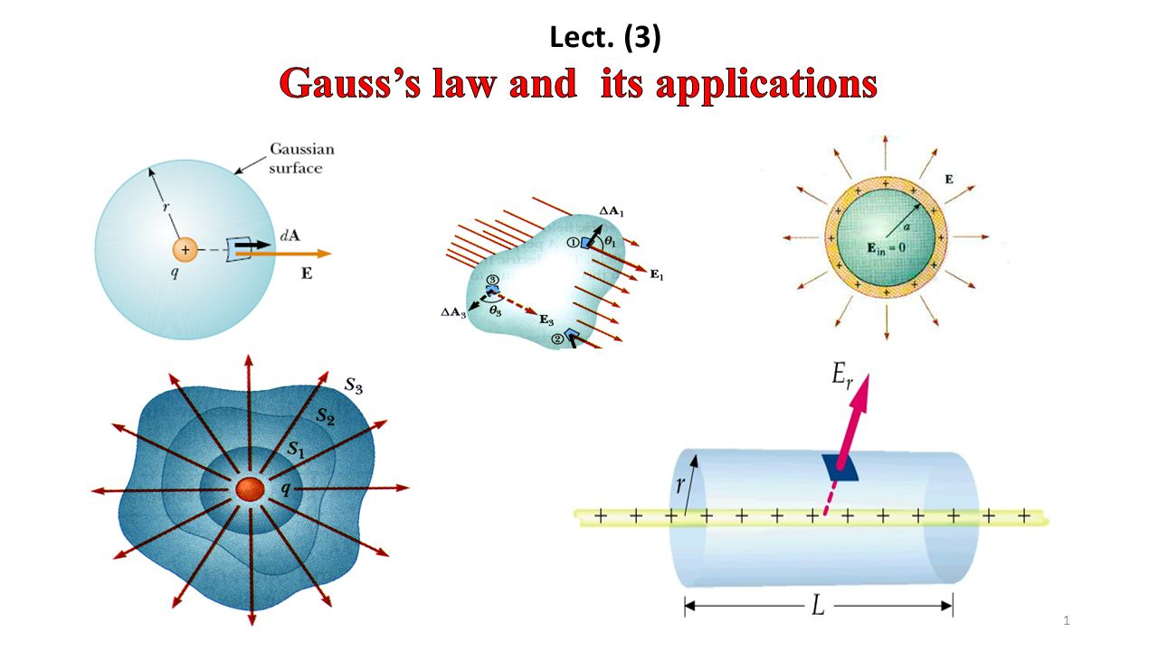

**Figure ‎2.1‑9:** Gauss's Applications for Different Source Elements

But given a flux density vector field $D$ continuous in a region containing the smooth closed surface S then the net outward flux of $D$ is given by

$$ψ=\oint_{s}{dψ}=\oint_{s}{D.ds}$$

Applying divergence theorem for above equation

$$\oint_{s}{D.ds}=\int_{v}{\left(∇.D\right) dv}$$

But the enclosed charge $Q_{enc}$ can be written as below

$$Q_{enc}=\int_{v}{ρ_{v} dv}$$

Substituting both the total flux equation and charge enclosed equation we get

$$ψ=Q_{enc}$$

$$\oint_{s}{D.ds}=\int_{v}{\left(∇.D\right) dv}=\int_{v}{ρ_{v} dv}$$

Equaling both volume integrals we get

$$∇.D=ρ_{v}$$

The first of Maxwell's equations, known as Gauss's law, is derived and asserts that the volume charge density is equal to the divergence of the electric flux density.

## APPLICATIONS OF GAUSS'S LAW

The procedure for applying Gauss's law to calculate the electric field involves the following:

1. Identify the charge distribution symmetry by knowing whether symmetry exists.
2. Once symmetric charge distribution exists, construct a mathematical closed surface (known as a Gaussian surface). The surface is chosen such that $D$ is normal or tangential to the Gaussian surface. When D is normal to the surface, $D.ds$ = $Dds$ because D is constant on the surface. When D is tangential to the surface, $D.ds=0$
3. Apply Gauss’s law

$$\oint_{s}{D.ds}=\int_{v}{\left(∇.D\right) dv}=\int_{v}{ρ_{v} dv}$$

## A Point charge

Suppose a point charge $Q$ is located exactly at the origin. To determine $D$ and $E$ at a point P, it is easy to see that choosing a spherical surface containing P will satisfy symmetry conditions. Therefore, a spherical surface that is centered at the origin serves as the Gaussian surface in this particular scenario, as seen in Figure.

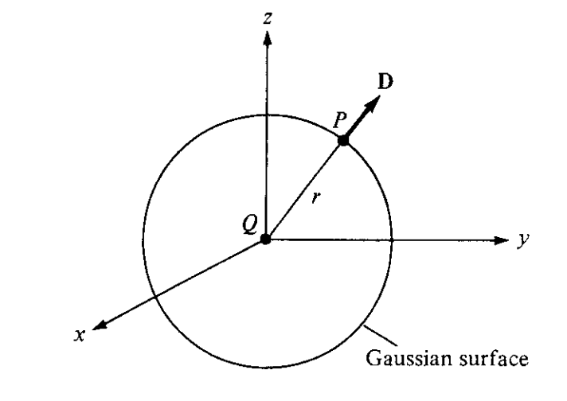



**Figure ‎2.1‑10:** Gauss Application for Point Charge

1. Locate the object at its location which is the origin (0,0,0)
2. Construct Gaussian mathematical symmetrical surface around the charged object, and in this case, it will be a sphere.
3. Apply Gauss’s Law

$$\oint_{s}{D.ds}=\int_{v}{\left(∇.D\right) dv}=\int_{v}{ρ_{v} dv}$$

First, we should find $$\oint_{s}{D.ds}$$

The flux density vector will be along $a_{r}$

$$D=Da_{r}$$

The differential displacement for the spherical coordinate system

$$dl=dr a_{r}+rdθ{ a}_{θ}+r\sin{θ}dϕ a_{ϕ}$$

And the differential surface ds will have a norm along $a_{r}$

$$ds=r^{2}\sin{θ}dϕdθa_{r}$$

$$\oint_{s}{D.ds}=\oint_{s}{Da_{r}}∙r^{2}\sin{θ}dϕdθa_{r}$$

$$Dr^{2}\int_{ϕ=o}^{ϕ=2π}{dϕ}\int_{θ=0}^{θ=π}{\sin{θ}dθ}=Dr^{2} ×2π×\left(-\cos{θ} \left|\begin{matrix}π \\ \\ 0\end{matrix}\right.\right)$$

$$Dr^{2} ×2π×\left(-\cos{{180}^{o}}+\cos{0^{o}} \right)=D ×4πr^{2}$$

Then, we should find $$Q_{enc}=Q$$

Equalizing both sides of Gauss’s equation will get

$$D×4πr^{2}=Q ⇒ D=\frac{Q}{4πr^{2}}$$

But $$D=ϵ_{o}E ⇒ E=\frac{D}{ϵ_{o} }$$

$$E=\frac{1}{ϵ_{o} } ×\left(\frac{Q}{4πr^{2}}\right)=\frac{Q}{{4πϵ}_{o}r^{2} }$$

## An Infinite Line charge

Suppose an infinite line of uniformly linear charge $ρ_{L}$ C/m lies along the z-axis. To determine the electric flux density $D$ at a point P, we will choose a gaussian cylindrical surface containing point P to satisfy symmetry condition as shown in Figure. $D$ is constant on and normal to the cylindrical Gaussian surface; that is, $D$ = *Dρaρ.* If we apply Gauss's law to an arbitrary length $l$ of the line



**Figure ‎2.1‑11:**Gauss Application for Line Charge

1. Locate the object at its location which is the along the z-axis
2. Construct Gaussian mathematical symmetric surface around the charged object, and in this case, it will be a cylinder
3. Apply Gauss’s Law

First, we should find

The flux density vector will be along

The differential displacement for the cylindrical coordinate system

Since the differential area’s normal vector is along $a_{ρ}$

$ds= ρdϕdza_{ρ}$

$$\oint_{s}{D.ds}=\oint_{s}{Da_{ρ}}∙ρdϕdza_{ρ}$$

$$Dρ\int_{ϕ=o}^{ϕ=2π}{dϕ}\int_{z=0}^{z=l}{dz}=Dρ ×2π×l$$

$$D×2πρl$$

Then, we should find $$Q_{enc}=ρ_{l} ×l$$

Equalizing both sides of Gauss’s equation will get

$$D×2πρl=ρ_{l} ×l ⇒ D=\frac{ρ_{l}}{2πρ}a_{ρ}$$

But $$D=ϵ_{o}E ⇒ E=\frac{D}{ϵ_{o} }$$

$$E=\frac{1}{ϵ_{o} } ×\left(\frac{ρ_{l}}{2πρ}\right)a_{ρ}$$

## Infinite Sheet of Charge

Considering an infinite sheet of uniform charge $ρ_{s}$ C/m2 lying on the z = 0 plane. To evaluate the electric flux density $D$ at point P, We will choose a rectangular prism that is bisected symmetrically by the sheet of charge and has two of its sides parallel to the sheet, as seen in the Figure.

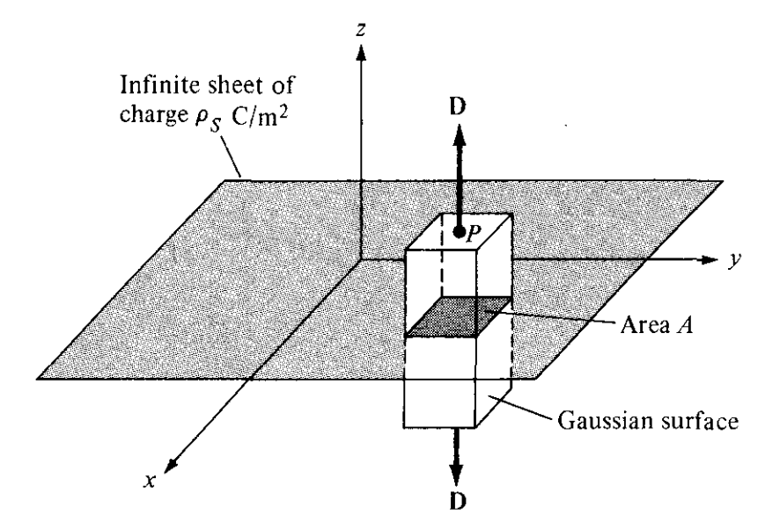

**Figure ‎2.1‑12:**Gauss Application for Infinite Surface Charge

1. Locate the object at its location which is lying on the z = 0 plane
2. Construct Gaussian mathematical symmetric surface around the charged object, and in this case, it will be a rectangular box
3. Apply Gauss’s Law

$$\oint_{s}{D.ds}=\int_{v}{\left(∇.D\right) dv}=\int_{v}{ρ_{v} dv}$$

$$\oint_{s}{D.ds}=D_{z} \left[\int_{top}{ds}+\int_{bottom}{ds}\right]=D ×2A$$

$$Q=\int_{s}{ρ_{s} ds}=ρ_{s} ×A$$

Equalizing both side of the equation

$$D ×2A=ρ_{s} ×A$$

$$D =\frac{ρ_{s}}{2}a_{z}$$

$$D=ϵ_{o}E ⇒ E=\frac{D}{ϵ_{o} }$$

$$E=\frac{1}{ϵ_{o} } ×\left(\frac{ρ_{s}}{2}\right)a_{z}$$

## Charged Sphere

Consider a sphere of radius $a$ with a uniform charge C/m3. To determine the electric flux density D everywhere, we will construct a spherical Gaussian surfaces for areas $r≤a$ and r > a separately.

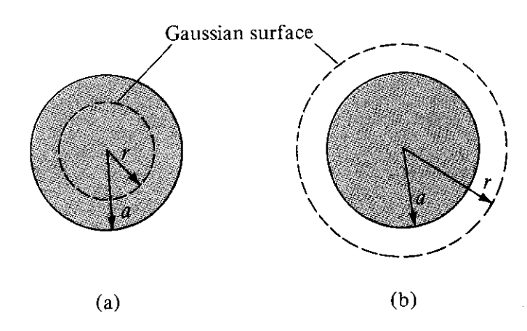

**Figure ‎2.1‑13:** Gauss Application for Charged Sphere

**For $r≤a$**

1. Locate the object at its location which is a sphere with center at origin (0,0,0)
2. Construct Gaussian mathematical symmetric surface around the charged object, and in this case, it will be a sphere with for r ≤ a
3. Apply Gauss’s Law

$$\oint_{s}{D.ds}=\int_{v}{\left(∇.D\right) dv}=\int_{v}{ρ_{v} dv}$$

First, we should find $$\oint_{s}{D.ds}$$

The flux density vector will be along $a_{r}$

$$D=Da_{r}$$

The differential displacement for the spherical coordinate system

And the differential surface ds will have a norm along $a_{r}$

$$ds=r^{2}\sin{θ}dϕdθa_{r}$$

$$\oint_{s}{D.ds}=\oint_{s}{Da_{r}}∙r^{2}\sin{θ}dϕdθa_{r}$$

$$Dr^{2}\int_{ϕ=o}^{ϕ=2π}{dϕ}\int_{θ=0}^{θ=π}{\sin{θ}dθ}=Dr^{2} ×2π×\left(-\cos{θ} \left|\begin{matrix}π \\ \\ 0\end{matrix}\right.\right)$$

$$Dr^{2} ×2π×\left(-\cos{{180}^{o}}+\cos{0^{o}} \right)=D ×4πr^{2}$$

Then, we should find $Q_{enc}$ $$Q_{enc}=\int_{v}{ρ_{v} dv}$$

$dv$ can be found by multiplying the differential displacement of the individual components of $dl$

$$dv=r^{2}sinθ drdθdϕ$$

$$Q_{enc}=\int_{v}{ρ_{v} r^{2}sinθ drdθdϕ}$$

$$Q_{enc}=ρ_{v}\int_{r=o}^{r=r}{r^{2}dr}\int_{ϕ=o}^{ϕ=2π}{dϕ}\int_{θ=0}^{θ=π}{\sin{θ}dθ}$$

$$ρ_{v}× \frac{r^{3}}{3}\left|\begin{matrix}r \\ \\ 0\end{matrix}\right. ×2π×\left(-\cos{θ} \left|\begin{matrix}π \\ \\ 0\end{matrix}\right.\right)=ρ_{v}×\frac{4}{3}πr^{3}$$

Equaling both sides

$$D ×4πr^{2}=ρ_{v}×\frac{4}{3}πr^{3}$$

$$D =\frac{ρ_{v}}{3}r$$

$$D =\frac{ρ_{v}}{3}r{ a}_{r}$$

**For $r≥a$**

1. Locate the object at its location which is a sphere with center at origin (0,0,0)
2. Construct Gaussian mathematical symmetric surface around the charged object, and in this case, it will be a sphere with r≥a
3. Apply Gauss’s Law

First, we should find

The flux density vector will be along

The differential displacement for the spherical coordinate system

And the differential surface ds will have a norm along $a_{r}$

$$ds=r^{2}\sin{θ}dϕdθa_{r}$$

$$\oint_{s}{D.ds}=\oint_{s}{Da_{r}}∙r^{2}\sin{θ}dϕdθa_{r}$$

$$Dr^{2}\int_{ϕ=o}^{ϕ=2π}{dϕ}\int_{θ=0}^{θ=π}{\sin{θ}dθ}=Dr^{2} ×2π×\left(-\cos{θ} \left|\begin{matrix}π \\ \\ 0\end{matrix}\right.\right)$$

$$Dr^{2} ×2π×\left(-\cos{{180}^{o}}+\cos{0^{o}} \right)=D ×4πr^{2}$$

Then, we should find $Q_{enc}$ $$Q_{enc}=\int_{v}{ρ_{v} dv}$$

$dv$ can be found by multiplying the differential displacement of the individual components of $dl$

$$dv=r^{2}sinθ drdθdϕ$$

$$Q_{enc}=\int_{v}{ρ_{v} r^{2}sinθ drdθdϕ}$$

$$Q_{enc}=ρ_{v}\int_{r=o}^{r=a}{r^{2}dr}\int_{ϕ=o}^{ϕ=2π}{dϕ}\int_{θ=0}^{θ=π}{\sin{θ}dθ}$$

$$ρ_{v}× \frac{r^{3}}{3}\left|\begin{matrix}a \\ \\ 0\end{matrix}\right. ×2π×\left(-\cos{θ} \left|\begin{matrix}π \\ \\ 0\end{matrix}\right.\right)=ρ_{v}×\frac{4}{3}πa^{3}$$

$$D ×4πr^{2}=ρ_{v}×\frac{4}{3}πa^{3}$$

$$D =ρ_{v}×\frac{a^{3}}{3r^{2}}$$

$$D =ρ_{v}×\frac{a^{3}}{3r^{2}}a_{r}$$

Sketching of $D$ against $r$ can be depicted below

## Charged Cylinder

|  |  |
| --- | --- |
|  |  |

**Figure ‎2.1‑14:**Gauss Application for Charged Cylinder

**For $ρ≤a$**

1. Locate the object at its location which is the along the z-axis
2. Construct Gaussian mathematical symmetric surface around the charged object, and in this case, it will be a cylinder
3. Apply Gauss’s Law

First, we should find

The flux density vector will be along

The differential displacement for the cylindrical coordinate system

Since the differential area’s normal vector is along $a_{ρ}$

$ds= ρdϕdza_{ρ}$

$$\oint_{s}{D.ds}=\oint_{s}{Da_{ρ}}∙ρdϕdza_{ρ}$$

$$Dρ\int_{ϕ=o}^{ϕ=2π}{dϕ}\int_{z=0}^{z=l}{dz}=Dρ ×2π×l$$

$$D×2πρl$$

Then, we should find $$Q_{enc}=\int_{v}{ρ_{v} dv}$$

$$Q_{enc}=\int_{v}{ρ_{v} }ρdρdϕdz=ρ_{v}\int_{ρ=o}^{ρ=r}{ρdρ} \int_{ϕ=o}^{ϕ=2π}{dϕ}\int_{z=0}^{z=l}{dz}$$

$$ρ_{v} ×\frac{ρ^{2}}{2} ×2π×l=ρ_{v} ×πρ^{2}l$$

Equalizing both sides of Gauss’s equation will get

$$D×2πρl=ρ_{v} ×πρ^{2}l ⇒ D=\frac{ρ_{v}}{2}ρa_{ρ}$$

But $$D=ϵ_{o}E ⇒ E=\frac{D}{ϵ_{o} }$$

$$E=\frac{1}{ϵ_{o} } ×\left(\frac{ρ_{v}}{2}ρ\right)a_{ρ}$$

$$E=\frac{ρ_{v}}{2ϵ_{o} }ρ{ a}_{ρ}$$

**For $ρ≥a$**

1. Locate the object at its location which is the along the z-axis
2. Construct Gaussian mathematical symmetric surface around the charged object, and in this case, it will be a cylinder
3. Apply Gauss’s Law

First, we should find

The flux density vector will be along

The differential displacement for the cylindrical coordinate system

Since the differential area’s normal vector is along $a_{ρ}$

$ds= ρdϕdza_{ρ}$

$$\oint_{s}{D.ds}=\oint_{s}{Da_{ρ}}∙ρdϕdza_{ρ}$$

$$D ρ\int_{ϕ=o}^{ϕ=2π}{dϕ}\int_{z=0}^{z=l}{dz}=D ρ×2π×l$$

$$D×2πρl$$

Then, we should find $$Q_{enc}=\int_{v}{ρ_{v} dv}$$

$$Q_{enc}=\int_{v}{ρ_{v} }ρdρdϕdz=ρ_{v}\int_{ρ=o}^{ρ=a}{ρdρ} \int_{ϕ=o}^{ϕ=2π}{dϕ}\int_{z=0}^{z=l}{dz}$$

$$ρ_{v} ×\frac{a^{2}}{2} ×2π×l=ρ_{v} ×πa^{2}l$$

Equalizing both sides of Gauss’s equation will get

$$D×2πρl=ρ_{v} ×πa^{2}l ⇒ D=\frac{ρ_{v}}{2ρ}a^{2}a_{ρ}$$

But $$D=ϵ_{o}E ⇒ E=\frac{D}{ϵ_{o} }$$

$$E=\frac{1}{ϵ_{o} } ×\left(\frac{ρ_{v}}{2ρ}a^{2}\right)a_{ρ}$$

$$E=\frac{ρ_{v}a^{2}}{2ϵ_{o} } ×\left(\frac{1}{ρ}\right)a_{ρ}$$

Then, the electrical flux density

$$D=\left\{ \begin{aligned}\begin{matrix}\frac{ρ_{v}}{2}ρ & ; ρ≤a\end{matrix} \\ \begin{matrix}\frac{ρ_{v}}{2ρ}a^{2} & ; ρ≥a\end{matrix}\end{aligned}\right.$$

## ELECTRIC POTENTIAL



Suppose we want to move a point charge $Q$ in an electric field $E$ from point **A** which is at distance $r_{A}$ from origin to point **B** which is at distance $r_{A}$ as shown in Figure below.



**Figure ‎2.1‑15:** Point Charge moving within Electric Field from Point A to B

From Coulomb's law, the electrostatic force on $Q$ is simply given in below equation

$$F=Q E$$

So that the work $W$ done in displacing the charge $Q$ by $dl$ is

$$dW=-F.dl=-QE.dl$$

The negative sign indicates that the work is being done by an external agent. Thus, the total work done, or the potential energy required, in moving Q from A to B is

$$W=\int{dW}=-\int_{A}^{B}{F.dl}=-Q\int_{A}^{B}{E.dl}$$

Dividing $W$ by $Q$ in eq. above gives the electric potential energy per unit charge. This quantity, denoted by $V_{AB}$, is known as the potential difference between points A and B. Thus

1. In determining $V_{AB}$, A is the initial point while B is the final point.

2. If is positive, there is a gain in potential energy in the movement; an external agent performs the work. However, If $V_{AB}$ is negative, there is a loss in potential energy in moving $Q$ from A to B; this implies that the work is being done by the field

3. is independent of the path taken.

4. is measured in joules per coulomb, commonly referred to as volts (V).

As an example, if the E field in Figure ‎2.1‑15 is due to a point charge $Q$ located at the origin, then

$$E=\frac{Q}{4πϵ_{o}R^{2}}a_{R}$$

Then the electric potential will be

$$V_{AB}=-\int_{A}^{B}{E.dl}=-\int_{r_{A}}^{r_{B}}{\frac{Q}{4πϵ_{o}r^{2}}a_{r}.dra_{r}}$$

$$V_{AB}=-\frac{Q}{4πϵ_{o}r^{2}}\int_{r_{A}}^{r_{B}}{\frac{1}{r^{2}}dr}=-\frac{Q}{4πϵ_{o}r^{2}} ×\frac{-1}{r}\left|\begin{matrix}r_{B} \\ \\ r_{A}\end{matrix}\right.=\frac{Q}{4πϵ_{o}r^{2}} ×\frac{1}{r}\left|\begin{matrix}r_{B} \\ \\ r_{A}\end{matrix}\right.$$

$$V_{AB}=\frac{Q}{4πϵ_{o}} ×\left[\frac{1}{r_{B}}-\frac{1}{r_{A}}\right]=\left[\frac{Q}{4πϵ_{o}r_{B}} -\frac{Q}{4πϵ_{o}r_{A}}\right]=V_{B}-V_{A}$$

Where $V_{A}$ and $V_{B}$ are the *potentials* (or *absolute potentials)* at *A* and *B,* respectively. Thus, the potential difference *VAB* may be regarded as the potential at *B* with reference to A. In problems involving point charges, it is customary to choose infinity as reference; that is, we assume the potential at infinity is zero. Thus, if *VA =* 0 as *rA —*» , the potential at any point *(rB* —> r) due to a point charge $Q$ located at the origin is

$$V=\frac{Q}{4πϵ_{o}} \frac{1}{r}$$

*The electric potential at any point is the potential difference between that point and a chosen point at which the potential is zero.* In other words, by assuming zero potential at infinity, the potential at a distance r from the point charge is the work done per unit charge ( $Q=1 C )$ by an external agent in transferring a test charge from infinity to that point. Thus

$$V_{AB}=-\int_{∞}^{r}{E.dl}$$

The potential V(x, y, z) or V(r) at position vector r, where the point charge Q in equation (4.63) is placed at a point with position vector r', is given by:

$$V\left(r\right)=\frac{Q}{4πϵ_{o}\left|r-r^{'}\right|}$$

We have examined the electric potential resulting from a point charge. Other forms of charge distribution may be analyzed using the same fundamental principles, since every charge distribution can be conceptualized as a collection of individual point charges. The superposition concept, which we used for electric fields, is also applicable to potentials. The potential at position vector r, due to n point charges Q1, Q2, Q3,... ,Qn placed at position vectors r1,r2,r3 ,. . ., rn, may be calculated.

$$V\left(r\right)=\frac{Q_{1}}{4πϵ_{o}\left|r-r_{1}\right|}+\frac{Q_{2}}{4πϵ_{o}\left|r-r_{2}\right|}+\frac{Q_{3}}{4πϵ_{o}\left|r-r_{3}\right|}+…+\frac{Q_{n}}{4πϵ_{o}\left|r-r_{n}\right|}$$

$$V=\frac{1}{4πϵ_{o}}\sum_{k=1}^{n}{\frac{Q_{k}}{\left|r-r_{k}\right|}}$$

For continuous charge distributions, we replace $Q_{k}$ in eq. (4.66) with charge element pL dl, ps dS, or pv dv and the summation becomes an integration, so the potential at r becomes

$$V\left(r\right)=\frac{1}{4πϵ_{o}}\int_{L}{\frac{ρ_{L}\left(r^{'}\right)dl^{'}}{\left|r-r^{'}\right|}} line charge$$

$$V\left(r\right)=\frac{1}{4πϵ_{o}}\int_{S}{\frac{ρ_{S}\left(r^{'}\right)dS^{'} }{\left|r-r^{'}\right|}} surface charge$$

$$V\left(r\right)=\frac{1}{4πϵ_{o}}\int_{v}{\frac{ρ_{v}\left(r^{'}\right)dv^{'}}{\left|r-r^{'}\right|}} volume charge$$

The potential difference $V_{AB}$ can be found generally from

$$V_{AB}=V_{B}-V_{A}=\frac{W}{Q}=-\int_{A}^{B}{E.dl}=\int_{B}^{A}{E.dl}$$

## Relationship Between E and V— Maxwell's Equation

$$V_{AB}=V_{B}-V_{A}$$

$$V_{BA}=V_{A}-V_{B}$$

Adding both equations:

$$V_{AB}+V_{BA} =V_{B}-V_{A}+V_{A}-V_{B}=0$$

$$V_{AB}+V_{BA}=\oint_{L}{E.dl}=0$$

This shows that the line integral of $E$ along a closed path as shown in Figure ‎2.1‑16 must be zero. Physically, this implies that ***no network is done in moving a charge along a closed path*** in an electrostatic field. Applying Stokes's theorem to above equation:

$$\oint_{L}{E.dl}=\int_{S}{\left(∇×E\right) .ds}=0$$

**Or**

$$\left(∇×E\right)=0$$

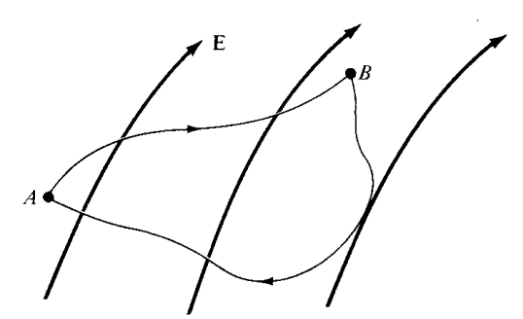

**Figure ‎2.1‑16:** Circulation within Electric Field

Any vector field that satisfies above equations is said to be **conservative**, or **irrotational**. Thus, an electrostatic field is a conservative field. Equations above is referred to as *Maxwell's equation* (the second Maxwell's equation to be derived) for static electric fields; they both depict the conservative nature of an electrostatic field.

From the way we defined potential, $dV=-E.dl$*,* it follows that

$$dV=-E.dl=-E_{x} dx-E_{y} dy-E_{z} dz$$

But

$$dV=\frac{∂V}{∂x}dx+\frac{∂V}{∂y}dy+\frac{∂V}{∂z}dz$$

Comparing the two expressions for $dV$*,* we obtain

$$E_{x}=-\frac{∂V}{∂x}, E_{y}=-\frac{∂V}{∂y} , E_{z}=-\frac{∂V}{∂z}$$

Thus

$$E=-∇V$$

## AN ELECTRIC DIPOLE AND FLUX LINES

An electric dipole is created by placing two point charges with equal magnitude but opposing signs close together. Examine the dipole shown in Figure 4.20. The potential at point P, located at coordinates $\left(r,θ,ϕ\right)$ is expressed as



**Figure ‎2.1‑17:** Electric Dipole

$$V_{+}=\frac{+Q}{4πϵ_{o}} \frac{1}{r_{1}} Electric Potential due to positive charge$$

$$V_{-}=\frac{-Q}{4πϵ_{o}} \frac{1}{r_{2}} Electric Potential due to negative charge$$

$$V=\frac{+Q}{4πϵ_{o}} \frac{1}{r_{1}}+\frac{-Q}{4πϵ_{o}} \frac{1}{r_{2}}=\frac{Q}{4πϵ_{o}} \left[\frac{1}{r_{1}}-\frac{1}{r_{2}}\right]$$

$$V=\frac{Q}{4πϵ_{o}} \left[\frac{r_{2}-r_{1}}{r_{1}r_{2}}\right]$$

Where $r_{1}$ and $r_{2}$ are the distances between P and +Q and P and -Q, respectively If $r≫d,r_{2}-r_{1}=d cosθ, r_{2}∙r_{1}=r^{2}$, and eq. (4.77) becomes

$$V=\frac{Q}{4πϵ_{o}} \left[\frac{d cosθ}{r^{2}}\right]$$

Since $d cosθ=d.a_{r}$, where $d=d.a_{z}$*,* if we define

$$p=Qd$$

$$V=\frac{1}{4πϵ_{o}} \left[\frac{P.a_{r}}{r^{2}}\right]$$

$$V=\frac{P.a_{r}}{4πϵ_{o}r^{2}}$$

To find the electric field intensity

$$E=-∇V$$

$$E=-\left[\frac{∂V}{∂r}a_{r}+\frac{1}{r}\frac{∂V}{∂θ}a_{θ}\right]$$

$$E=-\left[\frac{∂}{∂r}\left(\frac{Q}{4πϵ_{o}} \left[\frac{d cosθ}{r^{2}}\right]\right)a_{r}+\frac{1}{r}\frac{∂}{∂θ}\left(\frac{Q}{4πϵ_{o}} \left[\frac{d cosθ}{r^{2}}\right]\right)a_{θ}\right]$$

$$E=-\frac{Q}{4πϵ_{o}}\left[\frac{∂}{∂r}\left(\frac{d cosθ}{r^{2}} \right)a_{r}+\frac{1}{r}\frac{∂}{∂θ}\left(\frac{d cosθ}{r^{2}} \right)a_{θ}\right]$$

$$E=-\frac{Q}{4πϵ_{o}}\left[\frac{-d cosθ×2r}{r^{4}}a_{r}+\frac{1}{r}\frac{-d sinθ}{r^{2}}a_{θ}\right]$$

$$E=-\frac{Q}{4πϵ_{o}}\left[\frac{-d cosθ×2}{r^{3}}a_{r}-\frac{dsinθ}{r^{3}}a_{θ}\right]$$

$$E=\frac{Qd}{4πϵ_{o}r^{3}}\left\{2 cosθ a_{r}+d sinθ a_{θ}\right\}$$

$$E=\frac{P}{4πϵ_{o}r^{3}}\left\{2 cosθ a_{r}+d sinθ a_{θ}\right\}$$

An **electric flux line** is a conceptual trajectory or line that is shown in a manner that its orientation at any given position corresponds to the direction of the electric field at that specific place.

|  |
| --- |
|  |
| enter image description here |

**Figure ‎2.1‑18:** Electric Flux Lines

## ENERGY DENSITY IN ELECTROSTATIC FIELDS

In order to determine the electrical energy contained inside a collection of electric charges, it is necessary to first calculate the quantity of work required to build them. Let's consider the task of placing three-point charges, $Q_{1}$, $Q_{2}$, and $Q_{3}$, in an area that is originally empty, as seen in Figure ‎2.1‑19

**Figure ‎2.1‑19:** Energy available in an assembly of charges

No effort is necessary to move $Q_{1}$ from an infinite distance to $P_{1}$ since the space initially has no charge and there is no electric field present [ hence W = 0]. While $Q_{1}$, is present, the amount of effort required to move $Q_{2}$, from infinity to $P_{2}$ is equal to the product of $Q_{2}$ and the potential $V_{21}$ at $P_{2}$ caused by $Q_{1}$. Similarly, the amount of effort required to position $Q_{2}$ at $P_{3}$ is given by the equation $Q_{3}\left(V_{31}+V_{32}\right)$, where $V_{32}$ and $V_{31}$ represent the potentials at $P_{3}$ caused by $Q_{2}$ and $Q_{1}$, respectively. Therefore, the whole work performed in arranging the three charges is

$$W_{E}=W_{1}+W_{2}+W_{3}$$

$$W_{E}=0+{Q_{2}V}_{21}+Q_{3}\left(V_{31}+V_{32}\right)$$

If the charges were arranged in a reversed sequence

$$W_{E}=W_{3}+W_{2}+W_{1}$$

$$W_{E}=0+{Q_{2}V}_{23}+Q_{1}\left(V_{12}+V_{13}\right)$$

where $V_{23}$ is the potential at $P_{2}$ due to $Q_{3}$*, $V_{12}$* and $V_{13}$ are, respectively, the potentials at *P1* due to $Q_{2}$ and $Q_{3}$*.* Adding eqs. Of total work equation in each sequence

|  |
| --- |
| $$W_{E}=0+{Q_{2}V}_{21}+Q_{3}\left(V_{31}+V_{31}\right)$$ |
| + |
| $$W_{E}=0+{Q_{2}V}_{23}+Q_{1}\left(V_{12}+V_{13}\right)$$ |
| = |
| $${2W}_{E}=Q_{1}\left(V_{12}+V_{13}\right)+Q_{2}\left(V_{23}+V_{21}\right)+Q_{3}\left(V_{31}+V_{31}\right)$$ |

$${2W}_{E}=Q_{1}V_{1}+Q_{2}V_{2}+Q_{3}V_{3}$$

Where $V_{1},V_{2}, and V_{3}$ are total potentials at ${ P}_{1},P_{2}, and P_{3}$*,* respectively. In general, if there are *n* point charges, eq. (4.86) becomes

$$W_{E}=\frac{1}{2}\left(Q_{1}V_{1}+Q_{2}V_{2}+Q_{3}V_{3}\right)$$

$$W_{E}=\frac{1}{2}\sum_{k=1}^{n}{Q_{k}V_{k}}$$

If the area has a continuous charge distribution instead of point charges, the summation in equation (4.87) is replaced by integration. In other words,

$$W_{E}=\frac{1}{2}\int_{L}{ρ_{L} V dl}$$

$$W_{E}=\frac{1}{2}\int_{S}{ρ_{S} V dS}$$

$$W_{E}=\frac{1}{2}\int_{v}{ρ_{v} V dv}$$

Since $$∇.D=ρ_{v}$$

Then

$$W_{E}=\frac{1}{2}\int_{v}{\left(∇.D\right)V dv}$$

But as per below identity, for any vector ***D*** and scalar *V*

$$∇.\left(VD\right)=V \left(∇.D\right)+ D.∇V$$

Rearranging above equation will give us the following

$$V\left(∇.D\right)=∇.\left(VD\right)-D.∇V$$

Then upon substituting it in the work equation will give us

$$W_{E}=\frac{1}{2}\int_{v}{\left(∇.D\right)V dv}=\frac{1}{2}\int_{v}{\left\{∇.\left(VD\right)-D.∇V\right\}dv}$$

$$W_{E}=\frac{1}{2}\int_{v}{∇.\left(VD\right)dv}-\frac{1}{2}\int_{v}{D.∇Vdv}$$

Using divergence theorem on the first term on the right side of this equation yields

$$W_{E}=\frac{1}{2}\oint_{s}{\left(VD\right).dS}-\frac{1}{2}\int_{v}{\left(D.∇V\right)dv}$$

Note that V and $D$ vary as 1/r and 1/r2 for point charges, 1/r2 and 1/r3 for dipoles, etc. Thus, $VD$ in the first term on the right side of above equation must vary at least 1/r3 and as r2. As S grows, the first integral in equation must trend to zero. Thus, eq. (4.94) becomes into

$$W_{E}=0-\frac{1}{2}\int_{v}{\left(D.∇V\right)dv}=-\frac{1}{2}\int_{v}{\left(D.∇V\right)dv}$$

Since $$E=-∇V$$

Then

$$W_{E}=\frac{1}{2}\int_{v}{\left(D.E\right)dv}$$

But $$D=ϵ_{o}E$$

$$W_{E}=\frac{1}{2}\int_{v}{\left(ϵ_{o}E.E\right)dv}=W_{E}=\frac{1}{2}\int_{v}{\left(ϵ_{o}E^{2}\right)dv}$$

From this, we can define electrostatic energy density $w_{E}$ (in J/m ) as

$$w_{E}=\frac{{dW}_{E}}{dv}=\frac{1}{2}D.E=W_{E}=\frac{1}{2}ϵ_{o}E^{2}$$

# ELECTRIC FIELDS IN MATERIAL SPACE

In the preceding part, we examined electrostatic fields in a vacuum or an environment free of any materials. Therefore, the progress we have made in electrostatics may be considered as the theory of the "vacuum" field. Similarly, the content we will explore in this part may be seen as the theory of electrical phenomena in physical space.

Electric fields may occur in both free space and material mediums. Materials may be categorized into two main categories based on their electrical properties: conductors and nonconductors. Insulators or dielectrics are the terms often used to describe nonconducting materials. To facilitate comprehension of conduction, electric current, and polarization, a concise overview of the electrical characteristics of materials will be presented.

The following discussion will focus on many key features of dielectric materials, including susceptibility, permittivity, linearity, isotropy, homogeneity, dielectric strength, and relaxation time. This text will introduce the notion of boundary conditions for electric fields that occur in two distinct mediums.

# CONVECTION AND CONDUCTION CURRENTS

Electric current is caused by the electric charges motion within the conductor. The current (in amperes) through a given area is the electric charge passing through the area per unit time in other words it is the time rate of change for the electric charges.

$$I=\frac{dQ}{dt}$$

Thus, in a current of 1 ampere, is the charge is being transferred at a rate of one coulomb per second. We now introduce the concept of *current density* J. If current $ΔI$ flows through a surface $ΔS$*,* the current density is

$$J_{n}=\frac{ΔI}{ΔS}$$

Or

$$ΔI=J_{n}×ΔS$$

assuming that the current density is perpendicular to the surface. If the current density is not normal to the surface

$$ΔI=J.ΔS$$

Thus, the total current

$$I=\int_{s}{J.dS}$$

Current densities may vary depending on the method of creation. These variations include convection current density, conduction current density, and displacement current density. Convection current, in opposition to conduction current, does not need conductors and hence does not conform to Ohm's law. It occurs when an electric current flows through a medium that is not conductive, such as a liquid, a gas with low density, or a vacuum. An electron flow inside a vacuum tube might be referred to as a convection current.

Consider a filament of Figure ‎2.2.1‑1. If there is a flow of charge, of density *pv,* at velocity **u** = *y,* from eq. (5.1), the current through the filament is

**Figure ‎2.2.1‑1**: Convection Current through filament

$$I=\frac{ΔQ}{Δt}$$

$$I=\frac{ΔQ}{Δt}=\frac{ρ_{v} Δv}{Δt}=\frac{ρ_{v} ΔS×Δl}{Δt}=ρ_{v} ΔS×\frac{Δl}{Δt}=ρ_{v} ΔS u_{y}$$

The current density at a given point is the current through a unit normal area at that

point. The y-directed current density $J_{y}$ is given by

$$J_{y}=\frac{ΔI}{ΔS}=\frac{ρ_{v} ΔS u_{y}}{ΔS}=ρ_{v} u_{y}$$

Hence, in general

$$J=ρ_{v} u$$

The current I is the convection current, and $J$ is the convection current density in amperes/square meter (A/m2).

Conduction current requires a conductor. A conductor is characterized by a large number of free electrons that provide conduction current due an impressed electric field. When an electric field $E$ is applied, the force $F$ on an electron with charge $-e$ is

$$F=-e E$$

Due to the electron being in a non-vacuum environment, it will not experience acceleration when subjected to the electric field. Instead, it experiences many collisions with the atomic lattice and moves from one atom to another. According to Newton's rule, the average change in momentum of a free electron, with mass m, traveling in an electric field E with an average drift velocity u, must be equal to the applied force. Therefore,

$$\frac{mu}{τ}=-e E$$

Or

$$u=-\frac{eτ }{m}E$$

where $τ$ is the average time interval between collisions. This implies that the velocity at which the electron moves due to an electric field is precisely proportional to the strength of the field. The electronic charge density may be expressed as the product of the number of electrons per unit volume, denoted as n, and the charge of each electron.

$$ρ_{v}=-ne$$

Thus, the *conduction current density* is

$$J=ρ_{v} u=\left(-ne\right) ×\left(-\frac{eτ }{m}E\right)=\left(\frac{{n e}^{2}τ }{m}\right)E=σE$$

$$J=σE$$

Where $σ=\frac{{n e}^{2}τ }{m}$ is the conductivity of the conductor

# Conductors and Ohm’s Law

A conductor contains an excess of charge that is free to move. Consider an isolated conductor, as shown in **Figure ‎2.2.1‑1** below. When an external electric field, $E_{e}$, is applied, the positive free charges are pushed in the same direction as the applied field, while the negative free charges go the other way. This charge movement occurs quite fast.

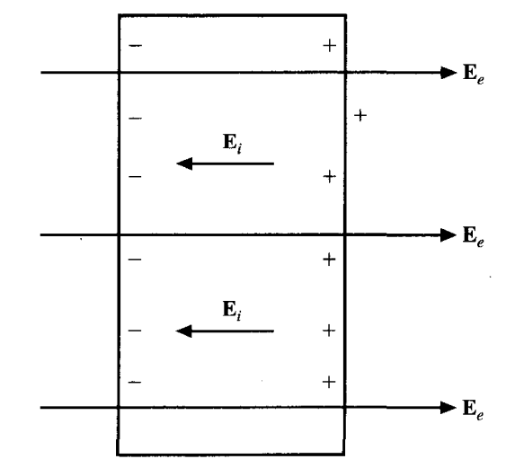

**Figure ‎2.2.2‑1:** Isolated Conductor subjected to Electric Field

Consequently, the free charges do (2) two things:

1- Initially, they accumulate on the conductor's surface and generate an induced surface charge.   
2. Subsequently, the induced charges establish an internal induced field $E_{i}$ that negates the externally applied field $E_{e}$. Figure ‎2.2.2‑2 below illustrates the outcome.

**Figure ‎2.2.2‑2:** Isolated Conductor at Equilibrium State

This leads to an important property and critical characteristic of a conductor:

A **perfect conductor or ideal conductor** cannot contain an electrostatic field inside it, and a conductor is called an *equipotential* body, implying that the potential is the same everywhere in the conductor. This is based on the fact that

$$E=-∇V=0$$

Another perspective to explore is to examine Ohm's law,

$$J=σE$$

To maintain a finite current density $J$, in a perfect conductor the conductivity is high ($σ ⟶ ∞$), and this consequently requires that the electric field inside the conductor (internal induced field $E_{i} )$ must vanish. In other words, $E ⟶ 0$ because ($σ ⟶ ∞$), in a perfect conductor.

$$E=\frac{J}{σ}=\frac{J}{∞}=0$$

Should any charges be added within such a conductor, the charges will migrate to the surface and rapidly spread themselves so that the field inside the conductor disappears. According to Gauss's law $∇.D=ρ_{v}⇒∇.E={ρ_{v}}/{ϵ_{o}}$, if there is no electric field ($E=0$), the charge density $ρ_{v}$ must be zero. Once again, we may deduce that a perfect conductor is incapable of confining an electric field inside its boundaries. When there are no changes or movements occurring (in other words under static conditions)

We now consider a conductor whose ends are maintained at a potential difference V, as shown in Figure ‎2.2.2‑3.

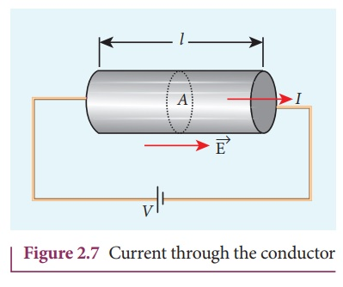

**Figure ‎2.2.2‑3**: Conductor Connected with Battery

Note that in this case, the electric filed inside the conductor does not equal to zero (E ≠ 0, as in **Figure ‎2.2.2‑2**. But the question is what is the difference?

The answer is that in **Figure ‎2.2.2‑3** there is no static equilibrium because the conductor is not isolated but it is wired to an electromotive force source which is the DC battery, which compels and forces free charges to migrate and prevents electrostatic equilibrium, so an electric field must exist within the conductor to sustain the current flow. As the electrons undergo motion, they experience resistance, which refers to the dampening forces that act upon them. Based on Ohm's law $J=σE$, we will derive the resistance of the conductor.

Suppose the conductor has a length $l$ and a uniform cross-sectional area $S$ as shown in Figure ‎2.2.2‑4. The direction of the produced electric field $E$ is in the same direction of the flow of positive (+ve) charges or conventional current $I$. This direction is opposite to the direction of the flow of negative (-ve) charges which is the electrons e.

Figure ‎2.2.2‑4: Ohm's Law Example with Uniform Conductor

The electric field applied will be uniform and its magnitude is given by

$$V_{AB}=V_{B}-V_{A}=\frac{W}{Q}=-\int_{A}^{B}{E.dl}=\int_{B}^{A}{E.dl}=E l$$

$$E=\frac{V}{l}$$

Since the conductor has a uniform cross section $S$, then the current density $J$ is

$$J=\frac{I}{S}$$

But $$J=\frac{I}{S}=σE=σ\left(\frac{V}{l}\right)$$

Hence

$$\frac{I}{S}=σ\frac{V}{l}⇒V=\left(\frac{l}{σS}\right)I=R I$$

$$V=R I Ohm^{'}sLaw$$

$$R=\frac{V}{I}=\frac{l}{σS}=\frac{ρl}{S}$$

$$\frac{1}{σ}=ρ$$

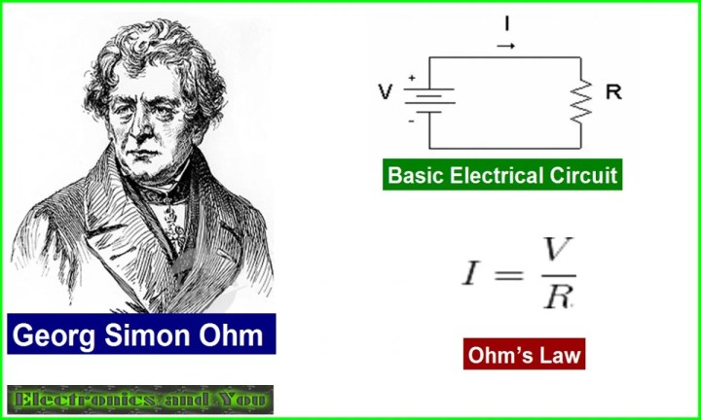

Where $ρ$ = $\frac{1}{σ}$ is the resistivity of the material. The Equation above is valid in determining the resistance of any conductor of uniform cross-sectional area. However, If the cross section of the conductor is **not** uniform, the above equation is not valid. Then, the basic definition of resistance R as the ratio of the potential difference $V$ between the two ends of the conductor to the current $I$ passing through the conductor will be applied. Therefore, and the resistance of a conductor of nonuniform cross section will be as per below:

$$R=\frac{V}{I}=\frac{\int{E.dl}}{\int{J.ds}}=\frac{\int{E.dl}}{\int{σE.dS}}$$

Power *P* (in watts) is defined as the time rate of change of energy *W* (in joules) or force times velocity. Hence,

$$P=\int{F.u}=\int{dQ E.u}=\int{ρ_{v}dvE.u}$$

But the electric force on charge is

$$F=Q E=\int{dQ E}$$

Substituting in Power equation, we will get

$$P=\int{F.u}=\int{dQE.u}=\int{ρ_{v}dvE.u}$$

Rearranging

$$P=\int{E.ρ_{v}udv}$$

But remember that the current density $$J=ρ_{v} u$$

$$P=\int{E.J dv}$$

Which is known as *Joule's law.* The power density *wP* (in watts/m3) is given by the integrand in eq. (5.18); that is,

$$w_{p}=\frac{dP}{dv}=E.J=E.σE=σ{\left|E\right|}^{2}$$

For a conductor with uniform cross section, $dv=ds dl$*,* so eq. (5.18) becomes

$$P=\int{E.J ds dl}$$

$$P=\int_{L}{E. dl}\int_{s}{J. ds}$$

$$P=V I$$

# POLARIZATION IN DIELECTRICS

The most significant difference between a conductor and a dielectric lies in the presence or absence of unbound electrons in the outermost atomic shells, which enable the conduction of electric current. While charges in a dielectric cannot move freely, they are nevertheless subject to finite forces. Therefore, it is reasonable to predict a displacement when an external force is applied.

In order to comprehend the overall impact of an electric field on a dielectric at a larger scale, it is helpful to see an atom inside the dielectric as comprising of a negative charge *- Q* (electron cloud) and a positive charge *+Q* (nucleus), as shown in the scenario. *Figure ‎2.2.3‑1* (a). An analogous representation may be used to a dielectric molecule, where the nuclei inside the molecules are seen as point charges and the electronic arrangement is considered as a single cloud of negative charge.

Due to an equal distribution of positive and negative charge, the whole atom or molecule maintains electrical neutrality. Then, when an electric field E is applied on the dielectric molecule, the positive charge inside the dielectric is displaced from its equilibrium position in the same direction of $E$ by the electrostatic force $F_{+}= QE$ while the negative charge is displaced in the opposite direction by the electrostatic force $F_{-}= QE$.

As a result of this deformation, an electric dipole is created from the displacement of the charges and the dielectric then is said to be polarized. In the polarized state, the electron cloud is distorted by the applied electric field $E$. This distorted charge distribution is equivalent, by the principle of superposition, to the original distribution plus a dipole whose moment is

$$p=Qd$$

Where $d$ is the distance vector directed from $-Q$ to $+Q$ of the dipole as in Figure ‎2.2.3‑1(b).Now, If there are N number of dipoles in a volume $∆v$ of the dielectric, the total dipole moment due to the electric field is the summation of the induvial dipoles

$$Q_{1}d_{1}+Q_{2}d_{2}+Q_{3}d_{3}+…+Q_{N}d_{N}=\sum_{k=1}^{N}{Q_{k}d_{k}}=\sum_{k=1}^{N}{p_{k}}$$

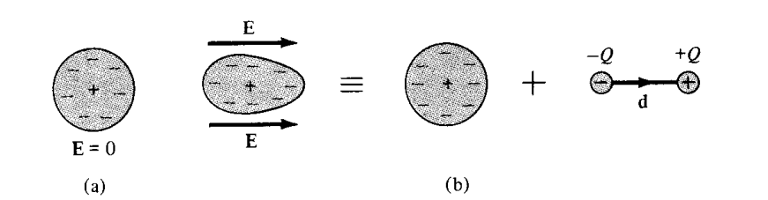

Figure ‎2.2.3‑1: (a) Atom without External E (b) Atom Subjected to E and dipole Formation

As a measure of intensity and the strength of the polarization, we will define polarization (in C/m2) as the dipole moment per unit volume $∆v$ of the dielectric; that is,

$$P=\lim_{∆v→0}{\sum_{k=1}^{N}{\frac{Q_{k}d_{k}}{∆v}}}=\lim_{∆v→0}{\sum_{k=1}^{N}{\frac{p_{k}}{∆v}}}$$

Thus, we can conclude that the major effect of the applied electric field E on a dielectric is the creation of dipole moments that align themselves in the same direction of E.

Let us now calculate the electric potential at point P due to a polarized dielectric. Consider the dielectric material shown in *Figure ‎2.2.3‑2* as consisting of dipoles with dipole moment **P** per unit volume .

**Figure ‎2.2.3‑2:** Dielectric Material

The electric potential $V$ at an exterior point O due to the dipole moment $P dv^{'}$ is given as below

$$V=\frac{p.a_{R}}{4πϵ_{o}R^{2}}$$

But

$$P=\lim_{∆v→0}{\sum_{k=1}^{N}{\frac{p_{k}}{∆v}}}⇒p_{k}=P ∆v$$

Thus

$$dV=\frac{P.a_{R}}{4πϵ_{o}R^{2}}dv^{'}=\frac{P.R}{4πϵ_{o}R^{3}}dv^{'}$$

From the position vector of the polarized material and point where we are calculating the electric potential

$$R=r-r^{'}=\left(x-x^{'}\right)a_{x}+\left(y-y^{'}\right)a_{y}+\left(z-z^{'}\right)a_{z}$$

$$\left|R\right|=\sqrt{{\left(x-x^{'}\right)}^{2}+{\left(y-y^{'}\right)}^{2}+{\left(z-z^{'}\right)}^{2}}$$

Solving the gradient of *1/R*

$$∇^{'}\left(\frac{1}{R}\right)=\frac{∂\left(\frac{1}{R}\right)}{∂x}a_{x}+\frac{∂\left(\frac{1}{R}\right)}{∂y}a_{y}+\frac{∂\left(\frac{1}{R}\right)}{∂z}a_{z}$$

$$∇^{'}\left(\frac{1}{R}\right)=\frac{-1×\frac{∂\left(R\right)}{∂x^{'}}}{R^{2}}a_{x}+\frac{-1×\frac{∂\left(R\right)}{∂y^{'}}}{R^{2}}a_{y}+\frac{-1×\frac{∂\left(R\right)}{∂z^{'}}}{R^{2}}a_{z}$$

$$∇^{'}\left(\frac{1}{R}\right)=\left\{\frac{-1×\frac{2\left(x-x^{'}\right)×\left(-1\right)}{2R}}{R^{2}}\right\}a_{x}+\left\{\frac{-1×\frac{2\left(y-y^{'}\right)×\left(-1\right)}{2R}}{R^{2}}\right\}a_{y}+\left\{\frac{-1×\frac{2\left(z-z^{'}\right)×\left(-1\right)}{2R}}{R^{2}}\right\}a_{z}$$

$$∇^{'}\left(\frac{1}{R}\right)=\frac{\left(x-x^{'}\right)}{R^{3}}a_{x}+\frac{\left(y-y^{'}\right)}{R^{3}}a_{y}+\frac{\left(z-z^{'}\right)}{R^{3}}a_{z}$$

$$∇^{'}\left(\frac{1}{R}\right)=\frac{1}{R^{3}}\left\{\left(x-x^{'}\right)a_{x}+\left(y-y^{'}\right)a_{y}+\left(z-z^{'}\right)a_{z}\right\}$$

$$∇^{'}\left(\frac{1}{R}\right)=\frac{R}{R^{3}}=\frac{a_{R}}{R^{2}}$$

Substituting above equation in the differential potential equations

$$dV=\frac{1}{4πϵ_{o}}\left\{\frac{P.a_{R}}{R^{2}}\right\}dv^{'}=\frac{1}{4πϵ_{o}}\left\{P.\frac{a_{R}}{R^{2}}\right\}dv^{'}=\frac{1}{4πϵ_{o}}\left\{P∙∇^{'}\left(\frac{1}{R}\right)\right\}dv^{'}$$

Applying the vector identity below

$$∇^{'}∙\left(\frac{1}{R}P\right)=\frac{1}{R}\left(∇^{'}∙P\right)+P∙∇^{'}\left(\frac{1}{R}\right)$$

Thus

$$P∙∇^{'}\left(\frac{1}{R}\right)=∇^{'}∙\left(\frac{1}{R}P\right)-\frac{1}{R}\left(∇^{'}∙P\right)$$

$$dV=\frac{1}{4πϵ_{o}}\left\{P∙∇^{'}\left(\frac{1}{R}\right)\right\}dv^{'}$$

$$dV=\frac{1}{4πϵ_{o}}\left\{∇^{'}∙\left(\frac{1}{R}P\right)-\frac{1}{R}\left(∇^{'}∙P\right)\right\}dv^{'}$$

$$V=\int{dV}=\int{\frac{1}{4πϵ_{o}}\left\{∇^{'}∙\left(\frac{1}{R}P\right)-\frac{1}{R}\left(∇^{'}∙P\right)\right\}dv^{'}}$$

$$V=\frac{1}{4πϵ_{o}}\int{\left\{∇^{'}∙\left(\frac{1}{R}P\right)-\frac{1}{R}\left(∇^{'}∙P\right)\right\}dv^{'}}$$

$$V=\frac{1}{4πϵ_{o}}\left\{\int_{v^{'}}{\left\{∇^{'}∙\left(\frac{1}{R}P\right)\right\}dv^{'}}-\int_{v^{'}}{\left\{\frac{1}{R}\left(∇^{'}∙P\right)\right\}dv^{'}}\right\}$$

By applying divergence theorem to the first term on the right-hand side of this equation, we have

$$V=\frac{1}{4πϵ_{o}}\left\{\oint_{s^{'}}{\frac{1}{R}P}.dS^{'}-\int_{v^{'}}{\left\{\frac{1}{R}\left(∇^{'}∙P\right)\right\}dv^{'}}\right\}$$

$$V=\left\{\oint_{s^{'}}{\frac{P.a_{n}}{4πϵ_{o}R}dS^{'}}+\int_{v^{'}}{\left\{\frac{-\left(∇^{'}∙P\right)}{4πϵ_{o}R}\right\}dv^{'}}\right\}$$

where a'n represents the outward unit normal vector to the surface dS' of the dielectric. By comparing the terms on the right side of equation (5.26) with equations (4.68) and (4.69), it can be seen that these terms represent the potential caused by surface and volume charge distributions, with densities (after removing the primes).

$$V=\frac{1}{4πϵ_{o}}\int_{S}{\frac{ρ_{S} dS^{'} }{r}} surface charge$$

$$V=\frac{1}{4πϵ_{o}}\int_{v}{\frac{ρ_{v} dv^{'}}{r}} volume charge$$

$$ρ_{ps}=P.a_{n}$$

$$ρ_{pv}=-∇∙P$$

In other words, eq. (5.26) reveals that where polarization occurs, an equivalent volume charge density $ρ_{pv}$ is formed throughout the dielectric while an equivalent surface charge density $ρ_{ps}$ is formed over the surface of the dielectric. We refer to $ρ_{ps}$ and $ρ_{pv}$ as *bound* (or *polarization) surface* and *volume charge densities,* respectively, as distinct from

*free* surface and volume charge densities *ps* and *pv.* Bound charges refer to charges that are immobile inside the dielectric material. These charges arise due to the molecular displacement that takes place during polarization. Free charges refer to electrons in a conductor that have the ability to move across a significant distance. These charges are the ones that we have influence over.

The net positive charge on the surface S that encloses the dielectric is

$$Q_{b}=\oint_{s}{P.dS}=\int{ρ_{PS} dS}$$

while the charge that remains inside *S* is

$$-Q_{b}=-\int_{v}{∇∙P}=\int_{v}{ρ_{Pv} dv}$$

Thus, the total electric charge of the dielectric material will remain zero, that is,

$$Total charge=\oint{ρ_{PS} dS}+ \int_{v}{ρ_{Pv} dv}=Q_{b}-Q_{b}=0$$

This is expected because the dielectric was electrically neutral before polarization.

We now consider the case in which the dielectric region contains free charge. If *pv* is the free charge volume density, the total volume charge density *p,* is given by

$$ρ_{t}=ρ_{v}+ρ_{Pv}=∇.ϵ_{o}E$$

$$ρ_{v}=ρ_{t}-ρ_{Pv}=∇.ϵ_{o}E-ρ_{Pv}$$

$$ρ_{v}=ρ_{t}-ρ_{Pv}=∇.ϵ_{o}E-\left(-∇∙P\right)$$

$$ρ_{v}=ρ_{t}-ρ_{Pv}=∇.ϵ_{o}E+∇∙P$$

$$ρ_{v}=ρ_{t}-ρ_{Pv}=∇.\left(ϵ_{o}E+P\right)$$

But we know that as per Gauss’s law and divergence theorem

$$∇.D=ρ_{v}$$

$$ρ_{v}=ρ_{t}-ρ_{Pv}=∇.\left(ϵ_{o}E+P\right)=∇.D$$

$$D=ϵ_{o}E+P$$

But for sine dielectric P is proportional to the applied electric field E, then the polarization can be mathematically written as below

$$P=χ_{e}ϵ_{o}E$$

where $χ_{e}$, defined as the electric susceptibility of the material, is essentially an indicator of how sensitive (or susceptible) a certain dielectric is to electric fields. Then

$$D=ϵ_{o}E+χ_{e}ϵ_{o}E$$

$$D=ϵ_{o}\left(1+χ_{e}\right)E$$

Let $ϵ_{r}=1+χ_{e}$

Then

$$D=ϵ_{o}ϵ_{r}E$$

$$D=ϵ E$$

$$ϵ=ϵ_{o}ϵ_{r}$$

$$ϵ_{r}=1+χ_{e}=\frac{ϵ}{ϵ_{o}}$$

$ϵ$ is called the permittivity of the dielectric, while $ϵ_{r}$ is called the dielectric constant or relative permittivity, while $ϵ_{o}$ is the permittivity of free space, and it is as approximately $10^(-9)/36π$ F/m,

# CONTINUITY EQUATION AND RELAXATION TIME

According to the concept of charge conservation, the rate at which charge decreases inside a certain volume ∆v must be equal to the total current flowing out of the closed surface surrounding the volume. The current $I_{out}$ exiting the enclosed surface is

$$I_{out}=\oint_{s}{J.dS}=-\frac{dQ_{in}}{dt}$$

Where *Qin* is the total charge enclosed by the closed surface.

Figure ‎2.2.4‑1: Continuity of Current through volume

Invoking divergence theorem

$$\oint_{s}{J.dS}=\int_{v}{\left(∇.J\right) dv}$$

But

$$-\frac{dQ_{in}}{dt}=-\frac{d}{dt}\left(\int_{v}{ ρ_{v}dv}\right)=-\int_{v}{\frac{∂ρ_{v}}{∂t}dv }$$

$$\oint_{s}{J.dS}=-\frac{dQ_{in}}{dt}$$

$$\int_{v}{\left(∇.J\right) dv}=-\int_{v}{\frac{∂ρ_{v}}{∂t}dv }$$

Since both volume integrals are equal, then

$$∇.J=-\frac{∂ρ_{v}}{∂t}$$

The equation that describes the continuity of current is referred to as the continuity of current equation. It is important to note that the continuity equation is derived from the concept of conservation of charge. It simply asserts that there cannot be any accumulation of charge at any place. For steady currents, $\frac{∂ρ_{v}}{∂t}$ = 0 and hence $∇.J=0$ showing that the total charge leaving a volume is the same as the total charge entering it. Kirchhoff's current law follows from this.

We make use of eq. (5.43) in conjunction with Ohm's law

$$J=σE$$

As per Gauss’s law

$$∇.D=ρ_{v}⇒but D=ϵ_{o} E$$

$$∇.ϵ_{o}E=ρ_{v}$$

$$∇.E=\frac{ρ_{v}}{ϵ_{o}}$$

$$∇.J=-\frac{∂ρ_{v}}{∂t}⇒∇.σE=-\frac{∂ρ_{v}}{∂t}$$

But

$$∇.E=\frac{ρ_{v}}{ϵ_{o}}$$

Multiplying both sides with $σ$

$$σ×∇.E=σ×\frac{ρ_{v}}{ϵ_{o}}$$

$$∇.σE=\frac{{σρ}_{v}}{ϵ_{o}}$$

But

$$∇.σE=-\frac{∂ρ_{v}}{∂t}$$

Then

$$-\frac{∂ρ_{v}}{∂t}=\frac{{σρ}_{v}}{ϵ_{o}}$$

$$\frac{∂ρ_{v}}{∂t}+\frac{{σρ}_{v}}{ϵ_{o}}=0$$

This is first order differential equation which can be solved using separable

$$\frac{∂ρ_{v}}{∂t}=-\frac{{σρ}_{v}}{ϵ_{o}}$$

$$\frac{1}{ρ_{v}}∂ρ_{v}=-\frac{σ}{ϵ_{o}}∂t$$

Integrating both sides

$$\int{\frac{1}{ρ_{v}}∂ρ_{v}}=\int{-\frac{σ}{ϵ_{o}}∂t}$$

$$\ln{ρ_{v}}=-\frac{σ}{ϵ_{o}}t+C$$

Taking e for both sides

$$e^{\ln{ρ_{v}}}=e^{-\frac{σ}{ϵ_{o}}t}+e^{C}$$

$$ρ_{v}\left(t\right)=ρ_{v0}e^{-\frac{σ}{ϵ_{o}}t}$$

$$ρ_{v}\left(t\right)=ρ_{v0} e^{-\frac{t}{T_{r}}}$$

In the equation provided, $ρ_{v0}$ represents the initial charge density, specifically the charge density at time t = 0. The equation demonstrates that the introduction of charge at an internal location of the material leads to a decrease in the volume charge density $ρ_{v}$. The deterioration is accompanied by the migration of electric charge from the initial site of introduction to the surface of the material. The time constant Tr, measured in seconds, is referred to as the relaxation time or rearrangement time.

# BOUNDARY CONDITIONS

So far, we have examined the presence of the electric field in a uniform medium. Boundary conditions refer to the criteria that a field must meet at the interface between two distinct media within an area. These requirements are useful for finding the field on one side of the boundary if the field on the other side is already known. The criteria will be determined by the composition of the media materials. Let us examine the boundary conditions for an interface that separates

• Dielectric ($ϵ_{r1}$) and dielectric *($ϵ_{r2}$)*

*•* Conductor and dielectric

• Conductor and free space

To determine the boundary conditions, we need to use Maxwell's equations:

$$\oint_{s}{D .dS}=Q_{enc}$$

and

$$\oint_{L}{E .dl}=0$$

Additionally, it is necessary to break down the electric field intensity E into two mutually perpendicular components:

$$E=E_{t}+E_{n}$$

where Et and *En* are, respectively, the tangential and normal components of E to the interface of interest. A similar decomposition can be done for the electric flux density D.

$$D=D_{t}+D_{n}$$

# Dielectric-Dielectric Boundary Conditions

Consider the E field existing in a region consisting of two different dielectrics characterized by $ϵ_{1}=ϵ_{r1}ϵ_{o}$ and $ϵ_{2}=ϵ_{r2}ϵ_{o}$ as shown in Figure 5.10(a). *E1* and E2 in media 1 and 2, respectively, can be decomposed as

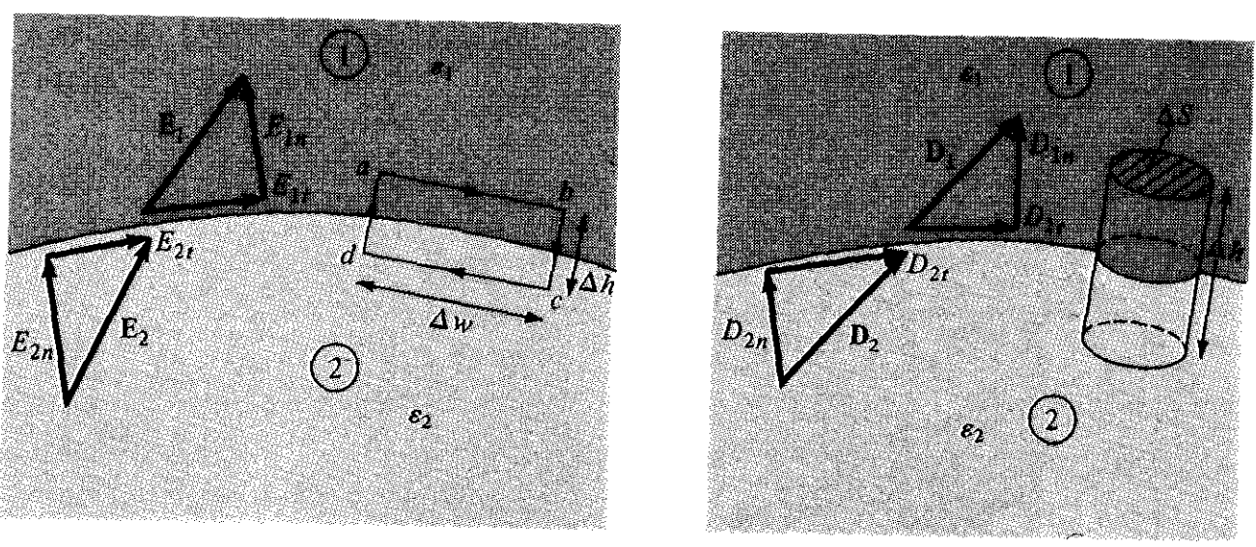

Figure ‎2.2.5.1‑1: Dielectric-Dielectric Boundary Condition

$\oint_{L}{E .dl}=0$

Applying the circulation of $E .dl$ to the closed path $a⟶b⟶c⟶d⟶a$

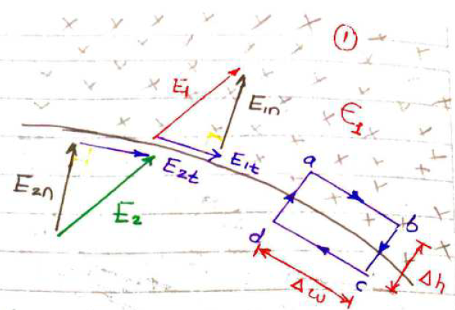



Figure ‑: Circulation of Electric Field Intensity along path a,b,c,d,a

$$\oint_{L}{E .dl}=E_{1t} ∆w\cos{0^{o}}+E_{1n} \frac{∆h}{2}\cos{{180}^{o}}+E_{2n} \frac{∆h}{2}\cos{{180}^{o}}+E_{2t} ∆w\cos{{180}^{o}}+E_{2n} \frac{∆h}{2}\cos{0^{o}}+E_{1n} \frac{∆h}{2}\cos{0^{o}}=$$

$$E_{1t} ∆w-E_{1n} \frac{∆h}{2}-E_{2n} \frac{∆h}{2}-E_{2t} ∆w+E_{2n} \frac{∆h}{2}+E_{1n} \frac{∆h}{2}=0$$

$$E_{1t} ∆w-E_{2t} ∆w=0$$

$$E_{1t} ∆w=E_{2t} ∆w$$

$$E_{1t} =E_{2t}$$

The tangential components of E are the same on the two sides of the boundary. In other words, $E_{t}$ undergoes no change on the boundary and it is said to be continuousacross the boundary

$$D=ϵ E⇒E=\frac{D}{ϵ }$$

$$E_{1t} =E_{2t}$$

$$\frac{D_{1t}}{ϵ_{1}} =\frac{D_{2t}}{ϵ_{2}}$$

The tangential component of D undergoes some changes on the boundary, and it is said to be discontinuousacross the boundary

$\oint_{s}{D .dS}=Q_{enc}$

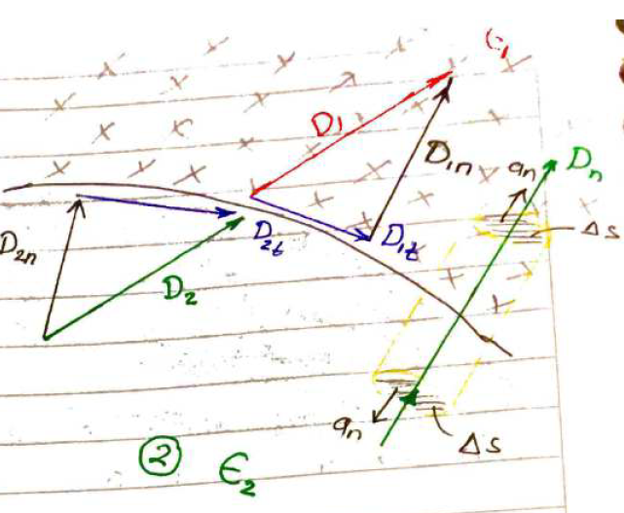



Figure ‎2.2.5.1‑3: Gauss's Law application for Dielectric-Dielectric

$$\oint_{s}{D .dS}=D_{1n} ∆s\cos{0^{o}}+D_{2n} ∆s\cos{{180}^{o}}=Q_{enc}=ρ_{s}∆s$$

$$D_{1n} ∆s-D_{2n} ∆s=ρ_{s}∆s$$

$$D_{1n} -D_{2n} =ρ_{s}$$

If no free charge is available at the interface

$$D_{1n} -D_{2n} =0$$

$$D_{1n}=D_{2n}$$

The normal component of D undergoes no changes on the boundary, and it is said to be continuousacross the boundary

$$D=ϵ E$$

$$ϵ_{1}E_{1n}={ϵ_{2}E}_{2n}$$

**Law of Refraction**

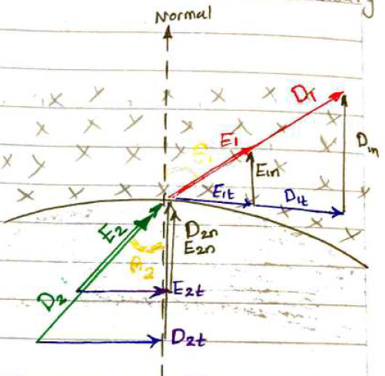

Figure ‎2.2.5.1‑4: Law of Refraction for Dielectric-Dielectric

From $\oint_{L}{E .dl}=0$

$$E_{1t} =E_{2t}$$

$$E_{1}\sin{θ_{1}} =E_{2} \sin{θ_{2}}------\left(1\right)$$

From $\oint_{s}{D .dS}=Q_{enc}$

$$D_{1n}=D_{2n}$$

$$ϵ_{1}E_{1n}={ϵ_{2}E}_{2n}$$

$$ϵ_{1}E_{1}\cos{θ_{1}}={ϵ_{2}E}_{2} \cos{θ_{1}}--------\left(2\right)$$

Dividing Equation (1) by (2)

$$\frac{E_{1}\sin{θ_{1}} }{ϵ_{1}E_{1}\cos{θ_{1}}}=\frac{E_{2} \sin{θ_{2}}}{{ϵ_{2}E}_{2} \cos{θ_{1}}}$$

$$\frac{\tan{θ_{1}} }{ϵ_{1}}=\frac{ \tan{θ_{2}}}{ ϵ_{2}}$$

$$\frac{\tan{θ_{1}} }{\tan{θ_{2}}}=\frac{ϵ_{1}}{ϵ_{2}}$$

# ELECTROSTATIC BOUNDARY-VALUE PROBLEMS

In previous chapters, the method for calculating the electric field E has often included either using Coulomb's law or Gauss's law when the charge distribution is known, or utilizing the equation $E=-∇V$ when the potential V is known throughout the whole area. However, in most real-life scenarios, both the distribution of charges and the distribution of potentials are often unknown.

# POISSON'S AND LAPLACE'S EQUATIONS

Poisson's and Laplace's equations are easily derived from Gauss's law (for a linear mater-ial medium)

$$∇.D=ρ_{v}⇒∇.ϵE=ρ_{v}$$

And

$$E=-∇V$$

Hence, substituting

$$∇.ϵ \left(-∇V\right)=ρ_{v}$$

$$∇. \left(∇V\right)=-\frac{ρ_{v}}{ϵ}$$

$$∇^{2}V=-\frac{ρ_{v}}{ϵ}$$

This is known as *Poisson's equation. A* special case of this equation occurs when pv = 0 (i.e., for a charge-free region). Equation (6.4) then becomes

$$∇^{2}V=0$$

# GENERAL PROCEDURE FOR SOLVING POISSON'S OR LAPLACE'S EQUATION

The following general procedure may be taken in solving a given boundary-value problem involving Poisson's or Laplace's equation:

1. Solve Laplace's (if $ρ_{v}=0$) or Poisson's (if $ρ_{v}≠0$) equation using either (a) direct integration when V is a function of one variable, or (b) separation of variables if V is a function of more than one variable. The solution at this point is not unique but expressed in terms of unknown integration constants to be determined.

2. Apply the boundary conditions to determine a unique solution for V. Imposing the

given boundary conditions makes the solution unique.

3. Having obtained V, find E using $E=-∇V$ and D from D = eE.

4. If desired, find the charge Q induced on a conductor using Q = J ps dS where ps — Dn and Dn is the component of D normal to the conductor. If necessary, the

capacitance between two conductors can be found using C = Q/V.

# Solving Poisson’s Equation for Cartesian Coordinate System

In high-voltage power equipment, it is necessary to cool the components that transport electric current in order to dissipate the heat generated by ohmic losses. An electric field is used to impart force to the cooling fluid, hence serving as a method of pumping. Figure 6.1 depicts the modeling of electrohydrodynamic (EHD) pumping. The space between the electrodes is filled with a consistent charge p0, which is created at the left electrode and collected at the right electrode. Determine the pump's pressure given that the initial pressure (po) mC per cubic meter and the initial volume (Vo).

This problem is a boundary value problem involving piosson’s or Laplace equation and below is the procedure of solving such problem in cartesian coordinate system

1. Solve Laplace’s equation (if $ρ_{v}=0$) or Poisson’s equation (if $ρ_{v} ≠0$)

Now, in above problem since $ρ_{v} ≠0$ we apply Poisson’s equation

$$∇^{2}V=-\frac{ρ_{v}}{ϵ}$$

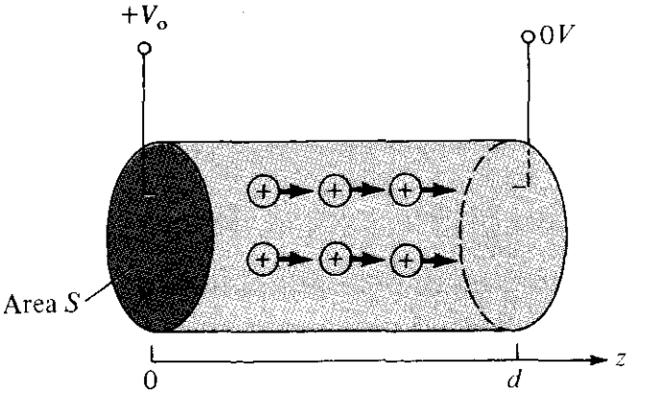

The boundary conditions:

$$V\left(z=0\right)=+V_{o}$$

$$V\left(z=d\right)=0$$

So that V depends only on Z

$$∇^{2}V=-\frac{ρ_{v}}{ϵ}$$

$$ρ_{v}=ρ_{o}$$

$$\frac{d^{2}V}{{dz}^{2}}=-\frac{ρ_{o}}{ϵ}$$

Integrating once

$$\int{\frac{d^{2}V}{{dz}^{2}}}=\int{-\frac{ρ_{o}}{ϵ}}⇒\frac{dV}{dz}=-\frac{ρ_{o}}{ϵ}Z+A$$

Integrating again yields

$$\int{\frac{dV}{dz}}=\int{-\frac{ρ_{o}}{ϵ}Z+A}⇒=V=-\frac{ρ_{o}}{ϵ}\frac{Z^{2}}{2}+AZ+B$$

$$V\left(Z\right)=-\frac{ρ_{o}}{ϵ}\frac{Z^{2}}{2}+AZ+B$$

1. Apply the boundary conditions to determine a unique solution of V

$$V\left(z=0\right)=V_{o}⇒V_{o}=-\frac{ρ_{o}}{ϵ}\frac{0^{2}}{2}+A0+B=B$$

$$V\left(z=d\right)=0⇒0=-\frac{ρ_{o}}{ϵ}\frac{d^{2}}{2}+Ad+V_{o}=$$

$$Ad=\frac{ρ_{o}}{ϵ}\frac{d^{2}}{2}-V_{o}⇒A=\frac{ρ_{o}}{2ϵ}d-\frac{V_{o}}{d}$$

Hence, the unique solution of V will be

$$V\left(Z\right)=-\frac{ρ_{o}}{ϵ}\frac{Z^{2}}{2}+\left\{\frac{ρ_{o}}{2ϵ}d-\frac{V_{o}}{d}\right\}Z+V_{o}$$

Having obtained V, we can obtain $E=-∇V$, then $D=ϵE$**,** and finally $J=σE$

$$E=-∇V=-\frac{∂V}{∂Z}a_{z}=-\frac{∂}{∂Z}\left\{-\frac{ρ_{o}}{2ϵ}Z^{2}+\left\{\frac{ρ_{o}}{2ϵ}d-\frac{V_{o}}{d}\right\}Z+V_{o}\right\}a_{z}$$

$$E=-\left\{-\frac{ρ_{o}}{2ϵ}2Z+\left\{\frac{ρ_{o}}{2ϵ}d-\frac{V_{o}}{d}\right\}\right\}a_{z}$$

$$E=\left\{\frac{ρ_{o}}{ϵ}Z-\left\{\frac{ρ_{o}}{2ϵ}d-\frac{V_{o}}{d}\right\}\right\}a_{z}$$

$$E=\left\{\frac{ρ_{o}}{ϵ}\left(Z-\frac{d}{2}\right)+\frac{V_{o}}{d}\right\}a_{z}$$

# Solving Poisson’s Equation for Cylindrical Coordinate System

Semi-infinite conducting planes $ϕ$ = 0 and $ϕ$ = $\frac{π}{6}$ are separated by an infinitesimal insulating gap as in Figure 6.3. If V($ϕ=0$) = 0 and V( $ϕ=\frac{π}{6}$) = 100 V, calculate V and E in the region between the planes.

This problem is a boundary value problem involving piosson’s or Laplace equation and below is the procedure of solving such problem in cartesian coordinate system

1. Solve Laplace’s equation (if) or Poisson’s equation (if $ρ_{v} ≠0$)

Now, in above problem since $ρ_{v}=0$ we apply Laplace’s equation

$$∇^{2}V=0$$

The boundary conditions:

$$V\left(ϕ=0\right)=0$$

$$V\left(ϕ=\frac{π}{6}\right)=100$$

So that V depends only on Φ

$$∇^{2}V=\frac{1}{ρ^{2}}\frac{∂^{2}V}{∂ϕ^{2}}=0$$

$$\frac{1}{ρ^{2}}\frac{∂^{2}V}{∂ϕ^{2}}=0$$

Multiplying both side with $ρ^{2}$

$$\frac{∂^{2}V}{∂ϕ^{2}}=0$$

Integrating once

$$\int{\frac{∂^{2}V}{∂ϕ^{2}}}=\int{0}⇒\frac{∂V}{∂ϕ}=0 ϕ +A=A$$

Integrating again yields

$$\int{\frac{∂V}{∂ϕ}}=\int{A}⇒=V=Aϕ+B$$

$$V\left(ϕ\right)=Aϕ+B$$

1. Apply the boundary conditions to determine a unique solution of V

$$V\left(ϕ=0\right)=0⇒V_{o}=-A0+B=B$$

$$V\left(ϕ=\frac{π}{6}\right)=100⇒100=A \frac{π}{6}+0$$

$$100=A \frac{π}{6}⇒A= \frac{600}{π}$$

Hence, the unique solution of V will be

$$V\left(ϕ\right)=\frac{600}{π}ϕ$$

Having obtained V, we can obtain $E=-∇V$, then $D=ϵE$**,** and finally $J=σE$

$$E=-∇V=-\frac{1}{ρ}\frac{∂V}{∂ϕ}a_{ϕ}$$

$$E=-∇V=-\frac{1}{ρ}\frac{∂}{∂ϕ}\left\{\frac{600}{π}ϕ\right\}a_{ϕ}$$

$$E=-∇V=-\frac{1}{ρ}×\frac{600}{π}a_{ϕ}$$

# Solving Poisson’s Equation for Spherical Coordinate System

Conducting spherical shells with radii a=10 cm and b=30 cm are maintained at a potential difference of 100V such that V($r=b$) = 0 and *V( $r=a$)* = 100 V, calculate *V* and E in the region between the shells.

This problem is a boundary value problem involving poisson’s or Laplace equation and below is the procedure of solving such problem in cartesian coordinate system

1. Solve Laplace’s equation (if) or Poisson’s equation (if $ρ_{v} ≠0$)

Now, in above problem since $ρ_{v}=0$ we apply Laplace’s equation

$$∇^{2}V=0$$

The boundary conditions:

$$V\left(r=b\right)=0$$

$$V\left(r=a\right)=V_{o}=100$$

So that V depends only on r

$$∇^{2}V=\frac{1}{r^{2}}\frac{∂}{∂r}\left(r^{2}\frac{∂V}{∂r}\right)=0$$

$$\frac{1}{r^{2}}\frac{∂}{∂r}\left(r^{2}\frac{∂V}{∂r}\right)=0$$

Multiplying both side with $r^{2}$

$$\frac{∂}{∂r}\left(r^{2}\frac{∂V}{∂r}\right)=0$$

Integrating once

$$\int{\frac{∂}{∂r}\left(r^{2}\frac{∂V}{∂r}\right)}=\int{0}⇒r^{2}\frac{∂V}{∂r}=0 ϕ +A=A$$

Integrating again yields

$$\int{\frac{∂V}{∂r}}=\int{\frac{A}{r^{2}}}dr⇒=V=\frac{-A}{r}+B$$

$$V\left(r\right)=\frac{-A}{r}+B$$

1. Apply the boundary conditions to determine a unique solution of V

$$V\left(r=a\right)=V_{o}⇒V_{o}=\frac{-A}{a}+B$$

$$V\left(r=b\right)=0⇒0=\frac{-A}{b}+B$$

$$\frac{A}{b}=B$$

Then

$$V_{o}=\frac{-A}{a}+\frac{A}{b}=A\left\{\frac{1}{b}-\frac{1}{a}\right\}$$

$$A=\frac{V_{o}}{\left\{\frac{1}{b}-\frac{1}{a}\right\}}$$

$$B=\frac{A}{b}=\frac{V_{o}}{b \left\{\frac{1}{b}-\frac{1}{a}\right\}}$$

Hence, the unique solution of V will be

$$V\left(r\right)=\frac{-\frac{V_{o}}{\left\{\frac{1}{b}-\frac{1}{a}\right\}}}{r}+\frac{V_{o}}{b \left\{\frac{1}{b}-\frac{1}{a}\right\}}$$

$$V\left(r\right)=\frac{-V_{o}}{r\left\{\frac{1}{b}-\frac{1}{a}\right\}}+\frac{V_{o}}{b \left\{\frac{1}{b}-\frac{1}{a}\right\}}=\frac{V_{o}}{\left\{\frac{1}{b}-\frac{1}{a}\right\}}\left\{\frac{-1}{r}+\frac{1}{b}\right\}$$

$$V\left(r\right)=\frac{V_{o}}{\left\{\frac{1}{b}-\frac{1}{a}\right\}}\left\{\frac{1}{b}-\frac{1}{r}\right\}=V_{o}×\left\{\frac{\left(\frac{1}{b}-\frac{1}{r}\right)}{\left(\frac{1}{b}-\frac{1}{a}\right)}\right\}$$

Having obtained V, we can obtain $E=-∇V$, then $D=ϵE$**,** and finally $J=σE$

$$E=-∇V=-\frac{∂V}{∂r}a_{r}$$

$$E=-∇V=-\frac{∂}{∂r}\left\{\frac{V_{o}}{\left(\frac{1}{b}-\frac{1}{a}\right)}×\left(\frac{1}{b}-\frac{1}{r}\right)\right\}a_{r}$$

$$E=-∇V=-\frac{V_{o}}{\left(\frac{1}{b}-\frac{1}{a}\right)}×\frac{+1}{r^{2}}a_{r}$$

$$E=-∇V=\frac{V_{o}}{\left(\frac{1}{a}-\frac{1}{b}\right)}×\frac{1}{r^{2}}a_{r}$$

# Resistance Evaluation using Boundary Value Problems

In Section ‎2.2.2 the definition of resistance was covered and we derived below equation for evaluating the resistance of a conductor with uniform cross-sectional area.

$$R=\frac{V}{I}=\frac{l}{σS}=\frac{ρl}{S}$$

However, If the cross section of the conductor is not uniform, above equation becomes not valid and the resistance should be obtained from equation below

$$R=\frac{V}{I}=\frac{\oint_{L}{E.dl}}{\int_{S}{J .ds}}=\frac{\oint_{L}{E.dl}}{\int_{S}{σE .ds}}$$

The problem of determining the resistance of a conductor with a nonuniform cross section can be viewed as a boundary-value problem. The following steps can be taken to determine the resistance R (or conductance G = l/R) of a given conducting material using eq. (6.16):

1. Choose a suitable and proper coordinate system.

2. Assume the potential difference $V_{o}$ as the initial voltage as between conductor terminals.

3. Solve Laplace's equation to obtain V.

4. Then determine E from

5. After this, obtain from

6. Finally, obtain R as $Vo/I$.

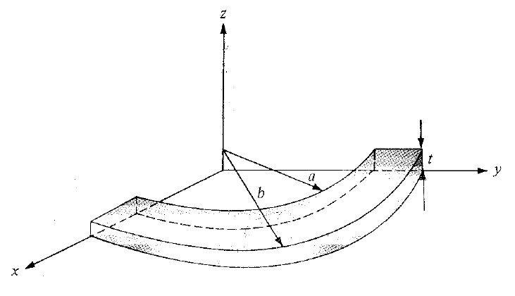

The resistance of the bar between the vertical curved surfaces at $ρ=a$ and $ρ=b$

This problem is a boundary value problem involving piosson’s or Laplace equation and below is the procedure of solving such problem in cartesian coordinate system

1. Solve Laplace’s equation (if) or Poisson’s equation (if $ρ_{v} ≠0$)

Now, in above problem since $ρ_{v}=0$ we apply Laplace’s equation

$$∇^{2}V=0$$

The boundary conditions:

$$V\left(ρ=a\right)=0$$

$$V\left(ρ=b\right)=V_{o}$$

So that $V$ depends only on $ρ$

$$∇^{2}V=\frac{1}{ρ}\frac{∂}{∂ρ}\left(ρ\frac{∂V}{∂ρ}\right)=0$$

$$\frac{1}{ρ}\frac{∂}{∂ρ}\left(ρ\frac{∂V}{∂ρ}\right)=0$$

Multiplying both side with $ρ$

$$\frac{∂}{∂ρ}\left(ρ\frac{∂V}{∂ρ}\right)=0$$

Integrating once

$$\int{\frac{∂}{∂ρ}\left(ρ\frac{∂V}{∂ρ}\right)}=\int{0}⇒ρ\frac{∂V}{∂ρ}=0 ρ +A=A$$

Integrating again yields

$$\int{\frac{∂V}{∂ρ}}=\int{\frac{A}{ρ}}⇒V=A\ln{ρ}+B$$

$$V\left(ρ\right)=A\ln{ρ}+B$$

1. Apply the boundary conditions to determine a unique solution of V

$$V\left(ρ=a\right)=0⇒0=A\ln{(a)}+B⇒ B=-A\ln{(a)}$$

$$V\left(ρ=b\right)=V_{o}⇒V_{o}=A \ln{(b})+B=A \ln{(b})-A\ln{(a)}$$

$$V_{o}=A \ln\left(\frac{b}{a}\right)⇒A=\frac{V_{o}}{\ln\left(\frac{b}{a}\right)} ⇒$$

Then we can find B

$$B=-\frac{V_{o}}{\ln\left(\frac{b}{a}\right)}×\ln\left(a\right)=-V_{o}\frac{\ln\left(a\right)}{\ln\left(\frac{b}{a}\right)}$$

Hence, the unique solution of V will be

$$V\left(ρ\right)=A\ln{ρ}+B=\frac{V_{o}}{\ln\left(\frac{b}{a}\right)}×\ln{(ρ)}-V_{o}\frac{\ln\left(a\right)}{\ln\left(\frac{b}{a}\right)}=\frac{V_{o}}{\ln\left(\frac{b}{a}\right)}\left\{\ln\left(ρ\right)-\ln\left(a\right)\right\}$$

$$V\left(ρ\right)=\frac{V_{o}}{\ln\left(\frac{b}{a}\right)}\ln\left(\frac{ρ}{a}\right)$$

Having obtained $V$, we can obtain $E=-∇V$, then $D=ϵE$**,** and finally $J=σE$

$$E=-∇V=-\frac{∂V}{∂ρ}a_{ρ}$$

$$E=-∇V=-\frac{∂}{∂ρ}\left\{\frac{V_{o}}{\ln\left(\frac{b}{a}\right)}\ln\left(\frac{ρ}{a}\right)\right\}a_{ρ}$$

$$E=-∇V=-\frac{V_{o}}{\ln\left(\frac{b}{a}\right)}×\frac{1/a}{ρ/a}a_{ρ}$$

$$E=-\frac{V_{o}}{ρ ln\left(\frac{b}{a}\right)}a_{ρ}$$

Having obtained $E$ we can find $J$

$$J=σE=-\frac{σV_{o}}{ρ ln\left(\frac{b}{a}\right)}a_{ρ}$$

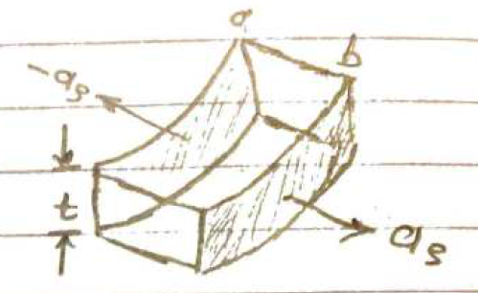

Then we can find the total current

For cylindrical coordinate system

Since the differential area normal vector is along $a_{ρ}$

$$dS=ρdϕdz(-a_{ρ})$$

Then we can calculate the total current as per below

$$I=\int_{s}{J.dS}=\int_{s}{\left(\frac{σV_{o}}{ρ ln\left(\frac{b}{a}\right)}\right)a_{ρ}.\left(ρdϕdz\right)a_{ρ}}=\int_{s}{\left(\frac{σV_{o}}{ρ ln\left(\frac{b}{a}\right)}\right)\left(ρdϕdz\right)}$$

$$I=\int_{s}{\frac{σV_{o}}{\ln\left(\frac{b}{a}\right)}dϕdz}=\frac{σV_{o}}{\ln\left(\frac{b}{a}\right)}\int_{ϕ=0}^{π/2}{dϕ}\int_{z=0}^{t}{dz}=\frac{σV_{o}}{\ln\left(\frac{b}{a}\right)}×\frac{π}{2}×t$$

$$I=\frac{π}{2}t\frac{σV_{o}}{\ln\left(\frac{b}{a}\right)}$$

Then we can calculate the resistance

$$R=\frac{V_{o}}{I}=\frac{V_{o}}{\frac{π}{2}t\frac{σV_{o}}{\ln\left(\frac{b}{a}\right)}}=\frac{2 \ln\left(\frac{b}{a}\right)}{σπt}$$

The resistance of the bar between the horizontal curved surfaces at $z=0$ and $z=t$

This problem is a boundary value problem involving piosson’s or Laplace equation and below is the procedure of solving such problem in cartesian coordinate system

1. Solve Laplace’s equation (if) or Poisson’s equation (if $ρ_{v} ≠0$)

Now, in above problem since $ρ_{v}=0$ we apply Laplace’s equation

$$∇^{2}V=0$$

The boundary conditions:

$$V\left(z=0\right)=0$$

$$V\left(z=t\right)=V_{o}$$

So that $V$ depends only on $z$

$$\frac{d^{2}V}{{dz}^{2}}=0$$

Integrating once

$$\int{\frac{d^{2}V}{{dz}^{2}}}=\int{0}⇒\frac{dV}{dz}=0 z+A$$

Integrating again yields

$$\int{\frac{dV}{dz}}=\int{A}⇒=V=A z+B$$

$$V\left(Z\right)=A z+B$$

1. Apply the boundary conditions to determine a unique solution of V

$$V\left(z=0\right)=0⇒0=A 0+B⇒ B=0$$

$$V\left(z=t\right)=V_{o}⇒V_{o}=A t+B=A t+0$$

$$V_{o}=A t⇒A=\frac{V_{o}}{t} ⇒$$

Hence, the unique solution of V will be

$$V\left(z\right)=Az+B=\frac{V_{o}}{t} z$$

Having obtained $V$, we can obtain $E=-∇V$, then $D=ϵE$**,** and finally $J=σE$

$$E=-∇V=-\frac{∂V}{∂z}a_{z}$$

$$E=-∇V=-\frac{∂}{∂z}\left\{\frac{V_{o}}{t} z\right\}a_{z}$$

$$E=-∇V=-\frac{V_{o}}{t}a_{z}$$

$$E=-\frac{V_{o}}{t}a_{z}$$

Having obtained $E$ we can find $J$

$$J=σE=-\frac{σV_{o}}{t}a_{z}$$

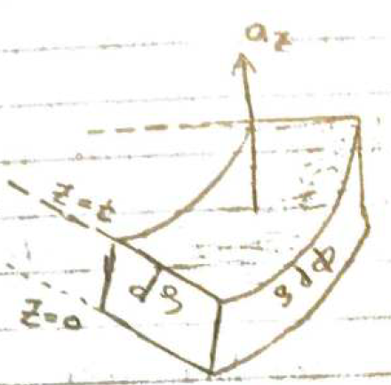

Then we can find the total current

For cylindrical coordinate system

Since the differential area normal vector is along $a_{ρ}$

$$dS=ρdρdϕ(a_{z})$$

Then we can calculate the total current as per below

$$I=\int_{s}{J.dS}=\int_{s}{\left(-\frac{σV_{o}}{t}\right)a_{z}.ρdρdϕ(a_{z})}=\int_{s}{\left(-\frac{σV_{o}}{t}\right)\left(ρdρdϕ\right)}$$

$$I=\int_{s}{-\frac{σV_{o}}{t}ρdρdϕ}=-\frac{σV_{o}}{t}\int_{ρ=a}^{b}{ρdρ}\int_{ϕ=0}^{π/2}{dϕ}=-\frac{σV_{o}}{t}×\frac{ρ^{2}}{2}\left|\begin{matrix}b \\ \\ a\end{matrix}\right.×\frac{π}{2}$$

$$I=\frac{σV_{o}}{t}×\left\{\frac{b^{2}}{2}-\frac{a^{2}}{2}\right\}×\frac{π}{2}=\frac{σπV_{o}}{4t}×\left\{b^{2}-a^{2}\right\}$$

Then we can calculate the resistance

$$R=\frac{V_{o}}{I}=\frac{V_{o}}{\frac{σπV_{o}}{4t}×\left\{b^{2}-a^{2}\right\}}=\frac{4t}{σπ\left\{b^{2}-a^{2}\right\}}$$

# Capacitance Evaluation using Boundary Value Problems

Typically, the existence of a capacitor necessitates the existence of two or more conductors that carry charges of the same magnitude but opposing in kind, see Figure ‎2.3.4‑1. This implies that every line of magnetic flux that emerges from one conductor must ultimately terminate at the surface of the other conductor. The conductors of the capacitor are sometimes referred to as plates. The plates may be separated either by a vacuum or by a dielectric substance.

Figure ‑: Two conductors -capacitor

Consider the two-conductor capacitor shown in Figure ‎2.3.4‑1. The two conductors are maintained at a potential difference of *V* given by

$$V=V_{1}-V_{2}=-\int_{2}^{1}{E.dl}=+\int_{1}^{2}{E.dl}$$

where $E$ is the electric field existing between the conductors and conductor 1 is assumed to carry a positive charge. (Note that the E field is always normal to the conducting surfaces.)

The *capacitance C* of the capacitor is a physical property of the capacitor and is measured in farads (F) and it is defined as the ratio of the magnitude of the charge $Q$ on one of the plates to the potential difference $V$ between them; that is,

$$C=\frac{Q}{V}=\frac{\oint_{s}{D.ds}}{\oint_{L}{E.dl}}=\frac{ϵ\oint_{s}{E.ds}}{\int{E.dl}}$$

The negative sign before $V=-\oint_{L}{E.dl}$ has been dropped because we are interested in the absolute value of $V$*.* Using eq. (6.18), *C* can be obtained for any given two-conductor capacitance by following either of these methods:

1. Assuming *Q* and determining *V* in terms of *Q* (involving Gauss's law)

2. Assuming *V* and determining *Q* in terms of *V* (involving solving Laplace's equation)

1. Choose a suitable coordinate system.

2. Let the two conducting plates carry charges + *Q* and - *Q*

3. Determine E using Coulomb's or Gauss's law and find V from *V =* — *J* E • *d\.* The

negative sign may be ignored in this case because we are interested in the absolute value of V.

4. Finally, obtain *C* from *C = Q/V.*

# Parallel Plate Capacitor

A parallel plate capacitor consists of two or more conducting plates that contain equal charges of opposing polarity. The flux lines originating from one plate end on the other plate. The plates may be separated by either empty space or a dielectric material.

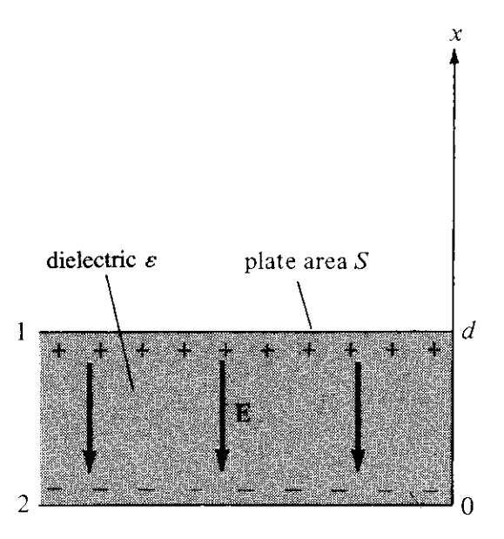

To derive the capacitance, we should follow below steps:

1. Choose the suitable coordinate system which will be the cartesian coordinate system in the parallel plate capacitor case.
2. We assume that plates 1 and 2 carry electric charge +Q and -Q respectively and they are uniformly distributed on them.
3. Find the electric field intensity $E$ using Gauss’s law

$$\oint_{s}{D.ds}=\int_{v}{\left(∇.\overset{⃑}{D}\right) dv}=\int_{v}{ρ_{v} dv}$$

$$\oint_{s}{D.ds}=D_{z} \left[\int_{top}{ds}+\int_{bottom}{ds}\right]=D ×2A$$

$$Q=\int_{s}{ρ_{s} ds}=ρ_{s} ×A$$

Equalizing both side of the equation

$$D ×2A=ρ_{s} ×A$$

$$D =\frac{ρ_{s}}{2}a_{x}$$

$$D=ϵ_{o}E ⇒ E=\frac{D}{ϵ_{o} }$$

$$E=\frac{1}{ϵ_{o} } ×\left(\frac{ρ_{s}}{2}\right)a_{x}$$

However, the electric field derived was assuming only one plate (sheet), but in case we have two sheets with different kind of charge, then at any point within the two sheets the total electric field will be the resultant field from the summation

$$E_{total}=E_{1}+E_{2}=\frac{ρ_{s}}{2ϵ_{o} }{(-a}_{x})+\frac{ρ_{s}}{2ϵ_{o} }{(-a}_{x})=\frac{2ρ_{s}}{2ϵ_{o} }{(-a}_{x})=\frac{ρ_{s}}{ϵ_{o} }{(-a}_{x})$$

$$E_{total}=\frac{Q}{ϵ_{o}S }{(-a}_{x})$$

1. Find the electric potential
$$V=V_{1}-V_{2}=-\int_{2}^{1}{E.dl}=-\int_{0}^{d}{\frac{Q}{ϵ_{o}S }{(-a}_{x}).dz}a_{x}$$

$$V=\int_{0}^{d}{\frac{Q}{ϵ_{o}S }dx}=\frac{Q}{ϵ_{o}S }\left[d-0\right]=\frac{Qd}{ϵ_{o}S }$$

2. Calculate the capacitance

$$C=\frac{Q}{V}=\frac{Q}{\frac{Qd}{ϵ_{o}S }}=\frac{ϵ_{o}S}{ d}$$

# Cylindrical Capacitor

This is essentially a coaxial cable or coaxial cylindrical capacitor. Consider length *L* of two coaxial conductors of inner radius *a* and outer radius *b (b > a)* as shown in Figure 6.14. Let the space between the conductors be filled with a homogeneous dielectric with permittivity ε . We assume that conductors 1 and 2, respectively, carry *+Q* and *-Q* uniformly distributed on them.

By applying Gauss's law to an arbitrary Gaussian cylindrical surface of radius *ρ (a < p < b),* we obtain

1. Choose the suitable coordinate system which will be the cylindrical coordinate system in the cylindrical capacitor case.
2. We assume that cylinders 1 and 2 carry electric charge +Q and -Q respectively and they are uniformly distributed on them.
3. Find the electric field intensity E using Gauss’s law.

**For**

1. Locate the object at its location which is the along the z-axis
2. Construct Gaussian mathematical symmetric surface around the charged object, and in this case, it will be a cylinder
3. Apply Gauss’s Law

First, we should find

The flux density vector will be along

The differential displacement for the cylindrical coordinate system

Since the differential area’s normal vector is along $a_{ρ}$

$ds= ρdϕdza_{ρ}$

$$\oint_{s}{D.ds}=\oint_{s}{Da_{ρ}}∙ρdϕdza_{ρ}$$

$$D ρ\int_{ϕ=o}^{ϕ=2π}{dϕ}\int_{z=0}^{z=l}{dz}=D ρ×2π×l$$

$$D×2πρl$$

Then, we should find $$Q_{enc}=\int_{v}{ρ_{v} dv}=\int_{S}{ρ_{S} dS}$$

$$Q_{enc}=\int_{s}{ρ_{s} }ρdϕdz=ρ_{s} a \int_{ϕ=o}^{ϕ=2π}{dϕ}\int_{z=0}^{z=l}{dz}$$

$$ρ_{s} ×a ×2π×l=ρ_{s} ×2πal$$

Equalizing both sides of Gauss’s equation will get

$$D×2πρl=ρ_{s} ×2πal ⇒ D=\frac{ρ_{s} ×2πal}{2πρl}a_{ρ}$$

$$D=\frac{Q}{2πρl}a_{ρ}$$

But $$D=ϵ_{o}E ⇒ E=\frac{D}{ϵ_{o} }$$

$$E=\frac{1}{ϵ_{o} } ×\left(\frac{Q}{2πρl}\right)a_{ρ}$$

$$E=\frac{Q}{2πϵ_{o}l }\left(\frac{1}{ρ}\right)a_{ρ}$$

1. Find the electric potential
$$V=V_{1}-V_{2}=-\int_{2}^{1}{E.dl}=-\int_{b}^{a}{\frac{Q}{2πϵ_{o}l }\left(\frac{1}{ρ}\right)a_{ρ}.dρ}a_{ρ}$$

$$V=\int_{b}^{a}{\frac{-Q}{2πϵ_{o}l }\left(\frac{1}{ρ}\right)dρ}=\frac{-Q}{2πϵ_{o}l }\left\{\ln{ρ} \left|\begin{matrix}a \\ \\ b\end{matrix}\right.\right\}$$

$$V=\frac{-Q}{2πϵ_{o}l }\left\{\ln{ρ} \left|\begin{matrix}a \\ \\ b\end{matrix}\right.\right\}$$

$$V=\frac{-Q}{2πϵ_{o}l }\left\{\ln{a}-\ln{b}\right\}=\frac{Q}{2πϵ_{o}l }\left\{\ln{b}-\ln{a}\right\}$$

$$V=\frac{Q}{2πϵ_{o}l }\left\{\ln\left(\frac{b}{a}\right)\right\}$$

2. Calculate the capacitance

$$C=\frac{Q}{V}=\frac{Q}{\frac{Q}{2πϵ_{o}l }\left\{\ln\left(\frac{b}{a}\right)\right\}}=\frac{2πϵ_{o}l}{ \ln\left(\frac{b}{a}\right)}$$

# Spherical Capacitor

This is the case of two concentric spherical conductors. Consider the inner sphere of radius *a* and outer sphere of radius *b{b> a)* separated by a dielectric medium with permittivity e as shown in Figure 6.15. We assume charges *+Q* and *-Q* on the inner and outer spheres

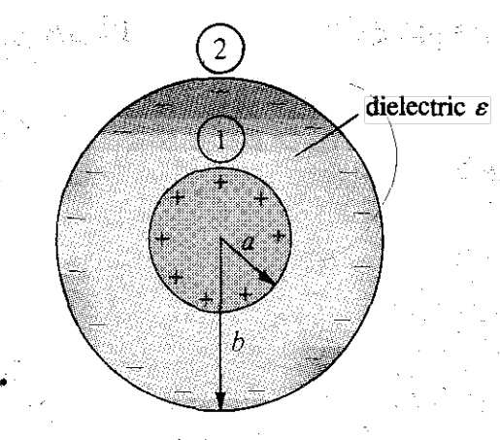



By applying Gauss's law to an arbitrary Gaussian cylindrical surface of radius *ρ (a < p < b),* we obtain

1. Choose the suitable coordinate system which will be the spherical coordinate system in the spherical capacitor case.
2. We assume that sphere 1 and 2 carry electric charge +Q and -Q respectively and they are uniformly distributed on them.
3. Find the electric field intensity E using Gauss’s law.

**For**

1. Locate the object at its location which is the along the z-axis
2. Construct Gaussian mathematical symmetric surface around the charged object, and in this case, it will be a cylinder
3. Apply Gauss’s Law

**For $r≥a$**

1. Locate the object at its location which is a sphere with center at origin (0,0,0)
2. Construct Gaussian mathematical symmetric surface around the charged object, and in this case, it will be a sphere with *r≥a*
3. Apply Gauss’s Law

First, we should find

The flux density vector will be along

The differential displacement for the spherical coordinate system

$$dl=dr a_{r}+rdθ{ a}_{θ}+r\sin{θ}dϕ a_{ϕ}$$

And the differential surface ds will have a norm along $a_{r}$

$$ds=r^{2}\sin{θ}dϕdθa_{r}$$

$$\oint_{s}{D.ds}=\oint_{s}{Da_{r}}∙r^{2}\sin{θ}dϕdθa_{r}$$

$$Dr^{2}\int_{ϕ=o}^{ϕ=2π}{dϕ}\int_{θ=0}^{θ=π}{\sin{θ}dθ}=Dr^{2} ×2π×\left(-\cos{θ} \left|\begin{matrix}π \\ \\ 0\end{matrix}\right.\right)$$

$$Dr^{2} ×2π×\left(-\cos{{180}^{o}}+\cos{0^{o}} \right)=D ×4πr^{2}$$

Then, we should find $Q_{enc}$ $$Q_{enc}=\int_{v}{ρ_{v} dv}=\int_{S}{ρ_{S} dS}$$

The differential displacement for the spherical coordinate system

$$dl=dr a_{r}+rdθ{ a}_{θ}+r\sin{θ}dϕ a_{ϕ}$$

And the differential surface ds will have a norm along $a_{r}$

$$ds=r^{2}\sin{θ}dθdϕa_{r}$$

$$Q_{enc}=\int_{s}{ρ_{s} r^{2}sinθ dθdϕ}$$

$$Q_{enc}=ρ_{s}a^{2}\int_{ϕ=o}^{ϕ=2π}{dϕ}\int_{θ=0}^{θ=π}{\sin{θ}dθ}$$

$$ρ_{s}× a^{2} ×2π×\left(-\cos{θ} \left|\begin{matrix}π \\ \\ 0\end{matrix}\right.\right)=ρ_{v}×4πa^{2}$$

$$D ×4πr^{2}=ρ_{s}×4πa^{2}$$

$$D =ρ_{s}×\frac{a^{2}}{r^{2}}$$

$$D =ρ_{s}×\frac{a^{2}}{r^{2}}a_{r}$$

But $$D=ϵ_{o}E ⇒ E=\frac{D}{ϵ_{o} }$$

$$E=\frac{1}{ϵ_{o} } ×ρ_{s}×\frac{a^{2}}{r^{2}}a_{r}$$

$$E=\frac{ρ_{s}}{ϵ_{o} } ×\frac{4π}{4π}×\frac{a^{2}}{r^{2}}a_{r}$$

$$E=\frac{ρ_{s}}{ϵ_{o} } ×\frac{S}{4πr^{2}}a_{r}$$

$$E=\frac{Q}{4πϵ_{o}r^{2}}a_{r}$$

1. Find the electric potential V
$$V=V_{1}-V_{2}=-\int_{2}^{1}{E.dl}=-\int_{b}^{a}{\frac{Q}{4πϵ_{o}r^{2}}a_{r}.dr}a_{r}$$

$$V=\int_{b}^{a}{\frac{-Q}{4πϵ_{o}r^{2}}dr}=\frac{-Q}{4πϵ_{o}}\left\{\frac{-1}{r} \left|\begin{matrix}a \\ \\ b\end{matrix}\right.\right\}$$

$$V=\frac{Q}{4πϵ_{o}}\left\{\frac{1}{r} \left|\begin{matrix}a \\ \\ b\end{matrix}\right.\right\}=\frac{Q}{4πϵ_{o}}\left\{\frac{1}{a}-\frac{1}{b} \right\}$$

2. Calculate the capacitance

$$C=\frac{Q}{V}=\frac{Q}{\frac{Q}{4πϵ_{o}}\left\{\frac{1}{a}-\frac{1}{b} \right\}}=\frac{4πϵ_{o}}{ \left\{\frac{1}{a}-\frac{1}{b} \right\}}$$

# Magnetostatics



# Magnetostatics

Oersted discovered a clear connection between electric and magnetic fields in 1820. An electrostatic field is generated by charges that are static or stationary. When charges move at a constant velocity, they generate a static magnetic field, also known as a magnetostatic field. A magnetostatic field is generated by a steady flow of electric current, also known as direct current. The flow of current may be attributed to magnetization currents, such as those seen in permanent magnets, electron-beam currents, as seen in vacuum tubes, or conduction currents, which occur in wires carrying current. This chapter focuses on the magnetic fields that arise in free space as a result of direct current.   
  
Our talks in Electrostatics were focused on static electric fields, which are described by either E or D. Our attention is now directed on static magnetic fields, which are defined by the symbols H or B.

# BIOT-SAVART'S LAW

**Biot-Savart's law** states that the magnetic field intensity $dH$ produced at a point P, as shown in Figure below, by the differential current element $I dl$ is proportional to the product $I dl$ and the sine of the angle a between the clement and the line joining P to the element and is inversely proportional to the square of the distance R between P and the element.

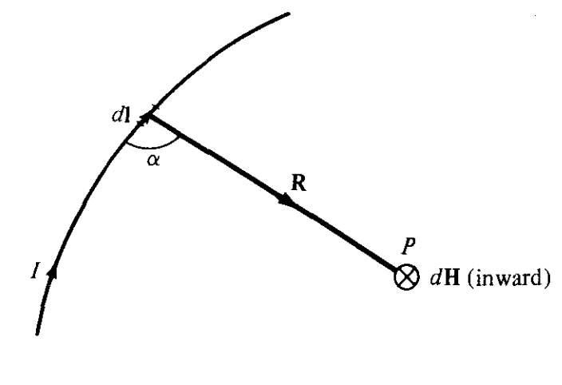

Figure ‎3.1.1‑1: Magnetic Field dH at point P due to differential current element Idl

$$dHα\frac{I dl sinα}{R^{2}}$$

$$dH=k\frac{I dl sinα}{R^{2}}$$

where k is the constant of proportionality. In SI units, k = 1/4 $π$, so eq. (7.2) becomes

$$dH=\frac{ I dl sinα}{{4πR}^{2}}$$

From the definition of cross product in eq. (1.21), it is easy to notice that eq. (7.3) is better put in vector form as

$$dH=\frac{ Idl ×a_{R}}{{4πR}^{2}}$$

$$dH=\frac{ Idl ×R}{{4πR}^{3}}$$

Thus, the orientation of $dH$ may be established using the right-hand rule, where the right-hand thumb indicates the direction of the current and the right-hand fingers encircle the wire in the direction of $dH$, as seen in *Figure ‎3.1.1‑2*(a). In contrast, we may use the right-handed screw rule to ascertain the orientation of $dH$. By aligning the screw parallel to the wire and pointing it in the direction of current flow, the direction in which the screw moves forward corresponds to the direction of dH, as seen in *Figure ‎3.1.1‑2* (b).

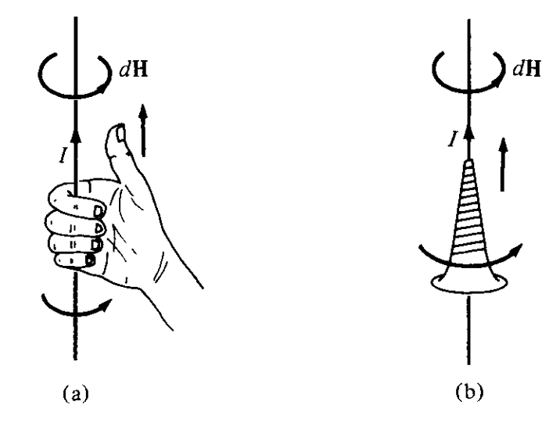

Figure ‎3.1.1‑2: Direction of $dH$ determination using Right Hand Rule and right-handed Screw

The conventional practice is to depict the direction of the magnetic field strength $H$ (or current $I$) using a tiny circle with a dot or cross symbol, depending on whether $H$ (or $I$) is directed out of or into the page, as shown in Figure ‎3.1.1‑3

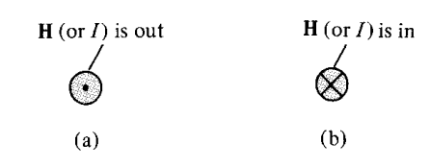

Figure ‎3.1.1‑3: Direction of H or I

We may also observe diverse arrangements of current: line current, surface current, and volume current, as illustrated in *Figure ‎3.1.1‑4*. The relationship between the source components may be defined by considering K as the surface current density (measured in amperes per meter) and J as the volume current density (measured in amperes per square meter).

$$Idl≡Kds≡Jdv$$

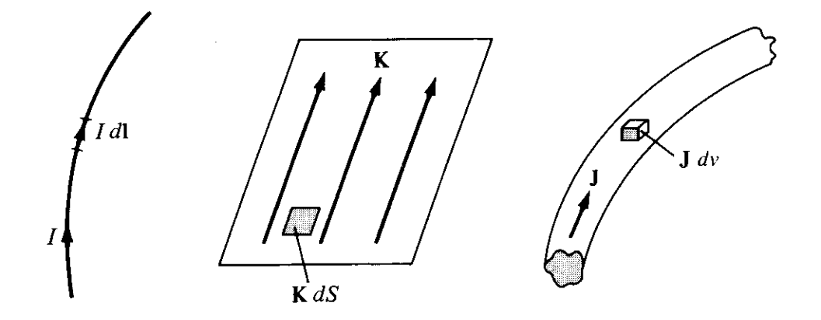

Figure ‎3.1.1‑4: Current Distributions

Thus, in terms of the distributed current sources, the Biot-Savart law as in eq. (7.4) becomes

$$H=\int_{L}{\frac{ Idl ×a_{R}}{{4πR}^{2}}}$$

$$H=\int_{s}{\frac{Kds ×a_{R}}{{4πR}^{2}}}$$

$$H=\int_{v}{\frac{Jdv ×a_{R}}{{4πR}^{2}}}$$

# Magnetic Field Strength due to Current Carrying Conductors

# Magnetic Field Strength due to Current Carrying Straight Conductor

To illustrate, we will calculate the magnetic field generated by a straight current-carrying filamentary conductor with a finite length **AB**, as shown in Figure ‎3.1.2.1‑1. It is assumed that the conductor is positioned along the z-axis, with its upper and lower ends subtending angles a2 and a} at point P, where the value of H is to be found. Special attention should be given to this assumption, since the resulting formula will need to be applied correctly. When evaluating the contribution $dH$ at point P caused by an element $dl$ located at coordinates (0, 0, z),

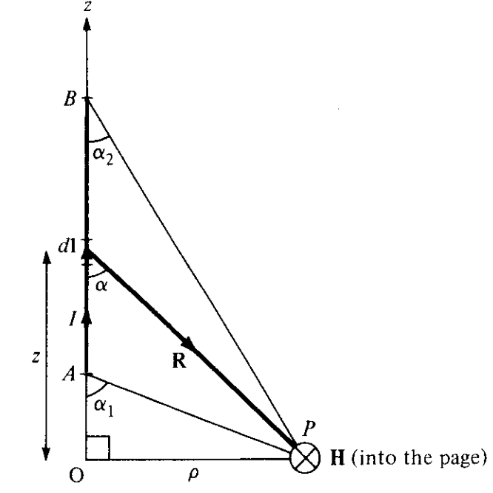



Figure ‑: Field at Point P due to Filamentary straight conductor

$$dH=\frac{ Idl ×a_{R}}{{4πR}^{2}}$$

$$dH=\frac{ Idl ×R}{{4πR}^{3}}$$

$$Idl=Idz{ a}_{z}$$

$$R=\left(0-0\right)a_{x}+\left(y-0\right)a_{y}+\left(0-z\right)a_{z}$$

$$R=ya_{y}-za_{z}$$

It is recommended that we transfer from cartesian coordinate to cylindrical coordinate as per transformation matrix

$$\left[\begin{matrix}R_{ρ} \\ R_{ϕ} \\ R_{Z}\end{matrix}\right]=\left[\begin{matrix}cosϕ & sinϕ & 0 \\ -sinϕ & cosϕ & 0 \\ 0 & 0 & 1\end{matrix}\right]\left[\begin{matrix}0 \\ y \\ -z\end{matrix}\right]$$

$R_{ρ}=0× cosϕ+y sinϕ=\left(ρ\sin{ϕ}\right)sinϕ=ρ\sin^{2}ϕ=ρ$

$$R_{ϕ}=-0 × sinϕ+y cosϕ=\left(ρ\sin{ϕ}\right)cosϕ=\frac{ρ}{2}\sin{2ϕ}$$

$$R_{Z}=-z$$

$$R_{ρ,ϕ,Z}=ρ a_{ρ}+\frac{ρ}{2}\sin{2ϕ}a_{ϕ}-za_{z}$$

But in our case $ϕ={90}^{o}$

$$R_{ρ,ϕ,Z}=ρ a_{ρ}+\frac{ρ}{2}\sin{2\left({90}^{o}\right)}a_{ϕ}-z a_{z}$$

$$R_{ρ,ϕ,Z}=ρ a_{ρ}-z a_{z}$$

$$\left|R\right|=\sqrt{ρ^{2}+z^{2}}$$

Substituting in $dH$ equation

$$dH=\frac{ Idl ×R}{{4πR}^{3}}=\frac{ Idz{ a}_{z} ×\left(ρ a_{ρ}-za_{z}\right)}{{4π\left(\sqrt{ρ^{2}+z^{2}}\right)}^{3}}$$

$$dz{ a}_{z} ×\left(ρ a_{ρ}-za_{z}\right)=\left|\begin{matrix}a_{ρ} & a_{ϕ} & a_{z} \\ 0 & 0 & dz \\ ρ & 0 & -z\end{matrix}\right|$$

$$dz{ a}_{z} ×\left(ρ a_{ρ}-za_{z}\right)=\left[0×0-0×ρ\right]a_{ρ}+\left[ρ×dz-0×\left(-z\right)\right]a_{ϕ}+\left[0×0-0×ρ\right]a_{z}$$

$$dz{ a}_{z} ×\left(ρ a_{ρ}-za_{z}\right)=+\left[ρdz\right]a_{ϕ}$$

$$dH=\frac{ Idl ×R}{{4πR}^{3}}=\frac{I{ρdza}_{ϕ}}{{4π\left(ρ^{2}+z^{2}\right)}^{3/2}}$$

From the red triangle

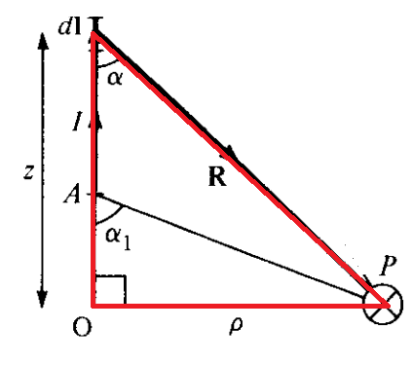

$$\tan{α}=\frac{ρ}{z} ⇒z=\frac{ρ}{\tan{α}}=ρ\cot{α}$$

Differentiating both sides

$$dz=-ρ \csc^{2}{α} dα=\frac{-ρ }{\sin^{2}{α}} dα$$

$$dH=\frac{Iρ\left(\frac{-ρ }{\sin^{2}{α}} dα\right)}{{4π\left\{ρ^{2}+{\left(ρ\cot{α}\right)}^{2}\right\}}^{3/2}}a_{ϕ}$$

$$dH=\frac{Iρ\left(\frac{-ρ }{\sin^{2}{α}} dα\right)}{{4π\left\{ρ^{2}+ρ^{2}\cot^{2}{α}\right\}}^{3/2}}a_{ϕ}=\frac{-Iρ^{2}\left(\frac{1 }{\sin^{2}{α}} dα\right)}{{4π\left\{ρ^{2}\left(1+\cot^{2}{α}\right)\right\}}^{3/2}}a_{ϕ}$$

$$dH=\frac{-Iρ^{2}\left(\frac{1 }{\sin^{2}{α}} dα\right)}{{4π\left\{ρ^{2}\left(\csc^{2}{α}\right)\right\}}^{3/2}}a_{ϕ}=\frac{-Iρ^{2}\left(\frac{1 }{\sin^{2}{α}} dα\right)}{4πρ^{3}\left(\csc^{3}{α}\right)}a_{ϕ}$$

$$dH=\frac{-Iρ^{2}\left(\frac{1 }{\sin^{2}{α}} dα\right)}{4πρ^{3}\left(\frac{1 }{\sin^{3}{α}}\right)}a_{ϕ}=\frac{\left(\frac{-I }{\sin^{2}{α}} dα\right)}{4πρ\left(\frac{1 }{\sin^{3}{α}}\right)}a_{ϕ}$$

$$dH=\frac{-I \sin{α}dα}{4πρ}a_{ϕ}=\frac{-I }{4πρ}\sin{α}dαa_{ϕ}$$

$$H=\int{dH}=\int{\frac{-I }{4πρ}\sin{α}dαa_{ϕ}}=\frac{-I }{4πρ}\int{\sin{α}dαa_{ϕ}}$$

$$H=\frac{-I }{4πρ}\int_{α_{1}}^{α_{2}}{\sin{α}dαa_{ϕ}}$$

$$H=\frac{I }{4πρ}×\left\{\cos{α}\left|\begin{matrix}α_{2} \\ \\ α_{1}\end{matrix}\right.a_{ϕ}\right\}=\frac{I }{4πρ}×\left\{\cos{α_{2}}-\cos{α_{1}}\right\} a_{ϕ}$$

# Magnetic Field Strength due to Current Carrying Circular Loop (Ring)

A circular current carrying loop located on *x2 + y2 =* 9, *z* = 0 carries a direct current of $I$ along *aϕ. We will* Determine H at (0, 0, h).

Figure ‎3.1.2.2‑1: Circular Current Carrying Loop

The differential magnetic field intensity $dH$ at point **P** due to differential current element $Idl$ is given by Biot’s Savart law

$$dH=\frac{ Idl ×a_{R}}{{4πR}^{2}}$$

$$dH=\frac{ Idl ×R}{{4πR}^{3}}$$

The differential displacement for the cylindrical coordinate system

$dl=dρ a_{ρ}+ρdϕ{ a}_{ϕ}+dz a_{z}$

$$Idl=I ρdϕ{ a}_{ϕ}$$

$$R=\left(0-x\right)a_{x}+\left(0-y\right)a_{y}+\left(h-0\right)a_{z}$$

$$R=-x a_{x}-y a_{y}+h a_{z}$$

It is recommended that we transfer from cartesian coordinate to cylindrical coordinate as per transformation matrix

$$\left[\begin{matrix}R_{ρ} \\ R_{ϕ} \\ R_{Z}\end{matrix}\right]=\left[\begin{matrix}cosϕ & sinϕ & 0 \\ -sinϕ & cosϕ & 0 \\ 0 & 0 & 1\end{matrix}\right]\left[\begin{matrix}-x \\ -y \\ h\end{matrix}\right]$$

$R_{ρ}=-x cosϕ-y sinϕ=-\left(ρ\cos{ϕ}\right)cosϕ-\left(ρ\sin{ϕ}\right)sinϕ=-ρ \left[ \sin^{2}ϕ+\cos^{2}ϕ\right]=-ρ$

$$R_{ϕ}=x sinϕ-y cosϕ=\left(ρ\cos{ϕ}\right)sinϕ-\left(ρ\sin{ϕ}\right)cosϕ=0$$

$$R_{Z}=h$$

$$R_{ρ,ϕ,Z}=-ρ a_{ρ}+h a_{z}$$

$$\left|R\right|=\sqrt{ρ^{2}+h^{2}}$$

Substituting in $dH$ equation

$$dH=\frac{ Idl ×R}{{4πR}^{3}}=\frac{ I ρdϕ{ a}_{ϕ} ×\left(-ρ a_{ρ}+h a_{z}\right)}{{4π\left(\sqrt{ρ^{2}+h^{2}}\right)}^{3}}$$

$$I ρdϕ{ a}_{ϕ} ×\left(-ρ a_{ρ}+h a_{z}\right)=\left|\begin{matrix}a_{ρ} & a_{ϕ} & a_{z} \\ 0 & ρdϕ & 0 \\ -ρ & 0 & h\end{matrix}\right|$$

$$I ρdϕ{ a}_{ϕ} ×\left(-ρ a_{ρ}+h a_{z}\right)=\left[ρdϕ×h-0×-\right]a_{ρ}+\left[-ρ×0-0×h\right]a_{ϕ}+\left[0×0-ρdϕ×-ρ\right]a_{z}$$

$$I ρdϕ{ a}_{ϕ} ×\left(-ρ a_{ρ}+h a_{z}\right)=ρhdϕa_{ρ}+ρ^{2}dϕa_{z}$$

By symmetry, the contributions along $a_{ρ}$ add up to zero because the radial components

produced by pairs of current elements 180° apart cancel. This may also be shown mathematically by writing $a_{ρ}$ in rectangular coordinate systems (i.e., $a_{ρ}$ *=* cos *ϕ ax +* sin *ϕ ay*

Integrating cos *ϕ* or sin ϕ over 0 < *ϕ* < 2π gives zero, thereby showing that Hp = 0. Thus

$$dH=\frac{ Idl ×R}{{4πR}^{3}}=\frac{ I ρ^{2}dϕ}{{4π\left(ρ^{2}+h^{2}\right)}^{3/2}}{ a}_{z}$$

$$H=\int{dH}=\int{\frac{ I ρ^{2}dϕ}{{4π\left(ρ^{2}+h^{2}\right)}^{3/2}}a_{z}}$$

$$H=\frac{ I ρ^{2}}{{4π\left(ρ^{2}+h^{2}\right)}^{3/2}}\int_{ϕ=0}^{2π}{dϕa_{z}}=\frac{ I ρ^{2}}{{4π\left(ρ^{2}+h^{2}\right)}^{3/2}}×2π=\frac{ I ρ^{2}}{{2\left(ρ^{2}+h^{2}\right)}^{3/2}}$$

# Magnetic Field Strength due to Current Carrying Solenoid

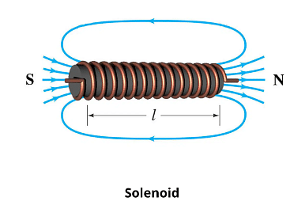

Figure ‎3.1.2.3‑1: Solenoid

Figure ‎3.1.2.3‑2: Cross-section of Solenoid

Since the solenoid consisting of circular loops, we shall apply ring equation whereby the contribution of the magnetic field at point P by the solenoid of length *dz*

$$H=\frac{ I ρ^{2}}{{2\left(ρ^{2}+h^{2}\right)}^{3/2}}⇒dH=\frac{ I a^{2}dl}{{2\left(a^{2}+z^{2}\right)}^{3/2}}$$

But

$$dl=n dz$$

$$dH=\frac{ I a^{2}n dz}{{2\left(a^{2}+z^{2}\right)}^{3/2}}$$

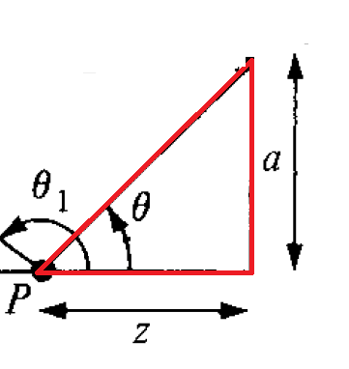

$$\tan{θ}=\frac{a}{z}⇒z=\frac{a}{\tan{θ}}=a cotθ$$

**Differentiating both sides**

$$dz=-a\csc^{2}{θ} dθ=\frac{-a dθ}{\sin^{2}{θ}}$$

Substituting in $dH$ equation

$$dH=\frac{ I a^{2}n dz}{{2\left(a^{2}+z^{2}\right)}^{3/2}}=\frac{ I a^{2}n \left\{\frac{-a dθ}{\sin^{2}{θ}}\right\}}{{2\left(a^{2}+{\left(a cotθ\right)}^{2}\right)}^{3/2}}$$

$$dH=\frac{- I a^{3}n dθ}{{2\sin^{2}{θ}\left(a^{2}+{\left(a cotθ\right)}^{2}\right)}^{3/2}}=\frac{- I a^{3}n dθ}{2\sin^{2}{θ}{\left\{a^{2}\left(1+\cot^{2}θ\right)\right\}}^{3/2}}$$

$$dH=\frac{- I a^{3}n dθ}{2a^{3}\sin^{2}{θ}{\left\{\left(\csc^{2}θ\right)\right\}}^{3/2}}=\frac{- I n dθ}{2\sin^{2}{θ}\csc^{3}θ}$$

$$dH=\frac{- I n dθ}{2\sin^{2}{θ}\left(\frac{1}{\sin^{3}θ}\right)}=\frac{- I n dθ}{2\left(\frac{1}{sinθ}\right)}=\frac{- I n sinθdθ}{2}$$

$$H=\int{dH}=-\int{\frac{1}{2}I n sinθdθ}=-\frac{I n}{2} \int_{θ_{1}}^{θ_{2}}{sinθdθ}$$

$$H=-\frac{I n}{2} ×\left\{-\cos{θ}\left|\begin{matrix}θ_{2} \\ \\ θ_{1}\end{matrix}\right.\right\}=\frac{I n}{2} ×\left\{\cos{θ_{2}}-\cos{θ_{1}}\right\}$$

$$H=\frac{I n}{2} ×\left\{\cos{θ_{2}}-\cos{θ_{1}}\right\}$$

If we have an infinitely long solenoid, then $θ_{2}=0^{o}, and θ_{1}={180}^{o}$

$$H=\frac{I n}{2} ×\left\{\cos{0^{o}}-\cos{{180}^{o}}\right\}=\frac{I n}{2} ×\left\{1-\left(-1\right)\right\}=I n$$

# Ampere's Circuit Law—Maxwell's Equation

Ampere's circuit law states that the line integral of the tangential component of magnetic field strength $H$ around a closed path L is the same as the net current $I_{enc}$. enclosed by the path.

In other words

$$\oint_{L}{H.dl}=I_{enc}$$

Ampere's law is comparable to Gauss's law, and it is straightforward to apply in order to ascertain H when the current distribution is symmetrical. It is important to mention that this equation is always valid regardless of whether the current distribution is symmetrical or not. However, the equation can only be employed to ascertain H when a symmetrical current distribution is present. A special case of Biot-Savart's law is Ampere's law; the former may be derived from the latter.

By employing Stoke's theorem on the left-hand side of equation (7.16), we can derive

$$I_{enc}=\oint_{L}{H.dl}=\int_{S}{\left(∇×H\right) .ds}$$

**But**

$$I_{enc}=\int_{S}{J .ds}$$

Comparing the surface integrals in eqs.

$$I_{enc}=\oint_{L}{H.dl}=\int_{S}{\left(∇×H\right) .ds}=\int_{S}{J .ds}$$

clearly reveals that

$$∇×H=J$$

# APPLICATIONS OF AMPERE'S LAW

We now apply Ampere's circuit law to determine H for some symmetrical current distributions as we did for Gauss's law. We will consider an infinite line current, an infinite current sheet, and an infinitely long coaxial transmission line.

# Infinite Line Current

Consider a current-carrying wire that is indefinitely long and is aligned along the z-axis, as illustrated in Figure 7.10. We examine a confined route that travels through a specific observation site (P) in order to measure the magnetic field strength (H). The Amperian path, which is analogous to the term "Gaussian surface," is the path along which Ampere's law is to be implemented. The Amperian route has been chosen as a concentric circle to guarantee that H remains constant, as illustrated in equation (7.14) when p remains constant. In accordance with Ampere's law, this route completely encircles the entire current in the circuit.

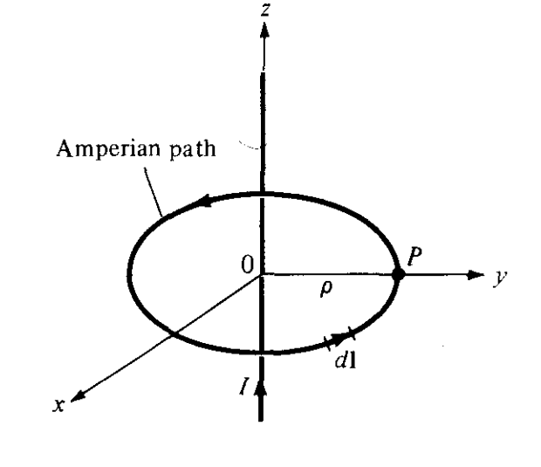

Figure ‑:indefinitely long current-carrying conductor

$$I_{enc}=\oint_{L}{H.dl}=\int_{S}{\left(∇×H\right) .ds}=\int_{S}{J .ds}$$

$$\oint_{L}{H.dl}$$

For cylindrical coordinate system

$dl=dρ a_{ρ}+ρdϕ{ a}_{ϕ}+dz a_{z}$

Since the differential displacement vector is along ${ a}_{ϕ}$

$$dl=ρdϕ{ a}_{ϕ}$$

$$⇒\oint_{L}{H.dl}=\oint_{L}{H_{ϕ}{ a}_{ϕ}.ρdϕ{ a}_{ϕ}}=\oint_{L}{H_{ϕ}ρdϕ}=H_{ϕ}ρ×\int_{ϕ=o}^{ϕ=2π}{dϕ}=H_{ϕ}ρ×2π$$

$$H_{ϕ}×2πρ$$

$$⇒\int_{S}{J .ds}=I_{enc}=I$$

Equaling both sides

$$H_{ϕ}×2πρ=I$$

$$H_{ϕ}=\frac{I}{2πρ}$$

# Infinite Sheet of Current

Let’s now consider an infinite current sheet in the z = 0 plane. If the sheet has a uniform current density ***K*** *= Kyay* A/m as shown in Figure 7.11, applying Ampere's law to the rectangular closed path (Amperian path) 1-2-3-4-1 gives

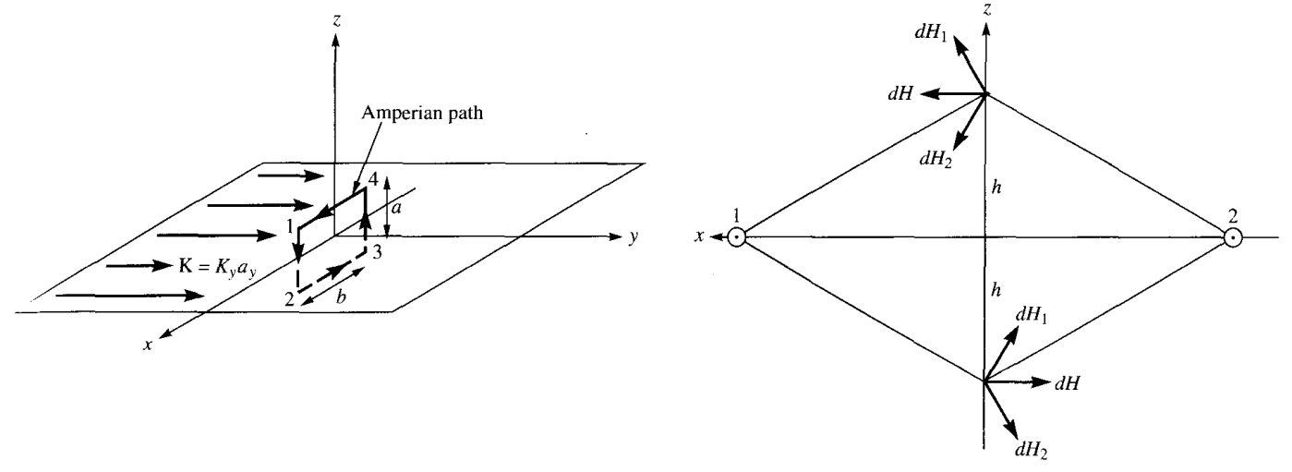

Figure ‎3.1.4.2‑1: Infinite Sheet of Current

$$\oint_{L}{H.dl}=I_{enc}$$

In order to compute the integral, it is necessary to have a clear understanding of the characteristics of $H$. In order to do this, we consider the infinite sheet as consisting of filaments. The magnetic field strength, dH, above or below the sheet caused by a pair of filamentary currents may be determined using equations (7.14) and (7.15). As seen in Figure 7.11(b), the resulting dH only contains a component in the x-direction. Furthermore, the negative of $H$ on one side of the sheet is present on the opposite side. Because the sheet is infinitely large, it may be seen as being made up of pairs of filaments. These filaments have the same properties for the infinite current sheets, namely, the attributes of $H$ for a pair.

$$H=\left\{\begin{matrix}H_{o}a_{x}, z>0 \\ \\ {-H}_{o}a_{x} z<0\end{matrix}\right.$$

where *Ho* is yet to be determined. Evaluating the line integral of H in eq. (7.21b) along the closed path in Figure 7.11 (a) gives

$$\oint_{L}{H.dl}=\left[\int_{1}^{2}{x}+\int_{2}^{3}{x}+\int_{3}^{4}{x}+\int_{4}^{1}{x}\right]H.dl$$

$$\oint_{L}{H.dl}=0\left(-a\right)+\left(-H_{o}\right)\left(-b\right)+0\left(a\right)+\left(H_{o}\right)\left(b\right)=2H_{o}b$$

$$I_{enc}=K_{y}b$$

Equaling both sides

$$2H_{o}b=K_{y}b$$

$$H_{o}=\frac{K_{y}}{2}$$

# Infinitely Long Coaxial Transmission Line

Consider a transmission line that is infinitely long and is composed of two concentric cylinders with their axes aligned with the z-axis. Figure 7.12 illustrates the line's cross section, with the z-axis extending beyond the page. The inner conductor has a radius of a and carries current $I$, whereas the outer conductor has a thickness of t and an inner radius of b and carries return current $-I$. Assuming that the current is uniformly distributed in both conductors, we aim to ascertain $H$ in all locations.

|  |  |
| --- | --- |
|  |  |

Since the current distribution is symmetrical, we will apply Ampere’s law

$$I_{enc}=\oint_{L}{H.dl}=\int_{S}{\left(∇×H\right) .ds}=\int_{S}{J .ds}$$

For cylindrical coordinate system

$dl=dρ a_{ρ}+ρdϕ{ a}_{ϕ}+dz a_{z}$

Since the differential displacement vector is along ${ a}_{ϕ}$, then dl will be

$$dl=ρdϕ{ a}_{ϕ}$$

And if the current direction is along az, then the differential area is

$$ds=ρdρdϕ a_{z}$$

**For path L1: $ρ≤a$**

$$I_{enc}=\oint_{L1}{H.dl}=\int_{S1}{\left(∇×H\right) .ds}=\int_{S1}{J .ds}$$

$$⇒\oint_{L1}{H.dl}=\oint_{L1}{H_{ϕ}{ a}_{ϕ}.ρdϕ{ a}_{ϕ}}$$

$$\oint_{L1}{H_{ϕ}ρdϕ}=H_{ϕ}ρ×\int_{ϕ=o}^{ϕ=2π}{dϕ}=H_{ϕ}ρ×2π$$

$$H_{ϕ}×2πρ$$

$$⇒\int_{S1}{J .ds}=I_{enc}$$

But

$$J=\frac{I}{πa^{2}}a_{z}$$

$$\int_{S1}{\frac{I}{πa^{2}}a_{z} .ρdρdϕ a_{z}}=\frac{I}{πa^{2}}\int_{ρ=0}^{ρ=a}{ρdρ}×\int_{ϕ=o}^{ϕ=2π}{dϕ}$$

$$\int_{S1}{\frac{I}{πa^{2}}a_{z} .ρdρdϕ a_{z}}=\frac{I}{πa^{2}}×\frac{ρ^{2}}{2}\left|\begin{matrix}ρ \\ \\ 0\end{matrix}\right.×2π=\frac{ρ^{2}I}{a^{2}}$$

Equaling both sides

$$H_{ϕ}×2πρ=\frac{ρ^{2}I}{a^{2}}⇒H_{ϕ}=\frac{ρ^{2}I}{2πρ{×a}^{2}}⇒$$

$$H_{ϕ}=\frac{Iρ}{2πa^{2}}$$

**For path L2: $a≤ρ≤b$**

$$I_{enc}=\oint_{L2}{H.dl}=\int_{S2}{\left(∇×H\right) .ds}=\int_{S2}{J .ds}$$

$$⇒\oint_{L2}{H.dl}=\oint_{L2}{H_{ϕ}{ a}_{ϕ}.ρdϕ{ a}_{ϕ}}$$

$$\oint_{L2}{H_{ϕ}ρdϕ}=H_{ϕ}ρ×\int_{ϕ=o}^{ϕ=2π}{dϕ}=H_{ϕ}ρ×2π$$

$$H_{ϕ}×2πρ$$

$$⇒\int_{S2}{J .ds}=I_{enc}=I$$

Equaling both sides

$$H_{ϕ}×2πρ=I$$

$$H_{ϕ}=\frac{I}{2πρ}$$

**For path L3: $b≤ρ≤b+t$**

$$I_{enc}=\oint_{L3}{H.dl}=\int_{S3}{\left(∇×H\right) .ds}=\int_{S3}{J .ds}$$

$$⇒\oint_{L3}{H.dl}=\oint_{L3}{H_{ϕ}{ a}_{ϕ}.ρdϕ{ a}_{ϕ}}$$

$$\oint_{L3}{H_{ϕ}ρdϕ}=H_{ϕ}ρ×\int_{ϕ=o}^{ϕ=2π}{dϕ}=H_{ϕ}ρ×2π$$

$$H_{ϕ}×2πρ$$

$$⇒\int_{S3}{J .ds}=I_{enc}=I+\int_{S3}{J .ds}$$

Where J is the current density for the outer conductor along **-az**

Equaling both sides

$$H_{ϕ}=\frac{I}{2πρ}\left\{1-\frac{ρ^{2}-b^{2}}{\left[t^{2}+2bt\right]}\right\}$$

**For path L4: $ρ≥b$**

$$I_{enc}=\oint_{L4}{H.dl}=\int_{S4}{\left(∇×H\right) .ds}=\int_{S4}{J .ds}$$

$$⇒\oint_{L4}{H.dl}=\oint_{L4}{H_{ϕ}{ a}_{ϕ}.ρdϕ{ a}_{ϕ}}$$

$$\oint_{L4}{H_{ϕ}ρdϕ}=H_{ϕ}ρ×\int_{ϕ=o}^{ϕ=2π}{dϕ}=H_{ϕ}ρ×2π$$

$$H_{ϕ}×2πρ$$

$$⇒\int_{S4}{J .ds}=I_{enc}=I-I=0$$

# Toroid

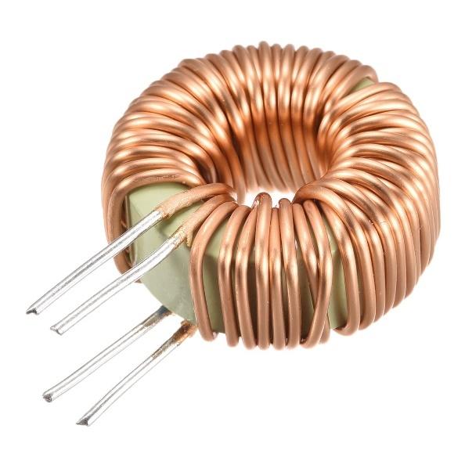

Figure ‑:Toroid

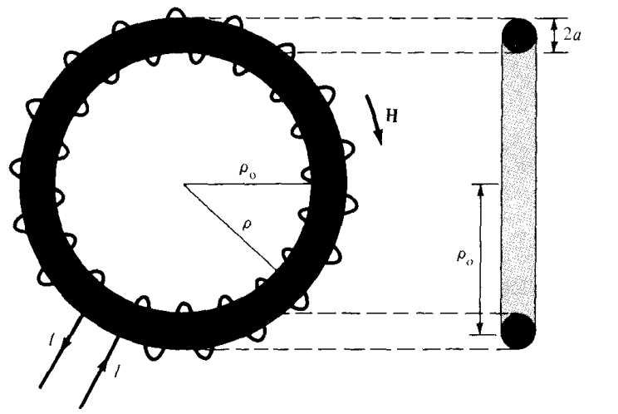

Figure ‑: Cross-section of Toroid

$$I_{enc}=\oint_{L}{H.dl}=\int_{S}{\left(∇×H\right) .ds}=\int_{S}{J .ds}$$

$$⇒\oint_{L}{H.dl}=\oint_{L}{H_{ϕ}{ a}_{ϕ}.ρdϕ{ a}_{ϕ}}$$

$$\oint_{L}{H_{ϕ}ρdϕ}=H_{ϕ}ρ×\int_{ϕ=o}^{ϕ=2π}{dϕ}=H_{ϕ}ρ×2π$$

$$H_{ϕ}×2πρ$$

$$⇒\int_{S}{J .ds}=I_{enc}=NI$$

Equaling both sides

$$H_{ϕ}×2πρ=NI$$

$$H_{ϕ}=\frac{N I}{2πρ}$$

# MAGNETIC FLUX DENSITY—MAXWELL'S EQUATION

The magnetic flux density ***B*** is like the electric flux density ***D***. whereby as $D=ϵ_{o}E$

in free space, also the magnetic flux density $B$ is related to the magnetic field intensity $H$ according to

$$B=μ_{o}H$$

where $μ_{o}$ is a constant and it is known as the permeability of free space. The constant is in henrys/meter (H/m) and has the value of

$$μ_{o}=4π×{10}^{-7}$$

The magnetic flux through a surface S is given by

$$ψ=\int_{S}{B.ds}$$

Where the magnetic flux $ψ$ is in webers (Wb) and the magnetic flux density **B** is in

webers/square meter (Wb/m2) or teslas. The magnetic flux line represents the trajectory along which the magnetic field vector **B** is tangential at every location inside a magnetic field. The magnetic field line is the orientation that the needle of a magnetic compass will align itself with when put in the magnetic field. Figure 7.16 displays the magnetic flux lines resulting from a straight, elongated wire.

Figure ‑: Magnetic Flux Lines for current carrying conductor

We know that in an electrostatic field, the flux passing through a closed surface is the same as the charge enclosed; that is, $ψ=\oint_{s}{D.ds}=Q$. Thus, it is possible to have an isolated electric charge as shown in *Figure ‎3.1.5‑2*, which also reveals that electric flux lines are not necessarily closed.



Figure ‎3.1.5‑2: Electric Flux Lines for Positive Charge terminated at negatively charged infinite sheet

Unlike electric flux lines, magnetic flux lines are always close upon themselves as in *Figure ‎3.1.5‑3*. This is due to the fact that it is not possible to have isolated magnetic poles (or magnetic charges)



Figure ‎3.1.5‑3: Magnetic Flux Line for Permeant magnet

For example, if we desire to have an isolated magnetic pole by dividing a magnetic bar successively into two, we end up with pieces each having north and south poles as illustrated in Figure 7.18. We find it impossible to separate the north pole from the south pole.



Figure ‎3.1.5‑4: Non-Existence of Magnetic Mono Pole

Thus, the total flux through a closed surface in a magnetic field must be zero; that is,

$$\oint_{s}{B.ds}=0$$

This equation is referred to as the law of conservation of magnetic flux or Gauss's law for magnetostatic fields just as $\oint_{s}{D.ds}=Q$ is Gauss's law for electrostatic fields. Although the magnetostatic field is not conservative, magnetic flux is conserved.

By applying the divergence theorem to eq. (7.33), we obtain

$$\oint_{s}{B.ds}=\int_{v}{\left(∇.B\right) dv}$$

**Or**

$$∇.B=0$$

# MAXWELL'S EQUATIONS FOR STATIC EM FIELDS

|  |  |  |
| --- | --- | --- |
| **Differential Form** | **Integral Form** | **Name of the Law** |
| $$∇.D=ρ_{v}$$ | $$\oint_{s}{D.ds}=\int_{v}{ρ_{v} dv}$$ | Gauss Law |
| $$∇.B=0$$ | $$\oint_{s}{B.ds}=0$$ | Nonexistence of Magnetic Monopole |
| $$∇×E=0$$ | $$\oint_{L}{E.dl}=0$$ | Conservativeness of Electrostatic Field |
| $$∇×H=J$$ | $$\oint_{L}{H.dl}=\int_{S}{J .ds}$$ | Amper’s law |

# MAGNETIC SCALAR AND VECTOR POTENTIALS

It is worth noting that some electrostatic field issues were made simpler by establishing a relationship between the electric potential V and the electric field intensity E (E=-∇V). Similarly, we may establish a potential that is linked to the magnetostatic field B. The magnetic potential may exist in two forms: scalar Vm or vector A. In order to define Vm and A, it is necessary to remember two significant identities.

$$∇×\left(∇V\right)=0 Curl of the gradient equals to 0$$

$$∇.\left(∇×A\right)=0 Divergence of the curl equals to 0$$

which must always hold for any scalar field V and vector field ***A***.

Just as $E=-∇V$, we define the magnetic scalar potential Vm (in amperes) as related

to H according to

$$H=-∇V_{m};if J=0$$

The condition attached to this equation is important and will be explained upon discussing the displacement current density.

Combining equation below

$$H=-∇V_{m}$$

and equation below together $$J=∇×H$$

We will get

$$J=∇×H=∇×\left(-∇V_{m}\right)$$

But

$$Curl of the gradient equals to 0; ∇×\left(∇V\right)=0$$

Hence for the above equation to be correct, J must equal to 0

We know that for a magnetostatic field, $∇.B=0$ as stated in eq. (7.34). In order to satisfy eqs. (7.34) and (7.35b) simultaneously, we can define the vector magnetic potential A (in Wb/m) such that

But we do know that

$$∇.\left(∇×A\right)=0$$

$$∇.B=0$$

For electrostatic field, the electric potential is

$$V=\int_{L}{\frac{dQ}{4πϵ_{o}r}} line charge$$

However, for magnetostatic the magnetic vector potential will be

$$A=\int_{L}{\frac{μ_{o}Idl}{4πR}} Line current$$

$$A=\int_{L}{\frac{μ_{o}KdS}{4πR}} Surface current$$

$$A=\int_{L}{\frac{μ_{o}Jdv}{4πR}} Volume current$$

For example, we can derive eq. (7.41) from eq. (7.6) in conjunction with eq. (7.39). To do this, we write eq. (7.6) as

$$dB=μ_{o}dH=\frac{μ_{o} Idl ×R}{{4πR}^{3}}$$

$$B=\int{dB}=\int{\frac{μ_{o} Idl ×R}{{4πR}^{3}}}$$

$$B=\frac{μ_{o}}{4π}\int{\frac{ Idl ×R}{R^{3}}}$$

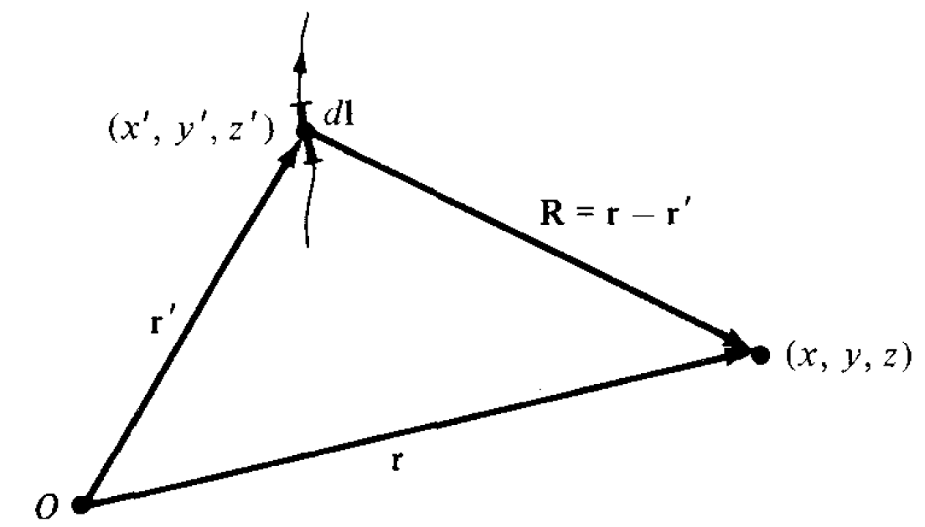

Figure ‎3.1.7‑1: Differential Current Line Current in xyz- Space

$$B=\frac{μ_{o}}{4π}\int{\frac{ Idl^{'} ×R}{R^{3}}}$$

$$B=\frac{μ_{o}}{4π}\int{Idl^{'}× \frac{ R}{R^{3}}}$$

Where $R=r-r^{'}$ is the distance vector from the line element Idl at the source point (x', y', z') to the field point (x, y, z) as shown in Figure ‎3.1.7‑1 and R = |R|, that is,

$$R=r-r^{'}=\left(x-x^{'}\right)a_{x}+\left(y-y^{'}\right)a_{y}+\left(z-z^{'}\right)a_{z}$$

$$\left|R\right|=\sqrt{{\left(x-x^{'}\right)}^{2}+{\left(y-y^{'}\right)}^{2}+{\left(z-z^{'}\right)}^{2}}$$

From the position vector of the polarized material and point where we are calculating the electric potential, we will Sol the gradient of $1/R$

$$∇\left(\frac{1}{R}\right)=\frac{∂\left(\frac{1}{R}\right)}{∂x}a_{x}+\frac{∂\left(\frac{1}{R}\right)}{∂y}a_{y}+\frac{∂\left(\frac{1}{R}\right)}{∂z}a_{z}$$

$$∇\left(\frac{1}{R}\right)=\frac{-1×\frac{∂\left(R\right)}{∂x}}{R^{2}}a_{x}+\frac{-1×\frac{∂\left(R\right)}{∂y}}{R^{2}}a_{y}+\frac{-1×\frac{∂\left(R\right)}{∂z}}{R^{2}}a_{z}$$

$$∇\left(\frac{1}{R}\right)=\frac{-1×\frac{2\left(x-x^{'}\right)×\left(1\right)}{2R}}{R^{2}}a_{x}+\frac{-1×\frac{2\left(y-y^{'}\right)×\left(1\right)}{2R}}{R^{2}}a_{y}+\frac{-1×\frac{2\left(z-z^{'}\right)×\left(1\right)}{2R}}{R^{2}}a_{z}$$

$$∇\left(\frac{1}{R}\right)=-\frac{\left(x-x^{'}\right)}{R^{3}}a_{x}-\frac{\left(y-y^{'}\right)}{R^{3}}a_{y}-\frac{\left(z-z^{'}\right)}{R^{3}}a_{z}$$

$$∇\left(\frac{1}{R}\right)=\frac{-1}{R^{3}}\left\{\left(x-x^{'}\right)a_{x}+\left(y-y^{'}\right)a_{y}+\left(z-z^{'}\right)a_{z}\right\}$$

$$∇\left(\frac{1}{R}\right)=\frac{-R}{R^{3}}=-\frac{a_{R}}{R^{2}}$$

$$\frac{R}{R^{3}}=-∇\left(\frac{1}{R}\right)$$

Substituting in B equation

$$B=\frac{μ_{o}}{4π}\int{Idl^{'}× \frac{ R}{R^{3}}}=-\frac{μ_{o}I}{4π}\int{dl^{'}× ∇\left(\frac{1}{R}\right)}$$

$$∇×\left(\frac{1}{R}dl^{'}\right)=\frac{1}{R}\left(∇×dl^{'}\right)+∇\left(\frac{1}{R}\right)×dl^{'}$$

$$∇\left(\frac{1}{R}\right)×dl^{'}=∇×\left(\frac{1}{R}dl^{'}\right)-\frac{1}{R}\left(∇×dl^{'}\right)$$

$$dl^{'}×∇\left(\frac{1}{R}\right)=\frac{1}{R}\left(∇×dl^{'}\right)-∇×\left(\frac{1}{R}dl^{'}\right)$$

$$dl^{'}×∇\left(\frac{1}{R}\right)=\frac{1}{R}\left(∇×dl^{'}\right)-∇×\left(\frac{dl^{'}}{R}\right)$$

Substituting in B equation

$$B=-\frac{μ_{o}I}{4π}\int{\left\{\frac{1}{R}\left(∇×dl^{'}\right)-∇×\left(\frac{dl^{'}}{R}\right)\right\}}$$

Since $∇$ operates with respect to *(x, y, z)* while $dl^{'}$ is a function of (x*' y', z'), $∇×dl^{'}$*  *=* 0. Hence,

$$B=-\frac{μ_{o}I}{4π}\int{\left\{0-∇×\left(\frac{dl^{'}}{R}\right)\right\}}=\frac{μ_{o}I}{4π}\int{∇×\left(\frac{dl^{'}}{R}\right)}$$

$$B=∇×\int{\frac{μ_{o}I}{4π}\left(\frac{dl^{'}}{R}\right)}=∇×A$$

$$B=∇×A$$

Where

$$A=\int{\frac{μ_{o}}{4π}\left(\frac{Idl^{'}}{R}\right)}$$

Substituting $B=∇×A$ in the flux equation

$$ψ=\int_{S}{B.ds}=\int_{S}{\left(∇×A\right).ds}$$

Applying the stocks theorem

$$\oint_{L}{A.dl}=\int_{S}{\left(∇×A\right).ds}$$

**Hence**

$$ψ=\int_{S}{B.ds}=\int_{S}{\left(∇×A\right).ds}=\oint_{L}{A.dl}$$

# MAGNETIC VECTOR POTENTIALS ON INFINIT CURRENT SHEET

If plane *z =* 0 carries uniform current K = *Kyay, the magnetic field strength will be*

$$H=\left\{\begin{matrix}H_{o}a_{x}, z>0 \\ \\ {-H}_{o}a_{x} z<0\end{matrix}\right.$$

*Obtain this by using the concept of vector magnetic potential.*

*For a surface current the magnetic vector potential will be*

$$dA=\frac{μ_{o}KdS^{'}}{4πR}$$

$$KdS^{'}=K_{y}dS^{'}a_{y}$$

*In cartesian coordinate system*

$$dl^{'}=dx^{'}{ a}_{x}+dy^{'} a_{y}+dz a_{z}$$

*For z>0*

$$dS^{'}=dx^{'}dy^{'}$$

$$KdS=K_{y}dx^{'}dy^{'}a_{y}$$

$$R=\left(0-x^{'}\right)a_{x}+\left(0-y^{'}\right)a_{y}+\left(z-0\right)a_{z}$$

$$R=-x^{'} a_{x}-y^{'} a_{y}+z a_{z}$$

$$R=\left|R\right|=\sqrt{{\left(x^{'}\right)}^{2}+{\left(y^{'}\right)}^{2}+z^{2}}$$

$$dA=\frac{μ_{o}KdS^{'}}{4πR}=\frac{μ_{o}K_{y}dx^{'}dy^{'}a_{y}}{4π\sqrt{{\left(x^{'}\right)}^{2}+{\left(y^{'}\right)}^{2}+z^{2}}}=A_{y}a_{y}$$

$$dB=∇×dA=∇×\frac{μ_{o}KdS^{'}}{4πR}=∇×\frac{μ_{o}K_{y}dx^{'}dy^{'}a_{y}}{4π\sqrt{{\left(x^{'}\right)}^{2}+{\left(y^{'}\right)}^{2}+z^{2}}}=∇×A_{y}a_{y}$$

$$dB=∇×A_{y}a_{y}=\left|\begin{matrix}a_{x} & a_{y} & a_{z} \\ \frac{∂}{∂x} & \frac{∂}{∂y} & \frac{∂}{∂z} \\ 0 & A_{y} & 0\end{matrix}\right|$$

$$dB=\left[\frac{∂}{∂y}\left(0\right)-\frac{∂A_{y}}{∂z}\right]a_{x}+\left[\frac{∂}{∂z}\left(0\right)-\frac{∂}{∂x}\left(0\right)\right]a_{y}+\left[\frac{∂A_{y}}{∂x}-\frac{∂}{∂y}\left(0\right)\right]a_{z}$$

$$dB=-\frac{∂A_{y}}{∂z}a_{x}=-\frac{∂}{∂z}\left\{\frac{μ_{o}K_{y}dx^{'}dy^{'}}{4π\sqrt{{\left(x^{'}\right)}^{2}+{\left(y^{'}\right)}^{2}+z^{2}}}\right\}a_{x}$$

$$dB=-\frac{1}{4π}\left\{\frac{-μ_{o}K_{y}dx^{'}dy^{'}×\left(\frac{2z}{2\sqrt{{\left(x^{'}\right)}^{2}+{\left(y^{'}\right)}^{2}+z^{2}}}\right)}{{\left(\sqrt{{\left(x^{'}\right)}^{2}+{\left(y^{'}\right)}^{2}+z^{2}}\right)}^{2}}\right\}a_{x}$$

$$dB=\frac{1}{4π}\left\{\frac{μ_{o}K_{y}zdx^{'}dy^{'}}{{\left({\left(x^{'}\right)}^{2}+{\left(y^{'}\right)}^{2}+z^{2}\right)}^{3/2}}\right\}a_{x}$$

$$B=\int{dB}=\int{\frac{1}{4π}\left\{\frac{μ_{o}K_{y}zdx^{'}dy^{'}}{{\left({\left(x^{'}\right)}^{2}+{\left(y^{'}\right)}^{2}+z^{2}\right)}^{3/2}}\right\}a_{x}}$$

$$B=\frac{μ_{o}K_{y}za_{x}}{4π}\int_{y^{'}=-∞}^{∞}{\int_{x^{'}=-∞}^{∞}{\frac{dx^{'}dy^{'}}{{\left({\left(x^{'}\right)}^{2}+{\left(y^{'}\right)}^{2}+z^{2}\right)}^{3/2}}}}$$

In the integrand, we may change coordinates from Cartesian to cylindrical for convenience so that

|  |  |
| --- | --- |
| **Cartesian Coordinate** | **Cylindrical Coordinate** |
| $$dl=dx{ a}_{x}+dy a_{y}+dz a_{z}$$ | $$dl=dρ a_{ρ}+ρdϕ{ a}_{ϕ}+dz a_{z}$$ |
| $$ds=dxdya_{z}$$ | $$ds=ρdρdϕa_{z}$$ |
| $$x=ρ\cos{ϕ}, y=ρ\sin{ϕ}$$ | $$ρ=\sqrt{x^{2}+y^{2}} , ϕ=\cos^{-1}\left(\frac{y}{x}\right)$$ |

$$B=\frac{μ_{o}K_{y}za_{x}}{4π}\int_{ϕ^{'}=0}^{2π}{\int_{ρ^{'}=0}^{∞}{\frac{ρ^{'}dρ^{'}dϕ^{'}}{{\left[{\left(ρ^{'}\right)}^{2}+z^{2}\right]}^{3/2}}}}$$

$$B=\frac{μ_{o}K_{y}za_{x}}{4π}\int_{ϕ^{'}=0}^{2π}{dϕ^{'}}\int_{ρ^{'}=0}^{∞}{ρ^{'}{\left[{\left(ρ^{'}\right)}^{2}+z^{2}\right]}^{{-3}/2} dρ^{'}}$$

$$B=\frac{μ_{o}K_{y}za_{x}}{4π}×2π×\int_{ρ^{'}=0}^{∞}{ρ^{'}{\left[{\left(ρ^{'}\right)}^{2}+z^{2}\right]}^{{-3}/2} dρ^{'}}$$

**This integration requires integration by substitution**

|  |  |
| --- | --- |
| Let |  |

**But**

$$B=μ_{o}H⇒ H=\frac{B}{μ_{o}}$$

$$H=\frac{1}{μ_{o}}×\left(\frac{μ_{o}K_{y}a_{x}}{2}\right)=\frac{K_{y}}{2}a_{x}, for z>0$$

$$H=\frac{K_{y}}{2}a_{x}, for z>0$$

By simply replacing *z* by *-z* in eq. (7.8.2) and following the same procedure, we obtain

$$H=-\frac{K_{y}}{2}a_{x}, for z<0$$

# DERIVATION OF BIOT-SAVART'S LAW AND AMPERE'S LAW

Both Biot-Savart's law and Ampere's law may be derived using the concept of magnetic vector potential. The derivation will involve the use of the following 2 vector identities

$$∇×\left(fF\right)=f\left(∇×F\right)+∇\left(f\right)×F$$

$$∇×∇×A=∇\left(∇.A\right)-∇.\left(∇A\right)=∇\left(∇.A\right)-∇^{2}A$$

Since Biot-Savart's law as given in eq. below

$$dH=\frac{ Idl ×R}{{4πR}^{3}}$$

Is basically on line current, we begin our derivation with eqs. (7.39) and (7.41); that is,

$$B=∇×A$$

Where

$$A=\int{\frac{μ_{o}}{4π}\left(\frac{Idl}{R}\right)}$$

Substituting A in B

$$B=∇×A=∇×\oint_{L}{\frac{μ_{o}Idl^{'}}{4πR}}=\frac{μ_{o}I}{4π}\oint_{L}{∇×\frac{1}{R}dl^{'}}$$

But applying below vector identity

$$∇×\left(\frac{1}{R}dl^{'}\right)=\frac{1}{R}\left(∇×dl^{'}\right)+∇\left(\frac{1}{R}\right)×dl^{'}$$

$$B=\frac{μ_{o}I}{4π}\oint_{L}{∇×\frac{1}{R}dl^{'}}=\frac{μ_{o}I}{4π}\oint_{L}{\left\{\frac{1}{R}\left(∇×dl^{'}\right)+∇\left(\frac{1}{R}\right)×dl^{'}\right\}}$$

Since $∇$ operates with respect to *(x, y, z)* and *dl'* is a function of *(x', y', z'), $∇×dl^{'}$* = 0

$$B=\frac{μ_{o}I}{4π}\oint_{L}{\left\{0+∇\left(\frac{1}{R}\right)×dl^{'}\right\}}$$

**But**

$$∇\left(\frac{1}{R}\right)=\frac{-R}{R^{3}}=-\frac{a_{R}}{R^{2}}$$

where $a_{R}$ is a unit vector from the source point to the field point. Thus eq. (7.54) (upon dropping the prime in $dl^{'}$*)* becomes

$$B=\frac{μ_{o}I}{4π}\oint_{L}{dl×\frac{a_{R}}{R^{2}}}$$

which is Biot-Savart's law.

Using the identity in eq. (7.52) with eq. (7.39), we obtain

$$∇×B=∇×∇×A=∇\left(∇.A\right)-∇.\left(∇A\right)=∇\left(∇.A\right)-∇^{2}A$$

It can be shown that for a **static magnetic field**

$$∇.A=0$$

so that upon replacing B with $μ_{o}H$ and using eq. (7.19), eq. (7.58) becomes

$$∇×B=∇×∇×A=-∇^{2}A$$

$$∇^{2}A=-∇×B=-∇×μ_{o}H$$

$$∇^{2}A=-∇×B=-μ_{o}∇×H$$

$$∇×∇×A=∇^{2}A=-μ_{o}∇×H=-μ_{o}J$$

$$∇^{2}A=-μ_{o}J$$

which is called the *vector Poisson's equation.* It is similar to Poisson's equation ( $∇^{2}V=-\frac{ρ_{v}}{ϵ}$*)* in electrostatics.

Furthermore, it can be shown that Ampere's circuit rule aligns harmoniously with our established understanding of the magnetic vector potential. By using Stokes's theorem and equation (7.39),

$$\oint_{L}{H.dl}=\int_{S}{\left(∇×H\right) .ds}=\int_{S}{\left(∇×\frac{B}{μ_{o}}\right) .ds}=\frac{1}{μ_{o}}\int_{S}{\left(∇×B\right) .ds}$$

$$\oint_{L}{H.dl}=\frac{1}{μ_{o}}\int_{S}{\left(∇×∇×A\right) .ds}$$

$$\oint_{L}{H.dl}=\frac{1}{μ_{o}}\int_{S}{\left(∇×∇×A\right) .ds}=\frac{1}{μ_{o}}\int_{S}{-μ_{o}J .ds}=-\int_{S}{J .ds}$$

$$\oint_{L}{H.dl}=\int_{S}{J .ds}=I$$

which is Ampere's circuit law.

# MAGNETIC FORCES, MATERIALS, AND DEVICES

There are at least three ways in which force due to magnetic fields can be experienced. The force can be (a) due to a moving charged particle in a B field, (b) on a current element in an external B field, or (c) between two current elements.

# Force on a Charged Particle

According to our discussion in Chapter 4, the electric force Fe on a stationary or moving electric charge Q in an electric field is given by Coulomb's experimental law and is related to the electric field intensity E as

$$F_{e}=QE$$

This shows that if *Q* is positive, *Fe* and E have the same direction.

A magnetic field can exert force only on a moving charge. From experiments, it is found that the magnetic force *Fm* experienced by a charge *Q* moving with a velocity u in a magnetic field B is

$$F_{m}=Qu×B$$

This clearly shows that Fm is perpendicular to both u and B.

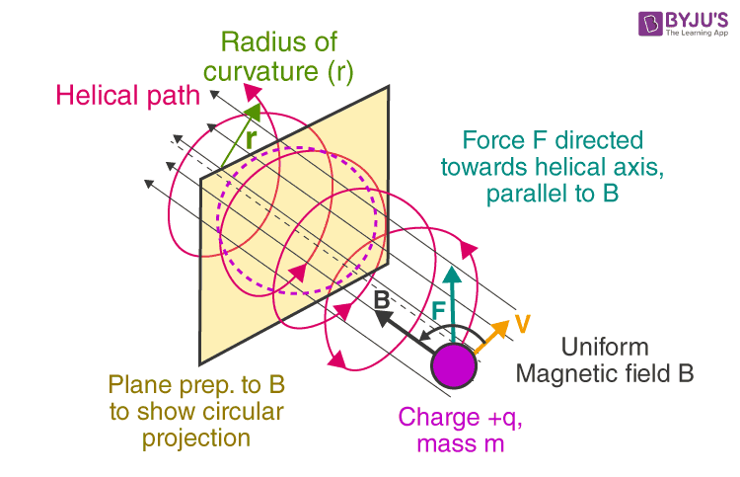

From eqs. (8.1) and (8.2), a comparison between the and they can be made.

|  |  |  |
| --- | --- | --- |
| **Criteria** | **Electric force $F_{e}$** | **Magnetic force $F_{m}$** |
| *Velocity of the charge u* | independent | dependent |
| *Work* | Perform work | Cannot perform work, because it is at right angles to the direction of motion of the charge (Fm • *dl =* 0) |
| *Kinetic Energy* | change its kinetic energy | does not cause an increase in kinetic energy |
| *Force Magnitude* | $$F_{e}=QE$$ | $F_{m}=Qu×B$**;** small except at high velocities |

For a moving charge *Q* in the presence of both electric and magnetic fields, the total force on the charge is given by

$$F=F_{e}+F_{m}$$

$$F=QE+Qu×B$$

$$F=Q\left(E+u×B\right)$$

The equation is commonly referred to as the Lorentz force equation. It establishes a relationship between mechanical force and electrical force. According to Newton's second equation of motion, the mass of a charged particle that is moving in electric (E) and magnetic (B) fields is denoted as m.

$$F=ma=m\frac{du}{dt}=Q\left(E+u×B\right)$$

|  |  |  |  |
| --- | --- | --- | --- |
| State of Particle | E field | B field | Combined E and B fields |
| Stationary | $$QE$$ | - | $$QE$$ |
| Moving | $$QE$$ | $$Qu×B$$ | $$Q\left(E+u×B\right)$$ |

# Force on a Current Element

To determine the magnetic force on a current element $Idl$ of a current-carrying conductor due to the magnetic field B, we modify eq. (8.2) using the fact that for convection current

$$J=ρ_{v} u$$

We recall below relationships for the current elements

$$Idl≡Kds≡Jdv$$

**Alternatively**

$$Idl=\frac{dQ}{dt}dl=dQ\frac{dl}{dt}=dQu$$

**Hence**

$$Idl=dQu$$

This shows that an elemental charge $dQ$ moving with velocity $u$ (thereby producing convection current element $dQu$ is equivalent to a conduction current element $Idl$*.* Thus, the force on a current element $Idl$ in a magnetic field B is found from eq. (8.2) by merely replacing $Qu$ by $Idl$*;* that is,

$$F_{m}=Qu×B$$

$$dF=dQu×B=Idl×B$$

If the current *I* is through a closed path***L*** or circuit, the force on the circuit is given by

$$F=\oint_{L}{dF}=\oint_{L}{Idl×B}$$

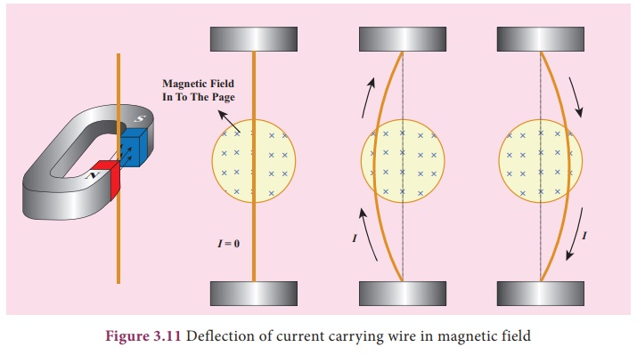

Figure ‑: Magnetic Force on Current Currying Conductor

# Force between Two Current Elements

Let us now consider the magnetic force between two elements $I_{1}dl_{1}$ and $I_{2}dl_{2}$

According to Biot-Savart's law, both current elements produce magnetic fields. So, we may find the force $d(dF_{1}$*)* on element $I_{1}dl_{1}$ due to the field $dB_{2}$ produced by element $I_{2}dl_{2}$ as shown below

$$d\left(dF_{1}\right)=I_{1}dl_{1}×dB_{2}$$

But from Biot-Savart's law,

Figure ‎3.2.3‑1: Force between two current elements

Also, we may find the force $d(dF_{2}$*)* on element $I_{2}dl_{2}$ due to the field $dB_{1}$ produced by element $I_{1}dl_{1}$ as shown below

$$d\left(dF_{2}\right)=I_{2}dl_{2}×dB_{1}$$

But from Biot-Savart's law,

$$dB_{1}=\frac{ μ_{o}I_{1}dl_{1} ×a_{R_{21}}}{4πR_{21}^{2}}$$

$$d\left(dF_{2}\right)=I_{2}dl_{2}×\frac{ μ_{o}I_{1}dl_{1} ×a_{R_{21}}}{4πR_{21}^{2}}$$

$$d\left(dF_{1}\right)=\frac{ μ_{o}I_{2}dl_{2}×I_{1}dl_{1} ×a_{R_{21}}}{4πR_{21}^{2}}$$

$$F_{2}=\frac{μ_{o}I_{1}I_{2}}{4π}\oint_{L_{1}}{\oint_{L_{2}}{\frac{ dl_{2}×dl_{1} ×a_{R_{21}}}{R_{21}^{2}}}}$$

# MAGNETIC TORQUE AND MOMENT

Having analyzed the force exerted on a current loop inside a magnetic field, we can now ascertain the torque acting upon it. The comprehension of the torque experienced by a current loop in a magnetic field is crucial for comprehending the behavior of orbiting charged particles, d.c. motors, and generators. When the loop is aligned parallel to a magnetic field, it encounters a force that induces rotational motion.   
  
The torque T, also known as the mechanical moment of force, is calculated by taking the vector product of the force F and the moment arm r.   
  
The value provided represents the torque in Newton-meters (N.m).

$$T=r×F$$

Let us apply this to a rectangular loop of length $l$ and width $w$ placed in a uniform magnetic field B as shown in Figure

Remember $a_{y}×a_{y}=0$, because we notice that $dl$ is parallel to **B** along sides 12 and 34 of the loop and no force is exerted on those sides

And

where |F0| = *IBl* because B is uniform. Thus, no force is exerted on the loop as a whole. However, Fo and — Fo act at different points on the loop, thereby creating a couple. If the normal to the plane of the loop makes an angle *a* with B, as shown in the cross-sectional view of Figure 8.5(b), the torque on the loop is

$$\left|T\right|=\left|F_{o}\right| w sinα$$

$$\left|T\right|=BIl w sinα$$

**But**

$$S=lw;area ofthe loop$$

$$\left|T\right|=B I S sinα$$

We define the Quantity

$$m=I Sa_{n}$$

as the magnetic dipole moment (measured in amperes per square meter) of the loop. In equation (8.18), "an" represents a unit normal vector that is perpendicular to the plane of the loop. The direction of "an" is determined using the right-hand rule, where the fingers point in the direction of the current and the thumb points along "an". The magnetic dipole moment is defined as the multiplication of the current flowing through a loop and the area enclosed by the loop. The direction of the magnetic dipole moment is perpendicular to the plane of the loop.

$$T=m×B$$

# A MAGNETIC DIPOLE

A magnetic dipole is commonly used to refer to either a bar magnet or a tiny filamentary current loop. The rationale for this and our definition of "small" will become apparent shortly. We will calculate the magnetic field B at the observation point P(r, θ, Φ) caused by a circular loop with current I, as shown in Figure 8.6. The magnetic vector potential at point P is.

|  |  |
| --- | --- |
|  |  |

For cylindrical coordinate

$$dl=dρ a_{ρ}+ρdϕ{ a}_{ϕ}+dz a_{z}$$

$$A=\frac{μ_{o}I}{4π}\left[\int_{0}^{π}{\frac{ρdϕ{ a}_{ϕ}}{r_{1}}}+\int_{2π}^{π}{\frac{ρdϕ{ a}_{ϕ}}{r_{2}}}\right]$$

But $ρ=a$

$$A=\frac{μ_{o}I}{4π}\left[\int_{0}^{π}{\frac{adϕ{ a}_{ϕ}}{r_{1}}}+\int_{2π}^{π}{\frac{adϕ{ a}_{ϕ}}{r_{2}}}\right]$$

$$A=\frac{μ_{o}Ia}{4π}\left[\int_{0}^{π}{\frac{dϕ}{r_{1}}}+\int_{2π}^{π}{\frac{dϕ}{r_{2}}}\right]{ a}_{ϕ}$$

$$A=\frac{μ_{o}Ia}{4π}\left[\frac{π-0}{r_{1}}+\frac{π-2π}{r_{2}}\right]{ a}_{ϕ}$$

$$A=\frac{μ_{o}Ia}{4π}\left[\frac{π}{r_{1}}+\frac{-π}{r_{2}}\right]{ a}_{ϕ}$$

$$A=\frac{μ_{o}Iaπ}{4π}\left[\frac{r_{2}-r_{1}}{r_{1}r_{2}}\right]{ a}_{ϕ}$$

Where r, and r2 are the distances between *P* and *+Qm* and *P* and *-Qm,* respectively. If $r≫d,r_{2}-r_{1}=d cosθ, r_{1}∙r_{2}=r^{2}$*,* and eq.

$$A=\frac{μ_{o}Iaπ}{4π}\left[\frac{d\cos{θ}}{r^{2}}\right]{ a}_{ϕ}$$

**But**

$$d\cos{θ}≅a\sin{θ}$$

$$A=\frac{μ_{o}Iaπ}{4π}\left[\frac{a\sin{θ}}{r^{2}}\right]{ a}_{ϕ}=\frac{μ_{o}Iπa^{2}}{4π}\left[\frac{\sin{θ}}{r^{2}}\right]{ a}_{ϕ}$$

$$A=\frac{μ_{o}Iπa^{2}\sin{θ}}{4πr^{2}}{ a}_{ϕ}$$

$$A=\frac{μ_{o}I S\sin{θ}}{4πr^{2}}{ a}_{ϕ}={ A}_{ϕ}{ a}_{ϕ}$$

$$A=\frac{μ_{o} m ×{ a}_{r}}{4πr^{2}}$$

$$B=∇×A=\frac{1}{r^{2}sin θ}\left|\begin{matrix}a_{r} & ra_{θ} & rsin θa_{ϕ} \\ \frac{∂}{∂r} & \frac{∂}{∂θ} & \frac{∂}{∂ϕ} \\ A_{r} & rA_{θ} & rsin θ A_{ϕ}\end{matrix}\right|$$

$$B=∇×A=\frac{1}{r^{2}sin θ}\left|\begin{matrix}a_{r} & ra_{θ} & rsin θa_{ϕ} \\ \frac{∂}{∂r} & \frac{∂}{∂θ} & \frac{∂}{∂ϕ} \\ 0 & 0 & rsin θ A_{ϕ}\end{matrix}\right|$$

$$B=∇×A=\frac{1}{r^{2}sin θ}\left\{\left[\frac{∂}{∂θ}\left(rsinθ A_{ϕ}\right)-\frac{∂}{∂ϕ}\left(0\right)\right]a_{r}+\left[\frac{∂}{∂ϕ}\left(0\right)-\frac{∂}{∂r}\left(rsin θ A_{ϕ}\right)\right]{ra}_{θ}+\left[\frac{∂}{∂r}\left(0\right)-\frac{∂}{∂θ}\left(0\right)\right]rsin θa_{ϕ}\right\}$$

$$B=∇×A=\frac{1}{r^{2}sin θ}\left\{\left[\frac{∂}{∂θ}\left(rsinθ A_{ϕ}\right)\right]a_{r}+\left[\frac{∂}{∂r}\left(rsin θ A_{ϕ}\right)\right]{ra}_{θ}\right\}$$

**But**

$$A_{ϕ}=\frac{μ_{o}I S\sin{θ}}{4πr^{2}}=\frac{μ_{o}I S}{4π}\frac{\sin{θ}}{r^{2}}=k\frac{\sin{θ}}{r^{2}}; k=\frac{μ_{o}I S}{4π}$$

$$B=∇×A=\frac{1}{r^{2}sin θ}\left\{\left[\frac{∂}{∂θ}\left(rsinθ ×k\frac{\sin{θ}}{r^{2}}\right)\right]a_{r}+\left[\frac{∂}{∂r}\left(rsin θ× k\frac{\sin{θ}}{r^{2}}\right)\right]{ra}_{θ}\right\}$$

$$B=∇×A=\frac{k}{r^{2}sin θ}\left\{ \left[\frac{∂}{∂θ}\left(\frac{\sin^{2}θ}{r}\right)\right]a_{r}+\left[\frac{∂}{∂r}\left(\frac{\sin^{2}θ}{r} \right)\right]{ra}_{θ} \right\}$$

$$B=\frac{k}{r^{2}sin θ}\left\{ \left[\frac{2 sinθ cosθ}{r}\right]a_{r}+\left[\frac{{-sin}^{2}θ×1}{r^{2}}\right]ra_{θ} \right\}$$

$$B=\frac{k}{r^{2}}\left\{\frac{2 cosθ}{r}{ a}_{r}-\frac{sinθ}{r}{ a}_{θ}\right\}$$

$$B=\frac{μ_{o}I S}{4πr^{3}}\left\{2 cosθ{ a}_{r}-sinθ{ a}_{θ}\right\}$$

$$B=\frac{μ_{o}m}{4πr^{3}}\left\{2 cosθ a_{r}-sinθ{ a}_{θ}\right\}$$

# MAGNETIZATION IN MATERIALS

It is understood that a certain substance is comprised of individual atoms. Every atom may be considered as composed of electrons circling around a central positive nucleus, with the electrons also spinning about their own axes. Therefore, electrons either circling around the nucleus (as shown in Figure 8.10(a)) or spinning (as shown in Figure 8.10(b)) generate an internal magnetic field. Both of these electrical movements generate internal magnetic fields B that resemble the magnetic field created by a current loop seen in Figure 8.11. The magnetic moment of the analogous current loop is given by the equation m = IbSan, where S represents the area of the loop and Ib represents the bound current, which is associated with the atom.

Without an external B field applied to the material, the sum of m's is zero due to random orientation as in Figure 8.12(a). When an external B field is applied, the magnetic moments of the electrons more or less align themselves with B so that the net magnetic moment is not zero, as illustrated in Figure 8.12(b).

The **magnetization M (in amperes/meter) is the magnetic dipole moment per unit volume.**

If there are *N* atoms in a given volume *∆v* and the *kth* atom has a magnetic moment m*.

$$M=\lim_{∆v→0}\left\{\frac{\sum_{k=1}^{n}{m_{k}}}{∆v}\right\}$$

A medium for which M is not zero everywhere is said to be magnetized.

For a differential volume *dv',* the magnetic moment is dm = M *dv'.* From eq. (8.21b), the vector magnetic potential due to *dm* is

**But**

**But**

$$∇^{'}\left(\frac{1}{R}\right)=\frac{R}{R^{3}}=\frac{a_{R}}{R^{2}}$$

$$A=\frac{μ_{o} }{4π}\int{M×∇^{'}\left(\frac{1}{R}\right)dv^{'}}$$

$$∇^{'}×\left(\frac{1}{R}M\right)=\frac{1}{R}\left(∇^{'}×M\right)+∇^{'}\left(\frac{1}{R}\right)×M$$

$$∇^{'}\left(\frac{1}{R}\right)×M=∇^{'}×\left(\frac{1}{R}M\right)-\frac{1}{R}\left(∇^{'}×M\right)$$

$$M×∇^{'}\left(\frac{1}{R}\right)=\frac{1}{R}\left(∇^{'}×M\right)-∇^{'}×\left(\frac{1}{R}M\right)$$

$$A=\frac{μ_{o} }{4π}\int{M×∇^{'}\left(\frac{1}{R}\right)dv^{'}}=\frac{μ_{o} }{4π}\int{\left\{\frac{1}{R}\left(∇^{'}×M\right)-∇^{'}×\left(\frac{1}{R}M\right)\right\}}dv^{'}$$

$$A=\frac{μ_{o} }{4π}\int_{v^{'}}{\frac{∇^{'}×M}{R}dv^{'}}-\frac{μ_{o} }{4π}\int_{v^{'}}{∇^{'}×\left(\frac{1}{R}M\right)dv^{'}}$$

We have below vector identity

$$\int_{v^{'}}{∇^{'}×M dv^{'}}=-\oint_{s}{M× ds^{'}}$$

$$A=\frac{μ_{o} }{4π}\int_{v^{'}}{\frac{∇^{'}×M}{R}dv^{'}}+\frac{μ_{o} }{4π}\oint_{s}{\frac{M× ds^{'}}{R} }$$

$$A=\frac{μ_{o} }{4π}\int_{v^{'}}{\frac{∇^{'}×M}{R}dv^{'}}+\frac{μ_{o} }{4π}\oint_{s}{\frac{M×a_{n} }{R}ds^{'} }$$

$$A=\frac{μ_{o} }{4π}\int_{v^{'}}{\frac{J_{b}dv^{'} }{R}}+\frac{μ_{o} }{4π}\oint_{s}{\frac{K_{b}ds^{'} }{R} }$$

$$J_{b}=∇×M, bond volume current density$$

$$K_{b}=M×a_{n}, bound surface current density$$

Jb represents the bound volume current density or magnetization volume current density, measured in amperes per meter square. Kb represents the bound surface current density, measured in amperes per meter. an is a unit vector that is perpendicular to the surface. Equation (8.29) demonstrates that the potential of a magnetic body is a result of a volume current density Jb existing inside the body and a surface current Kb present on the body's surface. The vector M is comparable to the polarization P in dielectrics and is sometimes referred to as the magnetic polarization density of the medium. In another sense, M is analogous to H and they both have the same units. Regarding this matter, just as J equals the cross product of V and H, Jb also equals the cross product of V and M. Additionally, the symbols Jb and Kb, used for a magnetic body, have resemblance to ppv and pps, which are used for a polarized body. It is clear from equations (8.29) to (8.31) that Jh and Kh may be obtained from M. Consequently, ib and Kb are not usually used.

In free space, M = 0 and we have

$$∇×H=J_{f}$$

$$∇×\frac{B}{μ_{o}}=J_{f}$$

where Jf is the free current volume density. In a material medium M ≠ 0, and as a result, B changes so that

$$∇×\frac{B}{μ_{o}}=J_{f}+J_{b}=J$$

$$∇×\frac{B}{μ_{o}}=∇×H+∇×M=J$$

$$∇×\frac{B}{μ_{o}}=∇×\left(H+M \right)=J$$

$$\frac{B}{μ_{o}}=H+M⇒B=μ_{o}\left(H+M\right)$$

The relationship in eq. (8.33) holds for all materials whether they are linear or not. The concepts of linearity, isotropy, and homogeneity introduced in Section 5.7 for dielectric media equally apply here for magnetic media. For linear materials, M (in A/m) depends linearly on H such that

$$M=χ_{m}H$$

where $χ_{m}$ is a dimensionless quantity (ratio of *M* to *H)* called *magnetic susceptibility* of the medium. It is more or less a measure of how susceptible (or sensitive) the material is to a magnetic field. Substituting eq. (8.34) into eq. (8.33) yields

$$B=μ_{o}\left(H+χ_{m}H\right)$$

$$B=μ_{o}\left(1+χ_{m}\right)H$$

$$B=μ_{o}μ_{r}H$$

$$B=μH$$

$$μ_{r}=1+χ_{m}=\frac{μ}{μ_{o}}$$

The quantity $μ=μ_{o}μ_{r}$ is called the *permeability* of the material and is measured in henrys/meter; the henry is the unit of inductance and will be defined a little later. The dimensionless quantity $μ_{r}$ is the ratio of the permeability of a given material to that of free space and is known as the *relative permeability* of the material.

# MAGNETIC BOUNDARY CONDITIONS

We define magnetic boundary conditions as the conditions that H (or B) field must satisfy at the boundary between two different media. Our derivations here are similar to those in Section 5.9. We make use of Gauss's law for magnetic fields

$$\oint_{s}{B.ds}=0$$

and Ampere's circuit law

$$\oint_{L}{H.dl}=I$$

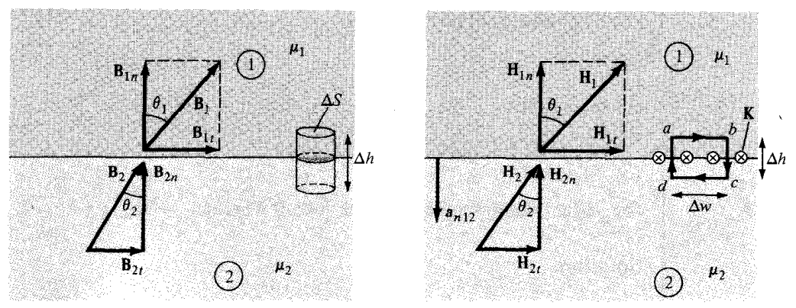

# INDUCTORS AND INDUCTANCES

A circuit (or closed conducting path) carrying current / produces a magnetic field B which causes a flux $ψ=\int{B.ds}$ to pass through each turn of the circuit as shown in Figure 8.19.

If the circuit has *N* identical turns, we define *the flux linkage $λ$* as

$$λ=Nψ$$

Also, if the medium surrounding the circuit is linear, the flux linkage X is proportional to the current / producing it; that is,

$$λ∝i$$

$$λ=L I$$

L represents a constant factor known as the circuit's inductance. Inductance Inductance (L) is a characteristic of the circuit's physical configuration. An inductor is a circuit or component of a circuit that has inductance. The inductance L of an inductor may be defined as the ratio of the magnetic flux linkage X to the current / passing through the inductor, as given by equations (8.50) and (8.51).

$$L=\frac{λ}{I}=\frac{Nψ}{I}$$

The unit of inductance is the henry (H), which is defined as the amount of inductance that produces one weber of magnetic flux per ampere of current. Inductances, being of considerable magnitude, are commonly quantified in millihenrys (mH).

The inductance, as described by equation (8.52), is commonly referred to as self-inductance because it is produced by the inductor itself. Inductance can be regarded as a measure of the magnetic energy stored in an inductor, much like capacitance measures the amount of electrical energy stored in a capacitor. The magnetic energy stored in an inductor in circuit theory is measured in joules. $W_{m}=\frac{1}{2}LI^{2}$

$$L=\frac{{2W}_{m}}{I^{2}}$$

If instead of having a single circuit, we have two circuits carrying current I1 and I2 as shown in Figure

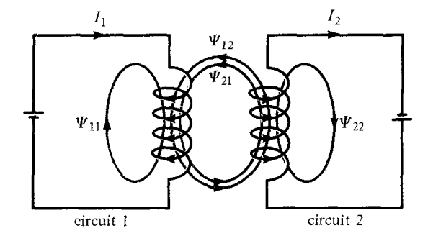

Above circuit shows the magnetic interactions exits between the circuits

$$ψ_{11} is the flux passing through circuit 1 due to current I_{1} in circuit 1$$

$$ψ_{11}=\int_{s1}{B_{1}.dS_{1}}$$

$$ψ_{12} is the flux passing through circuit 1 due to current I_{2} in circuit 2$$

$$ψ_{12}=\int_{s1}{B_{2}.dS_{1}}$$

$$ψ_{22} is the flux passing through circuit 2 due to current I_{2} in circuit 2$$

$$ψ_{22}=\int_{s2}{B_{2}.dS_{2}}$$

$$ψ_{21} is the flux passing through circuit 2 due to current I_{1} in circuit 1$$

$$ψ_{21}=\int_{s2}{B_{1}.dS_{2}}$$

**We shall define the mutual inductances as below**

$M_{12}$ is the ratio of flux linkage $λ_{12}$ in circuit 1 to current $I_{2}$

$$M_{12}=\frac{λ_{12}}{I_{2}}=\frac{N_{1}ψ_{12}}{I_{2}}$$

$M_{21}$ is the ratio of flux linkage $λ_{21}$ in circuit 2 to current $I_{1}$

$$M_{21}=\frac{λ_{21}}{I_{1}}=\frac{N_{2}ψ_{21}}{I_{1}}$$

If the medium surrounding the circuits is linear then

$$M_{12}=M_{21}$$

**We shall define the self-inductances as below**

$L_{11}$ is the ratio of flux linkage $λ_{11}$ in circuit 1 to current $I_{1}$

$$L_{11}=\frac{λ_{11}}{I_{1}}=\frac{N_{1}ψ_{11}}{I_{1}}$$

$L_{22}$ is the ratio of flux linkage $λ_{22}$ in circuit 2 to current $I_{2}$

$$L_{22}=\frac{λ_{22}}{I_{2}}=\frac{N_{2}ψ_{22}}{I_{2}}$$

An inductor is a type of conductor that is specifically designed to store magnetic energy. Common examples of inductors are toroids, solenoids, coaxial transmission lines, and parallel-wire transmission lines. The inductance of each of these inductors can be found by employing a process analogous to that used in determining the capacitance of a capacitor. To determine the self-inductance L of a given inductor, we follow these steps:

1. Choose a suitable coordinate system.
2. Let the inductor carry current $I$.
3. Determine **B** from Biot-Savart's law (or from Ampere's law if symmetry exists)
4. Calculate $ψ$ from $ψ=\int_{s}{B.ds}$
5. Finally find***L*** from

$$L=\frac{λ}{I}=\frac{Nψ}{I}$$

# Inductance for Toroid



$$I_{enc}=\oint_{L}{H.dl}=\int_{S}{\left(∇×H\right) .ds}=\int_{S}{J .ds}$$

$$⇒\oint_{L}{H.dl}=\oint_{L}{H_{ϕ}{ a}_{ϕ}.ρdϕ{ a}_{ϕ}}$$

$$\oint_{L}{H_{ϕ}ρdϕ}=H_{ϕ}ρ×\int_{ϕ=o}^{ϕ=2π}{dϕ}=H_{ϕ}ρ×2π$$

$$H_{ϕ}×2πρ$$

$$⇒\int_{S}{J .ds}=I_{enc}=NI$$

Equaling both sides

$$H_{ϕ}×2πρ=NI$$

$$H_{ϕ}=\frac{N I}{2πρ}$$

$$B=μH=μ ×\left\{\frac{N I}{2πρ}\right\}=\frac{μ N I}{2πρ}$$

$$dl=dρ a_{ρ}+ρdϕ{ a}_{ϕ}+dz a_{z}$$

$$ds=ρdρdϕa_{z}$$

$$ψ=\int_{S}{B .ds}=\int_{S}{\frac{μ N I}{2πρ} .ds}=\int_{S}{\frac{μ N I}{2πρ} .ρdρdϕ}$$

$$ψ=\frac{μ N I}{2π}\int_{ρ=0}^{ρ=a}{dρ}×\int_{ϕ=o}^{ϕ=2π}{dϕ}=\frac{μ N I}{2π}×a×2π=μ N Ia$$

$$L=\frac{λ}{I}=\frac{Nψ}{I}=\frac{N}{I}×μ N Ia=μ N^{2} a$$

# Inductance for Solenoid

Since the solenoid consisting of circular loops, we apply ring equation whereby the contribution of the magnetic field at point P by the solenoid of length *dz*

$$H=\frac{ I ρ^{2}}{{2\left(ρ^{2}+h^{2}\right)}^{3/2}}⇒dH=\frac{ I a^{2}dl}{{2\left(a^{2}+z^{2}\right)}^{3/2}}$$

But

$$dl=n dz$$

$$dH=\frac{ I a^{2}n dz}{{2\left(a^{2}+z^{2}\right)}^{3/2}}$$

$$\tan{θ}=\frac{a}{z}⇒z=\frac{a}{\tan{θ}}=a cotθ$$



**Differentiating both sides**

$$dz=-a\csc^{2}{θ} dθ=\frac{-a dθ}{\sin^{2}{θ}}$$

Substituting in *dH* equation

$$dH=\frac{ I a^{2}n dz}{{2\left(a^{2}+z^{2}\right)}^{3/2}}=\frac{ I a^{2}n \left\{\frac{-a dθ}{\sin^{2}{θ}}\right\}}{{2\left(a^{2}+{\left(a cotθ\right)}^{2}\right)}^{3/2}}$$

$$dH=\frac{- I a^{3}n dθ}{{2\sin^{2}{θ}\left(a^{2}+{\left(a cotθ\right)}^{2}\right)}^{3/2}}=\frac{- I a^{3}n dθ}{2\sin^{2}{θ}{\left\{a^{2}\left(1+\cot^{2}θ\right)\right\}}^{3/2}}$$

$$dH=\frac{- I a^{3}n dθ}{2a^{3}\sin^{2}{θ}{\left\{\left(\csc^{2}θ\right)\right\}}^{3/2}}=\frac{- I n dθ}{2\sin^{2}{θ}\csc^{3}θ}$$

$$dH=\frac{- I n dθ}{2\sin^{2}{θ}\left(\frac{1}{\sin^{3}θ}\right)}=\frac{- I n dθ}{2\left(\frac{1}{sinθ}\right)}=\frac{- I n sinθdθ}{2}$$

$$H=\int{dH}=-\int{\frac{1}{2}I n sinθdθ}=-\frac{I n}{2} \int_{θ_{1}}^{θ_{2}}{sinθdθ}$$

$$H=-\frac{I n}{2} ×\left\{-\cos{θ}\left|\begin{matrix}θ_{2} \\ \\ θ_{1}\end{matrix}\right.\right\}=\frac{I n}{2} ×\left\{\cos{θ_{2}}-\cos{θ_{1}}\right\}$$

$$H=\frac{I n}{2} ×\left\{\cos{θ_{2}}-\cos{θ_{1}}\right\}$$

If we have an infinitely long solenoid, then $θ_{2}=0^{o}, and θ_{1}={180}^{o}$

$$H=\frac{I n}{2} ×\left\{\cos{0^{o}}-\cos{{180}^{o}}\right\}=\frac{I n}{2} ×\left\{1-\left(-1\right)\right\}=I n$$

$$B=μH=μI n$$

$$ψ=\int_{S}{B .ds}=μI n S$$

Finding the flux linkage per unit length

$$λ^{'}=\frac{λ}{l}=\frac{Nψ}{l}=n ψ$$

$$L=\frac{λ^{'}}{I}=\frac{n ψ}{I}=\frac{n}{I}×μI n S=μ n^{2} S$$

# Inductance for Coaxial Cable

**L2**

**L1**

Since the current distribution is symmetrical, we will apply Ampere’s law

$$I_{enc}=\oint_{L}{H.dl}=\int_{S}{\left(∇×H\right) .ds}=\int_{S}{J .ds}$$

For Cylindrical coordinate system

$dl=dρ a_{ρ}+ρdϕ{ a}_{ϕ}+dz a_{z}$

Since the differential displacement vector is along ${ a}_{ϕ}$, then dl will be

$$dl=ρdϕ{ a}_{ϕ}$$

And if the current direction is along az, then the differential area is

$$ds=ρdρdϕ a_{z}$$

**Internal Inductance Lin:** For path L1: $ρ≤a$

$$I_{enc}=\oint_{L1}{H.dl}=\int_{S1}{\left(∇×H\right) .ds}=\int_{S1}{J .ds}$$

$$⇒\oint_{L1}{H.dl}=\oint_{L1}{H_{ϕ}{ a}_{ϕ}.ρdϕ{ a}_{ϕ}}$$

$$\oint_{L1}{H_{ϕ}ρdϕ}=H_{ϕ}ρ×\int_{ϕ=o}^{ϕ=2π}{dϕ}=H_{ϕ}ρ×2π$$

$$H_{ϕ}×2πρ$$

$$⇒\int_{S1}{J .ds}=I_{enc}$$

But

$$J=\frac{I}{πa^{2}}a_{z}$$

$$\int_{S1}{\frac{I}{πa^{2}}a_{z} .ρdρdϕ a_{z}}=\frac{I}{πa^{2}}\int_{ρ=0}^{a}{ρdρ}×\int_{ϕ=o}^{2π}{dϕ}$$

$$\int_{S1}{\frac{I}{πa^{2}}a_{z} .ρdρdϕ a_{z}}=\frac{I}{πa^{2}}×\frac{ρ^{2}}{2}\left|\begin{matrix}ρ \\ \\ 0\end{matrix}\right.×2π=\frac{ρ^{2}I}{a^{2}}$$

Equaling both sides

$$H_{ϕ}×2πρ=\frac{ρ^{2}I}{a^{2}}⇒H_{ϕ}=\frac{ρ^{2}I}{2πρ{×a}^{2}}⇒$$

$$H_{ϕ}=\frac{Iρ}{2πa^{2}}$$

$$B=μH=μ ×\left\{\frac{Iρ}{2πa^{2}}\right\}=\frac{μIρ}{2πa^{2}}$$

$$dl=dρ a_{ρ}+ρdϕ{ a}_{ϕ}+dz a_{z}$$

$$ds=dρdza_{ϕ}$$

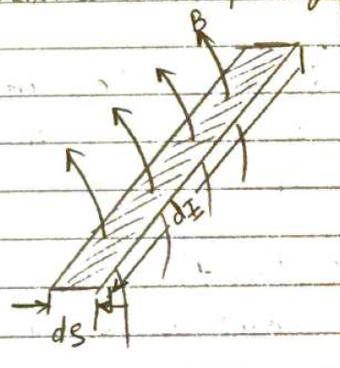

$$dψ=B .ds=\frac{μIρ}{2πa^{2}}a_{ϕ} .dρdza_{ϕ}=\frac{μIρ}{2πa^{2}}dρdz$$

$$dλ=N dψ=\left\{\frac{πρ^{2}}{πa^{2}}\right\}\frac{μI}{2πa^{2}}ρdρdz=\frac{μIρ^{3}}{2πa^{4}}dρdz$$

$$λ=\int{dλ}=\frac{μI}{2πa^{4}}\int_{ρ=0}^{a}{ρ^{3}}dρ×\int_{z=o}^{l}{dz}=\frac{μI}{2πa^{4}}×\frac{ρ^{4}}{4}\left|\begin{matrix}a \\ \\ 0\end{matrix}\right.×l$$

$$λ=\frac{μI}{2πa^{4}}×\frac{a^{4}}{4}×l=\frac{μIl}{8π}$$

$$L_{in}=\frac{λ}{I}=\frac{\left\{\frac{μIl}{8π}\right\}}{I}=\frac{μl}{8π}$$

$$L_{in}=\frac{μl}{8π}×\frac{1}{l}=\frac{μ}{8π};Indutance per unit length$$

**Internal Inductance Lin:** For path L2: $a≤ρ≤b$

$$I_{enc}=\oint_{L2}{H.dl}=\int_{S2}{\left(∇×H\right) .ds}=\int_{S2}{J .ds}$$

$$⇒\oint_{L2}{H.dl}=\oint_{L2}{H_{ϕ}{ a}_{ϕ}.ρdϕ{ a}_{ϕ}}$$

$$\oint_{L2}{H_{ϕ}ρdϕ}=H_{ϕ}ρ×\int_{ϕ=o}^{ϕ=2π}{dϕ}=H_{ϕ}ρ×2π$$

$$H_{ϕ}×2πρ$$

$$⇒\int_{S2}{J .ds}=I_{enc}=I$$

Equaling both sides



$$H_{ϕ}×2πρ=I$$

$$H_{ϕ}=\frac{I}{2πρ}$$

$$B=μH=μ ×\left\{\frac{I}{2πρ}\right\}=\frac{μI}{2πρ}$$

$$dl=dρ a_{ρ}+ρdϕ{ a}_{ϕ}+dz a_{z}$$

$$ds=dρdza_{ϕ}$$

$$dψ=B .ds=\frac{μI}{2πρ}a_{ϕ} .dρdza_{ϕ}=\frac{μI}{2πρ}dρdz$$

$$dλ=N dψ=\left\{1\right\}\frac{μI}{2πρ}dρdz=\frac{μI}{2πρ}dρdz$$

$$λ=\int{dλ}=\frac{μI}{2π}\int_{ρ=a}^{b}{\frac{1}{ρ}}dρ×\int_{z=o}^{l}{dz}=\frac{μI}{2π}×\ln{ρ}\left|\begin{matrix}b \\ \\ a\end{matrix}\right.×l$$

$$λ=\frac{μI}{2π}×\left\{\ln{b}-\ln{a}\right\}×l=\frac{μIl}{2π}\ln\left(\frac{b}{a}\right)$$

$$L_{ex}=\frac{λ}{I}=\frac{\left\{\frac{μIl}{2π}\ln\left(\frac{b}{a}\right)\right\}}{I}=\frac{μl}{2π}\ln\left(\frac{b}{a}\right)$$

$$L_{ex}=\frac{μl}{2π}\ln\left(\frac{b}{a}\right)×\frac{1}{l}=\frac{μ}{2π}\ln\left(\frac{b}{a}\right);Indutance per unit length$$

The total inductance shall be

$$L_{total}=L_{in}+L_{ex}=\frac{μ}{8π}+\frac{μ}{2π}\ln\left(\frac{b}{a}\right)=\frac{μ}{2π}×\left\{\frac{1}{4}+\ln\left(\frac{b}{a}\right)\right\}$$

# MAGNETIC ENERGY

Just as the potential energy in an electrostatic field was derived as

$$W_{E}=\frac{1}{2}\int_{v}{\left(D.E\right)dv}=\frac{1}{2}\int_{v}{\left(ϵ_{o}E^{2}\right)dv}$$

Just as the potential energy in an electrostatic field was derived as

$$W_{m}=\frac{1}{2}LI^{2}$$

Consider a differential volume in a magnetic field as shown in Figure 8.21. Let the

volume be covered with conducting sheets at the top and bottom surfaces with current .

We assume that the whole region is filled with such differential volumes. From eq. (8.52), each volume has an inductance

$$L=\frac{λ}{I}=\frac{Nψ}{I}$$

If N=1

$$L=\frac{ψ}{I}$$

Per volume $Δv$

$$ΔL=\frac{Δψ}{ΔI}=\frac{B ΔS}{ΔI}$$

But $ΔS=ΔxΔz$

$$ΔL=\frac{B ΔS}{ΔI}=\frac{B ΔxΔz }{ΔI}$$

$$B=μH$$

$$ΔL=\frac{μH ΔxΔz }{ΔI}$$

As per Ampere's circuit law

$$\oint_{L}{H.dl}=I_{enc}$$

$$H.Δl=I_{enc}⇒H.Δy=ΔI$$

$$ΔI=H.Δy$$

Substituting in

$$W_{m}=\frac{1}{2}ΔL {ΔI}^{2}$$

$$W_{m}=\frac{1}{2}\left\{\frac{μH ΔxΔz }{ΔI}\right\} {\left\{ΔI\right\}}^{2}=\frac{1}{2}μH ΔxΔz ×ΔI=\frac{1}{2}μH ΔxΔz ×H.Δy$$

$$W_{m}=\frac{1}{2}μH^{2}ΔxΔzΔy$$

$$W_{m}=\frac{1}{2}μH^{2}Δv$$

The magnetostatic energy density $w_{m}$

$$w_{m}=\frac{W_{m}}{Δv}=\frac{1}{2}\frac{μH^{2}Δv}{Δv}=\frac{1}{2}μH^{2}$$

$$w_{m}=\frac{1}{2}μH.H=\frac{1}{2}B.H=\frac{1}{2}\frac{B^{2}}{μ}$$

$$W_{m}=\frac{1}{2}\int_{v}{B.H dv}=\frac{1}{2}\int_{v}{\frac{B^{2}}{μ} dv}$$

In below we will utilize the magnetostatic energy to derive the inductance for the coaxial cable

$$W_{m}=\frac{1}{2}LI^{2}⇒L=\frac{2W_{m}}{I^{2}}$$

$$W_{m}=\frac{1}{2}\int_{v}{B.H dv}=\frac{1}{2}\int_{v}{\frac{B^{2}}{μ} dv}$$

$$L=\frac{2W_{m}}{I^{2}}=\frac{2}{I^{2}}×\left\{\frac{1}{2}\int_{v}{\frac{B^{2}}{μ} dv}\right\}$$

$$L=\frac{1}{I^{2}μ}×\left\{\int_{v}{B^{2} dv}\right\}$$

Internal Inductance

$$L_{in}=\frac{1}{I^{2}μ}×\left\{\int_{v}{B^{2} dv}\right\}=\frac{1}{I^{2}μ}×\left\{\int_{v}{{\left\{\frac{μIρ}{2πa^{2}}\right\}}^{2} ρdρdϕdz}\right\}$$

$$L_{in}=\frac{1}{I^{2}μ}×\left\{\int_{v}{\frac{μ^{2}I^{2}ρ^{2}}{4π^{2}a^{4}} ρdρdϕdz}\right\}$$

$$L_{in}=\frac{μ}{4π^{2}a^{4}}×\left\{\int_{v}{ρ^{3} dρdϕdz}\right\}$$

$$L_{in}=\frac{μ}{4π^{2}a^{4}}×\int_{ρ=0}^{a}{ρ^{3}dρ}×\int_{ϕ=o}^{2π}{dϕ}\int_{z=o}^{l}{dz}$$

$$L_{in}=\frac{μ}{4π^{2}a^{4}}×\frac{ρ^{4}}{4}\left|\begin{matrix}a \\ \\ 0\end{matrix}\right.×2π×l$$

$$L_{in}=\frac{μ}{4π^{2}a^{4}}×\frac{a^{4}}{4}×2π×l=\frac{μl}{8π}$$

External Inductance

$$L_{ex}=\frac{1}{I^{2}μ}×\left\{\int_{v}{B^{2} dv}\right\}=\frac{1}{I^{2}μ}×\left\{\int_{v}{{\left\{\frac{μI}{2πρ}\right\}}^{2} ρdρdϕdz}\right\}$$

$$L_{ex}=\frac{1}{I^{2}μ}×\left\{\int_{v}{\frac{μ^{2}I^{2}}{4π^{2}ρ^{2}} ρdρdϕdz}\right\}$$

$$L_{ex}=\frac{μ}{4π^{2}}×\left\{\int_{v}{\frac{1}{ρ} dρdϕdz}\right\}$$

$$L_{ex}=\frac{μ}{4π^{2}}×\int_{ρ=a}^{b}{\frac{1}{ρ}dρ}×\int_{ϕ=o}^{2π}{dϕ}\int_{z=o}^{l}{dz}$$

$$L_{ex}=\frac{μ}{4π^{2}}×\ln{ρ}\left|\begin{matrix}b \\ \\ a\end{matrix}\right.×2π×l$$

$$L_{ex}=\frac{μ}{4π^{2}}×\left(\ln{b}-\ln{a}\right)×2π×l=\frac{μl}{2π}\ln\left(\frac{b}{a}\right)$$

# MAGNETIC CIRCUITS

The concept of magnetic circuits involves the use of circuit theory to solve magnetic field difficulties. Magnetic circuits include many magnetic devices, including toroids, transformers, motors, generators, and relays. Analogizing magnetic circuits to electric circuits simplifies the analysis of such circuits. exploited. Once this is done, we can directly apply concepts in electric circuits to solve their analogous magnetic circuits.

The analogy between magnetic and electric circuits is summarized in Table below

|  |  |
| --- | --- |
| Analogy between Electric and Magnetic Circuit | |
| ***Electric*** | ***Magnetic*** |
| Conductivity $σ$ | Permeability $μ$ |
| Field intensity E | Field intensity H |
| Current $I=\int_{S}{J .ds}$ | Magnetic flux $ψ=\int_{S}{B .ds}$ |
| Current density *J* | Flux density B |
| Electromotive force (emf) *V or $Emf$* | Magnetomotive force (mmf) $F_{mm}$ |
| Resistance $R=\frac{V}{I}=\frac{l}{σS}$ | Reluctance $R_{m}=\frac{l}{μ_{o}μ_{r}S}$ |
| Conductance $G=\frac{1}{R}$ | Permeance $P=\frac{1}{R_{m}}$ |
| Ohm's law $V=R I=El$ | Ohm's law $F_{mm}=R_{m}ψ=NI$ |
| Kirchoff's laws $\sum{I}=0, \sum{V=\sum{I}R}$ | Kirchhoff's laws $\sum{ψ}=0, \sum{F_{mm}=\sum{ψ}R_{m}}$ |

The same can be portrayed in Figure 8.24.

The reader is advised to pause and study Table 8.4 and Figure 8.24. First, we notice from the table that two terms are new. We define the magnetomotive force (mmf) $F_{mm}$ (in ampere-turns) as

As per Ohm’s law in magnetism

$$\oint_{L}{H.dl}=\int_{S}{\left(∇×H\right) .ds}=\int_{S}{J .ds}$$

However, we can define the Magnetomotive force MMF $F_{mm}$

$$\oint_{L}{H.dl}=I_{enc}=NI=F_{mm}$$

$$F_{mm}=NI=H l$$

But we know that

$$B=μ_{o}μ_{r}H⇒H=\frac{B}{μ_{o}μ_{r}}$$

Then

$$F_{mm}=NI=\frac{B}{μ_{o}μ_{r}} l$$

However

$$ψ=\int_{S}{B .ds}⇒B=\frac{ψ}{S}$$

Then

$$F_{mm}=NI=\frac{ψ}{μ_{o}μ_{r}S} l=\left\{\frac{l}{μ_{o}μ_{r}S}\right\}ψ=R_{m}ψ$$

$$F_{mm}=R_{m}ψ$$

Where,

$$R_{m}=\frac{l}{μ_{o}μ_{r}S}$$

The source of mmf $F_{mm}$ in magnetic circuits is usually a coil carrying current as in Figure 8.24. We also define *reluctance $R_{m}$* (in ampere-turns/weber) as

where € and *S* are, respectively, the mean length and the cross-sectional area of the magnetic core. The reciprocal of reluctance is *permeance (3>.* The basic relationships for circuit elements is Ohm's law *(V = IR):*

$$F_{mm}=R_{m}ψ$$

# FARADAY'S LAW

Following Oersted's experimental revelation, which served as the foundation for the laws developed by Biot-Savart and Ampere, it became apparent that a consistent flow of electric current generates a magnetic field. Consequently, it was reasonable to investigate if magnetism might generate electricity. In 1831, almost 11 years after Oersted's first observation, Michael Faraday in London and Joseph Henry in New York independently ascertained that a magnetic field that changes over time may induce an electric current.

Based on Faraday's research, a stationary magnetic field does not generate any current, but a magnetic field that changes over time induces a voltage (known as electromotive force or emf) in a closed circuit, resulting in the flow of current.

Faraday discovered that the induced emf. $V_{emf}$ (in volts), in any closed circuit is

equal to the time rale of change of the magnetic flux linkage by the circuit

$$V_{emf}=-\frac{dλ}{dt}=-N\frac{dψ}{dt}$$

# TRANSFORMER AND MOTIONAL EMFs

Having considered the connection between emf and electric field, we may examine how

Faraday's law links electric and magnetic fields. For a circuit with a single turn (N = 1),

eq. (9.1) becomes

$$V_{emf}=\oint_{L}{E.dl}=-\frac{dλ}{dt}=-N\frac{dψ}{dt}=-\left(1\right)\frac{d}{dt}\left\{\int_{S}{B .ds}\right\}$$

where $ψ$ has been replaced by $\int_{S}{B .ds}$ and S is the surface area of the circuit bounded by the closed path L. It is obvious from eq. (9.5) that in a time-varying situation, both electric and magnetic fields are present and are interrelated. Note that $dl$ and JS in eq. (9.5) are in accordance with the right-hand rule as well as Stokes's theorem. This should be observed in

1. By having a stationary loop in a time-varying magnetic field B

2. By having a time-varying loop area in a static magnetic field B

3. By having a time-varying loop area in a time-varying magnetic field B

Figure 9.3. The variation of flux with time as in eq. (9.1) or eq. (9.5) may be caused in three ways:

**A. Stationary Loop in Time-Varying B Fit transformer emf)**

This is the case portrayed in Figure 9.3 where a stationary conducting loop is in a time varying magnetic B field. Equation (9.5) becomes

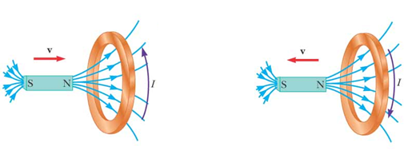

The electromagnetic force (emf) generated by the changing current in a stationary loop, which creates a changing magnetic field, is commonly known as transformer emf in power analysis since it is caused by the transformer's operation. By utilizing Stokes's theorem on the intermediate term in equation (9.6), we derive

$$V_{emf}=\oint_{L}{E.dl}=\int_{S}{\left(∇×E\right) .ds}=-\int_{S}{\frac{∂B}{∂t} .ds}$$

For the two integrals to be equal, their integrands must be equal; that is,

$$∇×E=-\frac{∂B}{∂t}$$

**B. Moving Loop in Static B Field (Motional emf)**

When a conducting loop is moving in a static magnetic field B field, an emf is induced in the loop. We recall from eq. (8.2) that the force on a charge moving with uniform velocity u in a magnetic field B is

$$F_{m}=Qu×B$$

$$E=\frac{F_{m}}{Q}=u×B$$

If we consider a conducting loop, moving with uniform velocity u as consisting of a large

number of free electrons, the emf induced in the loop is

$$V_{emf}=\oint_{L}{E.dl}=\oint_{L}{\left(u×B\right).dl}$$

The electromotive force (emf) generated by the movement of an item is known as motional emf or flux-cutting emf. This type of electromotive force (emf) is commonly observed in electrical devices such as motors, generators, and alternators. Figure 9.4 illustrates a two-pole direct current (dc) machine with a single armature coil and a commutator composed of two bars. Although this work does not delve into the intricate analysis of the d.c. machine, it is apparent that the coil's spinning within the magnetic field leads to the production of voltage. Figure 9.5 illustrates another example of motional electromotive force (emf), in which a rod is moving between a pair of rails. Since B and u are perpendicular, the equation (9.9) can be written in conjunction with equation (8.2) as:

$$F_{m}=Qu×B$$

$$F_{m}=Q\frac{dl}{dt}×B=\frac{dQ}{dt}l×B=il×B$$

$$F_{m}=ilB$$

$$V_{emf}=uBl$$

By applying Stokes's theorem

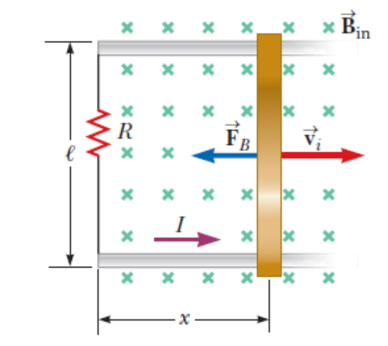

**C. Moving Loop in Time-Varying Field**

This scenario describes a common situation when a conducting loop is in motion and is exposed to a magnetic field that changes over time. Both transformer electromotive force (emf) and motional emf are present. The total electromotive force (emf) can be obtained by combining equations (9.6) and (9.10).

$$V_{emf}=\oint_{L}{E.dl}=-\int_{S}{\frac{∂B}{∂t} .ds}+\oint_{L}{\left(u×B\right).dl}$$

$$∇×E=-\frac{∂B}{∂t}+∇×\left(u×B\right)$$

# Conclusion

1. Electromagnetics (EM) is a branch of electrical engineering or physics in which electric and magnetic phenomena are thoroughly studied by the analyzing of the interactions between electric charges at rest which is the “electricity” and electric charge at motion which is the “magnetism”.
2. There is an analogy between the electricity and magnetism

|  |  |  |
| --- | --- | --- |
| ***Term*** | ***Electric*** | ***Magnetic*** |
| Force between source elements | $$F=\frac{1}{4πϵ_{o}}\frac{ Q_{1}Q_{2}}{R^{3}}R$$ | $$F_{1}=\frac{μ_{o}I_{1}I_{2}}{4π}\oint_{L_{1}}{\oint_{L_{2}}{\frac{ dl_{1}×dl_{2} ×a_{R_{21}}}{R_{21}^{2}}}}$$ |
| Field Intensity from continuous charge/current distribution | $$E=\int{\frac{1}{4πϵ_{o}}\frac{dQ}{R^{2}}a_{R}}$$ | $$H=\int_{L}{\frac{ Idl ×a_{R}}{{4πR}^{2}}}$$ |
| Gauss/ Ampere’s | $$\oint_{s}{D.ds}=\int_{v}{\left(∇.D\right) dv}=\int_{v}{ρ_{v} dv}=Q$$ | $$\oint_{L}{H.dl}=\int_{S}{\left(∇×H\right) .ds}=\int_{S}{J .ds}=I$$ |
| Force law | $$F_{e}=QE$$ | $F_{m}=Qu×B$ |
| Source Element | $$dQ$$ | $$Idl≡K ds ≡J dv$$ |
| Filed Intensity | $$E=\frac{V}{l}$$ | $$H=\frac{I}{l}$$ |
| Flux Density | $$D=\frac{ψ}{s}$$ | $$B=\frac{ψ}{s}$$ |
| Relationship between fields | $$D=ϵ E$$ $$D=ϵ_{o}E+χ_{e}ϵ_{o}E$$ $$D=ϵ_{o}\left(1+χ_{e}\right)E$$ $$D=ϵ_{o}ϵ_{r}E$$ $$ϵ=ϵ_{o}ϵ_{r}$$ $$ϵ_{r}=1+χ_{e}=\frac{ϵ}{ϵ_{o}}$$ | $$B=μH$$ $$B=μ_{o}\left(H+χ_{m}H\right)$$ $$B=μ_{o}\left(1+χ_{m}\right)H$$ $$B=μ_{o}μ_{r}H$$ $$μ=μ_{o}μ_{r}$$ $$μ_{r}=1+χ_{m}=\frac{μ}{μ_{o}}$$ |
| Potentials | $$V=\frac{1}{4πϵ_{o}}\int_{L}{\frac{ρ_{L} dl }{r}}$$ | $$A=\int{\frac{μ_{o}}{4π}\left(\frac{Idl}{R}\right)}$$ |
| Relationship between field and potential | $$E=-∇V$$ | $$H=-∇V_{m}$$ |
| Polarized and Magnetized material bound charge and current density | $$ρ_{ps}=P.a_{n}$$ $$ρ_{pv}=-∇∙P$$ | $$J_{b}=∇×M$$ $$K_{b}=M×a_{n}$$ |
| Dipole | $$p=Qd$$ | $$m=I Sa_{n}$$ |
| Dipole Potential and Field Intensity | $$V=\frac{P.a_{r}}{4πϵ_{o}r^{2}}$$ $$E=\frac{P}{4πϵ_{o}r^{3}}\left\{2 cosθ a_{r}+d sinθ a_{θ}\right\}$$ | $$A=\frac{μ_{o} m ×{ a}_{r}}{4πr^{2}}$$ $$B=\frac{μ_{o}m}{4πr^{3}}\left\{2 cosθ a_{r}-sinθ{ a}_{θ}\right\}$$ |
| Flux | $$ψ=Q=C V$$ $$ψ=\int_{s}{D.ds}$$ | $$ψ=L I$$ $$ψ=\int_{s}{B.ds}$$ |
| Relatoionship between I and V | $$I=C \frac{dV}{dt}$$ $$C=\frac{Q}{V}$$ | $$V=L \frac{dI}{dt}$$ $$L=\frac{λ}{I}$$ |
| Energy Density | $$w_{E}=\frac{{dW}_{E}}{dv}=\frac{1}{2}D.E$$ | $$w_{m}=\frac{{dW}_{m}}{dv}=\frac{1}{2}B.H$$ |
| Poisson’s Equ | $$∇^{2}V=-\frac{ρ_{v}}{ϵ}$$ | $$∇^{2}A=-μ_{o}J$$ |
|  |  |  |

**Bibliography**

1. Sadiku, M. N. (2015). *Elements of electromagnetics*.
2. Kovacs, J. (2001). Coulomb’s law. *Michigan State University*.
3. Tu, L. C., & Luo, J. (2004). Experimental tests of Coulomb's Law and the photon rest mass. *Metrologia*, *41*(5), S136.
4. Singh, C. (2006). Student understanding of symmetry and Gauss’s law of electricity. *American journal of physics*, *74*(10), 923-936.
5. Bisquert, J., Garcia-Belmonte, G., & Fabregat-Santiago, F. (1999). Modelling the electric potential distribution in the dark in nanoporous semiconductor electrodes. *Journal of Solid State Electrochemistry*, *3*, 337-347.
6. Guisasola, J., Almudí, J. M., Salinas, J., Zuza, K., & Ceberio, M. (2008). The Gauss and Ampere laws: different laws but similar difficulties for student learning. *European Journal of Physics*, *29*(5), 1005.
7. Kokernak, J. M., & Torrey, D. A. (2000). Magnetic circuit model for the mutually coupled switched-reluctance machine. *IEEE Transactions on magnetics*, *36*(2), 500-507.
8. Anta, J. A., Idigoras, J., Guillen, E., Villanueva-Cab, J., Mandujano-Ramirez, H. J., Oskam, G., ... & Palomares, E. (2012). A continuity equation for the simulation of the current–voltage curve and the time-dependent properties of dye-sensitized solar cells. *Physical Chemistry Chemical Physics*, *14*(29), 10285-10299.
9. Illias, H. A., Bakar, A. H. A., Mokhlis, H., & Halim, S. A. (2012). Calculation of inductance and capacitance in power system transmission lines using finite element analysis method. *Obliczenia indukcyjności i pojemności linii przesyłowej z wykorzystaniem metody elementu skończonego*, *88*(10 A), 278-283.
10. Charitat, T., & Graner, F. (2003). About the magnetic field of a finite wire. *European Journal of Physics*, *24*(3), 267.
11. Law, B. S. (2018). THE MAGNETIC FIELD.
12. Karapetoff, V. (1911). *The magnetic circuit*. McGraw-Hill book Company.
13. Zuza, K., Guisasola, J., Michelini, M., & Santi, L. (2012). Rethinking Faraday's law for teaching motional electromotive force. European Journal of Physics, 33(2), 397.
14. Graves, K. E., Toncich, D., & Iovenitti, P. G. (2000). Theoretical comparison of motional and transformer EMF device damping efficiency. *Journal of Sound and Vibration*, *233*(3), 441-453.

**Annex 1**

Analogous Relation between the quantities in electrostatics and those in magnetostatics is as follows
Electrostatics Magne...

Vector-Analysis:
Elements Rectangular Cylindrical Spherical
dl
dS
dV
[ ] [ ] [ ], [ ] [ ] [ ],
, ,
[ ] [ ] [ ], [ ] [ ] [ ...

**Annex 2**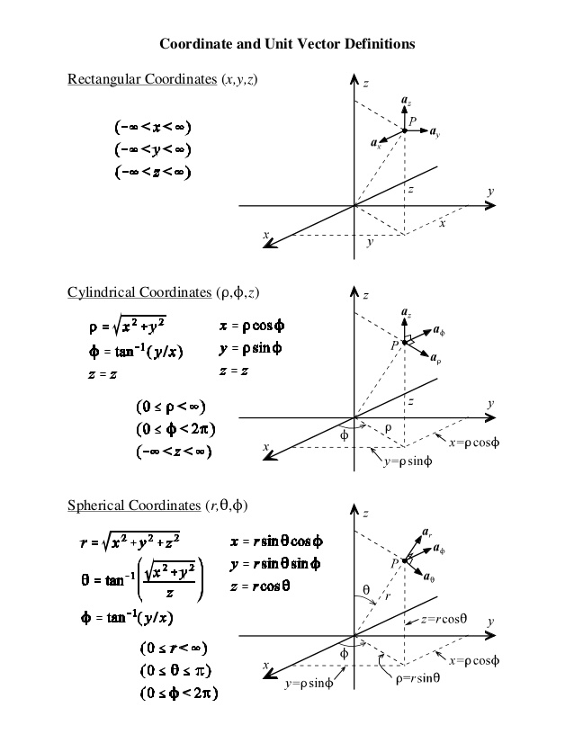

**Annex 3**

|  |  |
| --- | --- |
| Cartesian → Cylindrical |  |
| Cylindrical → Cartesian |  |
| Cartesian → Spherical |  |
| Spherical → Cartesian |  |
| Cylindrical → Spherical | barvení Přesnost skrýt transformation from cylindrical to spherical  coordinates - atelier-povetron.cz |
| Spherical→ Cylindrical | barvení Přesnost skrýt transformation from cylindrical to spherical  coordinates - atelier-povetron.cz |

**Annex 4**

