**Mohamed Khaled Dardar**

**a9UD83141**

COURSE NAME:

**(Introduction to Data Analysis)**

ATLANTIC INTERNATIONAL UNIVERSITY

**November/2023**

**Tabe of Contents**

**Introduction** 2

1_What is Data Analysis and why it is so important? 2

2_What are the Different Types of Data Analytics? 2

3_What are the Challenges associated with Data analytics? 2

**4_What is the difference between data analysis and data science?** 2

**Body of Assignment** 4

5_What are the different techniques used in data analysis? 4

6_What are the advantages of using data analytics? 4

7_What are the main components of data analytics systems? 4

8_How does data analytics help business make decisions? 4

9_What are the different applications of data analytics? 4

10_What are the different types of data analysis tools 4

11_What are the ethical considerations of data analytics? 4

12_What are the steps involved in a data analytics project? 4

13_What is the importance of data visualization in data analytics? 5

14_How can machine learning and artificial intelligence be used in data analytics? 5

15_What are the benefits of using big data analytics? 5

**Conclusion** 6

16_What are the best practices for data analyst? 6

17_How can data analytics be used to improve customer experience? 6

18_What are the challenges of implementing data analytics in an organization? 6

19_How does data analytics help identify trends and patterns? 6

20_What are security considerations for data analytics? 6

**Bibliography** 7

# 

# **Introduction**

## 1_What is Data Analysis and why it is so important?

According to Investopedia, it defines data analytics as the science of analyzing raw data to make conclusions about information. As data has its own properties, we can always turn data into useful information that can aid us in our goals. And the importance of data analysis is:

1_ It can help us get better insights into our business

2_ Create Targeted Strategies and Marketing

3_ Enhance Decision Making

4_ Minimizing Risks and Reducing Costs

5_ Identifying Opportunities

## 2_What are the Different Types of Data Analytics?

There are different types to data analytics which will be listed below:

1_ Descriptive Analysis: this can be used to describe the current situation and it helps the companies to answer the question of what is happening now.

2_ Diagnostic Analysis: this can be used to answer the question of why this thing is happening, which can include many hypotheses.

3_ Predictive Analysis: this helps to answer the question of what will happen. A lot of people rely on it to answer future questions.

4_ Prescriptive Analysis: this can be a middleware between the Descriptive and Predictive analysis, which can help us to suggest the course of action.

## 3_What are the Challenges associated with Data analytics?

There are many challenges that are associated with Data analytics. We can start with collecting meaningful data, we need to have the data that are relative to the thing that we are looking for, we need to find the right data that we want to collect. The second challenge that we might face, the huge amount of data. The third thing we need to do is to choose the correct analytical tools. The fourth challenge we might face is the low-quality data.

## **4_What is the difference between data analysis and data science?**

Both data analysis and data science work on data and on large set of data to uncover the hidden patterns within it, while data analysts focus more on past data and how to generate information from them, data scientists work on building models to predict future outcomes, but according to Microsoft “data scientist usually have more technical expertise and responsibilities when it comes to initiating research projects”. So, both are important, but we can see that data science involves more responsibilities and must have more years of experience, by which data analyst can become data scientist after years of experience in the field of analysis, and we can see that data scientist use more tools than the data analyst and can work on both structured and unstructured data.

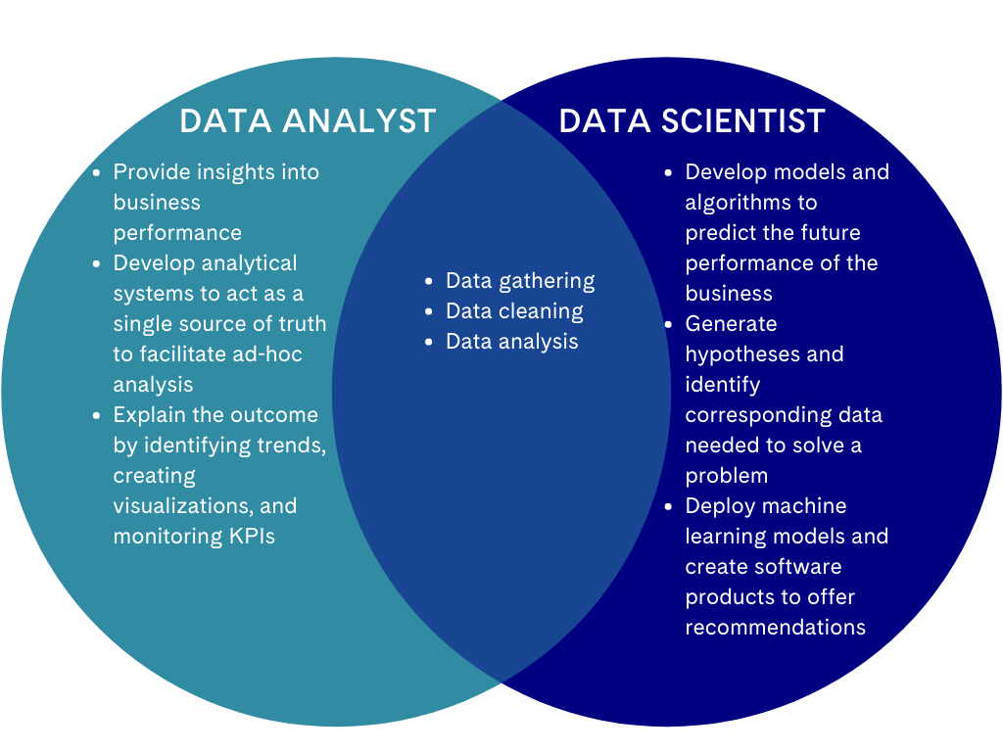

***Figure1.1: Different Between Data Analyst and Data Scientist***

# **Body of Assignment**

## 5_What are the different techniques used in data analysis?

We start with collaborating your needs, then we need to establish questions, then we need to collect the relevant data and clean this data, after that we need to analyze the data and share the results with the decision makers and stakeholders, the last step is to store the data and write a summary of what lesson were learned during the process.

## 6_What are the advantages of using data analytics?

There are many advantages of using data analytics, which can start from getting better insights into the data that are being generated from the daily processes, and getting real-time information that can be useful for the decision-making process. Acquiring new customers, knowing why we are excelling at something in our business can be beneficial to use it for marketing purposes and attracting new customers.

## 7_What are the main components of data analytics systems?

Computer Hardware- Software- Telecommunication Tools- Database or Data Warehouse- Data specialist.

## 8_How does data analytics help business make decisions?

By making decisions based on data quantitative techniques, to find the optimal result, or near to perfect results, as businesses operating in the industry, they cannot rely on intuition, decision makers need prove that this plan will work, or this choice will lead to better profit or better sales within the future. Data analysis can also help to improve the overall business’s strategy, by giving a better understanding of the environment that the business is operating in.

## 9_What are the different applications of data analytics?

It can be used in wide variety of applications, ranging from health as in insurance companies to collect the relative data, until all kinds of businesses, where we can find it in marketing to make an analysis to attract customers by finding hidden patterns, until finance to cut down the costs.

## 10_What are the different types of data analysis tools

There are many tools that are provided by the international companies that are operating in the world of business today, and each tool has its own specifics like Microsoft Excel is a simple analysis tool, RapidMiner where you can drag and drop and easy to use, Tableau for visualization analysis, and IBM Cognos which helps to uncover the hidden pattern but you will need a little background about coding.

## 11_What are the ethical considerations of data analytics?

Privacy of the customers information- Informing them about the analysis- Transparency- Use data only for analysis purposes without thinking of using it for malicious purposes.

## 12_What are the steps involved in a data analytics project?

1_ Identifying Business Questions.

2_ Collect and Store the Data

3_ Clean and Prepare the Data

4_ Analyze the Data

5) Visualize and Communicate

## 13_What is the importance of data visualization in data analytics?

By showing the decisions makers the results as visualization presentation they will be able to effectively make decisions based on them. Graphs are a better way of understanding the idea and easier to read more than the numbers, by simplifying the results. Visualization can be used to interpret large volumes of data on one dashboard or graph.

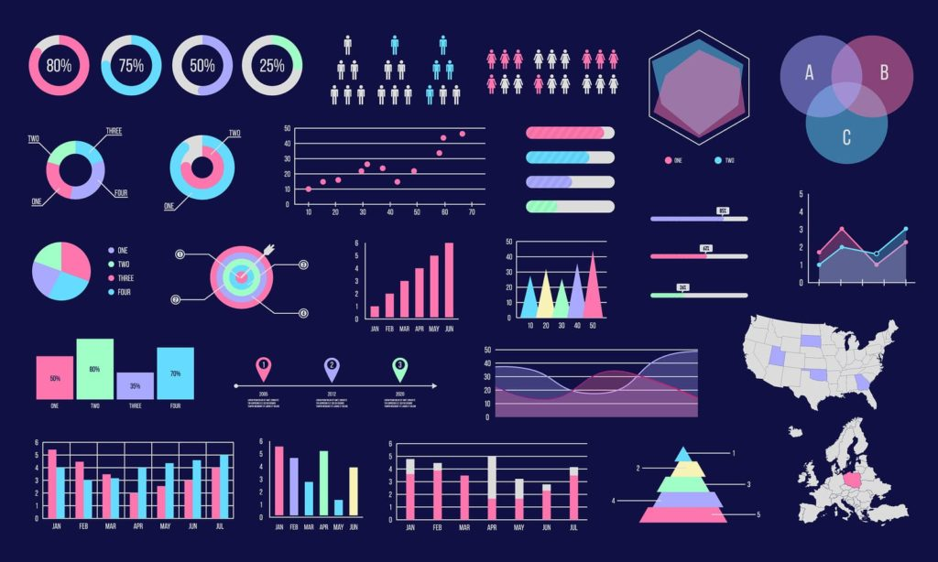

**Figure 1.2 Data Visualization Sample**

## 14_How can machine learning and artificial intelligence be used in data analytics?

By introducing new technologies and tools, and learning mechanism that is mainly consist for them, we can use them in finding hidden pattern and self-learner techniques as they provide solution for complex data and unstructured data and can generate the wanted result faster, by building automated methods to generate the results.

## 15_What are the benefits of using big data analytics?

Big data consists of the 3 V’s, which are volume, veracity, velocity, and now it has more included, but the main three are the one mentioned above, the benefit that it can analyze large volume of data within very high speed by studying the interdependencies and determine new ways to use the insights.

# **Conclusion**

## 16_What are the best practices for data analyst?

The best practices can vary a lot, but we can define them as below:

1_ Define our goals and objectives including the questions.

2_ Understanding Business and Understanding the Data.

3_ Choose the methods and the right tools for dealing with data (Cleaning, ETL, Importing)

4_ Analyze our data.

5_ Interpret the results

6_ Communicate the results

## 17_How can data analytics be used to improve customer experience?

Data analytics can be used to enhance customer experience by analyzing the needs of customers, knowing their demands and what they are looking for to discover the hidden patterns. Analyze their feedback to provide better service/product, enhance customer loyalty program. Ability to do target marketing campaign and KYC reports.

## 18_What are the challenges of implementing data analytics in an organization?

Collecting meaningful data, selecting the right tool for analysis, collecting data from multiple sources, quality of the collected data, building culture that support data and the importance of data, securing the data, and finally visualizing the data, all the mentioned are challenge that businesses face when they want to implement data analytics.

## 19_How does data analytics help identify trends and patterns?

As it includes data mining techniques which help to reveal what is hidden within the data, by making relationship within the data and help to predict the outcomes. By analyzing huge amounts of data, we can find trends within the data that support the process of decision making by understanding customer behavior and what industry the business is operating in.

## 20_What are security considerations for data analytics?

When it comes to security we need to think where we are going to store the data, who is going to handle and deal to the data as physical access to it, and if it was in cloud and securing the network, we need to make sure that the storage service provider is trustworthy, we also need to create a mechanism that detect the threat and data breach and create a contingency plan to deal with it if that happens.

# **Bibliography**

Article, CIO Webpage. *CIO*. 02 November 2023. Web Page: https://www.cio.com/article/191313/what-is-data-analytics-analyzing-and-managing-data-for-decisions.html. 10 November 2023.

Calzon, Bernardita. *Datapine*. 03 March 2023. Web Page:https://www.datapine.com/blog/data-analysis-methods-and-techniques/#data-analysis-techniques. 15 November 2023.

Cooper, Andy. *IIBA International Institute of Business Analysis*. 10 August 2023. Web Page:https://www.iiba.org/business-analysis-blogs/how-ai-is-rewriting-the-rules-of-data-analysis/#:~:text=AI%20for%20Data%20Analysis,forecast%20future%20trends%20and%20behaviours. 21 November 2023.

FRANKENFIELD, JAKE. *Investopedia*. 09 August 2023. Web Page: https://www.investopedia.com/terms/d/data-analytics.asp. 12 November 2023.

Ginsberg, Corey. *Classes Near Me*. 19 September 2023. Web Page: https://www.nobledesktop.com/classes-near-me/blog/history-of-data-analytics#:~:text=Modern%20data%20storage%20concepts%20emerged,advent%20of%20modern%20data%20analytics. 02 November 2023.

Reporter, By Creamer Media. *Engineering News*. 02 February 2023. Web Page: https://www.engineeringnews.co.za/article/the-benefits-of-data-analysis-for-decision-making-2023-02-02. 18 November 2023.

Smallcombe, Mark. *Integrate.io*. 070 December 2021. Web Page: https://www.integrate.io/blog/a-brief-history-of-data-analysis/. 05 November 2023.