Your name

Simone Kelly

Your student ID number

UD82214HU91431

COURSE NAME:

(Theories and Techniques of the Interview)

ATLANTIC INTERNATIONAL UNIVERSITY

November 10, 2023

Table of Contents

1.0 Introduction 2

2.0 Definition Of Term 4

2. 1 The Importance Of The Cover Letter 4

2.2 Resume 5

3. 0 Stages Of An Interview 5

3.1 Recording Interviews 8

4. 0 Research: Validity And Predictive Power 9

4.1 Strategies, Behaviors And Legal Issues 10

4. 2 Nonverbal Behaviors 10

4. 3 Physical Attractiveness 11

4.4 Faking It 12

4.5 Applicants With Disabilities 13

4. 6 Interview Behaviors & Bias 13

5. 0 Contribution of Paper 15

5.1 Conclusion 16

5.2 References 18

# 1.0 Introduction

As one elevates themselves in the area of professional development they need to get some things in order. It is good to be aware of an available vacancy but it is better to be prepared and equipped for that vacancy. As an individual pursue their career dreams they must put together a portfolio which comprises of their cover letter and resume additionally they must be prepared for an interview. In preparing for the interview there are various elements that one should be mindful of these include the environment, the location as well as the possibility of rejection.

An individual must be physically and mentally prepared for an interview. However, one must be mindful that their perception can also be influenced or shaped by societal standards, fears, threats, and goals. The way an interviewer perceives things and how the candidate expresses them may be shaped by their life experiences. This also indicates that the candidate must

think positively about themselves and have high self-esteem. (Beer, Watson, and McDade-Montez, 2013).

An individual must possess professional traits that make them suited for the job. Clear goals should be set and appropriate actions taken to be the best at what they can do. However, they must also take responsibility for their actions as this also has consequences. Personality attributes of the interviewer have a severe or great impact on the interview process. There is a need for candidates who may have a disability or are slow to express themselves to be provided with accommodations.

This paper is categorized into five main sections. Sections one and two will focus on the importance of cover letters and resumes. The third section will discuss the interview process and also one's level of preparedness which takes in being physically and mentally prepared. The fourth section speaks to the validity of the interview process, ethics relating to conducting an interview, non-verbal behaviours, and interviewing individuals with a disability. The last section highlights the contribution of the paper to society, its impact on the writer, and the conclusions drawn.

# **2.0 Definition of term**

**Cover letter**: A document aimed at convincing a manager why they should hire you.

**Resume**: A formal document that outlines the qualifications, experiences, and other personal

data about a candidate.

**Interview:** The process in which in-depth questions are asked about the strengths and

weaknesses of an individual, why they want the job, what makes them the best candidate, and how they can contribute to the organization.

# **2. 1 The Importance of the Cover Letter**

In the world of business, many aim to get the highest qualifications and upgrade their status in society. It is important to qualify to get a job but what is more important is letting the interviewer or prospective employer be aware of the reasons why you want the job. Studies have shown that the construction and presentation of a cover letter is the first effort of engaging a prospective employer and it may be the only opportunity to do such. (Doyle, 2021).  A cover letter is seen as a key marketing tool that is intended to persuade the employer to take the time to peruse the resume that is attached.

When constructing a cover letter it must be reader-friendly, there must be a direct tone, modest, and convey interest. A cover letter should be constructed using proper business format and the applicant should ensure that their address, phone number, and e-mail appear at the top of the page.  The cover letter should provide information on who the applicant is, why they have expressed interest in the job, and convince the employer why they should meet them.

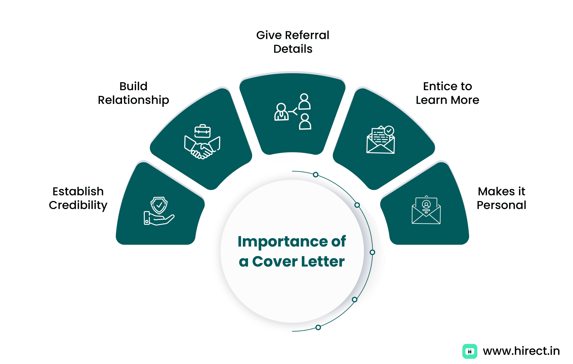

Figure 1- Importance of Cover Letter

# **2.2 Resume**

A resume contains a summary of personal data that help to establish the credibility of the information presented in the cover letter. (Doyle, 2021). The resume highlights ones education, qualification, experiences, and any involvement in extra curriculaactivities or voluntary services. References may be directly stated or it may be stated available upon request.

# **3. 0 STAGES OF AN INTERVIEW**

A job interview can be nerve-racking and many individuals spend days and hours preparing for an interview. A job interview is the process by which an employee is allowed to evaluate a prospective employee for an available post. (Wiersma, 2016). The interview process also allows the employer to determine whether or not the applicant is the right person for the job. An interview precedes the decision of the employee and individual, and the process is used to evaluate the candidate and assess his or her potential according to the skills that are presented on their resume.

The interview process is a selection process as many candidates vie for the same position. The job interview is considered to be an effective tool for assessing potential employees. The interview process also requires that the employer has the skills to select the best person for the excluding bias. The interview also allows candidates to assess the corporate culture ask questions and convince the employer why they are the best candidate for the job. (Anderson, and Killenberg, 2009).

A typical job interview has a single candidate who meets with one to three people representing the employer. A supervisor of the employee is also included in the interview process being that they are sometimes on the floor more than the employer.  A larger interview panel requires the use of specialized human resources workers. An interview generally spans between fifteen minutes to one hour.

There are three main stages of an interview. The first is the invitation, within this stage after assessing the cover letter and the resume and the employer is impressed or thinks the applicant can do the job, they will be called in. The second stage is where the candidate will be invited to a meeting. It is during the meeting that the employer and employee will discuss matters about their interest in the job and what makes them suitable candidate. The meeting is typically a question-and-answer process. The final stage is the closing and follow-up process if the employer is impressed with the candidate they will be notified of their selection. (Olthmann, 2016).

 In completing an interview a candidate must be mentally and physically prepared. The candidate should come prepared to answer questions as well as ask questions regarding what is expected of them if they should get the job. In some instances, interviewers may ask about what the referees will say about you, hence good introspection is key. The interviewee should also think about the interview from the interviewer’s point of view. The candidate must come mentally prepared to answer questions such as Why did you choose this particular institution? Why did you choose this job? How would you see yourself in 5 years? What skills/experience do you havethat would make you a good candidate?

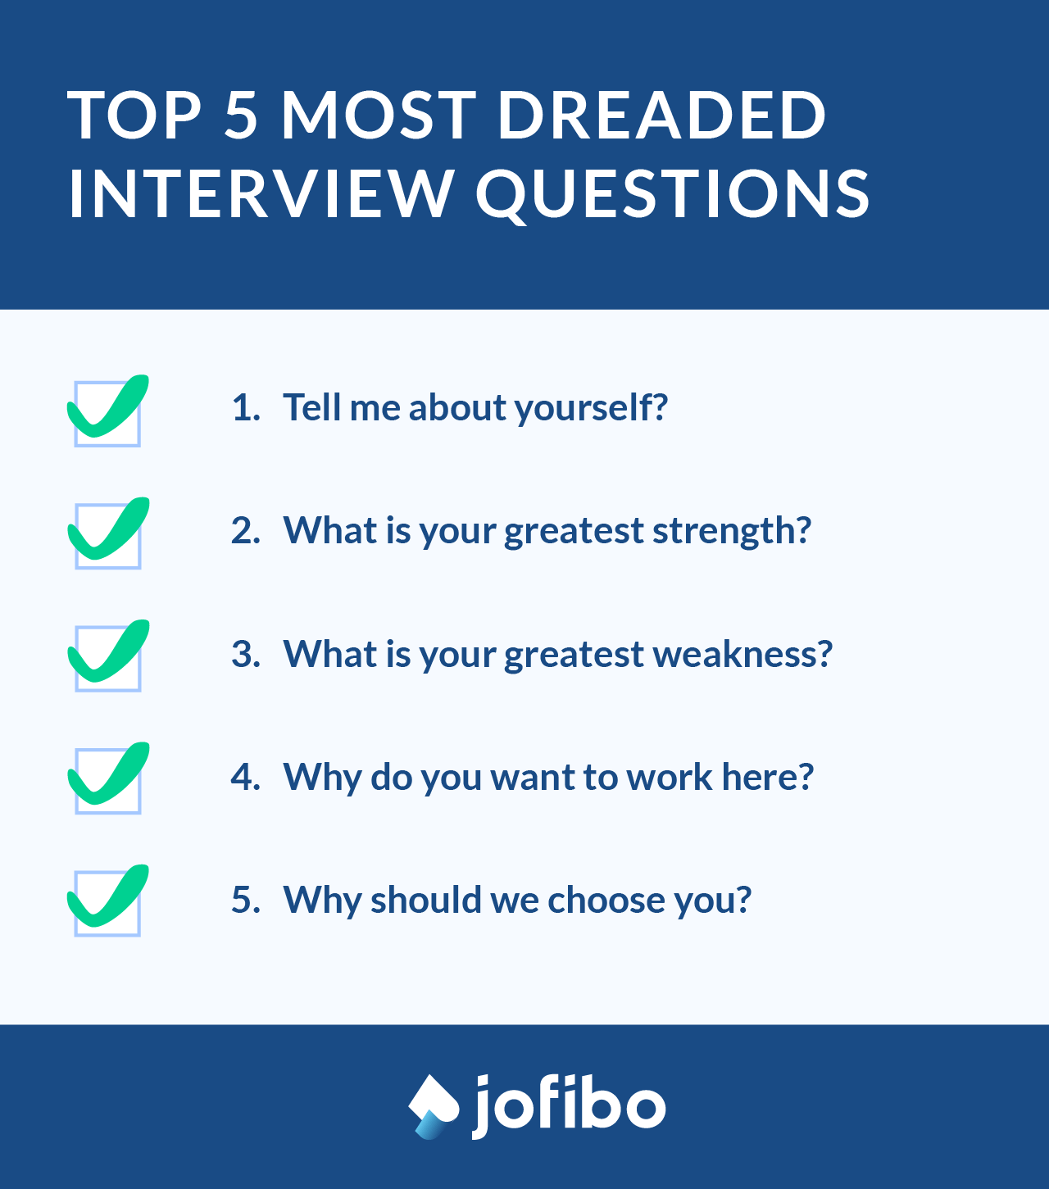

**Figure 2 –Top 5 interview questions**

In being physically prepared the interviewee must dress appropriately. It is said that *the*first impression lasts forever. Hence, it is necessary to be appropriately dressed for an interview as visual expression is key. The interviewer must select the right attire to wear, they must be groomed from hair to toe and should be presentable in all aspects.  This indicates that personal hygiene is necessary not only for the job but for personal and professional development. (Ada, 2023).

It is important to avoid making mistakes that may harm the interview process to avoid careless mistakes it is important that the candidate confirm the location of the interview, *and*ask for the address and phone number. If unaware of the address an appropriate and reliable mapping application can be used. For example Google Maps, Yahoo! Maps, and MapQuest. After an interview process, only one person can get the job at the end of the hiring process, hence another candidate will be rejected. Rejection letters are also a form of communication but it contains disappointing and unfavourable offerings.  Again the interviewee must be mentally prepared for any decisions.

# **3.1 RECORDING INTERVIEWS**

There are various ethics associated with recording an interview. Ethics is important as it helps in the expansion of knowledge and facilitates fairness and respect (Neuman, 2014). First, there is informed consent, the candidate must be notified of the purpose of the interview and the subject matter. The interviewee must be asked whether it is acceptable to record their responses.  Recordings can be audio or in video form.

This method is considered to be the most reliable yet simple form to obtain accurate responses. This method is effective because the devices that are being used are likely equipped with recording software and features for recording purposes.  However, one must be mindful that some participants may feel uncomfortable with the recording process.

Before the recording process participants should be informed about the purpose of the interview recording. Being brief about the purpose of the recording caters to voluntarily consenting to participate in the interview. The privacy of candidates should be respected. Hence, confidentiality is key. Reasonable steps should be taken to avoid harming candidates who participated in the interview process this should be done to reduce inevitable and predictable (Sun, Wu, Niu, 2012). The interview process should be fair and done in an unbiased manner.

**3. 2TYPES OF INTERVIEWS & QUESTION**

During the interview process, eight types of questions can be asked. Firstly there are the Credential verification questions, these types of questions ask questions about the individual’s background, it asks about their qualifications, and tenure of working at their last place of employment. There are also experience verification questions. Questions in this area ask about their responsibilities in a position. Opinion questions cater for the candidate to speak about what they would do in a particular situation or if a challenge arise. This type of question allows the respondent to speak about their strengths as well as their weaknesses. (Merriam, and Tisdell, 2016).

A candidate can be given case questions. This type of question deals with problem solving again the respondent are allowed to inject their opinion and speak about obstacles encountered and how they overcame the challenge. This also allows the interviewer to evaluate the problem-solving abilities of candidates and how well they can analyze and work through potential case situations. The interviewer may also focus on behavioural questions. These type of questions requires the candidate to speak about steps taken to address a problem. The purpose of using these types of questions is to anticipate future behaviours based on past behaviours. (Aguado, Rico, Rubio, 2016).

# 4**. 0 Research: Validity and Predictive Power**

Collecting data during an interview is very significant. The information gathered through the interview process aids in the process of decision-making. Hence, the instrument used to collect data during the interview process should be one that is valid. Validity is important as structuring of questions may interfere with the validity of the study based on the purpose outlined. The misinterpretation of questions may intrude on the results obtained during the interview process. Additionally, in the questions to be asked the interview process should be one that caters to a clear understanding of the participants (Ashton, 2014; Hoskins & White, 2013).   The validity of the interview process caters to a selection of participants and this too can be predicted through the responses that are given.

# **4.1 STRATEGIES, BEHAVIOURS AND LEGAL ISSUES**

In focusing on the matter of confidentiality, the legal protection of the candidate should be focused on. The interview process should dependent on the atmosphere confidence and trust in which the patient is willing to make a frank and complete disclosure of emotions, facts, fears, and memories. The place where the interview is conducted brings with it many influences which are direct and indirect. These include; distractions, unhealthy associations with the place of the interview lack of privacy, and immature behaviour on the part of the interviewees and interviewer can hinder the interview. (Madden, 2020). The location of the interview is important as some locations may be more convenient than others. The ethics of the interview are essential ingredients for a successful career in job placement.

During the interview process, the interviewer should possess certain attributes, qualities, and ethics to communicate with the candidates. Some candidates may be vulnerable to external factors so it is the responsibility of the interviewers to protect them from unethical behaviour (Zur, 2016).  By the nature of the profession, the interviewers should gain the attention of the candidates protect their rights, and not cause harm to them [Stein, 1990]. Some candidates may show externalizing behaviour which includes distrust, aggression, and impulsivity which can affect the overall interview process (Achenbach, Ivanova, Rescorla, Turner, &Althoff, 2016).

# **4. 2 Nonverbal Behaviors**

Silence is a personal yet valuable element during the interview process. However, the candidate must be reminded that there is a time and place for everything. Silence is also recognized as an active part of communication as the presence of silence could be an indication that listening is taking place embedded within a relationship and school of thoughts. Types of non-verbal behaviour include; using gestures.

Gestures are part of the communication process in one’s daily life but can also be an indication of being uncomfortable about a particular situation. A simple use of hand gestures says much about what a person is thinking. However, it can be contradicting as an intended message is confused or misinterpreted. A contradicting message could also be an indication that the listener may not be truthful and uncomfortable about the particular situation (Dailey, 2016).

 Not maintaining eye contact can also be a signal group members are uncomfortable with group silence. This is because the way an individual looks at someone can communicate many things, including interest, affection, hostility, or attraction. Additionally, the use of facial expressions is also an indication of being uncomfortable with silence. An individual facial expression sends a far more vivid message than words ever can.  Additionally, applicants’ nonverbal behaviours may influence interview ratings through the inferences interviewers make about the applicant based on their behaviour. (Lindzon, 2017).

# **4. 3 Physical Attractiveness**

Professionalism should be displayed when attiring for a job interview. If a candidate dresses

Unprofessionally, it gives the interviewer a negative reflection of the interest level of the participants, and their commitment to the interview process and it also serves as an element of distraction. The first impression that is made by the candidate can indicate whether he or she is favourable for the job.  Interview candidates should bear in mind that presentation is key and they should dress to impress a potential employee and not their peers. (Heine, 2023).

One must be mindful that the interviewer will make a judgment based on how ones present themselves and this can have a lasting effect.  In dressing for an interview dark suits are suitable, the attire must be pressed, clean, fit well and in good condition.  The footwear must be cleaned and polished, flip flops or other casual wear is not acceptable. Accessories worn should be tasteful and moderate. Overall the interviewee should strive to appear neat, fresh, and clean.

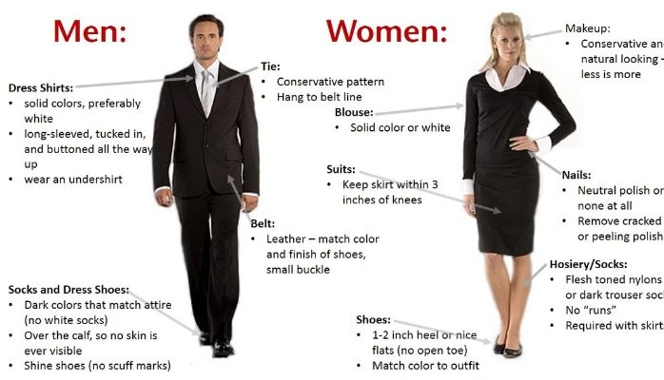

**Figure 3- Interview Attire**

# **4.4 Faking It**

Interviewers should be cognizant that applicants can intentionally misrepresent questions during the interview process and they can also fake responses given during the unethical process. Faking can be broken down into four elements. First, the interviewee may mislead the interviewer by portraying him or herself as an ideal job candidate by exaggerating about their skills or coining answers to fit the job. (Johns, 2023). He or she may put forward that their values, attitude, and personal beliefs are in line with the ethos of the organization.

The second aspect of faking is fabricating or inventing one's image. In this instance, the individual may speak or refer to made-up experiences portraying others’ experiences, and speak about accomplishments that are not their own.  Thirdly, faking may be done to protect one's image. This can be portrayed by leaving out negative experiences, or other background details that may hinder the acquisition of the job. The fourth component of faking involves putting forth personal opinions to align with those of the organization.

# **4.5 Applicants with Disabilities**

It is important to note that the job interview should focus on the ability of an applicant to perform the job, not on the disability. In completing a job interview with an individual who has a disability or is at risk accommodation should be provided. This should be considered to enable the applicant to have an equal chance of being selected for an available post. The interviewee also has a role to play as they should indicate that accommodation for an interview is needed and this should be requested in advance. If an applicant has a known disability that could interfere with a job task, the interviewer may ask that he or she explain how the task would be performed, or perform a similar task even if others were not required to do so. (University of Washington, 2021).

Behaviour modification strategies can be used to reduce overt behavioural symptoms. The interviewees should be aware of individuals who may struggle with internalizing behaviours which are negative behaviours that are directed towards oneself and this may be established to cope with varying stressful situations. In accommodating employees with internalizing behaviour during an interview process the interviewee needs to engage these individuals in adaptive thinking, and problem-solving situations. (Sonmez&Adiguzel, 2017).

# **4. 6 INTERVIEW BEHAVIOURS & BIAS**

An interviewer may hold preconceived ideas about a candidate who applies for a job. This can affect the result of the interview being that the bias that is developed outweighs the qualification of the candidate. Interview bias can be conscious as well as unconscious hence, the interviewer needs to be aware of elements that can result in bias and affect their decisions to select the best candidate.

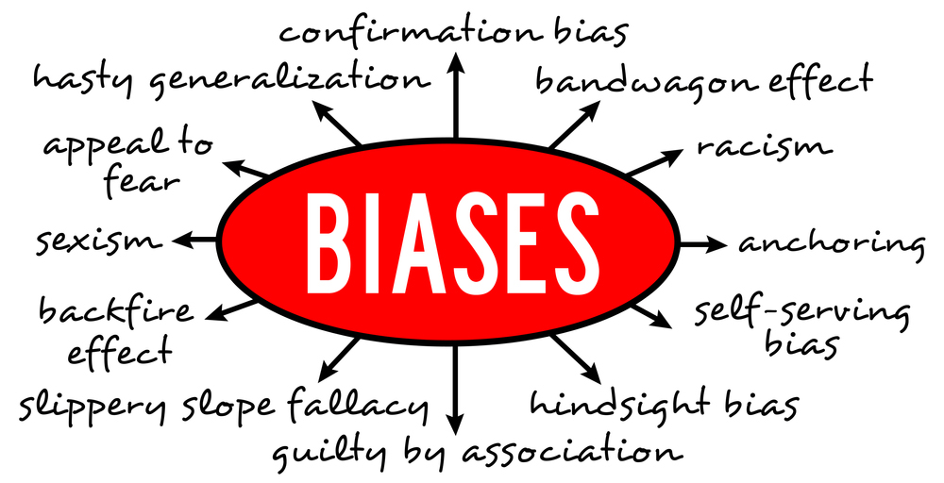

**Figure 4-Interview Biases**

Unconscious biases are established from direct experiences that one may have with past situations, or people. Bias can also be coined through indirect experiences which may be learned through interactions with books, stories, culture, and media. Several biases may present themselves during the interview process. These biases include stereotyping, nonverbal bias, the halo/pitchfork effect, and the “like me” syndrome. (Johns, 2023).

Stereotyping is when an interviewer forms an opinion about the individual based on their gender, race, or religious affiliation.  Nonverbal bias is expressed through the use of body language. This may be coined due to the appearance of the candidate, their style of dressing as well as their observed body language. Hence, candidates should be mindful of their hair length, exposure of tattoos, the way they speaks, how they dress and their overall mannerisms.

Next is the halo effect. This happens when one strong point made by the candidate influences the entire interview. For example a candidates qualification and the university that he or she attends may make that candidate appears highly competent and is looked upon favourably. The pitchfork effect on the other hand is when one negative point or characteristics can overshadow the interview. For example, a candidate may respond poorly to the first two questions and this may give the impression that the candidate is not competent enough or qualified.

# **5. 0 Contribution of Paper**

The completion of this paper has highlighted the importance of preparing for an interview and being aware of what role the applicant and the interviewer play.  The interview process is a form of communication. Communication is vital in the interview process as it enhances how well candidates relate with their prospective employers.  The paper also highlighted how technology is being integrated into the interview process as recordings are now being done upon consent of the interviewee.

Understanding why a job is important and how one can contribute is a plus in being selected for the post. However one must also be aware of the potential biases that exist which spill over into the functionality of society. The level of preparedness for an interview can also be dependent on the social and cultural world and how we understand ourselves as a person. The interaction that takes place between the interviewer and interviewee fosters a unique interaction.

Individuals, who are at risk of a disability, are not left out as accommodations are now being made to facilitate these individuals who can also contribute to society and nation-building. The interview process calls for one to be clear on the knowledge, skills, and attitude that is needed for the available position, the process also bridges the gap based on what the workplace requires and what the candidate can offer.

There are many ways in which an individual can contribute to society, however, the building of the economy is oftentimes focused on. Preparing for the world of work is one that requires motivation and having a positive attitude that can impact the organizational atmosphere. Prospective clients need to be up to date with what is required to fully function within the workplace and in society in general.

To fully function in society organizations and their workers must be aware of diversity. Workplace diversity appears in many forms for example it speaks to ethnicity, race gender, age, socioeconomic status religious and spiritual affiliation, sexual orientation, or disability status.  The writer has come to acknowledge that the culture that one is associated with can contribute to their response and how one functions within society.

The review of the paper has highlighted that one's level of preparedness can impact their chance of being part of an organization and contribute to the economic development of society. How individuals think, behave, and respond to changes can be associated with stereotyping which is one of the interview biases focused on. Hence, those who are searching for a job must be made aware of the different hindrances, and be prepared to respond positively to situations.

# **5.1 Conclusion**

Through the exploration of this paper, it was found that preparing for a job is one of the most tedious tasks of an individual. The level of preparedness takes much effort and motivation to contribute to society. (Public Policy Research (IPPR), 2020). The perception that an interviewer has about an interviewee can be a barrier for the individual and may hinder them from effectively contributing to society.

Individuals need to be conscious and possess high self-esteem to be able to handle different challenges that may arise. The personality of an individual can also influence the perception of the interviewee as such having a strong self-esteem and having motivation and drive can help in the response process.  (Hennecke et al., 2014; Wrzus& Roberts, 2017).  In the 21st-century workplace, we see that cultural diversity is on the increase. Hence there is a need to eliminate bias in the interview process and treat all members fairly.

The writer has come to realize that society is ever-changing and so is the operation of the workplace in the 21st century. The use of adaptive social behaviours can be effective in helping individuals respond to questions and situations appropriately and truthfully.  Conclusively, being culturally competent can serve as a driving force and help individuals to position their thoughts and respond to changes regardless of tradition, race, family, education, and cultural experiences. This initiative can help them to be a favorable prospective employee.

# **5.2 References**

Ada B (2023). *First Impression Challenges when Interviewing Candidates and the*

*Role of Technology Implications: Exploratory Case Study*.  University of Phoenix ProQuest Dissertations Publishing, 2020. 27999251. https://www.proquest.com/openview/58b692117f6066a4789e793604c75563/1?pq-origsite=gscholar&cbl=18750&diss=y

Achenbach, T. M., Ivanova, M. Y., Rescorla, L. A., Turner, L. V., &Althoff, R. R. (2016). Internalizing/Externalizing Problems: Review and Recommendations for Clinical and Research Applications. *Journal of the American Academy of Child and Adolescent Psychiatry*, *55*(8), 647–656. ttps://doi.org/10.1016/j.jaac.2016.05.012

Aguado, D., Rico, R., Rubio, V. J., &Fernández, L. (2016). Applicant reactions to

social network web use in personnel selection and assessment. *Journal of Work and Organizational Psychology,* 32, 183–190. http://dx.doi.org/10.1016/j.rpto.2016.09.001

Anderson, R., &Killenberg, G. M. (2009). *Interviewing: Speaking, listening, and*

*learning for professional life*. New York: Oxford University Press.

Ashton, S. (2014). Researcher or nurse? Difficulties of undertaking semi-structured

interviews on sensitive topics. Nurse Researcher, 22(1), 27-31.

Beer, A., Watson, D., & McDade-Montez, E. (2013). Self–other agreement and

assumed similarity in neuroticism, extraversion, and trait affect: Distinguishing the effects of form and content. *Assessment*, 20(6), 723-737. doi:10.1177/1073191113500521

Dailey R (2016). *Organisational Behaviour*. Published in Great Britain

Doyle A (2021). *What Is the Difference Between a Resume and a Cover Letter*?.

https://www.thebalancemoney.com/resume-vs-cover-letter-2060116

Eunson, Baden. (2020). Nonverbal Communication (1).

Johns M (2023). What is Interview Bias and How to Avoid It.

<https://www.thomas.co/resources/type/hr-blog/what-interview-bias-and-how-avoid-it>

Heine A (2023).*How to dress for a job interview (and what to wear).*

https://www.indeed.com/career-advice/interviewing/how-to-dress-for-a-job-interview.

Lindzon. J (2017) “*Five Skills That You’ll Need to Lead the Company of the Future,”*

*Fast Company,*<https://www.fastcompany.com/40420957/five-skills-youll->need-to-lead-the-company-of-the-future  Wall Street Journal, February 27, 1989, p. A–4.

Madden, T. (2020). Law and Strategy and Ethics?.*The Georgetown journal of legal*

*ethics*. XXXII. 181.

Neuman, W. (2014) Social Research Methods: Qualitative and Quantitative

Approaches. *Pearson, Essex*, UK.

Sun, G.F.; Wu, T.C.; Niu, Q. (2012). Occupational Health and Occupational Medicin;

People’s Health Publishing House: *Beijing, China, 2012*; Volume 8, pp. 36–37. (In Chinese)

Merriam, S., &Tisdell, E. A. (2016). *Qualitative research: A guide to design and*

*implementation* (4th ed.). John Wiley & Sons, Inc.

Olthmann, S. M. (2016). Qualitative Interviews: A *Methodological Discussion of the*

*Interviewer and Respondent Contexts*, Forum Qualitative Sozialforschung/Forum: Qualitative Social Research, 17 (2), 15.

SonmezCakir, F., &Adiguzel, Z. (2020). *Analysis of Leader Effectiveness in*

*Organization and Knowledge Sharing Behaviour on Employees and Organization*. SAGE Open, 10(1). https://doi.org/10.1177/2158244020914634

Wiersma, U-J (2016). The Four Stages of the Job Interview: Helping

Interviewers Put Two and Two Together. *Evidence-based HRM*. 4. 232-239. 10.1108/EBHRM-11-2015-0045.

University of Washington (UW). (2021, April 9). *What is the difference between accommodation and modification for a student with a disability?* Retreived from <https://www.washington.edu/doit/what-difference-between-accommodation-and-modification-student-disability>

Zur, O. (2016) Professional Organizations’ Codes of Ethics On Gifts in

Psychotherapy &Counselling. Retrieved from

https://www.zurinstitute.com/ethics_of_gifts_in_therapy.html