Your name and ID Number:

**(UD82214HU91431**

**Simone Kelly**

COURSE NAME:

**(**Leadership and Direction**)**

**Doctorate in Human Resource Management**

ATLANTIC INTERNATIONAL UNIVERSITY

**October 12, 2023**

**Table of Contents**

1.0 Introduction 3

2. 0 Type of Leadership 4

2.1 Democratic Leadership 5

2.2 Autocratic Leadership 5

2.3 Laissez-faire 6

3.0 Leadership and Organization Development 6

3.1 Transformational leadership and organizational outcome 8

3.2 Leadership and Organizational Behaviour 10

3.3 Characteristics of good leaders 11

3.4 Leaders managing change 12

4.0 Theory- Situational Business Model 13

4.1 Contribution of paper and conclusion 14

5.0 Conclusion 16

6. 0 Bibliography 18

# **1.0 Introduction**

Leadership is established when designated team leaders’ foster direction and set the tone for others to follow suit. In order for individuals to be influenced by the direction set by their leader the leader has to be proactive. This means that the leaders also have to be a facilitator and someone who can direct people to reach a common or shared goal. Every organization requires the presence of active and effective leaders. This type of leader is needed to set their vision.

A leader who is a visionary helps to shape and guide the path of their employees as they make an effort to meet organizational goals. In reaching organizational goals leaders must motivate the team and influence employees. In this way they strive to achieve a common goal. This also indicates that drive and innovation are key components of effective leadership.

For an organization to function effectively good leadership must be incorporated in the management process. (Snell, 2016). Effective leadership contributes to organizational structure. A central influence of leadership is structuring a well-developed community and this contributes to an accomplished task. For leaders to be effective they must have some positive characteristics. They must be goal-oriented, knowledgeable, flexible, strong, encouraging, and supportive. (Snell, 2016). These characteristics contribute to a transformational workforce regardless of the industry.

Leadership implies intentionality as there is a need to work purposely to achieve a shared goal. Effective leaders aim at fostering inherently value-based change. For this paper, the writer will focus on the key concept of leadership.  Sections one and two give a general overview of what is leadership and the different styles of leadership. The third section will focus on transformational leadership as well as the relationship between leadership and organization management and behavior. The fourth section speaks to the characteristics of effective leaders and highlights supporting theory. The writer will also zoom in on how leadership contributes to the shaping of society while the final section highlights recommendations and conclusions drawn.

**2. 0 Type of Leadership**

Leadership styles involve relationship-oriented behavior which has a positive relationship with satisfaction and performance. This section of the paper will focus on the different leadership styles that contribute to leadership and management within an organization. Effective leaders foster a good work culture and also create a climate that helps motivate and influence their employees. The types of leadership styles that will be elaborated on are democratic leadership, Autocratic leadership, and Laissez-faire leadership.

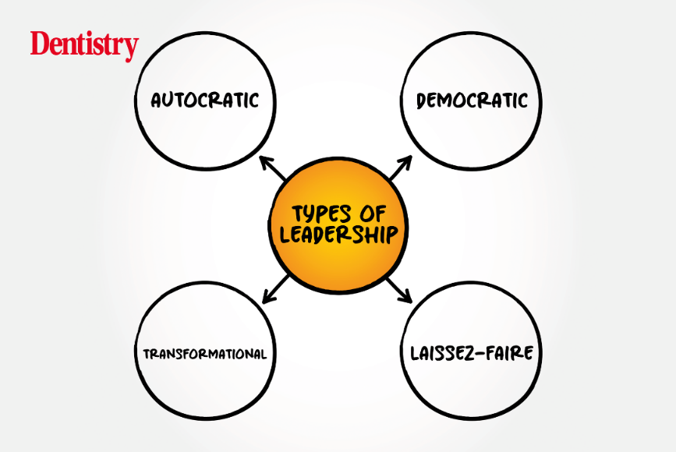

**Figure 1 showing types of leadership style**

# **2.1 Democratic Leadership**

A leader who practices democratic leadership encourages the participation of team members in the decision-making process. Democratic leaders offer guidance and allow team members to give their input on matters concerning organizational development. Democratic leadership is classified as the most effective leadership style due to its many benefits. (Cherry, 2023). Firstly, Democratic leadership increases organizational productivity, the satisfaction of employees, total involvement, and commitment from employees.

 Democratic leaders delegate authority and the same time lend ongoing support to team members. This leader motivates his or her team through effective guidance and direction. A democratic leader believes in the capabilities and their team members and gets them involved in different sections of organizational development.

When employees are engaged in organizational duties it results in greater productivity. Another benefit of democratic leaders is that they try to understand the problems of their employees and work with them to identify the problem and bring solutions.

# **2.2 Autocratic Leadership**

Autocratic leadership, also known as authoritarian leadership, is a leadership style characterized by leaders who make all the decisions with little or no input from group members. Autocratic leaders make choices on the basis of their own perception and rarely accept advice from followers. There are various characteristics of the authoritarian leadership style. (Hailu, 2023). For example, individuals who possess this style put little or no input from group members; they rarely trust their group members with decisions or important tasks. Autocratic leadership style may be problematic as this style can lead to resentment among group members. This leadership style is appropriate only when urgent action is necessary to be taken.

# 2.3 **Laissez-faire**

With **Laissez-faire** leadership the leader encourages team members to function independently and the team is encouraged to solve problems independently even though the leader is available for advice and assistance. This approach is not considered effective as it leaves teams to work on their own leaves and they sometimes struggle for motivation and direction. Laissez-faire is only useful when the team is highly motivated and skilled, and has a history of producing excellent work. (Khan, 2016).

# **3.0 Leadership and Organization Development**

A leader should be a visionary who contributes to the success of an organization.The vision that a leader has should be one that is realisticcredible, and one that will benefit the future of the organization.  When a leader sets a clear vision it influences and motivates employees to understand the ethos of the organization as well as work collaboratively to secure the future state of the organization. Organizations can benefit tremendously if the right leadership style is used along with a combination of other factors.

 A good leader is an influencer who encourages their staff to perform their duties having a goal mind and an expected outcome. With clear direction, employees are likely to follow the principles of the organization. The leader’s ability to have a vision shows a great deal of competency and this should be continuous in their endeavors. (Birt, 2023). The vision that a leader has for the organization be ongoing and dynamic rather than static. For this reason, leaders should continually develop a new and appealing vision for the future of their organization and be strategic in their doings.

 It is true that motivation plays a key role in organizational development. When employees are motivated they aim to contribute to the growth and development of the organization. Leaders who foster teamwork motivate staff and this can be strengthened through the use of praise and rewards. As employees work together

they set the tone for the organization. There is a need for leaders to motivate their employees as this can contribute to workplace performance.

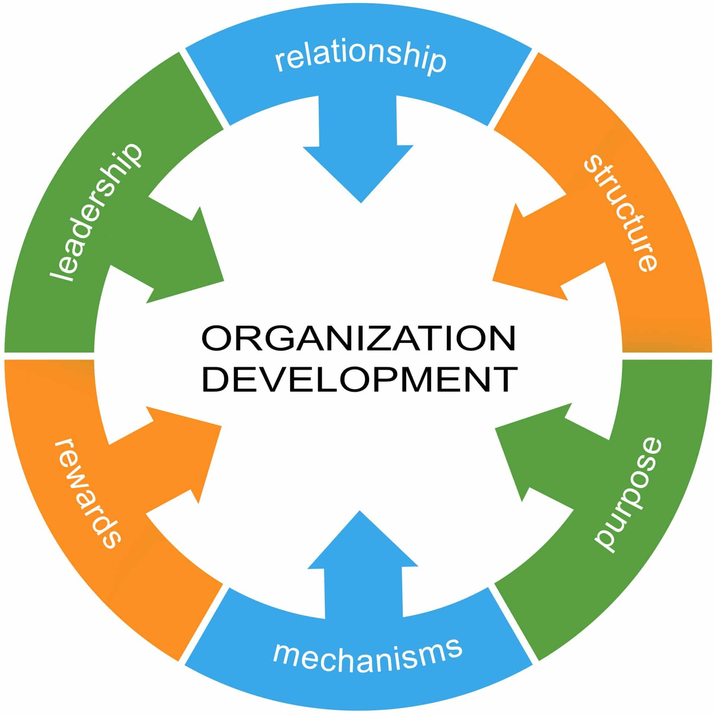

**Figure 2- factors that contribute to organizational development**

 Values and attitudes are foundational to organizational development. Hence, a leader should concentrate on the building of values and attitudes of employees and encourage positive organizational behavior. The building of values and attitude is a stepping stone to the functionality of the organization and it also contributes to the performance of employees in a changing business world. When a leader fails to lead and effectively direct their staff it may result in failure and this is detrimental, this can affect the culture of the organization which is foundational.

It is, therefore, necessary for employers to foster positive behavior in their organization and allow employees to be engaged (Krallis, 2014). The culture of an organization should also be one that encourages and supports a healthier balance for employees, this is a smart investment as the future of the organization is dependent on the output of the employees.  A positive organizational culture allows employees to feel valued. Effective leaders should not only look out for growth and productivity financially but also for the personal and professional development of their staff. Leaders must work towards staff retention. A positive culture also results in greater retention rates as this can result in growing profitability.

**3.1 Transformational leadership and organizational outcome**

The global economy in the twenty first (21st) centuries is continuously changing. A changing economy needs leadership that is transformational. In an effort to produce positive organizational outcomes, the work environment must be one that encourages team players and stimulates their interest. There is a need for innovative leaders who will motivate and increase the attitude of employees which will contribute to the overall success of the business atmosphere. (De Oliveira Rodriguez & Ferreira, 2015).

 It is necessary to have an influential and charismatic leader who is open to change. For organizational success, the leader has a responsibility to promote and improve the performance of any organization. This constitutes to positive outcome being that an organization that produces a positive outcome regardless of the structure is a result of a transformational leader.

An organization must have a culture that incorporates core organizational values, basic philosophies, and humanistic concerns as well as technical and financial attributes. (Giroux, &McLarney, 2014). A transformational leader is all about change and the change can be related to organizational policies, norms, and values. Leaders implementing transformational leadership have been effective at improving performance, employee satisfaction, and organizational functionality which is a positive organizational outcome.

Transformational leaders work to produce positive organizational outcome because they are positive influencers and influences their team in an optimistic way which results in the reaction of a positive work environment (Pradhan & Pradhan, 2015). The use of performance appraisal and rewards is key to organizational change and its upward mobility. (Pradhan & Pradhan, 2015).

For the success of an organization, leadership is important; a transformational leader should be innovative and also contributes to employee’s psychological well-being (Cherry, 2023). In a globalized society, transformational leadership is important and is very instrumental in responding to diverse situations. A transformational leader must be flexible in their response to situations in the business environment. They should be charismatic and display confidence in what they do, gain the trust of their employee, and be consistent in job performance.

The goal of transformational leadership is to provide satisfaction to the employee which drives their productivity and their potential. In an ever-changing business environment, the transformational may risk becoming the current "buzzword" for the sake of improving their organization. Transformational leadership has a positive relationship with organizational improvement job satisfaction, and staff morale. (Chen, 2021).

# **3.2 Leadership and Organizational Behaviour**

An organization represents a crucial perspective from which to view organizational behavior. Several contextual perspectives have increasingly influenced organizational behavior: some scholars view it from contingency perspectives, others focus on interactional views, and the popular-press perspectives. Leaders must be aware of organizational change and make an effort to capitalize on its opportunity (Hassan and Shkak, 2021).

 When managers have a clear understanding of organizational behavior they can better approach and appreciate the behavior of those around them as well as respond accordingly. In some organizations, managers are directly responsible for the work-related behaviors of their immediate subordinates.  For the success of an organization employees need to be motivated to work harder, leaders also have a responsibility to help resolve conflicts, evaluate their performance, and help employees to set rewarding goals. (Dyah, Mardanung, and Satyawati, 2017).

Understanding the dynamics of a team is necessary because this is how behaviors can be addressed and an avenue for change can be created. To fully understand work-related attitudes leaders assess the level of organizational commitment that is displayed by workers. The concept of organizational commitment relates to the degree to which people are involved with their organizations.

One of the main characteristics of behavior in organizations is that it involves the interrelationships between people. When it comes to the world of work, the adage, "no one is an island," is most certainly true. To get things done there is a need for effective communication. Communication is an important characteristic of organizational behavior. This is the process through which people send information to others and receive information from them, and power – the capacity that people have to influence others (Fiaz, Su, Ikram, and Saqib, 2017).

# **3.3 Characteristics of good leaders**

 It is said that good leaders are made not born but to what extent is this true?   Leadership is fundamental in every organization. The truth is that an organization can exist without an effective leader who can effectively direct their staff. Employees must have a vision that guides their path as they venture on their journey to meet organizational goals. This is an indication that effective administration and directing can influence employees in such a way that they all strive towards working to achieve a common goal.

An effective leader must display core values these include respect, dedication, precision, innovation, speed, quality, and effective leadership. These established traits are considered to be flexible and integrity is at the forefront of each. (Griffin, Phillips, and Gully, 2020).

The psychological approach is focused on the concept that leaders are conceptualized from birth they are not made. This is because they possess certain qualities that are limited to only leaders and these qualities distinguish them from other leaders.The cultural, social, and physical environment plays a complex role in the development of leaders who use the psychological approach and these leaders do not function in a vacuum but are rather open-minded.  (Valley, 2018).

Some leaders utilizedthesituational approach as they functioned effectively. Interaction is key because this is the basis of communication which is the bloodline of any organization and for organizations to fully operate communication is vital.

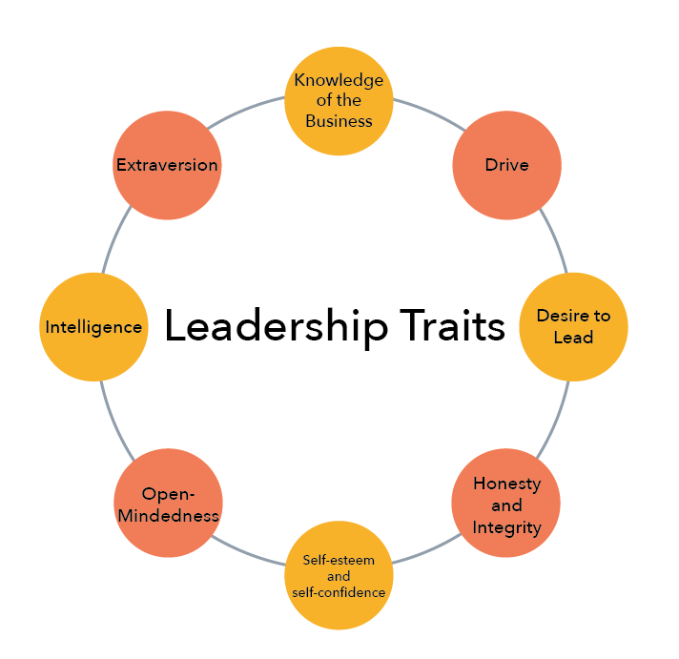

**Figure 3- Characteristics of a good leader**

# **3.4 Leaders managing change**

Many companies are striving to expand and survive in uncertain times. However, to do this it requires leaders to be flexible and be willing to adapt to change. Admittedly, COVID-19 adversely permitted many business leaders to assess how their businesses function as well as motivated them to address situations via the use of short, medium, and long-term goals. (Wolor, Supriyati, and Purwana, 2020). Leadership judgment and decision-making capability can be impacted by internal as well as external problems. There are leaders who focus on value in several ways: including value prioritization, value creation, and value determination.

In responding to change leaders have to be innovative. Innovation is visible through the designing of new products, new business models, new processes, and new performance initiatives. Liu, Jing, & Sheng, (2023) assert that as we live in an uncertain time there is a need for leaders to have that drive to solve problems and work on their initiatives. Some circumstances will upset the general routine of a business but leaders in these times have to be empowered to address issues.

Business leaders need to be proactive and use approaches that contribute to organizational recovery (Bowers et al., 2017). Leaders need to bear in mind that they employ individuals who may have different characteristics and approaches thus their leadership style should change by what is happening in the business environment (Wolor et al., 2020). Even though leaders are strategic they should they must take into consideration that there may be employees who may be reluctant to follow through with assigned tasks and as a leader, they should discourage employees from rendering such mediocre services to the organization.Responding to change demands that leaders display characteristics that are flexible and they should be able to think out of the box as they innovatively move forward. (Kniffin& Hanks 2018).

# **4.0 Theory- Situational Business Model**

The theory that caters to a better understanding of the relationship between leadership and organizational development is the Situational Leadership Model. This model is instrumental as it helps organizational leaders identify and strategically address various situations that may arise in the workplace.  Through the use of the situational leadership model those who lead have to be task-oriented to be successful.

This model posits that leaders have to be creative and flexible if they want to be successful. This approach points out that different situations should be addressed according to the nature of the situation.  As such, leaders may have to review and change the degree of directness exerted when addressing their employees to motivate them.

 Situation leaders should aim to identify the characters of their employees as this is key in allowing them to address varied situations that may affect organizational development.  Specchia, Cozzolino, Carini, Di Pilla, Galletti, Ricciardi, &Damiani (2022) argue that in being a situational leader there should be a level of openness in leaders and leaders should be competent in making organizational decisions.

# **4.1 Contribution of paper and conclusion**

Leaders play a developmental role in organizational development. This paper has demonstrated that leaders are crucial to societal development. They not only inspire organizational development but that of aspiring employees who are considered to be future nation builders. Being a leader takes much work because leaders must have the drive to tackle new problems as well as strategically address old problems.

 Leaders need to be effective in their planning, organizing, delegating, implementing, and evaluating processes. Being a transformational leader also involves improving the performance of employees, getting tasks done, and satisfying their employees. This paper has also highlighted that change in attitude and value can result in goals being accomplished. This can positively impact how an organization performs and how the employees and employer can work collaboratively to achieve a desired outcome. (Trmal, Bustamam, and Mohamed, 2017).

The dynamic of an effective leader is important because it shows how innovative a leader can be and the extent to which they can deal with change. Recently,   the COVID-19 pandemic has shown how leaders have to be dynamic and innovative to keep their businesses afloat in uncertain times. During this time many leaders had to go back to the drawing board and respond to the changes. Practices that were observed include working from home via the use of virtual teams to curb the spread of the virus. (Thatcher & Zhu 2019).

Leaders should be catalysts for change (Sembiring et al., 2020). Therefore there is a need for them to develop policies that may guide employees and how they function.  Within an organization, there is a need for strong interpersonal relationships between employees and leaders. Leaders should recognize the strides made by employees and also use strategies to improve on areas where there are shortfalls which can be realistic through training.

The democratic leadership style should be encouraged, as this leadership style encourages positive decision-making and contributes to the realization of the organization's goals and objectives. Programs planned should be geared towards enabling leaders and subordinates to be proactive and lead their staff as they work as a team. This not only enhances an organization's sustainability but also addresses its productivity, operation, and survival in society.

# **5.0 Conclusion**

Through the exploration of this paper, it was found that effective leaders should develop a tolerance for change and be transformational leaders. (Public Policy Research (IPPR), 2020). Change in leadership and management is vital to the Human Resources department and the functionality of the business within society. A striving organization requires that leaders have innate leadership styles, and a combination of technical, human, and technical skills which will better enable them to tackle challenges relating to organizational development.

It has been highlighted democratic or participative leadership style is best for the operation of a business. This is key because this leadership style encouragesemployee ownership of the decisions.  Democratic leaders encourage participation and delegates wisely. The leader should maximize the strengths of their employees or subordinates.  To obtain the best performance leaders should motivate team members by empowering them to direct themselves.

Leaders should stay true to their values through guided principles such as integrity, trust, loyalty, and respect and constantly abide by ethics. Thus, promoting positive civic engagement and social responsibility through an ethic of service and a concern for justice. Leaders should be assertive and decisive and enjoy taking risks. A true leader must be able to admit their shortfalls and mistakes, they must be committed to the mission of their organization, and always aspire for organizational excellence.

The completion of this paper has shown that leaders should have the dive and passion to lead others and get things done. Leaders should be interested in developing people’s skills. Leaders should make the employees feel confident and make an effort to improve their own performance.Finally leaders must have the following core values, respect and compassion, self-awareness and inner serenity as well as harmony and interdependence. With these positive value a business can do nothing but succeed.

# **6. 0 Bibliography**

Birt J (2023). 11 Leadership Principles To Implement in the Workplace.

https://www.indeed.com/career-advice/career-development/leadership-principles

Chen C (2021). Transformational Leadership and Employee Job Satisfaction: The

Mediating Role of Employee Relations Climate and the Moderating Role of Subordinate Gender. Int. J. Environ. Res. Public Health 2022, 19(1), 233; https://doi.org/10.3390/ijerph19010233

Cherry K (2023). *Is Democratic Leadership the Best Style of Leadership?*

https://www.verywellmind.com/what-is-democratic-leadership-2795315

Cherry K (2023). *How Transformational Leadership Can Inspire Others.*

https://www.verywellmind.com/what-is-transformational-leadership-2795313

De Oliveira Rodriguez, A., & Ferreira, M.C. (2015). The impact of transactional and

transformational leadership style on organizational citizenship behaviors. *Psico-USF*, 20(3), 493-504. doi: 10.1590/1413-8271201520031

Dyah, A. P., Mardanung, P. C., &Satyawati, E. (2017). Effect of Leadership on the

Job Satisfaction with Organizational Commitment and Trust in Leader as Mediators. *Review of Integrative Business and Economics Research*, , 6(4), 400-408.

Fiaz, M., Su, Q., Ikram, A., &Saqib, A. (2017). Leadership styles and employees’

motivation: Perspective from an emerging economy. *The Journal of Developing Areas,* 51, 143–156. doi:10.1353/jda.2017.0093

Giroux, T., &McLarney, C. (2014). Exploring the leadership continuum: The

relevance of transformational leadership on organizational performance. Proceedings of the Northeast Region Decision Sciences Institute, 862-886. <http://nedsi.org/>

Griffin, W. R., Phillips, J., & Gully, S. M. (2020). Organisationbehaviour: managing

people and Organisation (13th ed.). Boston, MA: Cengage.

Hailu, A (2023). LEADERSHIP STYLE. 10.13140/RG.2.2.11935.64160.

Hassan, H&Shkak, J. (2021). Organizational Behavior: *Leadership.*

10.13140/RG.2.2.29372.97926.

Hoxha, A. (2015). Empowerment and trust as mediators of the relationship between

transformational leadership and organizational effectiveness. European Journal of Economic & Political Studies, 8(1), 43-60. <http://www.ejeps.com/index.php/ejeps>

Institute for Public Policy Research (IPPR) (2020) *Covid-19 Survey on Health*

*Workers in the UK*. https://www.ippr.org/news-and-media/press-releases/covid-19-one-infive-healthcare-workers-could-quit-after-pandemic-unless-urgent-government-action-istaken-ippr-warns.

Khan Z (2016). Leadership Theories and Styles: A Literature Review. Journal of

Resources Development and Management

Krallis, A. (2014). *Leadership Style, National Culture and Employee Satisfaction:*

*Empirical Evidence from European R&D Companies*. Research Gate.

Kniffin, K. M., & Hanks, A. S. (2018). The trade-offs of teamwork among STEM

doctoral graduates. *American Psychologist*, 73(4), 420–432. <https://doi.org/10.1037/amp0000288>

Liu, X., Jing, Y., & Sheng, Y. (2023). Work from home or office during the COVID-19

pandemic: The different chain mediation models of perceived organizational support to the job performance. *Frontiers in public health*, 11, 1139013. <https://doi.org/10.3389/fpubh.2023.1139013>

Olutoye, A. A., Asikhia, O. (2022). The effect of leadership and organisational

behaviour on performance – A systematic literature review*. International Academic Journal of Human Resource and Business Administration*, 4(1), 165-183.

Pradhan, S., & Pradhan, R.K. (2015). Transformational leadership, affective

organizational commitment and contextual performance. Vision, 19(3), 227-235. doi: 10.1177/097226291559708

Snell, R.S., Yi, Z., &Chak, A.M.K. (2013). Representational predicaments for

employees: Their impact on perceptions of supervisors’ individualized consideration and on employee job satisfaction. *International Journal of Human Resource Management,* 24(8), 1646-1670. doi: 10.1080/09585192.2012.723634

Specchia, M. L., Cozzolino, M. R., Carini, E., Di Pilla, A., Galletti, C., Ricciardi, W., &

Damiani, G. (2021). Leadership Styles and Nurses' Job Satisfaction. Results of a Systematic Review. I*nternational journal of environmental research and public health*, 18(4), 1552. <https://doi.org/10.3390/ijerph18041552>

Trmal, Samir &Salwa, Ummi& Ahmad Bustamam, Ummi& Zainal, Abidin&

Mohamed,. (2017). The Process of Transformational Leadership in Achieving High Performance Workforce that Exceeds Organisational Expectations: A *Phenomenological Case Study*. 2017. 2222-6990. 10.6007/IJARBSS/v7-i3/2695

Thatcher, S. M. B., & Zhu, X. (2019).Changing identities in a changing workplace:

Identification, identity enactment, self-verification, and telecommuting. *Academy of Management Review*, 31(4), 1075–1088.

Valley, B. (2018). Jahre National. Leadership in Health Sectors. *Journal of public*

*health*. 32-40..

Wolor, C. W., Supriyati, Y., &Purwana, D. (2019a). Effect Of Organizational Justice,

Conflict Management, Compensation, Work Stress, Work Motivation On Employee Performance Sales People. *Humanities & Social Sciences Reviews*, 7(4), 1277–1284. ttps://doi.org/https://doi.org/10.18510/hssr.2019.74 176