**Your name**

Simone S. Kelly

**Your student ID number**

AD82214HU91431

**COURSE NAME:**

**(Communication Process.)**

Doctorate in Human Resource Management.

**ATLANTIC INTERNATIONAL UNIVERSITY**

October 10, 2023

**Table of Contents**

1.0 Introduction 3

2. 0 Overview Of Communication Process 4

3. 0 Communication Type 7

3.1 Types Of Nonverbal Communication 7

3.2 Listening Skills 8

3.3 Symbolic Communication And Conflict Management 10

3.4 Communication Barriers 11

4.0 Applicable Theories 12

4.1 Contribution To Paper 15

6.0 Bibliography 19

# **1.0 introduction**

Communication is the exchange of information between individuals which can be completed through speaking, writing, as well as using common signs or behaviour. Communication is a vital link to understanding and can be referred to as the lifeline of thoughtful exchange of information. Engagement in effective communication caters to the exchange of thoughts and this is extremely important to the survival of individualistically and collectively. Communication also forms the basis of every organization for nurturing and grooming the atmosphere of that particular organization. (Hargie, 2016).

 Without Communication, a task cannot be completed effectively because the avenue to understand what was said was not established. Communication takes in the sharing of ideas and messages within a specified place and at a particular time. Communication takes place via different modes including writing and talking, as well as through the use of nonverbal cues such as facial expressions, body language, or gestures. Other modes of communication include the use of images or videos. (Stacho, Stachová, Papula, Papulová, and Kohnová, 2019).

Communication is necessary for organizational success. For a relationship to be fruitful communication is key. It is impossible to imagine having a relationship without conflicts and for clarification, communication is key. Effective communication is required not only for human relations but also for good and successful relationships. There are certain characteristics of a healthy relationship these include, listening, trust, honesty, mutual respect, love, compromise, good communication, self-control, and problem-solving.Human communication is vital as such during the communication process it is important to be aware of the 5 W’s :*When, Who, Where, Why,*and *What.*

Personal or organizational-based communication is important as it helps to reduce conflicts. For this paper, the writer will focus on different categories of communication. Sections one and two give a general overview of why communication is important. The third section highlights various modes of communication. The fourth section speaks to the benefits of communication with the support of communication theories while the final section highlights recommendations and conclusions drawn.

# **2. 0 OVERVIEW OF COMMUNICATION PROCESS.**

Communication is the helping hand to any relationship or organizational performance. This is because understanding the meaning of another person’s message does not occur unless the two parties of communication can obtain meaning from the mode of communication that is being used. Charles Handy (1932) Irish-born British management educator and writer quoted “If there is one general law of communication it is that we never communicate as effectively as we think we do”. Indeed this is agreeable because communication is considered as an activity and the key ingredients are the exchanging of information and the understanding of thoughts.

# **2.1 Communication Process.**

Various principles govern the communication process these include having a level of conciseness, and the messages should be concise to grab the attention of others. The message should also concrete, full of clarity, and have some form of completeness. The information that is being exchanged should also have a complete meaning and this will help provide adequate information. Within an organization, there are various components of communication. These components include; the context that is the theme that a message has. The sender acts as an encoder as this is where the message is sourced. The message is the channel from where the message is bypassed and information flows towards the receiver. The receiver then acts as an encoder that understands the message, set by the sender and where information sinks. Finally, there is feedback, where the sender gets its audience and readers' responses in the form of criticism or appreciation.  (Markovik and Salamzadeh, 2018).

**Communication Process.**

**Figure 1- The Communication Process.**

To effectively function in any form of relationship there is a need for good conversational skills. Within this process the communicators should be aware of how to start and end a conversation, how to make themselves understood, how to respond to the statements of others, how to be sensitive to the concerns of others, and how to effectively listen. The abilities mentioned are classified as communication competence.

Problems sometimes arise in organizational communication between supervisors and workers, or between different groups of workers who are responsible for different parts of a task. Therefore, there is a need to develop adequate communication skills in order to relate with each other in the workplace or get a job done. (Surbhi 2018).

It is agreeable that communication is indeed essential for the smooth flow within an organization. (Boone and Kurtz, 2002). In the absence of communication, no work operation or function could be carried out. A breakdown in communication is present when individuals hold different perspectives and have different values and attitudes. The different perspectives can be a result of power and status (Antos, 2011).

# **2.2 Categories of Communication.**

Within an organization, communication is categorized into three (3) groups. These groups include upward communication, downward communication, and dyadic communication. Upward communication occurs in an organization from peers or employees to the managerial level. This type of communication also has a formal or proper tone. The tone can lie in how the employee responds to the manager about a specific task. Downward communication takes place from the upper stratum example from the manager to the employees. An example of such is when the manager gives out a specific set of instructions that is expected to be followed. Finally, dyadic communication is more of a friendly and informal communication that occurs between peers of the same organization. For example when workers exchange ideas amongst each other. (Petersons, A. &Khalimzoda, 2016).

Communication can be categorized as interpersonal or intrapersonal. The most common form of daily communication is interpersonal which is, face-to-face. The most basic form of interpersonal communication is one that exists between two persons. These communication relationship may exist over a long period of time, for example a marital relationship or business partnership.

To effectively function in an organization or society in general there is a need for individuals to communicate with themselves (Intrapersonal).  How an individual perceives himself or herself can make a difference in how they communicate. Effective communication fosters togetherness and working towards a common goal. It also ensures success as opinion and thought given at the organizational level contributes to productivity.

# **3. 0 COMMUNICATION TYPE**

This section of the paper will focus on discussing types of nonverbal. The five types of non-verbal communication include the use of gestures, body language, appearance, visual aids, and the setting of the physical environment. The writer will also elaborate on the importance of listening, and symbolic communication as well as how communication is used to solve conflicts.

# **3.1 TYPES OF NONVERBAL COMMUNICATION**

Non-verbal communication is observed in many forms these include Kinesics or gestures which are conscious body movements such as waving, pointing, or giving a thumb up. The use of body language or posture, the appearance of a person relating to their clothing or adornment, the use of visual aids, maintaining eye contact, and the physical setting (Manusov, 2014).

Gestures can be used by the speaker to draw the attention of the listeners to what is being said, hand gestures can also be used to emphasize a certain point. The speaker may use their body language to generate a great amount of emotion and interest as well as reinforce their sincerity and enthusiasm. The appearance of the speaker is a powerful tool. Looking like a credible and prepared presenter of thought will make the speaker feel confident and the audience will find the information given trustworthy.

Visual aids play an important role in conveying information. The use of this material also caters to a better understanding of what is being said by the speaker. Eye contact helps the speaker to establish credibility and keep the audience’s attention while they are speaking.  The physical environment can help the speaker deliver a speech effectively if it is conducive and welcoming this takes in the use of lighting, acoustic environment, setting, and furniture placement. The physical environment can contribute to a communication-friendly environment for conversations. (Richmond, McCroskey, James & Mark 2013).  The use of non-verbal communication is as effective as verbal communication because there is more than one way to get the attention of an audience and effectively convey messages to them.

# **3.2 LISTENING SKILLS**

Thedevelopment of listening skills is fundamental to communicative competence. To listen, an individual needs to make a conscious effort not to just hear but also to understand what was said. Not only does listening enhance one's ability to understand better and be a better communicator, but it also makes the experience of speaking to you more enjoyable to other people (Lesikar, Flatley, Rentz, and Pande, 2016).

Two types of listening are Critical and Comprehensive listening. Critical listening involves the analysis of what is spoken and said by a speaker, and the listener forming an opinion based on what was heard. Comprehensive listening requires that the listener pay key attention and interpret the words of the speaker. This process requires basic language skills and the use of vocabulary to understand what a speaker is saying. (Solak, & Altay, 2014).

Two important stages of listening are receiving and understanding. The receiving stage involves the listener hearing and attending to what was said.  In order to effectively gather information through listening, the listener must first be able to physically hear what is being said even though the process can be challenged due to different barriers. The understanding stage involves the listener determining the meaning of what has been said based on the context in which it was heard through a process called decoding.Strategies that can be used to improve listening skills include paying attention by using eye contact, being attentive to non-verbal signs such as the use of gestures, not interrupting the speaker, keeping an open mind, thinking about what the speaker is saying and lastly asking questions to clarify any misconception if necessary.

# **3.3 SYMBOLIC COMMUNICATION AND CONFLICT MANAGEMENT**

Communication is necessary for organizational success. However, conflict may arise stemming from different opinion which may result in conflict. Conflicts are something normal in any organization because people have different opinions and there are people who cannot accept different opinions. It is very dangerous for an organization to have too many conflicts as well as not to have any conflicts. Effective communication is required not only for human relations but also for good and successful business.

Organizational communication and conflict management are connected. There are many factors that prevent employees from direct and open communication and the result of that is a high risk for conflict situations. If managers apply direct communication on time, the conflict could be avoided or its impact would be minimal. Conflicts happen every day and successful conflict management is a key element of organizational and managerial success. (Holmes, 2016).

Organizational conflict occurs when members engage in activities that are incompatible with those of colleagues within their network, members of other collectivizes, or unaffiliated individuals who utilize the services or products of the organization. Within the workplace "miscommunication and misunderstanding can create conflict even when there are no incompatibilities" (Fisher, 2009).

Lack of effective communication skills could result in confusion, further leading to conflict. Effective communication results in achieving the purpose for which it was designed. Thus, team building and training are essential in reducing workplace conflict. It has to be applied effectively to help people in conflict to live in peace and harmony which can contribute to a productive work environment as individuals communicate effectively and manage conflict better.

**3.4 Communication Barriers**

Communication barriers can hinder the decoding of messages and may result in misinterpretations. These include: Language barriers, Physical barriers, attitudinal barriers and Psychological barriers. These barriers can hinder effective communication which plays a vital role in enriching personal relations, academics, business, and international interactions. (Brahmaiah, 2016).

Language barriers may include the use of jargon and abbreviations that may not be understandable by a receiver who is not familiar with the terminology used.The physical barrier to communication refers to the geographic distance between the sender and receiver(s). The attitude barrier was posited as everything for any task we do in our life, whether it is simple or complex. A good attitude can contribute to effective communication. When this is not established it may result from poor management, personality conflicts and resistance to change, or a lack of motivation. Psychological barriers were explored as barriers that are due to individual differences among human beings in behavioural aspects and mentality.

The most significant aspects of the barriers recognized were anger, stress, and unfamiliar accent. In highlighting the barriers the writer highlighted cause and effects. *T*he writer captured the attention of the reader by first highlighting the importance of education to academics, business, and international interactions. Other barriers that are worth mentioning include perceptual barriers, emotional barriers, and cultural barriers. (Rani, 2016).

Psychological Barriers are problems that exist a as result of stress or other psychological problems. Within this context, it is difficult to accept and overcome these barriers. According to Rani, (2016).), the smooth functioning of a workplace depends on the teamwork and relationship that exists between co-workers. In order to cooperate well, employees need to be able to communicate effectively. However, a stressful situation can be a hindrance. In doing so good communication must exist within and between the team as a whole and the rest of the company.

# **4.0 Applicable Theories**

**Aristotle**

Aristotle is one of the greatest philosophers who initiated the earliest mass communication model. Aristotle’s model of communication focuses on public speaking which is a process that involves the speaker playing a pivotal role in communication. Aristotle's Model of Communication contains five (5) basic elements (i) Speaker, (ii) Speech, (iii) Occasion, (iv) Audience, and (v) Effect. The model suggests that the speaker must prepare his speech, cater to a targeted audience, and persuade their thoughts toward the message being communicated.  During the process, the sender prepares content by carefully putting his thoughts in words with the objective of influencing the listeners to respond in a desired way or according to what is prompted.  (Editorial Team, 2020).

**Occasion**

*Figure 2- Diagram showing Aristotle Communication Model*

**Berlo’s Model of Communication**

There are four main parts associated with Berlo’s Model of Communication, these include the sender, the message, the channel, and thereceiver. During the communication process, the source is the sender from whom the thought originates. The sender transfers the information to the receiver after carefully putting his thoughts into words through the process called Encoding. The Channel is the medium by which the information flows from the sender to the receiver through a specific channel that allows the receiver to decode what is sent. According to Berlo’s Model of communication, the receiver should be on the same platform as the speaker in order to initiate the smooth flow of information and a better understanding of the intended message. (Kobiruzzaman,2021).

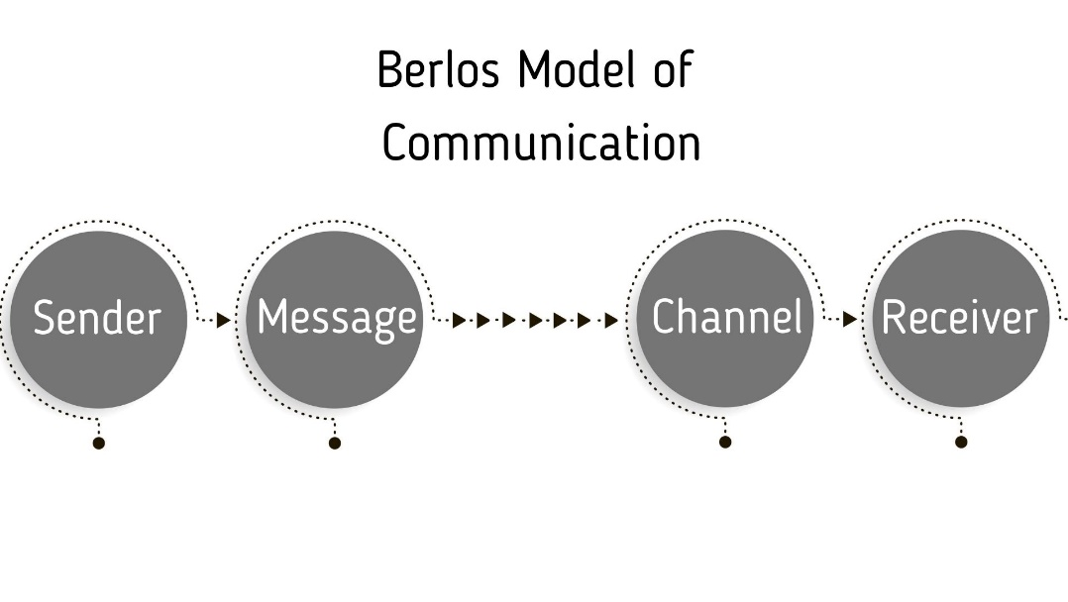

*Figure 3- Diagram showing Berlos’s Communication Model*

**Shannon and Weaver Model of Communication**

Shannon and Weaver's model is considered to be the most popular model of communication and is utilized globally. The model introduces five (5) key stages to the communication process namely, the sender, the encoder, the channel, the decoder, and the receiver. The model illustrates the communication process that exists between the source and the intended destination. The message that is created from the source can be one that is continuous or discrete. The Shannon-Weaver model was designed initially for electronic communication, and it does direct focus on the human factors that can influence how a receiver decodes their message. (Shannon, & Weaver, 1949).

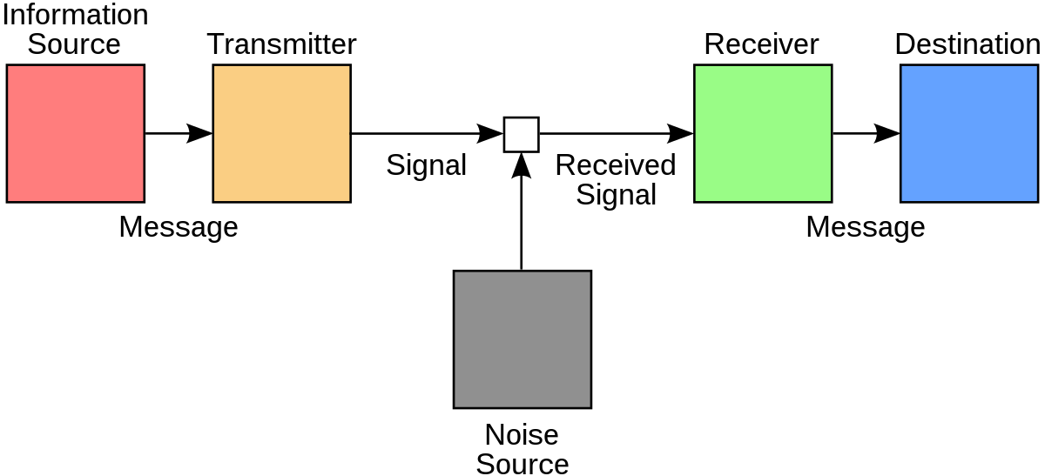

*Figure 4- Diagram showing Shannon and Weaver Model of Communication*

**Schramm’s Model of Communication**

In 1954 Wilbur Schramm suggested that communication is a two-way process where both sender and receiver alternately send and receive a message. According to this model information transmitted is useless until it is carefully put into words and transferred to others.

Encoding plays a very important role because it initiates the process of communication by changing the thought into the content. When the recipient receives the information his primary responsibility is to understand what the speaker intended to convey. The message is of no use until the second party is able to understand or decode the information that is been sent which is also dependent on the individual’s knowledge, experience, and cultural background. (van Ruler, 2018).

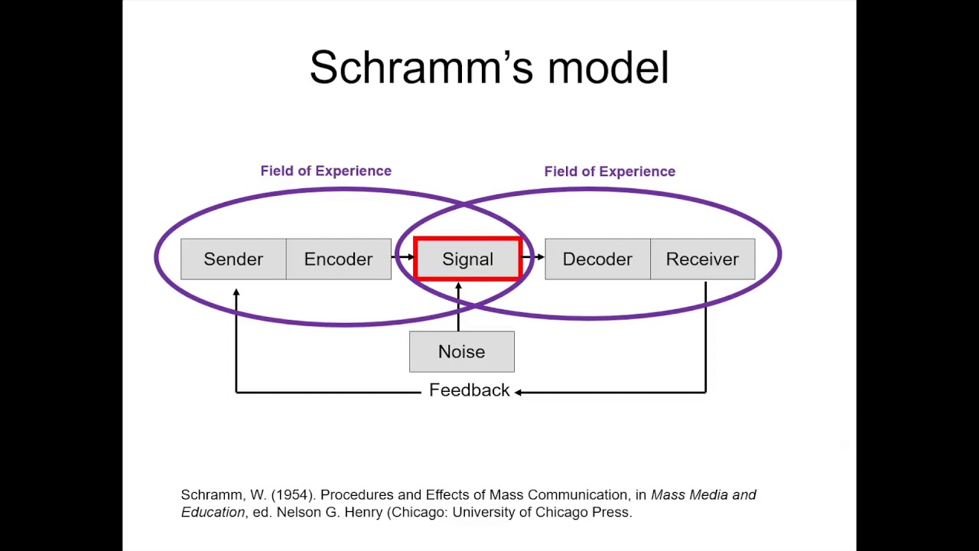

*Figure 5- Diagram Showing Schramm’s Model of Communication.*

# **4.1 Contribution to Paper**

The sections previously discussed have shown how communication is vital to one's existence. It has also shown scenarios in which the hallmarks of communication can be applied. I have come to realize that there are many factors that hinder direct and open communication and the result of that is a high risk for conflict situations. Applying the hallmarks of healthy communication within the workplace or in any relationship can help address matters immediately and also bring a reduction in conflict.

In order to communicate well listening must be a vital part. Taking in what people are saying permits appropriate responses. Listening is key in bringing about peace because listening allows individuals to respect the opinions of others. There are seven key active listening skills, which include being attentive, asking open-ended questions, asking probing questions, requesting clarification, paraphrasing, being attuned to and reflecting feelings, and summarizing information that was transmitted.  (Brahmaiah, 2016).

Communication involves more than talking it is more like making a connection and also making an effort to reach a common goal and reduce conflict. Communication should be meaningful and purposeful. The process of communication is vital because it contributes to human development in one way or another. It is agreeable that communication happens in a specific place and at a particular time. This indicates that a particular situation contributes to the communication process.  Being that all communication happens at a particular time and at a specific location there is a need to understand the situation for the purpose of communication. If the situation is not properly understood the message will be lost which results in communication being ineffective.

As individuals in society relate with each other there is a common goal which is to understand the message that is being delivered. The delivery of the message is one that is purposeful because the speaker expects a result from the message that is being delivered. The understanding grasped from the message is also dependent on the speaker’s knowledge of the situation.

I have come to understand that the level of communication that exists between individuals is also dependent on their attitudes and values. It is important for individuals to be aware that each individual has a unique ability to communicate. The attitude and perception can influence how the speaker communicates a problem as this can result in misinterpretation of an intended message.

**5.0 Conclusion**

In acknowledging the importance of communication there is a need to bridge the communication gaps that deter effective communication so that the process may be one that is meaningful. Firstly, there is a need to acknowledge the communication barriers that exist and learn how to approach situations differently. Overcoming these barriers may take actions such as identifying a getting rid of differences in perception, using simple language that is relatable, engaging in active listening, and avoiding information overload. Addressing these issues is vital in order to overcome all the communication barriers. (Brahmaiah, 2016).

Effective communication can result in the motivation of the presenter. This is due to the fact that motivation involves the conscientious efforts of individuals who are focused and whose aim is to achieve a common goal. (Ellemers et al, 2004). Effective communication is one of the primary goals of every relationship and it also contributes to success. Communication is an effective process that also informs individuals about what needs to be done. Communicating with others is a way to make individuals aware of others as well as their attitude toward others and their progress.

Within any organization or relationship communication is an effective strategy that aids in keeping employees motivated. (Muda, 2014). Through interaction, information is shared and this caters to a better understanding of concepts as well as the development of an appreciation of the goal that is to be attained. Engagement in communication is considered a recognizable opportunity that contributes to the building of trustworthy relationships.

The communication process is important as it caters to the desired level of goals being achieved. (Manzoor, 2013). Effective communication can lead to individuals overcoming challenges, and it also builds zeal, and self-reliance (Ryan and Deci, 2000). Communicating effectively can result in many benefits. It aids with connection and it also fosters constructive direction. As one communicates in different situations the opinion of others should be respected regardless of who the person is. In today’s society, communication is recognized as one of the most important factors that contribute to satisfaction in many domains hence it is fair to conclude that communication can be classified as the lifeline of survival and functionality in society.

# **6.0 Bibliography**

Antos, G. (2011). *Handbook of interpersonal communication*. The Hague, The

Netherlands: Mouton De Gruyter

Boone, L., & Kurtz, P. (2002). Contemporary business. Fort Worth, TX: Harcourt.

Brahmaiah D (2016). Barriers to Effective Communication. *Journal of English*

*Language And Literature* (Joell) An International Peer Reviewed Journal

Editorial Team (2020). *What is the communication Model*.

https://uk.indeed.com/career-advice/career-development/the-communication-model

Fisher R (2009) Interactive conflict resolution, identity, and culture

DOI:10.4324/9781315182070-22. In book: Routledge Companion to Peace and Conflict Studies (pp.259-268)

Gennaro C (2022). What Is The Helical Model Of Communication? The Helical

Model of Communication In A Nutshell. <https://fourweekmba.com/helical-model-of->communication/

Hargie, O. (2016) The importance of communication for organisational effectiveness.

In Lobo, F. (ed.) *Psychologies do Trabalho e das Organizações. Braga, Portugal*: Axioma. pp. 15-32.

Holmes T (2016) 10 Ways to Reduce Conflict in Your Organization.

https://www.linkedin.com/pulse/10-ways-reduce-conflict-your-organization-tyrone-holmes-ed-d-cpt

KobiruzzamanM (2021). *SMCR Model of Communication- David Berlo’s SMCR*

*Model of Communication*. <https://newsmoor.com/smcr-model-of->communication-david-berlos-smcr-model-of-communication-example/

Lesikar R. V., Flatley M. E., Rentz K., and Pande N., (2013), *Business*

*Communication: Making Connections in a Digital World,* 11th Ed., McGraw-Hill Education (India) Pvt. Ltd, New Delhi.

Manusov , Valery Lynn (ed.) 2014 , Th*e sourcebook of nonverbal measures: going*

*beyond words* , Kindle edn , Amazon Digital Services , Seattle, WA .

Manzoor, Q-A. (2012), Impact of Employees Motivation on Organizational

Effectiveness, *European Journal of Business and Management*, Vol. 3, No.3.

Markovik and Salamzadeh, (2018), *the Importance of Communication in Business*

*Management*. The 7th International Scientific Conference on Employment, Education and Entrepreneurship at: Belgrade, Serbia

Muda, I., Rafiki, A. &RezekiHarahap, M. (2014), Factors Influencing Employees’

Performance: A Study on the Islamic Banks in Indonesia, International Journal of Business and Social Science, Vol. 5 No. 2.

Petersons, A. &Khalimzoda, I. (2016). Communication models and common basis

for multicultural communication. *Proceedings of the International Scientific Conference,* 4, 423-433.

Rani U ( 2016). Communication Barriers. Ve*da’s Journal Of English Language And*

*Literature* (Joell) . Vol.3, Spl.Issue 2, <https://joell.in/wp-> content/uploads/2016/03/74-76COMMUNICATION-BARRIERS.pdf

Richmond, V. P , McCroskey, James C & Mark L (2013) *, Nonverbal*

*Communication in human interaction*, 8th edn , Cengage Learning , Independence, KY

Solak, E., & Altay, F. (2014). Prospective Efl Teachers’ perceptions Of Listening

Comprehension Problems In Turkey. *Journal of International Social Research*,

7(30)

Stacho, Z., Stachová, K., Papula, J., Papulová, Z., Kohnová, L. (2019) Effective

communication in organisations increases their competitiveness. *Polish Journal of Management Studies,* 19 (1), pp. 391-403

Surbhi S (2018) *Difference Between Intrapersonal and Interpersonal*

*Communication*. https://keydifferences.com/difference-between-intrapersonal-and-interpersonal-communication.html

van Ruler, B. (2018). Communication Theory: An Underrated Pillar on which

Strategic Communication Rests. *International Journal of Strategic Communication*, 12(4), 367-381. doi:10.1080/1553118X.2018.1452240