**Shaneille Sash-Nicole Samuels**

**UD81995EC91212**

**Doctor of Philosophy (PhD) in Financial Mathematics with Specialization in Economics**

COURSE NAME:

**(Applied Development Economics (ADE 612))**

Assignment Title:

**(An Insight into Agricultural Productivity and Rural Development in order to Identify Suitable Strategies for Sustainable Development)**

ATLANTIC INTERNATIONAL UNIVERSITY

**August/2023**

**Table of Contents**

**List of Tables** 4

**List of Figures** 4

**Introduction** 5

**1.** **What is the Role of Agricultural Productivity in Ensuring Rural Development?** 6

**1.1.** **Definition of Rural Development** 6

**1.2.** **Agricultural Productivity** 6

**1.3.** **Theoretical Framework** 7

**1.4.** **Importance of Improving Agricultural Productivity** 10

**2.** **Farming Techniques to consider in achieving Sustainable Growth** 13

**2.1.** **Reasons to Modernize Farming Techniques** 13

**2.2.** **Innovative Farming Practices** 15

**3.** **Bridging the Rural-Urban Divide through Access to Markets** 16

**3.1.** **Barriers to Market Entry and Strategies to Overcome Them** 16

**4.** **Assessing the Role of Technology in Transforming the Agricultural Sector** 17

**4.1.** **Role of Modern Technology in Catalyzing Agricultural Productivity and Rural Development** 17

**5.** **Striking a Balance between Production and Preservation – A Sustainable Resource Management Strategy** 19

**5.1.** **Sustainable Management Practices** 19

**6.** **Ways to Strengthen the Services of Agricultural Extension** 20

**6.1.** **Definition of Agricultural Extension Services** 20

**6.2.** **Role of Agricultural Extension Services** 20

**7.** **Farmer’s Access to Finance and Credit** 21

**7.1.** **Farmer’s Need of Funding and Strategies to Improve Access to Financial Services for Smallholder Farmers** 21

**8.** **Policy Interventions Needed to Establish Sustainable Rural Development** 22

**8.1.** **Supportive Policy Frameworks and their Importance** 22

**9.** **Overall Discussions** 23

**9.1.** **What is the relationship between agricultural productivity and rural development?** 24

**9.2.** **How agricultural productivity can contribute to economic development?** 24

**9.3.** **Why are policies and interventions necessary to enhance farming techniques?** 25

**9.4** **Contributions of Essay Paper to My Personal and Community Development** 25

**10.** **Conclusion** 26

**Bibliography** 27

# **List of Tables**

**Table 1** 10

# **List of Figures**

**Figure 1** 6

**Figure 2** 7

**Figure 3** 8

**Figure 4** 13

**Figure 5** 14

**Figure 6** 17

# **Introduction**

Agriculture is the pillar of societies and the backbone for all economies. Agriculture is able to guarantee societies survival whether directly or indirectly because people cannot survive without food. Historians have used an agricultural perspective to describe humans as people from a posture of food gathering to food growing. Thus, shaping the narrative of humans moving through a period of nomadic character to a more settled and developmental mindset. Therefore, agriculture has provided the opportunity for trade exchange to exist in all societies starting with the barter system until trade has developed using money. Now in our modern world, Agriculture is very crucial to foster sustainable rural development and in the long run economic development. Presently, there are two main strategies that have been identified to help drive development of the agricultural sector which are agricultural productivity and rural development. The more countries can improve agricultural productivity, the more they can ensure food security to address population growth as well as assisting in reducing poverty in rural areas.

This essay seeks to explore ways to improve agricultural productivity in rural areas to contribute to economic development. It also intends to examine linkages that exist between agricultural productivity and rural development as the drivers in developing the agricultural sector and by extension economic development. The paper highlights potential benefits from the relationship between agricultural productivity and rural development and examines each benefit while assessing the challenges with this relationship.

The essay will identify various strategies, policies and interventions needed to help enhance farming techniques to assess the possible balance between production and preservation. It will also address the importance of accessing markets by farmers, ways to access, and challenges they face as well as the need to develop rural infrastructure to foster and promote sustainable growth in rural communities.

# **What is the Role of Agricultural Productivity in Ensuring Rural Development?**

## **Definition of Rural Development**

The word ‘rural’ tends to be defined contextually based on each country (or island). NTU International (2023) stated that “rural development allows for the improvement of rural communities’ quality of life and prevents depopulation of regions affected by rural exodus.” In other words, it relates to the amenities (utilities or infrastructure) that one has in his or her household (or community) such as access to roadways, electricity, availability of internet, and running water in proximity.

## **Agricultural Productivity**

Agricultural Productivity is defined as the measure of the increase of output produced with the efficient use of inputs in the production process by farmers within the agricultural sector (Australian Government Department of Agriculture, Fisheries and Forestry, 2023). This can be referred to as the ratio of agricultural inputs to outputs.

According to StudySmarter (2023), agricultural productivity can be calculated as: output $÷$ input = productivity. StudySmarter (2023) shared that in the calculation and interpretation of agricultural productivity, agricultural energetics is normally used to help gauge or give a measurement of productivity by focusing on energy flows and stores in the agricultural system, productivity, and efficiency. Farmers usually seek to maximize productivity in order to increase food security and enhance farm income while providing opportunities for environmental benefits (StudySmarter, 2023). For instance, according to Figure 1 [picture of a table], the US experienced a fluctuation of productivity between 1948 and 1996 (United States Department of Agriculture, n.d.). The productivity level average growth rate between 1948 - 1959 was 1.00%, while it was 4.68% between 1980 - 1984 and 2.14% between 1990 - 1996 (see Table 1). United States Department of Agriculture (n.d.) explained that the small growth rate of 1.00% can be accounted for based on issues experienced in the agricultural sector such as the high level of input, take for example a lot of [11.4] pesticides was needed indicating that the land had quite a few pests needed to be ridden during that time period, thus the land needed to be properly dressed thereafter in order to plant and increase the productivity; so it is evident that the inputs was far more than outputs which accounts for the small ratio between inputs and outputs (see Table 1). While 4.68% between 1980 - 1984 indicated that the output was greater while the inputs required were far less in comparison to the period of 1948 - 1959 (see Table 1). However, this was followed by a decline in productivity between 1990 - 1996 by 2.54%, which reflected low output growth in comparison to the outputs used.

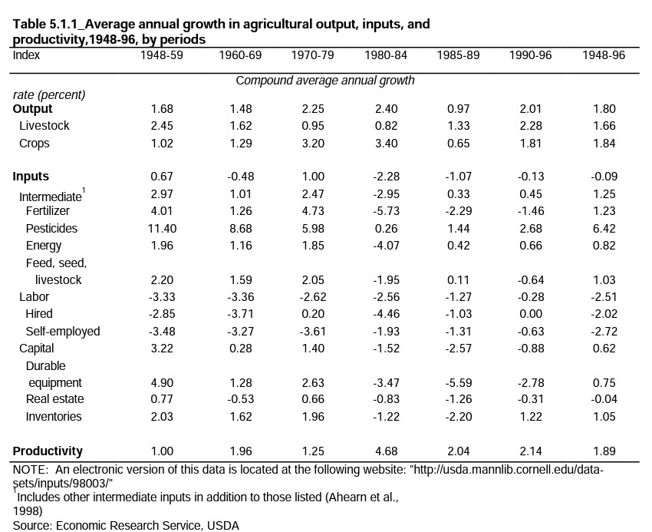

**Figure 1**

Average growth in agricultural output, inputs, and productivity in the US by periods (United States Department of Agriculture, n.d.)

## **Theoretical Framework**

Over the past 100 years, several theories have been developed about agriculture and rural development. Theorists have presented models such as the frontier model and the high payoff input model. The frontier model mostly focuses on the [graph] Production Possibility Frontier (PPF) that shows various combinations of different types of output possible of two goods produced using a fixed set of inputs and technology, where the interior part of the curve indicates attainable region and outside is unattainable. The PPF curve itself is known, however, to indicate the maximum combination of output possible of two goods produced using a fixed set of inputs and technology. For example, a farmer decides to produce both bananas and cabbage then he can either obtain a maximum output of 3600 units of bananas or 4200 units of cabbages, or a mixture of both units of bananas and cabbage but must be less than the maximum output possible for each (see Figure 2). This theory focused on the use of an economic model illustrated graphically to explain the problem of scarcity by efficient allocation of resources, the impact of technological advancements, aiming to balance trade-offs but making decisions and calculating opportunity choice, continuous improvements, and sustainable practices.

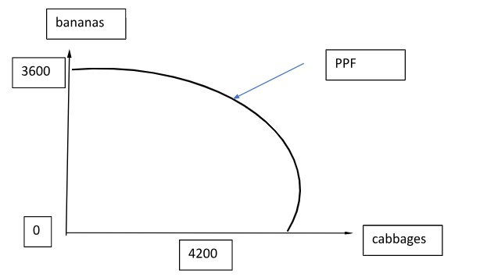

**Figure 2**

Production Possibility Frontier Curve – Bananas and Cabbages

According to Osegbue & Udemezue (2018), this model was initially developed based on western countries’ economies where there was an establishment of villages who sought to intensify their systems of cultivation. The aim of the PPF is to allow countries to analyze their agricultural sectors to assess trade-offs between outputs and input resources in order to make informed decisions needed to achieve economic growth. Countries such as Brazil, India, China, and the United States (US) have employed this model in using the PPF to enhance and analyze economic growth. In the frontier model, to achieve economic growth, there needs to be an outward shift of PPF as seen in Figure 3. This shift can only happen when there is an increase in productive resources such as capital and/or labour, as well as technological improvements in terms of knowledge and technological tools. Brazil, for example, has used the PPF to aid their production of soybean and beef to help them meet their global demand. The Brazilian government has been assessing how best to optimize resource allocation while promoting efficiency in the production of soybean and beef to obtain higher output of soybean and beef and achieve economic growth.

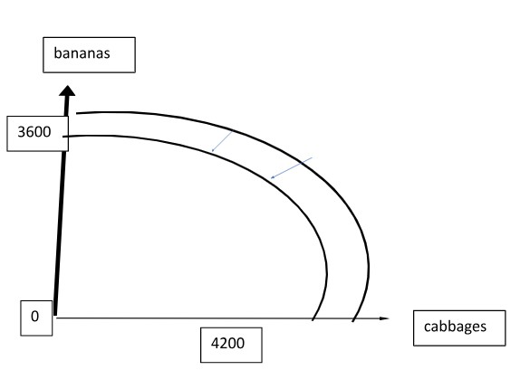

**Figure 3**

Outward Shift of Production Possibility Frontier Curve to achieve Economic Growth

It was noticed that between 2000 and 2005, the high returns from soybeans have affected the land space [requiring more space to plant soybeans] for production of both beef and soybean and thus the beef prices have been impacted (Richards, 2015). Also, with this expansion came deforestation which in turn has likely caused soil erosion. However, this model eventually became impossible to consider with the rapid population growth. It became very limited showing some negative issues such as environmental degradation [deforestation and soil erosion] and exploitation (Butler and Laurence, 2008; Udemezue and Osegbue, 2018). Butler and Laurence (2008) shared that environmental degradation is a well-known issue in the frontier model because of deforestation of areas or resource extraction. They believe this issue influences increasing climate change and can even harm biodiversity; consequently, threatening the life of rare species. Another drawback to the model is the exploitation of workers where people in developing countries tend to suffer from low wages and poor working conditions (Dolan and Humphrey, 2000). Nevertheless, Brazil and other countries such as China, India and US have still proceeded with the model, constantly letting policy makers make ongoing assessments of efficient allocations and have even considered investment decisions and technological advancement in hope of reshaping the model for continued use.

The High Payoff Input Model eventually came on the horizon to address the issues with previous models when countries decided to move towards economic growth to include investments in technology amongst other resources to drive productivity. This model focused on poor countries such as Ethiopia, that had traditional agricultural sectors that needed technological and economic opportunities to improve their farming activities using available high pay of inputs to drive increased crop yields (Osegbue and Udemezue, 2018). The model indicated that farmers needed availability of research institutions that kept providing new technical knowledge, training, educational and vocational institutions to facilitate capacity building and skills development. Ethiopia is one of the countries known to have adapted this model believing that their agricultural sector can be transformed by considering the use of high-yield inputs. This was mostly due to the frontier model becoming exhaustive for them because they had less land space as their population grew for cultivation and the frontier model considers the need to keep expanding cultivation on the land to achieve optimal economic growth and further land development seemed too costly to consider. Consequently, policy makers and donors of Ethiopia have paid a lot of attention to the use of farm technologies believing it to be the sole source of agricultural growth (Aredo, n.d.). They attempted to use this model in Chilalo district of Arsi region which initially had a strong impact and thus tried to adapt it across other areas in Ethiopia but was constrained (Aredo, n.d.). Ethiopia noticed that the research institutions were unable to provide new and innovative knowledge. As such, they struggled to develop new technical inputs in the industrial sector to drive high yield production, the farmers also lacked the skill sets needed to use new inputs effectively and lacked complementary inputs such as irrigation facilities to make fertilizers more effective (Aredo, n.d.). The model was found to be incomplete and lacking in stating the economic conditions that were believed to be needed to ensure the adaptation of technologies is efficiently done.

## **Importance of Improving Agricultural Productivity**

Agricultural productivity is very important to all countries of the world because agriculture is essential to everyone’s survival. The United Nations have even adopted 17 Sustainable Development Goals (SDGs), where the second goal focuses on ending hunger and malnutrition through finding sustainable tools to drive an increase of agricultural productivity to achieve this goal. The table below describes the tale of my country, Jamaica. For 2019 to present our imports are approximately 400% greater than our exports; a sign of what can be described as “economic diabetes or obesity” taking in too much and not pushing out enough (see Table 1). This explains why we must borrow and cut back on critical projects of national development.

**Table 1**

Jamaica’s Agricultural Data on Import and Export of Food and Animals in US millions of dollars (International Trade Administration, 2022)

|  |  |  |  |  |
| --- | --- | --- | --- | --- |
| **Food/Animals ($ US Millions)** | **2019** | **2020** | **2021** | **2022 Est** |
| Total Local Production | N/A | N/A | N/A | N/A |
| Total Exports | 219 | 238.5 | 268 | N/A |
| Total Imports | 1,025 | 932.6 | 1122 | N/A |
| Imports from the US | 451 | 390.3 | 488 | N/A |
| Total Market Size | N/A | N/A | N/A | N/A |
| Exchange Rates | 134.22 | 143.27 | 151.62 | N/A |

(total market size = (total local production + imports) - exports); *N/A indicates no data are available

Source: Statistical Institute of Jamaica (STATIN)

It is crucial that countries across the world improve agricultural productivity especially since food security is now paramount, along with ensuring sustainable development and economic growth. According to the United Nations, Department of Economic and Social Affairs, Population Division (2019), the world population was predicted to reach about 10 million by 2050, which is mostly attributed to the population of the smaller countries. Consequently, there is a growing demand for food. Increasing agricultural productivity will not only increase the food supply but is highly likely to create a series of ripple effects for each country. Consequently, countries need to set goals that can be used to increase food production that will be sufficient to accommodate the growing demand. Other significant reasons to improve agricultural productivity include alleviating hunger and poverty, enhancing rural development, consideration of environmental sustainability, becoming more resilient to climate change, efficiently using resources, contributing to one’s country’s economic growth and facilitating global trade. China has taken the initiative called China’s Green Revolution to modernize and increase agricultural productivity since the late 1960s after encountering food shortages and a growing population (Lin, 1992). One such step taken was the production of wheat and rice, which was believed to be the most lasting production line unlike other agricultural products. [The] Food and Agricultural Organization (2020) shared that Brazil has become one of the major exporters of agricultural products by adopting innovative solutions using technologies as well as sustainable practices that are measures to increase agricultural productivity. Countries have adopted measures and innovative solutions such as biodiversity amongst other sustainable agricultural practices which are believed to be essential in food production. [The] Food and Agriculture Organization of the United Nations (2019) shared that biodiversity has made “production systems and livelihoods of individuals more resilient to shocks and stresses, including the effects of climate change”. Agricultural productivity has been known to assist with reduction of hunger and poverty, especially in considering the use of biodiversity to facilitate an increase in the income of smallholder farmers and making more food available. Biodiversity, besides assisting with increasing food production, has also allowed farmers to move away from using costly inputs or inputs considered environmentally harmful. Once more food is available then hunger will be minimized as more people will now be able to access food and if there is a surplus of food it can be sold in markets locally or globally. Malnutrition in turn will be at a minimum as well. It is noteworthy that employment and income opportunities would also be available in the agricultural sector should there be high crop yields resulting from increased productivity and the efficient use of resources. As a result, there can be better living standards in the rural regions such as better healthcare, improved infrastructure such as roads and educational opportunities such as building schools and training facilities. The development of rural communities will also in turn facilitate a reduction in rural-urban migration since job opportunities and better facilities would also become available thus easing the pressure on urban resources and infrastructure. Also, women can become empowered to participate in farming and even gain recognition due to the positive impact of agricultural productivity on gender dynamics.

# **Farming Techniques to consider in achieving Sustainable Growth**

## **Reasons to Modernize Farming Techniques**

It has become clearer that farming techniques need to be modernized especially as countries consider sustainable development of their agricultural sector. Across the world, governments have considered a transformation of farming techniques to increase food production, sustainability, and climate change adaptation amongst other factors. These include resource efficiency, economic viability, labour savings, data-driven decision making, meeting consumer demands and global competitiveness. Foley (2011) pointed out that even though the yields of crops have increased across the world, only 60%were meant for people, while 35% were for animal feeding and the remainder used for biofuel. Foley (2011) went on to recommend as one solution, the use of genetically modified organisms (GMOs) and advanced irrigation methods to facilitate very high yield of crops. There is also the need to find optional solutions such as properly assessing and using resources such as water, fertilizers, and pesticides as well as reduction of waste and carefully consider measures to mitigate environmental impacts. Climate change in recent years has become a big issue with the increase of Saharan dust and droughts across the world. One of the main issues across the world at the present time is the drought experienced because of the intense heat as well as the need to harvest water, especially when rain falls. Lobell et al. (2011) shared that it is time for crops to be assessed to identify the ones that are drought resistant; as well as can create adaptable agricultural practices based on climate effects. Modernization of farming techniques can also bring economic viability for new generations based on improved forming operations that can be profitable. For instance, Brazil has used the modernized farming practices it adopted to increase crop yields and is said to be one of the world’s leading producers and exporters of soybeans, beef and other agricultural commodities to achieve significant economic growth (Food and Agriculture Organization, 2020). Figure 4 shows that in 2021 Brazil exported US$280 billion and imported US$234 billion of goods, earning approximately US$ 46 billion.

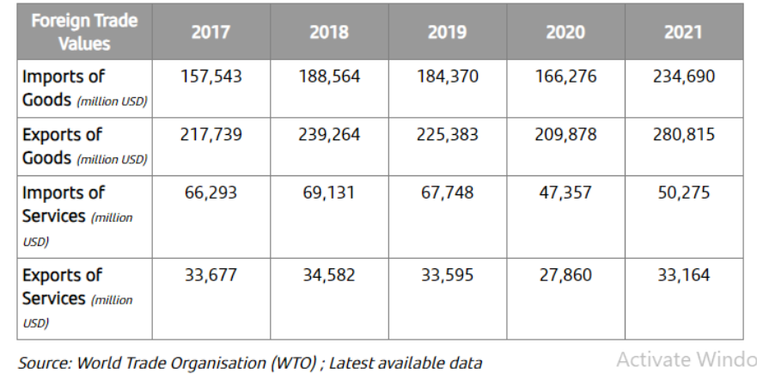

**Figure 4**

Brazil’s Exports and Imports of Goods and Services in billions of US dollars between 2017 and 2021 (Banco Santander, 2023)

Also, part of modernization is a move away from human labour-intensive activities to the use of equipment including machinery suited for farming to reduce the hours of farming and the stress on the human body. More than ever data is driving the farming operations because countries have made the decision to develop research programmes amongst others and have facilitated places such as statistical centers with the data for easy retrieval. Also, people who have developed expertise in farming have been sharing with fellow farmers. Exports in some countries have increased since farming practices have evolved, which has enhanced agricultural competitiveness in the global market. This in turn can facilitate economic growth. Also, with modernization, farmers can provide better quality of produce and safer food as demanded by consumers. Another exportation case since modernization is Spur Tree Spices Jamaica, an agro industry firm where about 90% of its company’s revenue is earned in the export market having exported to countries such as US, Canada, the United Kingdom (UK) and Cayman Islands. Spur Tree Spices include oxtail seasoning, pepper sauce, BBQ sauces amongst many others as seen in Figure 5. As at March 2023, their revenues increased to approximately $384 million, 62% above the previous quarter (Spur Tree seasons Q1 results, 2023). Hendricks (2023) further shared that Spur Tree Spices Jamaica signed a deal with Trinidad-based Massy Group, a conglomerate distributor, in 2022 which will distribute the seasonings and spices in Trinidad and Tobago, Barbados, Guyana and St. Lucia. Also, there are over 100 locations in north-eastern US where the seasonings and spices are sold alone. Consequently, they have employed at least 23 persons since 2022 to support increased production and capacity building (Hendricks, 2023).

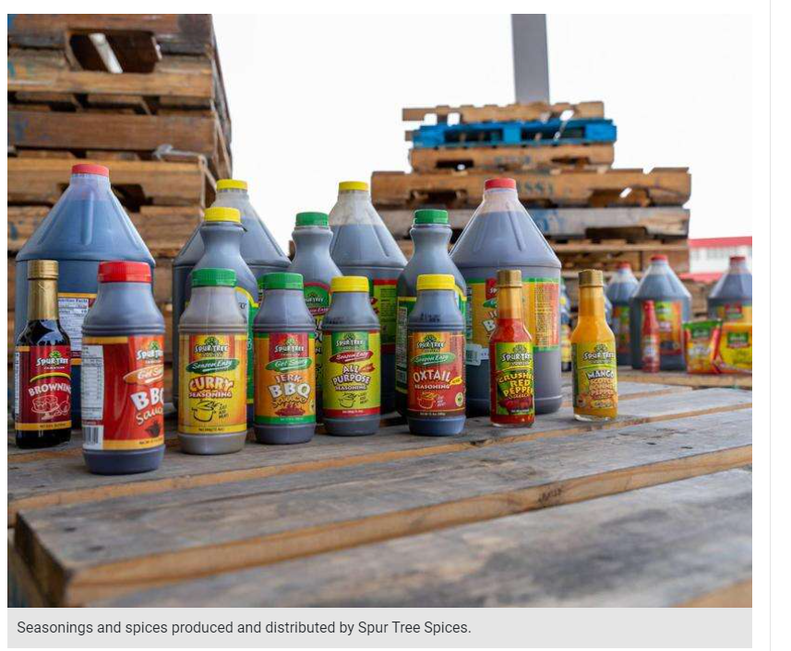

**Figure 5**

Seasonings and Spices Produced for Distribution by Spur Tree Spices (Hendricks, 2023)

## **Innovative Farming Practices**

Farmers seeking innovative farming practices came up with practices such as precision agriculture, agroforestry, and organic farming. Precision agriculture is known to involve the use of modern technologies such as Global Positioning Systems (GPS), sensors and drones. These tools were developed to help collect data on the health of crops, weather patterns and conditions of the soil to generate decisions to facilitate resource efficiency and optimal crop yields (Fountas et al, 2006). Brazil is one of the countries that rose to take the initiative of adopting modernized [innovative] agricultural strategies such as no-till farming, precision agriculture and GMOs (improved genetics in crops and livestock) (Food and Agriculture Organization, 2020). Precision agriculture provides real-time data so that resources can be properly targeted and organized to increase crop yields as environmental impacts are minimized as well as a reduction in waste to help ensure resource efficiency. Agroforestry is a developed practice to help mitigate deforestation and reduce poverty levels amongst farmers (Nair, 1993). This is done through the integration of trees with crops or livestock which facilitates soil fertilization and biodiversity. Consequently, trees have been protected against soil erosion while providing shade for crops that need minimal sunlight and contributed to sustainable yields (Nair, 1993). Organic farming has also been on the rise in recent years where natural fertilizers are developed from plant-based materials amongst other materials that do not contain synthetic chemicals that harm the crops. Thus, the ecosystem is healthier, and there is better water retention by the plants and soil biodiversity that facilitates sustainable yields (Bharucha et al, 2018). Bolfe et al (2020) conducted a survey with 504 Brazilian farmers about the use of digital technologies, their perceived benefits, and challenges from April 17 to June 2, 2020. The study showed that 423 (84%) farmers shared that they have used at least one digital technology in their agricultural production and believed that they have assisted with increasing productivity even though they were challenged with the costs of purchasing software, machines, equipment, and connectivity (Bolfe et al, 2020). However, about 478 (95%) farmers desire to learn more about the new technologies to help them develop their agricultural skills (Bolfe et al, 2020).

# **Bridging the Rural-Urban Divide through Access to Markets**

## **Barriers to Market Entry and Strategies to Overcome Them**

Rural Farmers have found it challenging to access new markets because they are often impeded and/ or are having difficulty growing their business. For instance, Kenya’s smallholder farmers have shared that they have difficulty accessing the market because they lack information, have poor value chain linkages and limited infrastructure (IFAD, 2021). It was found that 7 in 10 Kenyans lived in the rural areas prior to 2014 so they are reliant on farming as their main form of employment and possible income stream. IFAD (2021) also shared that about 50% of the 7 Kenyans living in the rural areas have been living in poverty. Moreover, around 2014, about 3.5 million of them needed food (IFAD, 2021). As such, these are some strategies that can help them: establishing rural market infrastructure, forming partnerships and alliances, and facilitating transport networks. To enhance access to markets, farmers and rural entrepreneurs need to have a platform setup for them to take their agricultural items to have better economic opportunities to display and sell their goods. According to the World Bank (2017), there is a need to reduce physical distance to markets to help rural communities to sell their goods and generate suitable income, as a result these communities can improve their livelihoods and diversify their income stream to have a better standard of living. Partnerships and alliances can be done through collaboration with various persons such as distributors, local partners and/ or companies. This collaboration is beneficial to help provide insight into the market to overcome barriers related to culture and operations while minimizing operations costs (Gulati & Singh, 1998). For example, a small-scale farmer can partner with a distributor who makes deliveries in proximity with his other partners such as supermarkets thus reducing his travel time and cost when he could otherwise be identifying other revenue streams. Partnerships are known to be the best guarantee to promote the credibility and trustworthiness of farmers (Gulati and Singh, 1998). As previously stated, forming transport networks with distributors can reduce the heavy transportation costs, especially to distribute to people distance away. The network also promotes an increase in customer base which can include urban marketplaces and export markets; thus, increasing farmers' revenue stream while they obtain market access (Arvis et al., 2015). Consequently, farmers can increase their production to reach different customers across multiple markets which will lead to agricultural growth. This in turn reduces the urban-rural divide, encouraging investors and improving their standard of living.

# **Assessing the Role of Technology in Transforming the Agricultural Sector**

## **Role of Modern Technology in Catalyzing Agricultural Productivity and Rural Development**

As governments across the world seek to transform their agricultural sectors, they have integrated advanced technologies in line with agricultural practices to address global issues such as food security and environmental sustainability. As previously mentioned above precision agriculture plays an important role in activating agricultural productivity and rural development, especially using remote sensing. Farmers are better able to obtain data images and sensors to know the amount of moisture in soil and nutrients as well as crop health. In monitoring crop health, outliers or any other problem can be detected early enough and addressed to minimize crop losses in a timely manner. This method is also cost effective in assisting with the reduction of production costs to guarantee profitability. In learning about precision agriculture farmers' expertise can be built to help them contribute to food security to reduce importation of food (Fountas et al, 2006). Consequently, there is a need for capacity building and education which provides farmers opportunities to acquire suitable skills and knowledge of modern farming practices and innovative tools through training, availability of education and vocational institutions that now facilitate improvement of their livelihoods. Abiodun Emmanuel et al (2020) shared that with the use of mechanization and automation, farmers no longer need to be dependent on manual labour which affects their health and time management skills. Abiodun Emmanuel et al (2020) further shared that planting of seeds and young plants into soil can be done by a planter machine which is usually operated by a farmer (see Figure 6). He shared that each machine has its limitations so, particularly, crops have been planted by them as ongoing assessments are being done to improve each limitation (Abiodun Emmanuel et al, 2020). So, farmers can optimize their time and resources to increase operational efficiency while upscaling their production. This in turn facilitates empowerment of rural communities.

**Figure 6**

Planters (a) Single-see corn planter, (b) Minimum-tillage planter, (c) Billet planter (Abiodun Emmanuel et al, 2020)

For instance, in Jamaica following the redevelopment of the radio network to facilitate communication among fishers and marine users along with the development of a national training programme, the fishers have developed expertise in areas such as seamanship, safety at sea, safe diving practices and first aid (Spence, 2023). Minister Charles Jr. shared that since the Ministry of Agriculture and Fisheries in Jamaica have been focusing on technological solutions along with capacity building and education, a 9.9% increase in domestic crop production was experienced 2022’s yield of 846,508 tonnes in comparison to 2021 yield of 770,456 tonnes (Spence, 2023). Muto et al (2009) shared that the availability of market information apps has now bridged the gap that once existed between farmers and traders, which has caused a reduction in asymmetry information in agricultural markets. Also, in catalyzing agricultural productivity and rural development, e-commerce platforms and digital markets (market information apps) have now afforded farmers the opportunity to connect with buyers and wider markets to drive the negotiation process of prices for their produce as they entertain income opportunities while reducing the risk of being exploited.

Vietnam has embraced digital agriculture and precision farming practices which include the use of sensors, drones, and satellites to optimize resource use in the Mekong Delta region under a project initiative with the World Bank (World Bank, 2019). The project started in 2016 costing US$387 million some of which was provided by the World Bank but has a committed amount of US$ 310 million (World Bank, 2019). Since Vietnam adopted digital technologies and precision agricultural practices, they have experienced a great increase in crop yields such as rice production and now have a much better water management plan, as well as improved nutrient management (World Bank, 2019). This has been contributing greatly to agricultural productivity and sustainability.

# **Striking a Balance between Production and Preservation – A Sustainable Resource Management Strategy**

## **Sustainable Management Practices**

Farmers have now found long-term viability measures for their rural communities which involve sustainable resource management practices such as water conservation, soil health improvement and biodiversity conservation. Water is a very essential resource for agriculture and the survival of rural communities and thus how it is used becomes very important. As such farmers have taken the decision to harvest water by setting up suitable catchment areas where drums, ponds and/ or dams collect the rainfall. Drip irrigation is also used which uses minimal amounts of water in a dripping mechanism to minimize water wastage. These water conservation strategies become even more important during periods of drought as presently being faced through to the intensity of sunlight because of climate change to make water available for efficient use. Besides water conservation, the health of soil and improvement thereof becomes crucial; so, to facilitate sustainable agriculture practices such as crop rotation, organic farming and cover cropping must be considered. As a sustainable management practice Denmark has embarked on organic farming practices and is leading globally in promoting organic food consumption (Duagbjerg and Schvartzman, 2022). The farmers in Denmark have reduced the use of chemical inputs, found ways to protect the environment and adopt sustainable livestock management initiatives. They have also developed a formation of governance to focus on policies that will last (Duagbjerg and Schvartzman, 2022). According to Rodale Institute (2023), crop rotation is important to minimize pests and soil diseases because when plants are planted in different locations, they require different nutrients from the previous ones which interrupts pest and disease cycles. Therefore, the health of the soil increases as well as biodiversity. Also, the likelihood of soil erosion is reduced while promoting soil fertility and hence long-term agricultural productivity. As previously shared, biodiversity is important especially for conservation. Biodiversity conservation is done through agroforestry, habitat restoration, promoting natural pest control and nutrient cycling (Gurr et al, 2016).

# **Ways to Strengthen the Services of Agricultural Extension**

## **Definition of Agricultural Extension Services**

Agricultural extension services as all the persons and entities that facilitate agricultural activities by aiding farmers whether through investments, information, and capacity building and education to solve arising problems. These services are usually provided by the public sector inclusive of government organizations such as Rural Agricultural Development Authority (RADA) and Jamaica Information Service (JIS) in Jamaica, private non-profit sector including Non-government Organizations (NGOs) and private profit sector.

## **Role of Agricultural Extension Services**

Agricultural extension services seek to promote farming practices while supporting activities to develop rural farmers and provision of market information. These services exist to create an arena of knowledge with people such as researchers and farmers, while ensuring information is disseminated through appropriate and observing best practices. These services provide space such as forums, television advertisements and programmes that promote farming techniques sharing innovations [through research-based knowledge] to farmers, especially new ones. For instance, in Jamaica JIS in collaboration with RADA provides a TV show on Sundays that give information on agricultural activities through the lens of farmers [new and seasoned], experts and researchers as they share their knowledge showcasing innovative tools and strategies adjusting agricultural areas that need to be developed. Also, RADA and the Ministry of Agriculture and Fisheries in Jamaica facilitate training sessions including crop selection, provision of seedlings, ways to manage pests, agronomic practices, and water-efficient technologies. These services endorse rural development initiatives such as the safeguarding of natural resources and encourage persons to become environmental stewards; also promote health and nutrition education, encouraging us to “grow what we eat and eat what we grow” [a Jamaican farming mantra]. Farmers are also empowered and encouraged to form farming communities to share farmer-farmer information to enhance the farming industry and thus promote sustainable development. In Brazil, a research corporation named Brazilian Agricultural Research Corporation (Embrapa) under the arm of the Brazilian Ministry of Agriculture and Livestock (MAPA) was established in 1973. Embrapa 50 (2023) shared that the corporation exists to conduct research to find innovative strategies and advanced technologies to help Brazil to drive agricultural productivity needed for food security as well as to obtain a leading position in the international market for food, fiber, and energy. In 2017, Brazil has exported eighty times more soybeans than they did in the last 40 years prior; and soybeans were known to make up about 11% of Brazil’s total exports (Arias et al, 2017). Brazil in driving export of soybeans have been researching heavily to improve and advance their production model. Research has been done using simulations to assess changes in land use in a municipality in order to drive the expansion of soybean production (Arias et al, 2017). Also based on research Brazil has been using no tillage farming as an innovative strategy to increase production (Arias et al, 2017).

# **Farmer’s Access to Finance and Credit**

## **Farmer’s Need of Funding and Strategies to Improve Access to Financial Services for Smallholder Farmers**

Farming not only takes time and effort but finances, especially when a farmer is beginning to farm for the very first time. Therefore, it is crucial for farmers to access funds needed to invest in modern technologies and inputs. Over the years, the agricultural extension services in conjunction with the farmers have identified possible strategies such as microfinance initiatives, crop insurance and cooperative farming models to improve finances of small scale [smallholder] farmers and provide financial inclusion for them. The Small Business Association of Jamaica (SBAJ) was formed to assist small business owners including farmers with accessing funds such as loans and assist them identify the one(s) best fitting them with the best interest rates affordable to them. Throughout the years, SBAJ has negotiated with both government and non-governmental enterprises to facilitate microfinancing and as such microfinancing institutions (MFIs) came on the Jamaican market. These MFIs exist to not only provide loans but opportunities for small businesses to have savings plans and other financial services suited for small scale farmers. Collinder (2022) shared that the Development Bank of Jamaica Limited reviewed the agricultural sector and noticed that farmers and entrepreneurs lacked the collateral needed to secure loans from lenders; however, they decided to invest in the agricultural sector because the sector “provides food and security and is a large employer of labour and provider of livelihoods” which can reduce costs related to food import, increase processing, access to markets amongst other things. Therefore, for the last 10 years, the Development Bank of Jamaica Limited have financed 14,358 loans valued over $9.7 billion to entrepreneurs and businesses in the Jamaica agricultural sector and they also provided 32 loans valued at $1.2 billion to the agro-processing sector to help provide access to markets for the agriculture supply chain (Collinder, 2022). Consequently, farmers have been able to purchase seeds, fertilizers, equipment amongst other things needed to facilitate agricultural productivity. Nowadays, farmers can insurance their business [farm] from the impact of crop losses due to pests, diseases, and adverse weather conditions. Thus, farmers benefit from climate-related risks such as hurricanes and even fire hazards against their control, receiving insurance payouts once they are insured. Farmers also have opportunities to benefit from government subsidies and public-private partnerships in order to access more affordable insurance products. Another strategy farmers can use to access funds is through a model called cooperative farming models where small-scale farmers can pool their resources together to borrow from financial institutions. Thes models also allow them to cooperate on platforms that develop their capabilities as they help each other, as well as affording them opportunities to increase their bargaining power once they form a collective market to set their produce at fair prices.

In 2019, IFAD supported Kenya’s smallholders through their 10-year initiative named Agriculture Sector Transformation and Growth Strategy (IFAD, 2021). The smallholder farmers were provided with loans and technical support along with value chain linkages in the dairy and cereal industry which included small traders and food processors (IFAD, 2021). Kenya was also provided with improved access to rural financial services to help smallholder farmers access loans at low interest rates or any other financial opportunities (IFAD, 2021).

# **Policy Interventions Needed to Establish Sustainable Rural Development**

## **Supportive Policy Frameworks and their Importance**

Policy frameworks have been developed over the years to address unique issues arising from rural communities while providing necessary resources and incentives to facilitate sustainable practices. Government policies have been put in place to prioritize and invest in rural infrastructure, provide subsidies for sustainable practices and equitable land tenure. Rural infrastructures are very crucial in the agricultural sector particularly in improving agricultural productivity to ensure food security. Therefore, as stated by Llanto (2012), there is a need to ensure that the good quality and availability of rural infrastructure are crucial to achieve economic growth and agricultural productivity as such investments are needed to facilitate this. Investments are needed to ensure roads are built, irrigation systems and market facilities are present in order to guarantee farmers being able to properly operate their farms through means of access and connectivity where they can be able to purchase things needed for the farm and can travel with ease to get them to the farm and once produce and products are available by them, they can be able to access markets easily to sell their goods. It is important to have proper infrastructure in rural areas in order to reduce costs such as transportation to and from the farm, easier to access inputs needed to raise agricultural productivity but be able to access markets for sale as well. Consequently, economic activities in those regions will be stimulated and even promote other job opportunities to minimize rural-urban migration.

There are also policies on government subsidies and incentives for sustainable practices. Governments have been promoting “green thumb” initiatives to promote environmentally friendly practices which includes farming techniques that can reduce environmental degradation along with conservation of natural resources. Consequently, farmers are given subsidies once they are engaged in agroforestry, organic farming and employing water conservation methods. These subsidies and incentives act as financial support for covering portions of farmers' costs based on discussions between them and the government. Another policy initiative undertaken by the government is helping farmers to secure land tenure rights especially when they seek investments to improve the land and agricultural practices. This affords farmers to become empowered while reducing conflicts over land ownership; to promote long-term planning and investment for rural communities.

Brazil has taken the initiative to implement forest conservation and land use regulation as a sustainable development goal. The country’s ministry of agriculture has implemented policies to combat deforestation in the Amazon rainforest by promoting sustainable land use, conserving the natural resources and reforestation. Rocha (2023) reported that between January and May of this year, deforestation fell by 31% compared to 2022. Rocha (2023) explained that the Amazon rainforest was under watch where an alert system was set up to measure the level of forest coverage between January and May 2022. Initially, it was found that the level of deforested area from January to May 2022 was 2,867 square kilometers which decreased to 1,986 square kilometers affecting 20 municipalities (Rocha, 2023). Brazil was also encouraged to preserve the forests by the World Bank and mentioned that preserving the Amazon rainforest will cost them about $317 billion annually (Rocha, 2023). The World Bank reported that if the situation of the rainforest is not addressed then “deforestation could bring the rainforest to a point where it would no longer be possible to reverse its harmful effects” (Rocha, 2023).

# **Overall Discussions**

This paper looked at issues related to rural development and agricultural productivity and how these issues relate to a country’s economic growth and sustainable development, identifying ways to address them. Upon review of the contents of this study, it became clearer to me that the agricultural sector is far more crucial to not just one’s livelihood but their very survival. In this section, I will explain what it is that I have learnt as well as highlighting how this paper is essential to myself and my community.

## **What is the relationship between agricultural productivity and rural development?**

Both agricultural productivity and rural development are very important to any country. Even though agricultural productivity is just a measure that reflects the growth or increase of outputs in the agricultural sector, it is still very important in helping a country to become aware of issues of hunger and poverty. Rural Development focuses on infrastructure development of rural areas driven by agricultural activities or any other activities requiring the need of a community; this also can be described based on indicators though not an indicator in and of itself. Usually, if there is minimal rural development, it is normally because of low agricultural productivity in a region (or regions). In other words, both agricultural productivity and rural development closely relate to each other because they influence each other's growth rate in some way or another.

## **How agricultural productivity can contribute to economic development?**

Economic development usually is related to indicators that signal when a country’s economic well-being has improved such as Gross Domestic Product (GDP), Poverty rate, Employment and Unemployment Rate, Infrastructure Development and Technological Advancement. The agricultural sector usually is one of the sectors of a country that is deemed very crucial to help ensure economic development takes place. Agricultural productivity is possible through the need for infrastructure development and technological advance that can minimize workload of farmers while providing greater crop yields. Also, the greater the production, the more hands needed to reap, package, deliver and sell the products as well as possibility of export; so, agriculture is often one of the main economic drivers for a country’s development. As of January 2023, Jamaica earned about US 14,926 million in GDP from Agriculture which contributes to the country's overall GDP US 17.25 billion, which is roughly 8.78% of the overall GDP (Statista, 2023; Trading Economics, 2023). Even though the GDP from Agriculture is less than 10% of the country's GDP, it still has been contributing to Jamaica’s economic growth, slowly but surely.

## **Why are policies and interventions necessary to enhance farming techniques?**

Policies are important in the development of practically anything, especially pertaining to a country. The purpose of the policies for farming techniques is to improve farming where they can find innovative solutions to address arising issues in the industry such as climate changes amongst other things, because things and times change. Take for example, the whole world is facing one of the most dramatic climate changes, heat which is more intense than usual and has been causing instances of drought. Recently, when I took a trip to Portland to access the rivers and beaches, I was in shock when I realized that two of the vacation (tour) sites Rio Grande and Sommerset Falls have been drying up rapidly. This experienced drought has affected the livelihood of persons living in those vicinities such as tour guides, fishermen, persons who cook and sell on rafts or along the Rio Grande amongst others. The problem is the government was not prepared to experience this situation and though trying to address it, policies need to be put in place. Consequently, government offices have been set up such as RADA to monitor, inspect, promote, and regulate the farming industries especially according to principles tied to UNESCO to achieve sustainable and economic development.

## **Contributions of Essay Paper to My Personal and Community Development**

This paper has contributed to my personal well-being in terms of being careful not to take farmers [and/ or vendors] for granted who have been the biggest player for my survival based on food security as well as contributing to economic development that in turn indirectly influences possible salary opportunities in Jamaica. I believe that farmers should be applauded more in Jamaica and given a much greater scope to help in mitigating hunger and poverty. This paper can help me inform my students as well as others to become more involved in the initiative “eat what you grow, grow what you eat” particularly at the teachers’ colleges where three of them including the one I work at have been participating in farming which has facilitated agricultural productivity even though on a minimal scale but having the right initiative. As such, I am encouraging other educational institutions to get on board in the farming industry, as well as re-adding farming across all schools, especially as a vocational subject. In the long run, food security can be better organized and improved.

# **Conclusion**

It was uncovered that agricultural productivity is crucial for the enhancement of the agricultural sector to mitigate hunger by ensuring food security. Agricultural productivity as well has an indispensable relationship with rural development, which greatly influences economic growth of the agricultural sector. Note though that even with this relationship, it is mainly the need to increase agricultural productivity that ensures rural development, although the more there is development in rural communities, further increase of agricultural productivity will take place.

The implementation of strategies to redefine and improve farming practices, while developing rural infrastructure by creating other jobs and educational opportunities, as well as improving farmers' access to markets have shown that sustainable growth can be achieved in rural communities. However, this becomes more guaranteed once agricultural extension services [government, non-governmental organizations, private sector entities and local communities] become available or involved in the agricultural sector. These services offer solutions, while promoting the sector and finding other ways to help develop the sector either through capacity building and skill development, or access to finances and/ or technological advancement. These services are seen to have positively impacted farmers so they can adopt improved practices in order to increase crop yields. It is noteworthy to mention that investments, foreign aid, and possible loans (grants) need to be considered to address issues such as conservation of natural resources and combating deforestation.

Nevertheless, sustainable agricultural practices need to be fostered to empower rural farmers whether it be providing incentives or capacity building and education opportunities. In turn, it was evident that the farmers’ livelihoods would be developed along with their rural communities while they ensure to preserve [and conserve on] natural resources. Overall, it was found that once the agricultural sector is ensuring continuous increase in agricultural productivity and rural development, then economic growth will take effect along with reduction of poverty and food security.

# **Bibliography**

Aredo, D. (n.d.). The Relevance of the Improvement Approach to Agricultural Growth in Ethiopia. The Ethiopian Economy: Structure, Problems and Policy Issues. Ethiopian Economics Association - EEA.

Arias, D. et al. (2017 September 24). Agricultural Productivity Growth in Brazil Recent trends and Future Prospects. World Bank Group: Agriculture.

Arvis, J. F., Duval, Y., Raj, A Shepherd, B., & Utoktham, C. (2015, March 9). Trade Costs in the Developing World: 1995-2012. World Bank Policy Research Working Paper No. 8009.

Australian Government Department of Agriculture, Fisheries and Forestry (2023, June 27). *Agricultural productivity*. https://www.agriculture.gov.au/abares/research-topics/productivity

Abiodun Emmanuel, A., Azimi Muhamud, M. S., Zainal Abidin, M. S., & Sahib Hasan, H. (2020, April 1). Robotics and Automation in Agriculture: Present and Future Applications. School of Electrical Engineering, Faculty of Engineering, Universiti Teknologi Malaysia, 81310 UTM Skudai, Johor, Malaysis.

Banco Santander. (2023). Brazilian foreign trade in figures. Santander | Trade Markets.

Bharucha, Z. P., Bento, T. G., Dicks, L. V., Flora, C. B., Godfray, H. C. J., Goulson, D., Hartley, S., Lampkin, N., Morris, C., Pierzynski, G., Prasad, Pretty, J., P.V. V., Reganold, J. P., Rockstrom, J., Smith, P., Thorne, P., & Wrateen, S. (2018). Global Assessment of Agricultural System Redesign for Sustainable Intensification. Nature Sustainability, 1, 441-446. doi: 10.1038/s41893-018-0114-0.

Bolfe, E. L. et al. (2020, December 21). Precision and Digital Agriculture: Adoption of Technologies and perception of Brazilian Farmers. Agriculture. MDPI.

Bulter, R. A. & Laurance, W. F. (2008). New Strategies for Conserving Tropical Forests. Trends in Ecology and Evolution, 23, 469 - 472.

Collinder, A. U. (2022, February 16). Opportunities for food sector growth: DBJ unlocks financing for agriculture. Retrieved from https://www.jamaicaobserver.com/business/opportunities-for-food-sector-growth-dbj-unlocks-financing-for-agriculture/.

Daugbjerg, C. & Schvartzman, Y. (2022 September). Chapter 2: Organic Food and Farming Policy in Denmark: Promoting a Transition to Green Growth. Successful Public Policy in the Nordic Countries: Cases, Lessons, Challenges.

Dolan, C. S. and Humphrey, J. (2000, February). Governance and Trade in Fresh Vegetables: The Impact of UK Supermarkets on the African Horticulture Industry. Journal of Development Studies, 37(2): 147 - 176.

Embrapa 50. (2023). Brazilian Agricultural Research Corporation (Embrapa).

Foley, J. A. (2011). Can we feed the world & sustain the planet? Scientific American, 305(5), 60-65.

Food and Agricultural Organization of the United Nations (2020). The State of the Food and Agriculture 2020: Overcoming Water Challenges in Agriculture. Rome.

Food and Agricultural Organization of the United Nations (2018). The State of the World's Biodiversity for Food and Agriculture, J. Belanger & D. Pillings (eds). FAO Commission on Genetic Resources for Food and Agriculte Assessments. Rome. 572 pp. Retrieved from http://www.fao.org/3/CA3129EN/CA3129EN.pdf.

Fountas, S., Wulfsohn, D., Blackmore, S., Jacobsen, H. L., & Pedersen, S. M. (2006). A review of the role of information and communication technologies (ICTs) in agriculture precision. Journal of Agricultural Engineering Research, 76, 1-15.

Gomes, P. (1985). *Rural Development in the Caribbean*. Kingston, Jamaica: Heinemann

Gulati, R. & Singh, H. (1998) The Architecture of Cooperation: Managing Coordination Costs and Appropriation Concerns in Strategic Alliances. Administrative Science Quarterly, 43, 781-814. http://dx.doi.org/10.2307/2393616

Gurr, G. M. et al. (2016 February 22). Multi-country evidence that crop diversification promotes ecological intensification of agriculture. Retrieved from https://pubmed.ncbi.nlm.nih.gov/27249349/.

Hendricks, D. (2023 June 2). *Spur Tree sets sight on Europe and Africa*. Business. Jamaica Observer. Retrieved from https://www.jamaicaobserver.com/business/spur-tree-sets-sight-on-europe-africa/.

International Fund for Agricultural Development (IFAD). (2021). Kenya.

International Trade Administration. (2022 July 13). Agriculture. Jamaica - Country Commercial Guide. Retrieved from https://www.trade.gov/country-commercial-guides/jamaica-agriculture.

Lin, J. Y. (1992). Rural Reforms and Agricultural Growth in China. The American Economic Review, 82(1), 34-51. American Economic Association.

Llanto, G. M. (2012). The Impact of Infrastructure on Agriculture Productivity. PIDS Discussion Paper Series No. 2012 - 12. Philippines Institute for Development Studies (PIDS), Makati City.

Lobell, D. B., Schelenker, W., & Costa-Roberts, J. (2011). Climate trends and global crop production since 1980. Science, 333(6042), 616-620.

Muto, M., Yamano, T. (2009). The Impact of Mobile Phone Coverage Expansion on Market Particination: Panel Data Evidence from Uganda. World Development 37(12): 1887-1896.

Nair, P. K. R. (2011). An Introduction to Agroforestry. Kluwer Academic Publishers.

NTU International. (2023). Sector: Agriculture & Rural Development, Denmark. Retrieved from https://www.ntu.eu/what-we-do/sectors/agriculture-rural-development/#:~:text=Rural%20development%20allows%20for%20the,the%20growth%20of%20a%20nation.

Richards, P. (2015 September). What Drives Indirect Land Use Change? How Brazil’s

Agriculture Sector Influences Frontier Deforestation. Annals of the Association of

American Geographers. Vol. 105, No 5, pp. 1026-1040. Taylor & Francis Ltd.

Rocha, J. A. (2023 June 8). Deforestation in Brazil’s Amazon fell by 31% in January-May:

INPE.

Rodale Institute. (2023). Crop Rotations. Retrieved from

https://rodaleinstitute.org/why-organic/organic-farming-practices/crop-rotations/

Spence, C. (2023, February 11). *9.9 per cent increase in domestic crop production for 2022*.Jamaica Information Service – The Voice of Jamaica. https://jis.gov.jm/9-9-per-cent-increase-in-domestic-crop-production-for-2022/

*Spur tree seasons Q1 results*. (2023, May 26). Jamaica Observer. Retrieved from https://www.jamaicaobserver.com/business/spur-tree-seasons-q1-results/.

Statista. (2023). Jamaica: Gross domestic product (GDP) in current prices from 1988 to 2028 (in billion U.S. dollars. Retrieved from https://www.statista.com/statistics/527074/gross-domestic-product-gdp-in-jamaica/.

StudySmarter. (2023). Agricultural Productivity. Retrieved from https://www.studysmarter.co.uk/explanations/environmental-science/biological-resources/agriculture-productivity/.

Trade Economics. (2023). Jamaica GDP from Agriculture. Retrieved from https://tradingeconomics.com/jamaica/gdp-from-agriculture.

Osegbue, E.G. & Udemezue, J.C. (2018, April 25). Theories and Models of Agricultural Development. Deparment of Agricultural Economics and Extension, Chukwuemeka Odumegwu Ojukwu University, Nigeria. Ann Rev Resear, 1(5): 555574.

United Nations, Department of Economic and Social Affairs, Population (2019, June). World Population Prospects 2019: Highlights. United Nations. Retrieved from https://population.un.org/wpp/Publications/Files/wpp2019_10KeyFindings.pdf.

United States Department of Agriculture. (n.d.). Agricultural Resources and Environmental Indicators, Chapter 5.1, page 1. USDA ERS. Retrieved from https://www.ers.usda.gov/webdocs/publications/41964/30296_agproductivity.pdf?v=0.

World Bank. (2019). Mekong Delta Integrated Climate Resilience and Sustainable Livelihoods Project.

World Bank. (2017). Reaping Digital Dividends: Leveraging the Internet for Development in Europe and Central Asia*.* World Bank. Retrieved from https://www.worldbank.org/en/region/eca/publication/digital-dividends-in-eca.