Shaneille Sash-Nicole Samuels
UD81995EC91212
Doctor of Philosophy (PhD) in Financial Mathematics with Specialization in Economics

COURSE NAME:
(Human Capital: Education and Health in Economic Development (HCA 641))

Assignment Title:
(Explore Potential Long-Term Impact of Early Childhood Education on Human Capital and Economic Growth)

ATLANTIC INTERNATIONAL UNIVERSITY
August/2023

Table of Contents

1. Introduction 3
2. Importance of Early Childhood Education 4
2.1. Definition Brief History and Purpose of Early Childhood Education 4
2.2. Definition and Brief Theoretical Perspectives of Cognitive Development 4
2.3. Definition of Social Development 5
2.4. Definition of Emotional Development 5
2.5. Importance of Early Childhood Education in Promoting Cognitive, Social and Emotional Development 6
3. Human Capital Development and Economic Growth 9
4. Examine the Long-Term Impact of Early Childhood Interventions 10
4.1. A Case Study: The Perry Preschool Project 11
4.2. A Case Study: Child-Parent Centers CPC program 12
4.3. The Need for Parental Involvement 13
5. Early Childhood Development: Nutrition and Health 13
6. Impact of Early Childhood Education on Social Equity 14
7. Economics of Early Childhood Education Investment 15
8. Policy Implications for Early Childhood Education 15
9. Early Childhood Education Models 16
10. Overall Discussions 18
10.1. Why is it important to consider ECE teachers well-being? 18
10.2. What are the disadvantages of not investing in early childhood education? 18
10.3. Contributions of Essay Paper to My Personal and Community Development 18
11. Conclusion 19
Bibliography 20

List of Figures
Figure 1 16
Figure 2 17
Figure 3 18

Introduction

Early childhood education (ECE) is usually the first exposure of children to the formal education system. Thus, ECE is a critical phase in any child’s [cognitive, social, and emotional] development, to create the foundation for lifelong learning and influences the readiness of human capital to provide a workforce to drive economic growth and productivity. This paper seeks to explore and emphasize the importance of ECE in promoting young children’s cognitive and emotional development in hopes to lead the way for future educational success. The paper will provide discussions of the role of ECE in nurturing a skilled and healthy workforce to promote economic development.
To make ECE important and relevant there is a need to consider possible ECE interventions that can yield long-term benefits. The paper explores evidence from studies that share the long-term impact of ECE based on the interventions on potential income streams, educational attainment, and socio-economic outcomes. The paper will also give accounts of findings and implications for policymaking from case studies. In the process of making ECE programmes beneficial to promote human capital development, the study seeks to give an account of the impact of nutrition and healthcare interventions on ECE programmes in fostering cognitive and physical development.
The essay also discusses the role of ECE in promoting social equity and addressing poverty issues. It will explore the economic aspects of investing in ECE to assess the cost-effectiveness of early childhood interventions and potential returns. The paper will also examine the policy implications by discussion recommendations to governments which include parental engagement, funding initiative, and teacher training to ensure that high-quality ECE programmes can exist. The paper will also explore early childhood education models highlighting successful approaches and identify possible takeaway lessons ministries of education across the world can make as they develop the ECE programmes.

Importance of Early Childhood Education

Definition, Brief History and Purpose of Early Childhood Education
According to Dr. Hawani Negussie [she], assistant professor of early childhood education at University of Massachusetts (UMass) Global, early childhood education (ECE) can be defined as the facilitation of education programmes suited for young children through their preschool years [usually between 0 and 5 years] in order provide a guide for these children’s growth and development (UMass Global, n.d). Monroe College (2023) shared that early childhood education has been around from about the 1500s founded by Martin Luther, Jean Rousseau and Friedrich Froebel. Martin Luther [he] believed that children should be able to read on their own to know the holy scriptures in the Bible (Monroe College, 2023). Jean Rousseau [he] believed that children should be provided with unlimited experiences to drive their sensual awareness and provide practical experiences; in other words, it should be child-centered but should focus on measuring, singing, drawing, and speaking which should be incorporated into school curriculum (Monroe College, 2023). Friedrich Froebel [he], found kindergarten to provide formal education for young children, encouraging schools to teach children through play as well as using more conventional methods to provide young children with positive experiences for learning (Monroe College, 2023). Dr. Negussie shared that the purpose of ECE is to “provide children with strategies that help them develop emotional, social and cognitive skills needed for them to become lifelong learners”. She further stated that during children preschool years it is important for them to master language and literacy [recognizing and communicating gestures, sounds and words], thinking [use and develop an understanding of math concepts to promote skills such as counting and sorting, and problem-solving], self-control [express and manage their emotions in appropriate ways as they learn to cope with frustration and resolve conflicts], and self-confidence [fee competent and believe in themselves and be willing to take on new challenges] (Monroe College, 2023).

Definition and Brief Theoretical Perspectives of Cognitive Development
Help me Grow (2023) defines cognitive development as children’s ability to think, explore and figure things out. Thus, they can build their knowledge based and competencies such as problem-solving while developing their dispositions to understand and know about the world and themselves. Theorists such as Lev Vygotsky and Jean Piaget have done work on Cognitive Development. Jean Piaget developed a learning theory which focuses on stages of development and names them sensorimotor, preoperational, concrete, and formal operations. The preoperational stage was found to be most suitable for early childhood for children ages 2 to 7 years. Professor Susan Tyler [she], Clinical Assistant Professor at University of Arkansas in Fayetteville, shared that in the preoperational stage children often pretend play [usually with a toy such as a doll treating it like a baby that needs taking care of]; believes that everyone thinks, feels and see things the way they do [egocentrism]; challenged with comparing size [conservation errors] such as two slices of cake of the same size but one is cut in two halves – the child usually counts the pieces to indicate that the one cut in halves is more than the other slice (also seen similarly when comparing liquids in containers); and finally them seeing inanimate objects as living things [animism] (Tyler, 2008). She also shared that Lev Vygotsky believed that children develop their cognitive processes by social interactions with the people around them who are considered to provide potential learning opportunities. She stated that Vygotsky referred to children having private speech where they often talk to themselves to better understand and problem; as well as children performing tasks with someone to guide or support temporarily for them to accomplish the tasks successfully [zone of proximal development and scaffolding] (Tyler, 2008).

Definition of Social Development
Social development is defined as children developing the ability to interact [communicate] with the people around them, understanding who they are within their community. Potomac Health Foundation (2023) shared that for children to have healthy social development then their language skills need to be developed [opportunities to practice and learn speech and language skills]; build their self-esteem; strengthening their learning skills [having healthy relationships with their peers], resolve conflicts [learn how to work through differences with their peers]; and establish positive attitudes.

Definition of Emotional Development
Trentacosta et al (2020) defines emotional development as the “emergence of the experience, expression, understanding, and regulation of emotions from birth and the growth and change in these capacities throughout childhood, adolescence, and adulthood”. Children at the preschool level can recognize emotions that are happy from those that are negative [such as sadness, anger, and fear] as well as beginning to recognize emotions in facial expressions prior to entering middle childhood (Trentacosta et al, 2023).

Constituents of High-Quality Early Childhood Education
High-quality early childhood education (ECE) encompasses various components needed to create a nurturing and enriching environment conducive for young children’s development. At this early developmental stage, social learning must be emphasized: young children as they play make sense of their environment in meaningful ways. In order to optimize learning at this delicate stage of children’s development some key elements must be targets. These elements are having qualified and responsive teachers, developmentally appropriate curriculum, small class sizes and low teacher-student [teacher-child] ratios, family engagement and involvement, and safe and nurturing environments [supportive physical and emotional atmosphere]. Studies have shown that children who received education from well-qualified and responsive teachers tend to develop characteristics that show significant cognitive and social gains over the long term (Meunier & Sparling, 2019). Developmentally appropriate curriculum usually provides students with learning experiences that promote social skills, creativity and problem-solving. Small class sizes and low teacher-student ratios are important particularly for young children to provide them with individualized attention, foster strong teacher-student relationships, and support their holistic development. Parental involvement in partnership with their children’s teachers supports strong cognitive, social, and emotional development of their children (Ee Lynn, 2022).

Importance of Early Childhood Education in Promoting Cognitive, Social and Emotional Development
Early Childhood Education (ECE) plays a vital role in promoting cognitive, social, and emotional development in young children particularly because early childhood is the period when the brain develops rapidly and children’s ability to begin critical learning. Dr. Negussie shared that based on research, there is a need for children to be engaged in high-quality education programmes before they turn 5 years old (UMass Global, n.d.). She elaborated that there is medium- and long-term benefits and further stated that children who participate in these programmes are: “less likely to repeat a grade and be identified as having special needs, more prepared academically for later grades” (UMass Global, n.d.). She explained that a high-quality early childhood education programme usually has a curriculum that constitutes of toys, art, songs, games, experiences, and possible nature exploration activities used to design daily lesson plans for young children (UMass Global, n.d.). At the ECE level, children are usually exposed to language, games, conversations, books, poems, songs related to mathematics and literature.
In an informal interview with my colleague [she] from Shortwood Teachers’ College, it was shared that the benefits of the course “Teaching Young Children Mathematics Through Play” is to equip teachers to help early childhood learn about mathematics through playing games and develop children's cognitive, social, and emotional skills. She explained that young children’s instinct is to play which usually begins without rules until they are developmentally ready to learn rules to play games. In learning mathematics through play and the dimensions [different types of games and different types of rules] of play based on their age or stage of development, one of the first skills they learn is listening to instructions to the games provided by the teachers, so they can participate in the games giving others opportunity to participate. They are also learning to win and lose gracefully; they can learn about team-building activities [working with a partner]; learning how to finish well by ensuring the task given is completed even if they are the last one to finish; learning to follow rules and the possibility of being removed from the game but given opportunities in other games; understanding about reward systems; create their own rules for a game and might want to adjust the rule mid-way in the game [they should not change it for selfish reasons such as wanting to win. In essence, the children are learning to communicate with each other, problem-solve and comprehend situations and not try to cheat; develop self-control, empathy [such as caring, forgiveness and kindness] towards others and themselves, working well with others, growing from their mistakes, and resolving conflicts.
An early childhood educator for 3 years at PCF Sparkletots (Marsiling) in Singapore, Jia Xin shares her firsthand experience in teaching young in a YouTube video titled “What do Early Childhood Educators do in Singapore? | Things You Wanted to Ask” (Mothership, 2021). She said that even though the work was tiring she is happy that she can see the children grow, mature, and behave with the values they were taught. She gave an account of one of her students [he] having bad anger management issues who she taught for two years began to show kindness to his classmates as he developed friendship with them; he also was able to comfort and console one of them who was crying sometime after which amazed her. In the short time, the child was able to learn how to control and express his feelings without throwing a tantrum or being rude and was very empathetic to his peers; he has been developing his social and emotional skills which are important for future situations such as decision-making and understanding people. She also shared that the curriculum is based on the Nurturing Early Learners (NEL) Framework which has six main learning domains: Learning and Literacy, Numeracy, Discovery of the World, Motor Skill Development, Aesthetics and Creative Expression and Social and Emotional Development, which are taught in an integrative way. She expressed these domains allow students to be engaged in a holistic approach to develop skills for adulthood. Similarly, WisconcinDPI (2018) shared a YouTube video titled “Early Childhood” which explains that a school in the Racine (Wisconcin) Unified School District uses a pyramid model to engage children in learning activities related to the real world including the use of blocks and solution cards. The purpose of the solution cards is to help the children address a problem that happened in the classroom like someone knocking over their blocks to identify strategically how to identify the best possible solution to resolve the problem (WisconcinDPI, 2018).
Jamaica early childhood education has been under discussion for years especially in recent times. The main reason for these recent discussions is the appeal to the government to reform and address issues with children at the primary and high school level. Dr. Adrian Stokes, an economist in Jamaica shared that it is best for Jamaica to start with early childhood education in order help the nation’s children to properly develop their academic skills needed to transition to the primary and further high school levels. He pointed out that the education sector is in crisis because one third of the children at the end of their primary school life could not read, while 56% were not able to write, and 57% could not identify information in a simple sentence; and there are only 28% of the children who are graduating from high school pass five subjects including Mathematics and English within one sitting of the Caribbean Secondary Examination Council (CSEC) (The Gleaner, 2022). He inferred that many of the deficiencies seen at the primary and high school levels began at early childhood level (The Gleaner, 2022). Thus, if the children were exposed to high quality ECE from an early age, they would not have to struggle with these deficiencies.
Early childhood education has been known to foster cognitive development because it allows young children to explore and figure out things and develop critical thinking skills. However, to accomplish this the programmes must be well-structured as Dr. Negussie shared which should engage young children in age-appropriate activities to help them their cognitive skills such as language development [being able to comprehend and communicate through speech], problem solve and learn early mathematics concepts related to counting and sorting. Meloy (2019) [she] shared from a study that children from affluent families and low-income families usually have different learning resources whether at school or at home tend to have gaps in their cognitive development as years go by unless exposed to high-quality education. She inferred that if rigorous research and investments are done to equalize what children learn in preschool can help students to be successful and even positively impact low-income children (Meloy, 2019). She further stated that 21 public preschool programme evaluations were done by LPI researchers which revealed that children who had preschool experience had greater learning gains and are more prepared for regular school than the children who did not attend. It was also found that children who participated in the Tennessee Voluntary Pre-K programme and Head Start when starting preschool, were at an advantage than the children who did not (Meloy, 2019).
Early childhood education is also essential to children’s social and emotional development. This affords children the opportunity to learn about social interaction with their peers which will help them develop crucial social skills [such as communication, cooperation skills and being empathic] so they are able resolve conflicts and develop a sense of belonging in their communities. The U.S. Department of Health and Human Services (2006) shared that the children who received higher quality childcare at 4 ½ were somewhat more compliant and cooperative and slightly less aggressive and disobedient than those at ages 2 and 3. These children also had positive interactions with their peers and adults. The study also revealed that the children who received lower quality care were found to be insecurely attached to their mothers which can be attributed to the mothers being less sensitive in interacting with the children. Ansari et al (2019) in a study focusing on the benefits of attending early childhood education at age 3 which shared children who attended at age 3 [in the following year] demonstrated “less optimal social behaviour than their peers with no earlier educational experience.
It is noticeable that the impact of early childhood education on cognitive, social, and emotional development is crucial to influence future educational success. Therefore, it is important that children experience the positive impact of early childhood education [high quality] to equip them to be able to think critically and problem and socialize well with others and have self-confidence to achieve success. NIH (2018) shared that “students who participated in an intensive childhood education program from preschool to third grade were more likely to achieve an academic degree beyond high school, compared to similar groups that received other intervention services as children”.

Human Capital Development and Economic Growth

Human capital comprises the skills, knowledge and the health of people are considered as valuable resources to drive economic growth and productivity in a country. There has been a long-standing relationship between economic development and human capital, particularly since economic development is not possible without human capital. Consequently, schooling is important to develop the skills and knowledge needed to create a workforce. It is against this backdrop that early childhood education (ECE) becomes crucial to properly nurture human capital so individuals can have a strong foundation from learning, socialization and develop healthy lifestyles to help his or country achieve economic development.
As such, children need to obtain quality early childhood education to enhance their skills and knowledge in a formal school setting. Dr. Ng Ee Lynn [she], a senior education research scientist with the Centre for Research in Child Development in Singapore shared that the “emotional, social and physical development of young children provides the building blocks for educational achievement, responsible citizenship and lifelong health” (Ee Lynn, 2022). She emphasized that people need to move away from the misconception of early childhood education only being related to facilitating children developing basic academic skills such as reading and writing to understand that it is not just preparing them for primary school but for the real world (Ee Lynn, 2022). Teng (2022) has also shared that Singapore has been developing the quality of ECE programmes as well as the educators in the ECE profession and has made this a priority for the nation. Singapore has invested a great deal in education because they believe that it will provide a strong foundation to equip their nation’s workforce to become highly productive and facilitate competition. Ee Lynn (2022) further shared that their ECE programmes have become high quality which focuses on four important areas of early childhood development: “cognitive, social and emotional, communication [speech and language], and fine and gross motor skills”. Therefore, the children can transition from preschool to primary school being able to control their emotions and express their feelings effectively to others while considering other people’s feelings as well; this will help them to develop social relationships so they can connect with others. She further shared that early childhood educators’ well-being is very important to ensure that the young children receive a high-quality early childhood education to accompany the professional development sessions that provide them with training opportunities. She expressed that the educators’ true well-being in terms of the stress and/or emotional exhaustion experienced needs to be focused on at the national level especially since how they feel and what they experience affects the quality of their lesson preparation and delivery.
High quality early childhood education provides young children with the opportunity to improve their cognitive abilities, develop soft skills [communication, teamwork, and problem-solving] which are crucial skill sets for a typical workforce. Consequently, the workforce will be equipped with strong skills where workers are able to cooperate and collaborate with each other to achieve tasks, be able to be creative, avoid being absent, communicate effectively and take care of themselves to facilitate productivity and economic development.

Examine the Long-Term Impact of Early Childhood Interventions

Governments, researchers, and educators across the world have been working to improve their education system [sector] because it is vital to providing human capital [workforce] to drive economic growth. Hence, high- quality early childhood education is needed to be accessible and equitable to all children regardless of socio-economic background. To help reshape ECE, interventions have been across countries such as providing professional development opportunities for educators and fostering parental involvement.
Countries such as Jamaica and Singapore have intervened by providing professional development opportunities for educators. The education ministry in Singapore have taken the initiative to “provide educators, teachers, and leaders with 180 hours of in-service training and professional development opportunities (eg. Online communities of practice) to complete at their own pace over three years” (Early Childhood Workforce Initiative, 2019). The ministry also provided an annual cash initiative to encourage the teachers’ participation in and completion of the development programmes. They have even provided three career tracks in the early childhood profession (educators): “Educarers (for children aged 2 months to 4 years), Teachers (for children aged 4-6 years), and Leaders, which currently has about 17,000 educators (Early Childhood Workforce Initiative, 2019). With Singapore prioritizing education, Scholastic Corporation international came on the rise based on the education policy changes and reformation of how children learn mathematics. I can share my first-hand experience since August 2017 with Singapore education model particularly for ECE and primary schools, having been a trainer through their subsidiary company Book Merchant Ltd in Jamaica and having worked alongside Kelly Lim Kai Ling, the leading Mathematics Expert from Singapore, a Scholastic Professional Development Specialist and lead PRIME Mathematics Trainer. Training sessions of early childhood and primary education are provided with training opportunities in short courses such as Problem-Solving, Mathematics Connections as well as others to equip teachers with the knowledge and skills to help children develop their competencies such as problem-solving, develop social interactions and collaboration with their peers. However, the Singapore government expressed that the growth of their workforce was slow and at least 56% of the new early childhood care and education (ECCE) graduates remained in the teaching profession one year after completing graduation (Early Childhood Workforce Initiative, 2019). The government found that the educators were leaving because of “low salaries, perceived low professional autonomy, esteem, or respect from the public, and a seeming lack of career advancement opportunities” (Early Childhood Workforce Initiative, 2019). As a result, the government proceeded to reform the sector to offer better pay packages to the educators including resources. However, Ee Lynn (2022) shared that she is very concerned about the well-being of the educators.
As for Jamaica, there have been similar interventions and policy changes. The teachers, especially in recent years have been provided with more educational opportunities to study at the teachers’ colleges and universities in early childhood education as well as provided with professional development programmes. The training sessions offered by Book Merchant Limited named the Amazing Math Powers (AMP) have been provided to early childhood and primary teachers every August, though in recent times [about two years] mainly primary teachers since the collaboration with Scholastic International. In 2017, there were 900 primary teachers from Jamaica, Belize and Barbados registered for the professional development sessions scheduled for August 21-24 (The Observer, 2017). This initiative was focused on improving students’ academic performance and by extension learning new ways to tackle mathematics concepts. The Observer (2017) shared that since 2000, at least “2000 primary school mathematics teachers, coaches, specialists in Jamaica and the Caribbean have been trained”. The drawback though with Jamaica just like Singapore is the teachers’ well-being as it relates to stress, and emotional exhaustion are not taken into consideration. As an educator myself I am very much aware of the large number of students in classes with just one teacher and the classroom space is usually compact.
However, this occasional opportunity per year is not enough though to address all the issues seen in the Jamaican early childhood education sector. Another drawback seen in Jamaica as Dr. Adrian Stokes pointed out only 93% (2,241) of the early childhood schools were registered but only 12% of them (282) were certified to provide high-quality education; however, the others were preparing the requirements needed to become certified (The Gleaner, 2022). The Gleaner (2022) expounded on Dr. Stokes' argument informs the public that 46% of the preliminary registered schools were able to meet at least 50% of the certification requirement. Also, 14% of the institutions had appropriately trained personnel and only 11% of them had sufficient materials for all their enrolled children (The Gleaner, 2022). Consequently, there is a need for Jamaica to address these issues to provide high-quality ECE programmes across the island for all young children to benefit.

A Case Study: The Perry Preschool Project
The Perry Preschool Project was done with 123 preschool children who were believed to be at risk to fail in school (HighScope Education Research Foundation, 2022). Two groups were formed from the 123 where one group was engaged in preschool education using an active learning approach and the other group had no preschool education and observed between the periods of 1962 and 1967 (HighScope Education Research Foundation, 2022). The study revealed that the children who were engaged in the high-quality early childhood education programme showed signs of improved language and academic skills as well as better cognitive abilities. This study therefore suggests that based on the outcome policymakers should develop high-quality ECE programmes by providing fundings to ensure that both low-income and high-income children have access to quality learning opportunities. This influenced the development of the Chicago CPC, a similar study but more robust which has also shown positive results. The study found that the participants in the preschool programme had much better social skills than those lacking preschool education, also exhibiting reduced behavioural issues and were less likely to participate in criminal activities in their adult life. The programme tracked the students up to age 40 and found that 36% of them were likely to be arrested at least 3 times by age 40 while those having no preschool education were 55% more likely to be arrested by age 40. Therefore, governments including policymakers are encouraged to invest in high-quality ECE programmes to minimize behavioural issues that could lead to criminal activities and hence foster safer and more stable communities. It was also found that there were economic benefits in the long run because the participants were more likely to complete higher education, secure better jobs and receive a higher salary when they reach adulthood thus minimizing reliance on welfare programmes. Seventy-seven percent (77%) of the participants in the programme were more likely to graduate high school while 60% of them who did not participate in the programme were more likely to graduate high school Again, policymakers need to increase investment in ECE so young children can benefit from resources including access to technology so they can become skilled and productive workers to promote economic development and minimize societal costs.

A Case Study: Child-Parent Centers CPC program
NIH (2018) shared a study that was done with 989 children who attended the Child-Parent Centers CPC program in inner-city Chicago as preschool students [from kindergarten age through third grade] and were engaged in intensive math and reading along with frequent educational field trips. NIH researchers compared graduates from 20 CPC schools with 550 children from low-income families who went to 5 other early randomly selected schools in intervention programmes [keeping track of them from birth through age 35 years] and found that the children in CPC group completed more years of education and were more likely to achieve a degree (NIH, 2018). It was reported that CPC graduates who attended the program through second or third grade had higher education gains than their peers: “associate degree or higher (18.5% vs 12.5%), including a bachelor's degree (14.3% vs 8.2%) and master’s degree (5.9% vs 2.3%)” (NIH, 2018). Dr. Arthur Reynolds and Mr. Barrett Whitener who did the study reported by NIH (2018) shared in a previous study that the graduates of the CPC were able to secure jobs with high incomes, had a lower rate of depression and lower rates of serious crime and incarceration in comparison with those who did not participate in the CPC program (Reynolds & Whitener, 2015). This study also provides similar implications for policymakers to consider just like the Perry Preschool Project but indicates for parental involvement to be considered to make it even more effective.

The Need for Parental Involvement
Another intervention governments have made to help enrich ECE is parental involvement. Countries such as Chicago and Singapore have placed emphasis on involving parents. NIH (2018) shared that they included parents in the CPC initiative in Chicago so that they could be equipped to help their children in the programme; as such, they provided employment and educational opportunities for the parents. This in turn facilitated children receiving food and better health care to improve their learning capabilities, as well as assist them with lessons at home. Ee Lynn (2022) shared that there is a homeschool partnership initiative in Singapore to create a connection between what the children learn at home and school to ensure they are synchronized. However, Ee Lynn (2022) expressed that the challenge is for the teachers to find a way to better engage the parents so they can effectively help their children’s learning.

Early Childhood Development: Nutrition and Health

Nutrition and Health are integral components of the Early Childhood education programme development. Life-long health benefits are known to be closely correlated with children's learning and development. This is so because when one is hungry, he or she lacks the energy and concentration needed to properly. I can attest to this because I struggled in both primary and high school due to lack of funds because my parents could not afford to send me to school, but I pushed, nevertheless. It affected my cognitive ability to properly think about what was happening in classes, so imagine the younger children. Presently in Jamaica there is a feeding initiative at the schools to promote healthy food. Minister of Health and Wellness Dr. Christopher Tufton along with the United Nations Children's Fund launched a programme where menu guides on healthy foods at school canteens will be provided (Morris, 2023). Research was done prior to the campaign which found that 23% of the nation’s children between ages 13 and 17 were obese due to unhealthy diets. Also, education ministries across the world have ensured that physical education is part of the ECE curriculum. Structured and free is recommended for ECE children because it contributes to physical growth and social skills as well. Physical education is known to develop children's gross motor skills, coordination, and fitness as inferred by Ee Lynn (2022). At the ECE level, children are usually engaged in hygiene habits such as teeth brushing, proper hand washing and toileting.

Impact of Early Childhood Education on Social Equity

For far too long there have been social inequalities in the education sector. For years, children must drop out of school because of poverty or disadvantaged backgrounds. Also, the education they benefit from is usually of poor quality. For example, in Jamaica there are traditional and non-traditional high schools, where children are placed based on their learning abilities or disabilities. Children who attend traditional high schools are usually the ones whose parents can afford to send them there and/ or high achievers. This has affected children, especially the ones I have taught in previous years at non-traditional schools, who felt the fact that they attended that school was simply because they are dunce so why attend school then. Consequently, there is a need to narrow the achievement gap by providing initiatives to promote social equity and break intergenerational poverty. As NIH (2018) shared, young children in inner-city communities are highly unlikely to attend these programmes because of their family’s socio-economic situation. Therefore, it is imperative that policies are developed to include them receiving high-quality, and financial assistance or job opportunities be provided to their parents or guardians. The more opportunities young children avoid the better it is for the economies of countries, particularly to become equipped to enter the job market to provide services suited for tax revenues, among other things to facilitate economic development. Also, ECE programmes need to also be provided to children who are orphanages and have disabilities to equip them to learn, grow and become responsible citizens who can access and stay in the job market. Consequently, schools need to build ramps and other things necessary to facilitate equity and inclusion so all young children can benefit from high-quality ECE programmes.

Economics of Early Childhood Education Investment

To facilitate a high-quality ECE programme, funds are needed to be able to facilitate its operation and up-keep directly and indirectly. Governments are encouraged across the world to invest in high-quality ECE, but it will cost quite a few million dollars. The Singapore government after prioritizing ECE decided to invest at least $13 million to provide professional development of early childhood educators so they can become better equipped to facilitate a high-quality ECE programme (Teng, 2022). It might seem expensive to invest in ECE now but the results of preparing these children to become productive and high-level skill capacities especially if they continue their study up to tertiary level will in the long run minimize the need for social welfare, experiencing an increased tax revenue and reduction in funding prison facilities.
Governments typically when investing in education are really concerned about the viability of a workforce, thus this investment in human capital will be extremely beneficial. So human capital investment involves “direct and opportunity costs [financial resources, time, and work experience]” needed to drive productivity of individuals who can receive benefits over time (Beblavy et al, 2018). Figure 1 shows the rate of returns from investing in preschool programmes exceed the rate of investing in other educational programmes such as high school and tertiary education. Heckman (2006) inferred that typically children’s skills and experiences are built overtime if afforded the right environment and opportunities. Hence, if they can start school earlier then they will be able to learn more to acquire the knowledge and skills suited to facilitate human capital. Figure 1 also indicates that the rate of return falls as children get older, especially since investment in programmes as children get older are usually more expensive (Beblavy, 2018).
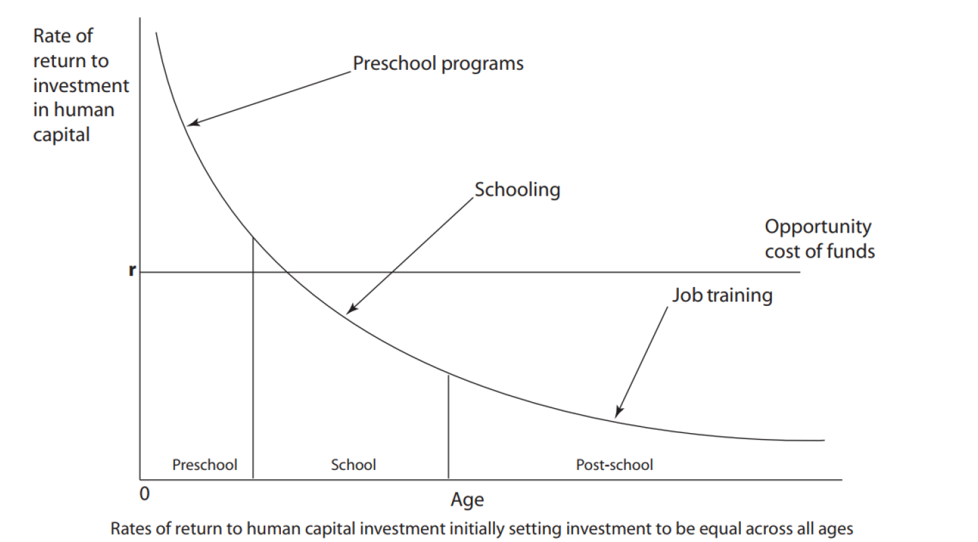
Figure 1
Rates of Return to all children in Investing in Education (Heckman & Masterov, 2014; Beblavy et al, 2018)
Karloy & Kilburn (2008) as cited in Beblavy et al (2018) shared that if governments invest early in individual’s productive capabilities, then these individuals can derive the opportunities to improve their lives and outcomes such as their financial situations and in turn facilitate high payoffs in the long run. Figure 2 shows that children from low socio-economic backgrounds are usually at a disadvantage than their counterparts. Therefore, high-quality ECE is even more beneficial to them because they lack the financial resources.

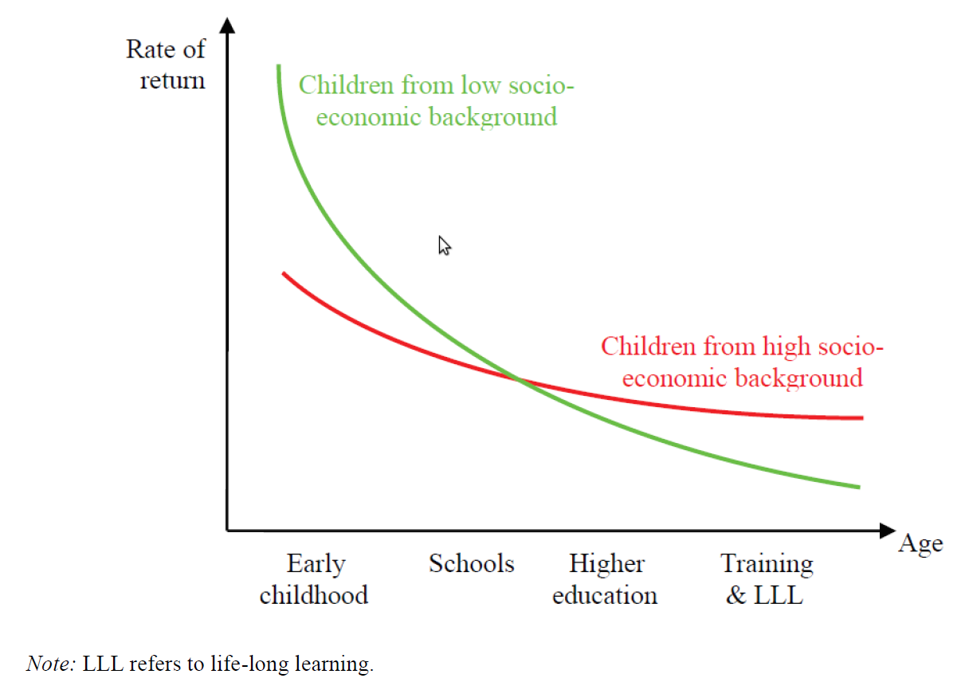
Figure 2
Rate of Return to Education for Children having Different Socio-Economic Backgrounds (Beblavy et al, 2018)
Becker (1994) explained that “though the optimal level of investment goes down with age for all children, more advantaged children receive major (limited) early investment from their parents” as cited in Beblavy et al (2018). Becker (1994) further explained that richer families are typically able to ensure that their children obtain quality education and even can send them to study at the tertiary; however poorer families are more likely to be willing to lend their children money [either from borrowing loans or their savings] for further studies but there is no guarantee that their children repay. Consequently, these disadvantaged children would prefer to not receive higher training.
Beblavy et al (2018) shared that based on cost benefits analysis, governments should invest to reap the returns in the long run. Figure 3 below shows three preschool programmes that were invested in by the US government at different time periods to develop high-quality programmes and expose children of various socio-economic backgrounds to each. The HighScope/ Perry Preschool Project cost US$17,599 to operate but the returns to government was approximately 16 times the cost (US$284,086); the Abecedarian Programme however obtained (US$176,284) a rate of return of about 2.5 on the investment of US$70,697; while the CPC programme in Chicago had a rate of return of 10 on the investment of US$8,224 (see Figure 3).
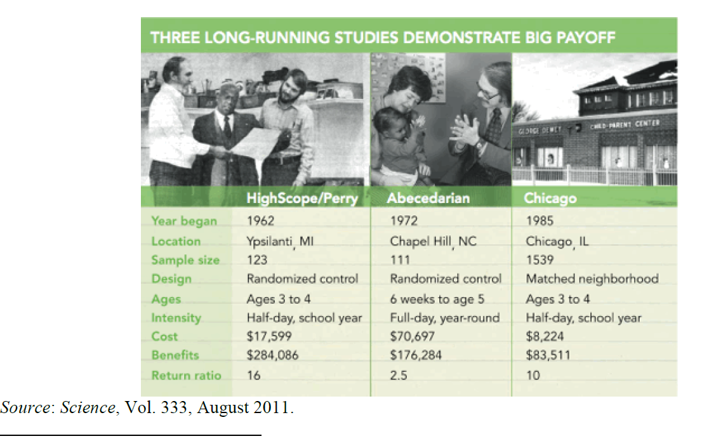
Figure 3
Examples of ECE Programmes invested in by US Government (Science, 2011; Beblavy et al, 2018)
Note that the calculation of returns was based on the maintained contact with the children who became adults having graduated from the programme to indicate the benefits they have afforded the government over the years of their adulthood lives. Notice that across all three programmes US spent US$96,520 but they ended up benefiting from US$543,881, having earned US$447,361 after deducting the cost. This is to show that even though the returns will be in the long run, the government should invest in high-quality ECE programmes because the benefits of deriving far outweigh the cost.

Policy Implications for Early Childhood Education

There is always a need for policy reformation in any sector of government, especially in education, to prepare and equip the workforce. As previously stated by Ee Lynn (2022), Early Childhood Workforce Initiative (2019) and NIH (2018), here are some policies that need to be considered to develop the education sectors across the world:
- Develop high-quality ECE programmes that are accessible to all young children.
- Increase investments in early childhood education if there is desire for economic growth to train teachers, improve the professional scope in the ECE sector and increase salaries, and provide resources and minimize class sizes.
- Get parents involved even if it means helping them overcome their social economic struggles as well as to bridge the gap in communications between educators and parents.
- Mitigate social inequalities that are preventing young children from accessing high-quality ECE programmes.
- Ensure to include health and nutrition services to address issues in the ECE programmes.
Should the government develop these policies then ultimately, they will be guaranteed of children staying in school rather than dropping out and even pursuing higher education. They would be less likely to feel left out and angered by their frustrations to resort to criminal activities, which are usually committed mostly by low-income families. Families will become more robust in the teaching and learning process of the young children to strengthen the ECE programmes while being able to work and feed their children. Also, there is a need for education sectors to spend time to figure out strategies needed to help teachers' well-being as they often suffer from stress and exhaustion to minimize negative emotions affecting the quality of teaching and learning. It is good that Jamaica has made the initiative to transform the menu in schools to make it healthier; but I hope some investments of funds [to subsidize the lunch costs] are also provided before school starts September 2023.

Early Childhood Education Models

There are a few ECE models that have been designed to drive high-quality education in countries across the world. These models have been developed for years now and adopted by different countries based on their unique socio-cultural contexts as well as education philosophies. The models are Reggio Emilia Approach (Italy), Forest Schools (Scandinavian Countries), HighScope Approach (United States), Te Whariki (New Zealand), and Play-Based Learning (Finland).
The Regilio Emilia Approach was developed in Italy by Loris Malaguzzi which focuses on the classroom at the “third teacher” (Monroe College, 2023). This approach is designed based on the principles of child-centered and project-based learning where children can explore their interests and ideas creatively through hands-on activities with the teacher being their facilitator. This model developed from Lev Vygotsky theory on Zonal Proximity and Scaffolding. Countries can adapt lessons from the model such as valuing what children say and help direct their learning encouraging creative expressions and critical thinking by considering inquiry-based [discovery] learning using their cultural experiences by making their learning their own.
Forest School approach is geared towards exploring children to their physical environment outside the classroom where they can learn outdoor activities and connect with nature. This approach is used in Forest Schools found in Scandinavian countries where there are actual forests to take the children to. The children would then become exposed to activities taking place in the forest, playing with natural materials, and learning about the environment. ECE needs to incorporate these ideas into their curriculum as field trip moments if the schools are far away from forests. Also, during lessons at these non-forest schools, children still can be taken outdoors to have similar experiences created for them or using what is already available.
HighScope Approach [also known as Plan-Do-Review] which has been used in the United States which started with the Perry Preschool Project. This approach focuses on active learning related to children’s daily routine and intentional teaching in a structured way. This affords children with the opportunity to be engaged in activities such as music, reading, science, dramatic play, writing, art, math, and motor development. Monroe College (2023) explains that “each day the children discuss with the teacher how they will plan their day” and the plan is what the child follows which is reviewed with the teacher at the end of the day. Its model is adaptable roughly across all countries, but it might require amendment of some curriculum’s such as Jamaica where this is possible for even one of the school days.
Te Whariki is a framework developed in New Zealand that outlines an early childhood curriculum. This model promotes cultural diversity and bicultural perspectives. This model can provide children with mixed cultural experiences to become aware of other cultures and their activities while also ensuring that they fully grasp their own culture. This will teach them about diverse cultures and how to interact with people outside of their cultures without any bias.
Play-based Learning developed in Finland which focuses on free play where children can participate in self-directed experiences such as games created by them or others and dramatized plays. Dr. Kelly-Williams (2021) [she] recorded an account of a child-initiated play having one episode [focuses on a fast-food restaurant with their assigned roles, a price list, labels, and name tags] that took place in a Jamaican preschool classroom amongst 3-5 years old. She explained that from this play the children learn self-expression, they enjoy it leaving them with a positive disposition and love of learning (Kelly-Williams, 2021).

Overall Discussions

Why is it important to consider ECE teachers' well-being?
It is important for policymakers to become cognizant about ECE educators’ well-being over the overall quality and effectiveness of ECE programmes. If a teacher is suffering from stress and/ or emotional exhaustion, then the following become impacted: teacher-child interactions, teacher retention and job satisfaction and professional development. So, if teachers have a higher well-being, they are more emotionally supportive of the young children and can engage them in positive interactions to influence better academic performances and social skills. Some teachers struggle with work-life balance and if they are not able to cope, they usually leave the school system. Therefore, with increased levels of well-being they are more likely to find job satisfaction. Also, if teachers feel discontented, they are less likely to be willing to participate in professional development sessions in order to positively impact their professional growth and development.

What are the disadvantages of not investing in early childhood education?
ECE programmes if not funded or properly funded are expected to fail and not properly prepare children for a skilled and healthy workforce. One, the programme would be of poor quality and not provide opportunities for social equity and inclusion and encourage a continuation of large sums being pumped into social welfare expenditure amongst other ripple effects such as criminal activities. Also, the rate of return on investments in education would not be possible without any investments for governments [countries] to benefit similarly to the US that funded three ECE projects. Consequently, there will be no development of human capital needed to drive economic development, since they would not be equipped [having the knowledge and capacity-building] or ready to take on certain job prospects that would be left empty. Hence, countries would be underdeveloped and might even become reliant on funds that put the country into some serious deficits in the long run.

Contributions of Essay Paper to My Personal and Community Development
This paper has contributed to my developing an even greater appreciation of ECE. While growing up and even when I became [before now teacher-educator], my focus was solely on high schools and developing their social, cognitive, and social skills. However, this study has allowed me to become more knowledgeable. This paper can contribute to my community, mostly by letting them become aware of the need for us to be more understanding of ECE teachers and be able to help where and when necessary to facilitate a support system for teachers especially those with large class sizes.

Conclusion

The study revealed that early childhood education is important in promoting cognitive, social, and emotional development not only because of academic skills development but rather for future educational purposes. It was found that young children when exposed to high quality ECE programmes will help provide a skilled and healthy workforce because they would have started to learn about team-building activities, conflict resolutions, empathy for others amongst other skills. The study uncovered that children who attend preschool from at least age 3 years old are more likely to graduate from high school, attend tertiary institutions and earn higher incomes, as well as being least likely to commit criminal activities.
It was also seen that early childhood interventions are very important to help promote educational attainment at the highest level and drive high-quality ECE programmes. The study shared that parents need to become involved in their children's learning regardless of background to synchronize what the children are learning at home and at school to ensure they obtain high quality education. The Perry Preschool Project inferred that governments could develop programmes for parents such as job employments and educational opportunities to help them develop themselves to better help themselves and their children.
It was also found that nutrition and health play a vital role in early childhood education to ensure that children are healthy. Nutrition and health were promoted based on healthy eating, particularly at school and physical education. Therefore, children can experience cognitive and physical development which is important in the long run for a workforce which is healthy and able to not easily get sick on the job. There is a need to promote social equity and inclusion as part of policymaker to mitigate social inequalities amongst vulnerable and marginalized individuals such as children from low-income families, orphans, and children with disabilities by investing in resources for them. There is a need as well to invest in ECE programmes so teachers can benefit from better salary packages and opportunities to grow on the job, receive professional development sessions, as well as resources to get the programme to be of high quality. Policies need to be designed to guarantee funding opportunities of these programmes overtime, to address and minimize social inequalities amongst other initiatives to ensure a high-quality programme can be made available. Also, in developing the programme there is a need to incorporate various perspectives [early childhood models] such as play-based learning to provide both the teachers and children with a variety of socio-cultural contexts. By investing in early childhood education, countries can not only nurture their greatest asset [their children] but be able to prepare and build a robust human capital base to achieve sustainable economic growth.

Bibliography

Ansari, A., Pianta, R. C., Whitaker, J. V. Vitiello, V. E., & Ruzek, E.A. (2019). Starting early: The benefits of attending early childhood education programs at age 3. American Educational Research Journal, 56(4), 1495 - 1523.
Beblavy, M., Lenaerts, K., & Vandenbroeck, M. (2018, January). Benefits of Early Childhood Education and Care and the conditions for obtaining them. Economics of Education (EENEE) Analytical Report No. 32. European Commission.
Becker, G.S. (1994). Human Capital Revisited. In: Human Capital: A Theoretical and Empirical Analysis with Special Reference to Education (3rd Edition), Chicago, IL: University of Chicago Press, pp. 15-28 (http://www.nber.org/chapters/c11229.pdf).
Ee Lynn, N. (2022, December). Early childhood education is a big deal. https://singteach.nie.edu.sg/2023/01/12/early-childhood-education-is-a-big-deal/#:~:text=The%20emotional%2C%20social%20and%20physical,the%20s
Heckman, J.J. and Masterov, D.V. (2004). The Productivity Argument for Investing in Young Children. Working Paper No. 5, Invest in Kids Working Group Committee for Economic Development, 4 October (http://jenni.uchicago.edu/Invest/FILES/dugger_2004-12-02_dvm.pdf).
Heckman, J.J. (2006). Skill Formation and the Economics of Investing in Disadvantaged Children. Science, 312(5782), 1900-1902 (doi:10.1126/science.1128898).
Help me Grow. (2023). What is Cognitive Development? Retrieved from https://helpmegrowmn.org/HMG/HelpfulRes/Articles/WhatCognitiveDev/index.html#:~:text=Cognitive%20development%20means%20how%20children,is%20part%20of%20cognitive%20development.
HighScope Educational Research Foundation. (2022, June 3). Perry Preschool Project. HighScope. https://highscope.org/perry-preschool-project/
Karoly, L. & Kilburn, M.R. (2008). The Economics of Early Childhood Policy – What the dismal science has to say about investing in children. Occasional Paper Series, RAND Corporation, Santa Monica, CA.
Kelly-Williams, S. (2021, December 21). Play in difficult circumstances in Jamaica. International Journal of Play, 10:4, 361 - 364.
Meloy, B. (2019, January 31). Research Shows High-Quality Pre-K Can Pay Off, Now Let's Deliver It. NIEER Research. Retrieved from https://nieer.org/2019/01/31/research-shows-high-quality-pre-k-pays-off-now-lets-deliver-it.
Meunier, K. & Sparling, J. (2019). Abecedarian: An Early Childhood Education Approach that has a Rich History and a Vibrant Present. IJEC 51, 207 - 216.
Monroe College. (2023). Early Childhood Education History: Theorists & Theorists. Retrieved from https://www.monroecollege.edu/news/early-childhood-education-history-theorists-theories.
Morris, A. (2023, February 11). Ministry to issue menu guides on healthy foods to school canteens. Jamaica Gleaner. https://jamaica-gleaner.com/article/lead-stories/20230211/ministry-issue-menu-guides-healthy-foods-school-canteens
Mothership. (2021, February 14). What do Early Childhood Educators do in Singapore? | Things You Always Wanted to Ask. (YouTube, Mothership). https://www.youtube.com/watch?v=EKsXeDPXhcc
NIH. (2018, January 29). Graduates of early childhood program show greater educational gains as adults. National Institutes of Health (NIH).
Potomac Health Foundation. (2023). Social Development in Children.
Reynolds, A., & Whitener, B. (2015, March). Small investment in children's education yields big results: NIH-funded research shows educating children leads to adult income gains.
Teng, A. (2022, July 13). Over $13 million invested in training early childhood educators: Sun Xueling. The Straits Times. https://www.straitstimes.com/singapore/parenting-education/more-than-13-million-invested-in-trainingearly-childhood-educators-sun-xueling.
The Gleaner. (2022, May 17). Editorial | Start with early childhood education. Jamaica Gleaner. https://jamaica-gleaner.com/article/commentary/20220517/editorial-start-early-childhood-education.
The Observer. (2017, July 18). 900 regional primary school teachers to receive training in mathematics – Ministry of education and youth. SSL Certificate & Digital Certificate Authority - SSL.com. https://moey.gov.jm/900-regional-primary-school-teachers-to-receive-training-in-mathematics/.
Trentacosta et al. (2020). emotional development. Science and Technology. Britannica. Retrieved from https://www.britannica.com/science/emotional-development.
Tyler, S. (2008). Chapter 14: Coginitive Development in Early Childhood. Human Behaviour and the Social Environment I. Retrieved from https://uark.pressbooks.pub/hbse1/chapter/cognitive-development-in-early-childhood_ch_14/.
UMass Global. (n.d.). What is early childhood education and why it is so important? Understanding it's impact. Retrieved from https://www.umassglobal.edu/news-and-events/blog/what-is-purpose-of-early-childhood-education#:~:text=The%20purpose%20of%20ECE%20is,needed%20to%20become%20lifelong%20learners.
U.S. Department of Health and Human Services. (2006). The NICHD Study of Early Child Care and Youth Development - Findings for Children up to Age 4 1/2 years. NICHD - Eunice Kennedy Shriver National Institute of Child Health and Human Development.
WisconcinDPI. (2018, May 21). Early Childhood Social and Emotional Learning. YouTube. https://www.youtube.com/watch?v=ohzEujRKtLg.

