**Sharmaine Marshall**

UD78058BHO87269

COURSE NAME:

**Restaurant and Food Service Management**

Assignment Title**: Enhancing Customer Experiences at the Hibiscus Training Restaurant**

ATLANTIC INTERNATIONAL UNIVERSITY

**January 2024**

**Contents**

List of Tables and Figures 2

Introduction 3

Customer Satisfaction and Perceived Quality 6

Instruments designed to measure service quality in the catering industry 7

Case Study: Starbucks SERVQUAL model case study 16

Restaurant Quality Dimensions 17

Criticisms of SERVQUAL and the model of service quality 19

Conclusion 20

Recommendations 21

Limitations of the Study 22

Recommendation for Further Research 22

References 24

Appendix 28

# **List of Tables and Figures**

**Table 1: Understanding the SERVQUAL Model** 11

**Table 2: The SERVQUAL Model in a Nutshell** 14

**Table 3: Summary of Gaps with Diagnostic Indications (**Zeithaml et al., 1990). 15

**Table 4: Examples of matched pairs of items in the SERVQUAL questionnaire ….**16

**Table 5: Restaurant Quality Dimensions - Constructs and Variables** 18

**Figure 1: Guyana GDP Growth 2019 - 2023** 3

**Figure 2: Scenes from the Hibiscus Training Restaurant** 3

**Figure 3: The SERVQUAL Model Diagram** 7

**Figure 4: The Revised SERVQUAL/RATER Model** 9

# **Introduction**

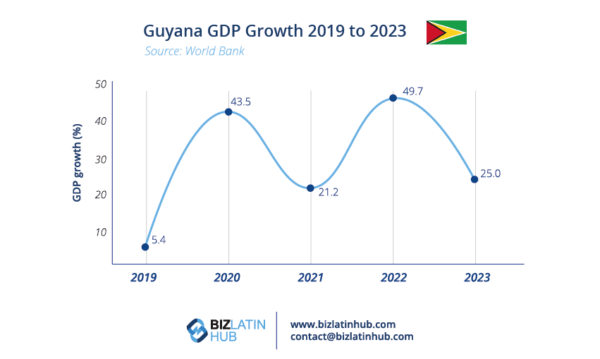The hospitality industry in Guyana is growing rapidly, thanks to the booming oil and gas sector. By 2025, the Government of Guyana (GoG) projects to have ten new hotels with a total accommodation of 2,000 rooms. This growth has prompted the Hibiscus Training Restaurant to adopt savvy marketing strategies to identify the needs of its customers and enhance their satisfaction and loyalty. As such, the restaurant must focus on key performance factors that enrich the customer experience, such as service encounters and customer orientation. These factors require close attention to service efficiency, quality, and availability.

**Figure 1: Guyana GDP Growth 2019 - 2023**

The Hibiscus Training Restaurant is located in the Carnegie School of Home Economics (CSHE) and has a rich history. Founded in 1933, the school is considered the premier institution in Guyana, offering unparalleled Home Economics and Hospitality training. The school comes directly under the Ministry of Education (MoE), Guyana, and is fully funded by the Government of Guyana (GoG). The Hibiscus Training Restaurant has offered specialised food preparation and service training since 1971. The school certifies graduates with a Diploma in Catering and Hospitality, exposing students to hands-on food preparation and service training. In addition, the institution is the primary supplier of the workforce for the Hospitality Industry in Guyana and beyond.

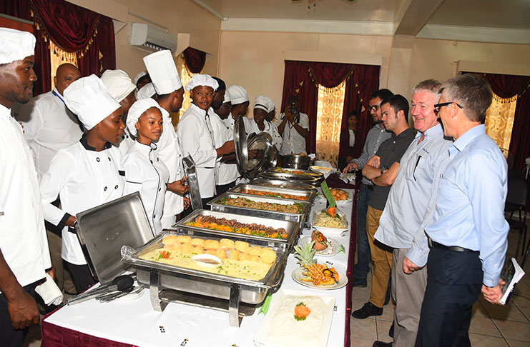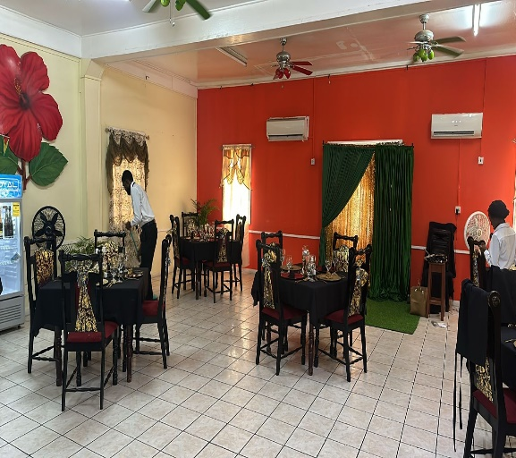

**Figure 2: Scenes from the Hibiscus Training Restaurant**

The training restaurant consists of two stages - front-stage and backstage. The front stage includes operational tasks that customers interact with directly, while the backstage involves tasks without direct customer interaction. The performance of both stages is critical to the overall performance of the service system. Therefore, it is crucial to incorporate and integrate both stages to enhance the overall service system. Additionally, measuring and monitoring both service stages is essential to ensure overall service operational effectiveness. With increasing competition from privately owned schools, the institution has become more aware of the need to customise services and service performance to meet customer requirements. Thus, monitoring, tracking, and improving service quality, availability, and efficiency in hospitality operational service settings is critical.

The hospitality industry in Guyana is on an upward trajectory, and the Hibiscus Training Restaurant is well-positioned to capitalise on this growth by prioritising customer satisfaction and adopting innovative strategies. The CSHE continues to be a vital contributor to the industry, offering specialised training and a skilled workforce to meet the demands of an ever-evolving industry. As such, this study offers a comprehensive view of quality applicable to the Hibiscus Training Restaurant, empowering the school manager and staff to make informed decisions that prioritise critical quality attributes. Additionally, the study aims to identify factors that impact customer satisfaction at the training restaurant and present tools designed to assess service quality in the catering unit.

**Keywords**: *restaurant, quality, satisfaction, guests*

# **Customer Satisfaction and Perceived Quality**

According to the research conducted by Dabholkar et al. (2000), customers evaluate their dining experiences based on three fundamental factors: (a) the quality of food, (b) the physical ambience of the establishment, and (c) the level of employee service. Hence, to achieve the highest possible service quality and ensure maximum customer satisfaction and loyalty, businesses must adopt a comprehensive approach to quality management (Oh, 2000; Chow et al., 2007; Namkung & Jang, 2008). Hence, the CSHE must recognise the importance of proper management, education, and staff training to meet customers’ expectations, as failing to identify customer expectations can result in reduced business volume for the restaurant.

Luo and Homburg's (2007) research demonstrated a direct correlation between customer satisfaction and an organisation's profitability, indicating that enhancing quality and adopting appropriate measures is imperative to ensure successful business outcomes in today's competitive market. This holds true for the Hibiscus Training Restaurant, where customer satisfaction must be prioritised (Blesic et al., 2011). Customer satisfaction and perceived quality are crucial concepts in effective service management. The term "customer satisfaction" was initially introduced in 1987 by Zeithaml, who defined it as a customer's overall assessment of their experience with a product or service. On the other hand, "perceived quality" refers to the consumer's evaluation of a product or service's performance, as Johnson et al. reinforced in 1995. These two factors play a critical role in service management and should not be overlooked by the management of CSHE, as they are highly interrelated and can significantly impact the institution’s profitability (Luo & Homburg, 2007; Blesic et al., 2011; Martínez-tur et al., 2011).

The attainment of maximal customer satisfaction within the Hibiscus Training Restaurant is a formidable objective, given the heterogeneity of services and the personal dimension of their realisation. Nonetheless, measuring customer satisfaction can assist the institution in comprehending what is of paramount importance to their customers and how they perceive the training restaurant. Through this understanding, priorities can be defined for improvement to augment customer satisfaction and profitability.

The relationship between customer satisfaction and service quality has received considerable attention in the services marketing literature, with researchers exploring whether service quality evaluation and customer satisfaction are interchangeable. It is generally assumed that delivering superior quality services is the primary means for gaining a competitive edge and satisfying customers (Ryu & Han, 2007). Therefore, the perceived quality of services is a critical determinant of overall customer satisfaction at the Hibiscus Training Restaurant, and the management should concentrate on delivering superior quality services to appease customers and meet their expectations.

# **Instruments designed to measure service quality in the catering industry**

Measuring the service quality of the Hibiscus Training Restaurant has always been challenging due to its subjective nature, unlike tangible goods. The difficulty mainly arises from the characteristics of its service, such as heterogeneity, inseparability of production and consumption, perishability, and intangibility. However, using the Service Quality Model (SERVQUAL) can aid in evaluating the Service Quality of the Hibiscus Training Restaurant. This multidimensional model was developed by Zeithaml, et al., (1990) and is also known as the gap model, which initially consisted of ten dimensions. This model helps to measure and capture the quality of service experienced by customers. Even in this digital economy, SERVQUAL is considered the industry standard for measuring service quality. The SERVQUAL model generally identifies the principal dimensions of service quality to bridge the gap 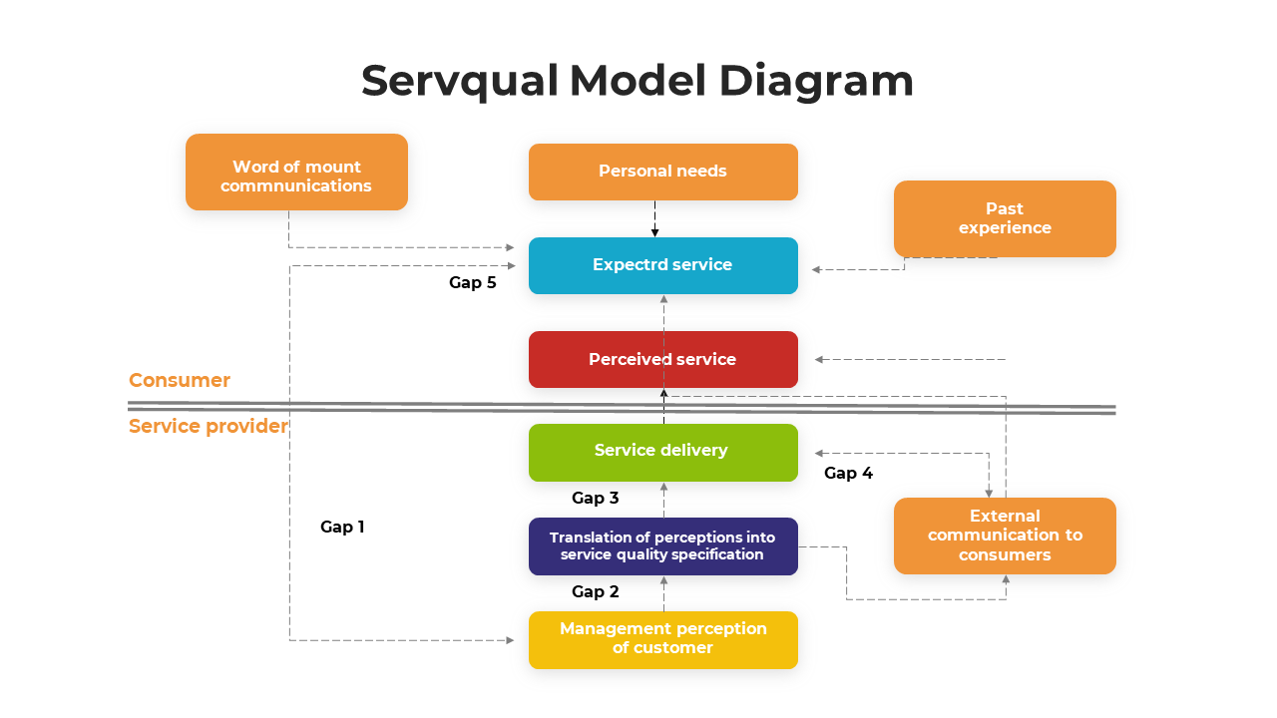between customer expectations and needs.

**Figure 3: The SERVQUAL Model Diagram**

The SERVQUAL questionnaire is commonly used by businesses to assess service quality issues, while the model of service quality aids in identifying the underlying causes of such problems (see Appendix). Based on the expectancy-confirmation paradigm, the model posits that consumers judge the quality of a service based on their perception of how well the service delivery meets their expectations. As such, service quality can be defined as a straightforward comparison between the customer's expectations and the actual service delivery equation:

**SQ = P- E**

where;

**SQ** is service quality

**P** is the individual's perceptions of a given service delivery

**E** is the individual's expectations of a given service delivery

The model of service quality measures the difference between customer expectations and perceptions of the received delivery. When perceptions exceed expectations, service quality is high; when expectations are more significant than perceptions, service quality is deemed low. The model identifies five gaps that may cause customers to experience poor service quality, with gap 5 being the only gap that can be directly measured. The SERVQUAL instrument was specifically designed to capture gap 5, while gaps 1-4 cannot be measured but have diagnostic value.

In 2009, Blešić et al. redefined the SERVQUAL Model into five dimensions, namely, Reliability, Assurance, Tangibility, Empathy, and Responsiveness (RATER Model), since some of these dimensions were auto-correlated. Using the SERVQUAL/RATER model can increase customer satisfaction, loyalty, positive word-of-mouth, and revenue for Hibiscus Training Restaurant.

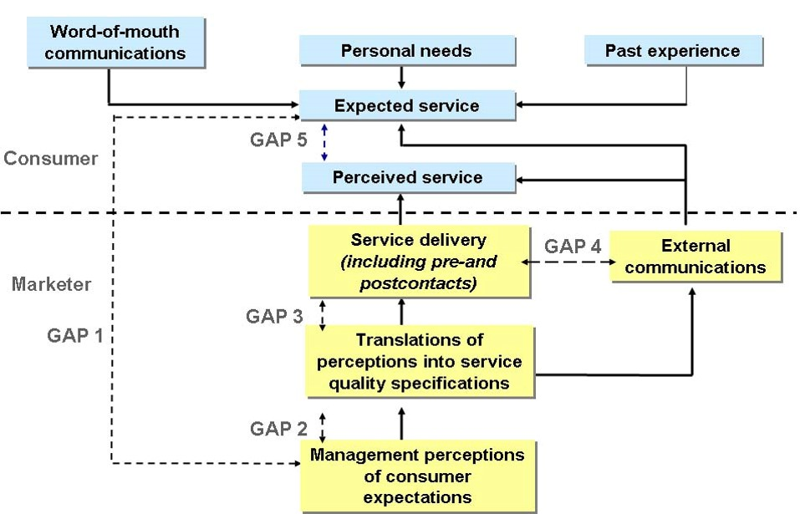

**Figure 4: The Revised SERVQUAL/RATER Model**

| **Element** | **Description** | **Analysis** | **Implications** | **Benefits** | **Challenges** | **Use Cases** | **Examples** |
| --- | --- | --- | --- | --- | --- | --- | --- |
| Service Quality Dimensions | SERVQUAL identifies five dimensions to measure service quality: Tangibles, Reliability, Responsiveness, Assurance, and Empathy. These dimensions help assess and improve service quality. | These dimensions provide a comprehensive framework for evaluating service quality from various angles, aiding in identifying strengths and weaknesses. | Understanding the dimensions helps organisations tailor their strategies to meet customer expectations and enhance overall service quality. | Enhanced service quality and customer satisfaction. | Challenges in quantifying and measuring subjective elements like empathy. | Service quality assessment and customer feedback. | A hotel uses SERVQUAL to assess its service quality by surveying guests. |
| Tangibles | Tangibles refer to the physical and tangible aspects of the service, such as facilities, equipment, appearance, and cleanliness. | Tangibles contribute to customers’ first impressions and can influence their overall perception of service quality. | Well-maintained physical assets and appealing aesthetics can positively impact customers’ perception of the service. | Improved customer satisfaction and loyalty. | Investments in tangibles may be costly. | Facility maintenance, interior design. | A restaurant is upgrading its decor and furnishings. |
| Reliability | Reliability is the consistency and dependability of the service, including the ability to deliver promised services accurately and on time. | Reliability is fundamental to service quality, as customers expect consistency and reliability in their service interactions. | Consistently meeting or exceeding customer expectations builds trust and loyalty. | Increased customer trust and repeat business. | There needs to be improvement in maintaining consistency across all service interactions. | Service process standardisation and quality control. | An airline ensuring on-time departures and arrivals. |
| Responsiveness | Responsiveness involves the willingness and ability of service providers to help customers promptly and address their needs and concerns. | Quick response to customer inquiries or issues is essential for providing a positive service experience. | Responsiveness demonstrates customer-centricity and can lead to increased customer satisfaction and loyalty. | Improved customer relationships and loyalty. | Inconsistent responsiveness due to varying workloads. | Customer service training, complaint resolution. | A call centre is responding promptly to customer inquiries. |
| Assurance | Assurance relates to service providers' competence, courtesy, credibility, and professionalism. Customers should feel confident in the service provider's abilities and trustworthiness. | Assurance is crucial for building trust and confidence in the service provider, as customers rely on the provider’s expertise and credibility. | Demonstrating competence and professionalism can enhance customers’ perception of service quality and reliability. | Greater customer trust and confidence. | Challenges in consistently delivering high levels of assurance. | Employee training and certification programs. | A financial advisor is building trust through professional certifications and expertise. |
| Empathy | Empathy refers to the service provider's ability to understand, care for, and empathise with customers' needs, feelings, and concerns. | Empathy is essential for creating a personalised, customer-focused service experience, demonstrating genuine customer care. | Showing empathy can lead to stronger customer relationships, increased satisfaction, and long-term loyalty. | Improved customer relationships and loyalty. | Challenges in training employees to demonstrate empathy authentically. | Customer service training, active listening. | A healthcare provider shows empathy toward a patient's concerns and fears. |

**Table 1: Understanding the SERVQUAL Model**

|  |  |  |
| --- | --- | --- |
| **SERVQUAL Model** | **Description** | **Example** |
| Tangibles | The Physical appearance of facilities, equipment, personnel, and communication materials. | Clean and well-maintained facilities, professional-looking staff, and visually appealing marketing materials. |
| Reliability | The ability to perform the promised service dependably and accurately. | Consistently delivering products or services on time and meeting customer expectations. |
| Responsiveness | The willingness to help customers and provide prompt service. | Quickly addressed customer inquiries, provided timely assistance, and efficiently resolved issues. |
| Assurance | Employees' knowledge and courtesy and ability to convey trust and confidence. | Well-trained staff that can answer questions, provide accurate information, and create a sense of trust with customers. |
| Empathy | The provision of caring, individualised attention to customers. | Take the time to understand customer needs, personalise the service, and demonstrate genuine concern for customer satisfaction. |

**Table 2: The SERVQUAL Model in a Nutshell**

As mentioned previously, service and food quality are crucial to customer satisfaction and loyalty, affecting the training restaurant’s brand image. However, it must be noted that the restaurant's physical environment can strengthen the brand image, reposition customers’ perceptual mapping among competition, and enhance customer satisfaction (Jang & Namkung, 2009). Hence, the Hibiscus Training Restaurant's physical environment can positively impact the perceived restaurant image and affect customer service quality evaluations through ambient conditions, facility design, and social factors (Barber & Scarcelli, 2009; Liu & Jang, 2009).

|  |  |  |
| --- | --- | --- |
| **Gap** | **Brief Description** | **Probable Causes** |
| **Gap 1**  The Knowledge Gap | Difference between the target market’s expected service and management’s perceptions of the target market’s expected service. | * Insufficient market research * Inadequate upward communications * Too many layers of management |
| **Gap 2**  The Standards Gap | Difference between management’s perceptions of customer expectations and the translation into service procedure and specifications | * Lack of management commitment to service quality * Employee perceptions of infeasibility * Inadequate goal setting * Inadequate task standardisation |
| **Gap 3**  The Delivery Gap | Difference between service quality specifications and the service delivered | * Technical breakdowns or malfunctions * Role conflicts/ambiguity * Lack of perceived control * Poor employee-job fit * Poor technology-fit * Poor supervision or training |
| **Gap 4**  The Communication Gap | Difference between service delivery intentions and what is communicated to the customer | * Lack of horizontal communications * Poor communication with the advertising agency * Inadequate communication between sales and operations * Differences in policies and procedures across branches or divisions of an organisation * Propensity to overpromise |

**Table 3: Summary of Gaps with Diagnostic Indications (**Zeithaml et al., 1990).

|  |  |  |
| --- | --- | --- |
| **Dimension** | **Sample Expectations Item** | **Sample Perceptions Items** |
| Reliability | When excellent restaurants promise to do something by a specific time, they do. | XYZ restaurant provides its services at the promised time. |
| Assurance | The behaviour of employees in excellent restaurants will instil confidence in customers. | The behaviour of employees in the XYZ restaurant instils confidence in you. |
| Tangibles | Excellence restaurant companies will have modern-looking equipment. | XYZ company has modern-looking equipment |
| Empathy | Excellent restaurants will have operating hours convenient to customers. | XYZ restaurant has convenient operating hours |
| Responsiveness | Employees of excellent restaurants will never be too busy to help a customer. | XYZ employees are never too busy to help you |

**Table 4: Examples of matched pairs of items in the SERVQUAL questionnaire (**Zeithaml et al., 1990).

# **Case Study: Starbucks SERVQUAL model case study**

Starbucks is a company that is widely regarded for its customer service. In this regard, it can be analysed using the SERVQUAL model's five dimensions.

One of the most critical aspects of the Starbucks experience is reliability. The company trains its baristas to work efficiently and serve customers promptly. Additionally, Starbucks requires its servers to learn about the various coffee varieties and how to make the perfect coffee. The baristas are then expected to pass on this knowledge to the customers. Starbucks promises to prepare each drink according to an individual's tastes, regardless of the location.

Starbucks is known for being responsive to customer feedback. In 2008, the company launched the "My Starbucks Idea" initiative, allowing customers to submit feedback, ideas, requests, and concerns on a microsite. Users could vote on comments and ideas they liked, and the most popular ideas and dedicated fans were listed on a public leaderboard. Over the years, the company received more than 150,000 ideas, out of which around 300 were incorporated into company operations.

The assurance dimension of the SERVQUAL model is closely related to reliability. Starbucks' well-trained staff understands how to make good coffee and can communicate their expertise and passion to customers. This quality helps the staff to convey confidence and trust to the customers. For many customers, the ambience of a Starbucks café is as important as the quality of the coffee. The company has carefully chosen every detail in a store, from the furniture to the lighting, to ensure customers feel comfortable and at home. Starbucks wants its stores to become a second or third home for customers. Starbucks places great emphasis on empathy in its service to others. The company makes every drink the customer wants, and employees are trained to recognise and respond to customer needs. Baristas are trained to respond to unpleasant situations using the Latte method - Listen to the customer, acknowledge their complaint, Solve the problem with action, Express thanks, and Explain why the problem occurred. When adequately implemented, this technique helps baristas positively address customers' negative emotions.

# **Restaurant Quality Dimensions**

As highlighted earlier in the study, assessing the quality of service in the Hibiscus Training Restaurant is complex and challenging due to its intangible nature (Andaleeb & Conway, 2006). Hence, the institution must establish standardised, quantitative, and systematic methods to evaluate performance. Therefore, identifying a service quality specification is critical to understanding the components of service quality, retraining or upskilling employees, and assessing and controlling performance.

|  |  |
| --- | --- |
| **Constructs** | **Variable** |
| Food Quality | * Tastiness of food * Menu Variety * Nutrition * Food is served at the right temperature * Food presentation is attractive * Serving size * Menu design * Healthy options * Freshness |
| Service Quality | * Employees are always willing to help me * Employees know to answer my questions * The restaurant has my best interest at heart * Staff appearance, friendly staff, and attentive managers. |
| Physical Environment | * Décor, ambience * Facility aesthetics * Lighting, layout * Table setting and service * Staff appearance. |
| Price Fairness | * Good value for money * Reasonable price items * The overall value of the dining experience. |

**Table 5: Restaurant Quality Dimensions - Constructs and Variables**

Research by Barber and Scarcelli (2009) and Liu and Jang (2009) said that the food service industry has demonstrated that various factors significantly contribute to customer expectations and service-quality perception, such as low price, food quality, value for money, service, location, brand name, and image. The authors further highlighted that several aspects also influence customer satisfaction, including food, physical provision, atmosphere, and service quality. Notably, restaurant guests have identified critical quality attributes such as food taste, presentation, textures, colours, temperature, freshness, nutritive value, and smell (Delwiche, 2004). This finding conforms to the previous literature; hence, Qin and Prybutok (2009) opined that the pleasure of the food experience can be enhanced through portion size and menu variety. Therefore, the quality of service delivery is an integral part of the Hibiscus Training Restaurant experience, and staff performance and attitude significantly impact the process. In addition, a positive employee experience is essential for customer satisfaction and loyalty, with up to 80% of customer satisfaction and loyalty depending on the employees' relationship (Brady et al., 2001).

As previously stated, the physical environment also plays a vital role in creating the desired experience, with facility aesthetics, ambience, lighting, table settings, layout, and service staff significantly influencing customers to revisit intention and the restaurant's brand image. This implies that the service quality at the Hibiscus Training Restaurant must align with the price to improve customer satisfaction, which is crucial. However, even though empirical studies have provided valuable insights into customer perceptions of the quality-of-service delivery related to the Hibiscus Training Restaurant, further research is needed to understand better how customers perceive specific service encounters.

# **Criticisms of SERVQUAL and the model of service quality**

The SERVQUAL model is a widely used tool for measuring service quality despite the criticisms it has received. However, there is a need for further validation of this measuring tool to ensure its reliability and validity in specific contexts. Although concerns have been raised about the validity of the expectations construct, the questionnaire's length, and the questionnaire's administration, SERVQUAL and its modified forms continue to be used in both academic research and industry practice. On the other hand, some research suggests that the SERVPERF instrument may be a better alternative to SERVQUAL. Nonetheless, with further research and validation, SERVQUAL has the potential to remain a valuable tool for measuring service quality.

# **Conclusion**

The CSHE places a high demand on providing exceptional customer service and quality improvement, but understanding service quality in this context clearly and identifying the "whats" and "hows" of service-quality improvement in ordinary and extraordinary contexts is crucial. Several studies were conducted regarding measuring service quality in the hospitality industry. The perception of service quality results from comparing customer expectations with actual performances, making it essential to use suitable tools to measure service quality and identify gaps.

As the study indicates, the SERVQUAL/RATER model is one of the most effective methods for measuring service quality in the hospitality industry, particularly in Hibiscus Training Restaurant. The study also indicates that customer satisfaction is a critical factor in the success of the Hibiscus Training Restaurant. In addition, the study identifies food quality, service quality, and ambience as significant factors that influence customer assessments of restaurant quality. Specifically, attributes such as food safety, environmental cleanliness, taste, service reliability, and fair pricing are essential for the training restaurant's success. The dining atmosphere, food authenticity, and value for money are also significant contributors to customer satisfaction and behavioural intention.

Ramseook-Munhurrun (2012) stated that the physical environment, food quality, and service quality are also critical determinants of the restaurant's image and customers' perceived value. It can be further deduced that customer satisfaction is a significant predictor of behavioural intentions, reinforcing the importance of identifying what determines customers’ satisfaction. Furthermore, cleanliness attributes are meaningful predictors of repeat patronage, indicating the importance of continued education and benchmarking customer cleanliness perceptions in service organisations.

In conclusion, customer satisfaction is not a static category, and the management of the CSHE should strive to meet and exceed customers' evolving expectations to retain their loyalty. Customers' satisfaction is an essential indicator of a restaurant’s overall performance, as customers may seek alternatives when service fails to meet their expectations.

# **Recommendations**

Following a thorough analysis of the challenges encountered by Hibiscus Training Restaurant, the following points are deemed essential for the successful operation of a restaurant: Firstly, establishing and maintaining robust relationships with suppliers, intermediaries, and related industries locally and internationally is crucial for the consistent success of the enterprise. Secondly, regular training and development programs are imperative to motivate and empower employees. Thirdly, constructing independent infrastructural facilities, such as storerooms and cold storage, can help manage situations of excess demand. Fourthly, developing innovative solutions such as fusion food and buffet options is necessary to analyse and comprehend consumers' tastes and preferences effectively. Fifthly, creating a suitable ambience that gives customers a relaxed and enjoyable dining experience can encourage repeat business. Lastly, establishing and maintaining equal pricing based on market competition is crucial. By implementing these strategies, Hibiscus Training Restaurant can ensure sustainable business success.

# **Limitations of the Study**

This research study is focused solely on the Hibiscus Training Restaurant within the Carnegie School of Home Economics premises. The study aims to investigate various aspects related to the operations and management of the restaurant, including factors such as staffing, training, customer service, and food quality. It is important to note that the scope of this study is limited to the Hibiscus Training Restaurant, and, as such, the findings cannot be generalised for other restaurants across Guyana. However, the insights gained from this study can provide valuable information to improve the operations and management of the Hibiscus Training Restaurant and similar establishments.

# **Recommendation for Further Research**

Based on the results, analysis, and discussion presented, it is recommended that restaurant owners and managers focus their attention on factors that have a significant impact on pricing strategies, such as licensing requirements and price sensitivity trends in different consumer groups. However, it is worth noting that the analysis did not consider the impact of legal factors on restaurant business operations. Therefore, further research is required to analyse a large volume of consumer data and explore additional tools that could be used to assess the validity of variables based on the selected parameters.

# **References**

Andaleeb, S. S., & Conway, C. (2006). Customer satisfaction in the restaurant industry: An Examination of the Transaction-specific model. Journal of Services Marketing, 20, (1), pp. 3–11.

Brady, M. K., Robertson, C. J., and Cronin, J. J. (2001). Managing behavioral intentions in diverse cultural environments: An investigation of service quality, service value, and satisfaction for American and Ecuadorian fastfood customers. Journal of International Management, 7, (2), 129-149.

Barber, N., and Scarcelli, J. M. (2009 ). Clean restrooms: How important are they to restaurant consumers? Journal of Foodservice, 20, (6), 309-320.

Blešic I., Tešanovic D., & Psodorov Ð. (2011). Consumer Satisfaction and Quality Management in the Hospitality Industry in South-East Europe, African Journal of Business Management 5(4), 1388-1396.

Blešić, I., Romelić, J., Bradić, M. (2009). Applying a Modified SERVQUAL Model in the

Evaluation of the Quality of Hotel Services, on the Example of the Western Morava Spa Zone, Journal of the Geographical Institute “Jovan Cvijić” SASA, 59(1), 93-110

Chow, I.H., Lau, V.P., Lo, T.Y., Sha, Z.Yun, H. (2007). Service quality in restaurant operations in China: decision- and experiential-oriented perspectives, International Journal of Hospitality Management 26(3), 698–710.

Dabholkar, P.A., Shepherd, C.D., Thorpe, D.I. (2000). A comprehensive framework for service quality: an investigation of critical conceptual and measurement issues through a longitudinal study, Journal of Retailing, 76(2), 139–73.

Delwiche, J. (2004 ). The impact of perceptual interactions on perceived flavor. Food Quality and Preference, 15, (2), 137-146

Johnson, M.D., Anderson, E.W. and Fornell, C. (1995). Rational and adaptive performance expectations in a customer satisfaction framework, The Journal of Consumer Research, 21(4), 695-707.

Jang, S., Namkung, Y. (2009). Perceived quality, emotions, and behavioral intentions: application of an extended Mehrabian–Russell model to restaurants. Journal of Business Research 62 (4), 451–460

Luo, X., Homburg, C. (2007). Neglected Outcomes of Customer Satisfaction. Journal of Marketing, 71(2), 133-149.

Liu, Y., and Jang, S. (2009). Perceptions of Chinese restaurants in the U.S.: What affects customer satisfaction and behavioural intentions? International Journal of Hospitality Management, 28, 338-348.

Martínez-tur, V., Tordera, N., Peiró, J., Potocnik, K., (2011). Linking Service Climate and Disconfirmation of Expectations as Predictors of Customer Satisfaction: A Cross Level Study 1, Journal of Applied Social Psychology, 41(5), 1189–1213.

Namkung, Y., Jang, S. (2008). Are highly satisfied restaurant customers really different? A quality perception perspective, International Journal of Contemporary Hospitality Management, 20(2), 142-55.

Oh, H. (2000). Quality, value, and satisfaction: a practical viewpoint, The Cornell Hotel and Restaurant Administration Quarterly, 41(3), 58–66.

Qin, H., and Prybutok, V. R . (2009 ). Service quality, customer satisfaction, and behavioral intentions in fastfood restaurants. International Journal of Quality and Service Science, 1, (1), 78-95.

Ramseook-Munhurrun, P. (2012). Perceived service quality in restaurant services. Global Conference on Business and Finance, (pp. 630-643).

Ryu, K., Jang, S. (2007). The effect of environmental perceptions on behavioural intentions through emotions: the case of upscale restaurants, Journal of Hospitality and Tourism Research, 31 (1), 56–72.

Zeithaml, V.A., Parasuraman, A., Berry, L. (1990). Delivering Quality Service: Balancing

Customer Perceptions and Expectations The Free Press, New York, NY.

# **Appendix**

|  |  |  |  |  |  |
| --- | --- | --- | --- | --- | --- |
|  | **Expectation Survey** | **Perception Survey** | **E** | **P** | **Gap** |
| **Tangibility** | Excellent ________ will have modern-looking equipment | "XYZ company" has modern-looking equipment |  |  |  |
| The physical facilities at Excellent ________ will be visually appealing | "XYZ company"’s physical facilities are visually appealing |  |  |  |
| Employees at Excellent ________ will be neatly appearing | ABC Hotel's reception desk employees are neatly appearing |  |  |  |
| Materials associated with the service (such as welcome, no smoking statements) will be visually appealing at an Excellent ________ | Materials associated with the service (such as welcome and no smoking statements) are visually appealing at "XYZ Company." |  |  |  |
| **Reliability** | When Excellent ________ promises to do something by a specific time, they do | When "XYZ company" promises to do something by a specific time, it does so |  |  |  |
| When a customer has a problem, excellent _________ hotels will show a sincere interest in solving it. | When you have a problem, "XYZ company" is sincerely interested in solving it. |  |  |  |
| Excellent ________ will perform the service right the first time | "XYZ company" performs the service right the first time |  |  |  |
| Excellent ________ will provide the service at the time they promise to do so | "XYZ company" provides its service at the time it promises to do so |  |  |  |
| Excellent ________ will insist on error-free records. | "XYZ company" insists on error-free records. |  |  |  |
| **Responsiveness** | Employees of Excellent ________ will tell customers exactly when services will be performed. | Employees in "XYZ company" tell you exactly when services will be performed. |  |  |  |
| Employees of Excellent ________ will give prompt service to customers | Employees in "XYZ company" give you prompt service |  |  |  |
| Employees of Excellent ________ will always be willing to help customers | Employees in "XYZ company" are always willing to help you |  |  |  |
| Employees of Excellent ________ will never be too busy to respond to customers' requests. | Employees in "XYZ company" are never too busy to respond to your request. |  |  |  |
| **Assurance** | The behaviour of employees in Excellent ________ will instil confidence in customers. | The behaviour of employees in "XYZ company" instils confidence in you. |  |  |  |
| Customers of Excellent ________ will feel safe in transactions | You feel safe in your transactions with "XYZ company." |  |  |  |
| Employees of Excellent ________ will be consistently courteous with customers. | Employees in the "XYZ company" area are consistently courteous with you. |  |  |  |
| Employees of Excellent ________ will have the knowledge to answer customers' questions. | Employees in "XYZ company" know how to answer your questions. |  |  |  |
| **Empathy** | Excellent ________ will give customers individual attention | "XYZ company" gives you individual attention |  |  |  |
| Excellent ________ will have operating hours convenient to all their customers. | "XYZ company" has convenient operating hours for all its customers. |  |  |  |
| Excellent ________ have employees who give customers personal attention | "XYZ company" has employees who give you personal attention |  |  |  |
| Excellent ________ will have their customer’s best interests at heart | "XYZ company" has your best interest at heart |  |  |  |
| The employees of excellent _____ will understand the specific needs of their customers. | The employees of "XYZ company" understand your specific needs. |  |  |  |
| **Total** |  | |  |  |  |