**Sharmaine Marshall**

UD78058BHO87269

COURSE NAME:

**Corporate Finance**

Assignment Title**: Forecasting Beyond the Balance Sheet: A New Approach to Demand Forecasting for the Tourism and Hospitality Sector in Guyana**

ATLANTIC INTERNATIONAL UNIVERSITY

**February 2024**

**Contents**

Glossary of Key Terms 0

List of Figures 2

Introduction 3

Demand Forecasting with Multilayer Perceptron Algorithm ANNs 5

Using Artificial Intelligence (AI) to Enhance Demand Forecasting 9

AI-powered Demand Forecasting vs Traditional Approaches 13

Conclusion 17

Practical Implications 19

Limitations and Future Research 20

# **Glossary of Key Terms**

|  |  |
| --- | --- |
| Forecasting | Forecasting in the Tourism and Hospitality Sector involves predicting future demand for rooms and other services. |
| Demand (in Hospitality and Tourism) | Tourism demand can be defined as the purchases tourists make during their trips to various destinations. This demand is generally measured by the number of tourists or the money they spend on goods and services. Li et al. in 2018 and Wu et al. in 2017. |
| Demand Forecasting | Demand forecasting is the process of predicting the future value of a specific tourism index, analysing the current tourism situation, and providing suggestions for future development. |
| Artificial Neural Networks | A neural network is a type of machine learning model that is designed to imitate the function and structure of the human brain. It consists of input, hidden, and output layers containing interconnected neurons or nodes, which simulate information processing in the human brain. These artificial neural networks (ANNs) are used in various applications, such as image and speech recognition, natural language processing, and predictive analytics. |
| Tourism and Hospitality Sector | The hospitality and tourism industry encompasses various economic activities directly or indirectly related to travel and tourism. This industry includes hotels and resorts, restaurants and catering, nightclubs and bars. |
| Artificial Intelligence | Artificial intelligence is the development of computer systems that can perform human-like tasks such as visual perception, speech recognition, decision-making, and language translation. |

# **List of Figures**

Figure 1: Basic Elements of Artificial Neutron 6

Figure 2: An ANNs Model 6

Figure 3: SWOT Analysis of AI Technologies in the Hospitality and Tourism Sector 10

Figure 4: Artificial Intelligence Market Global Forecast to 2030 10

Figure 5: Attractive Opportunities in the Artificial Intelligence Market - ASIA PACIFIC 11

Figure 6: AI adopters with a proactive strategy 11

Figure 7: Benefits of Artificial Intelligence and Machine Learning in Demand Forecasting 16

# **Introduction**

The Tourism and Hospitality Sector in Guyana has always relied on demand forecasting to anticipate future demands, making it a crucial element of an effective revenue management strategy. OilNOW (2024) reported that Guyana has experienced a significant increase in tourism, with a record-breaking 319,056 visitors in 2023, highlighting the growing appeal of Guyana as a tourism destination. Moreover, with the rapid expansion of ten new hotels by September 2024, the ability to accurately forecast demand and adjust to shifts in the market has become more critical than ever.

As Guyana’s Tourism and Hospitality Sector evolves rapidly, accurately anticipating customer demand is increasingly critical for businesses to succeed. As such, demand forecasting will continue to play a pivotal role in enabling businesses to align their operations with market needs, optimise resources and drive overall business performance. Furthermore, by providing a roadmap for anticipating and adapting to changing market conditions, demand forecasting will support businesses to minimise risks and seize new opportunities to meet and exceed customer expectations, increase revenue streams and gain a competitive advantage in a rapidly changing landscape (Farida & Setiawan, 2022)

This study demonstrates the potential benefits of using Artificial Neural Networks (ANNs) for demand forecasting in Guyana's Tourism and Hospitality industry. The research aims to develop an innovative framework that uses Artificial Intelligence (AI) techniques to enhance forecasting accuracy, thus contributing to the existing Tourism and Hospitality forecasting literature.

**Keywords:** *Forecasting, Demand, Demand Forecasting, Tourism, Artificial Neural Networks, Hospitality Sector, Artificial Intelligence*

# **Demand Forecasting with** **Multilayer Perceptron Algorithm ANNs**

Haar & Caus (2023) noted that Guyana's tourism sector is a vital contributor to the country's economy, providing employment, investment, and revenue and positively impacting the country's Gross Domestic Product (GDP). In light of this, accurate demand forecasting is crucial to manage this sector effectively, as revenue growth is a crucial Key Performance Indicator (KPI) for investors and shareholders since it encapsulates income, expenses, and net profit. Therefore, it is imperative for businesses to closely monitor potential demand to inform investment and decisions (Goh & Law, 2011). Therefore, it is evident that precise and reliable demand forecasting is critical for effective decision-making in the Tourism and Hospitality Sector (Li et al., 2022). Demand forecasting enables policy management, production planning, pricing, promotion, marketing programs, labour, and capital resource management (Pereira, 2016). For Guyana's Tourism and Hospitality Sector, which heavily relies on revenue generation, having precise demand forecasts is critical for making informed decisions.

As the aforementioned stated, accurately predicting tourism demand is crucial for the success of both public and private stakeholders within Guyana’s Tourism and Hospitality Sector. In this regard, reliable forecasting models play a significant role in enabling sustainable growth and development of the industry. Therefore, it is imperative for stakeholders in Guyana to consider utilising Artificial Neural Networks (ANNs). Research by Chhajer et al. (2022) showed that ANNs have effectively handled complex classification tasks, offering a promising solution for demand forecasting. Hence, by leveraging ANNs capabilities, Guyana's Tourism and Hospitality Sector can enhance their forecasting accuracy, leading to more informed decision-making and improved industry performance (Goh & Law, 2011).

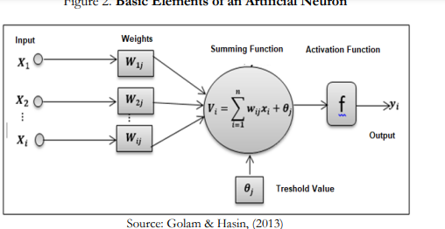

**Figure 1**: Basic Elements of Artificial Neutron

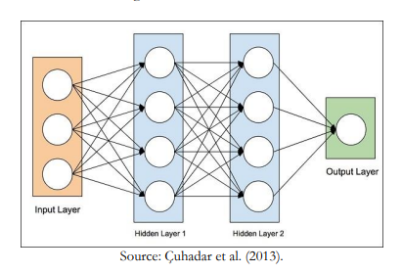

**Figure 2**: An ANNs Model

This fact was cemented by researchers Mamula et al. (2019) who concluded that using ANNs in the Tourism and Hospitality Sector has revolutionised how tourist segments are classified and predicting visitor behaviour. The authors emphasised that ANNs are self-adaptive and learn from experience, making them an ideal tool for demand forecasting in Guyana’s Tourism and Hospitality Sector. Mamula et al. further underpinned that ANNs’ ability to capture subtle functional relationships among data, even if the underlying relationships are unknown or hard to describe, makes them a practical and often the only feasible way to solve real-world problems where data is available but theoretical guesses about the underlying laws are difficult.

Research by Peng et al. (2014) further showed that ANNs can also generalise after learning the data presented to them, making them an excellent alternative method to identify the underlying function of a forecasting model. ANNs are universal functional approximators, meaning they can approximate any continuous function to any desired accuracy as they have more general and flexible applicable forms than traditional statistical methods, making them a valuable tool for identifying explicit relationships for the data series. Furthermore, ANNs are nonlinear and have advantages over traditional linear statistics in forecasting, such as the Box-Jenkins or ARIMA method, assuming that the time series under study is generated from linear processes. However, real-world systems are often nonlinear, and ANNs are well-suited for these systems as they are nonlinear time-series models (Peng et al). For example, Law (2000) and Palmer et al. (2006) used ANN models to analyse the demand for tourism. Law employed the back-propagation model of ANN analysis to investigate the demand for Taiwanese tourists in Hong Kong, while Palmer et al. used the ANN time-series model to predict the consumption of tourists in the Balearic Islands (Spain). Both studies demonstrated that the ANN model could analyse and predict the demand for tourism. Furthermore, the ANN model showed consistent and stable results across different scenarios, making it a reliable prediction model.

However, to achieve long-term success and safeguard sensitive customer data, businesses must take a proactive approach to forecasting, including diversifying forecasting methods by incorporating Machine Learning (ML) algorithms, data analytics, and expert opinions to create a more robust and accurate model. Additionally, it is crucial to regularly educate employees on cybersecurity best practices to mitigate the risk of security breaches. Nonetheless, by implementing these forecasting methods and security measures, businesses can stay ahead of market trends and protect themselves from potential threats. Also, regularly reviewing and updating these strategies will allow companies to adapt to changing circumstances and maintain their competitive edge.

In summary, integrating demand forecasting using ANNs into strategic planning is essential for businesses to make informed decisions regarding resource allocation and investment opportunities, leading to improved operational efficiency and profitability. Moreover, demand forecasting enables businesses to proactively identify potential threats and vulnerabilities and implement appropriate measures to protect their digital assets. Hence, businesses must prioritise demand forecasting using ANNs and invest the necessary resources to ensure success. By doing so, they can stay ahead of the competition and maintain the trust of their customers by safeguarding their sensitive data (Gupta et al., 2023).

# **Using Artificial Intelligence (AI) to Enhance Demand Forecasting**

Ghalehkhondabi et al. (2019) posited that demand forecasting has always been a crucial aspect of the Tourism and Hospitality Sector. The authors further explained that inaccurate predictions of future demand can result in significant loss, regardless of whether the predictions underestimated or overestimated the demand. Based on interviews with business owners/managers, Guyana's Hospitality and Tourism Sector relies only on historical data for demand forecasting, using past trends and patterns to predict future requirements. However, this approach has frequently produced imprecise outcomes. Nevertheless, the sector now requires predictive analysis beyond examining historical sales figures. The sector needs to focus on comprehending consumer behaviour and preferences to enable businesses to customise their strategies to surpass customer expectations.

In light of this study, it is evident that the Sector needs predictive analytics to provide insights that are impossible with traditional methods. As such, Artificial intelligence (AI) and Machine Learning (ML) have transformed demand forecasting. These technologies allow for real-time analysis of market conditions and can reduce network errors by up to 50%. AI-based demand forecasting also enables businesses to monitor every continuum aspect, track movement based on Stock Keeping Unit (SKU) numbers, and identify underperformance. Moreover, AI-based demand forecasting is dynamic and can adapt to changing market conditions, including seasonality and specific times of the year. This flexibility makes it an indispensable tool for businesses that want to stay competitive in an ever-changing Tourism and Hospitality environment.

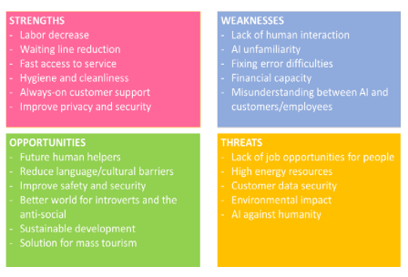

**Figure 3:**SWOT Analysis of AI Technologies in the Hospitality and Tourism Sector

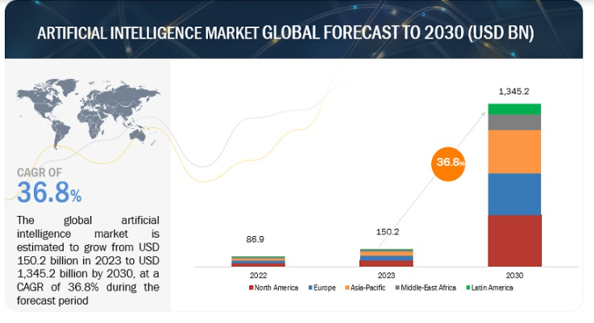**Figure 4:** Artificial Intelligence Market Global Forecast to 2030

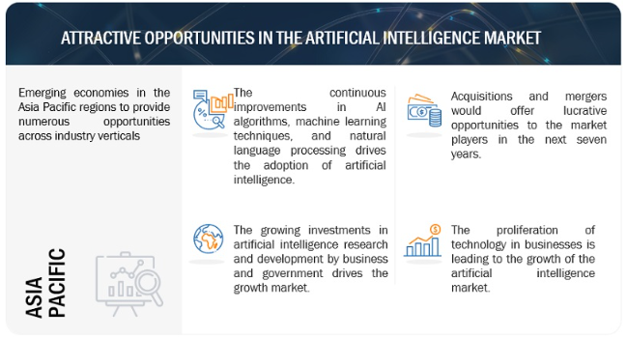

**Figure 5:** Attractive Opportunities in the Artificial Intelligence Market - ASIA PACIFIC

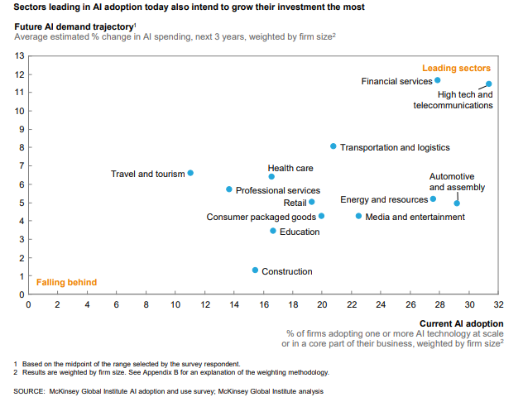

**Figure 6:** AI adopters with a proactive strategy – Source: McKinsey Global Institute AI Adoption and use survey: McKinsey Global Institute Analysis

AI-enabled demand forecasting is revolutionising the Tourism and Hospitality Sector by leveraging AI to refine and optimise the forecasting process. This approach considers many factors beyond past sales data, such as market trends, social media buzz, and online reviews. AI-powered algorithms mine this data, identify patterns, anticipate shifts, and offer predictive insights that traditional models cannot match. This significantly reduces errors by up to 50%, leading to a 65% decrease (Haleem et al., 2022). Furthermore, Yaiprasert and Hidayanto (2023) highlighted that integrating ML amplifies these benefits, offering highly nuanced, accurate, and deeply insightful forecasts. This fact was verified by Akter et al. (2022), who said that ML is particularly adept at tackling challenges posed by new products, in which traditional models need more historical data.

# **AI-powered Demand Forecasting vs Traditional Approaches**

AI-powered forecasting enables businesses to process diverse data streams, including external factors such as holidays, events, and web analytics, and deliver highly accurate predictions for Guyana’s Tourism and Hospitality Sector. However, implementing AI-driven forecasting poses challenges such as diverse data streams and cleaning. In contrast, traditional forecasting methods need more flexibility to adapt to market changes and require manual data processing, leading to limitations in accuracy. To address these challenges, businesses must carefully evaluate their forecasting needs and balance immediate costs and long-term benefits, aligning their approach with the demand profiles of their products. Krenn et al. (2023) stated that ML algorithms evolve by refining predictions with data as they are agile and can quickly incorporate new information, making them adaptable to unpredictable market scenarios. The operational benefits of AI-powered demand forecasting include increased sales, optimal inventory management, higher inventory turnover, and reduced spoilage. Short-term benefits include improved production planning, financial clarity, and focused marketing. Meanwhile, medium- to long-term benefits involve strategic decision-making, streamlined supply chain coordination, informed pricing, and risk management. Furthermore, enhanced customer engagement and organisational efficiency are achievable through AI-powered demand forecasting. Moreover, harnessing data-driven insights can drive business growth, manage risks, and foster a flexible, responsive organisation.

Demand forecasting is crucial for businesses to anticipate market changes and strategise accordingly (Ghalehkhondabi et al.). AI's unique selling points in demand forecasting are dimensionality, scalability, and feedback loop. AI models can analyse more variables than traditional models, including unconventional data types like word embeddings. This numeric representation allows models such as GPT to interpret and process information differently than traditional models.

The contemporary business landscape of the Tourism and Hospitality Sector in Guyana is characterised by a rapid pace of data generation. Therefore, AI-powered demand forecasting is ideal as it can efficiently process vast data volumes spanning terabytes or petabytes. Cloud computing advancements and the rise of data collection have facilitated the digestion, comprehension, and prediction of colossal data sets. Without AI, the massive datasets would splinter across thousands of Excel workbooks, impeding insights and efficiency. Hence, ML plays an integral role in demand forecasting software. However, before developing a demand forecasting model, managers must be familiar with the ML modelling workflow, which ensures a data-driven approach to efficient collaboration with software developers.

The following steps characterise how AI engineers tackle ML demand forecasting tasks: The first step is data review to provide clients with insightful preliminary information. The review involves collating accessible data, reviewing the data's structure, reliability, and consistency, and conducting preliminary data tests. Statistical summaries are examined over a short period to understand the current scenario and suggest potential resolutions.

The second step is to define business goals and success metrics, establishing a project's foundation and direction. Collaboration with clients is crucial in determining success metrics and defining goals, such as predicting demand for specific products over a set duration with a particular accuracy. Factors such as products/categories for forecasting, forecasting duration, and required accuracy level, including MAPE, MAE, and customised metrics, are also determined. The third step is data preparation and understanding, ensuring data quality for a precise forecast. The assessment of data on accuracy, consistency, relevance, and completeness criteria, cleaning, analysing, and restoring any imperfect data, and visualising data to understand trends, seasonality, and irregularities. Data often requires enhancement to achieve the desired readiness level, necessitating data science consultants' expertise.

The fourth step is developing ML models to find the best-fit forecasting algorithm. The activity involves choosing from various ML models, such as ARIMA/SARIMA, Regression models, XGBoost, and LSTM, based on business goals, data type, and forecasting duration. For time-series data, sequential data taken at equal intervals, models like ARIMA or SARIMA are utilised for short-term forecasts, which is beneficial in the Torism and Hospitality Sector. Linear or polynomial regression models are deployed for relationship estimation between variables. For more generalised solutions, ensemble techniques, like Random Forest, are considered. The right model selection depends on the specific business context and available data.

The fifth step is training and deployment, aimed at bringing the model to a production-ready state. The step involves training the model using historical data, validating by optimising model parameters for peak performance, improving by developing multiple models and selecting the most fitting ones, and deploying the forecasting model(s) into operational environments. Setting up a data aggregation pipeline for future AI projects is also advisable, simplifying data preparation and enhancing future forecasting capabilities.

In conclusion, AI-powered demand forecasting can enable businesses to make informed decisions, stay ahead of the competition, and achieve business goals with greater accuracy and speed. The optimisation of the ML forecasting model is crucial, with seasonality recognition being a key consideration in demand planning. Hence, the systematic approach outlined above gives businesses a data-driven approach to predict demand.

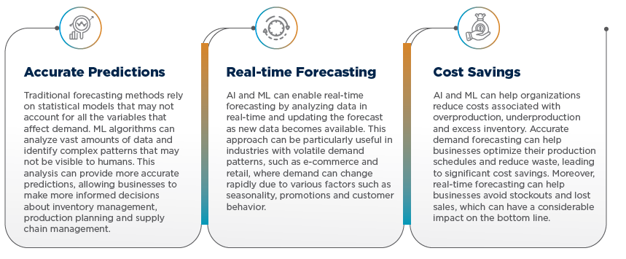

**Figure 7:** Benefits of Artificial Intelligence and Machine Learning in Demand Forecasting

# **Conclusion**

Tourism demand forecasting is becoming increasingly crucial for the Tourism and Hospitality Sectors worldwide. Hence, businesses need to improve demand forecasting performance using ANNs. It must be noted, however, that even though forecasting is crucial for businesses to make informed decisions and adapt to changing market conditions, it is essential to acknowledge that even advanced technologies like blockchain are not entirely immune to security breaches, as demonstrated by events like the Coincheck hack (Zamani et al., 2018). Therefore, continuous monitoring and improvement of forecasting methods and security measures are essential for the long-term success of businesses in this industry (Martínez-Peláez et al., 2023). It is recommended that to reduce reliance on a single approach, the businesses in the Tourism and Hospitality Sector in Guyana should consider diversifying their forecasting methods by incorporating ML algorithms, data analytics, and expert opinions to create a more robust and accurate forecasting model (Petropoulos et al., 2022).

Additionally, regular training and education of employees on cybersecurity best practices can help mitigate the risk of security breaches and ensure the protection of sensitive customer data. By combining these forecasting methods and security measures, businesses can stay ahead of market trends and protect themselves from potential threats. Regularly reviewing and updating these strategies will allow companies to adapt to changing circumstances and maintain their competitive edge in the industry.

In sum, businesses must integrate demand forecasting using ANNs into their strategic planning process to ensure long-term success and safeguard sensitive customer data. By doing so, businesses can proactively identify potential threats and vulnerabilities, allowing them to implement appropriate measures to protect their digital assets (Mizrak, 2023). It can be concluded that by conducting demand forecasting using ANNs, businesses make informed decisions regarding resource allocation and investment opportunities, ultimately improving operational efficiency and profitability (Soori et al., 2023). Additionally, using ANNs in demand forecasting enables businesses to understand customer preferences and behaviour patterns better, leading to more accurate sales projections. This allows businesses to optimise their production and inventory management, reducing costs associated with overstocking or stockouts.

Moreover, by leveraging ANNs for demand forecasting, businesses can gain a competitive advantage by ensuring the timely delivery of products and services, enhancing customer satisfaction and loyalty. Ultimately, integrating ANNs into strategic planning processes improves business performance and strengthens overall cybersecurity measures, fostering trust among customers and stakeholders. Nonetheless, businesses must note that integrating ANNs into strategic planning may lead to an overreliance on technology, potentially neglecting the importance of human intuition and judgment in decision-making. However, it must be noted that using ANNs in strategic planning processes is not meant to replace human intuition and judgment but to augment them. By leveraging the power of AI, businesses can make more informed decisions based on data-driven insights while still considering the expertise and experience of human decision-makers. Additionally, integrating ANNs into strategic planning processes can free up valuable time for employees to focus on more complex and creative tasks, further enhancing overall business efficiency and innovation.

# **Practical Implications**

The study introduces a new and practical approach to demand forecasting for Guyana's Tourism and Hospitality Sector. This approach allows practitioners to incorporate common trends in customers from all markets into neural networks to anticipate the evolution of demand simultaneously for different markets. Since demand is a fundamental force driving the sector’s growth, these findings aim to improve forecasting practices in the hospitality industry and provide new tools for planning purposes to anticipate future demand.

# **Limitations and Future Research**

It is essential to note that this study does have some limitations. Firstly, it would be beneficial to compare different tourist destinations to analyse the extent to which regional differences impact forecasting accuracy. Secondly, in future research, it would be worthwhile to investigate whether combining forecasts from various topologies could improve prediction accuracy. Lastly, it is worth considering whether utilising alternative AI techniques, such as support vector regressions, could enhance the forecasting performance of neural networks.

**References**

Akter, S. et al. (2022). ‘Algorithmic bias in machine learning-based marketing models’, Journal of Business Research, 144, pp. 201–216. doi:10.1016/j.jbusres.2022.01.083.

Chandrasekar, S. (2023). Using AI to enhance sales forecasting, AZoAi. Available at: https://www.azoai.com/article/Using-AI-to-Enhance-Sales-Forecasting.aspx (Accessed: 04 February 2024).

Chhajer, P., Shah, M., & Kshirsagar, A. (2022). The applications of artificial neural networks, support vector machines, and long–short-term memory for stock market prediction. Decision Analytics Journal, 2, 100015. <https://doi.org/10.1016/j.dajour.2021.100015>

Cuhadar, M., Güngör, İ. & Göksu, A. (2009). Forecasting Tourism Demand by Artificial Neural Networks and Time Series Methods: A Comparative Analysis in Inbound Tourism Demand to Antalya. Süleyman Demirel University, Faculty of Economics and Administrative Sciences Journal, 14(1), 99-114.

Haar, J. and Caus, C. (2023). Beyond oil: Guyana’s emerging potential in ecotourism. A column by Jerry Haar and Cristina Caus, Latin Trade. Available at: https://latintrade.com/2023/10/05/beyond-oil-guyanas-emerging-potential-in-ecotourism-a-column-by-jerry-haar-and-cristina-caus/ (Accessed: 03 February 2024).

Haleem, A. et al. (2022). ‘Artificial Intelligence (AI) applications for marketing: A literature-based study’, International Journal of Intelligent Networks, 3, pp. 119–132. doi:10.1016/j.ijin.2022.08.005.

Krenn, M. et al. (2023a). ‘Forecasting the future of artificial intelligence with machine learning-based link prediction in an exponentially growing knowledge network’, Nature Machine Intelligence, 5(11), pp. 1326–1335. doi:10.1038/s42256-023-00735-0.

Li, S. et al. (2018). ‘Effective tourist volume forecasting supported by PCA and improved BPNN using Baidu Index’, Tourism Management, 68, pp. 116–126. doi:10.1016/j.tourman.2018.03.006.

OilNOW (2024) Record-breaking 2023 visitor influx to Guyana equates to 40% of the country’s population, OilNOW. Available at: https://oilnow.gy/featured/record-breaking-2023-visitor-influx-to-guyana-equates-to-40-of-countrys-population/#:~:text=With%20growing%20appeal%20as%20a,substantial%2010.7%25%20increase%20from%202022. (Accessed: 03 February 2024).

Palmer, A., Jose Montano, J. J., & Sese, A. (2006). Designing an artificial neural network for forecasting tourism time series. Tourism Management, 27, 781–790. doi:10.1016/j.tourman.2005.05.006, <http://dx.doi.org/10.1016/j.tourman.2005.05.006>

Peng, B., Song, H. & Crouch, G.I. (2014). "A meta-analysis of international tourism demand forecasting and implications for practice", Tourism Management, Vol. 45, pp. 181–193.

Petropoulos, F. et al. (2022e) ‘Forecasting: Theory and practice’, International Journal of Forecasting, 38(3), pp. 705–871. doi:10.1016/j.ijforecast.2021.11.001.

Pereira, L. N. (2016). An introduction to helpful forecasting methods for hotel revenue management. *International Journal of Hospitality Management*, *58*, 13–23. <https://doi.org/10.1016/j.ijhm.2016.07.003>

Farida, I. and Setiawan, D. (2022). ‘Business strategies and competitive advantage: The role of Performance and Innovation’, Journal of Open Innovation: Technology, Market, and Complexity, 8(3), p. 163. doi:10.3390/joitmc8030163.

Ghalehkhondabi, I., Ardjmand, E., Young, W.A. and Weckman, G.R. (2019). "A review of demand forecasting models and methodological developments within tourism and passenger transportation industry", Journal of Tourism Futures, Vol. 5 No. 1, pp. 75-93. https://doi.org/10.1108/JTF-10-2018-0061

Goh, C. & Law, R. (2011). The Methodological Progress of Tourism Demand Forecasting: A Review of Related Literature. Journal of Travel & Tourism Marketing, 28(3), 296–317. doi:10.1080/10548408.2011.562856

Golam, K. & Hasin, M.A.A. (2013). Comparative Analysis of Artificial Neural Networks and Neuro-Fuzzy Models for Multicriteria Demand Forecasting. International Journal of Fuzzy System Applications, 3(1), 1-24. doi: 10.4018/ijfsa.201301010

Gupta, S. et al. (2023). ‘Identification of benefits, challenges, and pathways in E-commerce industries: An integrated two-phase decision-making model’, Sustainable Operations and Computers, 4, pp. 200–218. doi:10.1016/j.susoc.2023.08.005.

Law, R. (2000). Back-propagation learning in improving the accuracy of neural network-based tourism demand forecasting. Tourism Management, 21, 331–340. doi:10.1016/S0261-5177(99)00067-9,http://dx.doi.org/10.1016/S0261-5177(99)00067-9

Martínez-Peláez, R. et al. (2023). ‘Role of digital transformation for achieving sustainability: Mediated role of stakeholders, key capabilities, and Technology’, Sustainability, 15(14), p. 11221. doi:10.3390/su151411221.

Mizrak, F. (2023). ‘Integrating cybersecurity risk management into Strategic Management: A comprehensive literature review’, Pressacademia [Preprint]. doi:10.17261/pressacademia.2023.1807.

Mamula, M., Folgieri, R., & Duvnjak, K. (2019). Some considerations about artificial neural networks in hotel industry: State of the art and future developments. Tourism in Southern and Eastern Europe. https://doi.org/10.20867/tosee.05.8

Reynolds, D., Rahman, I. & Balinbin, W. (2013). “Econometric modelling of the US restaurant industry”, International Journal of Hospitality Management, Vol. 34, pp. 317-323

Soori, M., Arezoo, B. and Dastres, R. (2023). ‘Artificial Neural Networks in supply chain management, a review’, Journal of Economy and Technology, 1, pp. 179–196. doi:10.1016/j.ject.2023.11.002.

Wu, D.C., Song, H. & Shen, S. (2017). ‘New developments in tourism and Hotel Demand Modeling and Forecasting’, International Journal of Contemporary Hospitality Management, 29(1), pp. 507–529. doi:10.1108/ijchm-05-2015-0249.

Yaiprasert, C. and Hidayanto, A.N. (2023). ‘AI-Driven ensemble three machine learning to enhance digital marketing strategies in the Food Delivery Business’, Intelligent Systems with Applications, 18, p. 200235. doi:10.1016/j.iswa.2023.200235.

Zamani, E., He, Y. & Phillips, M. (2018). ‘On the blockchain security risks’, Journal of Computer Information Systems, 60(6), pp. 495–506. doi:10.1080/08874417.2018.1538709.