**Pedro Guadiana**

**UD75184HSa84363**

COURSE NAME:

**FEP622 Fundamentals of Epidemiology**

Assignment Title:

**Fundamentals of epidemiology in the pandemic of COVID-19 in Mexico**

**A glance from March 2020 to August 2023**

ATLANTIC INTERNATIONAL UNIVERSITY

**01/2024**

Contents

Introduction 3

The Research Pyramid Model of Six Levels to study the Fundamentals of Epidemiology 6

Level 1. Exploratory level 9

Level 2. Descriptive 11

Level 3. Relational 18

Level 4. Explanatory 21

Level 5. Predictive 23

Level 6. Applicative 28

Conclusion 36

Works Cited 38

# Introduction

According to the University of Pécs Faculty of Health Sciences, epidemiology is the “study of the distribution of health-related conditions or events and the factors influencing their occurrence in a particular population and the application of its results in the treatment of health problems” (Boncz, Imre, and Réka Vajda, Zsuzsanna Kívés 12) that involves one of the maximum interventions of the Public Health systems, whose mission is “preventing disease, prolonging life, and promoting health and efficiency through organized community efforts” (Charles-Edward and Amory Winslow, qtd. in Kemper n.pag.).

A pandemic is the highest level of diseases dissemination. The other levels are endemic and epidemy. And, as we know, from the end of 2019 until now, the world has suffered the pandemic of COVID-19 caused by the coronavirus SARS-CoV-2.

This pandemic surged in China, concretely in Wuhan city, and was expanded asynchronously worldwide. SARS-CoV-2 has had many mutations and has affected the world in different ways. The World Health Organization (WHO) declared COVID-19 as a pandemic on March 11th of 2020 (Cucinotta, Domenico, and Maurizio Vanelli 157).

Regardless of its shared etiology -causes or set of causes- every country has additional conditions or causes depending on their economies, geography, health systems, nutritional habits, and lifestyles. That’s the reason why the rates of prevalence, incidence, and lethality are different among the countries and inside of them. The same happens with research, from the basic research to the applied research, also called intervention: there is a general guide, but its way of application in every country depends on the mentioned factors.

This research is based on The SINCIE Model, that belongs to Hispanic Society of Scientific Researchers (SINCIE, according to its acronym in Spanish), because is one of the few phenomena that goes through its six levels of research in a short period: 1) exploratory, 2) descriptive, 3) relational, 4) explanatory, 5) predictive, and 6) applicative or intervention. Following this model, we can clarify how the fundamentals of epidemiology have taken place during the pandemic of COVID-19 in Mexico from March 2020 to August 2023. When is needed, we make comparisons with the world.

As a preview, we can say that the Exploratory level is worked when an event, in this case a sickness, is totally new. Descriptive level tells us its name and definition, its historic and current behavior and evolution. Relational level shows us how its variables are associated. Explanatory level gives us its causes and effects. Predictive level allows us to know which can be the future behavior and development of the phenomena. Applicative or Intervention level refers to all the implemented actions to face the event.

We chose the period from March 2020 to August 2023 for the following reasons: 1) On May 5 of 2023 the World Health Organization (WHO) declared the end of pandemic not of COVID-19, 2) We must wait official reports from Health Public System from Mexico. These reports were published in the third quarter of 2023, and 3) We started gathering and processing information since September. Besides, it is necessary to say that the author of this paper lost his job in August of 2023. That means he had to combine his time between searching for a job and doing this assignment.

We can find the fundamentals of epidemiology definitions on the right margin of this paper and their role in the pandemic is developed on the paper’s body. These concepts are not grouped alphabetically on the mentioned right margin, but by topics according to the studied levels of research.

# The Research Pyramid Model of Six Levels to study the Fundamentals of Epidemiology

Glossary of terms used in this research

**Public Health**. “*The science and act of preventing diseases, prolonging life, and promoting health and efficiency through organized community efforts” (Charles-Edward Amory Winslow, qtd. in Kemper n.pag.).*

**Epidemiology**. *“Study of the distribution of health-related conditions or events and the factors influencing their occurrence in a particular population and the application of its results in the treatment of health problems”* *(Boncz, Imre, and Réka Vajda, Zsuzsanna Kívés 12).*

**Disease***. “An abnormal condition of a part, organ, or system of an organism resulting from various causes, such as infection, inflammation, environmental factors, or genetic defect, and characterized by an identifiable group of signs, symptoms, or both” (The American Heritage Medical Dictionary n.pag.).*

**Morbidity***. “Frequency of a particular disease observed in a given population. General formula: number of patients in one year / average number of inhabitants in the same year × 100,000” (Boncz, Imre, and Réka Vajda, Zsuzsanna Kívés 17).*

The SINCIE Model of the Hispanic Society of Scientific Researchers, whose director is Doctor José Supo, has an important influence and prestige in Latin America. It has tens webinars on YouTube, teaches and certifies research programs in both personal and online modalities. It has created a structured, logical, sequential, and articulated model based on important Latin American researchers and philosophers. Its main theses and contributions are based on six levels of the research pyramid.

Figure 1. The six levels Research Pyramid and their main characteristics

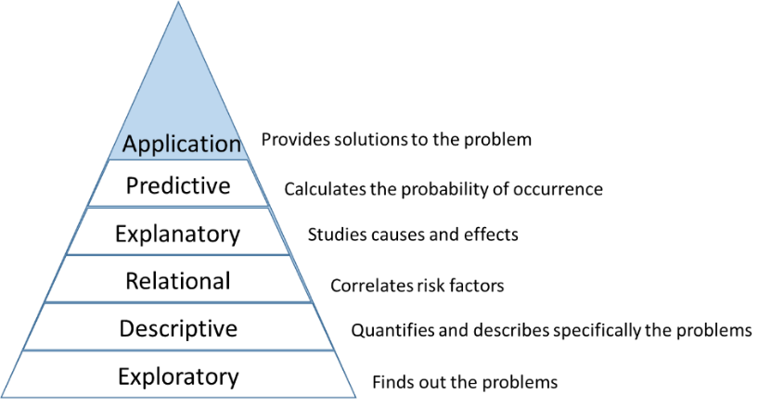

Source. Own elaboration based on SNCIE Model

Its six levels are worked transversally in reality. For instance, intervention or application level (the highest of the pyramid) is worked from the beginning. With the little information that was known about the pandemic, the first actions were taken. When the new sickness was being explored (first level), the world started applying simple test consisted if people had traveled to China. Once The WHO declared COVID-19 as a pandemic on March 11th of 2020, the intervention (sixth level) improved as more progress on research was made. Then, more actions of intervention were implemented in Mexico, such as flattening the curve by lockdown, healthy distancing, handwashing, wearing masks, covering sneezing and coughing, greets safely, hospital reconversion and vaccination.

Figure 2. The Research Pyramid. Variables per level

**Comorbidity**. Disease(s) that coexist(s) in a study participant in addition to the index condition that is the subject of study. *(*A dictionary of epidemiology *52).*

**Incidence**

*Incidence compares the number of new patients observed over a period of time to the average number of the population at risk over a given period.* (*Boncz, Imre, and Réka Vajda, Zsuzsanna Kívés 17).*

**Cumulative incidence**. It is calculated for a period of time and the number of new patients is measured for the same time interval. For example, if the follow-up is annual, we compare it to the mid-year population. (*Boncz, Imre, and Réka Vajda, Zsuzsanna Kívés 18).*

Source. Own elaboration based on SNCIE Model

**Prevalence**

*A measure of disease occurrence; in fact, a measure of the occurrence of any type of health condition, exposure, or other factor related to health (e.g., prevalence of depression, of smoking): the total number of individuals who have the condition (e.g., disease, exposure, attribute) at a particular time (or during a particular period) divided by the population at risk of having the condition at that time or midway through the period. When used without qualification, the term usually refers to the proportion of individuals in a population who have the condition at a specified point in time (point prevalence). It is a proportion, not a rate. (*A dictionary of epidemiology *223).*

**Point prevalence**. “*The number of patients at a given time is compared to the number of the population. Therefore, it is always a specified number of patients at a specific time (e.g. January 1 or December 31) that is used”* (*Boncz, Imre, and Réka Vajda, Zsuzsanna Kívés 18).*

**Duration prevalence**. “*It measures the number of patients over a given period of time (e.g. one year, two months)”* (*Boncz, Imre, and Réka Vajda, Zsuzsanna Kívés 18).*

Each level has different connotations. It is not just a question of names. Their treatment, operation, analysis are quite different.

This pyramid is the guide of the present assignment.

# Level 1. Exploratory level

**Exposure** *(A dictionary of epidemiology 104).*

1. *“The variable whose causal effect is to be estimated. Examples of exposures assessed by epidemiological studies are environmental and lifestyle factors, socioeconomic and working conditions, medical treatments, and genetic traits.”*
2. *Proximity and/or contact with a source of a disease agent in such a manner that effective transmission of the agent or harmful effects of the agent may occur.*
3. *The amount of a factor to which a group or individual was exposed; sometimes contrasted with dose, the amount that enters or interacts with the organism.*
4. *The process by which an agent comes into contact with a person or animal in such a way that the person or animal may develop the relevant outcome, such as a disease.*

Exploratory level finds out the problems. It means discovering something for the very first time. We are always capable of finding information in some place in the world by making analogies or find things alike. An accurate example is COVID-19. Nobody knew anything about it. Scientists suspected it was a kind of Coronavirus, but it was not SARS-CoV-1. It was alike. According to Jose Supo, the World Health Organization (WHO) took approximately six months in naming the new virus as SARS-CoV-2, which means Severe Acute Respiratory Syndrome Coronavirus 2 (World Health Organization n.pag.) as the cause of COVID-19 (Coronavirus Disease of 2019), where CO stands for corona, VI is for virus, D is for disease, and 19 for 2019, the year in which the new illness appeared.

In this level is not possible yet to make statistical analysis, projections, trends, etcetera. However, scientists start monitoring to find patterns, such as main symptoms, making first comparisons to identify similarities and differences, doing first tests referred only to trips from and to Chine, number of personal contacts, ways of transmission, speed of contagious, number of people infected in certain periods of time, among other findings.

**R0, pronounced “R naught.”** It is a mathematical term that indicates how contagious and infectious disease is. It’s also referred to as the reproduction number. As an infection is transmitted to new people, it reproduces itself (Luisiana State University n.pag.).

**Lethality**. It measures the rate of death relative to the number of people suffering from a given disease(*Boncz, Imre, and Réka Vajda, Zsuzsanna Kívés 19).*

**Mortality**. Mortality refers to the frequency of deaths observed in a given population. (*Boncz, Imre, and Réka Vajda, Zsuzsanna Kívés 19).*

**Mutation**. “*A mutation refers to a single change in a virus’s genome (genetic code). Mutations happen frequently, but only sometimes change the characteristics of the virus” (**Centers for Disease Control and Prevention n.pag.).*

This stage is characterized by gathering the most possible information. Once the quantitative and qualitative data is processed, is possible to work on the next levels of research.

# Level 2. Descriptive

**Lineage**. “*A lineage is a group of closely related viruses with a common ancestor. SARS-CoV-2 has many lineages; all cause COVID-19” (Centers for Disease Control and Prevention n.pag.).*

**Sublineage**. “*A term used to define a lineage as it relates to being a direct descendent of a parent lineage. For example, BA.2.75 is a sublineage of BA.2” (Centers for Disease Control and Prevention n.pag.).*

**Variant**. “*A variant is a viral genome (genetic code) that may contain one or more mutations. In some cases, a lineage or group of lineages with similar genetic changes, may be designated by the World Health Organization (WHO) or the U.S. SARS-CoV-2 Interagency Group (SIG) as a* ***Variant of Interest (VOI), Variant of Concern (VOC), Variant of High Consequence (VOHC) or Variant Being Monitored (VBM) due to shared attributes and characteristics that may require public health action****” (Centers for Disease Control and Prevention n.pag.).*

**Basic types of epidemiological indicators**

**Proportion** “describes the ratio of the value of a variable to an integer. The formula = A / N, where A is the fraction of N, can be expressed in %” (*Boncz, Imre, and Réka Vajda, Zsuzsanna Kívés 16).*

Level descriptive gives details of the research core. In this case, knowing features, similarities and differences between SARS-CoV-2 and its predecessor SARS-CoV-2 is needed. In this level, COVID-19 is the interest variable and the rest, contained in Table 1, columns 1 and 2, are named characterization variables. We worked this level as it follows:

First, we must clarify that COVID-19 is part of a group of diseases that share some features with other ones but have their own characteristics. In 2002, 2012 and 2019 there have occurred events related with a high morbidity and population mortality provoked by SARS-CoV-1 (Severe Acute Respiratory Syndrome Coronavirus), MERS-CoV (Middle East Respiratory Syndrome Coronavirus), and SARS-CoV-2.

Second, we needed to make a comparison between SARS-Cov-1 and SARS-CoV-2 to describe their similarities and differences.

Table 1. Comparison between main variables of SARS and COVID-19



Sources. Own information with data from:

1 Fung, Sing and Ding Xiang. “Similarities and Dissimilarities of COVID-19 and Other Coronavirus Diseases.” The USA. Annual Reviews. 2021.

2 Rodríguez, Marisleidy, and Ceylin León. “Similitudes y diferencias entre el síndrome respiratorio agudo severo causado por SARS-CoV y la COVID-19.” Cuba. Revista Cubana de Pediatría. 2020.

3 Centers for Disease Control and Prevention. “Long COVID or Post-COVID Conditions.” < https://www.cdc.gov/coronavirus/2019-ncov/long-term-effects/index.html>.

4 World Health Organization. WHO COVID-19 dashboard. <https://data.who.int/dashboards/covid19/cases?n=c>.

5 Matt, Anthony. “A reprieve from COVID-19, but the threat remains.” The USA. Essentia Health. 2022. <https://www.essentiahealth.org/about/essentia-health-newsroom/a-reprieve-from-covid-19-but-the-threat-remains/#:~:text=4%2F5%20strains%20have%20a,SARS%2DCo%2DV2%20virus.>.

6 Worldometer. Countries where COVID-19 has spread. <https://data.who.int/dashboards/covid19/cases?n=c>.

Note 1: Image of note 4 taken on August 16th that supports data of note 4.

Note 2. Image of note 6 taken on August 25th that supports data of note 6.

The information on table 1 gives us very important information.

**Ratio** “compares the frequency of a variable’s value with another variable’s value. Formula = A / B, where A is not part of B” (*Boncz, Imre, and Réka Vajda, Zsuzsanna Kívés 16)*.

**Rate.** “A measure of the value of a variable relative to another measured quantity. Shows the rate at which events accumulate” (*Boncz, Imre, and Réka Vajda, Zsuzsanna Kívés 16)*.

|  |  |  |
| --- | --- | --- |
|  | Numerator | Denominator |
| Proportion | persons with a particular disease | all people (with or without a disease) |
| Ratio | persons with a particular disease | people free of a specific disease |
| Rate | persons with a given disease at  a given time | all people (with or without a disease)  at a given time |

**Epidemiological surveillance**. the systematic collection, analysis, interpretation and timely dissemination of health data for the planning, implementation and evaluation of public health programmes. The application of these data to disease-prevention and health-promotion programmes completes a surveillance cycle in public. (Thacker, Stephen. A. Gibson Parrish, Frederick L. Trowbridgeb, and Surveillance Coordination Group 1)

The main similarities are both viruses were detected first in China; they came possibly from bats; they are transmitted by direct contact person to person and indirectly by contaminated objects, they share symptoms such as fever, headache, myalgia, chills, diarrhea, dry cough, shortness of breath; also, they share these complications: encephalitis, ischemic stroke, and acute symptomatic chills.

In contrast, SARS dissemination was much less than COVID-19 (32 versus 229 countries, 14% versus 97%), as was its contagiousness (R0 = 3 versus a wide R0 range that went from 1.5 to 18.6). This means SARS-CoV-2 mutations were becoming less mortal, but they have reached many more people. In the specific case of Mexico, R0 was equal 2 at the beginning, but reached 15 at the end of 2022. Despite the SARS pandemic lasted 8 months compared to 4 years (still going) of COVID-19, it was almost 11 times more lethal than COVID-19 in relative terms, but much less lethal in absolute terms. The SARS lethality (rate of death relative to the number of people suffering this disease) was 10.8% versus 0.9% of COVID-19 in relative terms, but this less percentage disseminated in 97% of the Earth countries has meant 6,995 497 deaths versus 916 deaths occurred in 32 countries. In what concerns to male to female ratio, the SARS affected more women than men (1.25 women for each man), and COVID-19 affected more men than women (2.7 men for each woman). On its part, COVID-19 has more symptoms and complications than SARS: besides their shared symptoms, COVID-19 additional symptoms are rhinorrhea, vomiting, fatigue, smell and taste disturbances, brain fog, chess pain, dizziness when standing up, pins- and-needles, depression and/or anxiety, rash, changes in menstrual cycles. Among the additional complications that COVID has, we can mention the following: acute respiratory distress syndrome, neurological complications: acute necrotizing, encephalopathy, ischemic stroke, acute symptomatic crisis, ataxia, neuropathic type pains, postinfectious myelitis; cardiac complications: acute-onset heart failure, myocardial infarction, myocarditis, heart attack; hematological complications: hypercoagulability, thrombotic microangiopathy, immune thrombocytopenic purpura, pulmonary embolism, ophthalmological complications: dry eye, blurry vision, foreign body sensation, conjunctival congestion; kidneys complication: acute renal failure.

**Lockdown**. “A temporary condition imposed by governmental authorities (as during the outbreak of an epidemic disease) in which most people are required to refrain from or limit activities outside the home involving public contact (such as dining out or attending large gatherings)” (Merriam Webster dictionary n.pag.).

**Flattening the curve**. Refers to a strategy adopted to slow down and spread out the outbreak dynamics. FTC is a succinct way of communicating an important public health message that physical distancing and other public health measures will reduce the peak number of cases (Aslah, Auni 40).

**Vaccination**. Strictly speaking, vaccination refers to inoculation (from Latin in oculus, into a bud) with vaccinia virus against smallpox. Nowadays the word is broadly used synonymously with procedures for immunization against all infectious disease. The original use of the word was confined to vaccination against smallpox. This was the first method of preventing a lethal disease by immunizing humans. It was introduced by Edward Jenner (1749–1823). Jenner’s discovery led to the worldwide eradication of smallpox. Immunization is a more semantically and etymologically correct word than vaccination *(*A dictionary of epidemiology *287).*

Finally, another big difference is the absence of asymptomatic individuals in the SARS pandemic, in comparison with the surprising, sudden, unexpected, high, and critical presence of asymptomatic people in COVID-19 pandemic. This implied an additional challenge and was a reason of fear and uncertainty for the world population. Jose Supo, the SINCIE principal, made an explanation that could help us to understand an important part of this phenomenon: when the virus enters in our body, we are infected; if we are infected, there are two possibilities: either we can develop symptoms, or we cannot, it means we can be asymptomatic. In both cases, we will most likely transmit the virus. The presence of asymptomatic patients ranged from 25 to 40% on average in the world. To understand better the asymptomatic patients’ roll, we need to know the prevalence data: the occurrence of people with COVID-19 (confirmed cases) related to at-risk population. In Mexico, this measurement is also called “positivity”, “positivity index” or “positive cases”, and is represented either in proportion or percentage. Mexican Public Health System authorities have said phenomena such as COVID-19 are immeasurable. Thus, they cannot be directly measured, but they can be calculated by approximation through interviews and direct observation, which means there will be a margin of error. A representative survey called Health and Nutrition National Survey (ENSANUT, according to its acronym in Spanish) conducted from August to November of 2020 determined that 70% of “positive cases” were asymptomatic (Capital 21 n.pag.). National Population and Housing Census 2020 informed that Mexico had more than 126 million of inhabitants. Of this population, about 100 million were the at-risk population.

Figure 3. How Mexico determined the number of asymptomatic people

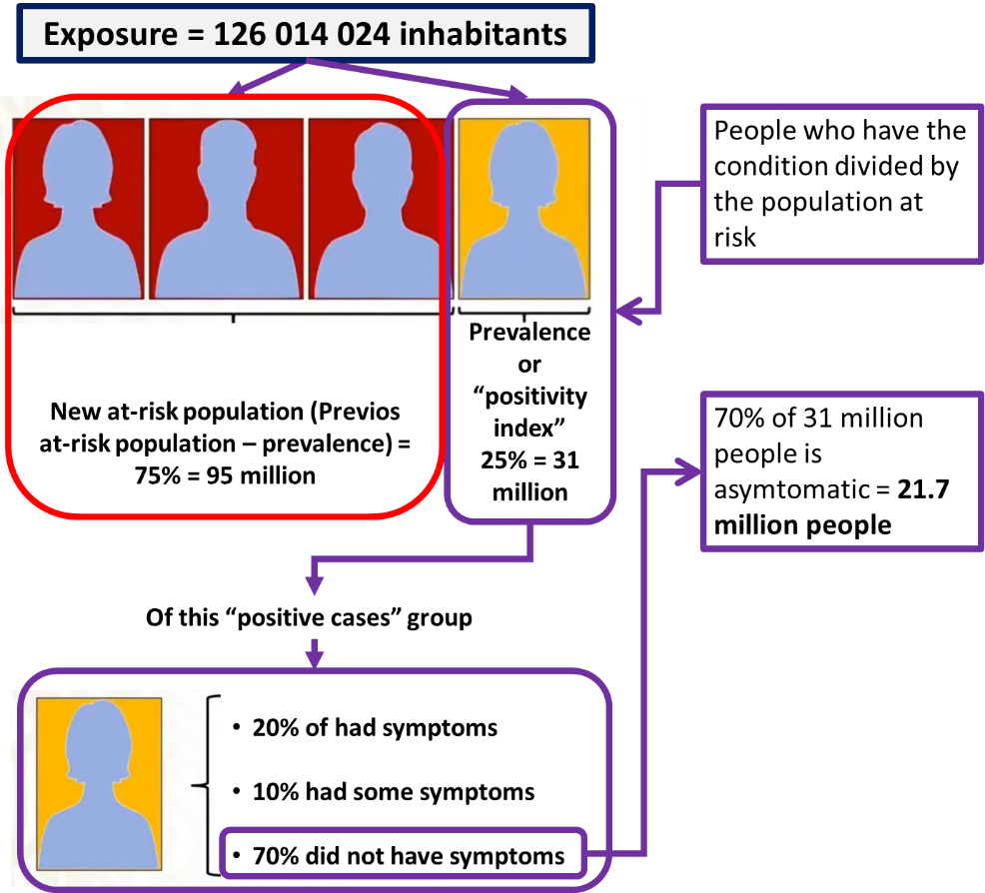

Source. Own calculation with images of Capital 21

Now, it is time to go next level.

# Level 3. Relational

Figure 4. Variables belonging to levels 3 and 4 of research

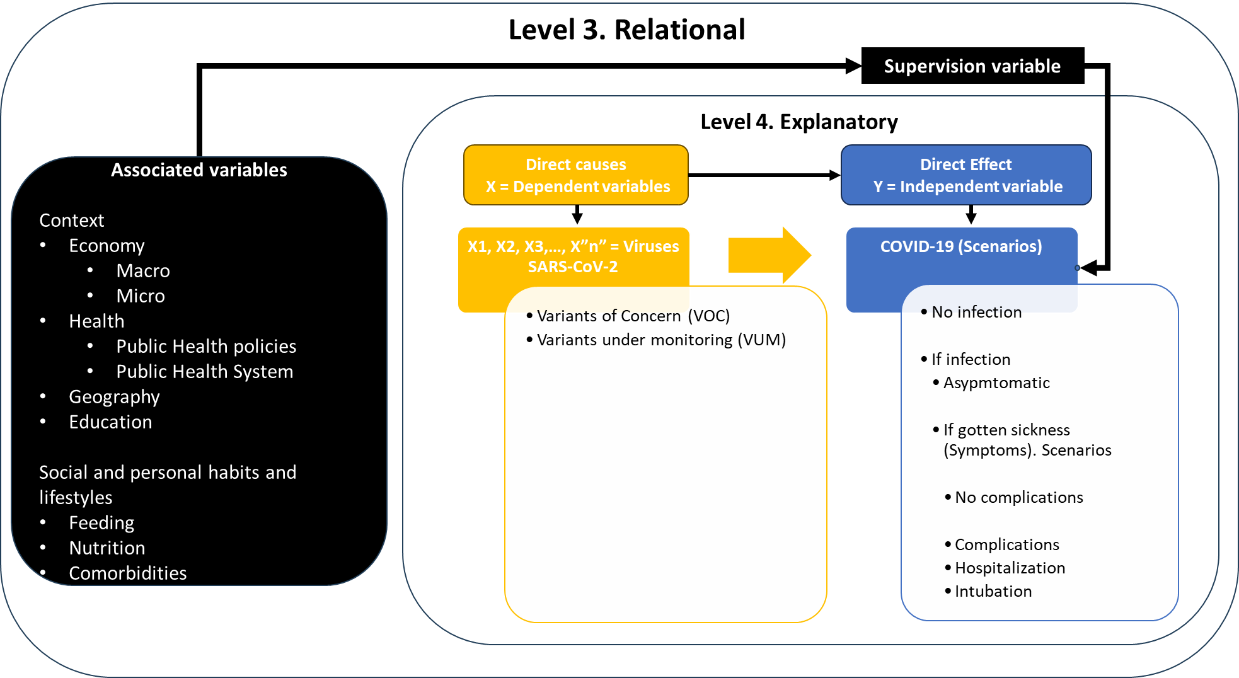

Source. Own elaboration

The correlational level shows associated variables to main disease. In Mexican case, talking about four comorbidities that make it harder to deal with COVID-19 is quite important. The report “Global prevalence and effect of comorbidities and smoking status on severity and mortality of COVID‑19 in association with age and gender: a systematic review, meta‑analysis and meta‑regression” (National Library of Medicine n.pag.), which is a compilation of 190 studies comprising 105 million COVID-19 patients, says the main comorbidities associated to COVID-19, and their prevalence are: obesity, 27%; diabetes, 27%; hypertension, 39%; and smoking, 15%. In Mexico, these comorbidities had a severe impact in deaths. The most affected population is 60 and more years old. More than 50% of the deceased in this range of age had hypertension, 40% had diabetes, 18% had obesity, and less than 10% were smokers (Graphic 1).

Graphic 1. Distribution of cumulative COVID-19 deaths in older adults associated with the four main comorbidities in Mexico from 2020 to Epidemiological Week (EW) 26 (Jul 1st), 2023.

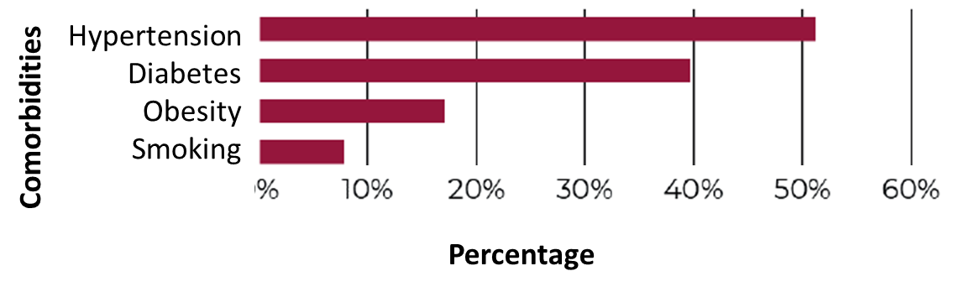

Source. Secretaría de Salud. Informe integral de COVID-19 en México. México, No. 02-2023. 1º de julio de 2023.

Unfortunately, many deceased had one or more comorbidities (Graphic 2):

Graphic 2. Distribution of deaths by COVID-19 in older adults by number of comorbidities in Mexico from 2020 to SE 26 of comorbidity in Mexico from 2020 to EW 26 (Jul 1st) of 2023

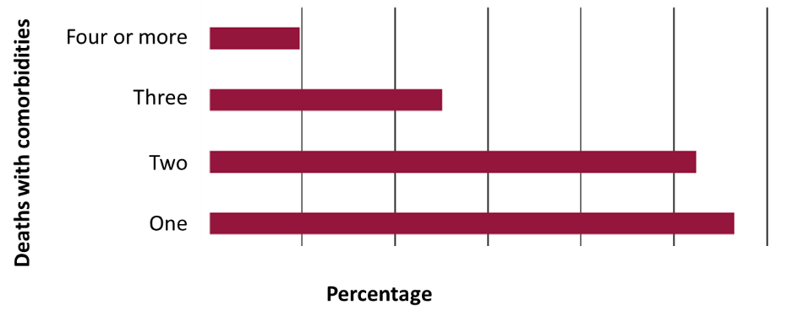

Source. Secretaría de Salud. Informe integral de COVID-19 en México. México, No. 02-2023. 1º de julio de 2023.

In level 3, COVID-19 is the supervision variable and comorbidities are associated variables but, frequently, people confuse this level with the correlational one. In the third level we talk about how comorbidities make it harder for us to deal with COVID-19, but we did not mean that COVID-19 is caused by them. Level 4 is about causes and effects. Hypertension, diabetes, obesity, and smoking are highly related to COVID-19, but they are not its causes. For instance, smoking is one important cause of lung cancer, but is not a cause of COVID-19. Its main cause is SARS-CoV-2, but its occurrence is connected to other factors that are a sort of indirect causes that must be proved like determinants, in other word: causes.

Even though the study “Determinants of COVID‑19 cases and deaths in OECD countries” mixes causes and determinants (level 4) with correlation (level 3), feeding unwittingly the confusion between associated (level 3) and causative (level 3) variables, it goes further the disease itself by enlarging its analysis spectrum to economy, health systems, and public policies. According to this study (Determinants 4):

“It is determined that there is a significant and very high correlation between current health expenditure (%) of Gross Domestic Product (GDP) and government expenditure (%), health expenditures per capita, also between nurses per 1000 people and health expenditures per capita (r > 0.80, p = 0.00). The conclusion is that there is a significant and high correlation between intensive care beds per 1000 people and hospital beds per 1000 people... Results of the analysis: health expenditures per capita which is very highly correlated with government expenditure (%), current health expenditure (%) of GDP which is highly correlated with health expenditures per capita, and intensive care beds per 1000 people which is highly correlated with hospital beds per 1000 people are excluded from the variables.”

# Level 4. Explanatory

Figure 5. Variables belonging to level 4 of research (extracted and extended from figure 4)

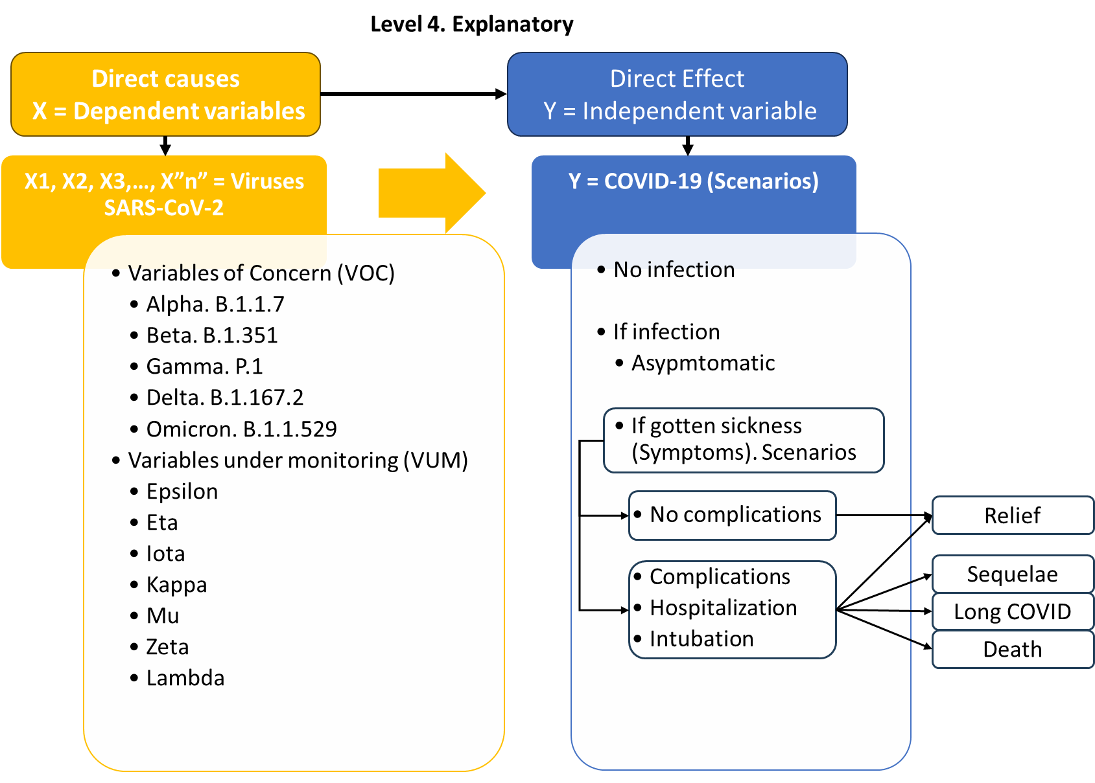

Source. Own elaboration.

Note 1: “In general terms, the epidemiological classification of the variants follows the SARS-CoV-2 Interagency Group (SIG), identifying variants of concern (VOC), variants of interest (VOI), variants under monitoring (VUM), and variants of high consequences (VOHC). Currently, there are neither VOHC nor VOI; only VOC and VUM are considered” (Ortega, Miguel, Cielo García, Oscar Fraile, Paolo Colet, Ardak Baizhaxynova, Kymbat Mukhtarova, Melchor Alvarez-Mon, Kaznagul Kanatova, Angel Asúnsolo, and Antonio Sarría-Santamera n.pag.).

Note 2: The VUM list was gathered from “Variantes genéticas del SARS-CoV-2 y sus implicaciones clínicas”, Cuba, 2021, n.pag.

As we can see (Figure 5), independent and dependent variables belong to Explanatory level. SARS-CoV-2, the main cause of COVID-19, is a set of variants or specific causes. All of them are independent variables. “A variant is a viral genome (genetic code) that may contain one or more mutations” (Centers for Disease Control and Prevention n.pag.). Based on their shared attributes, the WHO has classified them in two groups, “considering several features like transmissibility, detrimental change in epidemiology, virulence pattern, therapeutics escape, immune escape, antibody or vaccine escape” (Bhattacharya, Manojit, Srijan Chatterjee, Sang-Soo Lee, Kuldeep Dhama, and Chiranjib Chakraborty n.pag.). These groups are: 1 variables of Concern (VOC), and 2) variables under monitoring (VUM). VOCs are (Bhattacharya, Manojit, Srijan Chatterjee, Sang-Soo Lee, Kuldeep Dhama, and Chiranjib Chakraborty n.pag.): “Alpha (Origin: UK, lineage: B.1.1.7), Beta (Origin: South Africa, lineage: B.1.351), Gamma (Origin: Brazil lineage: P.1), Delta (Origin: India lineage: B.1.617.2)”… and “Omicron” (Origin: Botswana lineage: B.1.1.529), belongs to VOC due to its “transmissibility, immune escape, antibody or vaccine escape” (Bhattacharya, Manojit, Srijan Chatterjee, Sang-Soo Lee, Kuldeep Dhama, and Chiranjib Chakraborty n.pag.). VUM are Epsilon, Eta, Iota, Kappa, Mu, Zeta, and Lambda.

On its part, dependent variable COVID-19 is also a set of effects, even possible scenarios, from no infection to death. As we said (Figure 5) if we are infected. we can be asymptomatic or fall sick; in this case, we develop symptoms that can lead us to no complications and be relieved, or having complications, being hospitalized, or being intubated. In any of the last three cases, we can be relieved, have sequelae, have long COVID or die.

# Level 5. Predictive

Predictive level is about visualizing future scenarios and working to build the most feasible. At this point, the General Timeline (Figure 6)-a tool of the Structured Thinking Corpus belonging to the Knowledge and Management Model that we worked on our first assignment of this doctorate in Public Health- is quite useful.

Figure 6. General Timeline for Strategic Planning

Source. Own elaboration based on Serbolov, Yuri comp. ed. and author. *Modelo Universal de Gestión del Conocimiento y Percepción Prospectivo Estratégico*. México, 2008. Digital file. Indautor 03-2008-081511360200-01.

As we said in our first assignment (Serbolov n.pag.), the present or current situation is like a photograph. Paste narrative is like telling the movie or story on how we have arrived to current, concrete and specific situation. The future is the set of possible future movies or scenarios we can reach as results of planning and taking actions.

Variables of this level are called: Variable to Predict (COVID-19) and Predictor Variable (all mentioned in precedent levels).

Before going to timeline, we give an example of how predictive level 5 works because many times it is a result coming in part from the timeline. On table 2 we can see the main scenarios visualized in April 2020 when the main expectation was around the production of vaccines.

Table 2. Scenarios related to COVID-19 vaccines visualized in April 2020

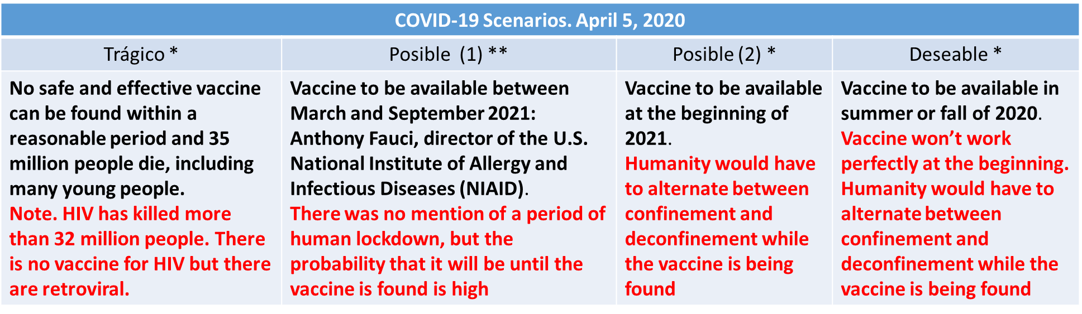

Source. Report (translated title) “When will the coronavirus vaccine be ready? Out of 3 scenarios, only one is good.” Online Mexican magazine Sin embargo.mx, April 5, 2020, https://www.sinembargo.mx/05-04-2020/3762164.

Notes.

1. Even though this publication refers to 3 scenarios pf the magazine Naked Science (*), it speaks about a fourth scenario mentioned by Anthony Fauci (**).

2. Data of March 18th of 2021: Globally, as of 4:53pm CET, 18 March 2021, there have been 120,915,219 confirmed cases of COVID-19, including 2,674,078 deaths, reported by WHO. As of 16 March 2021, a total of 363,691,238 vaccine doses have been administered. https://covid19.who.int/

Based on the information of Table 2, the scenario predicted in April 2020 eight months in advance that came closest to reality was "possible (2) *"

In this level, COVID-19 is called variable to be predicted. This includes its effects from no infection to death (Figure 5). The rest of variables belonging to the six levels turn into predictor variables due to their behavior move the future scenarios. We can say predictor variables are embodied in the COVID-19 waves. On a timeline we can see them clearly and identify trends visually.

A timeline allows us to make estimations. From the beginning of 2020 to August 2023, Mexico has had six waves of COVID 19 (Secretaría de Salud 11): Pandemic is measured weekly (Graphics 3 and 4). Every week is named Epidemiological Week (EW). First wave went from 8 EW to 39 EW of 2020; second curve, from EW 40 of 2020 to 15 EW of 2021; third wave, from 23 EW to 42 EW of 2021; fourth wave, from 51 EW of 2021 to 9 EW of 2022; fifth wave, from 22 EW to 33 of 2022; and the sixth wave went from 49 EW of 2022 to 4 EW of 2023.

Graphic 3. Estimated positive cases and confirmed deaths in Mexico from March of 2020 (EW 10) to August 2023 (EW 34)

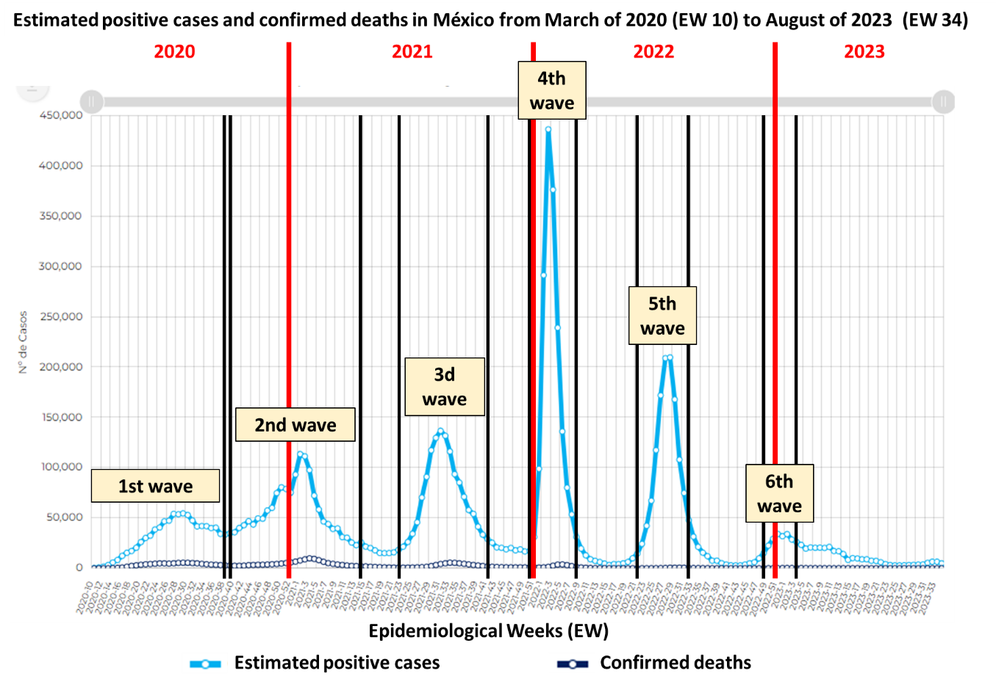

Source. Own arrangement on graphics of report “Informe integral de COVID-19 en México. México, No. 02-2023. 1º de julio de 2023” of Mexico’s Ministry of Health

Graphic 4. Confirmed deaths in Mexico from March of 2020 (EW 10) to August of 2023 (EW 34)

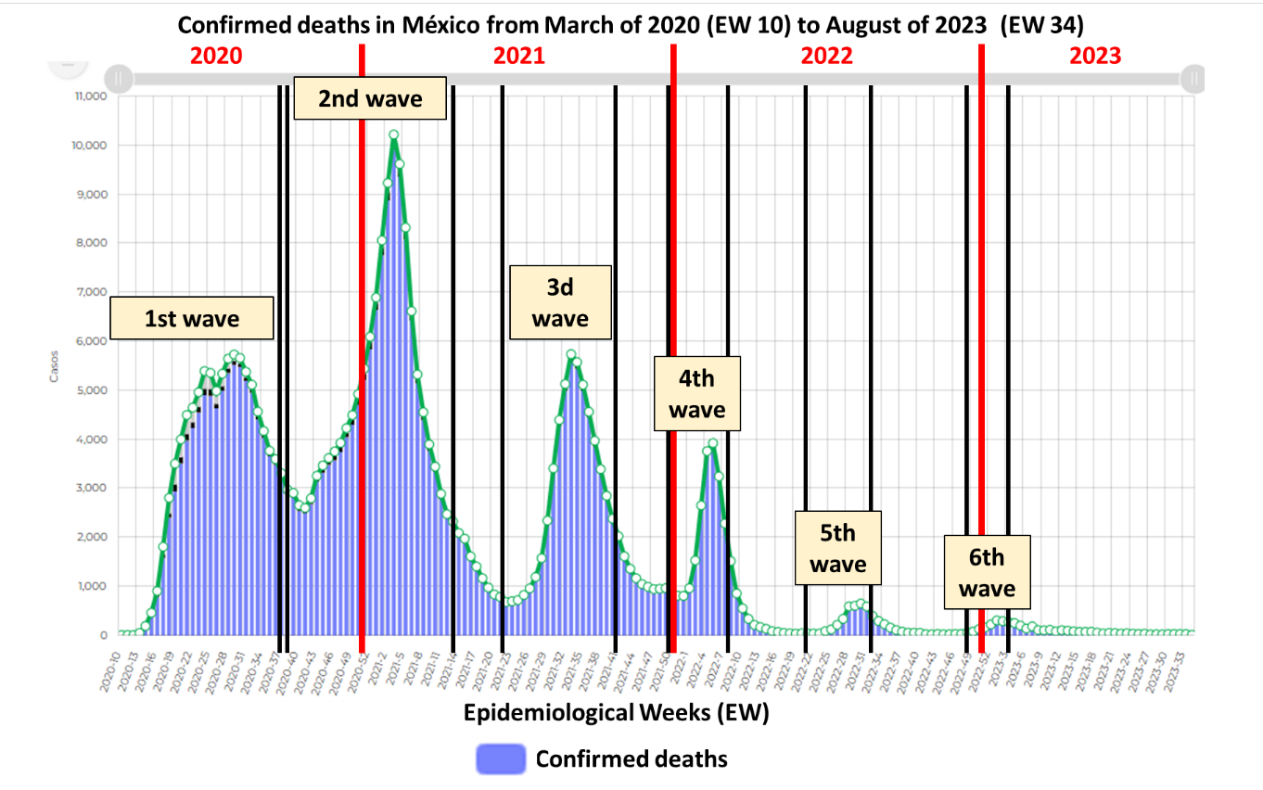

Source. Own arrangement on graphics of report “Informe integral de COVID-19 en México. México, No. 02-2023. 1º de julio de 2023” of Mexico’s Ministry of Health

As we can see in the two graphics above, the relation between positive cases and deaths was directly proportional in the first two waves. Both were increasing dramatically, reaching the highest number of deaths in the 3 EW of 2021. This started changing in the third wave, when the increase in incidence was slightly higher than in the second wave and the highest numbers of deaths were going down until they were like the first wave, but with a notable difference: in the third wave we had a highest point, while in the second wave a sort of plateau with several high points quite close to the highest point for seven weeks. Also, after the application of public policies -such as epidemiological surveillance, flattening the curve, lockdown, hospital reconversion, healthy distance, handwashing, greets safely, covering sneezing and coughing, wearing masks, get tested, among others- and vaccination (topics that we are going talking about in the sixth level of the research pyramid), deaths were decreasing while incidence were exponentially increasing, due to new variants and the growing of R0 from R0=2 at the beginning of pandemic to R0=18 in the fourth wave. The highest point of incidence occurred in the 3 EW of 2022. In the fourth wave we had both the highest incidence and the lowest lethality until then. The highest rate of lethality occurred in 2020, with 2.3%.

WHO declared the end of pandemic on May 5 of 2023. Now the predictive scenarios go to the transformation of COVID-19 from the pandemic to an endemic and the dealing with new and different variants due to COVID-19 will never go.

# Level 6. Applicative

The main purpose of an intervention or Applicative level is to improve the situation of the study population. Jose Supo, director of SINCIE, explains the applicative or intervention level as it follows: “intervention’s purpose is a public health policy that consist in 1) you don’t get infected, 2) if you get infected, you don’t get sick, 3) if you get sick, you don’t become seriously ill, 4) if you become seriously ill, you don’t die.”

WHO made a strategy that countries adopted and adapted according to their specific situation. Every country must design and implement an emergent public policy of health.

In Mexico, as in the world, there has been a big polemic about their public policies of health, but the adoption of drastic measures was a necessity and the adaptation of their different realities depended on its political, economic, geographic, and social situation.

The Mexican public policy of health has consisted in:

1. Mexican Presidente Andrés Manuel López Obrador (AMLO, according to its acronym in Spanish) delegated the management of the pandemic on the Secretary of Health directed by doctor Dr. Jorge Alcocer Varela which, in turn, assigned Dr. Hugo López-Gatell, Undersecretary of Prevention and Health Promotion as a spokesman and chief in charge of the management of the pandemic.
2. interdisciplinary and multisectoral job. Mexican President instructed to do an interdisciplinary and multisectoral job. All Mexican institutions worked: Education, Economy, National Statistics, Secretary of Governance, Exterior Relationships, Secretary of Defense, Secretary of Navy... the entire public sector.
3. Information. As a general coordinator of the pandemic, during 450 weekdays (Luna 11), from February 19th of 2020 to June 11th of 2021, López-Gatell explained the actions taken. At this point, due to many deaths and contagions, the political actions of opposition to the presidency of AMLO and the role of López-Gatell were becoming difficult, and scientific journalism was critically absent. There was an alarming gap between the spokesman and journalists. While he was explaining statistics based on quantitative and qualitative variables and indicators, they blamed him for cases and deaths. Anyway, the Secretary of Health has been informed, besides these conferences, through the website https://www.gob.mx/salud, https://coronavirus.gob.mx/ and https://datos.covid-19.conacyt.mx/. All information about COVID-19 is available for the public and experts.
4. Epidemiological surveillance. (Secretaría de Salud 25). It is focused on immediate detection of suspicious cases to contain the spread of the virus in Mexico. It has two programs (Salud 25): i) Sentinel Surveillance in 473 medical unities called Viral Respiratory Disease Monitoring Health Unit (USMER, according to its acronym in Spanish), ii) Surveillance of not USMER unities or in the rest of Mexico.
5. Lockdown, but not stopping main economic activities nor closing frontiers. The policy was called “Stay at home”. It started on March 28th of 2020 (Mexico government n.pag.) and ended on October 10th of 2022 (Vásquez Antonio n.pag.). Unlike countries whose Human Development Index (HDI) is higher than Mexico, our country could not close its frontiers like (e.g.) New Zealand or South Korea. These countries have 13 and 14 positions on world ranking of 2021, while Mexico has the 86th position (Expansion n.pag.). And, according to Arturo Herrera, who was de Secretary of the Treasury under the pandemic, in South Korea three out of a thousand lives in poverty while in Mexico more than 50% (around 70 million people) of its population lives in poverty. That’s why Mexico could not close its frontiers. On the contrary, Mexican government allowed population to do for a living.
6. The educational policy was named “Learn at home.” Due to the information mentioned in the previous point, Mexico had problems because it was difficult to have more than one technological device to attend classes online. In the poorest communities in the country was almost impossible to learn at home, but we do not have a choice due to the severe impact of cases and deaths.
7. Flattening the curve (Figure 7) and hospital reconversion. The remarkable researcher Tomas Pueyo (Pueyo n.pag.) says the goal of this strategy “is not to eliminate coronavirus contagions... It’s to postpone them.” While the curve is flattened, hospital reconversion took place.

Figure 7. Flattening the curve (theory)

Source. Stephanie King. Image taken of the Medical Medicine unit of University of Michigan. <https://www.michiganmedicine.org/health-lab/flattening-curve-covid-19-what-does-it-mean-and-how-can-you-help>

Hospital reconversion is the process of preparing all kinds of hospitals to attend patients during a health crisis (Mendoza-Popoca, Cecilia 151). According to Mexican Social Security Institute (IMSS, according to its acronym in Spanish) went (IMSS n.pag.) from 463 beds in April of 2020 to 19,999 in June of 2021; also, there was and increasing of oxygen and air sources, mechanic ventilators, doctors, and nurses. Besides, temporary hospitals were built, and expansion of non-hospital units took place.

1. To all previous actions, the world and Mexico spread more actions since March 2020, such as:
   1. Healthy distancing between 1.5 and 2 meters.
   2. Handwashing 20 times a day.
   3. Greets safely. A friendly wave, bowing, hand over heart, blow a kiss, fist bump, just say hello.
   4. Covering sneezing and coughing, also called cough and sneeze etiquette which consists in using the upper sleeve and tissue and putting the used tissue in the rubbish bin.
   5. Wearing masks. Do it in public spaces e.g. public transportation, while being in touch with other people, and if it is difficult to keep healthy distances. Wearing masks is useful when is combined with actions mentioned in precedent paragraphs.
   6. Get tested in case of having one or more than the following symptoms: fever, chest pain or pressure, cold, nasal flow, throat pain, shortness of breath or breathing difficulties, sudden loss of speech or movement, loss of taste and smell, severe confusion, the inability to stay awake or wake up, pale, gray, or blue-colored lips, skin, or nail beds.

Did Mexico flatten the curve? The response is yes (Figure 8). And, while flattening the curve, the Mexican Health System worked in the hospital reconversion to expand its capacity to serve people. It rehabilitated more than 400 hospitals that were neglected by previous governments.

Figure 8. Flattening the curve in Mexico

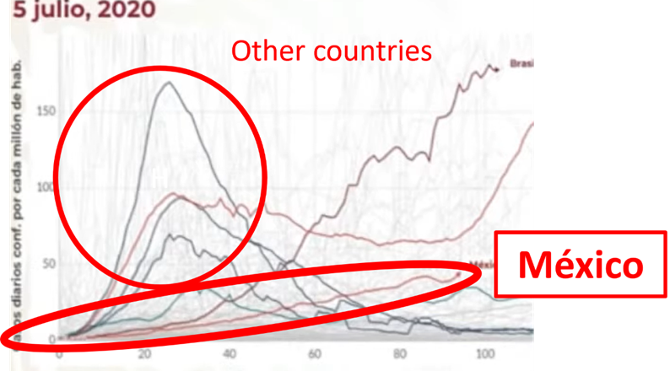

Source. Own arrangement based on an image of Mexico’s Ministry of Health conference on July 5th of 2020.

1. Vaccination.

The vaccine must have quality, be efficient, and safe. Depending on the companies that develop vaccines we will have variations in design, doses, schemes, and secondary effects.

Mexican government decided the vaccination would be universal, free (no cost), and voluntary, and put available the following vaccines:

Vaccination in Mexico started at December 24th of 2020 and it will be permanent due COVID is here to stay.

Table 3. Available vaccines in Mexico since December of 2020



Source. Own translation of report “Informe integral de COVID-19 en México. México, No. 02-2023. 1º de julio de 2023” of Mexico’s Ministry of Health

In the sixth level of research, COVID-19 IS called Evaluative Variable (COVID-19) and all those that must be monitored, such as vaccines, are called Calibration Variables. For instance, efficacy, quality, and security are Calibration Variables of vaccines. Same way, all mentioned factors from points 4 to 9 are called Calibration Variables.

So far, the world keeps learning to deal with an illness which will never disappear. That means, intervention or applicative level of research will be a permanent practice worldwide since COVID-19 pandemic appeared.

# Conclusion

On this paper, we have worked through six levels of research (SINCIE Pyramid Model), examining the main aspects of each one to show how the fundamentals of epidemiology have taken place in Mexico from March 2020 to August 2023. In this short period, we could analyze exploratory, descriptive, relational, explanatory, predictive, and applicative levels of research.

On May 5 of 2023, doctor Tedros Adhanom Gebreyesus declared the end of COVID-19 as an international health emergency, but not the end of this illness. COVID-19 has arrived to stay here forever. It will never disappear. Thus, health public actions must be maintained to have less transmission. We human beings must be prepared to handle it. Every century the world faces these kinds of events but, due to the many changes that humans are making, there is a possibility of more epidemics and pandemics in less than hundred years. This pandemic will become endemic.

Viruses existed before humans. Diseases, epidemics, and pandemics are results of interaction and alteration of natural habitats caused by human settlements. The increase of life expectancy, thanks to the development of science, has expanded the time of contact between animals and humans, making it possible more transmission of unexpected and unknown illnesses. These interactions and alterations have been accelerated since the Industrial Revolution, due to the overexploitation of limited resources. This combination has had an impact on overpopulation, pollution, and climate change, among other effects. A process that would have occurred in a thousand years, the human being has shortened it to just over two centuries, with a high probability of the apprearing of emerging diseases, a topic that will be addressed in the next assignment of this doctorate in Public Health.

# Works Cited

A dictionary of epidemiology. The USA, University of Oxford, 2014. PDF File.

Aslah, Auni. “Five common misconceptions regarding flattening-thecurve of COVID-19.” Switzerland, History and Philosophy of the Life Sciences, 2022. PDF File

Bates, Vanessa. *What Is "R-naught"? Gauging Contagious Infections*.” Healthline. 2023. <https://www.healthline.com/health/r-naught-reproduction-number>

Bhattacharya, Manojit, Srijan Chatterjee, Sang-Soo Lee, Kuldeep Dhama, and Chiranjib Chakraborty. “Antibody evasion associated with the RBD significant mutations in several emerging SARS-CoV-2 variants and its subvariants.” The USA, ScienceDirect, 2023. <https://www.sciencedirect.com/science/article/abs/pii/S1368764623000912?via%3Dihub>

Boncz, Imre, and Réka Vajda, Zsuzsanna Kívés. “Epidemiology.” Hungary, University of Pécs Faculty of Health Sciences, 2022. PDF File

Capital 21. “70% de los mexicanos que dieron positivo a COVID-19 no tuvieron síntomas: INSP.” Mexico, 2021. <https://www.capital21.cdmx.gob.mx/noticias/?p=6617>

Centers for Disease Control and Prevention. “Long COVID or Post-COVID Conditions.” < https://www.cdc.gov/coronavirus/2019-ncov/long-term-effects/index.html>. Accessed 9 August 2023

Centers for Disease Control and Prevention. “SARS-CoV-2 Variant Classifications and Definitions.” <https://www.cdc.gov/coronavirus/2019-ncov/variants/variant-classifications.html>. Accessed 9 August 2023

Cucinotta, Domenico, and Maurizio Vanelli. “WHO Declares COVID-19 a Pandemic”. The USA, Acta Biomedica, Vol. 91., 2020. PDF File

Expansion. Datosmacro.com <https://datosmacro.expansion.com/idh> Accessed 10 November 2023

Expósito, Alexander, Gisela Feria, Sonia González, and Pedro Soca. “Variantes genéticas del SARS-CoV-2 y sus implicaciones clínicas.” Cuba, Medisan, 2021. PDF File

Fung, Sing and Ding Xiang. “Similarities and Dissimilarities of COVID-19 and Other Coronavirus Diseases.” The USA. Annual Reviews. 2021. PDF File.

IMSS. “IMSS garantizó atención de emergencia sanitaria mediante reconversión, apertura anticipada y atención hospitalaria.” Mexico, 2021. <https://www.imss.gob.mx/prensa/archivo/202106/244> Accessed 20 November 2023.

Kemper, Steve. “C.-E. A. Winslow, who launched public health at Yale a century ago, still influential today”. The USA. Yale School of Public Health. 2015. <https://news.yale.edu/2015/06/02/public-health-giant-c-ea-winslow-who-launched-public-health-yale-century-ago-still-influe#:~:text=%E2%80%9CPublic%20Health%20is%20the%20science,principles%20of%20personal%20hygiene%2C%20the>

Luna, Dolores. “López-Gatell: ‘Estamos declarando el fin de las conferencias, no de la epidemia’". México, Expansión Política, 2023 <https://politica.expansion.mx/mexico/2021/06/11/lopez-gatell-estamos-declarando-el-fin-de-las-conferencias-no-de-la-epidemia>

Lusiana State University. “A new approach to modeling disease outbreaks”. The USA, < https://www.lsu.edu/science/news_events/cos-news-events/2020/may/rapid_award.php > Accessed 30 October 2023.

Matt, Anthony. “A reprieve from COVID-19, but the threat remains.” The USA. Essentia Health. 2022. <https://www.essentiahealth.org/about/essentia-health-newsroom/a-reprieve-from-covid-19-but-the-threat-remains/#:~:text=4%2F5%20strains%20have%20a,SARS%2DCo%2DV2%20virus.>.

Mendoza, Cecilia, and Mario Suárez. “Reconversión hospitalaria ante la pandemia de COVID-19.” México. Revista Mexicana de Anestesiología. 2020.

Merriam Webster dictionary. The USA. <https://www.merriam-webster.com/dictionary/lockdown>. Accessed 25 September 2023

Mexico government. “#ConferenciaDePrensa: #Coronavirus #COVID19 | 28 de marzo de 2020,” <https://www.youtube.com/watch?v=fI2xMq2gWbw&t=534s>

National Library of Medicine. “Global prevalence and effect of comorbidities and smoking status on severity and mortality of COVID‑19 in association with age and gender: a systematic review, meta‑analysis and meta‑regression.” The USA, 2023. <https://pubmed.ncbi.nlm.nih.gov/37076543/>

Ortega, Miguel, Cielo García, Oscar Fraile, Paolo Colet, Ardak Baizhaxynova, Kymbat Mukhtarova, Melchor Alvarez-Mon, Kaznagul Kanatova, Angel Asúnsolo, and Antonio Sarría-Santamera. “Recapping the Features of SARS-CoV-2 and Its Main Variants: Status and Future Paths”. The USA. PubMed Central. 2022. < https://www.ncbi.nlm.nih.gov/pmc/articles/PMC9225183/>

Pueyo, Tomas. “Coronavirus: Why You Must Act Now.” The USA, 2020. <https://tomaspueyo.medium.com/coronavirus-act-today-or-people-will-die-f4d3d9cd99ca>

Rodríguez, Marisleidy, and Ceylin León. “Similitudes y diferencias entre el síndrome respiratorio agudo severo causado por SARS-CoV y la COVID-19.” Cuba. Revista Cubana de Pediatría. 2020. PDF File.

Secretaría de Salud. Informe integral de COVID-19 en México. México, No. 02-2023. 1º de julio de 2023. PDF File

Serbolov, Yuri comp. ed. and author. *Modelo Universal de Gestión del Conocimiento y Percepción Prospectivo Estratégico*. México, 2008. Digital file. Indautor 03-2008-081511360200-01.

Tekerek, Burak, Meliha Melis, Gökcen Ozler, and Meryem Turgut. “Determinants of COVID‑19 cases and deaths in OECD countries.” The USA, University of Oxford, 2023. PDF File

Thacker, Stephen. A. Gibson Parrish, Frederick L. Trowbridgeb, and Surveillance Coordination Group. “A method for evaluating systems of epidemiological surveillance.” The USA, World Health Statistics, 1988. PDF File.

The American Heritage Medical Dictionary. “Disease.” <https://medical-dictionary.thefreedictionary.com/disease>. Accessed 20 August 2023

Vásquez, Antonio. “En México ¿Cuándo se acabó la cuarentena y pandemia por el coronavirus?” México. Goal, 2023 <https://www.goal.com/es-mx/noticias/cuando-acaba-cuarentena-mexico-coronavirus/qxe7pn3b8o3i1rr5pn8ysr43b>

Who Health Organization. “Naming the coronavirus disease (COVID-19) and the virus that causes it”. <https://www.who.int/emergencies/diseases/novel-coronavirus-2019/technical-guidance/naming-the-coronavirus-disease-(covid-2019)-and-the-virus-that-causes-it>

…, WHO COVID-19 dashboard. <https://data.who.int/dashboards/covid19/cases?n=c>. Accessed August 16 2023

Worldometer. Countries where COVID-19 has spread. < https://www.worldometers.info/coronavirus/countries-where-coronavirus-has-spread/>. Accessed August 25 2023