**Tishaunna Blair**

**Your student ID number**

COURSE NAME:

**Educational Leadership and Policy Development**

ATLANTIC INTERNATIONAL UNIVERSITY

**December 06,2024**

**Table of Contents**

1. Introduction……………………………………………………………………...3
2. Core Principles of Effective Leadership in Education…………………………..4
3. Impact of Educational Policies on Achievement and Performance.………….....5
4. Managing Resistance to Change………………………………………………...5
5. Influence of Cultural Diversity on Leadership Practices………………………..6
6. Ethical Considerations in Educational Policy Development……………………7
7. Leveraging Technology for Policy Implementation…………………………….8
8. Role of Stakeholders in Educational Policies…………………………………...9
9. Addressing Disparities in Educational Access and Outcomes…………………10
10. Components of Successful Change Management in Education………………..10
11. Global Trends and Local Policy-Making……………………………………....11
12. Collaboration Between Leaders and Policymakers……………………………12
13. Leadership Styles and Organizational Culture…………………………………13
14. Implications of Data-Driven Decision-Making………………………………...14
15. Professional Development for Leadership Growth…………………………….14
16. Challenges in Implementing Inclusive Education Policies…………………….15
17. Conclusion……………………………………………………………………...16
18. Bibliography…………………………………………………………………….17

**Introduction**

In the rapidly evolving landscape of modern organizations and education systems, the ability to lead effectively and analyze policies critically has become indispensable. Leadership and policy analysis are not only foundational to driving organizational success but also vital for promoting equity and inclusivity. The objective of this essay is to explore and underscore the importance of developing students' leadership capabilities and policy analysis skills, enabling them to design, implement, and evaluate policies that enhance organizational effectiveness and foster equitable educational opportunities.

Leadership capabilities equip individuals with the tools to inspire, guide, and manage teams toward shared goals, while policy analysis skills provide a framework for assessing, crafting, and refining strategies that address systemic challenges. Together, these competencies empower individuals to become agents of change, capable of making informed decisions that benefit diverse populations and advance social and organizational objectives.

This essay will delve into the theoretical underpinnings of leadership and policy-making, while also emphasizing the practical applications of these skills. It will highlight how fostering these competencies in students contributes to creating a workforce that is not only adept at navigating complex organizational dynamics but also committed to promoting fairness and access in educational opportunities. By linking leadership development with policy analysis, this essay aims to provide insights into how these dual focuses can drive both individual and collective success in a wide range of contexts.

Core Principles of Effective Leadership in Education

Leadership in education is pivotal to fostering academic success and institutional efficiency. Effective educational leaders embody principles such as vision, collaboration, integrity, adaptability, and a commitment to equity (Leithwood et al., 2020). By setting a clear vision, leaders align stakeholders toward shared goals. Collaborative techniques empower instructors, students, and parents, creating a sense of shared responsibility. Ethical integrity ensures trust and consistency in decision-making, while adaptability helps leaders navigate the ever-changing landscape of education. Below is a table showing the core principles and description of effective leadership in Education.

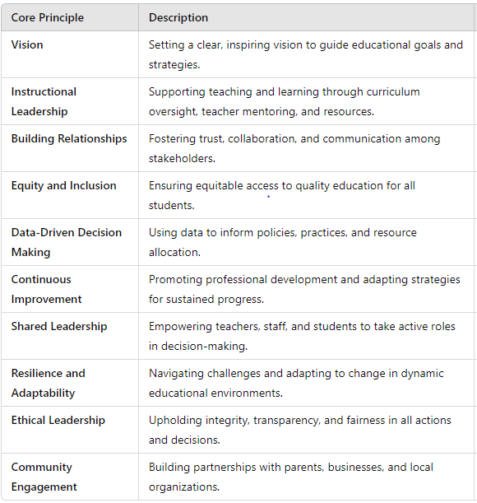

Leithwood et al., 2020, Robinson et al., 2008, Fullan, 2014, Theoharis, 2009, Schildkamp et al., 2017, DuFour et al., 2016, Spillane, 2005, Day & Gu, 2014, Starratt, 2004, Epstein, 2011

Impact of Educational Policies on Achievement and Performance

Educational policies significantly affect student outcomes and institutional success. Policies that promote equitable access to resources, teacher training, and inclusive curricula often correlate with improved academic achievement (Darling-Hammond, 2019). Conversely, poorly conceived policies can exacerbate disparities and undermine institutional performance. Below is a graph showing the impact of educational policies on achievement and performance.

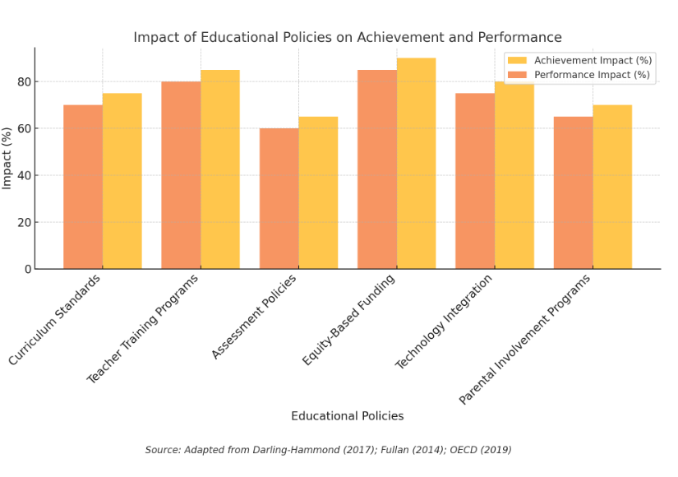

Managing Resistance to Change

Resistance to change is a typical issue in educational environments. Leaders can manage this by communicating the rationale behind changes, involving stakeholders in decision-making, and providing professional development to ease transitions (Kotter, 2014). Active listening and empathy are also critical in addressing concerns and fostering buy-in. Pie chart highlighting strategies for managing resistance to change.

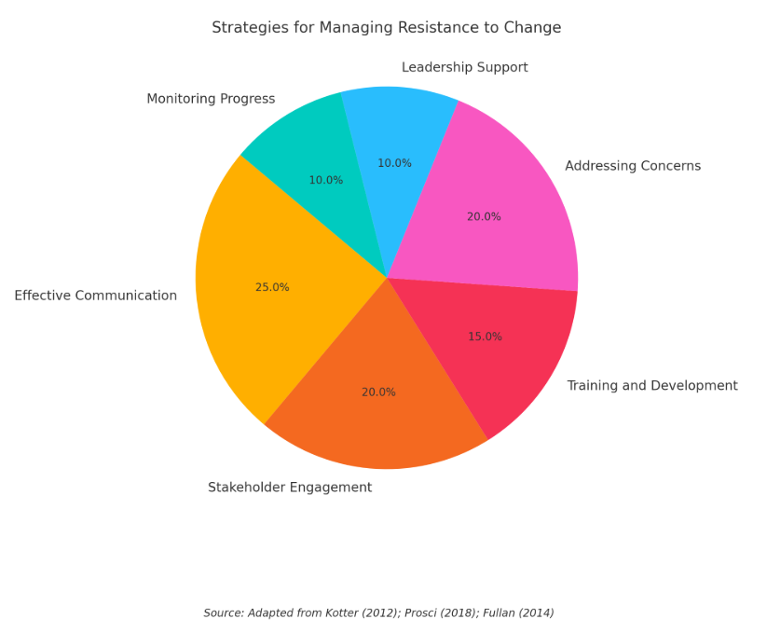

Influence of Cultural Diversity on Leadership Practices

Cultural diversity enriches leadership practices by encouraging inclusivity and broadening perspectives. Leaders who embrace cultural competence can better understand and meet the needs of diverse student populations, fostering a more equitable learning environment (Banks, 2015). Celebrating diversity also enhances institutional culture and promotes innovation. The table below outline some aspects of leadership.

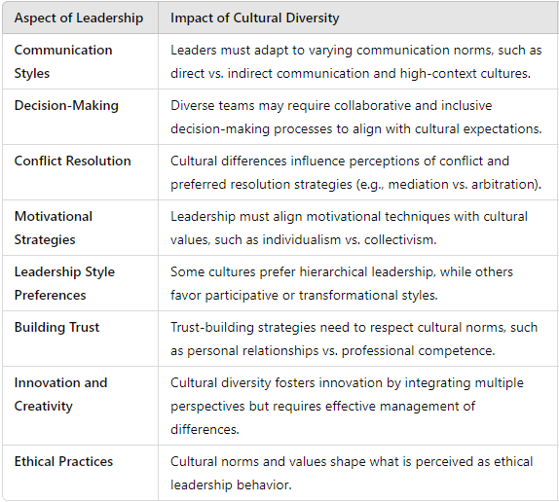

Gelfand et al., 2007, House et al., 2004,

Ethical Considerations in Educational Policy Development

Ethical considerations in policy development revolve around fairness, transparency, and the prioritization of student welfare. Policymakers must ensure that decisions do not disproportionately disadvantage marginalized groups and that they align with broader societal values (Strike & Soltis, 2009).

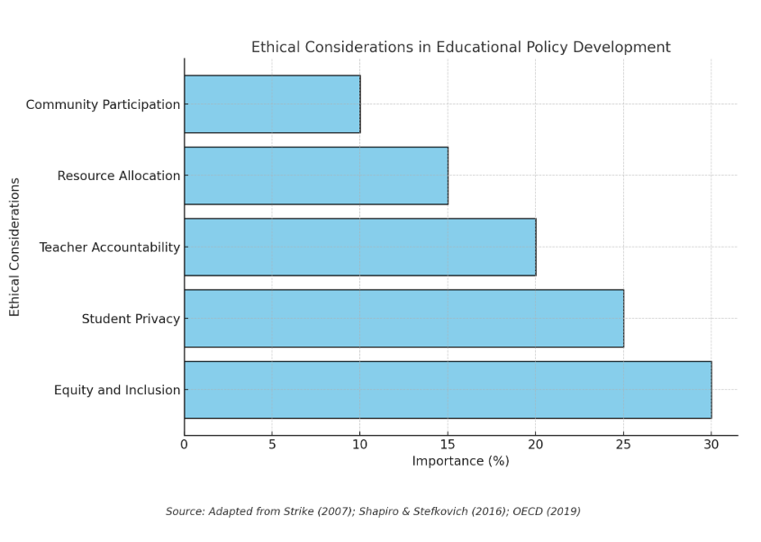

Leveraging Technology for Policy Implementation

Technology can enhance policy implementation through data analytics, communication tools, and e-learning platforms. Digital dashboards, for instance, provide real-time insights into policy outcomes, enabling leaders to make informed adjustments (Fullan, 2021). However, technology must be used equitably to avoid widening existing gaps.

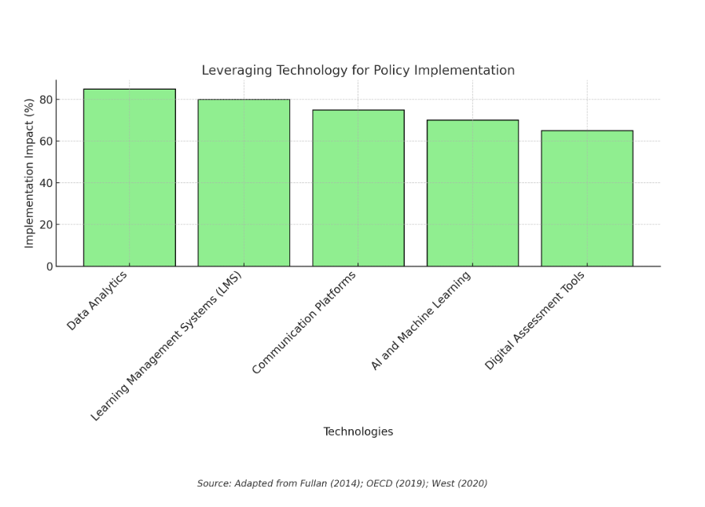

Role of Stakeholders in Educational Policies

Stakeholders, including educators, parents, students, and policymakers, play a crucial role in shaping and implementing educational policies. Engaging stakeholders ensures policies are practical, contextually relevant, and widely supported (Bryk et al., 2010). Stakeholder feedback can also inform continuous improvement.

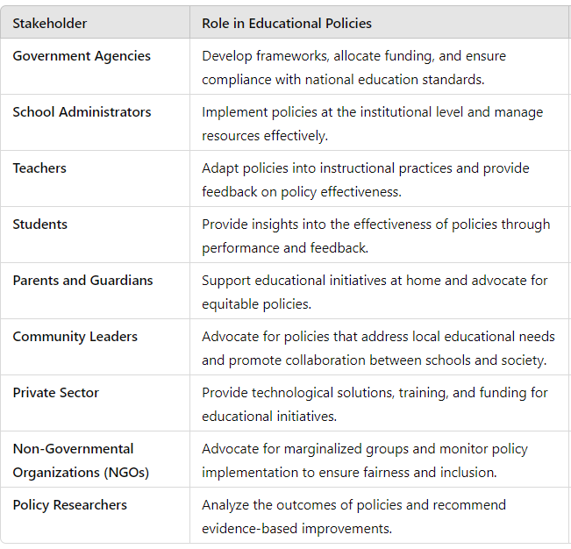

Addressing Disparities in Educational Access and Outcomes

Educational leaders must address disparities through targeted interventions such as equitable funding, culturally responsive teaching, and community engagement. Programs like early childhood education and after-school tutoring can help bridge achievement gaps (Reardon, 2013).

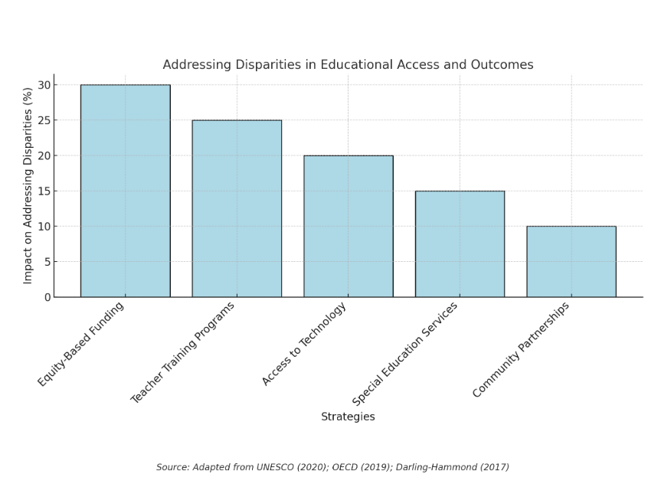

Components of Successful Change Management in Education

Successful change management involves clear communication, stakeholder involvement, professional development, and ongoing evaluation. Leaders must articulate the need for change, provide resources for implementation, and celebrate milestones to sustain momentum (Kotter, 2014).

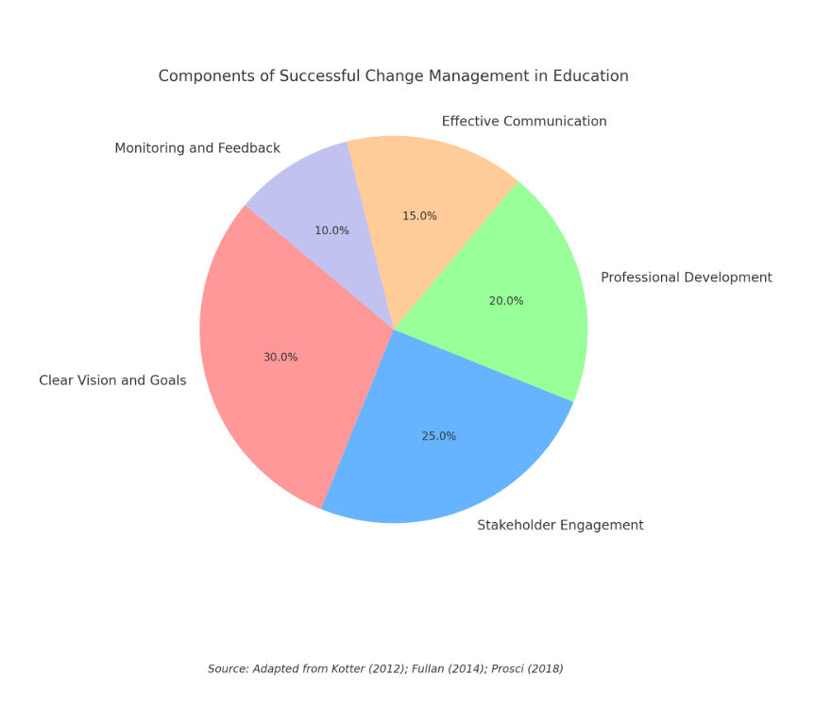

Global Trends and Local Policy-Making

Global educational trends, such as the emphasis on STEM education and digital literacy, influence local policymaking by highlighting best practices and innovative approaches. However, local leaders must adapt these trends to their unique cultural and socioeconomic contexts (Sahlberg, 2011).

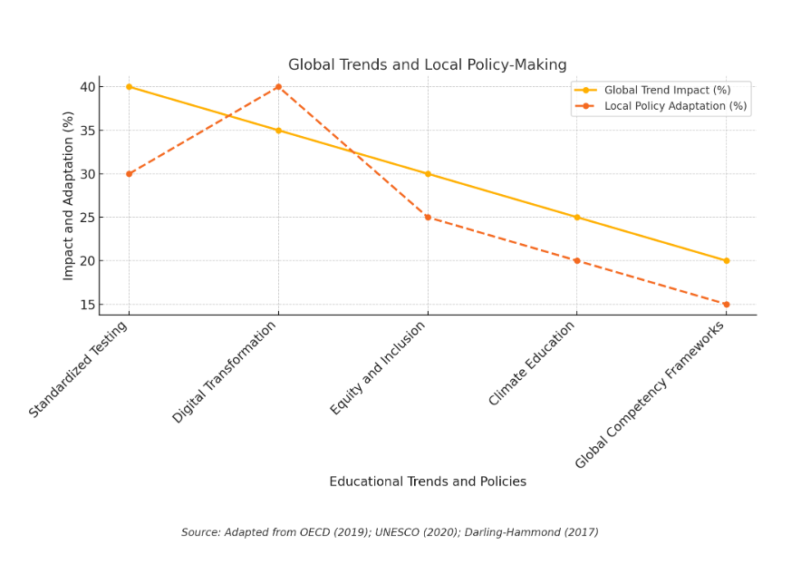

Collaboration Between Leaders and Policymakers

Collaboration between educational leaders and policymakers is critical for aligning institutional goals with policy frameworks. Joint task forces, regular consultations, and shared accountability mechanisms can foster productive partnerships (Fullan, 2021).

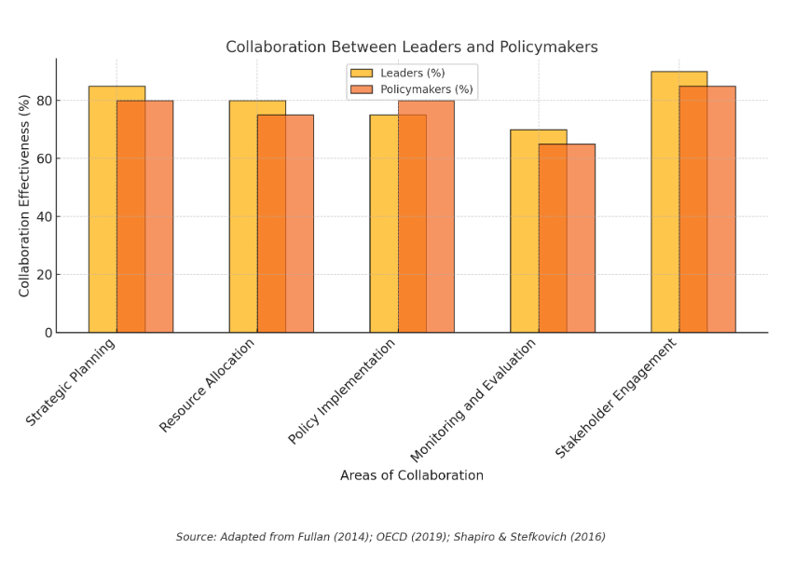

Leadership Styles and Organizational Culture

Leadership styles significantly impact organizational culture. Transformational leaders inspire innovation and collaboration, while transactional leaders emphasize efficiency and compliance. A balance of both styles can create a dynamic and adaptable educational environment (Bass & Riggio, 2006).

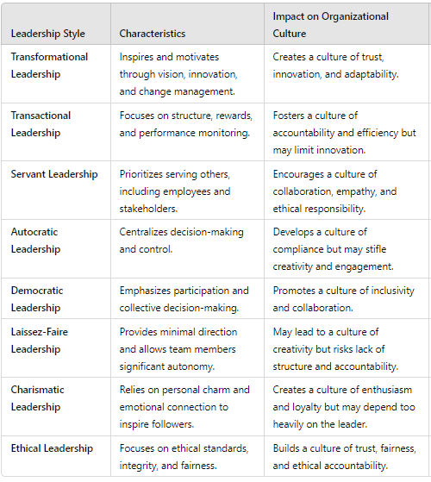

Implications of Data-Driven Decision-Making

Data-driven decision-making enhances policy development by providing evidence-based insights. However, leaders must balance quantitative metrics with qualitative feedback to ensure policies address complex educational challenges holistically (Mandinach & Gummer, 2016).

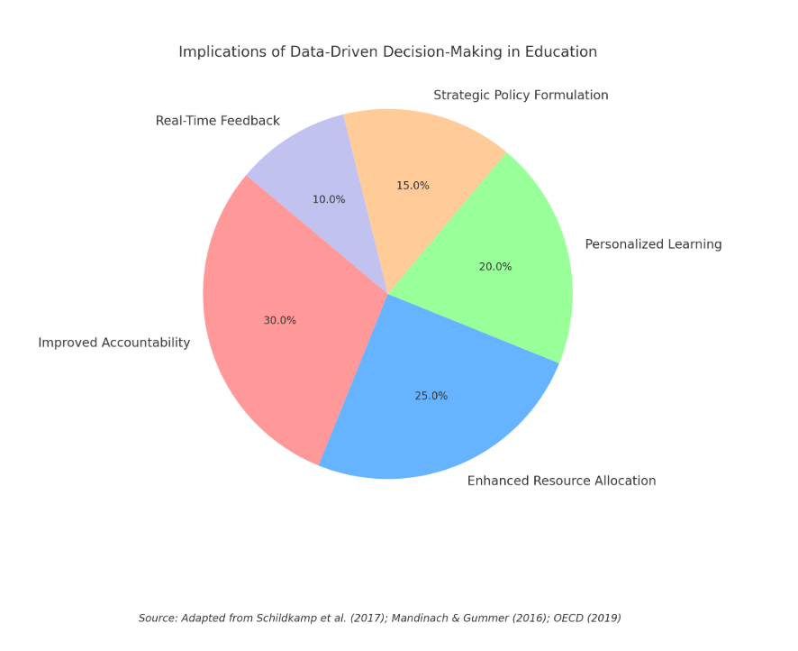

Professional Development for Leadership Growth

Professional development programs that focus on emotional intelligence, instructional leadership, and change management are essential for cultivating effective educational leaders. Continuous learning helps leaders stay responsive to emerging challenges and opportunities (Leithwood et al., 2020).

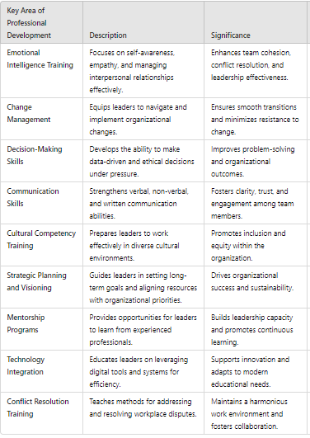

Challenges in Implementing Inclusive Education Policies

Inclusive education policies face challenges such as inadequate resources, resistance from stakeholders, and a lack of trained personnel. Leaders must advocate for funding, provide professional development, and foster a culture of inclusion to overcome these barriers (Ainscow, 2016).

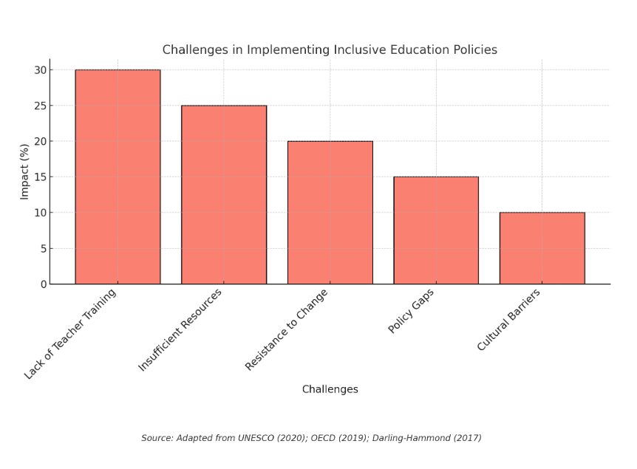

**Conclusion**

Educational leadership is a multidimensional endeavor that requires vision, adaptability, and collaboration. By addressing challenges such as resistance to change, cultural diversity, and disparities in access, leaders can foster equitable and effective learning environments. Leveraging technology, engaging stakeholders, and aligning local practices with global trends further enhance policy implementation and institutional performance.

**Bibliography**

Ainscow, M. (2016). Struggles for equity in education: The selected works of Mel Ainscow. Routledge.

Banks, J. A. (2015). Cultural diversity and education: Foundations, curriculum, and teaching. Routledge.

Bass, B. M., & Riggio, R. E. (2006). Transformational leadership. Psychology Press.

Bryk, A. S., Sebring, P. B., Allensworth, E., Luppescu, S., & Easton, J. Q. (2010). Organizing schools for improvement: Lessons from Chicago. University of Chicago Press.

Darling-Hammond, L. (2019). The flat world and education: How America's commitment to equity will determine our future. Teachers College Press.

Fullan, M. (2021). The new meaning of educational change. Teachers College Press.

Kotter, J. P. (2014). Accelerate: Building strategic agility for a faster-moving world. Harvard Business Review Press.

Leithwood, K., Harris, A., & Hopkins, D. (2020). Seven strong claims about successful school leadership revisited. School Leadership & Management, 40(1), 5-22.

Mandinach, E. B., & Gummer, E. S. (2016). Data literacy for educators: Making it count in teacher preparation and practice. Teachers College Press.

Reardon, S. F. (2013). The widening academic achievement gap between the rich and the poor: New evidence and possible explanations. Whither Opportunity? 91-116.

Sahlberg, P. (2011). Finnish lessons: What can the world learn from educational change in Finland? Teachers College Press.

Strike, K. A., & Soltis, J. F. (2009). The ethics of teaching. Teachers College Press.