

Course:
Innovations in Digital Education

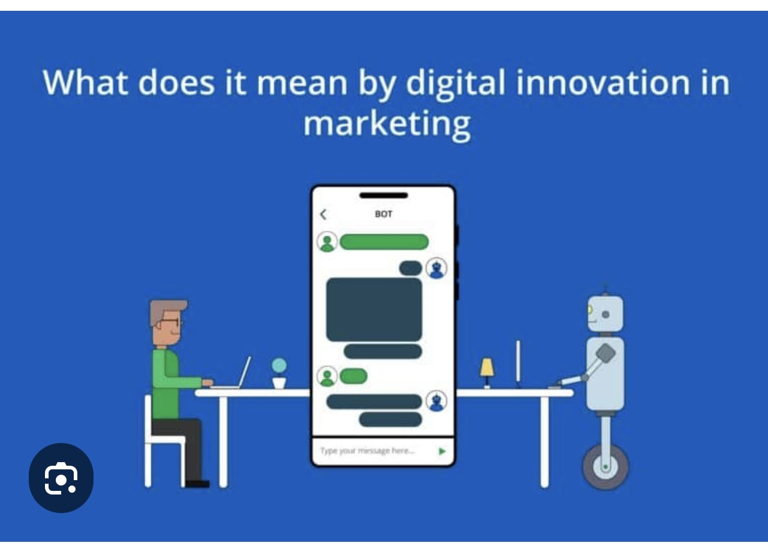

Name: Eloni-Nakarawa
Id Number: (UB94896ED104117)

Innovations in Digital Education

Table of Contents

Title 1

Essay 3

Conclusion 4

Digital Education is Superior
In today’s modern world, digital education is transforming how people learn and gain knowledge. With the advancement of technology, learning is no longer limited to traditional classrooms. Students can now access information, attend classes, and complete assignments online from anywhere in the world. Digital education has become especially important for students who need flexibility due to work, family responsibilities, or location. In my opinion, digital education is superior because it provides accessibility, flexibility, and opportunities for personal and financial growth.
One of the biggest benefits of digital education is accessibility. Students no longer need to be physically present in a classroom to learn. This is especially helpful for people living in remote areas, such as many islands in Fiji, where access to higher education institutions may be limited. Through online platforms, students can enroll in courses, watch lectures, and access study materials anytime. This makes education more inclusive and allows more people to achieve their academic goals.
Another important advantage is flexibility. Digital education allows students to learn at their own pace and schedule. This is very helpful for working individuals or parents who cannot attend regular classes. For example, a student can study at night after work or during weekends. This flexibility reduces stress and allows learners to balance education with other responsibilities. It also helps students to better understand topics because they can revisit lessons as many times as needed.
Digital education also encourages independent learning. Students develop important skills such as time management, self-discipline, and critical thinking. Instead of relying only on teachers, learners take responsibility for their own progress. This is an important life skill that prepares students for future careers. In addition, digital tools such as videos, quizzes, and interactive platforms make learning more engaging and effective.
However, digital education also has some challenges. One major issue is access to technology. Not all students have reliable internet connections or devices such as laptops or tablets. This creates inequality among learners. Another challenge is lack of face-to-face interaction, which can sometimes make learning feel isolating. Some students may also struggle with motivation and discipline in an online environment.
Despite these challenges, digital education remains important for the future. It prepares students for a technology-driven world where digital skills are highly valued. Many jobs today require knowledge of computers, online communication, and digital tools. By engaging in digital education, students become more prepared for these opportunities.

Digital education can also improve income opportunities. With online learning, students can gain new skills such as IT, business management, teaching, or communication. These skills can lead to better job opportunities or promotions. Additionally, digital education opens doors to remote work, where individuals can work for international companies from home. For example, a teacher can offer online tutoring, or a graduate can work as a freelancer in writing, data entry, or virtual assistance. These opportunities can significantly increase income and financial stability.
Furthermore, digital education allows individuals to start their own businesses. By learning skills such as digital marketing, entrepreneurship, or e-commerce, students can create online businesses and generate income. This is especially useful in countries like Fiji, where tourism and small businesses play a major role in the economy.
To maximize the benefits of digital education, it is important to address its challenges. Governments and institutions should invest in better internet infrastructure and provide affordable devices for students. Schools should also offer training on how to effectively use digital tools. Teachers can create interactive and engaging online lessons to keep students motivated. In addition, students should develop good study habits and time management skills to succeed in digital learning environments.
In conclusion, digital education is superior because it provides accessibility, flexibility, and opportunities for personal and financial growth. Although it has some challenges, these can be overcome with proper support and resources. In today’s digital age, embracing online learning is essential for success. By taking advantage of digital education, students can improve their knowledge, skills, and income, leading to a better future.

