

Virtual Reality In Education
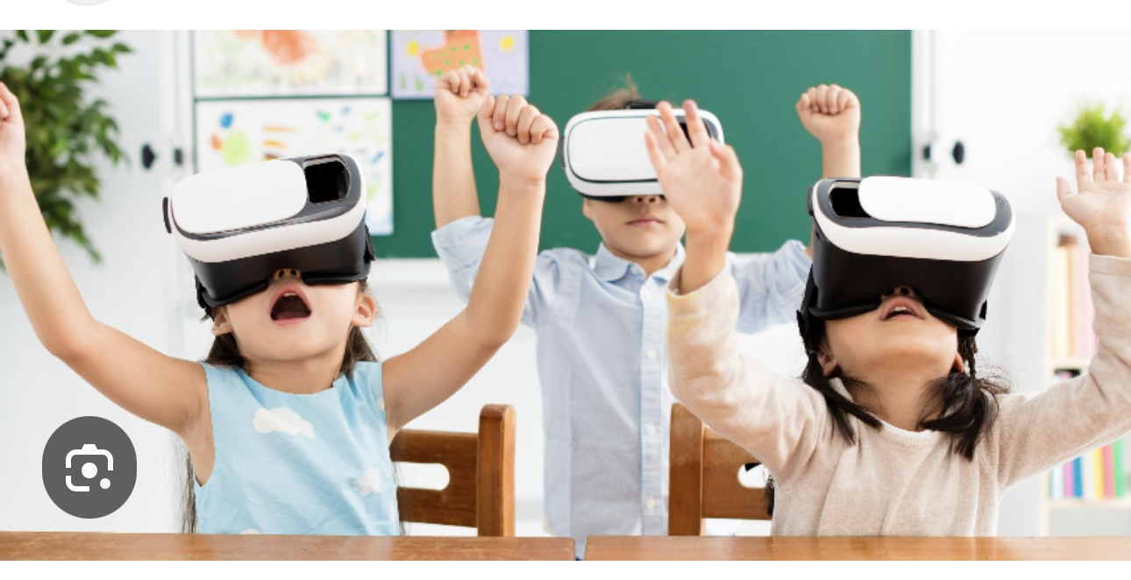

Name: Eloni-Nakarawa
Id Number: (UB94896ED104117)

Tutor (Chris Soto)

Virtual Reality In Education

Table of Contents

Title 1

Introduction 3

Why Virtual Education is Important 4

Conclusion 5

Title:
The Role of Virtual Reality in Education and Its Impact on Learning and Income

Introduction
Education is continuously evolving as technology becomes more advanced. One of the most exciting developments in modern education is virtual reality (VR). Virtual education allows students to experience learning in a more interactive and immersive way, even without being physically present in a classroom. From my perspective as a teacher, I believe that virtual reality has the potential to transform how students learn by making lessons more engaging and meaningful. This topic is important because it can improve access to quality education and also create new opportunities for income and career growth. In this essay, I will explain what virtual education is, share my opinion, discuss its importance, and explain how I can apply it to improve my income.

What is Virtual Education?
Virtual education refers to learning that takes place through digital environments rather than in a physical classroom. With virtual reality, students can enter simulated environments where they can interact with objects, explore places, and experience situations in real time.
For example, instead of just reading about history, students can virtually visit historical locations. Instead of only learning science through textbooks, they can explore the human body or conduct experiments in a virtual lab. This makes learning more practical and easier to understand.
Virtual education goes beyond traditional online learning because it creates a feeling of “being there,” which improves student engagement and understanding.

My Opinion on Virtual Reality in Education
In my opinion, virtual reality can make learning more effective, especially for students who struggle with traditional methods. From my experience as a teacher, I have seen that many students learn better when they can see and experience things rather than just listen or read.
In Fiji, where I have taught, some students may not have access to resources such as science labs or educational trips. Virtual reality can solve this problem by bringing those experiences into the classroom or even into students’ homes.
However, I also believe that virtual reality should not completely replace teachers. Teachers play an important role in guiding, supporting, and motivating students. VR should be used as a tool to support teaching, not replace it.

Why Virtual Education is Important
Virtual education is important because it improves access to learning opportunities. Students who are in remote areas or who cannot attend school regularly can still receive quality education through virtual platforms.
It also prepares students for the future. Technology is becoming a major part of everyday life, and learning through virtual environments helps students develop digital skills that are needed in modern careers.
Another important reason is engagement. Many students lose interest in traditional lessons. Virtual reality makes learning more exciting, which can increase motivation and improve results
Challenges of Virtual Reality in Education
Although virtual education has many benefits, there are also challenges. One of the main problems is cost. Virtual reality equipment can be expensive, and not all schools or students can afford it.
Another challenge is access to technology and internet. In some areas, including parts of Fiji, reliable internet is not always available. This can limit the use of virtual education.
There is also a need for proper training. Teachers must learn how to use virtual tools effectively to make lessons meaningful.

How I Can Apply This to Improve My Income
Virtual reality in education also creates new opportunities for income. As a teacher, I can use this technology to expand my skills and reach more students beyond my local area.
For example, I can offer online or virtual tutoring using interactive tools. I can also learn how to create digital learning content, which can be shared or sold online. Teaching subjects like the Fijian language or cultural studies through virtual platforms can attract students from different parts of the world.
In addition, learning about virtual education can help me qualify for better job opportunities in the future. Schools and institutions are increasingly looking for teachers who are skilled in using technology.
By combining my teaching experience with new digital skills, I can increase my income and career growth.

Conclusion
In conclusion, virtual reality has the potential to greatly improve education by making learning more interactive, engaging, and accessible. From my experience as a teacher, I believe it can help overcome many challenges, especially in areas with limited resources. However, to fully benefit from virtual education, issues such as cost, access, and training must be addressed. This topic is important because it not only improves the quality of education but also creates opportunities for personal and financial growth. By learning and applying virtual education tools, I can improve my teaching and increase my income while helping students succeed.

