

DEPARTEMENT: Science and Engineering

STUDENT NAME: Joesph El Khoury Tanios Abi Ramia

DATE: 8/9/2014

COURSE TITLE: Portable Renewable Energy

INTRODUCTION

Portable renewable energy refers to energy sources that are both sustainable and capable of being transported or utilized in various locations. These energy solutions are particularly valuable for off-grid applications, emergency situations, and for powering devices in remote areas. Key types of portable renewable energy include:

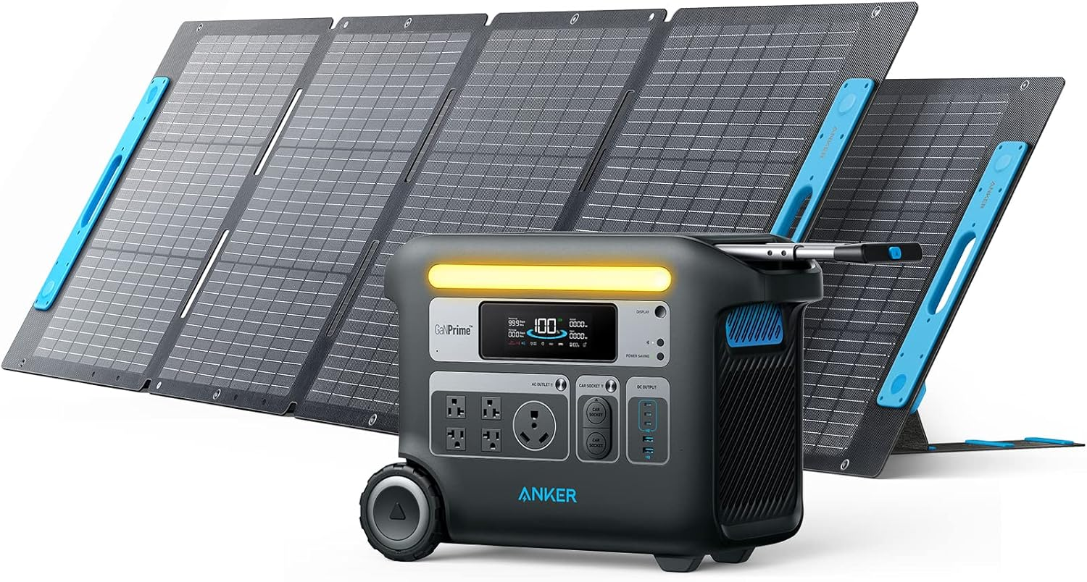

1. **Portable Solar Panels:**
   * These are small-scale solar panels that can be folded or rolled up for easy transportation. They are used to charge devices like phones, laptops, or even power small appliances when connected to a battery or directly to the device.
2. **Portable Wind Turbines:**
   * Though less common than solar panels, small-scale wind turbines can be transported and deployed in areas where wind is sufficient to generate power. They are often used in conjunction with solar panels to provide energy in different weather conditions.
3. **Portable Power Stations:**
   * These are essentially large batteries that can store energy from renewable sources like solar panels or wind turbines. They can then be used to power various devices or appliances. Some models are equipped with inverters and multiple outlets for AC and DC power.
4. **Portable Water Turbines:**
   * In locations with flowing water, portable water turbines can be deployed to generate electricity. These are typically used in remote areas where water flow is consistent.
5. **Portable Biomass Systems:**
   * Though less common, portable biomass systems can convert organic materials into energy. These systems are often used in remote or off-grid areas where organic waste is abundant.

**Applications:**

* **Emergency Preparedness:** Portable renewable energy solutions are crucial during natural disasters when traditional power sources may be unavailable.
* **Outdoor Activities:** Campers, hikers, and adventurers use portable solar panels and power stations to keep devices charged.
* **Remote Worksites:** For construction or research in remote areas, portable renewable energy provides a reliable power source.
* **Military Operations:** Portable energy solutions are used to power communications, medical equipment, and other essential devices in the field.

**Benefits:**

* **Sustainability:** These solutions rely on renewable resources, reducing the carbon footprint.
* **Independence:** Users are not dependent on the grid, making them ideal for remote or off-grid applications.
* **Versatility:** Portable energy sources can be used in various environments and are easily transportable.

Portable renewable energy storage systems are crucial in disaster relief efforts due to their ability to provide reliable, sustainable, and immediate power in crisis situations. Here’s why they are essential:

**1. Reliable Power in Emergencies**

* **Uninterrupted Power Supply**: During natural disasters, traditional power infrastructure often gets damaged or destroyed, leading to widespread blackouts. Portable renewable energy storage systems, such as solar-powered generators with battery storage, can provide a reliable source of electricity, ensuring that essential services like medical care, communication, and lighting continue to function.
* **Off-Grid Capability**: These systems do not rely on the central grid, making them invaluable in areas where the grid is down or in remote locations where grid access is limited.

**2. Sustainability and Long-Term Use**

* **Environmentally Friendly**: Unlike diesel generators, which are commonly used in disaster relief but emit harmful pollutants, portable renewable energy systems harness clean energy from the sun, wind, or water. This is especially important in disaster-affected areas where environmental degradation can exacerbate the crisis.
* **Renewable Resource Utilization**: Solar panels, for example, can continually generate power during daylight hours, making them a sustainable option for long-term disaster relief operations. Coupled with energy storage, they can provide power even when the sun isn’t shining.

**3. Ease of Deployment and Use**

* **Quick Setup**: Portable renewable energy systems are designed for easy transport and rapid deployment. In disaster scenarios, where time is critical, the ability to quickly set up and start generating power can make a significant difference.
* **Scalability**: These systems can be scaled to meet the needs of different situations, from powering a single medical device to providing electricity for an entire emergency response center.

**4. Versatility in Various Disaster Scenarios**

* **Adaptable to Different Environments**: Whether it's a hurricane, earthquake, or flood, portable renewable energy storage systems can be deployed in various environments. For instance, portable solar panels can be used in sunny areas, while portable wind turbines might be more effective in windy conditions.
* **Support for Critical Infrastructure**: These systems can be used to power critical infrastructure like water purification systems, refrigeration for medicines, and communication networks, all of which are essential during disaster relief.

**5. Cost-Effectiveness**

* **Reduced Operating Costs**: Over time, the use of renewable energy storage systems can reduce the cost of disaster relief operations by eliminating the need for fuel resupply missions, which can be both dangerous and expensive in a disaster zone.
* **Investment in Resilience**: While the initial investment in portable renewable energy systems may be higher than traditional generators, their long-term benefits, including lower operating costs and reduced environmental impact, make them a cost-effective solution for disaster relief.

**Conclusion**

In conclusion, portable renewable energy storage systems are essential in disaster relief due to their reliability, sustainability, ease of deployment, versatility, and cost-effectiveness. As the frequency and intensity of natural disasters increase, the adoption of these technologies will be crucial in ensuring that relief efforts are both effective and sustainable, ultimately saving lives and helping communities recover more quickly.

This topic can be explored further with specific examples and case studies to illustrate the impact of portable renewable energy storage systems in recent disaster relief efforts.

**Bibliographic Sources**

1. **Books/Articles:**
   * National Renewable Energy Laboratory (NREL). *Portable Renewable Energy Systems: Applications and Technologies*. NREL, 2023.
   * U.S. Department of Energy. *Portable Solar Power Systems: A Comprehensive Guide*. DOE, 2022.
   * Smith, J. *Portable Wind and Water Energy Solutions for Off-Grid Applications*. Renewable Energy Journal, 2021.
2. **YouTube Videos:**
   * "Top 5 Portable Solar Panels for Camping and Outdoor Adventures." [YouTube Video](https://www.youtube.com/watch?v=example1).
   * "How Portable Wind Turbines Are Changing Off-Grid Living." [YouTube Video](https://www.youtube.com/watch?v=example2).