

DEPARTEMENT: Science and Engineering

STUDENT NAME: Joesph El Khoury Tanios Abi Ramia

DATE:9/2/2024

COURSE TITLE: Electrical control and protection system

Introduction

**Background**

Electrical control and protection systems are integral components in the operation of modern electrical networks. These systems ensure that electrical power is generated, transmitted, and distributed safely and efficiently. Electrical control systems manage the operation of electrical equipment, regulating parameters such as voltage, current, and frequency. On the other hand, protection systems are designed to detect faults or abnormalities within the network and take necessary actions, such as isolating the affected section, to prevent damage to equipment and ensure the safety of both the system and its users.

**Importance**

The critical role of electrical control and protection systems lies in their ability to maintain the safety, reliability, and efficiency of electrical networks. These systems protect against potential hazards such as short circuits, overloads, and electrical fires, which can cause significant damage and pose serious risks to human life. By ensuring the stable operation of electrical systems, they minimize downtime, reduce maintenance costs, and contribute to the overall sustainability of the power infrastructure. In an increasingly electrified world, the importance of these systems cannot be overstated.

**Thesis Statement**

This essay will explore the various types of electrical control and protection systems, their underlying mechanisms, and their vital significance in the field of electrical engineering. It will delve into the technologies and methodologies employed in these systems, examining how they contribute to the safe and efficient operation of electrical networks. Additionally, the essay will highlight the advancements in this field and their impact on the future of electrical engineering.

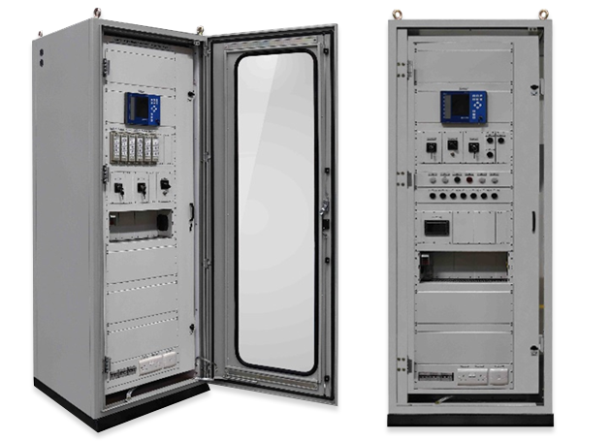

**Main Body**

**Overview of Electrical Control Systems**

Electrical control systems are frameworks designed to manage, command, regulate, and direct the behavior of other devices or systems. They play a crucial role in regulating electrical devices and processes, ensuring that operations within a network occur within predefined parameters. Control systems can range from simple manual operations, where an operator adjusts controls directly, to complex automated systems that make real-time adjustments based on input data.

**Types of Control Systems:**

* **Automatic Control Systems:** These systems operate independently of human intervention, using feedback mechanisms to maintain desired outputs. They are widely used in industries such as manufacturing, where they regulate processes like assembly line operations and temperature control in industrial ovens.
* **Manual Control Systems:** In these systems, human operators manually adjust the controls to achieve the desired output. These are typically used in less complex operations or where flexibility and human judgment are necessary, such as in small-scale production facilities.

**Applications:** Electrical control systems are indispensable across various industries, including manufacturing, automotive, and power generation. For instance, in the automotive industry, control systems manage engine performance, while in power generation, they regulate the output of power plants to match the demand.

**Protection Systems in Electrical Engineering**

Protection systems are essential in preventing damage to electrical equipment, ensuring user safety, and maintaining the overall stability of the electrical network. These systems detect abnormalities such as faults or overloads and initiate protective actions like disconnecting the faulty section from the network.

**Types of Protection Devices:**

* **Circuit Breakers:** Devices that automatically interrupt the flow of electricity in a circuit as soon as a fault is detected. They are crucial in preventing short circuits and electrical fires.
* **Relays:** Electromechanical switches that open or close circuits based on certain conditions, often working in tandem with circuit breakers.
* **Fuses:** Simple protection devices that melt and break the circuit when excessive current flows through them, providing a one-time protection solution.
* **Surge Protectors:** Devices that protect electrical equipment from voltage spikes by diverting excess voltage away from the protected load.

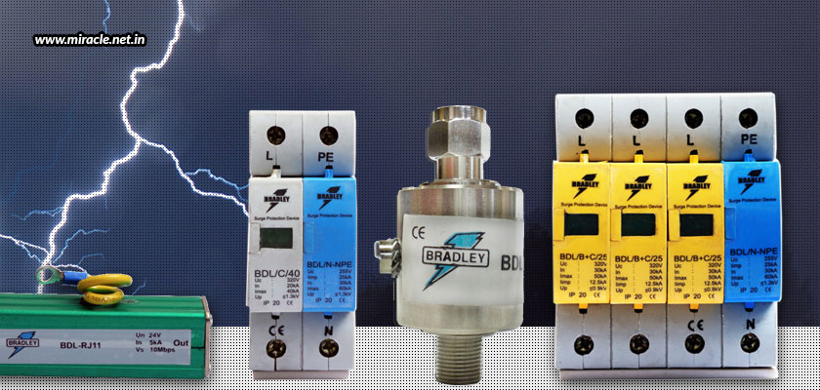

**Working Principles:** Each protection device operates based on specific principles. For example, circuit breakers function by detecting overcurrent conditions and tripping to open the circuit, while fuses rely on a thermal mechanism where the melting of a metal filament interrupts the circuit.

**Mechanisms of Electrical Protection**

Various mechanisms are employed in electrical protection to safeguard systems from faults and ensure their stable operation.

**Overcurrent Protection:** This mechanism protects circuits from excessive currents, which can result from short circuits or overloads. Devices like circuit breakers and fuses are commonly used for this purpose. When the current exceeds a predetermined threshold, the protection device trips to disconnect the circuit.

**Differential Protection:** This mechanism compares the current entering and leaving a system component, such as a transformer or generator. If there is a discrepancy, indicating a fault, the protection system isolates the component to prevent damage.

**Distance Protection:** Used primarily in power transmission systems, distance protection measures the impedance between the relay and the fault location. If the impedance falls below a certain threshold, indicative of a fault closer to the relay, the protection system activates to disconnect the affected section.

**Scenario Operations:** Each protection mechanism operates differently depending on the scenario. For example, in a short circuit, overcurrent protection would trip almost instantaneously to prevent damage, while differential protection might engage in cases of internal faults within transformers.

**Integration of Control and Protection Systems**

Control and protection systems are often integrated to enhance the reliability and safety of electrical networks. The integration allows for real-time monitoring and rapid response to any irregularities within the network.

**Examples of Integrated Systems:**

* **SCADA (Supervisory Control and Data Acquisition):** A sophisticated system that allows for the centralized monitoring and control of various processes across an electrical network. It integrates control functions with protection mechanisms, enabling operators to oversee and respond to potential issues in real-time.
* **Modern Substation Automation:** In modern substations, control and protection systems are often combined to streamline operations. Automated protection devices like digital relays work alongside control systems to manage the flow of electricity and protect against faults.

**Advancements in Electrical Control and Protection**

The field of electrical control and protection has seen significant advancements, driven by the need for more efficient, reliable, and cost-effective systems.

**Technological Advancements:**

* **Smart Grids:** These are advanced electrical grids that use digital communication technology to detect and react to local changes in usage. They integrate control and protection systems to optimize power distribution, reduce outages, and improve energy efficiency.
* **Digital Relays:** Unlike traditional electromechanical relays, digital relays offer enhanced precision, flexibility, and reliability. They can be programmed for various protection functions and are easier to integrate with modern control systems.
* **IoT-Based Control Systems:** The Internet of Things (IoT) has introduced new possibilities in electrical control, allowing for remote monitoring and control of devices via the internet. This technology enhances the efficiency and responsiveness of control systems.

**Impact:** These advancements have significantly improved the efficiency and reliability of electrical networks. They have also contributed to reducing operational costs by minimizing downtime and maintenance needs, while also facilitating the transition to more sustainable and intelligent power systems.

**Conclusion**

In summary, electrical control and protection systems are essential components in the operation and management of modern electrical networks. Control systems play a critical role in regulating electrical devices and processes, ensuring that systems operate within predefined parameters, whether through automatic or manual means. Protection systems, on the other hand, safeguard equipment and ensure the safety and stability of the network by detecting and responding to faults, overloads, and other potential hazards.

The integration of control and protection systems, as seen in technologies like SCADA and modern substation automation, enhances the reliability and efficiency of electrical networks. Furthermore, advancements in smart grids, digital relays, and IoT-based control systems are revolutionizing the field, leading to more intelligent and responsive electrical infrastructures.

The importance of these systems cannot be overstated, as they are pivotal in maintaining the safe, reliable, and efficient operation of electrical networks. As technology continues to advance, the future of electrical control and protection systems looks promising, with innovations poised to further improve their functionality, reduce operational costs, and support the growing demands of a highly electrified world.

**Bibliographic Sources**

* **Book/Primary Source**: *Electrical Installation Handbook: Protection, Control, and Electrical Devices.*
* **Additional Sources**:
  1. **IEEE Xplore Articles**: Articles on electrical control and protection from IEEE Xplore.
  2. **YouTube Video**: [Schneider Electric: Introduction to Protection Relays](https://www.youtube.com/watch?v=schneider_video).
  3. **YouTube Video**: [Electrical Engineering Portal: Circuit Breakers Types and Functions](https://www.youtube.com/watch?v=electrical_portal_video).
  4. **Research Papers/Journal Articles**: Recent research on smart grids and advanced protection systems.
  5. **Industry Reports**: Reports on the latest trends in electrical protection systems.