**NAME IN FULL: BEKEZELA MANGENA**

**STUDENT I.D NUMBER: UB85783BHU95004**

COURSE NAME:

**(WEALTH BEYOND MONEY)**

**OPTIONAL**

ATLANTIC INTERNATIONAL UNIVERSITY

**AUGUST 2024**

**TABLE OF CONTENTS**

**CONTENT PAGE**

**Essay Cover Page ………………………………………………………1**

**Table Of Contents……………………………………………………….2**

**Introduction……………………………………………………………….3**

**Body Essay ……………………………………………………………….5**

**Conclusion ………………………………………………………………..8**

**Bibliography……………………………………………………………….9**

**ESSAY TOPIC: WEALTH BEYOND MONEY (OPTIONAL)**

**INTRODUCTION**

As people, we almost always associate wealth with money or even worst still confuse

wealth for how much money one has got. However, true wealth goes beyond material

possessions. Wealth is about having an abundance of all things that truly matter in life

e.g. self-purpose, love, happiness, good health and well-being.

In essence, as a people, we need to redirect our focus from external factors to internal

ones. This involves rearrangement and re-prioritizing the center in our lives to do with,

giving values to relationships, personal growth, experiences, and above all making a

positive impact on the world that we live in. by redefining wealth, we undoubtedly open

ourselves up to a whole new marvelous world full of possibilities and self-fulfillments.

As people we should train ourselves never to be unethical in order to achieve wealth

Money can look and sound as the whole answer to buy you almost everything. The

opposite is however true; money will never buy you everything. If it did, then let me see

the form of money that will buy you just one important thing happiness.

Now that I have given some new look at how we define wealth generally, let us now

move on to assess some of the most important factors to do with wealth beyond money.



[This Photo](https://www.pngall.com/wealth-png/download/32353) by Unknown Author is licensed under [CC BY-NC](https://creativecommons.org/licenses/by-nc/3.0/)

**BODY ESSAY**

The main concepts and rules to do with appreciating **‘’wealth beyond** **money’**’

philosophy resides in one understanding the following major life factors:

* **Inner Peace And Happiness**: in peace and happiness are usually over looked in

life but truly speaking, they form a bigger part in the ultimate riches of life. True

wealth is not about external circumstances but more about enriching a deep

sense of peace, contentment, and joy from within. By practicing self-reflection,

adopting a positive mindset, and letting go of attachments to external outcomes,

we migrate towards a wellspring of inner wealth. True wealth lies in embracing

the present moment, finding peace amidst chaos and choosing happiness as a

way of life.

* **Time And Freedom**: time is one of life’s most valuable and finite resources. True

wealth is mainly about having the freedom to spend our time as we choose. It’s

about creating a life that aligns with our values, having flexibility to pursue our

passions, spend time with our loved ones. Instead of being buried in pursuit of

material wealth, true wealth allows us to **live life to our terms.** It comes with the

freedom to have full control of our time.

* **Gratitude And Mindfulness**: cultivating a gratitude practice and embracing

mindfulness allows us to find joy and contentment in the present moment. In the

world so full of striving for more, gratitude and mindfulness are often starved.

However, true wealth begins with appreciating what we already have and being

fully present each moment. Come a day when we will start to shift our focus from

what we lack to what we have, only then will we realize that true wealth is not

about accumulating more possessions but about finding fulfillment in the here

and now.

* **Giving Back**: true wealth is not about accumulating all for ourselves but, it is

rather about sharing, our abundance with others. By giving back, we contribute to

making the world a better place, create positive change, and at the same time

inspiring others to do the same. True wealth is about the impact that we make

and the lives that we touch through our acts of generosity and compassion.

* **Health And Well**-**Being:** true wealth is having the energy, vitality, and the

strength to live a fulfilling and purposeful life. Taking care of mental, physical and

emotional well-being. What good is wealth if you don’t have the health to enjoy

it?

* **Balancing Work and Life**: creating boundaries, making time for the things that

truly matter, prioritizing self-care balance are essential for experiencing true

wealth. True wealth is not achieved by sacrificing every other aspect of life for the

sake of career success. On the contrary, it is about finding a balance between

work and life.



[This Photo](https://happy-cats.trader3day.com/78) by Unknown Author is licensed under [CC BY-NC-ND](https://creativecommons.org/licenses/by-nc-nd/3.0/)

**CONCLUSION**

True wealth is a holistic concept that encompasses love, relationships, good health,

personal growth, making a life difference, giving back, gratitude, work-life balance inner

peace, happiness etc. as people, we should avoid choosing expediency over integrity

because no amount of financial wealth can replace a good night sleep, a clear

conscience and a peaceful mind. Money is a shallow motivator; too shallow to drive you

deep enough to achieve any success.

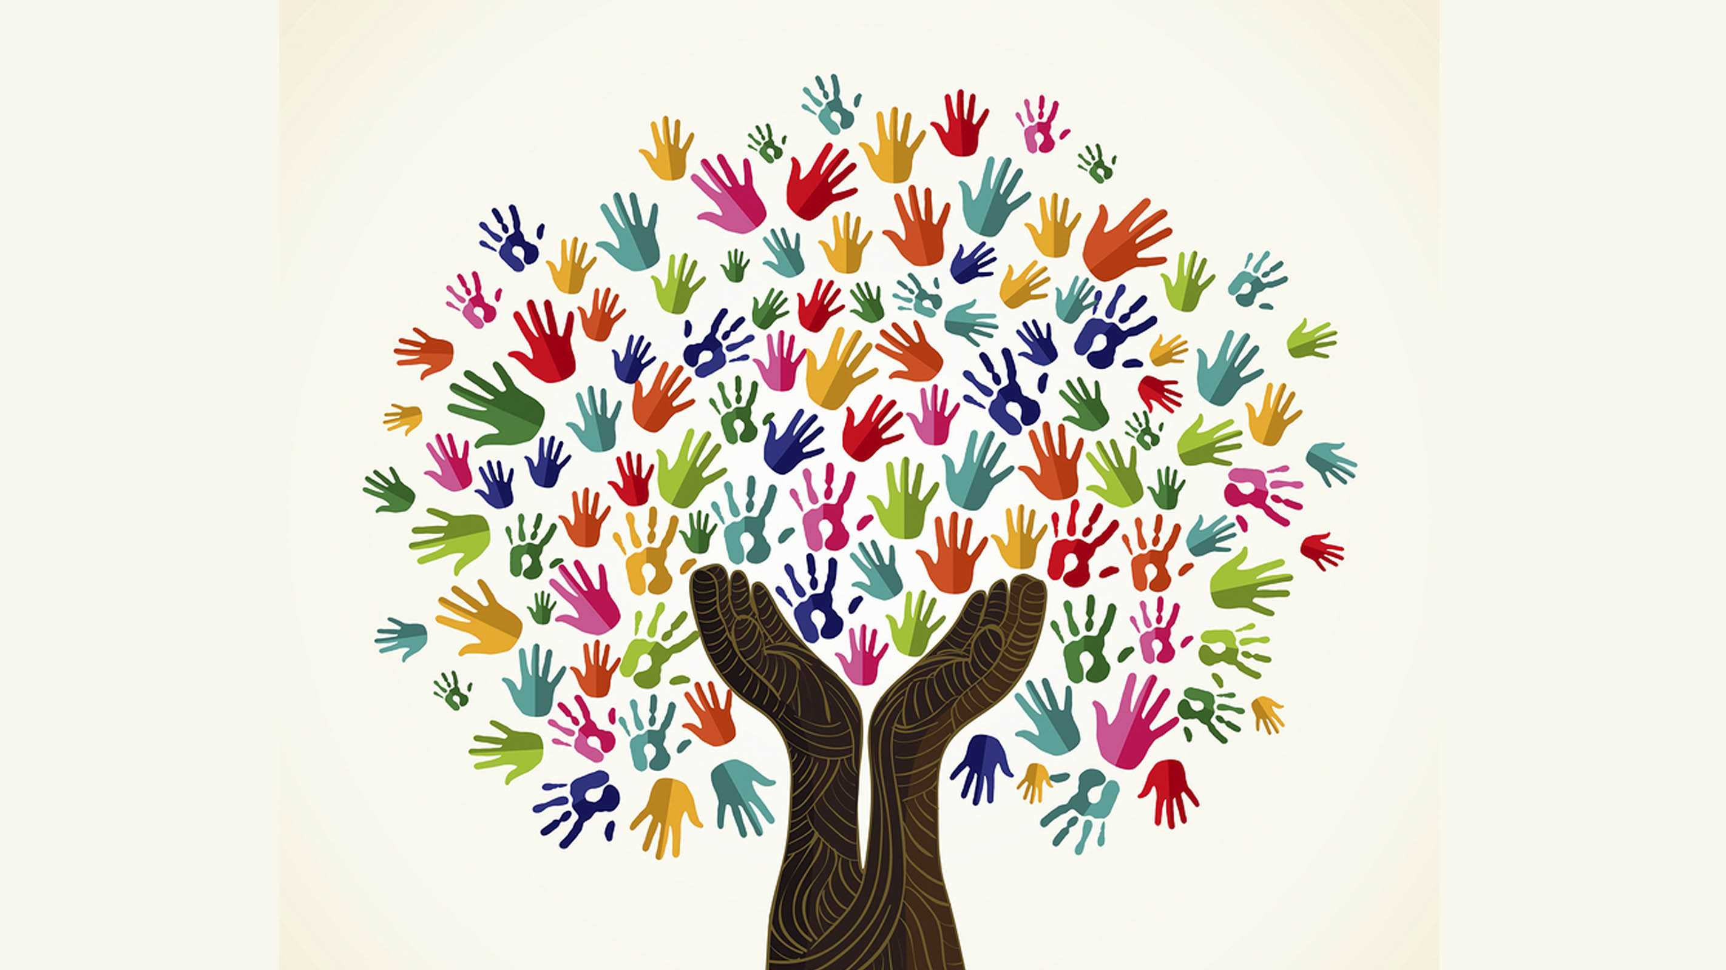

[This Photo](https://netivist.org/debate/helping-the-poor) by Unknown Author is licensed under [CC BY-SA-NC](https://creativecommons.org/licenses/by-nc-sa/3.0/)

***Bibliography;*** *The Money Resolution, by Frankie Calkins; Awaken Your Wealth, by Julie Murphy; Get Rich, by K. Connors;*

**Table of Contents**

List the sections of your assignment with page numbers. If you are using Word to prepare your assignments, use the functions in the “Table of Contents” section under References. There are you tube videos that teach how to use these functions.

**Introduction**

Write 3 to 6 paragraphs introducing the topics of the essay or exam.

**Body of Assignment**

Write your essay here separating the parts into different sections. The content of the essay should include:

• Summary of the topic. Describing course concepts.

• Write your opinions and analysis of the course concepts.

• Explain how you will apply the knowledge to your life, work and community.

• Write about personal experiences.

• Use case examples to demonstrate the concepts.

• Add pictures, tables and graphs.

If you are completing an exam, copy the questions into this section. Then write your answers under the questions.

**Conclusion**

Write 3 to 6 paragraphs summarizing the key ideas that you learned in the assignment.

**Bibliography**

Put the bibliography of the books and other sources used to prepare this essay in correct format in alphabetical order.

At least 3 references - Bachelor's degree.

At least 4 references - Master's degree.

At least 5 references - Doctorate.

Here are links on how to do your bibliography.

<https://students.aiu.edu/student/AIUWebinar.aspx?p=1&id=356>

<https://www.youtube.com/watch?v=I-IEWabgf0I&t=19s>