**NAME IN FULL: MR. BEKEZELA MANGENA**

**STUDENT I.D NUMBER: UB85783BHU95004**

COURSE NAME:

**(POWER OF HUMAN RESOURCES MANAGEMENT)**

**OPTIONAL**

ATLANTIC INTERNATIONAL UNIVERSITY

**SEPTEMBER 2024**

**TABLE OF CONTENTS**

**CONTENT PAGE**

**COVER PAGE…………………………………………………………………1**

**ASSIGNMENT TOPIC…………………………………………………………3**

**INTRODUCTION……………………………………………………………….5**

**CONCEPTS…………………………………………………………………….7**

**CONCLUSION…………………………………………………………………13**

**BIBLIOGRAPHY……………………………………………………………….14**

**ASSIGNMENT TOPIC: HUMAN RESOURCES MANAGEMENT IN THE**

**HOSPITALITY INDUSTRY**

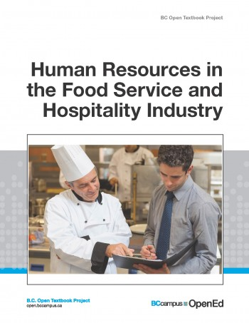

[This Photo](https://ecampusontario.pressbooks.pub/hrinfoodservices/) by Unknown Author is licensed under [CC BY](https://creativecommons.org/licenses/by/3.0/)

**KEY AREAS TO BE COVERED IN ADDRESSING THE TOPIC**

* Summary and Analysis of Concepts in Human Resources Management.
* Detailed outline of the Power of Human Resources Management in the Hospitality Industry



[This Photo](https://researchleap.com/hrm-in-relation-to-employee-motivation-and-job-performance-in-the-hospitality-industry/) by Unknown Author is licensed under [CC BY](https://creativecommons.org/licenses/by/3.0/)

**INTRODUCTION**

The hospitality industry is one of the largest economic industries in the world as well as

it being the most important sources of income and employment in most countries. The

hospitality industry is labor intensive which means that it requires a lot of labor. It then

follows that human resources are a very important factor in the competitiveness of the

hospitality industry. It is not disputed that while other resources are also important in this

industry, human resources stand out as the main resource that bring all other

resources into a unified organization. Human resources management today is not as

easy as most people might think. Managers and leaders have to face and deal with so

many challenges. If these challenges are managed effectively, they can become

opportunities, but if not, they can become threats. In fact, sometimes companies plan in

such a way that human resources retention does not match what should happen. With

immature planning, mistakes in recruitment, lack of training and development, the

company does not progress, there is no compensation for employees who work beyond

the target. The immaturity of planning in the selection of human resources more

specifically in hospitality industry, has dire outcome effects for the company. Likewise,

in terms of recruitment, training and development, compensation and job evaluation

these have a major impact on the effectiveness of company under the hospitality

industry performance and will reduce overall performance. Where this happens,

resources management will not function properly. It is worth pointing out that the

hospitality industry is one part of the larger travel and tourism industry that, in addition to

hospitality consists of transportation services. By its definition, it is known as the range

for profit and not for profit organizations that provide lodging and/or accommodation

including food for people while they are away from their homes. Labor intensive relates

to the situation in which people rather than technology and equipment are used to

provide products and services for an organization’s consumers.

**HUMAN RESOURCES MANAGEMENT CONCEPTS**

The major concepts in Human Resources Management that I am going to summarize

and analyze relative to my topic include mainly the following:

* Recruitment and Selection
* Performance Management
* Compensation and Benefits
* Succession Planning
* Learning and Development
* Human Resources Information Systems (HRIS)
* HR Data and Analysis

**Summary and Analysis of the above Concepts relative to the Topic**

While the hospitality industry is broad and diverse, organizations within it share some

things in common. One important factor is the need for staff members with a variety of

knowledge, skills, and experience to produce the products and services that are needed

or desired by the customers. The industry is best described as a people business. In

this context, the people typically referred to are both the employees who produce the

products and services as well as those who purchase and consume them. The need to

devote an entire focus on producing vivid procedures to facilitate the work of staff

members in the hospitality industry are easy to defend and justify. Almost without

exception, hospitality managers in all types and sizes of organizations consistently note

concerns about recruiting and retaining the right staff members at all organizational

levels. The paramount goal of the organizations in the hospitality industry is to employ

persons with right attitudes and abilities required to best meet the needs of those being

served. To achieve all the above, hospitality organizations must have a correct

appreciation of the following concepts in human resources management.

1. **Recruitment And Selection**

The most visible element in HR is recruitment and selection. Selecting the right

candidates to work for a company is a key responsibility for managers. This is more so

in the hospitality industry. Different selection tools and instruments like interviews,

assessments, reference checks and other recruitment methods are put to use.

1. **Performance Management**

Performance management is a process whereby the organization helps employees to

perform better in their respective jobs. Performance management helps people to get

feedback on their performance and this in turn helps the manager to identify areas

where subordinates need help and training. The entire exercise revolves around getting

better performance especially in the hospitality industry. Forms of performance

management are formal one-on-one performance reviews or 360-degree feedback

instruments.

1. **Compensation and Benefits**

The answer to retaining and motivating employees is hinged on fair compensation of

employees. There are two types of compensation namely primary and secondary.

Directly paid money is the primary composition while all non-monetary rewards

comprise secondary benefits.

1. **Succession Plan**

For continuity of success in the hospitality industry, every organization has to put in

place proper planning for succession. The process of planning contingencies in case

key employees leave the company is called succession planning. A talent pool of

candidates, who are qualified and ready to fill positions in case of some employees

leaving is created.



[This Photo](https://www.hrbartender.com/2019/recruiting/succession-planning-replacement/) by Unknown Author is licensed under [CC BY-NC-ND](https://creativecommons.org/licenses/by-nc-nd/3.0/)

1. **Learning and Development**

For the hospitality industry, learning and development can be really helpful in advancing

the organization towards its long-term goals. It helps hospitality industry employees to

improve their work performance. Hospitality industry organizations must have defined

budgets for learning and development efforts. To achieve this, they can use the nine

Box grid which has proven gto be an excellent framework that connects performance

management with learning and development activities.

1. **Human Resources Information Systems (HRIS**)

HRIS can be used by organizations in the hospitality industry to support the rest of the

concepts enshrined in the human resources management scope. For recruitment and

selection, an applicant tracking system (ATS) can be used to keep track of applicant’s

employment record. For performance management system, it is used to keep track of

individual goals and put in performance ratings for performance management.

1. **HR Data and Analysis**

HR metrics or HR KPIs helps to keep track of critical data. They specify how a company

is doing on a given measurement and is known as HR reporting. More data-driven

decisions can be made by HR through data analytics.

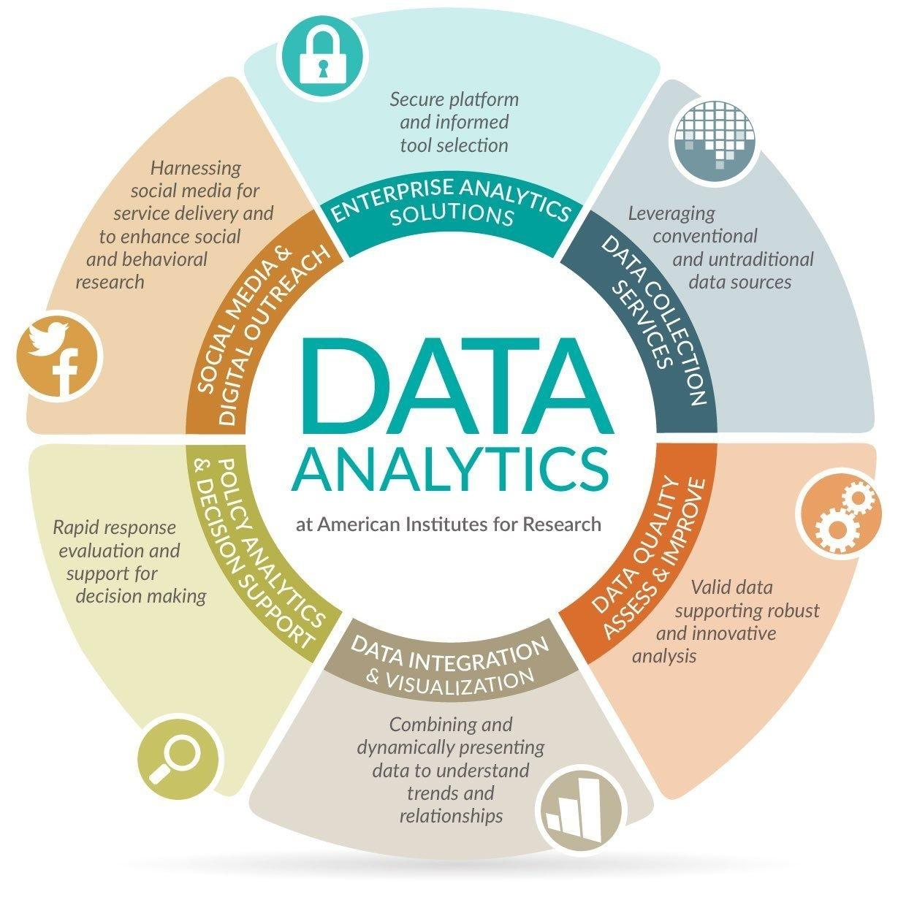

[This Photo](https://engenhoeengenhocas.blogspot.com/2018/08/analitica-integracao-e-qualidade-dos.html) by Unknown Author is licensed under [CC BY-SA](https://creativecommons.org/licenses/by-sa/3.0/)

**CONCLUSION**

The power of human resources management in the hospitality industry must essentially

be centered mainly to accomplish the following employee expectations:

* Provision of handsome salaries.
* Provision of Good Overtime Reimbursement.
* Provision of Accommodation and Transport Facilities.
* Conducting in-doors activities
* Practicing a Friendly Employment culture.
* Efficient Grievance Handling System.
* Provision of Life Insurance
* Provision of Medical Insurance

The hotel industry would get a larger benefit by adopting appropriate strategies for

talent retention as this would not only enable in retaining the existing talented

employees for a longer tenure but also help in attracting new and fresh talent for a

successful future with the organization. On the other hand, the hospitality industry could

adopt strategies like performance-based incentive schemes, comfortable and friendly

working conditions coupled with a handsome pay package would have a great impact

on talent retention.

*BIBLIOGHRAPHY;* ***C. Ashton & L. Morton,*** *(2005); Managing Talent for Competitive Advantage;* ***S. Watson,*** *(2008); Where are we now?;* ***V. Jauhari****, (2006); Competencies for a career in the hospitality industry*

**Table of Contents**

List the sections of your assignment with page numbers. If you are using Word to prepare your assignments, use the functions in the “Table of

Contents” section under References. There are youtube videos that teach how to use these functions.

**Introduction**

Write 3 to 6 paragraphs introducing the topics of the essay or exam.

**Body of Assignment**

Write your essay here separating the parts into different sections. The content of the essay should include:

• Summary of the topic. Describing course concepts.

• Write your opinions and analysis of the course concepts.

• Explain how you will apply the knowledge to your life, work and community.

• Write about personal experiences.

• Use case examples to demonstrate the concepts.

• Add pictures, tables and graphs.

If you are completing an exam, copy the questions into this section. Then write your answers under the questions.

**Conclusion**

Write 3 to 6 paragraphs summarizing the key ideas that you learned in the assignment.

**Bibliography**

Put the bibliography of the books and other sources used to prepare this essay in correct format in alphabetical order.

At least 3 references - Bachelor's degree.

At least 4 references - Master's degree.

At least 5 references - Doctorate.

Here are links on how to do your bibliography.

<https://students.aiu.edu/student/AIUWebinar.aspx?p=1&id=356>

<https://www.youtube.com/watch?v=I-IEWabgf0I&t=19s>