**FEYIKEMI OCHUKE IMIRUAYE**

**UB85410HPS94631**

COURSE NAME:

**HUMAN FACTOR I (HFA 242)**

ATLANTIC INTERNATIONAL UNIVERSITY

**FEBRUARY/2025**

**Table of Contents**

Introduction………………………………………………………………………………..3

Body of assignment………………………………………………………………………3-9

Illustrations……………………………………………………………………………….9-10

Conclusion…………………………………………………………………………………10

**Introduction**

**Personnel Management**

Personnel Management, are the processes involved in obtaining, using and maintaining a satisfied workforce. This concept introduced during the era of industrialization, where there was the need to manage a rapidly growing workforce. This birthed the introduction of systems to efficiently manage the recruitment and payment of employees, managing employee records, as well as employee-employer relationships. Over time, this evolved to a broader and more strategic approach involving onboarding, orientation, training and development, performance management, etc. This is currently known as Human Resource Management, with [Robert Owen](https://www.whatishumanresource.com/robert-owen) often cited as a key figure in its early development.

**Organizational Behaviour**

This is the study of how employees behave within an organization and how these behaviours affect the success of the organization. It is important for an organization to study its behaviour because it allows the organization to understand how its employees behave and interact with each other and the organization itself. Using the results, organizations can then implement changes that enhance performance and efficiency, as well as improve employee satisfaction.

There are generally four key elements of organizational behaviour which are:

1. **People**: This refers to the employees working within the organization. They either work individually or in groups and make up the organization’s working structure. They are the most important element, so it is important that the organization learns how to manage and treat them properly so that the organization can thrive.
2. **Structure**: This refers to the roles and relationships of those in an organization. It’s important that an employee’s role in the structure is clearly defined to them. This will lead to more work efficiency and help employees avoid confusion.
3. **Technology**: Having the necessary technology in your business ensures that tasks are carried out more effectively, at the same time, you should also be cautious of not allowing technology take over too many processes so that the employees feel free and valuable.
4. **Environment**: This refers to the business environment which is influenced by both internal and external factors such as government, society, family and other organizations. It is important to pay attention to these factors so you can make necessary adjustments for the benefit of your business when necessary.

Between 1924 and 1932, a study was conducted in Hawthorne Works to determine if its workers would become more productive in brighter or dimmer levels of light. The workers' productivity seemed to improve when changes were made but returned to their original level when the study ended. It has since been alternatively suggested that the workers' productivity increased because they were motivated by interest being shown in them. It was later on referred to as [The Hawthorne Effect](https://www.scribbr.com/research-bias/hawthorne-effect/#:~:text=The%20Hawthorne%20effect%20refers%20to,external%20validity%20of%20your%20research.), by John R.P. French in 1953 and is said to be the best known study of organizational behaviour.

**Models of Organizational Behaviour**

These are the structural models that describe the relationship between employees at different levels in the organization i.e on the individual level, group level and organizational level.

1. **Feudal model**: This model should be highly discouraged, as this model considers the employees to be an inferior element of the organization.
2. **Autocratic model**: This is based on power and formal authority, as the employees are expected to follow orders from higher managerial authorities as they are the only ones considered to have the expertise in the business.
3. **Custodial model**: In this model, economic resources drive performance. The organization commits to providing additional benefits and security in order to bring out the best in its employees. This model is usually deployed in organizations with high economic resources.
4. **Supportive model**: A leadership approach is adopted in this model, as the top managers aim to get the work done by helping and encouraging their employees. Here, importance is placed on a friendly relationship between superiors and subordinates, the psychological needs of the employees and ensuring job satisfaction.
5. **Collegial model**: This is similar to the supportive model. Teamwork approach is adopted here. It is the responsibility of the superiors to create a positive and healthy workplace for the employees.

It is important for employees and organizations alike to recognize that their relationship is mutually beneficial. The same way an organization cannot exist without employees, so also, the employee needs an organizational structure to work, so as to get paid. This constant realization would encourage diligence, respect and appreciation from both parties, which would essentially lead to a thriving work environment.

**Process Management**

Irrespective of the model of organizational behaviour being adopted, there are processes that need to be put in place within the organization to ensure employee reporting channels and systems are being managed and adhered to. One of such processes, is the Leadership of the organization.

John Maxwell defines a good leader as someone who “knows the way, goes the way and shows the way”. This means that a leader must have adequate knowledge of the vision he is trying to accomplish, be prepared to lead by example, and then be able to guide his followers accordingly.

There are four primary factors to leadership:

1. **Leader**: You must truly know who you are and have a complete understanding of what you want to accomplish and how. It is this confidence in yourself and your vision that would inspire people to follow you and work with you.
2. **Follower**: Knowing and understanding your people is an essential skill for a good leader. Different people have different temperaments and different levels of understanding, so it is your responsibility as a leader to know how to navigate your followers accordingly and know what style of leadership to adopt in different situations.
3. **Communication**: Your ability to communicate effectively through verbal and non-verbal cues is a crucial skill in leadership. You need to be able to articulate your message clearly and concisely, and at the same time, your body language should be warm, encouraging and depict confidence in the actualization of your vision.
4. **Situation**: Different situations require different causes of action, so it is your responsibility as a leader to always make the right judgement call, depending on what issue is being addressed per time.

There are also different styles of leadership, which can either be practiced individually or combined, depending on how dynamic the leader is. Kurt Lewin in 1939, broke it down into three major styles which are:

1. **Autocratic leadership**: Here, the leader holds all authority and responsibility and makes decisions on behalf of the team without taking any inputs or suggestions from them. While this is not the best style of leadership, it can be adopted in situations where there is no time to deliberate on a decision or when the leader is genuinely the most savvy in the group.
2. **Democratic leadership:** Here, there is collaboration, as members have the opportunity to contribute and make inputs. It is based on these that the leader is then able to make a final decision.
3. **Laissez-faire leadership**: This is a passive style of leadership where the leader provides the group with the necessary information and resources to carry out the task and allows them work without supervision. This is usually best with a creative or highly skilled group or with people who are self-motivated.

Other leadership styles were introduced over time, such as:

1. **Transformational leadership**: This was developed by James MacGregor Burns in 1978 in his book, titled ‘Leadership’. This type of leadership expects the best out of their group and pushes them consistently until their work, lives, and businesses go through a transformation or considerable improvement.
2. **Transactional leadership**: This term is attributed to Max Weber (1947), James MacGregor Burns (1978) and Bernard Bass, and it is a mutually beneficial style of leadership style that focuses on exchanging resources, skills and effort between the leadership and its employees.

Other factors to be put in place in an organization to ensure proper process management is Power and Authority.

Authority is the formal power given to an individual in an organization, based on their position, that allows them to give orders, make decisions and expect compliance from the staff based on their scope of responsibility within the organization.

The three forms of authority are:

1. **Line authority**: This is a clear path of command from the top of the organization and the frontline employees, and decisions made are binding and must be followed by the subordinates.
2. **Staff authority**: This happens when the staff have the power to advise and support the line managers, thereby making the line managers make more informed decisions.
3. **Team authority**: This is when a group of employees are put in work teams and are responsible for their decision making as a group as long as they effectively fulfil the deliverables which the organization expects from them.

Power in the workplace is the measure of control or influence that a person or their role have within the organization. The different types of workplace power dynamics are:

1. **Reward power**: This is the ability to incentivize people to do what you ask them to do.
2. **Expert power**: This is when you are highly skilled in the area or topic, making the staff respect and admire you and automatically make them want to do your bidding.
3. **Referent power**: This is when the leader has the ability to empathise with the staff and is always considerate of them, which in turn makes the staff trust the leader and are willing to do what they ask.
4. **Legitimate power**: This is power borne out of the role or position the leader has in the organization, which makes the staff has no choice but to obey their instructions.
5. **Coercive power**: This is when threats and punishments are used to control a person’s behaviour.

**Recruitment and Induction**

Recruitment is the process of actively seeking out, finding and hiring candidates for a particular role in an organization. This includes the entire hiring process up until the individual’s integration into the organization.

Recruitment can be done internally by encouraging existing staff who have shown potential to apply for the vacant roles or externally by outsourcing to outside firms or utilising advertisements, job boards, social media sites, and others. It is ideal for every organization to use both methods of recruiting, perhaps in a 30/70 proportion (30% internal and 70% external).

A typical recruitment process involves:

1. **Identifying the need**: Determine what kind of people are needed for the organization
2. **Creating a plan**: Develop a strategy for finding and hiring the right people
3. **Writing a job description**: Create a detailed description of the role and responsibilities
4. **Advertising**: Promote the position to attract potential candidates
5. **Reviewing applications**: Screen applications to find the most qualified candidates
6. **Interviewing**: Conduct interviews with top candidates
7. **Selecting**: Choose the best candidate for the role
8. **Onboarding**: Integrate the new hire into the organization

Induction is the initial onboarding phase for new hires where they are introduced to the company, their role and their work environment in order to help them settle in and get accustomed to the organization’s culture, policies and procedures. Some of such induction processes include security procedures, signing in/out procedures, GDPR training and confidentiality, how to access systems, file sharing, communication tools, quality assurance procedures, individual rights, diversion and inclusion policies, disciplinary procedure, introduction to the team and ways of working, meeting immediate line managers and key personnel, etc.

**Training**

On-the-job training in a workplace refers to when an employee is being guided and instructed by a more experienced supervisor, allowing them to gain practical experience in real-time work situations. It is the responsibility of the Personnel department to ascertain the needs of the employees, so they know when a training is needed, in what area(s) and the particular training method to be deployed.

Some common methods of providing on-the-job training to employees are:

1. **Shadowing**: This is when new employees observe and learn from more experienced colleagues. This encourages practical learning as it helps the new hire understand the day-to-day operations easily.
2. **Mentoring**: This is when an experienced employee offers support and guidance to a less experienced colleague. This method helps the employee feel supported and provides them with a valuable internal resource for career development.
3. **Lateral move/Job rotation and Cross training**: This is when employees are rotated through different roles so that they can have experience in multiple areas. This expands their skillset, adaptability and provides them with a comprehensive understanding of various organizational functions.
4. **Coaching**: This is when a designated coach works closely with an employee to help them develop a particular skill or level of competency.
5. **In-house Workshops and Seminars**: This is when internal experts or external professionals organize training sessions on specific topics relevant to employees’ roles.
6. **Simulation training**: This is when employees participate in simulated work scenarios that mirror real life workplace challenges. This helps the employee to think critically in advance about how they would handle certain situations if/when they arise.
7. **Promotion**: This is when an employee is moved to a higher role with more responsibility, forcing them to grow.

After an on-the-job training, it is important to determine if the training program achieved its intended purpose or if some things need to be adjusted in subsequent trainings. Here are some evaluation methods that can be useful:

1. **Direct observation**: This is simply watching the trainees perform their daily duties to see if there are any improvements based on previous training and identify areas that require further development.
2. **Supervisor feedback**: Receiving feedback on the trainer or supervisor about the performance of the trainees during the training sessions.
3. **Self-assessment**: Trainees can be asked to evaluate their own progress and identify ways they think they may have improved.
4. **Performance metrics**: Setting key performance indicators (KPIs) before the training, like productivity, efficiency, etc and tracking the performance of the trainees after the training, based on these metrics.

On-the-job training practices are highly beneficial for both the employees and the organization as a whole, as it boosts employee morale, increases productivity, improves employee retention, helps employees develop new skills, allows for better team building, enables employees require less supervision, fewer accidents and errors occur, etc.

**Job Analysis – Job Description and Specification**

Before employees are recruited for any role, the personnel management is required to perform job analysis. This involves studying the job to determine what responsibilities and activities the job entails in order to ascertain the qualifications necessary for the optimal performance of the job as well as the conditions required for performance efficacy such as training, compensation and performance appraisal.

Job analysis is usually conducted by:

1. Identifying the purpose of the job analysis.
2. Choosing methods for collecting data.
3. Gathering information about the job.
4. Analysing the data.
5. Documenting the findings.
6. Validating the results.
7. Maintaining and update the analysis.

Some of the benefits of job analysis are:

1. Helps the personnel manager/recruiter identify the right person for the job.
2. Helps identify the areas where employees need training.
3. Helps determine appropriate salary benefits and incentives.
4. Helps establish appropriate criteria for performance appraisal.

Job analysis has two general outcomes;

1. **Job description**: This is a written explanation, outlining the essential responsibilities and requirements for an available job position.
2. **Job specification**: This is a written document that describes the attributes desired in a potential employee; the required knowledge, skillset, abilities and minimum qualification.

**Performance Appraisal**

This is the process of evaluating and documenting how well an employee is performing on the job. A good performance appraisal summary includes an employee’s achievements, strengths and areas of improvement and how their contributions may have impacted the organization or society as a whole.

This practice is very important because it increases employee engagement and development, is a good determining factor for promotions and compensations, reduces employee turnover rate, enhances communication between managers and employees, etc.

Performance appraisals can be conducted in several different ways e.g

1. Design a standard form for the appraisal which will include certain performance metrics and a rating system.
2. Collect feedback from the people who work with the employee, which includes subordinates, colleagues, supervisors and clients.
3. Peer reviews: Colleagues reviewing each other’s performance.
4. Rank each employee based on certain performance factors, starting from the highest to the lowest.

**Illustrations**

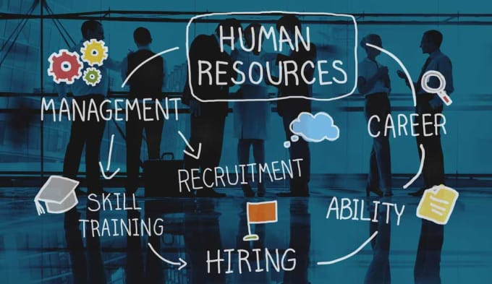

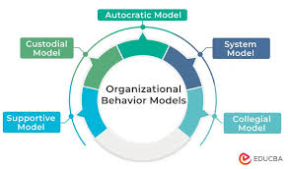

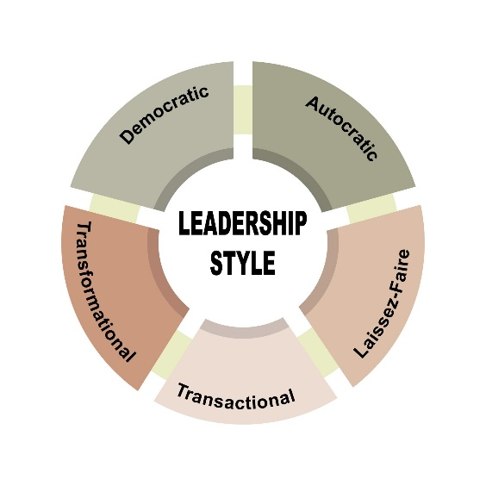

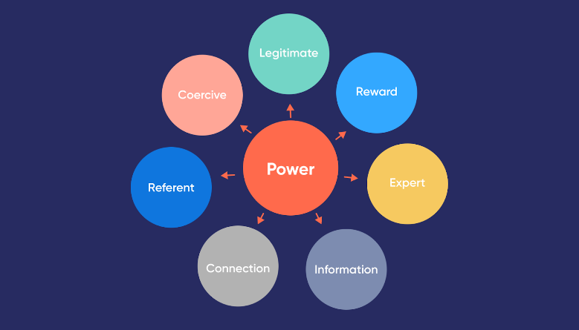

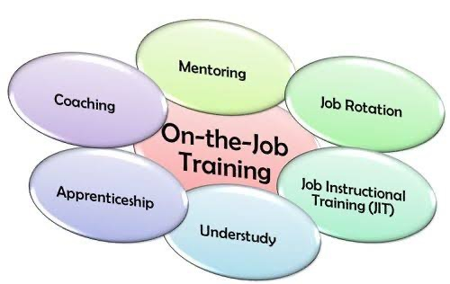

**Conclusion**

Personnel management plays a multifaceted and critical role in modern organizations. In today's dynamic business environment, where organizations face globalization, technological advancements, changing demographics, and evolving employee expectations, personnel management plays a pivotal role in helping organizations adapt and thrive. By focusing on strategic personnel management practices, organizations can gain a competitive advantage by attracting and retaining the best talent, enhancing employee performance and productivity, and fostering a positive work culture that promotes innovation and growth.

**References**

<https://www.betterup.com/blog/power-vs-authority>

<https://corporatefinanceinstitute.com/resources/management/leadership-styles/>

<https://cosuite.com/the-key-elements-of-organizational-behavior/#:~:text=Structure%20relates%20to%20the%20roles%20and%20relationships,work%20efficiency%20and%20employees%20can%20avoid%20confusion>.

<https://cpdonline.co.uk/knowledge-base/business/staff-induction>

<https://www.geeksforgeeks.org/types-of-models-of-organisational-behaviour/>

<https://humaans.io/hr-glossary/on-the-job-training>

<https://www.icao.int/safety/CMAForum/Pages/USOAP-CMA-OJT.aspx>

<https://www.investopedia.com/terms/o/organizational-behavior.asp>

<https://www.personio.com/hr-lexicon/examples-of-performance-appraisals/>

<https://www.scribbr.com/research-bias/hawthorne-effect/#:~:text=The%20Hawthorne%20effect%20refers%20to,external%20validity%20of%20your%20research>.

<https://www.shrm.org/mena/topics-tools/tools/toolkits/performing-job-analysis#:~:text=Job%20analysis%20is%20the%20process,which%20the%20work%20is%20performed>.

<https://www.smartrecruiters.com/resources/glossary/recruitment/>

<https://www.whatishumanresource.com/robert-owen>