FEYIKEMI OCHUKE IMIRUAYE
UB85410HPS94631

COURSE NAME:
RELIGIOUS STUDIES & PSYCHOLOGY (RST 277)

ATLANTIC INTERNATIONAL UNIVERSITY
JUNE/2025

Table of Contents
Introduction………………………………………………………………………………..3-4
Body of assignment………………………………………………………………………4-5
Conclusion…………………………………………………………………………………5
Illustration…………………………………………………………………………………5-6

Introduction
What is mental health?
Mental health refers to one’s emotional, psychological and social wellbeing and how these affect how a person thinks, feels and acts. No one is expected to be in a perpetual state of bliss and happiness, however, a person with a good mental health state is someone whose cognitive abilities, perception and behaviour is said to be stable. They can cope with change, handle stress and deal with difficult situations.
The key aspects of mental health are:
- Emotional well-being: This involves managing emotions, coping with stress and staying positive.
- Psychological well-being: This refers to cognitive abilities like thinking, problem-solving and decision making.
- Social well-being: This is the ability to establish and maintain healthy relationships and participate optimally in social activities and gatherings.
- Physical health: These are the physical factors like exercise, diet and sleep which impact mental health.
- Resilience: This refers to one’s ability to withstand and bounce back from challenges and difficult situations.
- Self-awareness: This involves being able to understand and interpret one’s thoughts and feelings and also being aware of your strengths and weaknesses.
- Motivation: Being inspired to achieve goals and get involved in meaningful activities.
- Healthy coping mechanisms: Being able to manage stress, anxiety and unpleasant emotions.
What is Orthodox Christianity?
Orthodox Christianity is also known as Eastern Orthodox Christianity and is one of the three (3) major Christian communities in the world, the other two being the Catholic and the Protestant. It is characterised by its adherence to ancient traditions, its distinct practices of public worship and its emphasis on the continuity of the Church with the apostles.
Here are the major characteristics of Orthodox Christianity:
- Continuity with the Apostolic Church: They believe that their Church is directly descended from the early Church founded by Jesus Christ and His apostles.
- Liturgical worship: The Divine Liturgy is the primary form of worship and icons play a major role in their devotional life.
- Doctrinal beliefs: They have specific understandings of certain doctrines. For example, while the Catholics believe that the Holy Spirit proceeds from the Father and Son, they believe that it proceeds only from the Father.
- Sacraments: They recognise seven (7) sacraments, namely: Baptism, Confirmation, Eucharist, Repentance, Holy Orders, Marriage and Holy Unction.
- Ecumenical Councils: They recognize the authority of the first seven (7) Ecumenical Councils (held between the 4th and 8th centuries) as defining key doctrines of the faith.
- Old Testament Canon: They use the Septuagint (a Greek translation of the Hebrew Bible) as the basis for their Old Testament.
- Geographical distribution: Even though they are spread throughout the world, their largest concentrations are in Eastern Europe, the Balkans, the Middle East, and parts of Russia.
Religious Misconceptions about Mental health
There is often a misconception that mental health and the Christian faith are mutually exclusive concepts. Oftentimes, mental health is viewed as purely psychological, while our faith is limited to the confines of the spiritual realm. This leads to vastly different explanations for mental struggles. Some people may leave out spiritual health as a possible contributing factor to mental struggles, while others may over spiritualise these problems, attributing them solely to poor spiritual health. As well-rounded human beings however, it is important that we take into consideration mental, spiritual and even physical health in order to truly understand the struggles of those battling with mental health challenges.
Some of these misconceptions are:
- Mental illness is a result of sin or wrongdoing: While sin can impact our psychological well-being, mental illness is not necessarily indicative of moral flaws. Even devout individuals can suffer from mental health struggles like depression. In biblical narratives, figures like King David and Job grappled with profound despair and anxiety, which can be likened to modern-day depression.
- Lack of faith or weak spirituality causes mental illness: People tend to make statements like “if you just prayed hard enough…”, which imply spiritual deficiency or lack of faith as the root of mental illness. This myth disregards the multifaceted nature of mental health, which involves biological, psychological, environmental and social factors.
- Prayer alone can cure mental illness: While prayers offer comfort and support, they are not a substitute for professional help. Scriptures encourage continuous prayer and the acceptance of wise counsel, thus acknowledging the importance of both spiritual and practical approaches to healing. We are encouraged to “pray without ceasing” (1 Thessalonians 5:17) as well as to “listen to counsel and receive instruction, that you may be wise in your latter days” (Proverbs 19:20).
- Relying on psychiatric medication or therapy signifies a lack of trust in God: There is a stigma around mental illness that discourages individuals from seeking psychiatric care, unlike seeking treatment for physical ailments. This attitude overlooks the biological factors that can contribute to psychological disorders.
Conclusion
Challenging these myths requires an empathetic understanding of both religious beliefs and mental health issues. It is crucial to foster mental health awareness within religious communities, so as to dispel the stigma, and also educate mental health practitioners on incorporating spiritual beliefs into therapy when appropriate. Both mental health care and religious practice can complement each other, alongside peer and social support, offering a comprehensive approach to well-being. Conversations with God and therapists need not be mutually exclusive; God’s renewal of the mind and restoration of the soul can align with the guidance provided by competent therapists, helping individuals reach their fullest potential. The Lord is the One who renews the mind (Romans 12:2) and restores the soul (Psalm 23:3), both through His divine grace and through professional mental health care providers.
Illustrations
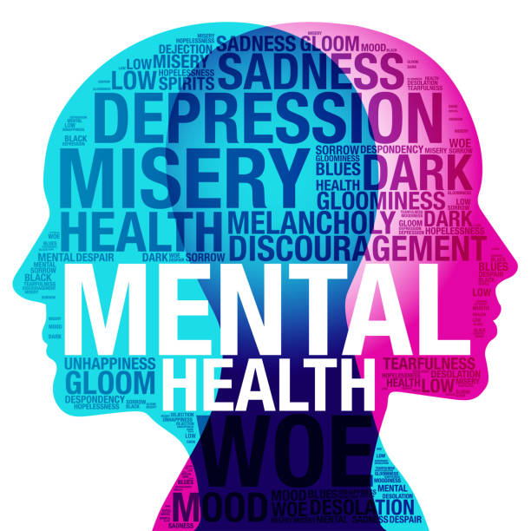

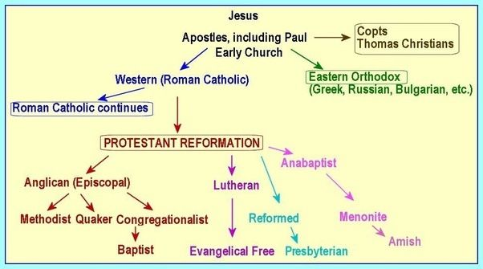
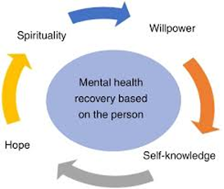

References
https://www.christianity.com/church/denominations/the-orthodox-church-history-and-beliefs-of-orthodoxy.html
https://www.goarch.org/introduction
https://www.medicalnewstoday.com/articles/154543
https://sheriffsrelief.org/2024/07/religious-misconceptions-about-mental-illness/
https://www.who.int/news-room/fact-sheets/detail/mental-health-strengthening-our-response

