**FEYIKEMI OCHUKE IMIRUAYE**

**UB85410HPS94631**

COURSE NAME:

**CONTEMPORARY SOCIAL PROBLEMS (CSO 217)**

ATLANTIC INTERNATIONAL UNIVERSITY

**JANUARY/2025**

**Table of Contents**

Introduction………………………………………………………………………………3-4

Body of assignment……………………………………………………………………..4-7

Illustrations……………………………………………………………………………….7

Conclusion………………………………………………………………………………..8

**Introduction**

Social problems are controversial problems that undermine the wellbeing of a significant population in a society. They are mostly caused by tension factors which challenge some values of society, social values which are being challenged and the intense reaction of individuals and groups to the challenge.

Common characteristics of social problems are:

* They directly or indirectly disintegrate social systems because they cause dissatisfaction, suffering and misery.
* They usually have no single or simple cause.
* They are relative in nature; what could be a social problem in one society might not be in another society.
* They are usually interconnected.

Social problems are largely philosophical, so in order to examine and address them effectively, it is important that we are able to identify what is considered as right or wrong from an ethical perspective.

Ethics is divided into three major fields, two of which are Normative ethics and Applied ethics. Normative ethics is concerned with the formulation of moral rules that have direct implications for what human actions, institutions and ways of life should be like. It begs to find answers to certain questions, as cited in Britannica’s biography of Peter Singer – “How should we live? Shall we aim at happiness or at knowledge, virtue, or the creation of beautiful objects? If we choose happiness, will it be our own or the happiness of all? And what of the more particular questions that face us: is it right to be dishonest in a good cause?”

There are different types of normative ethical theory which are:

1. **Ethical egoism**: This suggests that people should act in their own self-interest and prioritize their needs over others’. While this theory avoids any conflict between self-interest and morality, thereby, making moral behaviour by definition, rational, it is highly contradicted in a thought experiment known as “prisoner’s dilemma”, which came up in the late 20th century.  The basic prisoners’ dilemma is an imaginary situation in which two prisoners are accused of a crime. If one confesses and the other does not, the prisoner who confesses will be released immediately and the prisoner who does not will be jailed for 20 years. If neither confesses, each will be held for a few months and then released. And if both confess, each will be jailed for 15 years. It is further stipulated that the prisoners cannot communicate with each other. If each of them decides what to do purely on the basis of self-interest, each will realize that it is better for him or her to confess than not to confess, no matter what the other prisoner does.
2. **Altruism**: This theory on the other hand, proposes that one should act in the best interest of others rather than in your own self-interest. However, while this leads us to do what is best for others, and also makes us feel good about ourselves in the process, it is often argued that if no one has the moral obligation to procure his own happiness, then why should anyone else have an obligation to procure happiness for him?
3. **Utilitarianism**: This theory states that the right action is the one that produces the most good for the highest number of people. It is a form of consequentialism which is a general ethical doctrine that believes that actions should be evaluated on the basis of their consequences. Utilitarianism also does not purely believe that right or wrong is dependent on the motive of the actor as it is possible for someone to do the right thing but with a wrong motive.
4. **Ethical formalism**: This is a deontological theory defines moral judgement logically rather that by its content. This theory is largely associated with Immanuel Kant who believed that the only thing that is intrinsically good is one’s good will. The widely accepted interpretation of his theory as stated by Jensen & D. Phil. (2009), was – “our moral experience is fundamentally a consciousness of the difference between Duty and Inclination, between "doing what we ought to whether we like to or not, and doing merely what we like whether we ought to or not."

**Body**

Major examples of contemporary social problems are:

1. **Poverty**: This is a situation in which a person or group of people are unable to cater for their basic needs necessary for survival such as nutrition, housing and clothing. Over the centuries, poverty has also perhaps unfairly been associated with poor health, low levels of education or skills, inability or unwillingness to work, high rates of disruptive and disorderly behaviour and improvidence. These characteristics certainly could be attributed to poverty, but not on a general scale as they do not necessarily relate to a person being unable to provide for their basic needs. The level of poverty in a given community is measured according to the criterion income per capita of that area. This helps to differentiate between extreme and relative poverty. For example, according to the [National Bureau of Statistics](https://nigerianstat.gov.ng/news/78), as at 2022, an estimated 88.4 million people living in Nigeria are living in extreme poverty, which is defined as living on less that $1.90 a day while a total of 133 million are generally living in poverty. This makes up about 63 percent of the nation’s population.
2. **Homelessness**: This is mostly an offshoot of poverty, and basically refers to when a person does not their own regular place of dwelling. Nigeria has one of the world’s largest homeless population, with about 18 to 24 million people suffering from this. Some other common factors which impact heavily on the rate of homelessness are natural disasters, terrorism, housing deficit, urbanization, etc. Unfortunately, unlike some other countries like the United States, Canada and South Africa who have halfway homes to cater for a significant portion of their homeless population, Nigeria currently does not have any, which means people how are homeless for the long term, have no choice but to sleep in the streets or other obscure places.
3. **Mental health**:This refers to one’s emotional, psychological and social wellbeing and affects how a person thinks, feels and acts. No one is expected to be in a perpetual state of bliss and happiness, however, a person with a good mental health state is someone whose cognitive abilities, perception and behaviour is said to be stable. They are able to cope with change, handle stress and deal with difficult situations. In the reverse, according to [The World Health Organization (WHO)](https://www.who.int/news-room/fact-sheets/detail/mental-health-strengthening-our-response/?gad_source=1&gclid=Cj0KCQiAx9q6BhCDARIsACwUxu5ZzqUlLx_ZBAp93sowJBRN10lQ3kTqBNc0xn_jJdkPHwjbYqIgfHYaAv-5EALw_wcB), mental illness include mental disorders and psychosocial disabilities as well as other mental states associated with significant distress, impairment in functioning, or risk of self-harm. Some cases of mental illness include clinical depression, dementia, schizophrenia, dementia, post-traumatic stress disorder, etc. Oftentimes, mental illness goes hand in hand with drug abuse/addiction and this is because often times, people with these types of disorders tend to take drugs to alleviate their problems and as such become heavily dependent on them. The good news however, is that mental illness and/or drug addiction can be managed through different ways, depending on the severity of the condition. Options like rehabilitation, prescribed medication, lifestyle changes such as improved nutrition and regular exercising, and alternative remedies like yoga, meditation, herbal remedies, etc could be of tremendous help. Also, people should learn to treat others suffering from these illnesses with kindness and empathy, as mental illnesses are as serious as any physical illness.
4. **Gender inequality**: This is the unequal treatment and unequal availability of opportunities to individuals based on their gender. It mostly stems from cultural norms both locally and across cultures. This is because, biologically, men are mostly bigger in physique than women and are said to have bigger brains, as such, over the centuries, women have been perceived to be the lesser of both genders. Gender inequality is one of the most pervasive forms of inequality worldwide, posing several challenges in the areas of human rights, educational and economic opportunities, maternal mortality, access to resources, academic achievement, occupational aspirations, social relationships, domestic roles, and sexuality and sexual prejudice (Jones, Holmes, & Espey, 2008; Russell, Kosciw, Horn, & Saewyc, 2010). In this present day information age where people know better and have come to see that everyone should be treated equally in any given society, irrespective of their gender, it is important that we make deliberate attempts to promote this equality by ensuring equal access to education, empowering women in the workplace, strengthening legal protection for women, generally prioritizing the most marginalized, among other things.
5. **Incarceration rate (Nigeria)**: According to [World Prison Brief](https://www.prisonstudies.org/country/nigeria), Nigeria’s prison population/incarceration rate is said to be around 36 in 100,000 people as at November 2024. 66.8% of this population are pre-trial detainees and only 2.2% of the prison population are female. The prisons have been struggling with overcrowding for a long time now due to inadequate resources to build more prisons, at the same time there are issues of delays in administration of justice and prison sentences are being overused by judges. The overcrowding of these prisons poses a serious problem as it violates the human rights of the incarcerated because a large population of them are exposed to physical and mental harm.
6. **Freedom of speech**: This is a fundamental human right that offers an individual or organization the constitutional protection to express their ideas and opinions without fear of legal action or censorship. While freedom of speech is mostly progressive because it fosters unique perspectives which help in building a stronger democratic system and helps in tackling and addressing societal problems, it also leaves room for hate speech. This is probably why freedom of speech is practiced in different variations depending on the society. In some cases, even within the same Continent, the degree of freedom of speech may vary from one continent to another. According to the [World Press Freedom Index](https://rsf.org/en/index), the level of media freedom is categorised as “fairly good” in three West African countries, namely Burkina Faso, Cabo Verde and Ghana. Owing to the reforming of the legal frameworks guaranteeing freedom of expression and access to information. At the index’s bottom end, Chad, Mali and Nigeria still face serious challenges related to the safety of journalists and censorship. Abductions, arbitrary detentions, the closure of radio stations and Internet restrictions continue to hinder the freedom of expression and the public’s right to information in Nigeria.
7. **Climate change/Global warming**: [Natural Resources Defence Council (NRDC)](https://www.nrdc.org/stories/global-warming-101) refers to global warming as “the increase in the concentration of carbon dioxide (CO2) and other greenhouse gases that trap heat in the earth’s atmosphere. This trapped energy comes from incoming solar radiation absorbed by the earth’s surface and re-radiated back into the atmosphere as infrared energy”. “As the earth’s atmosphere heats up, it holds more water, changing weather patterns and fueling more severe rainfall events. At the same time, warmer air causes more moisture to evaporate from the planet’s surface in dry weather, resulting in more frequent and intense droughts and heat waves”. This has already been responsible for things like heavy flooding and wildfires in recent years, which inadvertently lead to homes being threatened, transport networks being destroyed, etc. Also, water availability, productivity of crops and energy usage would be negatively affected, therefore poor countries/communities are expected to continue suffering.

**Illustrations**

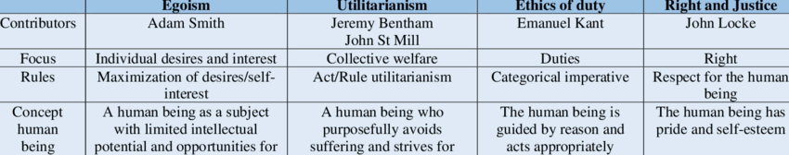

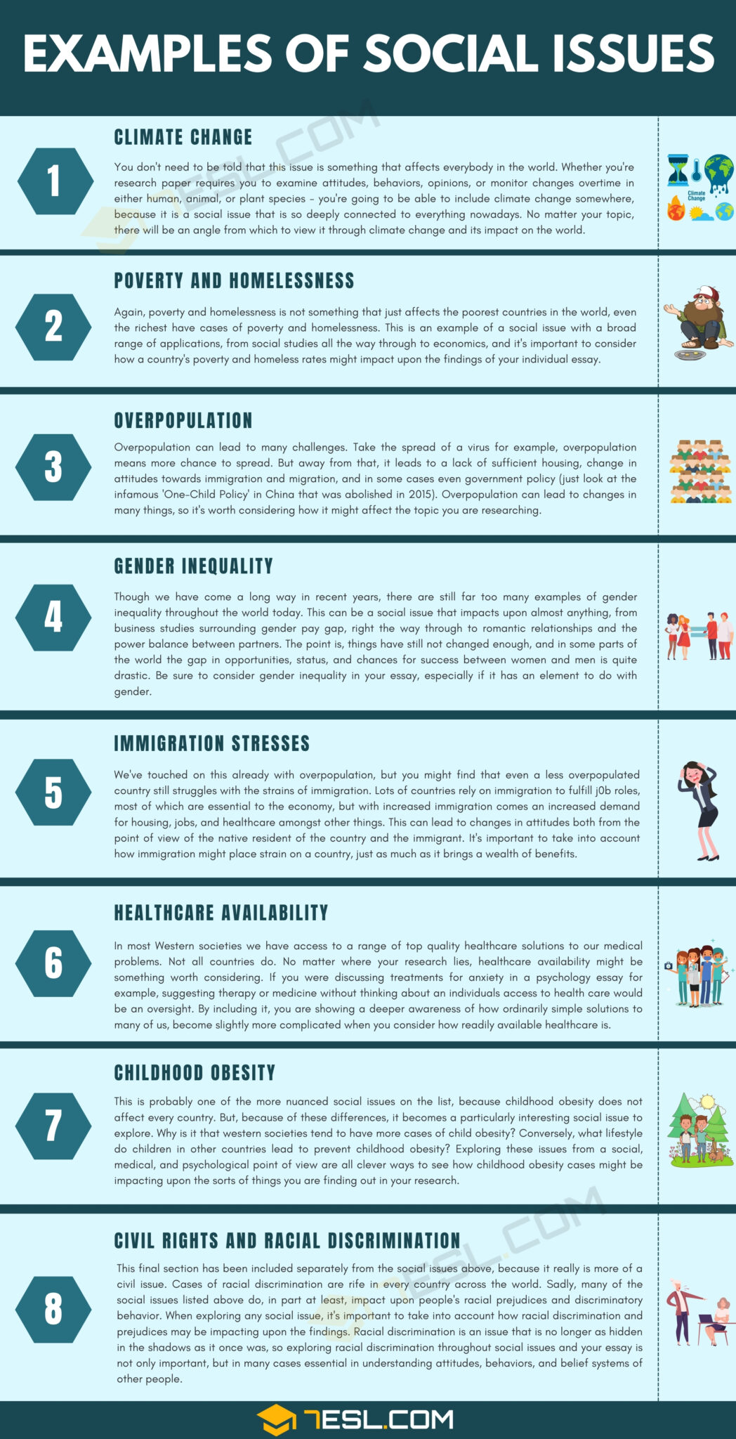

**Conclusion**

Every individual has the right to live a comfortable and fair life, so it is very unfortunate that basic necessities such as feeding, housing, education, fair trials, etc appear to be luxury to millions of people across the world. While it has been established that the standard of living is generally better in some countries than in others, I am of the opinion that every country still has its work cut out for them. More well-funded government agencies need to be set up both locally and across the world to be able to cater to these issues on a large scale. There also needs to be more community awareness to encourage individual and group donations, collaboration and partnerships towards these causes. Together, with deliberate and consistent efforts, we can indeed make the world a better place.

**References**

Jensen OC. Kant’s Ethical Formalism. *Philosophy*. 1934;9(34):195-208

<https://www.britannica.com/topic/ethics-philosophy>

<https://ethicsunwrapped.utexas.edu/glossary/altruism>

<https://nigerianstat.gov.ng/news/78>

<https://www.nrdc.org/stories/global-warming-101#weather>

<https://www.prisonstudies.org/country/nigeria>

<https://rsf.org/en/index>

<https://www.who.int/news-room/fact-sheets/detail/mental-health-strengthening-our-response/?gad_source=1&gclid=Cj0KCQiAx9q6BhCDARIsACwUxu5ZzqUlLx_ZBAp93sowJBRN10lQ3kTqBNc0xn_jJdkPHwjbYqIgfHYaAv-5EALw_wcB>