AJAY PALMER

ID #: a9UB85094BU94315 UB85ID:

Course Name:

Ethics in Business

An Essay

Compiled and Presented to

Academic Department

School of Business and Economics

In

Partial Fulfilment of the Requirement

for the Degree of Bachelor of Business Administration

Date: May 2024

**ATLANTIC INTERNATIONAL UNIVERSITY**

**Table of Contents**

Introduction..…………………………………………………. 3

Body of Essay ……………………………………………….. 4 - 11

Recommendation …………………………………………… 12

Conclusion………………………………………………….… 13

References ………………………………………………….. 13

Appendices: …………………………………………………… 14 - 16

INTRODUCTION

In today’s business arena, business ethics is consider by many scholars and authors to be the moral value, principles, and policies that oversee the practices of industries and individuals in business activity on a whole. However, the concept of ethics in business came about in the early 1960s as a result of the culture being practice and used as the norm by organisations, hence, the improved emphasis on social issues was a trademark of the era. On the other hand, ethics in business also helps to build trust between an entity and its clienteles, therefore, it is observe as issues of moral right and wrong in the organisation based on the situation.

This essay will explore the definition of ethics in business, the various types of fundamental ethics in business, and the eight (8) theories of ethics. It will also give an understanding of the three (3) Cs of ethics in business and also the principles of ethics on business.

The importance of ethics in business will also be reviewed. It will also give a listing of some advantages and disadvantages of ethics in business, as well as a recommendation and conclusion.

DEFINITION

Ethics in business is generally define as a set of moral principles, values and practices that monitor the conduct or culture displays in an organisation continually. Hence, these morals are the gatekeeper of the operations of the entity and its stakeholders. However, according to Socrates, who is considered to be the Father of Ethics and Inquiry “(The Greatest Greek Philosophers, 6) *Library Binding Edition* – July 30, 2015)”, he defines ethics as an “inter-personal and inner-personal dialogue”. While, Joseph Weiss, (Business Ethics, 2005) believes that business ethics is a practical guide for defining right and wrong in the business environment. He also believes that in order for a business to be upheld, one must be socially accountable, because this will have an effect on the outcome of the business arena.

Peter Drucker, on the other hand, in his book “The Effective Executive 1966” is of the opinion that the grit of right and wrong is questionable due to the behaviour and morality regarding ethical rules in general, and as such, is of the judgement that an establishment should not be watched contrarily. While, Scholar. J. Angelo Corlett, in his Journal “A Marxist Approach to Business Ethics, 1998”, is of the opinion that Karl Marx refers to morality as “a property of one's behaviour, which is habituated by social and ancient existence.

THE IMPORTANCE OF ETHICS IN BUSINESS

Ethics in business is very important, because it helps to control the behaviour of clients, both internal and external within the organisation. Therefore, companies implement rules in order for employees to follow and establish ethical behaviour amongst their staff in order to attract investors and customers. This also creates a type of recognition and help to increase productivity within the organisation, it also increases the capability to negotiate benefits and also trust in products and services

Ethics in business is also used as strategies for clients to evade blunders, while they are of the impression that they are right in their doing. the laws. Therefore, the following paragraphs will look at the ethical issues in the scenario.

ETHICAL PRINCIPLES IN BUSINESS

In the business environment, there are several ethical principles that govern the organisation and its surrounding. These are as follows:- fairness, honesty, integrity, leadership, respect, compassion, loyalty,, responsibility, transparency, law-abiding and environmental concerns. See Appendix 1.

*Fairness:*

In everything we do or say, it ought to be fair, and as such, the organisation is no exception when it comes on to fairness, because it must be exercised in all level of the organisation hierarchy.

*Honesty:*

As the phrase goes, honesty is the best policy, so is telling the truth in all instances, whether it be in or out of the organisation. This can create and enhance good will for the organisation in order to foster an ethical climate.

*Integrity:*

In business, integrity is of high regards in the organisation, because it means connecting any gaps between the objectives and activities, ensuring your connections with clienteles, employees, contractors, investors and controllers are in line with your detailed aims and determination The integrity is also the moral practices of ethical framework.in the organisation, therefore, you must act with honesty and stability and to be responsible and accountable for your actions, regardless of being observed by others.

*Leadership*

It is of vital importance, that organisations have effective leaders in order to accomplish success, and that is why the Father of Leadership, Warren Bennis (1989) “On Becoming a Leader”, believes that effective leaders are the backbone of the organisation, and as a result of this, they were made and not born, Therefore, they must possess fundamental traits in their proficient and private life in order to be successful.

*Respect:*

Ethical leaders must be very respectful to all, as well as respect for laws that govern their entity and countries, which should be enforced at all levels, whether it be local or federal laws.

*Compassion*:

This is a very sensitive area, because everyone (from an individual to a business) has different personality and must be treated with compassion, that is; some sort of urgency to their situation in order to satisfy their well-being, and as such empathizing with someone is important in order to minimize their pain, especially, on the job when your colleagues are not in the best form due to work situation.

*Loyalty:*

In every organisation employees at all level must exhibit a sense of loyalty, confidentially and commitment to their colleagues and the organisation in general, so that the objectives can be met in order for to create and enhance goodwill for the betterment of the organisation.

*Moral Responsibility and Accountability*

Every employee must be responsible and accountable for their work and action within the organisation. Therefore, they must adhere to the guidelines, rules and policies of the organisation in order to achieve targets set out to accomplish.

*Transparency*

It is very important that both the internal and external clients must be dealt with in a fair and transparent manner in order for the organisation to meet its objectives. Therefore, significant information such as financial, wages and salaries, hiring and firing practices of the entity, must not be divulged to any and every one. This is very crucial to the organisation and can cause conflicts amongst members.

THE EIGHT THEORIES OF ETHICS

In earlier years, scholars and authors study ethical theories as it relates to the moral of human behaviour, and as such they try to learn and imply normative rules which relate to what is "right action" and what is "wrong action."  Hence, no matter the outcome of any situation the moral rules must be followed; and as such theories of ethics can be classified as Utilitarianism, Egoism, - Naturalism and virtue theory, Hedonism, Existentialism, Deontology, Kantianism and Ethics in religion. See Appendix 2

*Utilitarianism*

Utilitarianism is an ethical theory that determines right from wrong by focusing on outcomes, whether it is family related or ethical theories. Hence, it is a form of consequentialism. Utilitarianism theory also believes that the most ethical choice is the one that will produce the greatest good for the greatest number.

*Egoism*

This ethical theory, Egoism refers to the moral search of one’s own self-development to end or leave a personal relationship

*Naturalism and virtue theory*

This is a theory that relates to a scientific method to philosophy by whereby you affirm that all beings and events in the universe, irrespective of what it may be are natural and as a result of this, all awareness of the universe is investigated as scientific.

*Hedonism*

The intrinsic value of this theory is pleasure. .Therefore, persons who are consider to be Hedonists frequently define pleasure and pain on a wide scale as to include the physical and mental occurrences.

*Existentialism*

Theorists is of the view that Existentialism is where human realization is drastically free, therefore, they are always able to be apart, thus, such freedom necessitates that one's ethical system is chosen

*Deontology*

According to Kant “Introduction to Philosophy, Ethics Chapter 6” in the seventeen century, and same republished by Scholars Christina Hendricks and George Matthews 2019, they are of the belief that Deontology is an ethical theory that views the action of a person as good or bad depending on the rules that govern the action.

*Kantianism*

Immanuel Kant's ethical theory is of the reasoning, that decency is rooted in rationality and as such ethical principles must apply on a worldwide scale unconditionally. He also suggested that rationality and autonomy, arguing that individuals must act without regard to personal desires or incentives.

*Ethics in Religion*

Ethics in religion is a bit different from regular business ethics, and as such it is viewed as a process of empathetic moral issues from the standpoint of methodical faith and practice. It therefore, investigates into the character of the celestial and how it cooperates with the moral demeanour and behaviour of individual and the society.

THE THREE Cs OF ETHICS IN BUSINESS

There are three Cs that you ought to consider when dealing with ethics in business. These are compliance, contribution and consequences. See Appendix 3.

*Compliance:*

Employees follow certain commitment concerning their organisations, such as regulation, laws and internal policies; hence, compliance guarantees that the organisation functions within authorize boundaries and observe the industry values.

*Contribution*

The contributions that ethics in business have on an organisation is its day to day activities as well as its values and goals, therefore, an ethical organisation operates on the principles of ethics.

*Consequences*

In ethics, consequence is a variety of possible action to artefact the best outcome. Therefore, when an organisation performs ethical consequence, it means that the corporation regulates to act for the betterment of people.

THREE FACTORS THAT CONQUER ETHICAL BEHAVIOUR

However, there are three factors that conquer good ethical behaviour or conduct. Top of this list is *education*, which is very enthusiastic in business ethics, because it assist prospective and current managers to make better business decision While, *personal value* is gear towards shaping one’s understanding of the moral principles in the organisation, therefore, ethical outline recognized by personal values on how persons view business outcome and the last is *culture*, this is very vital in business because the practices of stakeholders can have good or bad effect on the organisations.

ADVANTAGES AND DISADVATAGES OF ETHICAL BUSINESS

A we all know, ethics is a way of encouraging people to reflect the impact of actions of individuals, that is gear towards the greater good. Therefore, it aids us to regulate what is right and wrong in general, whether it is in the organisation or in our private lives; thus making conclusions based on moral values. Hence, there are several advantages and disadvantages of ethics in business that allow an organisation to produce and grow to their fullest potentials. These are as follows;

Advantages

1. It is very important for organisation to provide competitive advantages between organisations and customers, both internal and external. This is so true, because once the ethics in an organisation is good, then they will attract more investors
2. Ethics in business must be practiced in a fair manner so that employees will be happy with the inclination of the organisation and what is being done for all. .
3. Time consuming is very vital in business, therefore, the organisation must be effective and efficient on their product and services offer.
4. When the ethics in business is on high, then it can also create better society
5. Good ethics in business also increase productivity in organisation, and minimize turnover rates, and undertaking towards a justifiable work culture.

Disadvantages

1. According to the behaviour display by employees and top level managers, there are several unethical practice that does not create good will for the organisation, because they affect the moral and productivity of the organisation, and as such, leaders who exhibit unethical behavior allow people to question their honesty and integrity, which leave negative impression on the decisions taken.
2. Unethical behaviour can reduce the ability of an organisation to gain profit due to the culture being practice overall.
3. Organisations without sturdy set of ethics can have adverse effect of the moral dilemma and the downside of the organisations finances.
4. Unethical practices can also create high overhead strain on the organisation
5. Unethical business practices lo create false expectations on a false prudency

RECOMMENDATIONS

1. It is recommended that organisation create an ethical business culture, in order to improve to eradicate twofold standards and encourage trust amongst the employees, and s such policies must be implemented.

### It is also, recommended that workers are encourage to report illegal or unethical conduct.

### It is recommended that the organisation focuses on social responsibility in order to uphold the longevity of the establishment and integrity of the organisation.

### It is also recommended that organisations invest in consistent ethics training. Therefore, ethical training should be on a regular basis as the issues arise.

### It is important that a clear oath for rewarding and recognizing employees be implemented, and as such the criteria must be clearly defined for achieving reward and recognition

**CONCLUSION**

In conclusion, ethical behaviour is dangerous to the realization of any business. Therefore, implementing ethical principles, organisations can appreciate countless customer loyalty, stakeholder support and retaining employee. Organisations can also control the culture within their arena, so that clients, both internal and external can adopt to a smoother working environment which will create and enhance goodwill for their entities.

REFEREENCES

Joseph Weiss,

(Business Ethics, 2005)

Kant “Introduction to Philosophy, Ethics Chapter 6”

in the Seventeen Century, and same republished by

Scholars Christina Hendricks and George Matthews 2019

Peter Drucker

The Effective Executive 1966”

Scholar. J. Angelo Corlett, in his Journal

“A Marxist Approach to Business Ethics, 1998

Socrates, Father of Ethics and Inquiry

“(The Greatest Greek Philosophers, 6) *Library Binding Edition* –

July 30, 2015)

Warren Bennis, Father of Leadership

(1989) “On Becoming a Leader

APPENDICES

Appendix 1 – Ethical Principles

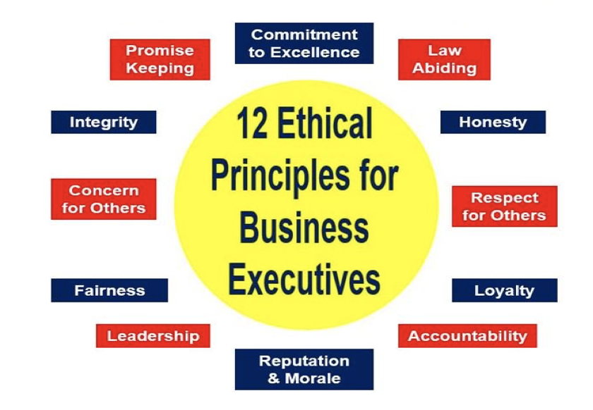

Appendix 2 - Ethical Theories

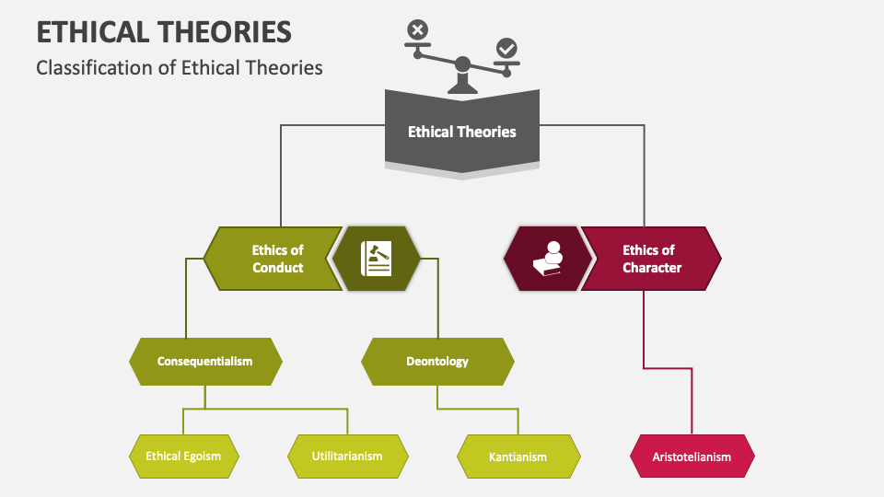\

*Appendix 3 – The Three C’s*

