Alwyn Adair

ID: UB84363SED93582

COURSE NAME: CONSTRUCTIVISM AND STUDENT-CENTRED LEARNING

ATLANTIC INTERNATIONAL UNIVERSITY

March/2024

Contents

Introduction 3

Summary of Topics 4

Opinions and Analysis 7

Application to Self, Work and Community 10

Personal Experiences 14

Case Examples 15

Pictures, Tables, and Graphs 17

Conclusion 20

References 21

# Introduction

The course “Constructivism and Student Centered Learning” explores the fundamental principles and practices of two main educational methods that seek to bring about a great level of transformation to the way teaching is done. Constructivist theory and practice seeks to highlight the important role learner’s play in the teaching learning process as they actively engage in their own learning through learning experiences that facilitate this development. Student-centred learning theories and practice equally does this giving the learner a greater level of autonomy enabling critical thinking and collaboration. In this course, it seeks to highlight some theorists and their contributions to these pedagogical approaches, including Jean Piaget’s theory of cognitive development, Lev Vygotsky’s zone of proximal development, Carl Rogers’ concept of freedom to learn, Jean Lave and Etienne Wenger’s Community of Practice theory, Maria Montessori’s innovative educational methods, Jerome Bruner’s work on cognitive development, Benjamin Bloom’s taxonomy of educational objectives, and Howard Gardner’s theory of multiple intelligences. By examining these theories and practices, educators can gain valuable insights into creating engaging and effective learning environments that cater to the diverse needs and abilities of students.

# Summary of Topics

“Student-centered learning is an approach to education that focuses on the needs and interests of the students rather than those of the teacher. It involves active participation by students in their own learning, and encourages them to take responsibility for their own education. Constructivism is a theory of learning that suggests that learners construct their own understanding of the world through their experiences and interactions with it (Smith, 2020)”.

The key concepts covered in this course entail:

1. Constructivism Theory and Practice: This subtopic explores the idea that learners actively construct their own understanding and knowledge of the world through experiencing things and reflecting on those experiences. It emphasizes the importance of hands-on activities, problem-solving, and critical thinking in the learning process.
2. Student-Centered Learning Theories and Practices: Student-centered learning focuses on placing the student at the center of the learning process, allowing them to take control of their education. This approach values student autonomy, collaboration, and self-directed learning.
3. Jean Piaget’s Theory of Cognitive Development: Jean Piaget was a Swiss psychologist known for his work on child development. His theory posits that children progress through distinct stages of cognitive development, each characterized by different ways of thinking and understanding the world.
4. Lev Vygotsky’s Zone of Proximal Development: Lev Vygotsky, a Soviet psychologist, introduced the concept of the zone of proximal development (ZPD), which refers to the range of tasks that a learner can perform with the help of a more knowledgeable other. This theory highlights the importance of social interaction in learning.
5. Carl Rogers and the Freedom to Learn: Carl Rogers was an influential psychologist who advocated for a student-centered approach to education. His concept of “freedom to learn” emphasizes creating a supportive environment where students feel free to explore, learn from their experiences, and grow personally.
6. Jean Lave and Etienne Wenger’s Community of Practice: This concept focuses on how learning occurs within social contexts where individuals engage in shared activities and develop a sense of belonging to a community with common goals and interests.
7. Maria Montessori: Maria Montessori was an Italian physician and educator known for developing the Montessori method, an educational approach that emphasizes independence, freedom within limits, and respect for each child’s natural psychological development.
8. Bruner’s Background: Jerome Bruner was an American psychologist who made significant contributions to cognitive psychology and educational theory. His work emphasized the importance of active learning, discovery-based approaches, and scaffolding in education.
9. Bloom’s Taxonomy: Bloom’s taxonomy is a hierarchical framework used to classify educational objectives into levels of complexity ranging from simple recall to higher-order thinking skills like analysis, synthesis, and evaluation.
10. Howard Gardner’s Theory of Multiple Intelligences: Howard Gardner proposed that intelligence is not a singular entity but rather encompasses multiple distinct types or “intelligences,” such as linguistic, logical-mathematical, spatial, musical, bodily-kinesthetic, interpersonal, intrapersonal, and naturalistic intelligences.

# Opinions and Analysis

Constructivism and Student-Centered Learning are essential concepts in education that focus on active learning, critical thinking, and student empowerment. Constructivism is a learning theory that suggests learners construct their understanding and knowledge of the world through experiences and reflection. In practice, educators facilitate this process by providing opportunities for exploration, inquiry, and collaboration. Students are encouraged to build upon their existing knowledge and make connections to new information. Student-centered learning places the student at the centre of the educational experience. This approach focuses on individual needs, interests, and abilities, allowing students to take ownership of their learning. Teachers act as facilitators, guiding students through inquiry-based activities and projects that promote critical thinking and problem-solving skills. These approaches emphasize the importance of students constructing their own knowledge through experiences and interactions. Here is a deeper understanding of work done by influential theorists to further develop this whole idea:

1. Jean Piaget’s Theory of Cognitive Development: “A theory of cognitive development that has had a profound impact on education is that of Jean Piaget, a Swiss psychologist. According to Piaget, children actively construct their understanding of the world through their interactions with it.” (Santrock, 2019). He was well known for his work on cognitive development in children. His theory emphasizes the importance of active learning and interaction with the environment in shaping intellectual growth. Piaget identified stages of cognitive development, highlighting how children construct knowledge through assimilation and accommodation.
2. Lev Vygotsky’s Zone of Proximal Development: “The zone of proximal development is the distance between the actual developmental level as determined by independent problem solving and the level of potential development as determined through problem solving under adult guidance or in collaboration with more capable peers.” (Vygotsky & Cole, 1978). Lev Vygotsky was a Soviet psychologist who proposed the concept of the Zone of Proximal Development (ZPD). This theory suggests that learning occurs within the range of what a learner can achieve with guidance from a more knowledgeable other. Vygotsky emphasized the role of social interaction and collaboration in cognitive development.
3. Carl Rogers and the Freedom to Learn: “Carl Rogers was a pioneer in the field of humanistic psychology, emphasizing the importance of empathy, unconditional positive regard, and genuineness in fostering personal growth and self-actualization. His work continues to inspire educators and therapists around the world to create environments that support individual autonomy and learning.” (Boeree, 2006) Carl Rogers was a humanistic psychologist who advocated for student-centered approaches to education. His concept of “freedom to learn” emphasizes creating supportive environments where students feel empowered to explore their interests and capabilities. Rogers believed in fostering intrinsic motivation and self-directed learning.
4. Jean Lave and Etienne Wenger’s Community of Practice: Jean Lave and Etienne Wenger introduced the concept of Communities of Practice, which are groups of people who share a common interest or profession and engage in collaborative learning activities. This approach emphasizes social interaction, shared expertise, and collective learning within a community context.
5. Maria Montessori: Maria Montessori was an Italian physician and educator known for developing the Montessori Method, an educational approach that emphasizes independence, freedom within limits, and hands-on learning experiences. Montessori believed in creating child-centered environments that support individual growth and development.
6. Bruner’s Background: Jerome Bruner was an American psychologist who made significant contributions to cognitive psychology and educational theory. Bruner emphasized the importance of active learning, discovery-based instruction, and scaffolding to support students’ understanding of complex concepts.
7. Bloom’s Taxonomy: Bloom’s Taxonomy is a framework that classifies educational objectives into cognitive domains, ranging from simple recall of information to higher-order thinking skills such as analysis, synthesis, and evaluation. This taxonomy provides educators with a structured approach to designing curriculum and assessing student learning outcomes.
8. Howard Gardner’s Theory of Multiple Intelligences: Howard Gardner proposed the theory of multiple intelligences, which suggests that individuals possess different types of intelligence beyond traditional measures like IQ. Gardner identified eight distinct intelligences, including linguistic, logical-mathematical, spatial, musical, bodily-kinesthetic, interpersonal, intrapersonal, and naturalistic intelligence.

# Application to Self, Work and Community

These educational theories and practices can be applied to both personal and professional settings life, work as a teacher, and at the community level:

1. Constructivism Theory and Practice: Understanding constructivism theory helps you recognize that learners actively construct their own understanding and knowledge of the world through experiencing things and reflecting on those experiences. In your life, you can apply this by engaging in hands-on learning experiences and reflecting on them to deepen your understanding. As a teacher, you can design lessons that encourage students to explore, question, and discover knowledge for themselves. In the community, you can promote experiential learning opportunities that empower individuals to construct their own knowledge.
2. Student-Centered Learning Theories and Practice: Embracing student-centered learning means placing students at the center of the learning process, allowing them to take ownership of their education. In your life, you can adopt a self-directed approach to learning, setting goals and seeking resources independently. As a teacher, you can facilitate student-led discussions, projects, and assessments that cater to individual needs and interests. In the community, you can advocate for educational programs that prioritize student agency and autonomy.
3. Jean Piaget’s Theory of Cognitive Development: Piaget’s theory emphasizes the importance of cognitive development stages in learning. Applying this knowledge to your life involves recognizing your own cognitive abilities and limitations at different stages of life. As a teacher, understanding Piaget’s theory helps you tailor instruction to match students’ developmental levels. In the community, promoting activities that stimulate cognitive growth in children aligns with Piaget’s principles.
4. Lev Vygotsky’s Zone of Proximal Development: Vygotsky’s concept highlights the importance of social interaction and guidance in learning. Utilizing this theory in your life involves seeking out mentors or peers who can support your growth in various areas. As a teacher, scaffolding instruction based on students’ proximal development zones enhances learning outcomes. In the community, creating collaborative learning environments fosters collective advancement.
5. Carl Rogers and the Freedom to Learn: Rogers’ humanistic approach underscores the significance of self-directed learning and personal growth. Applying this philosophy to your life entails embracing autonomy in decision-making and pursuing interests that align with your values. As a teacher, fostering a supportive classroom climate where students feel empowered to explore their passions promotes meaningful learning experiences. In the community, advocating for educational practices that prioritize individual agency contributes to holistic development.
6. Jean Lave and Etienne Wenger Community of Practice: Lave and Wenger’s concept emphasizes the role of social learning within communities of practice. Implementing this idea in your life involves engaging with communities that share common interests or goals to enhance your skills and knowledge. As a teacher, cultivating a collaborative classroom environment where students learn from each other mirrors the principles of communities of practice. In the community, establishing networks that facilitate skill-sharing and mutual support benefits collective growth.
7. Maria Montessori: Montessori’s educational approach focuses on self-directed activity, hands-on learning, and collaborative play. Incorporating Montessori principles into your life may involve creating structured environments that promote exploration and independence. As a teacher, implementing Montessori methods encourages student autonomy and creativity in learning. In the community, advocating for child-centered educational practices inspired by Montessori can enhance early childhood development.
8. Bruner’s Background: Jerome Bruner emphasized the importance of active learning through discovery and interaction with the environment. Applying Bruner’s ideas to your life may involve seeking out diverse experiences that challenge your thinking and problem-solving skills. As a teacher, designing lessons that encourage inquiry-based learning aligns with Bruner’s belief in constructing knowledge through active engagement. In the community, promoting lifelong learning opportunities that foster curiosity and exploration reflects Bruner’s educational philosophy.
9. Bloom’s Taxonomy: Bloom’s taxonomy categorizes cognitive skills into levels ranging from simple recall to complex evaluation and creation. Understanding Bloom’s taxonomy in your life enables you to set clear learning objectives and assess your progress effectively across different cognitive domains. As a teacher, aligning instructional strategies with Bloom’s taxonomy helps scaffold students’ thinking processes towards higher-order thinking skills. In the community, supporting educational initiatives that incorporate Bloom’s taxonomy enhances critical thinking abilities among learners.
10. Howard Gardner’s Theory of Multiple Intelligences: Gardner proposed that individuals possess diverse intelligences beyond traditional measures like IQ tests. Applying Gardner’s theory to your life involves recognizing and developing strengths across various intelligences to achieve personal fulfillment and success. As a teacher, incorporating multiple intelligence approaches into lesson planning accommodates diverse learner preferences and abilities. In the community, promoting inclusive educational practices based on Gardner’s theory fosters appreciation for individual differences and talents.

# Personal Experiences

In a constructivist approach to education, students are encouraged to engage in hands-on activities, collaborate with peers, and reflect on their learning experiences.

Student-centered learning is an instructional approach that places the student at the center of the learning process. It focuses on the individual needs, interests, and abilities of students, allowing them to take ownership of their learning and progress at their own pace. In student-centered classrooms, teachers act as facilitators, guiding students through inquiry-based activities and providing support as needed.

Combining constructivism with student-centered learning creates a dynamic and engaging educational environment where students are actively involved in constructing their knowledge through meaningful experiences. This approach promotes critical thinking, problem-solving skills, and a deeper understanding of concepts.

# Case Examples

Here are some use case examples to demonstrate the concepts related to constructivism and student-centered learning:

1. Constructivism Theory and Practice: In a science classroom, students are given a hands-on experiment to explore the concept of photosynthesis. Instead of just lecturing about the process, students are encouraged to observe plants, conduct experiments, and discuss their findings with peers. This approach aligns with constructivist theory by allowing students to actively engage in the learning process and construct their understanding of photosynthesis through firsthand experiences.
2. Student-Centered Learning Theories and Practice: In a language arts class, students are given the freedom to choose books they are interested in reading for a literature circle discussion. Each student selects a book based on their preferences, reads it independently, and then collaborates with peers who have read different books to share insights and perspectives. This student-centered approach empowers learners to take ownership of their learning by selecting materials that resonate with them and engaging in meaningful discussions with their peers.
3. Jean Piaget’s Theory of Cognitive Development: In an elementary math class, students are presented with math problems that require them to think critically and apply logical reasoning. The teacher observes how students approach the problems at different stages of cognitive development according to Piaget’s theory. By understanding each student’s cognitive abilities, the teacher can tailor instruction to support individual growth and development.
4. Lev Vygotsky’s Zone of Proximal Development: In a social studies classroom, students work in small groups to research and present on different historical events. The teacher provides scaffolding and support as needed based on each group’s zone of proximal development. By guiding students through challenging tasks within their reach but slightly beyond their current abilities, the teacher helps them advance their understanding and skills collaboratively.
5. Maria Montessori’s Approach: In a preschool setting following Montessori principles, children engage in self-directed activities using specially designed materials that promote hands-on learning. The environment is carefully prepared to encourage exploration and independence, allowing children to learn at their own pace while developing concentration, coordination, and a love for learning.

These use case examples illustrate how various educational theorists’ ideas can be applied in real-world teaching practices to promote active learning, critical thinking, collaboration, and student empowerment.

Pictures, Tables, and Graphs

**1. Constructivism Theory and Practice:**

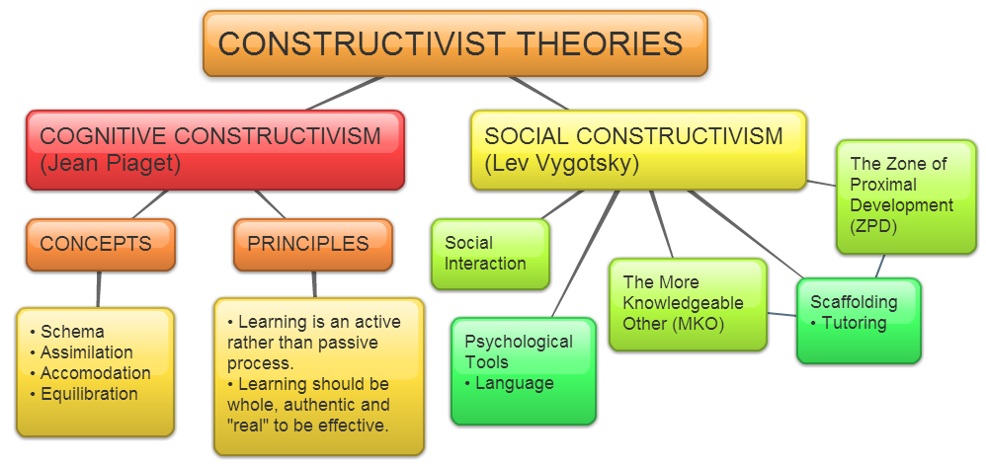

(Main, Structural Learning, 2021)

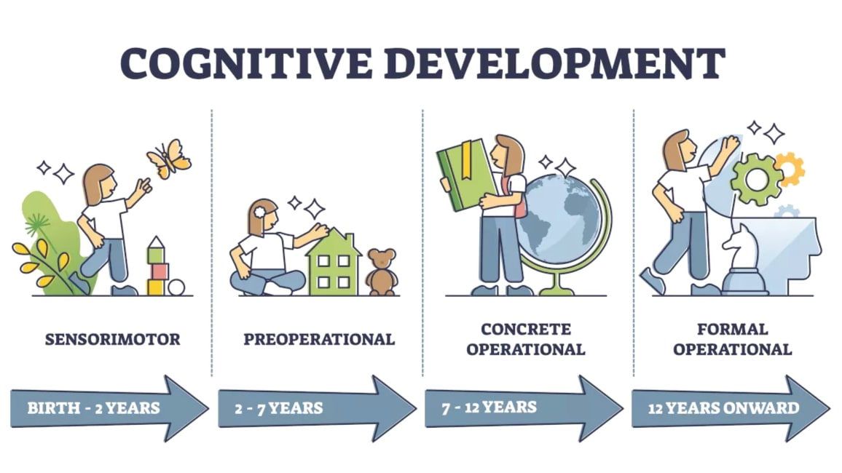

(Saul McLeod, 2024)

**3. Lev Vygotsky’s Zone of Proximal Development:**

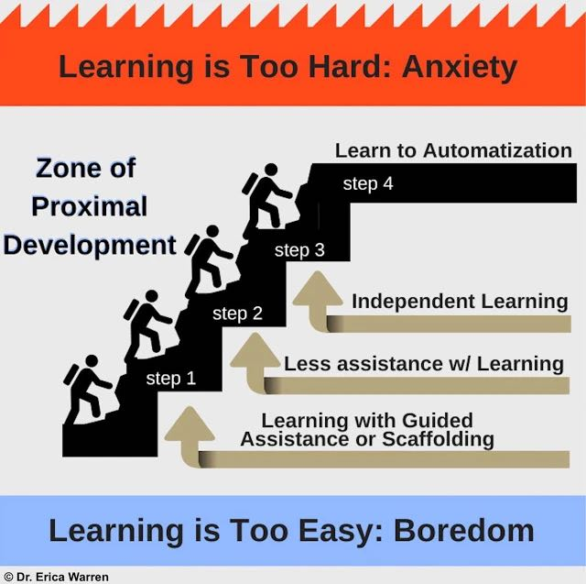

(Main, Structural Learning, 2021)

**4. Bloom’s Taxonomy and Howard Gardner’s Theory of Multiple Intelligences:** 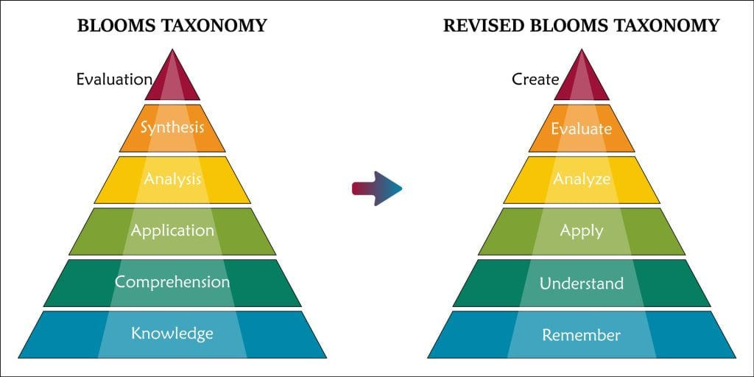

(Ruhl, 2024)

# Conclusion

In conclusion, the course on “Constructivism and Student Centered Learning” delves into the fundamental principles and practices of constructivist theory and student-centered learning. Through exploring the works of prominent theorists such as Jean Piaget, Lev Vygotsky, Carl Rogers, Jean Lave, Etienne Wegner, Maria Montessori, Jerome Bruner, Benjamin Bloom, and Howard Gardner, students gain a comprehensive understanding of how learners construct knowledge actively and how educators can facilitate this process through student-centered approaches. By emphasizing the importance of cognitive development, social interaction, individual autonomy, community engagement, experiential learning, and diverse intelligences, this course equips educators with the tools to create dynamic and inclusive learning environments that cater to the unique needs and abilities of each learner.

# References

Boeree, D. C. (2006). *Personality Theories: Carl Rogers*. Retrieved from Personality Theories: Carl Rogers: http://webspace.ship.edu/cgboer/rogers.html

Main, P. (2021, August 16). *Structural Learning*. Retrieved from Structural Learning: https://www.structural-learning.com/post/embracing-the-learning-theory-constructivism

Main, P. (2021, August 16). *Structural Learning*. Retrieved from Structural Learning: https://www.structural-learning.com/post/the-zone-of-proximal-development-a-teachers-guide

Ruhl, C. (2024, February 1). *Simply Psychology*. Retrieved from Simply Psychology: https://www.simplypsychology.org/blooms-taxonomy.html

Santrock, J. W. (2019). *Life-Development, 19th Edition.* Texas: McGraw Hill Connect’s.

Saul McLeod, P. (2024, January 24). *Simply Psychology*. Retrieved from Simply Psychology: https://www.simplypsychology.org/piaget.html

Smith, J. (2020). The Handbook of Student-Centred Learning. *New York: Academic Press*.

Vygotsky, L. S., & Cole, M. (1978). *Mind in Society: The Deevlopment of Higher Psychological Prrocesses.* USA: Harvard Univrsity Press.