**ATLANTIC INTERNATIONAL UNIVERSITY**

Organization development (OD) focuses on improving a company's capability through the alignment of strategy, structure, people, rewards, metrics, and management processes. It's a science-backed, interdisciplinary field rooted in psychology, social sciences and human resource management

**ORGANIZATIONAL DEVELOPMENT**

**Organizational Development Essay**

Judith N. Chama

Judith.chama@hotmail.com

Bachelors in supply chain management

AUDREY MUJIDAH

**ORGANIZATIONAL DEVELOPMENT**

Organizational development is a critical and science-based process that helps organizations build their capacity to change and achieve greater effectiveness by developing, improving, and reinforcing strategies, structures, and processes.

Organization development (OD) focuses on improving a company's capability through the alignment of strategy, structure, people, rewards, metrics, and management processes. It's a science-backed, interdisciplinary field rooted in psychology, social sciences and human resource management.

Organization development (OD) is a response to change, a complex educational strategy intended to change the beliefs, attitudes, values, and structure of organizations so that they can better adapt to new technologies, markets, and challenge, and the dizzying rate of change itself (Bennis, 1969).

One helpful, though general, definition offered by Edgar Schein of MIT's Sloan School of Management is that organizational culture is: a pattern of shared basic assumptions that the group learned as it solved its problems of external adaptation and internal integration, that has worked well enough to be considered.

Schein divided organizational culture into 3 levels.

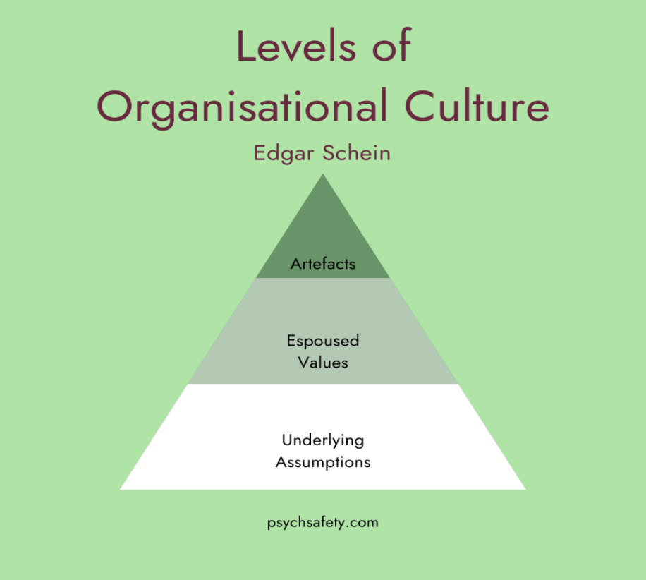

**Schein's Three Levels of Organizational Culture**

* Artefacts. These describe any overt, visible, describable aspects of the organization. ...
* Espoused values. This is how people would describe the organization, in current or aspirational terms. ...
* Underlying assumptions.

**Understanding the Three Cs of Company Culture**   
   
In order to create good company culture, there are three key elements that must be considered: communication, collaboration and community.

They identified 4 types of culture – clan culture, adhocracy culture, market culture, and hierarchy culture. You can take the Organizational Culture Assessment Instrument (OCAI) to assess your organization's culture in just 15 minutes and make strategic changes to foster an environment that helps your team flourish.

Schein organizational structure

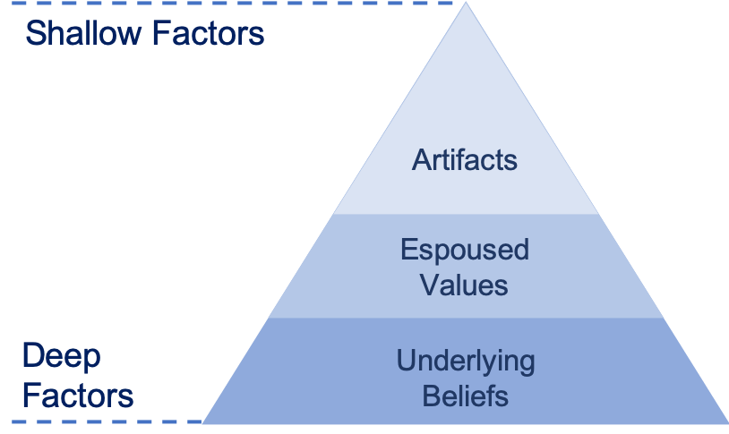

Edgar Schein's Organizational Culture Triangle details three layers of organizational cultures: Artifacts, Espoused Values and Underlying Assumption. They are of differing levels of importance in shaping the actual culture of an organization.

Edgar Schein, a prominent organizational psychologist, identified four key elements of an organization's structure: common purpose, coordinated effort, division of labor, and hierarchy of authority. Each of the four elements represents an essential component of an effective structure.

**Organizational Change**

Organizational changes are those that have a significant impact on the organization as a whole. Major shifts to personnel, company goals, service offerings, and operations are all considered different forms of organizational change. It's a broad category.

 Organizational changes would be a multi-year initiative to redesign the organization, its hierarchy, defining new roles for employees and establishing new communication channels across and within departments.

Recognizing the need for change and knowing how to make that change successful are two very different skills. Change Management strategy is key—but, where to begin? It all starts with understanding what types of organizational change you’re making.

Before you can design your change management strategy, it is crucial to determine the type of organizational change. This helps execute the right change management plan for the best possible results. Knowing the type of organizational change will also help you choose the right [change management tools](https://whatfix.com/blog/change-management-tools/).

**Why is Organizational Change Important?**

Organizational change is a business necessity. Employees depart, and new employees are hired, new teams and departments are created as the company expands, and businesses adopt new technology to stay ahead of the curve.

The key to successful, productive organizational change is the way you manage it. It’s vital to keep employees in the loop and ensure that they understand what the changes are and how employees will be affected.

With effective organizational change management, you can keep the business running smoothly during the transition. For example, offering [effective training](https://whatfix.com/blog/effective-training-program/) helps employees learn new technology faster. That way, they fully adopt the technology, and the organizational change isn’t bogged down by support tickets and frustrated users.

By identifying the types of organizational change you will be implementing, you can make a plan for keeping employees informed. You can ask for [change feedback](https://whatfix.com/blog/change-feedback/) as you implement the change and then make adjustments to your change management plan so that your team has the support, they need to maintain high morale and facilitate the change from their end.

**6 Types of Organizational Changes**

Different approaches to organizational change require different strategies. Everything from implementation to communication must be tailored to the type of change to be made.

Here are the six most common types of organizational change, along with [change management examples](https://whatfix.com/blog/change-management-examples/) for each

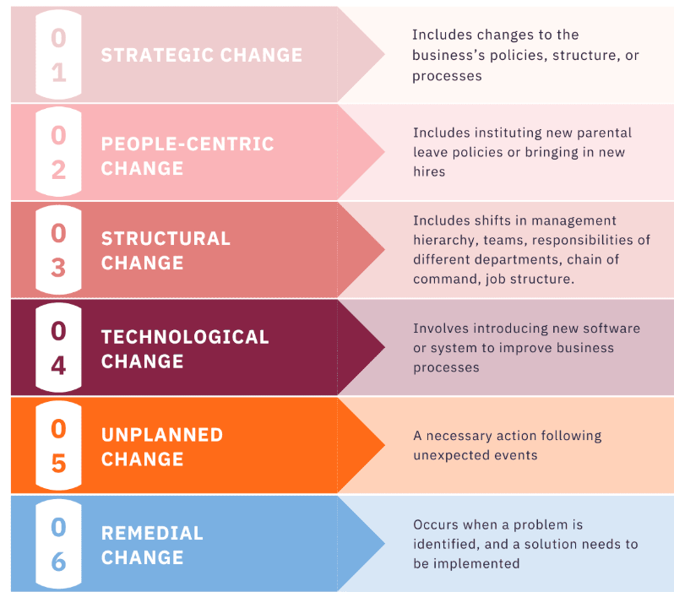

**1. Strategic change**

Organizations implement strategic changes to their business to achieve goals, boost competitive advantage in the market, or respond to market opportunities or threats. A strategic change includes making changes to the business’s policies, structure, or processes. The upper management and the Chief Executive Officer often have the responsibility for a strategic change.

**2. People-centric organizational change**

While all changes affect people, people-oriented organizations include instituting new parental leave policies or bringing in new hires. When implementing a people-centric change, the leadership must bear in mind that employees will naturally resist change.

A people‐centric change requires transparency, communication, effective leadership, and an empathetic approach.

**Note:** Many [change management models](https://whatfix.com/blog/10-change-management-models/), such as the [Kübler-Ross Change Curve](https://whatfix.com/blog/kubler-ross-change-curve/) and [Satir Change Model](https://whatfix.com/blog/satir-change-model/), focus specifically on managing emotional reactions to change.

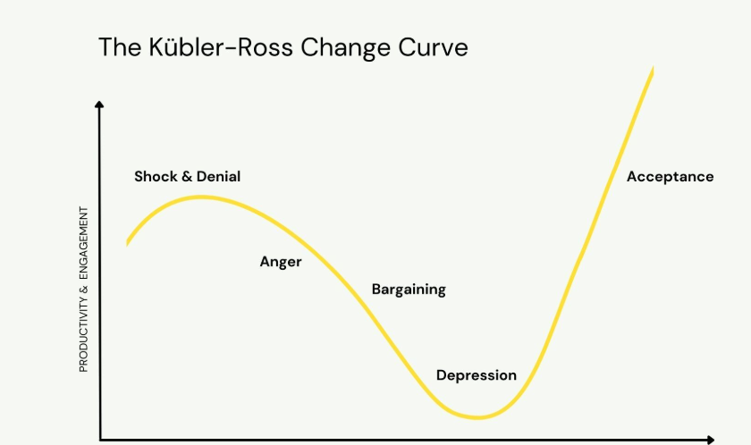

**3. Structural change**

Structural changes are changes made to the organization’s structure that might stem from internal or external factors and typically affect how the company is run. Structural changes include major shifts in the management hierarchy, team organization, the responsibilities attributed to different departments, the chain of command, job structure, and administrative procedures.

Circumstances that lead to structural change include mergers and acquisitions, job duplication, changes in the market, and process or policy changes. These changes often overlap with people-centric changes as they directly affect most, if not all, employees.

**4. Technological change**

The increasing market competition and constantly evolving technology led to technological advancements within organizations. Technology change often involves introducing new software or systems to improve business processes through [SaaS change management](https://whatfix.com/blog/saas-change-management/). However, technology project goals are often improperly defined and poorly communicated, which scares and frustrates your employees and ultimately leads to resistance.

Technology change management is all about identifying new technology and implementing a [digital strategy](https://whatfix.com/blog/digital-strategy/) for improved productivity and profitability.

**5. Unplanned change**

Unplanned change is defined as a necessary action following unexpected events. An unplanned change cannot be predicted but can be dealt with by effective change management.

**6. Remedial change**

Remedial changes are reactionary. This type of change occurs when a problem is identified, and a solution needs to be implemented. As these changes are designed to address an issue; they call for immediate action.

Reactionary changes may not be ideal, yet it is inevitable. The benefit of the remedial change is that judging its success is quick and simple with just one question – was the problem solved or not?

**Organizational Development Approach to Change**

The Organizational Development Approach to Change identifies the organization as a system. A system is an orderly group of logically related parts, principles and beliefs. Alternatively, it is a grouping or arrangement that engages or interacts with each other in such a way as to form a whole.

**Thus, this approach has the following characteristics:**

 (a) Total view not a limited view

(b) Relationship between the organization and the environment and the internal dynamics of the organization

(c) Teams-temporary, semi-permanent and permanent- continuous improvement

 (d) Inter-personal Communication (e) Individuals- self-awareness and self-acceptance-developing skills, knowledge and ability

**Characteristics of organizational development**

Organizational Development (OD) is a multifaceted approach to enhancing an organization’s effectiveness and adaptability.

Characteristics of OD include Changes to the structure, culture, strategy and processes of an individual job through to an entire organization. The application of behavioral science knowledge and practice to facilitate transformation within an organization.



An organization promotes stability by establishing clear processes and structures. It reduces confusion, ensuring smoother operations and adaptability. It enhances team collaborations, open communication, and effective leadership strategies to make businesses more stable.

**Here are four common characteristics of organizational development:**

1. **Collaborative Management**: In contrast to the traditional management system where orders are issued at lower levels and simply carried out by low levels. OD promotes a collaborative approach to management, involving employees at all levels in the change process. It encourages teamwork, open communication, and effective leadership.
2. **Change Agent Involvement:** OD often involves external consultants or internal change agents who facilitate the change process. These experts provide an objective perspective and specialized expertise to guide the organization through the transition. The involvement of change agents ensures that the OD process is managed effectively, leveraging their expertise to overcome resistance and drive successful outcomes. Partners with stakeholders to determine causes for performance gaps and identifies developmental solutions, to improve organizational effectiveness.
3. **Directive leadership:** Is a task-oriented approach in which the leader takes an active role in setting clear objectives and ensuring employees follow through on them.

This type of leadership style is most effective when employees face ambiguous demands that are intrinsically satisfying.

1. **Action Oriented:** OD focuses on practical implementation rather than theoretical discussions. It emphasizes taking action to address issues and achieve measurable results. This characteristic of OD ensures that OD initiatives contribute to tangible improvements and real-world outcomes, enhancing organizational performance and effectiveness.

**There are 5 Characteristics of a Successful Organizational Development Program**

An organizational development program utilizes employee training to improve organizational functioning and help employees develop their skills so they can be of greater benefit to the company. Organizational development is important in meeting established goals, and for growth and gaining market share. Even for organizations not focused on financial goals, like non-profits, organizational development can increase the organization’s reach and help it do better in the community or help more people.

**Here are some characteristics of a successful organizational development program.**

**1. Training aligned to goals.**

The foundation of any successful OD program is to make sure that the training is consistent with the organization’s mission, vision, and goals. Growth and development won’t meet objectives without this alignment — you may reach goals, but they won’t be your goals.

**2. Leadership committed to the process.**

Organizational development begins at the top. If the [leadership isn’t committed](https://www.linkedin.com/pulse/20140408204256-12071417-the-15-keys-to-successful-organizational-development) to the process, they shouldn’t expect their employees to be committed either. Executive coaching will enable leadership to be on board so they can support the process as it progresses through the entire organization.

**3. Communication is effective at all levels.**

Being able to communicate the principles and skills required to achieve organizational goals is essential, and no one should be left out of the communication process. Written, spoken, and video communication are all important and should be consistent, clear, and targeted to different positions and departments so that everyone knows where they fit and how to do their part to help the organization develop.

**4. High quality of training and coaching.**

Organizational development will only be as effective as the coaching and training employees receive, so the highest quality of training and coaching is necessary to move an organization forward in significant ways. Not only are many training programs dull, but also many are not even effective at teaching people how to improve and develop their skills. Make sure you have high quality training in place if you want the initiative to succeed.

**5. Taking a long-term view.**

Most organizations have short- and long-term goals. Focusing on only short-term goals doesn’t give organizations the chance they need to develop over time. Meeting short-term goals is one step in the process, but taking a longer view will be more comprehensive and lead to more growth over time.

**Organizational Development (OD) Intervention Techniques**

A set of sequenced, planned actions or events intended to help an organization to increase its effectiveness. Purposely disrupt the status quo; they are deliberate attempts to change an organization or sub-unit toward a different and more effective state.

**Effective Interventions**

1. The Extent to which it (the Intervention) fits the needs of the organization, Dx -> Rx

2. The degree to which it is based on causal knowledge of intended outcomes

3. The extent to which the OD intervention transfers change-management competence to organization members.

**Factors That Impact the Success of OD Interventions**

Factors relating to Change Situation:

1. Readiness for Change

2. Capability to Change

3. Cultural Context

4. Capabilities of the Change Agent (OD Consultant)

Factors Related to the Target of Change:

**A. Organizational Issues**

1. Strategic Issues

2. Technology and Structure Issues

3. Human Resource Issues

4. Human Process Issues

**B. Organizational Levels**

OD interventions are aimed at different levels of the organization: individual, group, organization and trans-organization (for example different offices of the organization around the globe; or between organization and its suppliers, customers, etc.)

**Three Basic Approaches to Organizational Change**

1. Structural

2. Technical

3. Behavioral Developing strategy includes planning activities to resolve difficulties and build on strengths.

**Organizational Development Training Experience**

Organizational Development training aims to teach employees how to work in groups, lead group activities, and solve problems. Organizations use this kind of training because it boosts employee morale, which is important for increasing productivity at the workplace.

Organization development involves an ongoing, systematic, long-range process of driving organizational effectiveness, solving problems, and improving organizational performance.

Sometimes OD functions are under HR Umbrella.

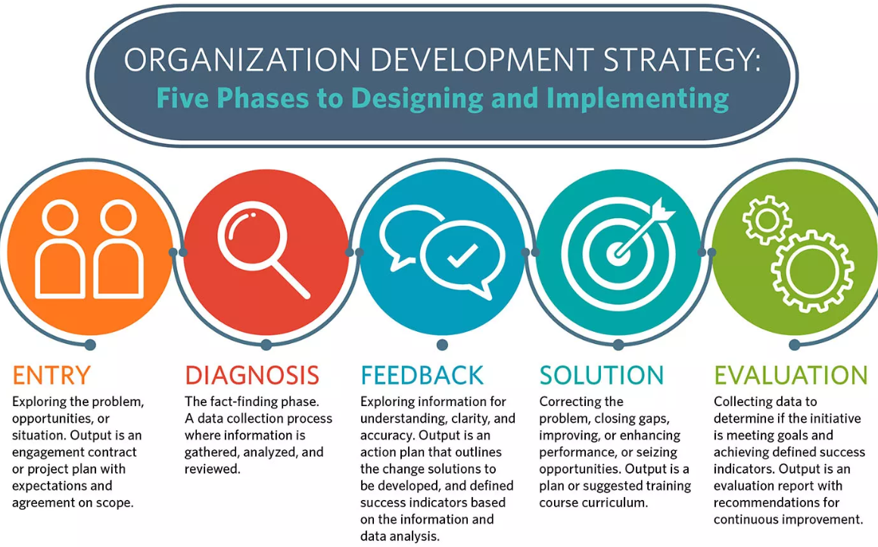

 Training activities should be aligned with overall objectives of the Organization, with a meaningful emphasis on value addition to our Human Resource.

**Why Training?**

The sharing of information through training is our most valuable tool to develop our most valuable assets.

**Trainings should Aim At:**

• Empowering the employees

• Increase Productivity

• Making The Process more efficient and effective to ensure ultimate customer satisfaction

• Improve the overall

• Performance of the Organization.

**Importance of Training**

1. Respond to technology changes affecting job requirements.

2. Respond to organizational restructuring.

3. Adapt to increased diversity of the workforce.

4. Support career development.

5. Fulfill employee need for growth.

• Maintain skill levels

• Advance skill and knowledge to improve of Performance (efficiency) of Service delivery (error rate) of Profitability (productivity, manpower)

• Integrate new technologies into work

• Establish standards for work practices

• **Optimum Utilization of Human Resources** –Training and Development helps in optimizing the utilization of human resource that further helps the employee to achieve the organizational goals as well as their individual goals.

• **Development of Human Resources** – Training and Development helps to provide an opportunity and broad structure for the development of human resources’ technical and behavioral skills in an organization. It also helps the employees in attaining personal growth.

• **Development of skills of employees** – Training and Development helps in increasing the job knowledge and skills of employees at each level. It helps to expand the horizons of human intellect and an overall personality of the employees.

**Training Process Model**

* Needs Assessment
* Developing and Conducting Training
* Evaluating training

**Needs Assessment**

1. **Organizational Level**
2. **Job Level**
3. **Individual Level**

**Issues in Consultant-Client Relations**

The various issues in the client-consultant relationship include entry and contracting, defining the client system, trust, consultant's expertise, diagnosis, depth of intervention, culture absorption, consultant as a model, consultant team as a microcosm, action research, client dependency, ethical standards and practices.

**Action Research & OD**

Action research is problem centered, client focused, and action oriented. It involves the client system and an OD change agent in conducting a diagnostic, active-learning, problem-finding, and problem-solving process. The client and the change agent collaborate together to identify and prioritize specific problems, analyze data to find the root causes, and develop action plans for coping with problems realistically and practically.

**What is the main purpose of action research?**

Action research is focused on solving a problem or informing individual and community-based knowledge in a way that impacts teaching, learning, and other related processes. It is less focused on contributing theoretical input, instead producing actionable input.

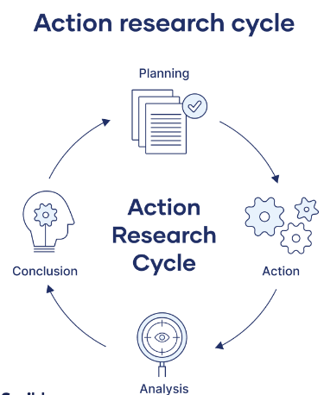

In political science, power is the ability to influence or direct the actions, beliefs, or conduct of actors. Power does not exclusively refer to the threat or use of force (coercion) by one actor against another but may also be exerted through diffuse means (such as institutions).

It can have both positive and negative impacts on the organizational environment. While politics can be used to create a positive work environment and promote healthy competition, it can also lead to conflict, distrust, and an unhealthy workplace environment.

**Future of OD**

The future of organizational development is closely linked to ongoing trends such as AI-driven decision-making and adaptive leadership models. Research by McKinsey & Company suggests that organizations that embrace these trends can expect a 30% boost in overall performance.

**Conclusion**

To conclude, organizational development should be considered a vital element in today's ever-changing business environment. It provides a strategic roadmap for businesses to navigate change, improve processes, and foster a culture of continuous learning and improvement.

Since OD aims at organizational effectiveness, the variable outcomes include financial performance, employee engagement, customer satisfaction, and overall change management.

Organizational management stands as the keystone to an organization's success, underpinning its ability to navigate the complexities of today's business world. It encompasses the strategic planning, effective resource allocation, and sound decision-making that guide a company toward its goals.

However, the future of organizational development is charting a new course, one that is characterized by holistic, systemic, and agile methodologies. In the face of rapid technological advancements, shifting employee expectations, and the rise of remote work, organizations must recalibrate their approach to OD.

Human growth and development are a complex and ongoing process of changes in physical, cognitive, social, emotional, and moral domains. A thorough understanding of the stages of human growth and development helps provide age-appropriate care, guidance, and education at different stages of life.

As a finale for organizing, an organizing is the second role in the managerial functions. When the organization is well-organized, it can be said that it is in the most advantageous circumstances.

**BIBLIOGRAPHY**

What is Organizational Development

http://www.roffeypark.com

http://www.ibm.com

Organization Development, Its Nature, Origins and Prospects

Edition 2

Author, Waren G Bennis

Publisher, Addison-Wesley Longman, Limited, 1969

Organizational Culture and Leadership

Author, Edgar H. Schein

Jossey Bass, 3rd Edition, 2004

https://courses.aiu.edu/ORGANIZATIONAL%20DEVELOPMENT/1/1.pdf

(Session 1/1 - Session 5/5)

https://courses.aiu.edu/ORGANIZATIONAL%20DEVELOPMENT/6/6.pdf

https://courses.aiu.edu/ORGANIZATIONAL%20DEVELOPMENT/9/9.pdf

https://courses.aiu.edu/ORGANIZATIONAL%20DEVELOPMENT/10/10.pdf

Organization Development: Strategies and Models

Author, Richard Beckhard

Publisher, Addison-Wesley, (1969)

Organization Development & Change,

9th Edition

Thomas G. Cummings &

Christopher G. Worley

© 2009, 2005 South-Western, a part of Cengage Learning

Organizational Theory, Design and Change

Seventh Edition, Global edition

Gareth R Jones, Texas A&M University

© Pearson Education Limited 2013, Ch 1, p23-81, Ch 2, p114, p229, p262, Ch 3, p295-Pg413