1. **Introduction**

The presentation of this essay shows the very important about Public Administration: the Definition, the three types of Public Administration Theories, the diagram of Public Administration, what Public Administration practices, the contributors to Public Administration, and the summary and the conclusion**.**

1. **History of Public Administration**

First of all, I would like to introduce Public administration which is collected from kano Consultant Ltd and other sources like:

* When and where the Public administration did start?

The first sign of public administration date back to the 8th and 7th century BC , which is better known as the antiquity era. During this time the king, pharaohs and emperors who ruled, chose citizens to act as their ‘eyes’ and ‘ears’ for public affairs.

* What are the 5 stages in the evolution of public administration as a discipline?

1. Politics Administration dichotomy (1887-1926)
2. Principles of administration (1927-1937)
3. Era of challenges (1938-1947)
4. Crisis of Identity (1948-1970)
5. Public Policy Perspective (1971-onwards).
6. **Definition**

Public administration is a field in which leaders serve communities to advance the common good and effect positive change. And I say then Public Administration is to serve or bring common comprehension and controls of day to day’s activities of governmental, Nonprofits’ Organizations and private sectors.

Public administration professionals or call Administrators are equipped with skills to manage at all levels of government (local, state, and federal) as well as nonprofit organizations. Skills employed across the field of public administration such as project management and program management are often transferrable to the private sector. Therefore, the Public Administration or Public sector is the pillar of the development of any Nation in the world.

**Let’s materialize by this diagram**

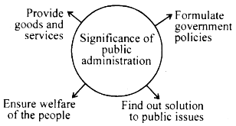

1. **Public Administration Theory**

**Public administration theory** is a mixture of history, organizational theory, social theory, political theory, and other related subject focusing on the meaning, structure, and function of public service under all circumstances. Form. It often describes the main historical underpinnings of bureaucracy research as well as epistemological issues related to public service as a profession and an education field**.**

1. **The three types of Public Administration**

Several types of public administration have emerged throughout this complex field's evolution, including **classical public administration, new public management, and finally, postmodern public administration**.

1. **Classical public administration theory**

**Woodrow Wilson** and **Max Weber** are frequently linked to classical public administration. Woodrow Wilson is regarded as "The Father of Public Administration" in the United States. He wrote "The Study of Administration" in 1887 and made the case that a bureaucracy should be managed similarly to a business. Wilson advocated for concepts like professionalization, a non-political system, and merit-based promotions (since the spoil system was already in place). Since sympathy can bring down an administration, bureaucracy should be practical. Then Thamas Woodrow Wilson being Father of Public Administration and creator of the concept of the bureaucracy to manage the businesses, public and private sectors, and non-profit organizations as well as government of any nation development, then Thomas Woodrow Wilson’s theory is more profitable to the modern concept of bureaucracy and management that whole world benefits today for an equitable development.

1. **New Public Management**

A body of theory, a consulting interest, and a set of administrative methods known as "New Public Management" are used to analyze current changes in public administration. There is a strong case made by many academics that the new public management is more of a theory than a passing trend. The new public administration is an integral part of the widespread infiltration of free market values into public life that threatens the complete eradication of political values. In this way, the idea of bringing political principles into the "private" space to better democratize society is the exact opposite of modern public administration. Then to my understanding, the new public management system portrays that public services or public management should not be politicize, but it is rather a continuation of services of any nation development.

1. **Post-Modern Public administration theory**

The internal operations of almost all existing government organizations are referred to as post-modern public administration. Even members of Congress in Washington, D.C. or Department of Public Safety staff members who handle paperwork for applicants seeking a driver's license at any DPS location. Public administration is a broad concept to include all functions in the executive branch that have an impact on the general public. Members of public administration come in different forms and quantities. When understanding the theory of postmodern public administration, it is important to make a differentiation between postmodern theory and the postmodern era as well as being able to differentiate between post-modernity (period of time) and [postmodernism](https://en.wikipedia.org/wiki/Postmodernism/Philosophy) (theory/philosophy). My understanding, the postmodern theory modifies the two existing (Classical and new public management), modernize the system of the public administration and public management today.

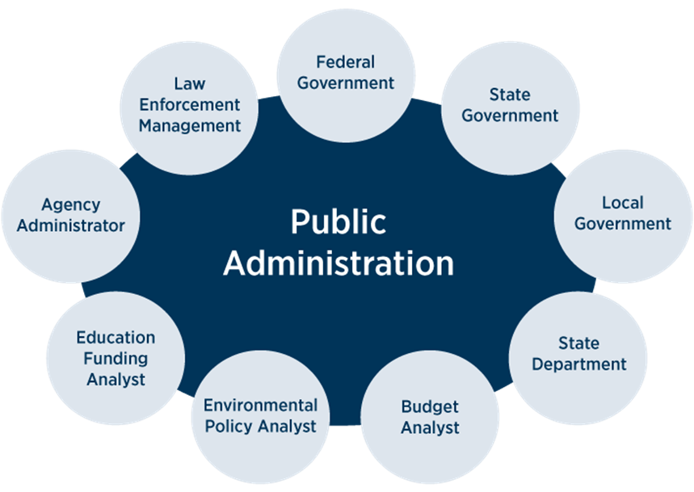

1. **Public administration theories in practice**
2. **Classical public administration- United States**

Often considered the best way for organizing public sector work, it was used highly in the western world in the 19th and early 20th century. A differing proponent between America and Europe is the transferring of effective management methods between large private and public organizations. The first effective theory in America was Scientific Theory coined by **Frederick W. Taylor in 1911**. His work "Principles and Methods of Scientific Management" was used to implement ideas that would increase the efficiency of American government. Taylor's ideas of standardizing work, systematic control, and a hierarchical organization were perfect fits for the public sector of the 1940s.

1. **New public management - United Kingdom**

New Public Management was the prominent theory that inspired health care reforms for the United Kingdom. Its application to health care coincided with the growing expenditures that were being made due to the progress of technology and an aging population. The difference between the private and public sectors in terms of budget process and ideology provided a clash of interests. 1990 saw the National Health Service create an internal market of separate care providers and hospitals. This creation of markets in turn stopped the state from being the funder and service provider simultaneously, but just primarily the funder. Although not privatized, these markets became competitive in nature. The assumption that the competition would lead to more empowerment, efficiency, and equity became rampant. Soon, the publicly owned hospitals were granted quasi-autonomous status by the district health authorities, leading to competition for patients and funds. Their status has led to little, if any, interference in everyday operations.

1. **Postmodern public administration - United States**

Postmodern Public Administration is linked to the capitalist model of the late 20th and 21st century. It relates to globalization, consumerism, and the fragmentation of authority and state. The concepts of science and reason are de-centered and viewed as the defining truths. It tends to negate any faith based action **public administration theory** is a mixture of history, organizational theory, social theory, political theory, and other related subject focusing on the meaning, structure, and function of public service under all circumstances. It often describes the main historical underpinnings of bureaucracy research as well as epistemological issues related to public service as a profession and an education field.

***I observe that the postmodern public administration is applicable today by all governments around world specially: United States, Africa, Asia, Western and Eastern Europ, United Kingdom, and the rest of the world.***

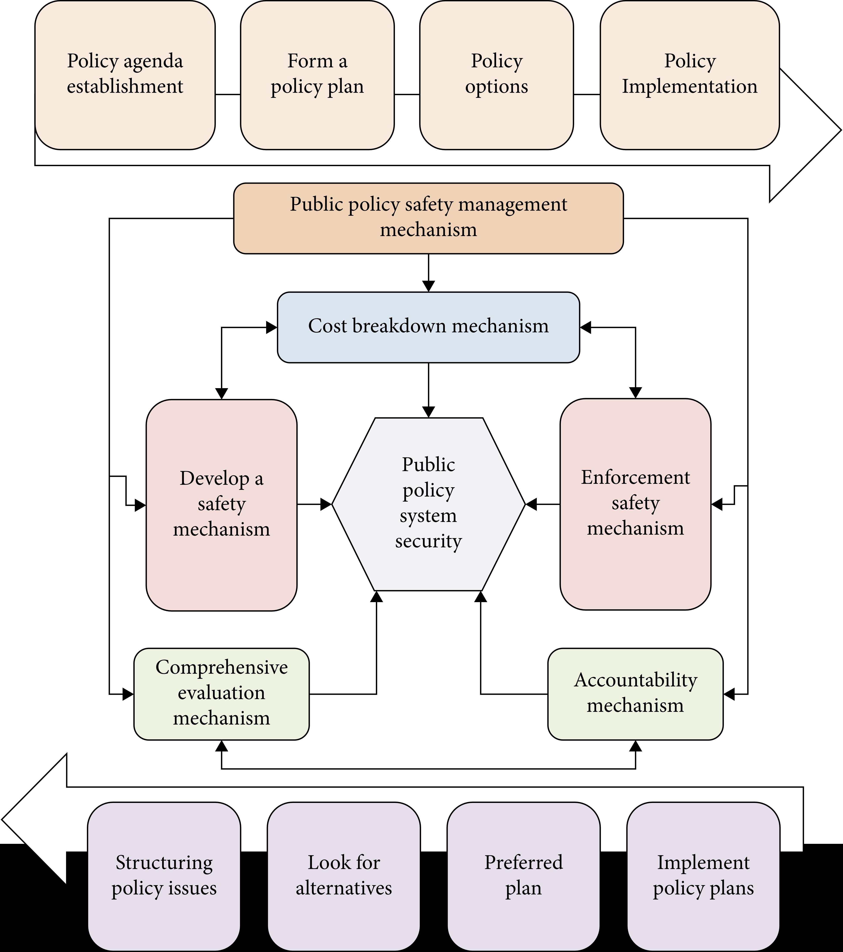

1. **SUMMARY**

The summary followed by series of questions and answers Public Administration: 1st signs of public administration started date back from 8th and 7th BC which is better known as the Antiquity Era. During this time the kings, pharaohs and emperors that ruled then chose citizens to act as their eyes and ears for public affairs.

The 10 characteristics of Public Administration are as follow:

1. Serving public interest
2. Formulation of rules and Procedures
3. Transparency in government
4. Equity in Society
5. Ensures Compliance with public
6. Responsible for state administrative function
7. Tax collection on behalf of the government
8. Focus on services and not on money-making
9. Support the private sector through public-private partnership
10. Enhances public sector efficiency

The 6 functions of Public administration are as follow:

1. Function of Public Administration
2. Policy Making
3. Controlling government operations
4. Budgetary Planning and Control.
5. Resource Provision
6. Determination of Correct procedure

The 12 principles of Public Administration are as follow:

1. Transparency
2. Equity
3. Economy
4. Subsidiarity
5. Pluralism
6. Accountability
7. Participation
8. Access services
9. Representation
10. Legitimacy
11. Responsibility
12. Integrity

Many scientists and philosophers gave different definitions of Public administration and all these definitions have the same common aims and objectives.

* **According to L.D. white 1955**, Public Administration consist of all those operations having for their purpose, the fulfillment or enforcement of public policy as declared by competent authority.
* Public administration consist of getting the work of government done by coordinating the efforts of people so that they can together to accomplish their set tasks**. (J.M Pfiffmer 1946)**
* Public Administration consists is detailed and systematic application of law. **(Thomas Woodrow Wilson 1889)**
* Public Administration is administration related with the operation of government whether central or local. **(Percy McQueen)**
* Public administration is meant in common usage, the activities of the executive branch of the national, state and local government. **(Herbert Simon 1957)**
* Public administration is the art and sentence of management as applied to the affairs of state**.(Dwight Wale 1967)**

# **Conclusion**

The conclusion of on this public administration, I have seen and understood the different definitions by the different Scientists and Philosophers Theorists, such as: **Thomas Woodrow Wilson** is considered as founder of public administration: **public administration theory** has been a mixture of history, organizational theory, social theory, political theory, and other related subject focusing on the meaning, structure, and function of public service under all circumstances of Public Administration’s characteristics are as follow:

1. Serving public interest
2. Formulation of rules and Procedures
3. Transparency in government
4. Equity in Society
5. Ensures Compliance with public
6. Responsible for state administrative function
7. Tax collection on behalf of the government
8. Focus on services and not on money-making
9. Support the private sector through public-private partnership
10. Enhances public sector efficiency.

Based on what I read and learned in this assignment of public administration, I then concluded and philosophy that Public Administration is the brain or key to any successful nation development in the world.

Therefore, I recommend to AIU administrators and faculty members’ that Public administration should be used to educate the people of the free world because it is the only entity or body that gives the existence mandate to private sectors to exist in any government in the world.

I philosophy that the private sector only exist by the name but, in reality all are public, because all the authentic documents that permit the private sector to exist depends on the public sector of any government.

**Thanks and appreciations**

I cannot finish this assignment without extending my gratitude thanks and appreciations to all faculty of AIU members specially to my academic Counselor **Sandra Gracia Ferro,** my Tutor **Amiakhor Ejaeta,** and my Academic Advisor **Niliani Ljunggren De Silva**

**ANTYLANTIC INTERNATION UNIVERSITY**

Student name: **Mr. Amadson Yankoye Gbattara KOLLIE**

Major**: Bachelors’ of Political Science**

Department**: Social and Human Studies**

Courses of phase II: **Public Administration**

**TABLE OF CONTENT**

**Introduction, History, and Definition--------------------------------------------Page 1**

**Public Administration Theories-------------------------------------------------Page 2**

**Three types of Public Administration----------------------------------------- Page 2,3**

**Diagram of Public Administration---------------------------------------------Page 3**

**Public Administration in Practice---------------------------------------------Page 3,4**

**Diagram of Post-modern Public administration--------------------------Page 4**

**Summary------------------------------------------------------------------------------Page 4, 5**

**Different definitions---------------------------------------------------------------Page 5, 6**

**Conclusion and recommendation--------------------------------------------Page 7**