Department: **Social and Human Studies**

Major: **Bachelor of Political Science**

Course: **Judiciary Systems**

Student**: Mr. Amadson KOLLIE**

**The Content**

|  |  |
| --- | --- |
| Contents | Pages |
| Introduction and History | 2 to 3 |
| Judicial Process | 4 |
| Definition, Judicial general information | 4 to 5 |
| Structure of Judicial branch in USA | 5 to 9 |
| Country’s specific function , some countries’ judicial system | 9 to 19 |
| Summary | 19 to 22 |
| Conclusion | 22 |

1. **Introduction**

The **judicial branch** of a government is the system of courts and judges that interprets laws made by the **legislative** branch and enforced by the **executive** branch which you will read about the following: history, Definition, Judicial General information, Structure of The Judicial Branch in the USA,Difference between a State Court System and the Federal Court System, The Different Levels of State Courts,Structure of the Judicial Branch Flash, Functions of the judiciary in different law systems, Country-specific functions, Some countries’ Judicial system Structure, USA Check and Balance Judicial System,Notable philosophers of law, Summary, and Conclusion.

**History of Judicial Branch**

The Supreme Court of the United States is the highest court in the land and the only part of the federal judiciary specifically required by the Constitution.

The Constitution does not stipulate the number of Supreme Court Justices; the number is set instead by Congress. There have been as few as six, but since 1869 there have been nine Justices, including one Chief Justice. All Justices are nominated by the President, confirmed by the Senate, and hold their offices under life tenure. Since Justices do not have to run or campaign for re-election, they are thought to be insulated from political pressure when deciding cases. Justices may remain in office until they resign, pass away, or are impeached and convicted by Congress.

Article III of the Constitution of the United States guarantees that every person accused of wrongdoing has the right to a fair trial before a competent judge and a jury of one's peers.

Where the Executive and Legislative branches are elected by the people, members of the Judicial Branch are appointed by the President and confirmed by the Senate.

Article III of the Constitution, which establishes the Judicial Branch, leaves Congress significant discretion to determine the shape and structure of the federal judiciary. Even the number of Supreme Court Justices is left to Congress — at times there have been as few as six, while the current number (nine, with one Chief Justice and eight Associate Justices) has only been in place since 1869. The Constitution also grants Congress the power to establish courts inferior to the Supreme Court, and to that end Congress has established the United States district courts, which try most federal cases, and 13 United States courts of appeals, which review appealed district court cases.

Federal judges can only be removed through impeachment by the House of Representatives and conviction in the Senate. Judges and justices serve no fixed term — they serve until their death, retirement, or conviction by the Senate. By design, this insulates them from the temporary passions of the public, and allows them to apply the law with only justice in mind, and not electoral or political concerns.

Generally, Congress determines the jurisdiction of the federal courts. In some cases, however — such as in the example of a dispute between two or more U.S. states — the Constitution grants the Supreme Court original jurisdiction, an authority that cannot be stripped by Congress.

The Court's caseload is almost entirely appellate in nature, and the Court's decisions cannot be appealed to any authority, as it is the final judicial arbiter in the United States on matters of federal law. However, the Court may consider appeals from the highest state courts or from federal appellate courts. The Court also has original jurisdiction in cases involving ambassadors and other diplomats, and in cases between states.

Although the Supreme Court may hear an appeal on any question of law provided it has jurisdiction, it usually does not hold trials. Instead, the Court's task is to interpret the meaning of a law, to decide whether a law is relevant to a particular set of facts, or to rule on how a law should be applied. Lower courts are obligated to follow the precedent set by the Supreme Court when rendering decisions.

In almost all instances, the Supreme Court does not hear appeals as a matter of right; instead, parties must petition the Court for a writ of certiorari. It is the Court's custom and practice to "grant cert" if four of the nine Justices decide that they should hear the case. Of the approximately 7,500 requests for certiorari filed each year, the Court usually grants cert to fewer than 150. These are typically cases that the Court considers sufficiently important to require their review; a common example is the occasion when two or more of the federal courts of appeals have ruled differently on the same question of federal law.

If the Court grants certiorari, Justices accept legal briefs from the parties to the case, as well as from amicus curiae, or "friends of the court." These can include industry trade groups, academics, or even the U.S. government itself. Before issuing a ruling, the Supreme Court usually hears oral arguments, where the various parties to the suit present their arguments and the Justices ask those questions. If the case involves the federal government, the Solicitor General of the United States presents arguments on behalf of the United States. The Justices then hold private conferences, make their decision, and (often after a period of several months) issue the Court's opinion, along with any dissenting arguments that may have been written

.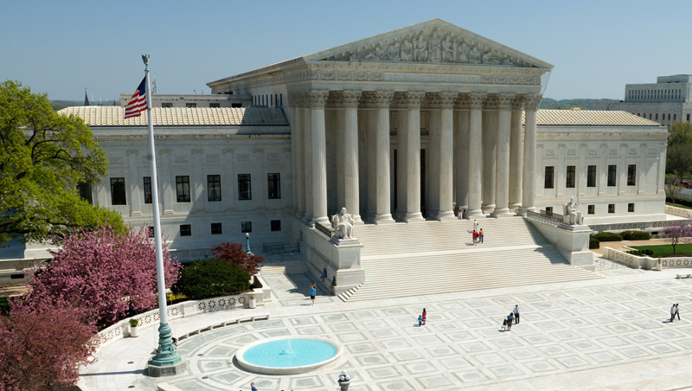

**USA Judicial Temple**

**The Judicial Process**

Article III of the Constitution of the United States guarantees that every person accused of wrongdoing has the right to a fair trial before a competent judge and a jury of one's peers.The Fourth, Fifth, and Sixth Amendments to the Constitution provide additional protections for those accused of a crime. These include:

* A guarantee that no person shall be deprived of life, liberty, or property without the due process of law
* Protection against being tried for the same crime twice ("double jeopardy")
* The right to a speedy trial by an impartial jury
* The right to cross-examine witnesses, and to call witnesses to support their case
* The right to legal representation
* The right to avoid self-incrimination
* Protection from excessive bail, excessive fines, and cruel and unusual punishments

Criminal proceedings can be conducted under either state or federal law, depending on the nature and extent of the crime. A criminal legal procedure typically begins with an arrest by a law enforcement officer. If a grand jury chooses to deliver an indictment, the accused will appear before a judge and be formally charged with a crime, at which time he or she may enter a plea.

1. **Definition**

The judiciary is the system of [courts](https://en.wikipedia.org/wiki/Courts) that interprets, defends, and applies the [law](https://en.wikipedia.org/wiki/Law) in the name of the [state](https://en.wikipedia.org/wiki/State_(polity)). The judiciary can also be thought of as the instrument or mechanism for the resolution of disputes. Under the doctrine of the [separation of powers](https://en.wikipedia.org/wiki/Separation_of_powers), the judiciary generally does not make [statutory law](https://en.wikipedia.org/wiki/Statutory_law) (which is the responsibility of the [legislature](https://en.wikipedia.org/wiki/Legislature)) or enforce law (which is the responsibility of the [executive](https://en.wikipedia.org/wiki/Executive_(government))), but rather interprets, defends, and applies the law to the facts of each case. However, in some countries the judiciary does make [common law](https://en.wikipedia.org/wiki/Common_law).

In many [jurisdictions](https://en.wikipedia.org/wiki/Jurisdiction) the judicial branch has the power to change laws through the process of [judicial review](https://en.wikipedia.org/wiki/Judicial_review). Courts with judicial review power may annul the laws and rules of the state when it finds them incompatible with a higher norm, such as [primary legislation](https://en.wikipedia.org/wiki/Primary_and_secondary_legislation), the provisions of the [constitution](https://en.wikipedia.org/wiki/Constitution), [treaties](https://en.wikipedia.org/wiki/Treaty) or [international law](https://en.wikipedia.org/wiki/International_law). Judges constitute a critical force for interpretation and implementation of a constitution, therefore, some countries creating common [law](https://en.wikipedia.org/wiki/Common_law) in the body of constitutional law.

1. **Judicial General information:**

“Judicial” is a descriptive term used to indicate that a thing refers, relates, or pertains to a judge or the court. For example:

* A [judicial proceeding](https://www.law.cornell.edu/wex/judicial_proceeding) is a proceeding over which a judge presides.
* A [judicial sale](https://www.law.cornell.edu/wex/judicial_sale) is a sale ordered by or under the supervision of a court.
* [Judicial discretion](https://www.law.cornell.edu/wex/judicial_discretion) is a term used to describe the judge’s freedom to make decisions based on what is right given the circumstances.
* [Judicial ethics](https://www.law.cornell.edu/wex/judicial_ethics) are the standard and norms that bear on judges.
* [Judicial administration](https://www.law.cornell.edu/wex/judicial_administration) consists of the practices, procedures and offices that deal with the management of the system of the courts.

1. **Structure of The Judicial Branch in the USA**

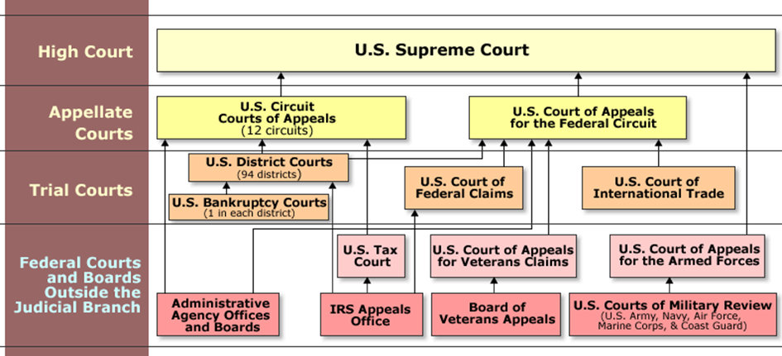

1. **Difference between a State Court System and the Federal Court System**

The legal system in the United States is made of the **state court system** and a **federal court system** that have different judicial branch powers. The various powers granted to these court systems are generally defined by jurisdiction or the types of cases that a specific court can hear. For example, state courts have **broad jurisdiction**. They can hear a wide variety of court cases, including everything from criminal cases in which someone is accused of breaking the law to family or personal disputes over legal issues (e.g., disputes over inheritance or breach of contract cases). Federal courts have a narrower jurisdiction and can only hear certain types of cases. Federal courts are generally limited to:

* Cases in which the United States is one of the parties involved in the legal matter. These cases have national importance.
* Cases in which a person or party is accused of breaking a constitutional or federal law.
* Cases that involve bankruptcy, copyright violations, and disputes over patents.
* Cases involving parties from different states where the dispute involves $75,000 or more.

Aside from the general difference in jurisdiction between the state and federal courts, there are other essential differences between these court systems. For example, the power of the federal courts is granted by Article III of the Constitution. States establish their own laws that allow them to create courts. The Supreme Court is the highest court in the United States, and rulings from this court are considered final. Rulings from state courts are not always conclusive and can be taken to either appeals courts or the Supreme Court if the Supreme Court chooses to hear the case. Members of the Supreme Court are nominated by the President of the United States and then confirmed by the Senate. State court judges can be elected or appointed depending on the state.

There is also something called the U.S. Court of Appeals, which is made of 13 appellate courts that are below the Supreme Court. These courts determine whether or not a law has been used correctly during the trial part of the court case. They often revisit cases where someone wants to challenge the ruling of lower courts.

There are also the U.S. District Courts, which include 94 district or trial courts in the United States. Each state has at least one district court. District courts handle many court cases, including simple misdemeanor cases.

1. **The Different Levels of State Courts**

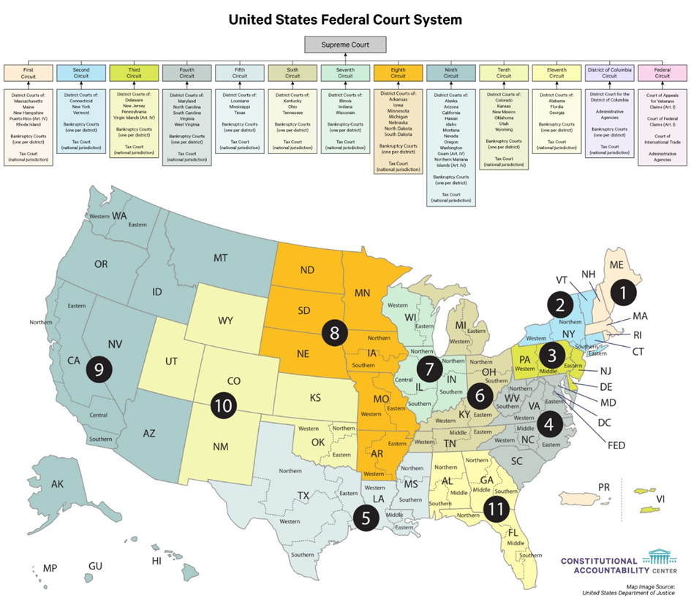

Understanding what the judicial branch does helps to explore the different levels of state courts. Each state court system is generally divided into

1. **Structure of the Judicial Branch Flash**

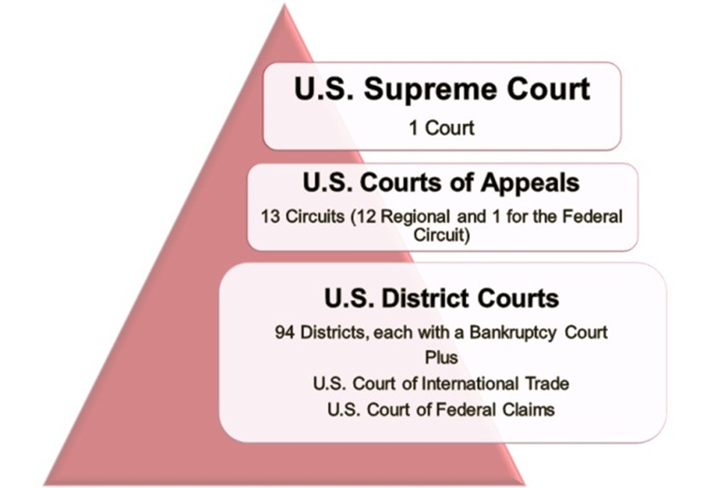

**The four levels of courts in the states**

The Superior Court sees serious criminal cases. The special courts have limited jurisdiction and view only certain types of cases. The Intermediate Court of Appeals only reviews cases that involve state laws. The State Supreme Court is the highest in the state and is called the court of final resort.

**Supreme Court Court Of Appeal Cheap** 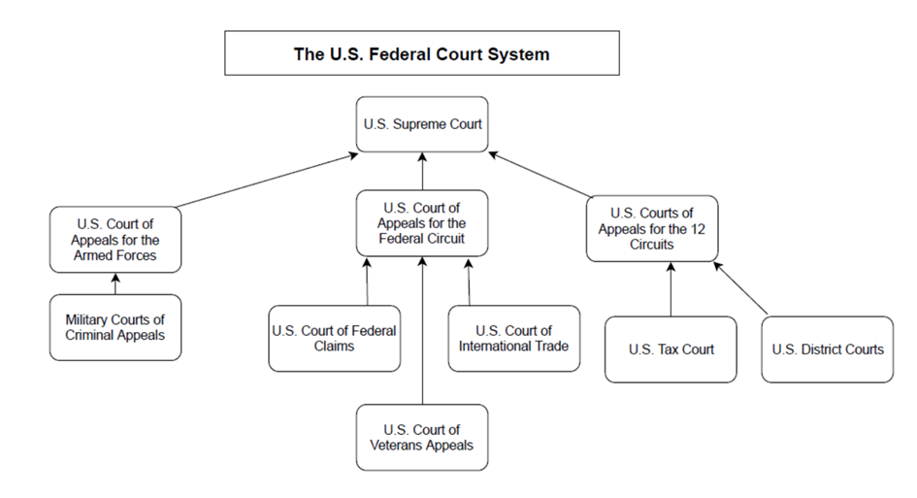

**The way the court system in the United States work**

The court system in the U.S. is made of the federal court system and the state court system. Each has its own jurisdiction, with state courts having broader jurisdiction. Both court systems have different levels of courts, such as appellate courts and the Supreme Court.

1. **Functions of the judiciary in different law systems**

In common law jurisdictions, courts interpret law; this includes constitutions, statutes, and regulations. They also make law (but in a limited sense, limited to the facts of particular cases) based upon prior [case law](https://en.wikipedia.org/wiki/Case_law) in areas where the legislature has not made law. For instance, the [tort](https://en.wikipedia.org/wiki/Tort) of [negligence](https://en.wikipedia.org/wiki/Negligence) is not derived from statute law in most common law jurisdictions. The term *common law* refers to this kind of law. Common law decisions set precedent for all courts to follow. This is sometimes called [*stare decisis*](https://en.wikipedia.org/wiki/Precedent).

1. **Country-specific functions**

In the [United States court system](https://en.wikipedia.org/wiki/Courts_of_the_United_States), the [Supreme Court](https://en.wikipedia.org/wiki/Supreme_Court_of_the_United_States) is the final authority on the interpretation of the federal Constitution and all statutes and regulations created pursuant to it, as well as the constitutionality of the various state laws; in the [US federal court system](https://en.wikipedia.org/wiki/United_States_federal_courts), federal cases are tried in [trial courts](https://en.wikipedia.org/wiki/Trial_court), known as the [US district courts](https://en.wikipedia.org/wiki/United_States_district_court), followed by [appellate courts](https://en.wikipedia.org/wiki/Appellate_court) and then the Supreme Court. [State courts](https://en.wikipedia.org/wiki/State_court_(United_States)), which try 98% of [litigation](https://en.wikipedia.org/wiki/Litigation),[[29]](https://en.wikipedia.org/wiki/Judiciary#cite_note-ABACourtStructure-29) may have different names and organization; trial courts may be called "courts of common plea", appellate courts "superior courts" or "commonwealth courts" The judicial system, whether state or federal, begins with a court of first instance, is appealed to an appellate court, and then ends at the court of last resort.

In [France](https://en.wikipedia.org/wiki/France), the final authority on the interpretation of the law is the [Council of State](https://en.wikipedia.org/wiki/Council_of_State_(France)) for administrative cases, and the [Court of Cassation](https://en.wikipedia.org/wiki/Court_of_Cassation_(France)) for civil and criminal cases.

In the [People's Republic of China](https://en.wikipedia.org/wiki/China), the final authority on the interpretation of the law is the [National People's Congress](https://en.wikipedia.org/wiki/National_People%27s_Congress).

Other countries such as [Argentina](https://en.wikipedia.org/wiki/Argentina) have mixed systems that include lower courts, appeals courts, a [cassation court](https://en.wikipedia.org/wiki/Court_of_cassation) (for criminal law) and a Supreme Court. In this system the Supreme Court is always the final authority, but criminal cases have four stages, one more than civil law does. On the court sits a total of nine justices. This number has been changed several times.

1. **Some countries’ Judicial system Structure**

For judicial systems of individual countries other than Japan, Mexico, and the US (for which see below), and some US states, see "Judiciary of...

1. **United States**

Main articles: [Federal judiciary of the United States](https://en.wikipedia.org/wiki/Federal_judiciary_of_the_United_States) and [List of courts of the United States](https://en.wikipedia.org/wiki/List_of_courts_of_the_United_States) [United States Supreme Court](https://en.wikipedia.org/wiki/Supreme_Court_of_the_United_States) justices are appointed by the [President of the United States](https://en.wikipedia.org/wiki/President_of_the_United_States) and approved by the [United States Senate](https://en.wikipedia.org/wiki/United_States_Senate). The Supreme Court justices serve for life term or until retirement. The Supreme Court is located in [Washington, D.C.](https://en.wikipedia.org/wiki/Washington,_D.C.) The [United States federal court system](https://en.wikipedia.org/wiki/Federal_judiciary_of_the_United_States) consists of 94 [federal judicial districts](https://en.wikipedia.org/wiki/United_States_federal_judicial_district). The 94 districts are then divided up into [twelve regional circuits.](https://en.wikipedia.org/wiki/United_States_courts_of_appeals) The United States has five different types of courts that are considered subordinate to the Supreme Court: [United States bankruptcy courts](https://en.wikipedia.org/wiki/United_States_bankruptcy_court), [United States Court of Appeals for the Federal Circuit](https://en.wikipedia.org/wiki/United_States_Court_of_Appeals_for_the_Federal_Circuit), [United States Court of International Trade](https://en.wikipedia.org/wiki/United_States_Court_of_International_Trade), [United States courts of appeals](https://en.wikipedia.org/wiki/United_States_courts_of_appeals), and [United States district courts](https://en.wikipedia.org/wiki/United_States_district_court).

Immigration courts are not part of the judicial branch; immigration judges are employees of the [Executive Office for Immigration Review](https://en.wikipedia.org/wiki/Executive_Office_for_Immigration_Review), part of the [United States Department of Justice](https://en.wikipedia.org/wiki/United_States_Department_of_Justice) in the executive branch.

**Notabe philosophers of law**

|  |  |  |  |
| --- | --- | --- | --- |
| [Plato](https://en.wikipedia.org/wiki/Plato)  [Aristotle](https://en.wikipedia.org/wiki/Aristotle)  [Thomas Aquinas](https://en.wikipedia.org/wiki/Thomas_Aquinas)  [Francis Bacon](https://en.wikipedia.org/wiki/Francis_Bacon)  [John Locke](https://en.wikipedia.org/wiki/John_Locke) [Francisco Suarez](https://en.wikipedia.org/wiki/Francisco_Suarez) [Francisco de Vitoria](https://en.wikipedia.org/wiki/Francisco_de_Vitoria)  [Hugo Grotius](https://en.wikipedia.org/wiki/Hugo_Grotius) [John Austin (legal philosophy)](https://en.wikipedia.org/wiki/John_Austin_(legal_philosophy))  [Frederic Bastiat](https://en.wikipedia.org/wiki/Frederic_Bastiat)  [Evgeny Pashukanis](https://en.wikipedia.org/wiki/Evgeny_Pashukanis) [Jeremy Bentham](https://en.wikipedia.org/wiki/Jeremy_Bentham)  [Emilio Betti](https://en.wikipedia.org/wiki/Emilio_Betti)  [Norberto Bobbio](https://en.wikipedia.org/wiki/Norberto_Bobbio)  [António Castanheira Neves](https://en.wikipedia.org/wiki/Ant%C3%B3nio_Castanheira_Neves) | • [Jules Coleman](https://en.wikipedia.org/wiki/Jules_Coleman)  [Ronald Dworkin](https://en.wikipedia.org/wiki/Ronald_Dworkin)  [Francesco D'Agostino](https://en.wikipedia.org/wiki/Francesco_D%27Agostino)  [Francisco Elías de Tejada y Spínola](https://en.wikipedia.org/wiki/Francisco_El%C3%ADas_de_Tejada_y_Sp%C3%ADnola)  [Carlos Cossio](https://en.wikipedia.org/wiki/Carlos_Cossio)  [Miguel Reale](https://en.wikipedia.org/wiki/Miguel_Reale)  [John Finnis](https://en.wikipedia.org/wiki/John_Finnis)  [Lon L. Fuller](https://en.wikipedia.org/wiki/Lon_L._Fuller)  [Leslie Green](https://en.wikipedia.org/wiki/Leslie_Green_(philosopher))  [Robert P. George](https://en.wikipedia.org/wiki/Robert_P._George)  [Germain Grisez](https://en.wikipedia.org/wiki/Germain_Grisez)  [H. L. A. Hart](https://en.wikipedia.org/wiki/H._L._A._Hart)  [Georg Wilhelm Friedrich Hegel](https://en.wikipedia.org/wiki/Georg_Wilhelm_Friedrich_Hegel)  [Oliver Wendell Holmes, Jr.](https://en.wikipedia.org/wiki/Oliver_Wendell_Holmes,_Jr.) | [Tony Honoré](https://en.wikipedia.org/wiki/Tony_Honor%C3%A9)  [Rudolf Jhering](https://en.wikipedia.org/wiki/Rudolf_von_Jhering)  [Johann Gottlieb Fichte](https://en.wikipedia.org/wiki/Johann_Gottlieb_Fichte)  [Hans Kelsen](https://en.wikipedia.org/wiki/Hans_Kelsen)  [Joel Feinberg](https://en.wikipedia.org/wiki/Joel_Feinberg)  [David Lyons](https://en.wikipedia.org/wiki/David_Lyons_(legal_philosopher))  [Robert Alexy](https://en.wikipedia.org/wiki/Robert_Alexy)  [Reinhold Zippelius](https://en.wikipedia.org/wiki/Reinhold_Zippelius)  [Neil MacCormick](https://en.wikipedia.org/wiki/Neil_MacCormick)  [William E. May](https://en.wikipedia.org/wiki/William_E._May)  [Martha Nussbaum](https://en.wikipedia.org/wiki/Martha_Nussbaum)  [Gustav Radbruch](https://en.wikipedia.org/wiki/Gustav_Radbruch)  [Joseph Raz](https://en.wikipedia.org/wiki/Joseph_Raz)  [Jeremy Waldron](https://en.wikipedia.org/wiki/Jeremy_Waldron)  [Friedrich Carl von Savigny](https://en.wikipedia.org/wiki/Friedrich_Carl_von_Savigny) | [Robert Summers](https://en.wikipedia.org/wiki/Robert_Summers)  [Roberto Unger](https://en.wikipedia.org/wiki/Roberto_Unger)  [Catharine MacKinnon](https://en.wikipedia.org/wiki/Catharine_MacKinnon)  [John Rawls](https://en.wikipedia.org/wiki/John_Rawls)  [Pierre Schlag](https://en.wikipedia.org/wiki/Pierre_Schlag)  [Robin West](https://en.wikipedia.org/wiki/Robin_West)  [Carl Schmitt](https://en.wikipedia.org/wiki/Carl_Schmitt)  [Jürgen Habermas](https://en.wikipedia.org/wiki/J%C3%BCrgen_Habermas)  [Carlos Santiago Nino](https://en.wikipedia.org/wiki/Carlos_Santiago_Nino)  [Geoffrey Warnock](https://en.wikipedia.org/wiki/Geoffrey_Warnock)  [Scott J. Shapiro](https://en.wikipedia.org/wiki/Scott_J._Shapiro)  [Shen Buhai](https://en.wikipedia.org/wiki/Shen_Buhai)  [Shang Yang](https://en.wikipedia.org/wiki/Shang_Yang)  [Han Fei](https://en.wikipedia.org/wiki/Han_Fei)  [Zhu Xi](https://en.wikipedia.org/wiki/Zhu_Xi) |

Each [state](https://en.wikipedia.org/wiki/U.S._state), [district](https://en.wikipedia.org/wiki/District_of_Columbia) and [inhabited territory](https://en.wikipedia.org/wiki/Territories_of_the_United_States) also has its own [court system](https://en.wikipedia.org/wiki/State_court_(United_States)) operating within the legal framework of the respective jurisdiction, responsible for hearing cases regarding [state and territorial law](https://en.wikipedia.org/wiki/State_law_(United_States)). All these jurisdictions also have their own [supreme courts](https://en.wikipedia.org/wiki/State_supreme_courts) (or equivalent) which serve as the highest courts of law within their respective jurisdictions.

**USA Check and Balance Judicial System**

|  |  |  |
| --- | --- | --- |
| [**Legislative**](https://en.wikipedia.org/wiki/Legislature) **(**[**Congress**](https://en.wikipedia.org/wiki/United_States_Congress)**)** | [**Executive**](https://en.wikipedia.org/wiki/Executive_(government)) **(**[**President**](https://en.wikipedia.org/wiki/President_of_the_United_States)**)** | [**Judicial**](https://en.wikipedia.org/wiki/Judiciary) **(**[**Supreme Court**](https://en.wikipedia.org/wiki/Supreme_Court_of_the_United_States)**)** |
| * Passes bills; has broad [taxing and spending power](https://en.wikipedia.org/wiki/Taxing_and_Spending_Clause); regulates inter-state commerce; controls the [federal budget](https://en.wikipedia.org/wiki/United_States_federal_budget); has power to borrow money on the credit of the United States (may be vetoed by President, but [vetoes may be overridden](https://en.wikipedia.org/wiki/Veto_override) with a two-thirds vote of both houses) * Has sole power to [declare war](https://en.wikipedia.org/wiki/Declaration_of_war_by_the_United_States), as well as to raise, support, and regulate the [military](https://en.wikipedia.org/wiki/U.S._Military). * Oversees, investigates, and makes the rules for the government and its officers. * Defines by law the jurisdiction of the federal judiciary in cases not specified by the Constitution. * Ratification of treaties signed by the President and gives [advice and consent](https://en.wikipedia.org/wiki/Advice_and_consent) to presidential appointments to the [federal judiciary](https://en.wikipedia.org/wiki/United_States_federal_courts), [federal executive departments](https://en.wikipedia.org/wiki/United_States_federal_executive_departments), and other posts (Senate only).[[note 1]](https://en.wikipedia.org/wiki/Separation_of_powers#cite_note-31) * Has sole power of [impeachment](https://en.wikipedia.org/wiki/Federal_impeachment_in_the_United_States) (House of Representatives) and trial of impeachments (Senate); can remove federal executive and judicial officers from office for [high crimes and misdemeanors](https://en.wikipedia.org/wiki/High_crimes_and_misdemeanors) | * Is the [commander-in-chief](https://en.wikipedia.org/wiki/Commander-in-chief) of the [armed forces](https://en.wikipedia.org/wiki/United_States_armed_forces) * Executes the instructions of Congress. * May veto bills passed by Congress (but the veto may be overridden by a two-thirds majority of both houses) * Executes the spending authorized by Congress. * Declares states of emergency and publishes [regulations](https://en.wikipedia.org/wiki/Regulations) and [executive orders](https://en.wikipedia.org/wiki/Executive_order_(United_States)). * Makes executive agreements (does not require ratification) and signs treaties (ratification requiring approval by two-thirds of the Senate) * Makes appointments to the federal judiciary, [federal executive departments](https://en.wikipedia.org/wiki/United_States_federal_executive_departments), and other posts with the advice and consent of the Senate. Has power to make [temporary appointment during the recess of the Senate](https://en.wikipedia.org/wiki/Recess_appointment) * Has the power to grant "reprieves and pardons for offenses against the United States, except in cases of impeachment." | * Determines which laws Congress intended to apply to any given case * Exercises [judicial review](https://en.wikipedia.org/wiki/Judicial_review_in_the_United_States), reviewing the constitutionality of laws * Determines how Congress meant the law to apply to disputes * Determines how a law acts to determine the disposition of prisoners * Determines how a law acts to compel testimony and the production of evidence * Determines how laws should be interpreted to assure uniform policies in a top-down fashion via the [appeals](https://en.wikipedia.org/wiki/Appeal_(law)) process, but gives discretion in individual cases to low-level judges. The amount of discretion depends upon the [standard of review](https://en.wikipedia.org/wiki/Standard_of_review), determined by the type of case in question |

1. **Japan**

[Japan](https://en.wikipedia.org/wiki/Japan)'s process for selecting judges is longer and more stringent than in various countries, like the [United States](https://en.wikipedia.org/wiki/United_States) and in [Mexico](https://en.wikipedia.org/wiki/Mexico).[[32]](https://en.wikipedia.org/wiki/Judiciary#cite_note-32) Assistant judges are appointed from those who have completed their training at the Legal Training and Research Institute located in [Wako](https://en.wikipedia.org/wiki/Wako,_Saitama). Once appointed, assistant judges still may not qualify to sit alone until they have served for five years, and have been appointed by the [Supreme Court of Japan](https://en.wikipedia.org/wiki/Supreme_Court_of_Japan). Judges require ten years of experience in practical affairs, as a public prosecutor or practicing attorney. In the [Japanese judicial branch](https://en.wikipedia.org/wiki/Judicial_system_of_Japan) there is the Supreme Court, eight high courts, fifty district courts, fifty family courts, and 438 summary courts.

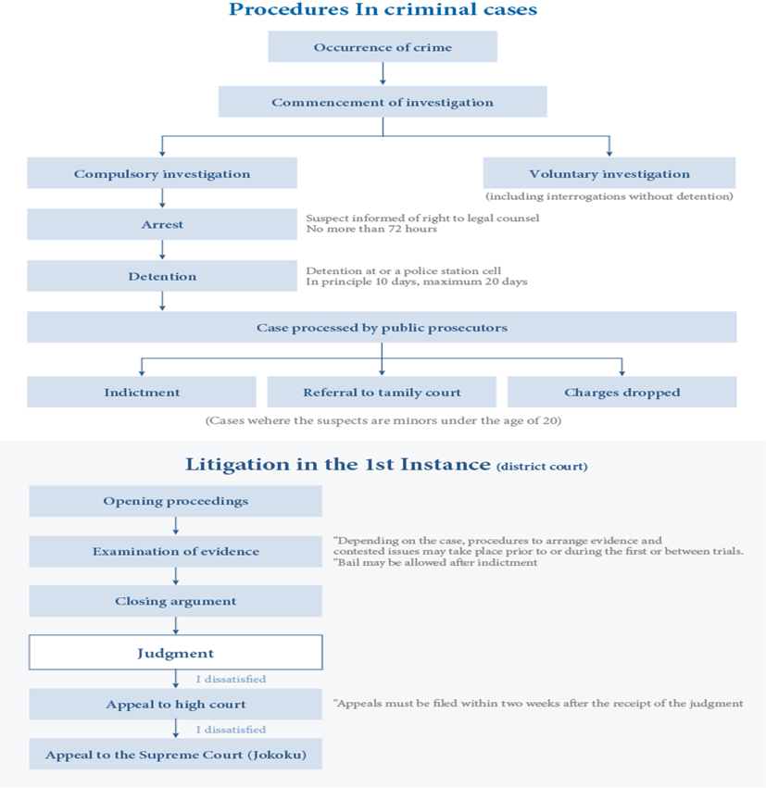

1. **Mexico**

Justices of the [Mexican Supreme Court](https://en.wikipedia.org/wiki/Mexican_Supreme_Court) are appointed by the [President of Mexico](https://en.wikipedia.org/wiki/President_of_Mexico), and then are approved by the [Mexican Senate](https://en.wikipedia.org/wiki/Mexican_Senate) to serve for a life term. Other justices are appointed by the Supreme Court and serve for six years. Federal courts consist of the 11 ministers of the Supreme Court, 32 circuit tribunals and 98 district courts. The Supreme Court of Mexico is located in [Mexico City](https://en.wikipedia.org/wiki/Mexico_City). Supreme Court Judges must be of ages 35 to 65 and hold a law degree during the five years preceding their nomination.

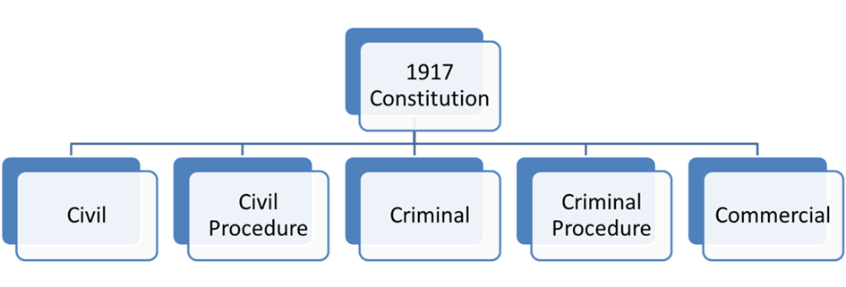

1. **France**

At the basic level, the courts can be seen as organized into:

* [ordinary courts](https://en.wikipedia.org/wiki/Ordinary_courts) (*ordre judiciaire*), which handle criminal and civil litigation
* administrative courts (*ordre administratif*), which supervise the government and handle complaints

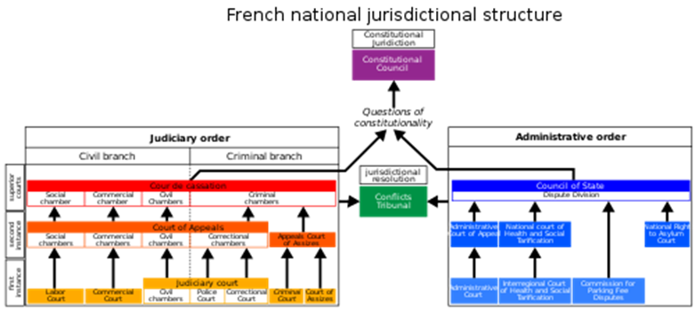

1. **Russia**

The Ministry of Justice administers Russia's judicial system. The ministry's responsibilities include the establishment of courts and the appointment of judges at levels below the federal district courts. The ministry also gathers forensic statistics and conducts sociological research and educational programs applicable to crime prevention.

Many Western observers consider the judicial and legal systems weak links in Russia's reform efforts, stymieing privatization, the fight against crime and corruption, the protection of civil and human rights, and the general ascendancy of the rule of law. Many judges appointed by the regimes of Leonid I. Brezhnev (in office 1964-82) and Yuriy V. Andropov (in office 1982-84) remained in place in the mid-1990s. Such arbiters were trained in "socialist law" and had become accustomed to basing their verdicts on telephone calls from local CPSU bosses rather than on the legal merits of cases.

For court infrastructure and financial support, judges must depend on the Ministry of Justice, and for housing they must depend on local authorities in the jurisdiction where they sit. In 1995 the average salary for a judge was US$160 per month, substantially less than the earnings associated with more menial positions in Russian society. These circumstances, combined with irregularities in the appointment process and the continued strong position of the procurators, deprived judges in the lower jurisdictions of independent authority (see The Procuracy, ch. 10). Under the constitution, judges of the three highest courts serve for life and are appointed by the Federation Council after nomination by the president. The president appoints judges at the next level, the federal district courts. The minister of justice is responsible for appointing judges to regional and city courts. However, in practice many appointments below the national level still are made by the chief executives of subnational jurisdictions, a practice that has perpetuated local political influence on judges' decisions.

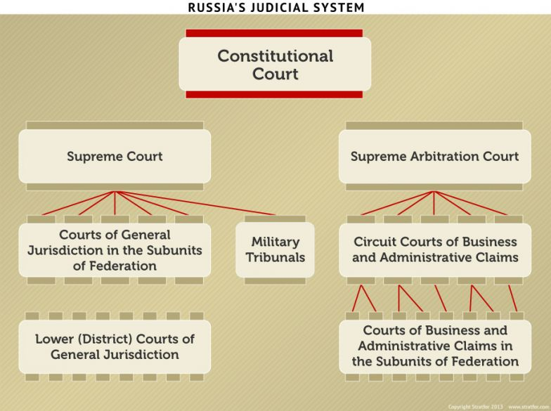

1. **China**

The courts in China are divided into four levels in accordance with the descending order of powers, i.e. the Supreme People's Court (the SPC), high people's courts, intermediate people's courts, and primary people's courts. Courts at the latter three levels are collectively referred to as local courts.

China's authorities are divided into five levels ranging from the central government to the local governments, i.e., the central government, the governments at provincial, municipal, county (district), and township levels. The courts are established correspondingly at the higher four levels. Different courts at the four levels correspond to the government at the same level respectively.

Each court has jurisdiction over cases within the territorial scope of the authority at the same level, which include cases at first instance under its jurisdiction and appeal cases against the judgments or rulings at first instance made by the lower court under its jurisdiction.

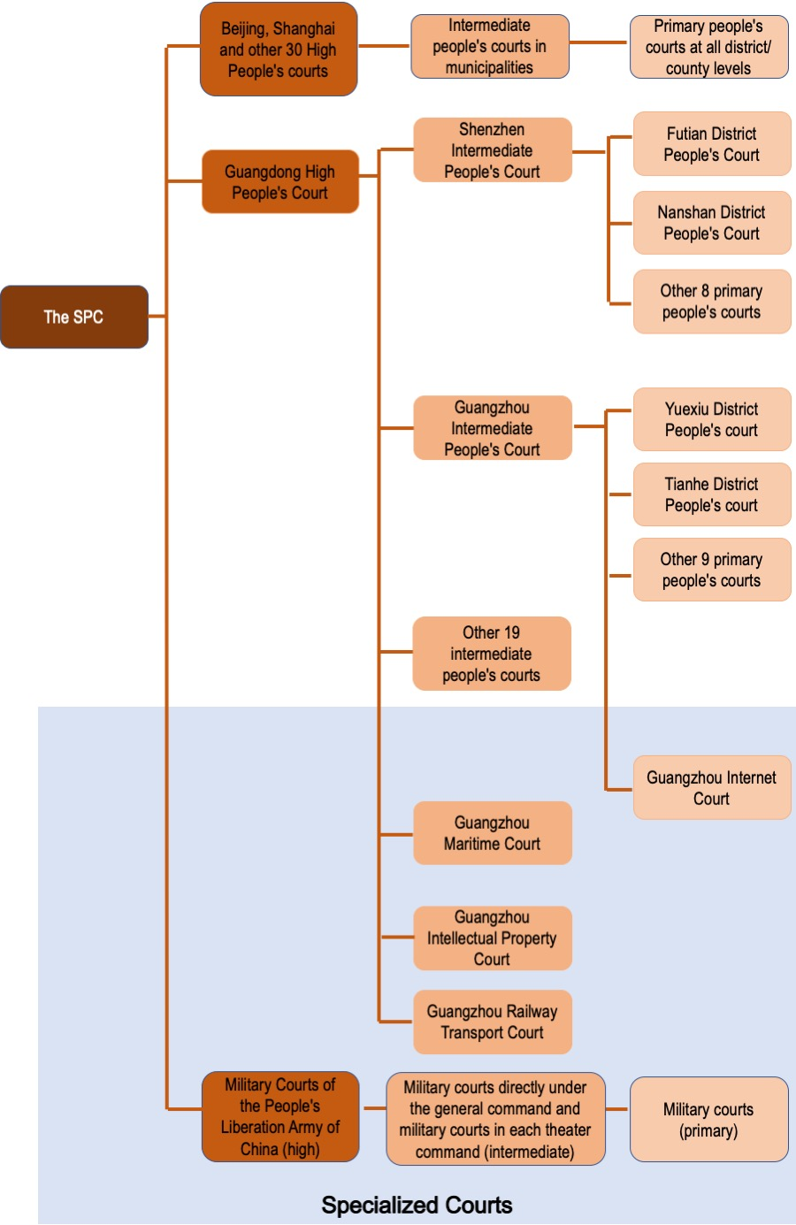

1. **United Arab Emirates**

The legal structure in the UAE runs in two systems: the Federal Judiciary presided by the Federal Supreme Court as the highest judicial authority in the UAE and the local judicial departments at the local government level.

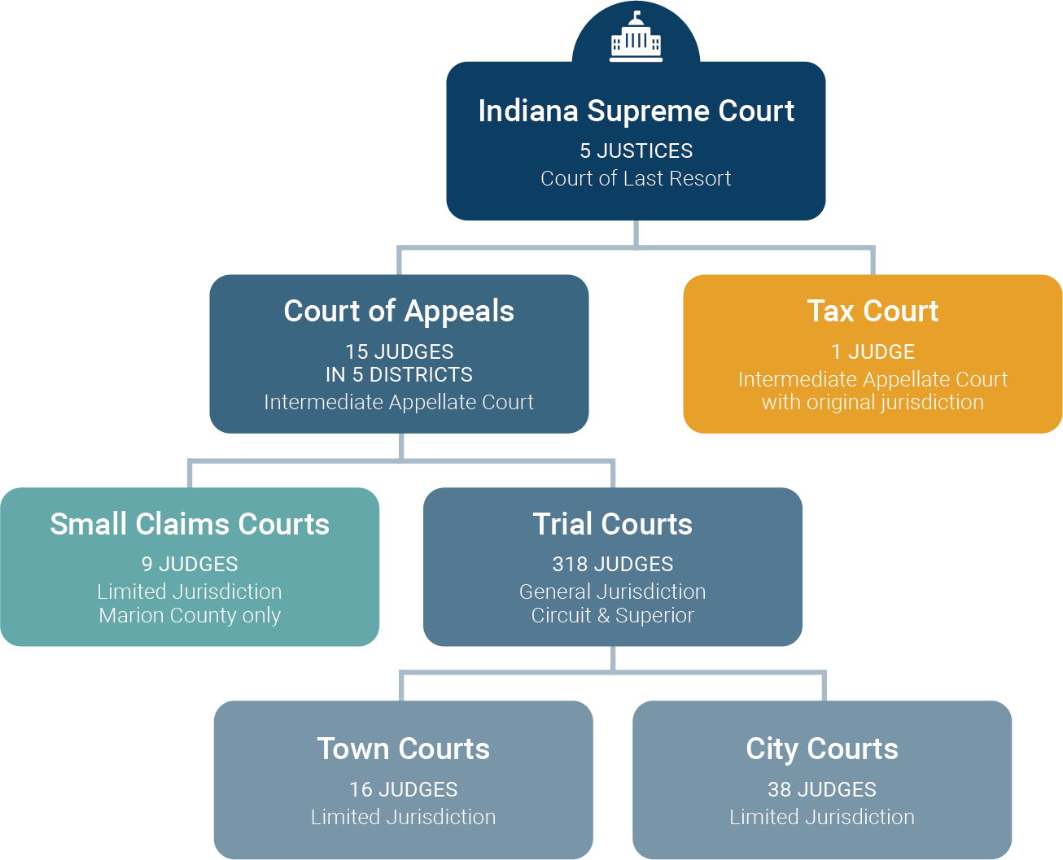

1. **Nigeria**

The Nigerian legal system refers to the totality of laws in Nigeria and the machinery through which these laws are enforced. It has been said that all the laws in a legal system are based on a fundamental norm from which they get their validity. This is referred to as the grundnorm. The grundnorm is the fons et origo, the source of every other law and authority in the legal system. The grundnorm in colonial Nigeria was the queen of England while the grundnorm after independence became the constitution as it is the most basic law in the country from which all other laws gain their validity. The 1999 constitution of the federal republic of Nigeria states in section 1(1) that it is supreme and its provisions shall have binding force on every authority and person and it states in section 1(3) states that any law which is inconsistent with the constitution is void to the extent of its inconsistency.

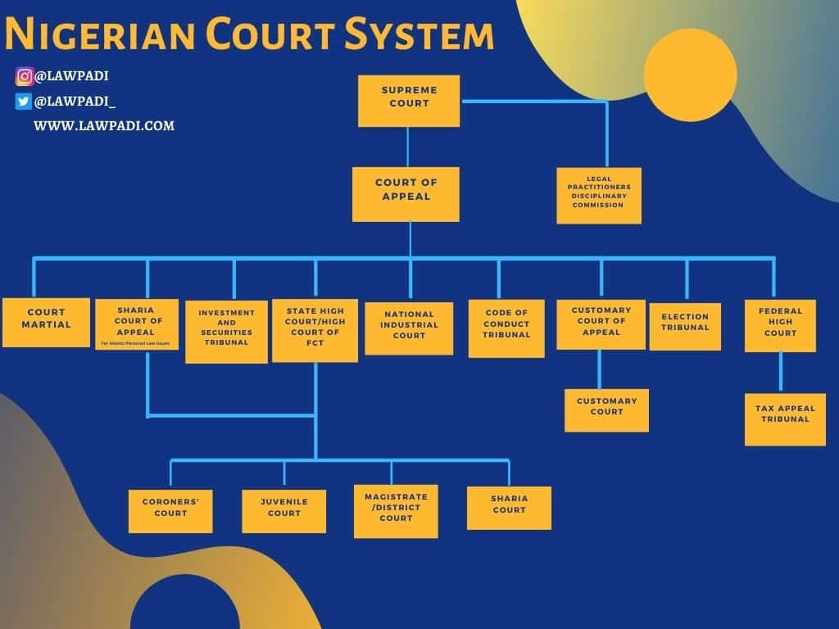

1. **The Hierarchy of UK Courts**

**The court system in England and Wales can be considered as consisting of 5 levels:**

* Supreme Court (formerly the House of Lords) and the Judicial Committee of the Privy Council
  + Court of Appeal
    - High Court
      * Crown Court and County Courts
        + Magistrates’ Courts and the Tribunals Service

There is a similar court system in Northern Ireland and a different court system in Scotland.

**Judicial Committee of the Privy Council**

The Judicial Committee of the Privy Council is the court of final appeal for Commonwealth countries that have retained appeals to either Her Majesty in Council or to the Judicial Committee. It is also the court of final appeal for the High Court of Justiciary in Scotland for issues related to devolution. Some functions of the Judicial Committee were taken over by the new Supreme Court in 2009.

**Supreme Court (formerly the House of Lords)**

In 2009 the Supreme Court replaced the House of Lords as the highest court in England, Wales and Northern Ireland. As with the House of Lords, the Supreme Court hears appeals from the Court of Appeal and the High Court (only in exceptional circumstances). It also hears appeals from the Inner House of the Court of Session in Scotland. Appeals are normally heard by 5 Justices (formerly Lords of Appeal in Ordinary, or Law Lords), but there can be as many as 9.

**Court of Appeal**

The Court of Appeal consists of 2 divisions, the Criminal Division and the Civil Decision. Decisions of the Court of Appeal may be appealed to the Supreme Court (formerly the House of Lords).

**Civil Division**

The Civil Division of the Court of Appeal hears appeals concerning civil law and family justice from the High Court, from Tribunals, and certain cases from the County Courts.

**Criminal Division**

The Criminal Division of the Court of Appeal hears appeals from the Crown Court.

**High Court**

The High Court consists of 3 divisions, the Chancery Division, the Family Division, and the Queen’s Bench Division. Decisions of the High Court may be appealed to the Civil Division of the Court of Appeal.

**Chancery Division: Companies Court**

The Companies Court of the Chancery Division deals with cases concerning commercial fraud, business disputes, insolvency, company management, and disqualification of directors.

**Chancery Division: Divisional Court**

The Divisional Court of the Chancery Division deals with cases concerning equity, trusts, contentious probate, tax partnerships, bankruptcy and land.

**Chancery Division: Patents Court**

The Patents Court of the Chancery Division deals with cases concerning intellectual property, copyright, patents and trademarks, including passing off.

**Family Division: Divisional Court**

The Divisional Court of the Family Division deals with all matrimonial matters, including custody of children, parentage, adoption, family homes, domestic violence, separation, annulment, divorce and medical treatment declarations, and with uncontested probate matters.

**Queen’s Bench Division: Administrative Court**

The Administrative Court of the Queen’s Bench Division hears judicial reviews, statutory appeals and application, application for *habeas corpus*, and applications under the Drug Trafficking Act 1984 and the Criminal Justice Act 1988. It also oversees the legality of decisions and actions of inferior courts and tribunals, local authorities, Ministers of the Crown, and other public bodies and officials.

**Queen’s Bench Division: Admiralty Court**

The Admiralty Court of the Queen’s Bench Division deals with shipping and maritime disputes, including collisions, salvage, carriage of cargo, limitation, and mortgage disputes. The Court can arrest vessels and cargoes and sell them within the jurisdiction of England and Wales.

**Queen’s Bench Division: Commercial Court**

The Commercial Court of the Queen’s Bench Division deals with cases arising from national and international business disputes, including international trade, banking, commodities, and arbitration disputes.

**Queen’s Bench Division: Mercantile Court**

The Mercantile Court of the Queen’s Bench Division deals with national and international business disputes that involve claims of lesser value and complexity than those heard by the Commercial Court.

**Queen’s Bench Division: Technology and Construction Court**

The Technology and Construction Court of the Queen’s Bench Division is a specialist court that deals principally with technology and construction disputes that involve issues or questions which are technically complex, and with cases where a trial by a specialist TCC judge is desirable.

**County Courts**

The County Courts deal with all except the most complicated and the most simple civil cases (including most matters under the value of £5000), such as claims for repayment of debts, breach of contract involving goods or property, personal injury, family issues (including adoption and divorce), housing issues (including recovery of mortgage and rent arrears, and re-possession), and enforcement of previous County Court judgments. Cases are heard by a judge, without a jury. Decisions of the County Courts may be appealed to the appropriate Division of the High Court.

**Crown Court**

The Crown Court deals with indictable criminal cases that have been transferred from the Magistrates’ Courts, including hearing of serious criminal cases (such as murder, rape and robbery), cases sent for sentencing, and appeals. Cases are heard by a judge and a jury. Decisions of the Crown Court may be appealed to the Criminal Division of the Court of Appeal.

**Magistrates’ Courts**

The Magistrates’ Courts deal with summary criminal cases and committals to the Crown Court, with simple civil cases including family proceedings courts and youth courts, and with licensing of betting, gaming and liquor. Cases are normally heard by either a panel of 3 magistrates or by a District Judge, without a jury. Criminal decisions of the Magistrates’ Courts may be appealed to the Crown Court. Civil decisions may be appealed to the County Courts.

**Tribunals Service**

The Tribunals Service makes decisions on matters including asylum, immigration, criminal injuries compensation, social security, education, employment, child support, pensions, tax and lands. Decisions of the Tribunals Service may be appealed to the appropriate Division of the High Court.

**Courts in Scotland**

**The hierarchy of courts in Scotland**

The court system in Scotland can be considered as consisting of 4 levels:

* Supreme Court (formerly the House of Lords) and the Judicial Committee of the Privy Council
  + Court of Session and the High Court of Justiciary
    - Sheriff Courts
      * District Courts

**Judicial Committee of the Privy Council**

In addition to its role as the court of final appeal for Commonwealth countries, the Judicial Committee is also the court of final appeal for the High Court of Justiciary in Scotland. Some functions of the Judicial Committee were taken over by the new Supreme Court in 2009.

**Supreme Court**

In addition to its role as the highest court in England, Wales and Northern Ireland, the Supreme Court also hears appeals from the Inner House of the Court of Session in Scotland.

**Court of Session**

The Court of Session is the supreme civil court for Scotland, and serves both as a court of first instance and as a court of appeal. The Court of Session consists of 2 houses, the Inner House and the Outer House.

**Inner House**

The Inner House of the Court of Session mainly deals with appeals, though it also deals with a small range of first instance business. Appeals are heard from the Outer House, from the Sheriff Court, and from certain tribunals and other bodies. Appeals are heard by at least 3 judges, without a jury. Decisions of the Inner House may be appealed to the Supreme Court.

**Outer House**

The Outer House hears cases at first instance on a wide range of civil matters, including tort, contract, intellectual property, commercial cases and judicial review. Cases are presided over by a judge, when appropriate with a civil jury. Decisions of the Outer House may be appealed to the Inner House.

**High Court of Justiciary**

The High Court of Justiciary is the supreme criminal court for Scotland, and serves both as a court of first instance and as a court of appeal. When sitting as a court of first instance, the Court deals only with the most serious crimes such as murder, rape, culpable homicide, armed robbery, drug trafficking and serious sexual offences, particularly those involving children, and cases are tried by a judge and a jury. When sitting as an appellate court, the court consists of at least 2 judges, without a jury. Decisions of the High Court of Justiciary that concern devolution may be appealed to the Privy Council; there is no right of appeal for any other matters.

**Sheriff Courts**

The Sheriff Courts deal with more serious criminal cases than the District Courts, but not with the most serious ones, which are heard in the High Court of Justiciary. The Sheriff Courts also deal with civil matters such as probate, adoption and bankruptcy; the most serious civil cases are heard by the Outer House of the Court of Session. Cases are presided over by a judge, with a jury when appropriate. Civil decisions may be appealed to the Sheriff Principal and then to the Outer House of the Court of Session. Criminal decisions may be appealed to the High Court of Justiciary.

**District Courts**

District Courts deal only with summary criminal matters such as breach of the peace, assault, vandalism, theft, speeding, vehicle excise, television licensing and electricity fraud. Cases are tried by one or 3 Justices of the Peace, or by one stipendiary magistrate, without a jury. More serious cases are tried in the Sheriff Courts or in the High Court of Justiciary. District Courts will be replaced by Justice of the Peace Courts in 2007.

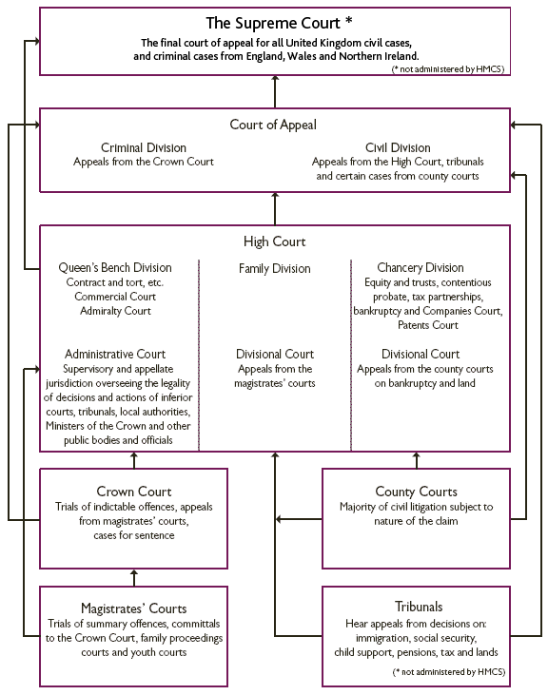

1. **Summary of Judicial Branch**

In this essay assignment of Judicial Branch or Judicial Powers and Judicial Systems interaction with organizations’ constitutional democracy governments around the world, Leading me discovered knowing be a judicial, judiciary or jurisdiction and their systems, be a public or private administrations, it’s all about to guarantee security for human services. Therefore, I am very delighted to invite you to join me read the judicial meaning, functions, responsibilities and it’s important especially you may also come across the way Judicial System works in different countries by their constructional policies in this summary.

The Court Roles and Structures:We became with federal courts hear cases involving the constitutionality of a law, cases involving the laws and treaties of the U.S. ambassadors and public ministers, disputes between two or more states, admiralty law, also known as maritime law, and bankruptcy cases. The contracts, Regulations, MOU, and other documents setup for any disputes between human organizations in order to be stander principles to show equality and human differences no matter how rich or poor you should be , to respect the rights of people in the society.

The federal judiciary operates separately from the executive and legislative branches, but often works with them as the Constitution requires. Federal laws are passed by Congress and signed by the President. The judicial branch decides the constitutionality of federal laws and resolves other disputes about federal laws. However, judges depend on our government’s executive branch to enforce court decisions.

Courts decide what really happened and what should be done about it. They decide whether a person committed a crime and what the punishment should be. They also provide a peaceful way to decide private disputes that people can’t resolve themselves. Depending on the dispute or crime, some cases end up in the federal courts and some end up in state courts. Learn more about the different types of federal courts.

**Supreme Court**

The Supreme Court is the highest court in the United States. Article III of the U.S. Constitution created the Supreme Court and authorized Congress to pass laws establishing a system of lower courts. In the federal court system’s present form, 94 district level trial courts and 13 courts of appeals sit below the Supreme Court. **Courts of Appeals**

There are 13 appellate courts that sit below the U.S. Supreme Court, and they are called the U.S. Courts of Appeals. The 94 federal judicial districts are organized into 12 regional circuits, each of which has a court of appeals.  The appellate court’s task is to determine whether or not the law was applied correctly in the trial court. Appeals courts consist of three judges and do not use a jury.

A court of appeals hears challenges to district court decisions from courts located within its circuit, as well as appeals from decisions of federal administrative agencies.

In addition, the Court of Appeals for the Federal Circuit has nationwide jurisdiction to hear appeals in specialized cases, such as those involving patent laws, and cases decided by the [U.S. Court of International Trade](http://www.cit.uscourts.gov/) and the [U.S. Court of Federal Claims](http://www.uscfc.uscourts.gov/).

Learn more about the [courts of appeals](https://www.uscourts.gov/about-federal-courts/court-role-and-structure/about-us-courts-appeals).

**Bankruptcy Appellate Panels**

Bankruptcy Appellate Panels (BAPs) are 3-judge panels authorized to hear appeals of bankruptcy court decisions. These panels are a unit of the federal courts of appeals, and must be established by that circuit.

Five circuits have established panels: [First Circuit](http://www.bap1.uscourts.gov/), [Sixth Circuit](http://www.ca6.uscourts.gov/internet/bap/bap.htm), [Eighth Circuit](http://www.ca8.uscourts.gov/bankruptcy-appellate-panel), [Ninth Circuit](http://www.ca9.uscourts.gov/bap/), and [Tenth Circuit](http://www.bap10.uscourts.gov/).

**District Courts**

The nation’s 94 district or trial courts are called U.S. District Courts. District courts resolve disputes by determining the facts and applying legal principles to decide who is right.

Trial courts include the district judge who tries the case and a jury that decides the case. Magistrate judges assist district judges in preparing cases for trial. They may also conduct trials in misdemeanor cases.

There is at least one district court in each state, and the District of Columbia. Each district includes a U.S. bankruptcy court as a unit of the district court. Four territories of the United States have U.S. district courts that hear federal cases, including bankruptcy cases: Puerto Rico, the Virgin Islands, Guam, and the Northern Mariana Islands.

There are also two special trial courts. The [Court of International Trade](http://www.cit.uscourts.gov/) addresses cases involving international trade and customs laws. The [U.S. Court of Federal Claims](http://www.uscfc.uscourts.gov/) deals with most claims for money damages against the U.S. government.

**Bankruptcy Courts**

Federal courts have exclusive jurisdiction over bankruptcy cases involving personal, business, or farm bankruptcy. This means a bankruptcy case cannot be filed in state court. Through the bankruptcy process, individuals or businesses that can no longer pay their creditors may either seek a court-supervised liquidation of their assets, or they may reorganize their financial affairs and work out a plan to pay their debts.

**Article I Courts**

Congress created several Article I, or legislative courts, that do not have full judicial power. Judicial power is the authority to be the final decider in all questions of Constitutional law, all questions of federal law and to hear claims at the core of habeas corpus issues. Article I Courts are:

* [U.S. Court of Appeals for Veterans Claims](http://www.uscourts.cavc.gov/)
* [U.S. Court of Appeals for the Armed Forces](http://www.armfor.uscourts.gov/newcaaf/home.htm)
* [U.S. Tax Court](http://www.ustaxcourt.gov/)

**Judicial review in government,** judicial review is a type of court proceeding in which a judge reviews the lawfulness of a decision or action made by a public body.

**Judicial General information:**

“Judicial” is a descriptive term used to indicate that a thing refers, relates, or pertains to a judge or the court. For example:

• A judicial proceeding is a proceeding over which a judge presides.

• A judicial sale is a sale ordered by or under the supervision of a court.

• Judicial discretion is a term used to describe the judge’s freedom to make decisions based on what is right given the circumstances.

• Judicial ethics are the standard and norms that bear on judges.

• Judicial administration consists of the practices, procedures and offices that deal with the management of the system of the courts.

**Functions of the judiciary in different law systems;** in common law jurisdictions, courts interpret law; this includes constitutions, statutes, and regulations.

In other words, judicial reviews are a challenge to the way in which a decision has been made, rather than the rights and wrongs of the conclusion reached.

Examples of the types of decision which may fall within the range of judicial review include:

* Decisions of local authorities in the exercise of their duties to provide various welfare benefits and special education for children in need of such education;
* Certain decisions of the immigration authorities and the Immigration and Asylum Chamber;
* Decisions of regulatory bodies;
* Decisions relating to prisoner’s rights.

The above summary on Judicial Branch, consisted of all these important judicial matter including Check and balance system Chart and the Philosophers that contributed to the creation of administration or system of governing the democratic constructional government its jurisdiction.

**Conclusion**

The judicial branch interprets and applies the law, ensuring the constitutionality of actions by the legislative and executive branches and thereby safeguarding the rights of citizens be a public or private organizations. Judicial Branch or Judicial Power is the key democratic lawful body or players, treaties, legal contracts, MOU, internal external regulations to bring all players in human activities especially administration be a public or private sectors to respect the rules and regulations and the rights of the people in the society.

As you learned from this essay that judicial jurisdiction, Judges have been central players in a series of major political controversies throughout around the world, and their involvement has resulted in moves to restrict or alter the power of many powerful so call leader’s players around the world.The Judicial or Judiciary, be a Branch of government in which judicial power is vested. The principal work of any judiciary is the **adjudication** of disputes or controversies. Regulations govern what parties are allowed before a judicial assembly, or court, what evidence will be admitted, what trial procedure will be followed, and what types of judgments may be rendered. **Typically present in court are the presiding** [**judge**](https://www.britannica.com/summary/judge-law), the parties to the matter (sometimes called litigants), the lawyers representing the parties, and other individuals including witnesses, clerks, bailiffs, and jurors when the proceeding involves a [jury](https://www.britannica.com/summary/jury). Though the courts’ stated function is to administer justice according to rules enacted by the legislative branch, courts also unavoidably make law. In deciding, for example, how legislative provisions are to be applied to specific cases, the courts in effect make law by laying down rules for future cases; this is known as **the doctrine of precedent**. In some jurisdictions, courts have the power of [judicial review](https://www.britannica.com/summary/judicial-review), enabling them to declare unconstitutional legislation or acts of the executive. Therefore, I conclude this essay assignment of AIU given me to discovered knowing be a judicial, judiciary or jurisdiction and their systems, be a public or private administrations, it’s all about to guarantee security for human services. I remember and pay homage to all political Theorists, political philosophers, other philosophers and scientists who by their contributions to creations of public administration, government, and the three branches of government and different levels of Judicial System I see it as safeguarded protections, Guarantee and security for both public and private sectors in the free world today.

**Thanks so much to all my staff of AIU for your effort, for redirecting me for every assignment given to discover the new innovative global experience.**