

Richard Musinguzi,

Student at AIU, ID: UB74408BLE83573

ACCOMPLISHMENT; Problem-Solving

5th Feb 2023

**Problem-solving is my great accomplishment.**

Accomplishment is the relevant achievement that is earned from doing something. This may include skills or knowledge, grades, social capital, awards, and honors.

One of the major accomplishments I achieved at AIU is problem-solving skills while leveraging the knowledge acquired from the strategic planning course. Strategic planning includes critical thinking and identifying the sequences through which solutions to specific problems or goals can be achieved so that the business can reach its stated vision **(Stephen J. Bigelow).** Therefore, during the course, I appreciated the problem-solving approaches such as troubleshooting, analysis, rational thought, experimenting, critical thinking, and creativity which have always guided me in finding solutions. Business managers should use this as a tool to enable the business to work effectively and efficiently.

Proper handwashing supports efforts to improve education by reducing missed school days and preventing diseases that hinder critical child development. Yet, about 2.3 billion people globally lack a handwashing facility with water and soap and it needs everyone’s intervention if we are to achieve universal access to basic hygiene services by 2030, **(Partnership, Global Handwashing).**

Africa Community Technical (ACTS), a WASH organization where I work as the Operations Director, had a challenge of not achieving some of its activity objectives especially hand handwashing promotion at the institutional level. Most schools and health facilities we triggered would just comply by installing a hand washing station (HWS) made of small plastic containers (10 L jerricans) near the latrine facility. These HWSs were not serving the purpose due to the containers’ small size which did not hoard enough water and instead caused sporadic functionality of these handwashing facilities. This did not only deny the users a chance to access a full-time service but limited our organization from achieving its intentions. There was a challenge with the water taps being at a long distance from the latrine facility which would cause laxity among users to draw water for refilling the hand washing containers whenever water was used up. Also, the surveys from our M&E department indicated that at times, pupils lacked the motivation to wash their hands even when there was water in the handwashing containers.

Being a student at AIU and having studied strategic planning, I started thinking of how I could apply the gained knowledge to motivate beneficiaries on handwashing and also improve the quality of our services. I started brainstorming together with my staff on what was the probable cause and solutions of low hand washing practices in schools.

1. **A problem of the long distance between the water points and the latrine facility:** We released that walking a long distance to draw water for refilling the HW containers discourages users from actively maintaining HW containers with water. This barrier was solved by extending the water pipeline to the latrine wall and installing the tap in the menstrual hygiene room for females.
2. **The problem of small-sized plastic containers**: This was managed by installing the 2,000-liter capacity tank near the latrine for hoarding water to supplement tap flow in time of pipe breakage and a concrete handwashing basin was constructed right on the latrine wall near the entrance. This innovation solved the issue of lack of enough water for handwashing after use of the latrine and it is believed to have increased handwashing practice based on the reduced rate of absenteeism due to sickness from water related diseases. High handwashing soap consumption as indicated during commissioning ceremony speech by Mrs Natukunda Beatrice, the head teacher of Katanoga Primary school indicates increased handwashing practices.
3. **The problem of some users just not having a zeal for washing hands:** In addition to constructing a concrete hand-washing basin near the entrance, I thought of another innovation that would encourage users to make sure they come to the HWS after the use of a latrine, and this was to install mirrors on every HWS just located at the entrance. Everyone wants to see their faces and they feel happy seeing how beautifully God created them. This is intentionally done to act as bait to catch everyone that uses the latrine facility to wash their hands in the process of seeing their faces.

**More about the relevant courses studied at the University.**

**Human resource management:** The functions of this course enriched me with knowledge on the benefits of employee performance management, hiring and recruiting the right talents, training, job design, and job analysis. This has helped me to identify the traits and skills of some staff I recommended for specific training and assignments. Edward Mugabe the foreman, Asaph the water quality tech, Bonita the sanitation trainer, Rachel the WASH coordinator, and Chrispus the Manson are some of the staff that I encouraged to go for further studies. As a leader, I found it important to be aware of the administrative law in which I enrolled and attained a certificate.

**Marketing:** I didn't know that marketing was a necessary component in growing a business but having learned about the advantages, I started practicing some aspects of marketing by mobilizing local journalists to record and post our events on social media and television programs.

**Delegation:** Learning about the power of delegation helped me know how to delegate and what tasks to delegate. I have been able to delegate tasks to heads of departments and this has not only increased production but somehow freed me time to do other important things.

**Strategic planning:** This course together with the ability to delegate has invested in me the capacity to organize and lead the team to work effectively and efficiently towards achieving intended goals and objectives. I have been able to review the internal and external factors, measure performance, and take corrective steps to make our strategy more effective, hence becoming confident to manage three projects concurrently.

**Risk analysis:** The course has facilitated me with the ability to identify program risk factors and actions that mitigate such risks. I have been able to define the project purpose, project design, project deliverables, project priorities, and project schedule with stakeholders. Because of the gained skills in communication and bargaining, I have minimized delays in delivering project materials by suppliers, and material estimation errors. I learned that timely resolving conflicts, and adjustment to climate change, workload, policy, the outbreak of a pandemic, and inflation are key.

Some of the other courses I studied are Principles of management, Project planning, Accounting and Accountability, Business mistakes, Conflict Management and Negotiation, Financial planning, and control, globally gender equality, and Business Ethics among others.

**Conclusion**

Generally, the knowledge attained from Atlantic International University has not only motivated my critical thinking but innovative ideas. The introduction of the concrete hand washing basin to our newly constructed institutional latrines and the installation of the wifi at work campsites was a result of knowledge gained from this course. The wifi increased communication flow amongst the stakeholders, and the innovations have improved the quality of work and saved funds. The marketing clips increased our visibility and awareness of what my organization is doing. Being a student at AIU was a win-win deal for me.

**PICTURES AND LINKS TO THE PRACTICAL WORK**

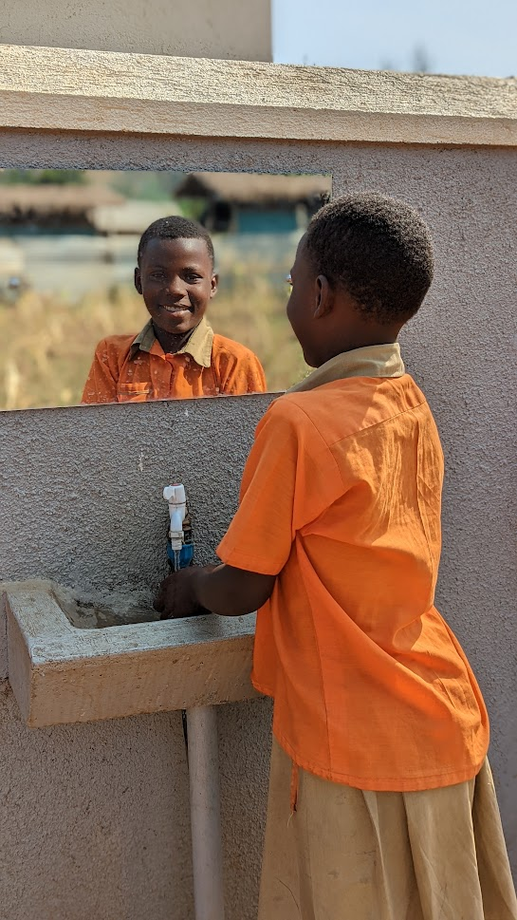

A pupil at Katanoga PS washing hands- Isingiro District Uganda

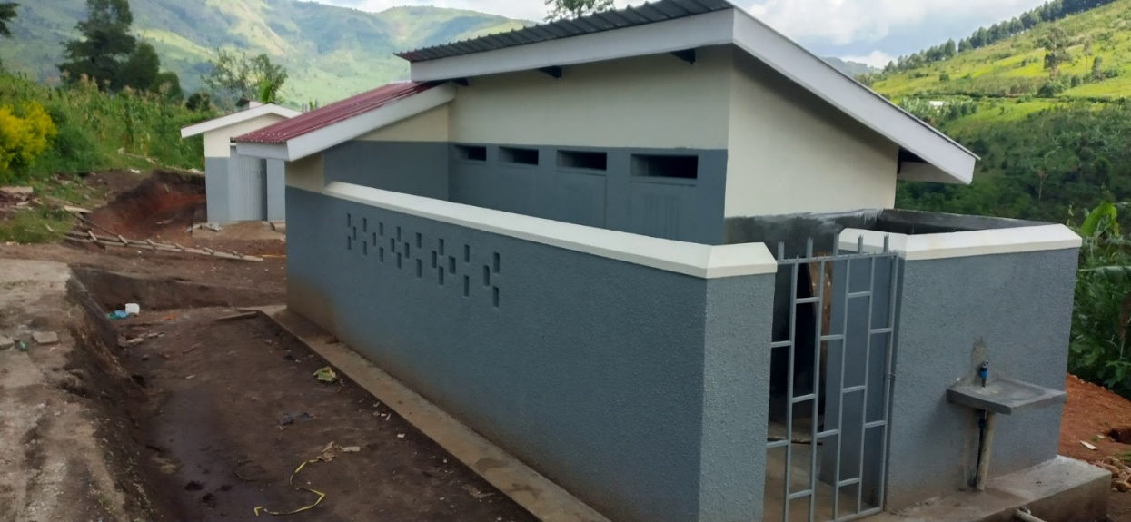

Ryabatenga's new latrine was installed with a concrete hand wash basin.

**Marketing**

<https://youtu.be/AEJS5Rp2ZIQ>

<https://newsfeed.co.ug/2022/10/27/act-uganda-commissions-ugx-300m-water-project-in-ibanda-district/>

Bibliography

Partnership, Global Handwashing. (n.d.). *Global Handwashing Partnership Annual Report.* Retrieved from https://globalhandwashing.org/wp-content/uploads/2022/02/GHP-2021-Annual-Report.pdf

Stephen J. Bigelow. (n.d.). strategic planning. *What is strategic planning?* Retrieved from https://www.techtarget.com/searchcio/definition/strategic-planning