**WILLIAM PHIRI**

**UB42545SME51349**

COURSE NAME:

**(MECHANICAL ENGINEERING)**

ASSIGNMENT TITLE:

**ANALYSIS OF MATERAILS**

ATLANTIC INTERNATIONAL UNIVERSITY

**OCTOBER 2023**

Contents

**INTRODUCTION** 3

**MATERIAL COMPOSITION** 5

**ORGANIC MATERIALS** 5

PROPERTIES OF ORGANIC COMPOUNDS 6

COVALENT NATURE 6

CONTAIN CARBON 7

LOW BOILING POINT AND MELTING POINT 7

SOLUBILITY 7

**INORGANIC MATERIALS** 8

PROPERTIES OF INORGANIC MATTERIALS 9

HIGH BOILING AND MELTING POINT 9

RIGID STRUCTURES 9

SOLUBILITY 10

COLOR DISPLAY 10

**CERAMICS** 11

STRUCTURAL CERAMICS 11

ABRASIVE CERAMICS 12

REFRACTORY CERAMICS 12

ELECTRICAL CERAMICS 12

MAGNETIC CERAMICS 13

**METALS** 13

STRUCTURE OF METALS 14

POINT DEFECTS 16

Missing Atom 17

Misplaced Atom 17

Replaced Atom 17

LINEAR DEFECTS 17

EDGE or PLANE DISLOCATION 18

SCREW DISLOCATION 18

METAL TRANSFORMATION PROCESS 19

MATERIAL PROPERTIES 19

GRAIN SIZE MORDIFICATION 21

METAL COOLING 21

INOCULANTS 22

PLASTIC DEFORMATION 22

COLD ROLLING 22

FORGING 23

ALLOYING 23

IRON ALLOYS 23

ALUMINIUM ALLOYS 24

COPPER ALLOYS 24

**PLASTICS/POLYMERIC MATERIALS** 25

CLASSIFICATION 25

**ROCK** 26

SEDIMENATARY ROCK 26

METAMORPHIC ROCK 27

IGNEOURS ROCK 27

**WOOD** 28

COMPOSITION 28

**CONCLUSION** 29

**Bibliography** 31

WEB CITED 31

# **INTRODUCTION**

Analysis of Materials brings detailed examination of substances or mixtures of substances that constitutes matter. These materials can be pure or impure, animate or inanimate matter. In analyzing these materials, they are classified basing on their physical and chemical properties. The analysis also considers material geological origin or biological function. It employs scientific investigations on complex material category, structure and behavior when exposed to external or internal material disposition.

The study brings an understanding to determine and harness important features of a material under review. Materials in their natural state can only perform so much and so need to modify the structure capability to improve them by means of cross breading in animate beings and alloying in inanimate substances.

Materials are construction; repairs or replacement substances that help correct or solve a problem. These materials can be finished goods or intermediate materials. When they are used in that way, they are considered as feed stock. Feed stock in general matter. The behavior of the material for it to be used has to be compatible to the unit or system in which it is to be applied. These substances constitute materials which can exist in form of solids, Liquids, Gas or plasma. Materials can be pure or impure. They can as well be Organic or Inorganic matter.

Organic materials, which are mostly living matter, exist in solid state or as plasma; whereas Inorganic or nonliving materials constitute most of the engineering raw materials used in Mechanical or Electrical products and function utilities of operation, and control systems. As mentioned above, these materials can exist as pure or impure materials. They can be identified and the difference or compatibility determined through the study of their Chemical and structural properties.

The Chemical and Structural properties of the materials once understood and classified, enables the decision to use them for production, repair and or replacement in the system or equipment it is compatible with. The material once concluded for the purpose it was being looked into, or even accidental benefits discovered, various operational areas can benefit. Ranging from domestic to industrial applications. That is in homes by the use of simple water heating elements which are made from a material that can convert electricity to heat. The use of sand to make glass, Limestone a rock mined from the ground, made into cement for civil and cementation works. Copper, this one is used in making pivotal bushes and bullets; Cables, earthing stripes and rods are all made from copper which is mined just as rock from open cast or underground mines, but crushed, processed, separated for use, even for bacterial treatments in environmental health. Cotton from plants, wool from animals and sisal from plants, all these used in textile industries. Therefore all materials have certain qualities that need to be analyzed and understood, their composition, properties and application determined for human benefits in communities and the world at large.

# **MATERIAL COMPOSITION**

All materials exist as organic or inorganic in nature. By ecological cycle, a break down into other forms occurs. The properties present in these materials distinguish the likely bonds to be made between donating or accepting atomic structures and those that result from covalent bonds as to produce stable chemical compounds and elements. These can be desirable and sometimes undesirable. Figure 2.0 shows what results when there is a fusion of organic compounds with inorganic compounds.

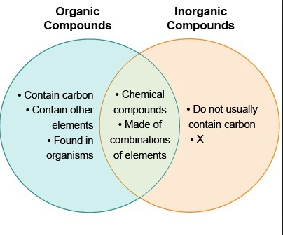

Figure 2.0

# **ORGANIC MATERIALS**

Organic materials are natural Chemical Compounds containing carbon and can exist as synthetic compounds engineered in laboratories. They are a large source of carbon based compounds found within nature and engineered terrestrial and aquatic environments. Organic materials contain matter that is composed of organic compounds which come from human wastes and remains of organisms such as plants and animals. Upon decomposition, they form compounds with other elements. These compounds mostly exist with their atoms’ outer energy level electrons in covalent bonding with other elements. The likely elements to bond with include hydrogen, oxygen, and nitrogen. There are however, a few compounds containing carbon which are classified as inorganic compounds. These include carbides, carbonates, simple carbon oxides like carbon monoxide (CO), carbon dioxide ( CO**2**) and cyanides. Fuel oil derived from fossilized plants and animals, synthetic materials such as plastics made from chemical extracts of plants and animal products are other physical inorganic materials. Historically, organic materials contain a life force (Vis – vitalis) which has for a long time been used to naturally cause a mix to produce required results. Organic compounds produced by natural processes could take longer to give results and the results were fundamentally different from today’s chemically manipulated organic compounds.

## PROPERTIES OF ORGANIC COMPOUNDS

There are four common properties of organic compounds. These include; Covalent nature; Carbon presence; Soluble mostly in non polar organic solvents and have low melting and boiling points.

### COVALENT NATURE

Organic compounds easily share its bonds with other elements. This forms building blocks for all living organisms. The covalent nature makes these compounds non ionic. As a result, organic compounds present non conductivity of both heat and electricity. They make good insulators.

### CONTAIN CARBON

Carbon has atomic number 6 from the periodic table. Its atomic mass is 12.011g with the density of 2.2g. This gives it incredible chemical diversity with catenation. It can easily self link with four other elements to even produce aromatic compounds. The carbon content entails that the materials are flammable though with great dispersion force in between the molecules. This makes these compounds good fuels.

### LOW BOILING POINT AND MELTING POINT

Due to covalent bonds in organic compounds, they have a comparatively low boiling and melting points to that of inorganic compounds.

### SOLUBILITY

Organic compounds are only soluble in nonpolar solvents. Nonpolar solvents are solvents which lack partial charge. These solvents have their bonds between atoms with similar electronegativities such as carbon and hydrogen. They show a phenomenon called isomerism in which more than one compound have the same chemical formula but different chemical structures. But easily dissolve in organic solvents. However, these organic solvents can be carcinogenic, high reproductive hazards and neurotoxins. These include benzene, carbon tetrachloride, acetone, acetonitrile and trichloroethylene among others. Nevertheless, it should be understood that all organic materials deteriorate over time and become disfunctional in their usual existence.

Figure 2.1 below shows how the ecosystem takes charge of the material regeneration. By decomposition, organic materials are turned into inorganic compounds. There are at least five levels of decomposition. These include fragmentation, leaching, catabolism, humification, and mineralization.

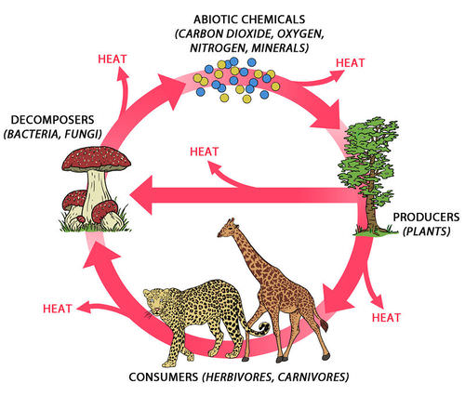Figure 2.1

# **INORGANIC MATERIALS**

However, inorganic compounds are considered as not organic. Inorganic materials as shown in figure 2.2 below include stone, metal, ceramic, and glass, which are all made from rocks or minerals. Inorganic materials can be natural or synthetic. If we take for instance some pigments, see, they occur as natural mineral materials but can also be manufactured from other inorganic materials. The distinction between organic and

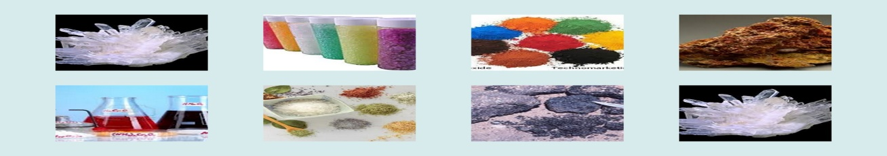

Figure 2.2

inorganic compounds is not always clear. Hence the definition for an organic to inorganic compounds in a multidisciplinary context can be viewed as spanning from animate materials that contains carbon, to inanimate matter with carbon deficiency.

## PROPERTIES OF INORGANIC MATTERIALS

The common properties of inorganic materials include:

### HIGH BOILING AND MELTING POINT

Inorganic compounds due to their strong ionic bonds require high thermal energy to break and loosen them. The high melting point with specific high or low electrical conductivity properties make them useful for specific purposes.

### RIGID STRUCTURES

Structures of inorganic compounds are rigid and so make them poor conductors of electricity in solid form. They make up crystalline structures .But, can easily dissolve in water.

### SOLUBILITY

These compounds can easily dissolve in water. Once in solvent state, their electrons begin to freely move and ionize the solvent. This makes the solvent a good conductor of electricity.

### COLOR DISPLAY

When burning, these materials display beautiful colors. This color display serves as a maker to indicate the type of a metal present in the substance.

All engineering materials exhibit certain properties which gives a chance of choice for use. However, most useful engineering materials are grouped into four main classes. For purposes of application, the properties focused on in these materials include, Mechanical, Electrical, Thermal and Atomic structures. The four classes of materials are listed below:

1. CERAMICS
2. METALS
3. POLYMERS/ PLASTICS
4. COMPOSITES

# **CERAMICS**

Ceramics can be defined as Inorganic crystalline materials which are compounds of metal and non metal solid but inert elements. These are in various forms but hard,brittle,strong in compression, heat resistant, corrosion resistant materials which are weak in shearing and tention.There are five general types of ceramics, including structural,refractory,electrical,magnetic and abrasive ceramics. Other examples include porcelain. This material is widely used in making of electrical insulators, but few others are superconductors. It is also used as lining material for chemical erosions in acidic or caustic environments.

## STRUCTURAL CERAMICS

Structural ceramics are crystalline materials which can withstand stress and heat ranging from 1000 – 1600 degrees Celsius. They are often clay based. Examples include bricks and tiles. The physical properties of ceramic materials are a direct result of its crystalline structure and chemical composition. The connection between microstructure and properties such as localized density variations, grain size distribution, and type of porosity correlate to mechanical strength. Glass is not a ceramic in that it is not a crystalline material. It is an amorphous solid. However, it undergoes through several ceramics processes and its mechanical properties are similar to ceramics.

## ABRASIVE CERAMICS

Silicon carbide and tungsten carbide are modern advanced ceramic materials with high abrasive resistance. It is also used in wear plates of crushing equipments in mining operations. Because ceramics are strong in compression, brittle and hard, they are used in cutting and grinding away other softer materials.

## REFRACTORY CERAMICS

Because ceramics withstands very high temperatures, they are used in high temperature processing applications. Base materials being alumina, magnesia, or aluminosilicates. Other thermal and refractory ceramics include ceria, cordierite, electrostrictive ceramics, forsterites, mullite, quartz, steatite, zirconia, zircon and zirconium phosphate.

## ELECTRICAL CERAMICS

Traditional ceramics are used in insulation components for electrical junctions and terminations. However, advanced ceramics have become increasingly important in electrical technologies including communications, energy conversion and storage, electronics and automation where they are used as super conductors. Example of usage include: Ferroelectrics – high dielectric capacitors, non - volatile memories; ferrites – data and information storage; solid electrolytes – energy storage and conversion among the many others. Ferrites like iron(III)oxide and strontium carbonate displays magnetic properties.

## MAGNETIC CERAMICS

Magnetic ceramics are made of ferrites which are crystalline minerals composed of iron oxide in combination with some other metal. These are usually grouped into two large classes: soft ferrites and hard ferrites. The receptivity and coerctivity properties in these make get magnetized and demagnetized controllably.

# **METALS**

The periodic table which is an arrangement of chemical elements in table form, lists all metals, metalloids and non metals from the least by atomic number **1, Hydrogen** to the most with atomic number **118, Oganesson**. 89 are metal elements, 7 are metalloids and 22 are non metals. Metalloids are elements that have intermediate properties between metals and non metals. They are also understood as semimetals. However, metals naturally occur as opaque, hard, lustrous or shiny elements which are effective conductors of heat and electricity. But eight of the metals are used mostly for engineering purposes. Such metals include;

1. Magnesium with atomic number 12 symbolized as Mg
2. Aluminum with atomic number 13 symbolized as Al
3. Tin with atomic number 22 symbolized as Ti
4. Iron with atomic number 26 symbolized as Fe
5. Sodium with atomic number 28 symbolized as Ni
6. Copper with atomic number 29 symbolized as Cu
7. Zinc with atomic number 30 symbolized as Zn
8. Lead with atomic number 82 symbolized as Pb

Pure metal elements have three most common structures in which their atoms compact together when cooled. These are (1) Face centred cubic structure **(FCC)** (2) Body centred cubic structure **(BCC)** and (3) Hexagonal close packed **(HCP).** Denser materials have high percentage packing factor. By commercial purposes, pure metals are not usually applied with elementally structural properties. They are modified into metal alloys. That entails the mixture or making of metallic solid solution composed of two or more elements. The end metal presents different desired properties from those of the component elements. Metal alloys are far more versatile. This process has become the form in which most metals are produced for engineering purpose. Pure metals are an arrangement of molecules in crystalline structure, liquid or solid state. The connection between microstructure and properties such as localized density variations, grain size distribution, and type of porosity correlate to mechanical strength of a metal. Therefore, to produce the perfect alloy of a metal, the structure of each metal has to be analyzed and understood.

## STRUCTURE OF METALS

Atoms of pure metals are arranged in a regular grid known as a lattice. They are parked together tightly to form crystalline material structures called crystal lattice. However, not all materials form crystal lattice arrangement. Some have irregular arrangements known as amorphous. For example, glass, its atoms are arranged in random form and so it does not present a lattice.

The repeating number of crystalline unit cells in three dimension (3D), form a crystal lattice. As can be seen in figure 4.1 below. Figure 4.1c, shows the buildup of repeating number of crystal units called unit cells. Figure 4.1b shows the enlarged figure 4.1a in Face Centred Cubic **(FCC)** structure form.

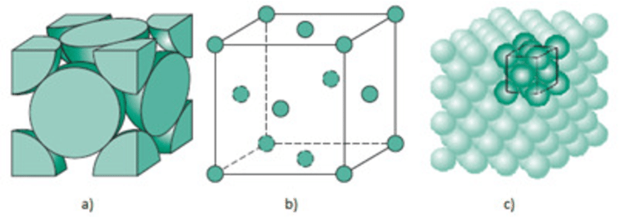Figure 4.1

Copper for example has common alloys: Bronze which is a mixture of Copper with Tin. The other alloy is Brass, a copper mixed with Zinc. As a pure solid metal, copper presents its atoms in face centred cubic structure.

Iron with a wide range of engineering applications is alloyed with Carbon to create steel. At room temperature Iron presents its structure in Body centred cubic **(BCC)** form. As can be seen in figure 4.2 below. Figure 4.2c, shows the buildup of repeating number of crystal units called unit cells. Figure 4.2b shows the enlarged figure 4.2a in Body Centred Cubic **(BCC)** structure form.

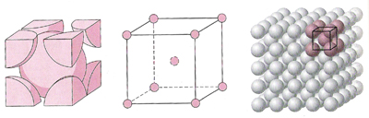Figure 4.2

Titanium has its structure presented in Hexagonal close packing. Figure 4.3 gives the details:

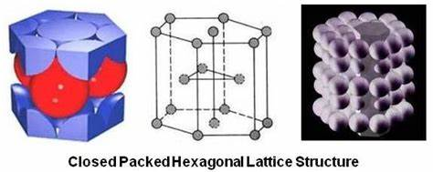Figure 4.3

In real practice, pure metal lattices are not always perfect. They contain a number of defects which presents themselves in different types. The major metal defects are in three groups. 1. Point defects 2. Linear defects and 3. Plane defects

## POINT DEFECTS

Point defects are abnormalities in the lattice structure of a unit cell. They affect a single location in a lattice like missing atoms, misplaced atoms and replacement of atoms.

### Missing Atom

This is a defect of vacancy. An atom misses from its likely position in a lattice. This happens during crystallization process into a solid, an atom misses from its regular position in the lattice. This leaves an open end in the crystal lattice creating a missing atom abnormality called vacancy defect.

### Misplaced Atom

When an atom of the same or different type is squeezed off its position into the space of the lattice, a defect of misplaced atom occurs. This is known as interstitial defect. These are caused by the bombardment of a crystal with elementary particles possessing energy above its stretch limit.

### Replaced Atom

This defect occurs when atoms of a different type takes up the place of another atom in a lattice. Additives which are non same materials known as impurities or inoculants mostly create substitutional defects in the metals’ atomic structure.

## LINEAR DEFECTS

Point defects focus only on individual atoms. However, even along the lattice lines, defects also occur. These defects are known as lattice line dislocations. They are presented as an edge or screw dislocations.

### EDGE or PLANE DISLOCATION

Edge dislocation occurs in the row of a lattice point. This is a crystal defect in a complete line see Figure 5.2a below. Constituent particles in a crystalline solid are not normal. For example in between points, an extra half plane of atoms fails to meet its complete lattice line ends up creating an offset in the lattice edge and distorting the plane. This defect allows shear stress to move the atomic bonds. The bonds break during stress and form. The extra half plane of atoms glides through the lattice and forms along the edge.

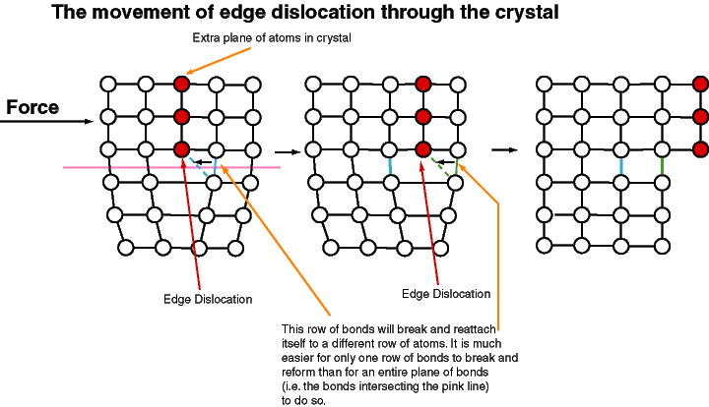

Figure 5.1

### SCREW DISLOCATION

Figure 5.2 below shows the edge and screw dislocations. Screw dislocation is a shift out of alignment in the atoms that formed a perfect structure. The shifts in atoms create a screw like pattern as seen in figure 5.2b below.

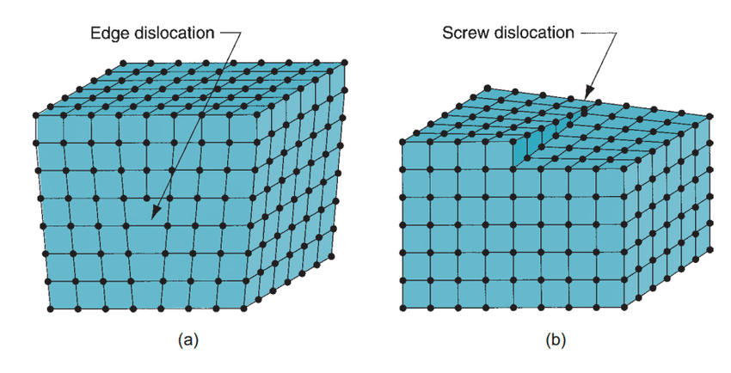

Figure 5.2

All dislocations in pure metals under shear stress keep plastic deformation even after the force is removed. Pure metals do not maintain regular crystalline structures over a long time. Such metals can only be used in specific operations. To achieve elasticity in metals, yield strength should be improved. As such materials undergo structural transformation to improve their mechanical ability.

## METAL TRANSFORMATION PROCESS

Metals can be transformed through several phase changes. For example, the thermal processes through which mater can undergo transformation are; Melting, Freezing, Evaporation, Condensation, Sublimation, deposition, Ionization, and recombination. All these processes work with the properties that materials possess.

### MATERIAL PROPERTIES

These properties are as listed below:

HARDNESS: Materials’ ability to resist plastic deformation.

DENSITY: Physical property that relates mass of material to its volume in homogenous state.

DUCTILITY: How easy a material gets deformed under tensile stress or the ability of a material to extend under plastic deformation without rapture.

BRITTLENESS: Breaking without much distortion.

PLASTICITY: tendency to hold its new shape even after the forming force.

MALLEABITY: ability to be flattened into thin sheets without cracking.

STIFFNESS: ability to resist elastic deformation under load.

THERMAL CONDUCTIVITY: how fast heat moves through a material.

TENSILE STRENGTH: resistance to snap when pulled.

MELTING POINT: minimum required temperature for a solid to become liquid at one atmosphere of pressure.

THERMAL EXPANSION: increase of material dimension with heat.

PERMEABILITY: the ease with which magnetic flux builds up in material.

POROCITY: ease with which water and other fluids filters through a material.

YIELD: the point a material under load fails to hold.

DIELECTRIC CONSTANT: a fixed value of a material to store electric energy.

BULK MODULUS: ratio of pressure to volumetric compression.

FRACTURE TOUGHNESS: stress level factor for a drastic crack propagation through a material.

Metals are transformed by controlling their grain size, plastic deformation and employing alloying.

## GRAIN SIZE MORDIFICATION

The grain size of a metal is an important characteristic of a material. This is an estimate of an average grain diameter. These grains in metals have specific planes along which they can easily slide during deformation. The bigger the grain sizes, the easier they can slide. But this then increases chances of material plastic deformation. The smaller the grain size, the more the packing percentage and increased material density, thereby, the grains impede structural dislocations and so prevents plastic deformation. In a molten metal, as it cools, atoms begin to group together forming lattice structures. The formation of the lattice structures occur at different location at the same time. Each lattice structure formed takes up its own orientation and continues to grow as the metal cools to solid. In the end a complete and continuous multidirectional polycrystalline material is formed.The grain boundaries seperates these grains and adds to the structural strength of the metal. The multidirectional orientation of the grains improves the impediment of grain sliding. This gives an idea that polycrystalline materials tend to be stronger than materials of a single uniform crystal.

### METAL COOLING

When a molten metal is allowed to cool at a normal rate, the grains of the metal continues to grow in the structure lattice and continues until full sizes once the metal has reached room temperature. However, if the cooling of the molten metal is increased, the points at which the metal begins to crystallize will as well increase. The grains will then not reach their full grown size before the solid metal is formed. The is called as grain boundary strengthening. The process increases compactness of metal grains and reduces grain diameter. The reduced diameter increase number of elementally particles in the cooled metal with multidirectional polycrystalline orientations. The metal strength is further improved.

### INOCULANTS

Impurities called inoculants can be added to the molten metal. This is done to cause multiple sided crystal nucleation than otherwise it would normally have. Small sizes of grain collection begin to form in the metal as it cools .If the metal cools faster, the grains will not grow to full size but into smaller sizes thereby increasing interlocking points in the metal and making it stronger.

## PLASTIC DEFORMATION

Making the metal stronger by plastic deformation is achieved it two forms. (1) Cold rolling and (2) Forging.

### COLD ROLLING

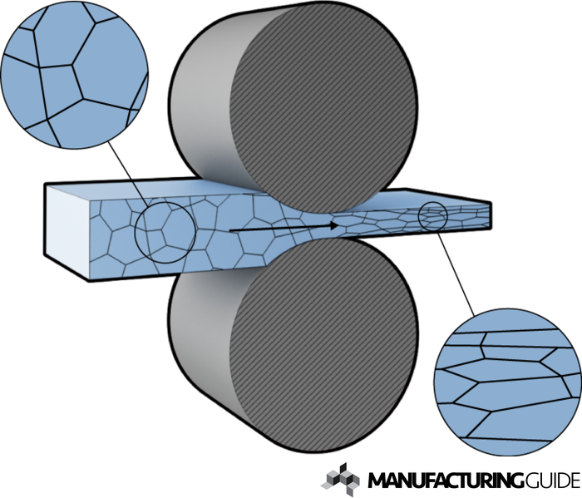

Figure 5.3

The smaller the grain size, the stronger the material. Cold rolling is the process by which a metal is passed through compressing and squeezing rollers. This increases the number of dislocations in the metal reducing its ductility and strengthening the material.

### FORGING

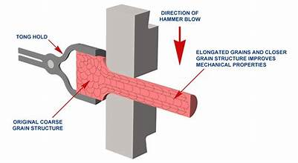

Figure 5.4

The smaller the grain size of the metal, the stronger it becomes. Forging is the process by which a metal is shaped through compressing and squeezing forces using a hammer. This increases the number of dislocations in the metal reducing its ductility and strengthening the material. It can be categorized as, cold, warm or hot forging.

## ALLOYING

Alloys are metals formed from a combination of two or more different metals, semimetals or non metals. They can be typically split into Ferrous and Non ferrous metals. This depends on whether the base metal is iron. Common alloying elements are Iron, Aluminum, Copper, Manganese, Silicon, Zinc and Magnesium.

### IRON ALLOYS

Iron however is the most used metal in Engineering and produces and important metal called Steel. Pure Iron is too soft to be used for structural operations. It is used as a basic ingredient of all ferrous metals. These metals containing over 90% Iron, range from Cast Irons with more than 4% carbon, and Carbon steels with less than 1% carbon, to specialty Iron alloys in which there is a variety of other elements.

Metallic elements that do not contain Iron are considered as non ferrous metals. Aluminum which is second in use to Steel is the metal widely used structural metal nowadays. Magnesium, Titanium and Beryllium are among other used metals considered as light metals because of their density which is below that of Steel.

### ALUMINIUM ALLOYS

Aluminum alloys are also important in Engineering. They are often used for the good strength properties and the light weight with reasonable cost. Classification of these alloys is according to how they are designed. Those alloys designed for casting as Cast Aluminum and those for Wrought as Wrought Aluminum. Cast Aluminum alloys yield cost effective products due to the low melting point although they have lower tensile strength to that of wrought alloys.

### COPPER ALLOYS

There are so many different Copper and Copper alloy compositions. Their main principle metal is Copper. They all have high corrosion resistance for as long as the added element is kept under 15 % to that of Copper.

Brass for example; this is a non ferrous alloy of Copper and Zinc. It contains 65% Copper and 35% Zinc and appears yellow in color. But it also has some other alloying elements in smaller percentage. It is used for its attractive appearance, enhanced strength, improved ductility and the ease with which it can be machined. Bronze is an alloy of Copper and other metals, mostly Tin at 12%, but also Aluminum, Silicon, Arsenic, Manganese, and Phosphorus. Bronze shows greater hardness than pure Copper. It is more durable and more resistant to wear and tear.

# **PLASTICS/POLYMERIC MATERIALS**

These are moldable natural and synthetic or semi synthetic organic materials. Plastics are polymeric macromolecular materials composed of many repeating subunits. Many are partially natural but mostly derived from Petrolchemicals. They are created by the process called Polymerization of many small molecules called Monomers. The Monomers possess a large molecular mass which produces unique mechanical properties such as Toughness, Viscoelectricity and have a tendency to form crystalline structures.

There are two key categories of plastics. These are Thermoplastics and thermosetting plastics. Thermoplastics have the ability to be recycled continually. This is because they do not undergo any chemical transformation when heated. Plastics like, Polyethylene, Polypropylene, Polystylene and Polyvinyl chloride can be heated and remolded several times without losing their chemical properties. Thermoset plastics form chemical bonds that make them irreversible once cured. They cannot be recycled.

### CLASSIFICATION

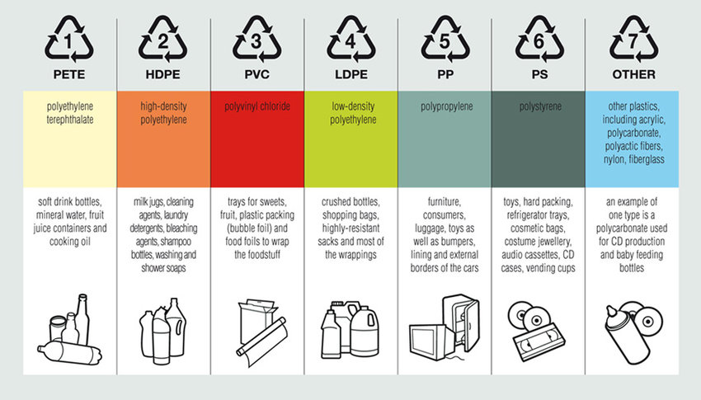

Figure 6.1

Other materials used for engineering purposes include the following: Rock, Wood, and many others.

# **ROCK**

This is a naturally occurring and coherent aggregate of one or more minerals. It forms a part of the surface of the earth and other similar planets. The rock exists in three forms:

## SEDIMENATARY ROCK

This is a rock that has been eroded into small pieces and redeposited. Erosion forces include water through rain, rivers, lakes, seas and ice; wind through storms, whirlwinds and tornados; Temperature as well as pressure. Figure 7.1 shows the pilling up of rock layers called strata. Examples include Sandstone and shale. The mineral is mined for minerals found in it and also for construction and civil works.

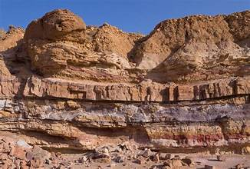Figure 7.1

### METAMORPHIC ROCK

The rock that has changed mineralogically due to very high temperatures and pressures in the lower part of the earth’s crust. Rocks like quartzite and marble are examples of metamorphic rock. The rock is mined for mineral content in it and the waste used for construction. See figure 7.2 below.

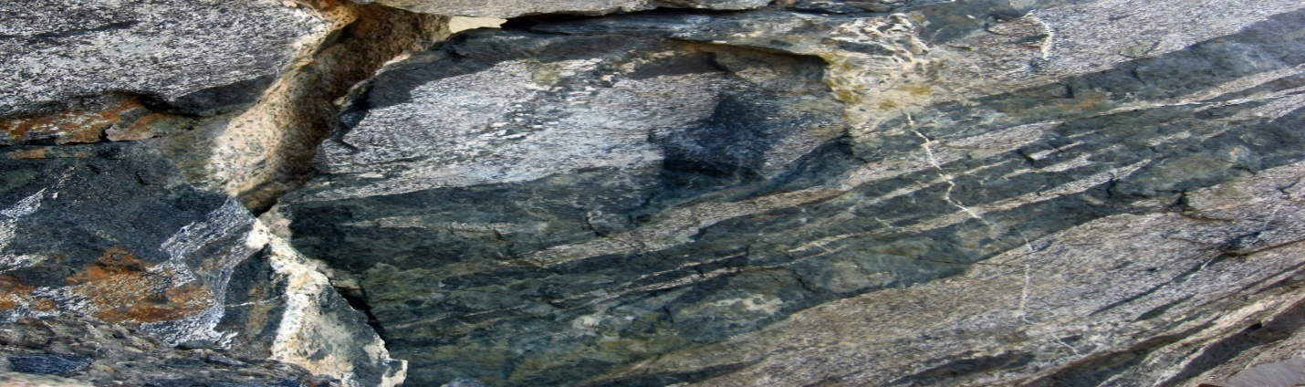Figure 7.2

### IGNEOURS ROCK

Rock formed from the solidification of molten rock material generated below the earth’s crust. Examples include Dolomite and Granite. The rock is mined for minerals it contains and the waste used for construction. See figure 7.3 below.

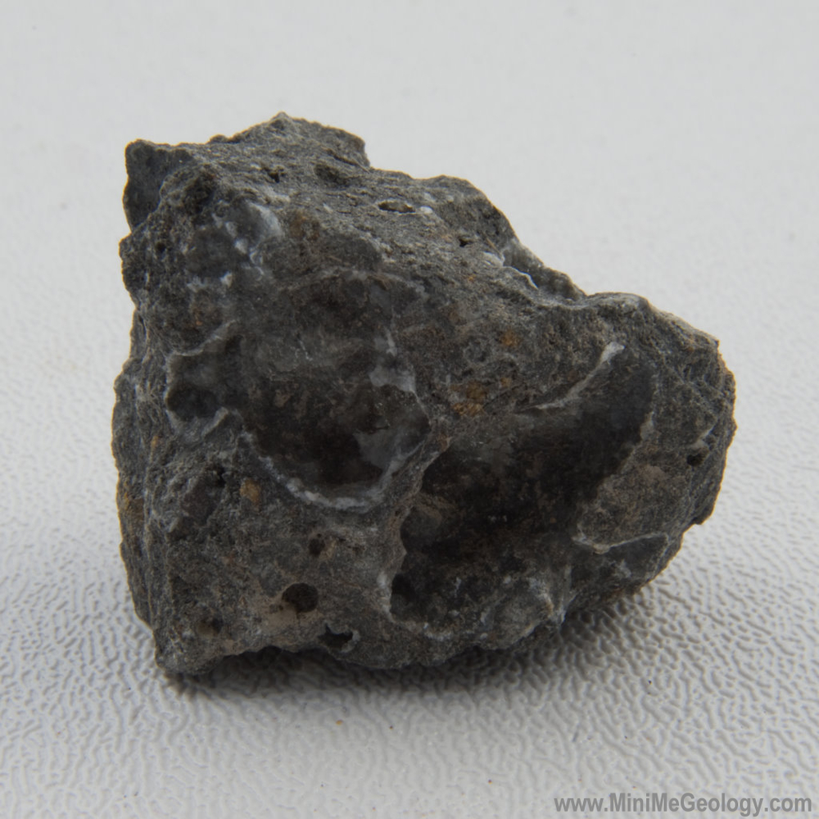

Figure 7.3

# **WOOD**

This is a hard fibrous material that forms the main substance of the tree trunk or branches. It includes shrubs and twigs all of it used as fuel or timber.

## COMPOSITION

The chemical composition varies in species, but, it contains approximately 50% carbon, 42% oxygen,6% Hydrogen,1 % Nitrogen and 1 % other elements like calcium, potassium, sodium ,magnesium ,iron and manganese. Wood has three major components; Cellulose which is a crystalline polymer, Hemicellulose and Lignin. Lignin is the major focus for the paper industry. The major wood components including water form fibres which give strength and toughness to wood. Figure 8.1 below shows wood fibre rings in a cut trunk.

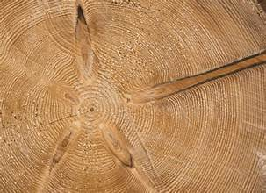

Figure 8.1 showing wood fibre rings

# **CONCLUSION**

Material analysis as a general concept is wide. It spans into all fields that call human activities for development and transition. Most materials used in engineering have been concluded but still there stands a larger room for more discoveries owing to a dynamic current state of life. The structure composition reveals the material properties that can be harnessed for structural construction, electrical application and general domestic and industrial works.

Ecological materials like organic materials and inorganic materials which were the first to be used for human survival give guild to discover other materials for improved life. All pure metals need to be improved to get the benefit of using them. Therefore, most engineering metals are blended with other metal or non metal elements to improve their mechanical properties.

Alloys of iron as steels and those of copper, and aluminum are the most used metals in engineering. Ceramics and some other materials are also used in engineering and the list of materials continues with new technological advances in smart materials.

Overall the findings of this study provide adequate information mostly on Mechanical engineering materials composition, relationship between material structure and the properties the material possesses giving an idea of choice for application. The many other materials like, textile fibres, animal textiles, plant and mineral textiles are mechanical materials in use. That as well has highlighted the need for further research conveniently for smart and dynamic life today.

# **Bibliography**

Adrian P. Sutton. (2021, July 1). **Concepts of Materials Science**. (Oxford Publishers)

Alan H., Andrew K., Michael C., McWilliam, Paul S., Philip S., Richard B., Stephen P. and Stewart( 2013 Jan 1) **Introduction to Mechanical Engineering**. (Hodder Education)

Charles and Eugene (2010, July 1). **Handbook of Materials Science Research**. (Nova Science Publishers)

Christopher, H.(2014,Dec 23). **Materials Introduction**. (Oxford Publishers)

James E. Gordon and Philip B.(2018,May 22). **The new Science of Strong Materials**. (Princeton Library Science)

## WEB CITED

<http://www.brooksforgings.co.uk>

<http://www.manufacturingguide.com>

<http://www.researchgate.net>