**SHWETANK PARIHAR**

##### **ID UPD68581BRI77709**

**COURSE NAME:**

**Leadership and Direction**

**ATLANTIC INTERNATIONAL UNIVERSITY**

**LEADERSHIP AND SOCIAL PSYCHOLOGY**

The aspects which cover the guiding of organization and steering its way as per behavioural aspects of individuals involved to achieve a particular goal in simple terms refer to Leadership and Social Psychology. It is found in the works like (Haslam, Reicher, & Platow, 2011) that psychology is one such aspect in which the leadership can be studied. The basic behaviour of leader is tracked by the help of organizational traces. In the starting the book explains the behaviour of children’s aspects of the overall conformity and this leads to the corresponding entries made by the two groups named as “rattles” & “snakes’. The groups were given competitive tasks and when they went on performing the same it goes in such a way that the groups stated having natural competitive feeling and never tries to show the basic issues. The other aspects are that are to be studied is that the same groups were then given collective tasks and after the same they returned to their native places with same friendly behaviour. This experiment proves that leadership and the team work is dependent on the surroundings and the whole concept of the same is that the overall criteria of managing the groups behaviour is what the leaders do and emerge from the situations like the same, the leadership works included in this study are (Hogg & Tindale, 2001), (Pearson, 2012), (Vugt, 2012), (Naidoo, Muthukrishna, & Hobden, 2012), (Ng’ambi & Bozalek, 2013) and (Harrel, 2018). All the studies are related to leadership and direction aspects and used in different sections of this study for presenting different analysis outcomes.

The study then moves in the direction of conformity and it applies that the overall trend of psychology can be divided into two portions that is the traditional ones and the non-traditional ones. The traditional approach is committed towards the great leader’s traits and it was suggested that the leadership is the behaviour which was shown by these great personalities. The examples from great presidents and the examples from great literature like Othello etc is also given to emphasize the need for the same and it refers to the art of influencing the common masses which is possessed by these great persons but it was found that organizational behaviour related aspects perceived as a setback in the above cases and this leads to the first drawback of the traditional system. The traditional system emphasize on the factors like allowing the work to be done by the others or influencing the masses in such a way that the overall criteria is decided by the whole and this leads to the common belief that leaders are those which are able to reflect their thoughts into the minds of masses in such a way that it appears to be their own, which is one of the basic characteristics of this type of leadership psychology. The new psychological leadership approach is explained with the concept of situational paradigm, which is explained in the later part of the study.

The situational approachThis approach foretells that leaders are not present with a constituent formula of leadership but they are derived from the situations. This aspect is covered in such a way that the overall constituent corresponding to the whole of the situation is that the leaders are derived, the simple example explained in the study is based on the Prisoner experiment.

The Stanford Prisoner experiment

This study was conducted in the basement of Stanford department of psychology and this proves that the overall effect of this situation is that the same level students were made to participate in the prison experiment in two groups namely –

1. Guards
2. Prisoners

It was found that –

* Suddenly the guards started behaving in an authorities way and the experiment went off to a further level when the guards were given responsibility and right to punish the prisoners.
* The experiment resulted that the behaviour and leadership attribute developed in the guard batch of the students and they started inflicting autocracies on the prisoners group.
* The experiment went such a viral that it had to be stopped in mid-way due to serious autocracies being inflicted by the guards
* It was found that the effect of uniform and authority related surroundings leads to such a situation.
* Some of the guard batch students found that they really enjoyed in inflicting hardships on the prisoners batch, which is a very disturbing move as a part of organizational psychology.

The other aspects are like to be governed by the natural and non-natural leaders can be found from the statements mentioned in the study by (Haslam, Reicher, & Platow, 2011) the same are mentioned in the figure below-

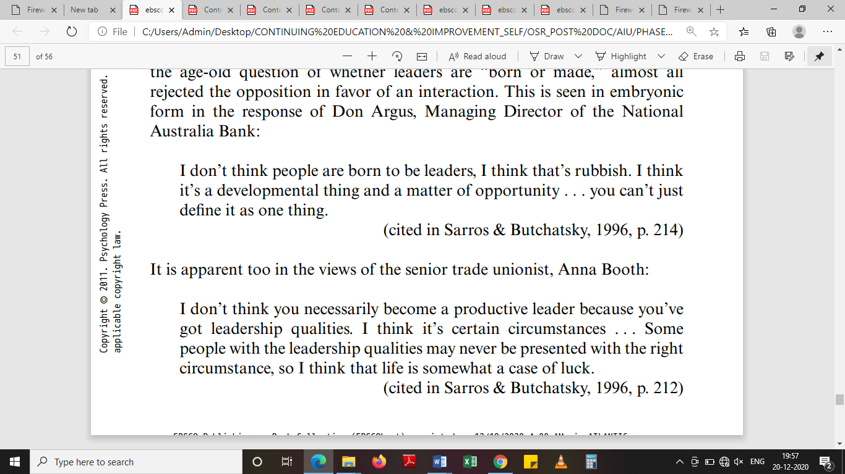

**Fig: The leadership related remarks [Source: (Haslam, Reicher, & Platow, 2011)]**

The modern theory stresses that the leadership attributes are governed by circumstances and the modern outlook converges into the same aspects. The other computational studies also remarks that situations are the only catalyst in such a condition. The overall convergence is that the system as a whole now makes a confirmation in the direction of overall convergence of leadership quantity as per situations.

The third type of leadership modules are that prevalent are like the Fiedler’s least preferred co-worker theory (LPC) and this method is one of the most prevalent though process and as per the analysis of its concept it means that the overall criteria for leadership is that it is sum of conditions and the characteristics traits.

LPC configures as successful leadership to be a fit of the situations and traits and this is the fundamental aspect of development of a leader. This concept lies on the configuration of the traits and situations as a formula for effective leadership and this concept dwells on the simultaneous aspects of the configuration of LPC and this forms the basis of configuration. The instructions for the process (Haslam, Reicher, & Platow, 2011) is explained in the figure given below –

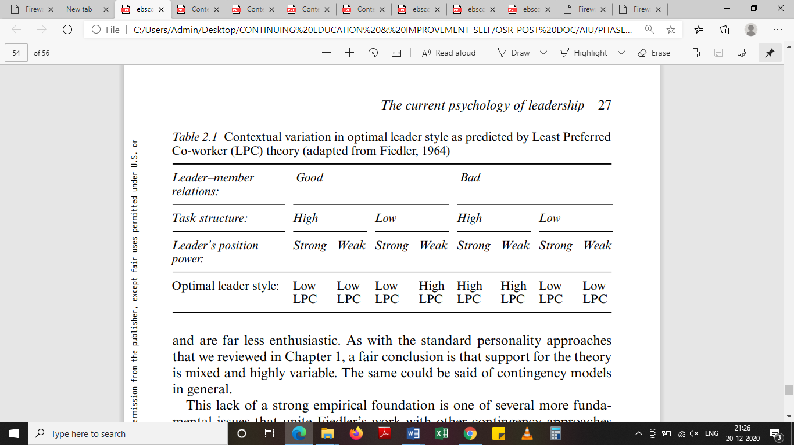

**Fig : LPC aspects [Source (Haslam, Reicher, & Platow, 2011)]**

The above matrix arrangement shows the variation of the score as per the leader position or situation and the leader style. It shows that position can change in two aspects High and Low but the leadership style shall move on to the Low LPC and High LPC. The author also feels that the same criteria’s can also be used for showing the division in the quadrant form as the style and position graph.

The instructions for the process (Haslam, Reicher, & Platow, 2011) is explained in the figure given below –



**Fig: LPC as a process (Source: (Haslam, Reicher, & Platow, 2011))**

This particular technique works on the basis of emergence of the preferable working division on the whole of the scale developed and this configuration employs the basis of comparison of the whole of the surroundings and this particular aspect is governed by the ability to link of the preferability of the whole conditions listed in the figure above.

The cases to be discussed also contains the higher education area (Ng’ambi & Bozalek, 2013) and one of the discussion points is that the overall leadership concept is dependent on the use of emerging technologies and their effect on the same. This study foretells how the technology is changing at a rapid pace and this allows the subsequent change in the overall criterion of the system. The technology plays a very important role in the life of an administrator and educational institutions have a deep rooted effect of the same. The study gives a Wheel Model for the adoption and diffusion of technologies in the educational systems. The wheel model figure is given in the figure below-

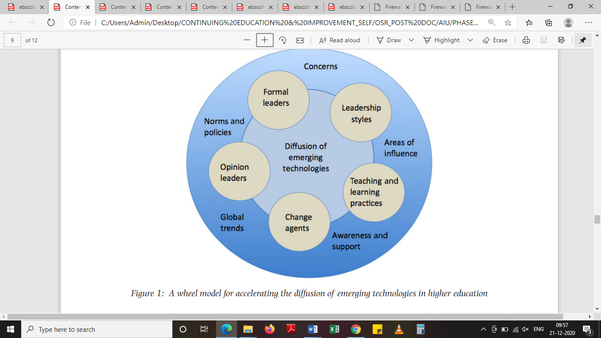

**Fig: Wheel Model for technology diffusion [Source: (Ng’ambi & Bozalek, 2013)]**

The change agents and opinion leaders are the most dominant factors for adoption or diffusion of technology, this aspect is widely governed by the other sectors also and with the increase in the service sector the business leaders have to play a pivotal role in technology. This aspect is governed by the use of modern technologies in the factors of corresponding technology upgrade. This leads to the overall criteria showing the importance of technology and its role in leadership aspects of the firm’s management and the pivotal role in vise-versa technology adoption of the same. The study can be implied in several other aspects also like that of commutation and diffusion of technologies. The list of new technologies is also given in this study and the same is ranked for its adaptability. The list of major technology diffusions in the field is given in the figure below -

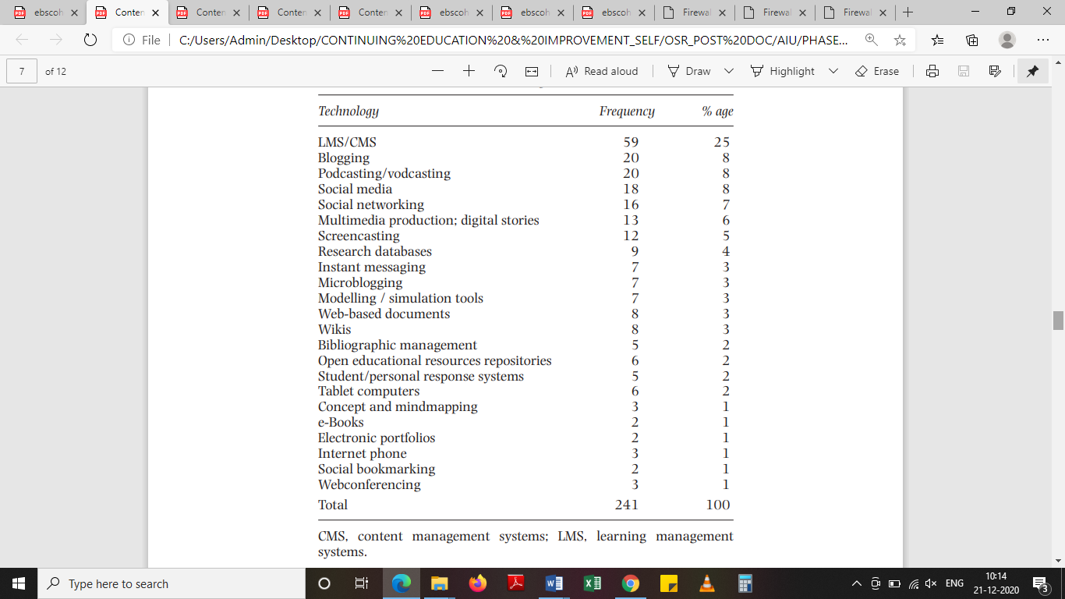

**Fig: Technology changes [ (Ng’ambi & Bozalek, 2013)]**

The role of technology is very pivotal and from the list above we can very well conclude that several new ventures like that of E books etc but more prominent and wide spread is the use of software and e-learning modules which are networking based and visual aid based. The same interventions are found on the project management aspects also and hence the same effect can be replicated in various other aspects of different industries and projects.

The studies have also been conducted on direction and leadership styles in which the overall criteria for assessment of elected leaders and appointed leaders have been discussed (Harrel, 2018), the study marks the development of leadership groups and its associated periphery. The study embanks the use of corresponding differences in the type of leadership. The leaders group that is appointed and selected are mapped for punishment phases and it was found that no relationship or linkage exists between the punishment phases in case of appointed or elected leaders. The statistics derived is shown in the figure given below-

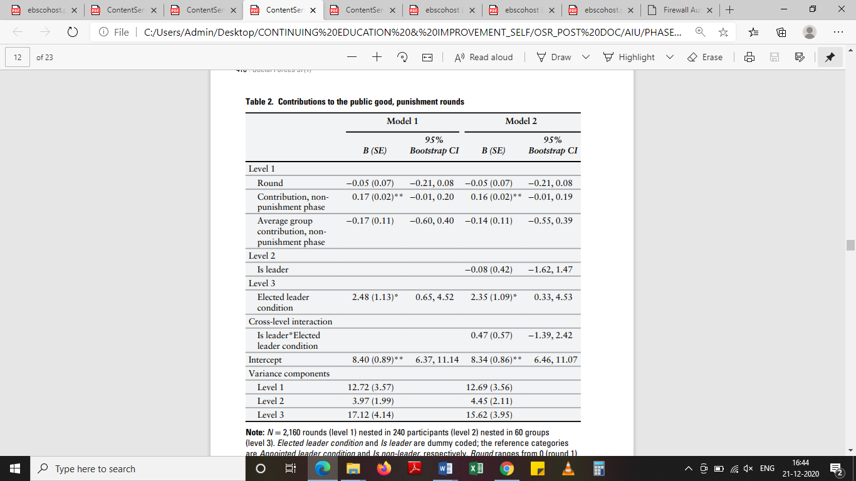

**Fig: Punishment phase statistics [Source (Harrel, 2018)]**

This data shows that some of the direction or leadership traits are not having any difference between the type of leadership aspects and the method by which leader has taken birth.

In the transformational leadership related studies like that of (Pearson, 2012) it is mentioned that with the advent of leadership styles the true leader needs to evolve itself with the surroundings as per the need of the hour and the book explains the various aspects that are needed to be covered in the peripheral for converting a true leader as per the time demands. The aspects related to transformational leaders is related to the convergence of the overall criteria for the entire breed of leaders, the study excerpts is mentioned in the figure given below –

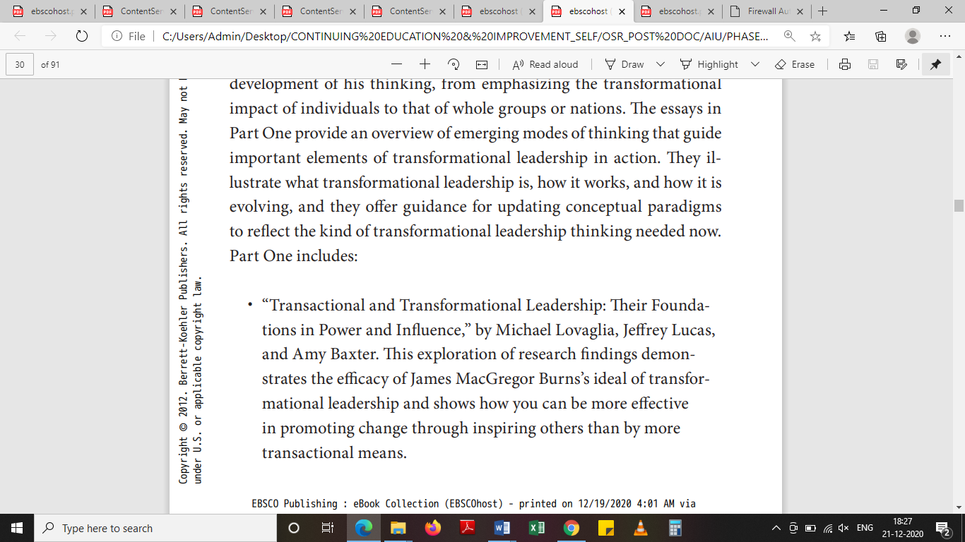

**Fig: Transformational leadership point of view [Source: (Pearson, 2012)]**

The evolution of leadership is incomplete without the study of its constituent changes and this aspect is related and studies with the help of various examples in this study. It is mentioned that in Roman era the friends of the rulers are not punished but who so even other than the friends come in the way are being dealt in a very hard fashion (Crucification). The same aspect can never be imagined today and this is a basic example of transformation effects in the leadership.

The inclined nature of the leaders is such that the system as a whole configures the changes and the paradigm shift that natures changes as a whole in this case the commutation is working as a whole and this system configures as whole which demands the supreme aspects as a whole and this leads to the configure of the true leaders and evolution of the commanding systems. The leadership transformation is actually the evolution of the whole system and this system involves the changes as a whole in the system of development.

In the studies where direction and leadership often go hand in hand it was found that the results in experimenting condition may not follow exactly the same path in real world. It was found that many new ventures start to come and play their role this defines a very soothing atmosphere of practical leadership approach and this is where the role of leaders is encouraging. This is where the personality traits come to play its role in the leadership. The result by (Haslam, Reicher, & Platow, 2011) in this aspect is given as under –

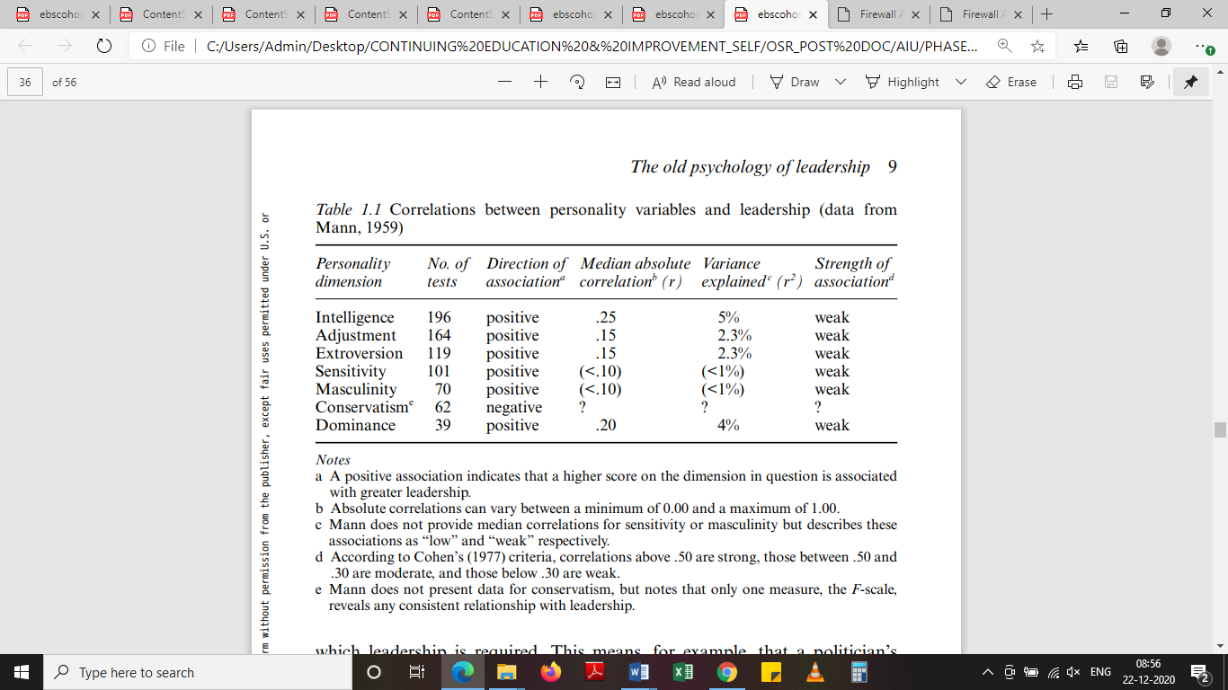

**Fig: The personality traits of leadership [Source: (Haslam, Reicher, & Platow, 2011)]**

The study shows the effects of personality traits in the overall criteria but the most number of tests were governed by the intelligence and this aspect is covered by the role of peculiar testing on the basis of all the other criteria. The other tests included the test on emotional and other aspects of the personality like that of emotional quotient, dominance and conservatism etc.

The other main aspects which are covered in this study are the secrets associated with the leaders and this aspect is covered in the overall criteria of corresponding means and this measures an immediate feature of the whole of the system. The overall criteria of secrets is very exhaustively covered by the author and this leads to the assessment of corresponding criteria and the same is given in the figure below-

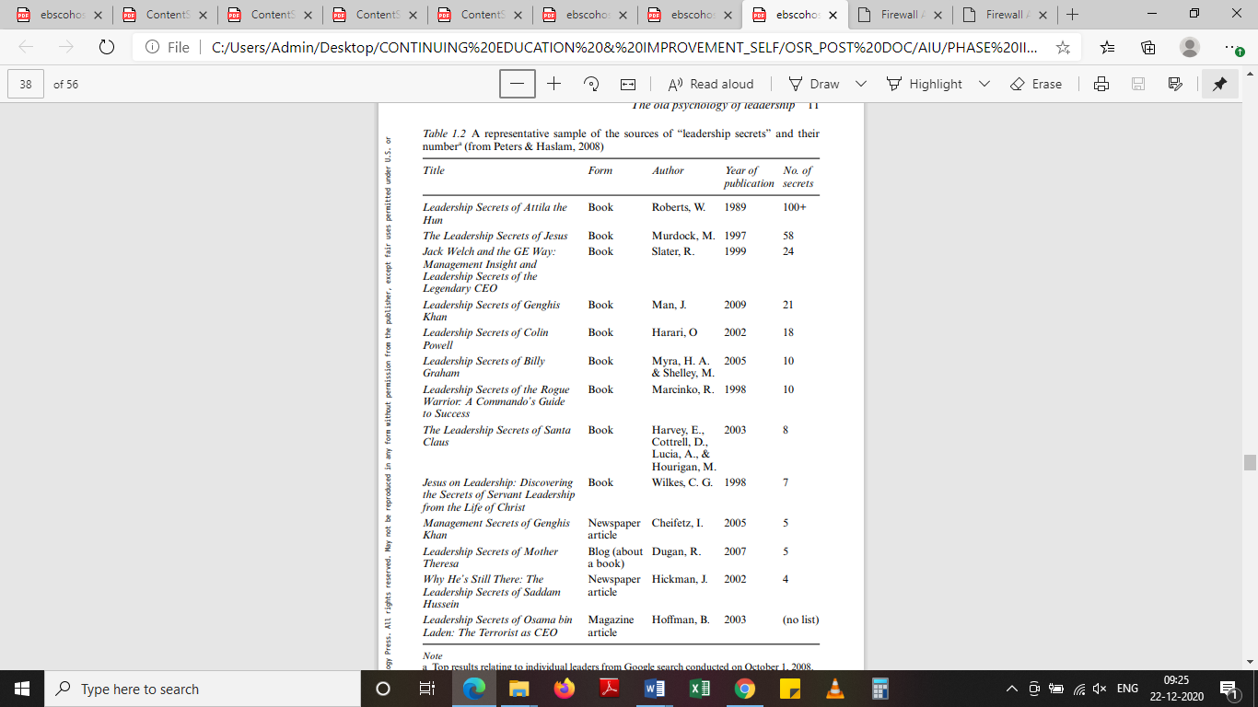

**Fig: Secrets of leadership programme [Source: (Haslam, Reicher, & Platow, 2011)]**

The other aspects which are covered in this study is how a leadership acts in the direction of overall criteria of maintaining the system as a whole. The system corresponds the consequent analysis of leadership and its associated periphery, the system as a whole corresponds to the meeting of secrets of a leader and how well it matches to the system peripherals. The system is having a corresponding feature of the system and this monitoring system is having a link for the overall criteria and whenever the situation demands the same is being reflected in the figure already given above. The general act of leaderships is commuted by many examples which appears more to be of ultra-importance when a timeline is based to be decided on the same, the same aspect is governed for the use of overall criteria of assessment for the regulated leaders.

The overall aspect which is governed by these is explained byb avery unique poetry example which is mentioned in the figure given below-



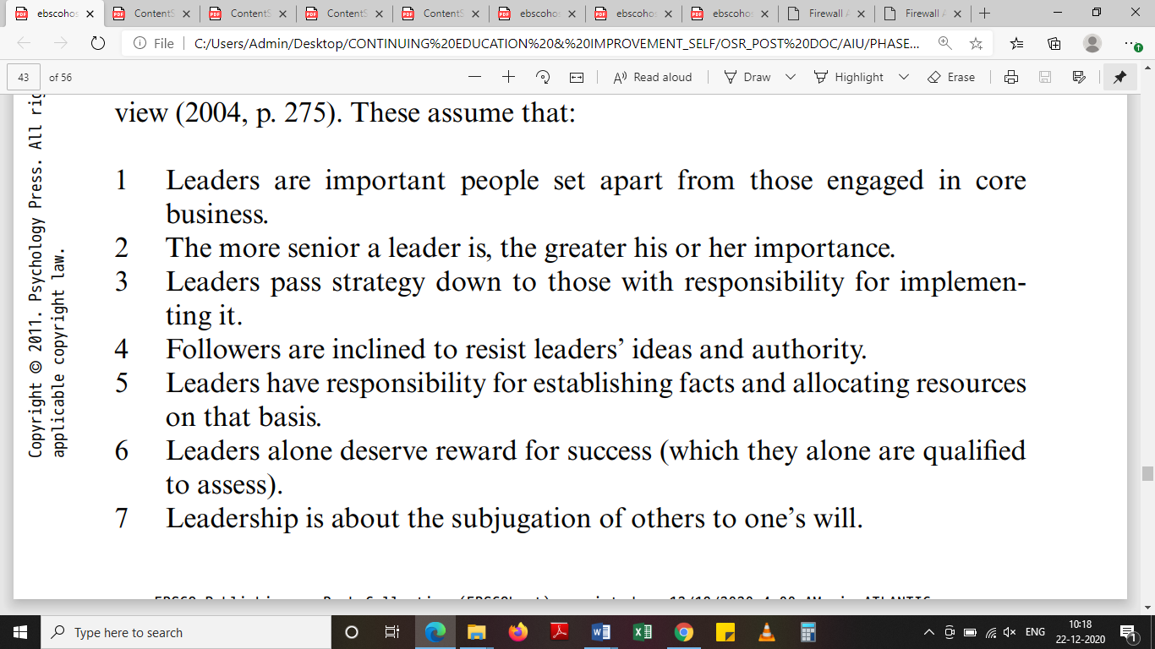

**Figure: Leadership nascent stages & Seven beliefs [Source: (Haslam, Reicher, & Platow, 2011)]**

The above aspects cover the conventional leadership and the evolution of transformative leadership along with its associated developed attributes, shown in the characters of leaders.

The role of psychology is also very crucial in the deciding of commutation of leadership, in many studies the cognitive models are being discussed along with their evolution, it is mentioned that shared cognition is mentioned as a whole and it allows for a corresponding analysis of commutation of these shared cognition models. It is analysed that the models have deep rooted sharing of cognition at various levels.

Transactive memory is also discussed as a model over the memory related experiments and it was found that some of the related aspects of memory model behave in particularly fixed manner and in more progressive modules.

In this aspect the various experiment series were conducted with pairs and non-paired individuals. Some of the subjects were also related as couples. It was found that most of the couples perform in better rank when it was intimately related.

The results of the experiment found that the use of relationship are commanding in such aspects and it will help in the case of group assignments in the case of leadership this particular aspect can generate a full fledged schedule of the same. This study helps how leadership is influenced by the use of relationship based models in the units and this particularly helps in the corresponding view point of models that are being used the particular aspect says that pairs perform better but when some constraints are removed then the results does not show the changes in the various aspects and this method proves helpful in the aspects of leadership and group dynamics.

This leads to the conclusion that many small pairing aspects are to be done in order to achieve a better result and this result is one such method in which the formal leaders can help and achieve the goal of better models and better place.

Equipment and task models are also present which infuses the idea of having a prior knowledge of the equipment in advance and the task model stresses the task applicability as a whole and two other models are in relation to the same aspects.

The team model says that the team is managed when a group is large and it configures the changes to be done in a group it says that the equilibrium is established with a fever change in a large group.

The study dwells that in place of its corresponding entries the leadership has evolved into many aspects and the transformative leadership and direction issue came into existence.

The birth leader and elected leader is another concept and finally the corresponding issue is discussed and this corresponding entry leads to the formation of a time line in the system. The manual follower entries are only dependent on the face value of the leader and the personal traits and enquiries also form a major portion of the unit and this entry is usually marked by the system of group based studies and hence the direction and leadership is derived out to be highly dependent on surroundings and individual’s reaction and thinking, so a tailor made system needs to be evolved for each scenario and that depends on the systems sensitivity towards the leadership.

**References**

Harrel, A. (2018). Competition for Leadership Promotes Contributions to collective actions. *Social Forces*, 405-426.

Haslam, S. A., Reicher, S. D., & Platow, M. J. (2011). *The New Psychology of Leadership.* East Sussex: The Psychology Press.

Hogg, M. A., & Tindale, R. S. (2001). *Blackwell Handbook of Social Psychology:Group Processes.* Massachusetts: Blackwell Publications.

Naidoo, L., Muthukrishna, N., & Hobden, S. (2012). The Leadership Behaviour of the School Principal: An Exploratory Study in Five Special Schools in Kwazulu-Nata. *Gender & Behaviour*, 4883-4912.

Ng’ambi, D., & Bozalek, V. (2013). Leveraging informal leadership in higher education institutions: A case of diffusion of technologies. *British Journal of Educational Technology*, 940-950.

Pearson, C. S. (2012). *The Transforming Leader.* San Francisco: Berrett-Koehler Publishers Inc.

Vugt, M. v. (2012). The missing link: Leadership, identity, and the Social Brain. *British Journal of Psychology*, 177-179.