Carol Jannette Suzal Aguilar
A9UM75857
Masters in Psychology

Models Techniques Stress Management

ATLANTIC INTERNATIONAL UNIVERSITY
August 2022

We are more stressed today than ever before, going through moments of great uncertainties. We sentient beings interpret turbulent times and chaos as a threat to our integrity: past years have shown us that we must be prepared for what fate might bring to our lives; proof of this was the recent situation we have all suffered in the face of the COVID-19 pandemic that occurred without prior notice. We had to learn to distance ourselves from each other, to isolate, to be on our own maybe for months without being able to hug a loved one, to work at home, and to lose our significant ones in many cases without even being able to say goodbye to them. Situations that have been the root cause of depression and anguish. Over time stress can lead to depression, pain, and chronic diseases, either as a result of changes to the mind and body itself or because stress leads to unhealthy behaviors such as drinking, smoking, or overeating.
We are biologically, physically, emotionally, and spiritually made to love and to be loved. When those needs are not met, we don’t function at our best. We suffer, we hurt other people, we fail in our jobs and we can even get sick. We must learn to talk to ourselves compassionately. People are getting used to living in what is called the survival mode. Suddenly, we acknowledged more than ever that investing in our mental health is imperative. Today I’m going to discuss and teach you how to implement some of the best modern techniques to better cope with stress.
One of the paramount reasons for psychological consultation revolves around the following symptoms:
Sleep disturbances, extreme worries about the future, flashbacks about traumatic events, fearing something bad may come out of nowhere, hypervigilance, lack of energy, loss of interest in previously pleasant activities, difficulty concentrating, hopelessness, and anger, to mention the most common ones.
This is often framed in clinical conditions such as anxiety disorders and depressed moods; many people consult their PCP and refer to suffering from physical pains that in the long run show their origin in the accumulation of unresolved stress.
I would like to point out that stress management techniques are in no way intended to replace medical, psychological, or pharmacological treatment; they are a crucial element of treatment, a therapeutic prescription increasingly recognized by doctors, psychiatrists, and psychologists for their enormous benefits on the psyche and the body.
What makes them increasingly important is the fact that they do not have contraindications or adverse effects of frequently prescribed psychopharmaceuticals to treat depression and anxiety disorders. Statistics are showing these adverse effects are alarming and growing exponentially.
In our everyday living, we as human beings are exposed to a wide range of emotions simultaneously; they are considered an evolutionary element that has enabled humanity to provide shelter, protection, and survival through the centuries. We must learn how to manage our emotions, especially since we constantly face challenging situations and events that represent threats to our minds and lives. These situations are experienced as traumatic events, and our bodies and minds experience stress. Stress has a bad reputation, and this isn’t fair.
Stress is a response, and there are two kinds of Stress: Eustress and Distress. Stress isn’t negative or unhealthy. It is a physiological response of our organism aimed to prepare us to better cope with our situations and requires extra motions on our part, as well as physiological responses to avoid possible dangers. The mechanism of Stress is common in every human being. How we react to those triggers determines whether it becomes eustress or distress.
What are the situations that trigger stress? Anything we feel we can’t quickly find the right answer to remedy the situation. Stress may be, as previously mentioned, a positive response to certain situations in which we must act immediately, hence we call this EUSTRESS.
This means that a eustress is a form of strong energy that enhances our ability to respond and face adversity to achieve our goals and objectives, turning problems into opportunities. We have learned from medicine and neuroscience that a proportional amount of stress is expected and healthy as a source of inspiration and creativity. It allows us to be enthusiastic, stimulating our brains, giving us the strength to stay motivated for daily function and/or to surf situations hard to undergo otherwise. In other words, Eustress helps us to move forward and improves our ability to be creative, proactive, and productive.
According to Dr. Mario Alonso Puig, a 67-year-old Spanish surgeon who studies the impact of mental processes on development, ability, health, and wellness, we associate stress with negative connotations due to “a tremendous lack of knowledge in depth on what that word means”, and he states, “If we destroy the mechanisms of the stress (eustress) we would not survive for more than two or three weeks”.
He defines Stress as a process that has two mechanisms:
- Survival Mechanism.
- Creative Mechanism.
Survival mechanism: this function as an alarm and it is very useful when we are in real danger and when we must defend ourselves from something that represents a severe risk to ourselves. So, they are meant to protect us so that mechanism is healthy when activated sporadically but we shouldn’t have to resort to them very often. But when this survival mode is habitually active which is the current worldwide situation a region of the brain called the amygdala associated with emotional processes is activated. Sustained activation of the amygdala impacts deeply our immune system. It plays an important role in the processing of fear. So, whenever we are exposed to a fearful stimulus, information about that stimulus is sent to the amygdala which in turn sends signals to the hypothalamus to trigger a “fight-or-flight” response which implies increased heart rate and breathing to prepare our bodies for action while interrupting the functioning of the digestive system. It is a reflexive response and as I have previously said it is useful if we are in great danger. Puig explains that when we are under constant stress, we become distressed which is the negative form of Stress. This is known as the “chronification of the stress mechanism”; what does it mean? That it is activated BUT is not deactivated once the real danger situation is over. It is analogous to getting out of the vehicle once we arrive at our destination but never turning off the engine.
The possibility of deactivation of this mechanism is what differentiates us from animals which would react by instinct since they lack the indissoluble pair of emotion/reason.

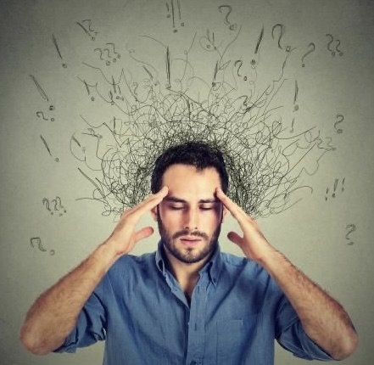
- The mechanism is as follows: a real danger is perceived, a situation that puts us in danger and our CNS receives the alarm activating the amygdala; the digestive tract is emptied into a high percentage of blood so that it is sent to the cardiovascular system.

One of the greatest discoveries of the last decades is that we have a second brain, and it is in our digestive tract; in fact, it does produce more than 80% of serotonin which is a neurotransmitter (chemical messenger) known as the happy chemical. It contributes to feelings of happiness. Too little serotonin has shown an association with fatigue, negative stress, depression, anxiety, and mood disorders, while too much could result in serotonin syndrome, which could lead to confusion and even hallucinations. It controls cardiovascular function, bladder control, and bowel movements. It can be identified in almost every neuropsychological process; it has a role in attention, perception, appetite, memory, motor skills, and anger among others. ( Guy- Evans, O. (2021, June 14). What is serotonin? Simply Psychology. www.symplypsychology.org/what-is-serotonin.html)
When we are undergoing distressful situations, the survival mode is activated thus our entire being is severely affected. The five vital dimensions of our lives, physical, psychological, emotional, social, and spiritual, suffer consequences sustained over time that are hard to reverse.
In survival mode, our heart can work five times continuously and develops cardiac pathology; then if our digestive tract paralyzes because it doesn’t receive the amount of blood it needs to function, so today diseases of the digestive system caused by poor stress management are becoming more frequent; two hormones are released: adrenaline and cortisol; adrenaline is most of all proactive, propulsive while cortisol if sustained it will in turn impact/affect negatively our immune system

We can’t help this response if we don’t learn how to manage stress healthily. Why? Because this is a natural psycho/physiological activation that serves to react against threats, dangers, and sudden changes in the environment.
I would like to introduce the techniques that are the most effective ones to go from survival to creative mechanism.

Dr. Puig is an advocate of MEDITATION, one of the best stress management techniques currently being implemented worldwide.
What is Meditation?
It is a technique of enormous effectiveness to manage emotions; they won’t disappear but will decrease in intensity, enabling us to recover from difficult and complex situations.
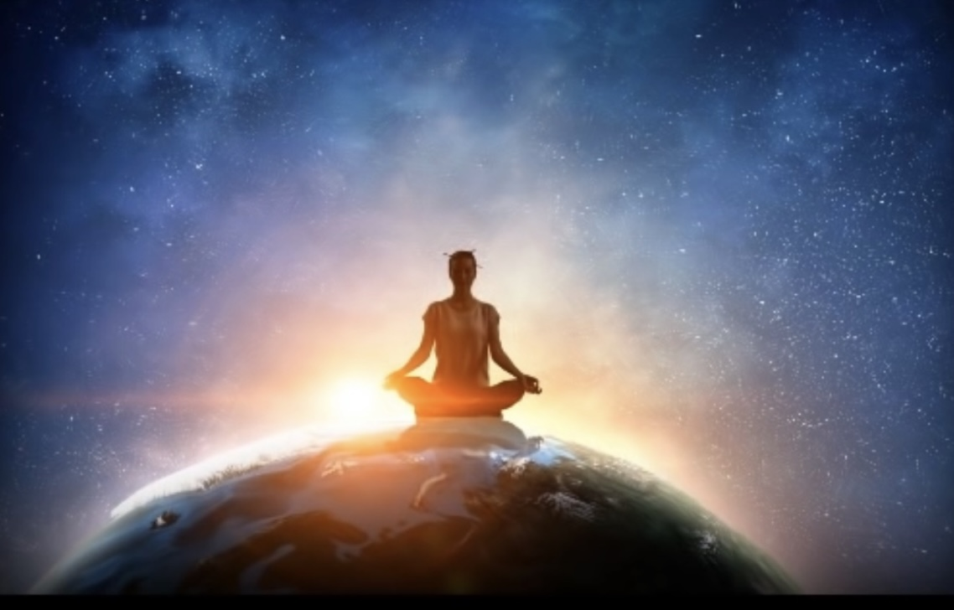
Eastern philosophy such as Buddhism and Hinduism teaches us that meditation is one of the best ways to achieve positive changes. I want to stress that this is not a religious philosophy, it is considered an existential ideology that implies a non-materialistic lifestyle based on compassion, altruism, and meditation.
There are several ways to define this millennial practice. Meditation means awakening and awareness; it teaches us to live in the HERE and NOW, to be where and who we are, and to live in our highest truth. In the West, most of the practices stem from Buddhism. One thing we have to accept is that it will take time to see the benefits meditation will bring to our life.
Mindfulness Meditation is the simplest way to start because it is about paying attention to our breath.
How to breathe correctly? Let’s go through those steps because they may seem simple but we usually do it the wrong way. We always have our breath available thus we can always come back to it as a form of meditation, as simple as that. You can close your eyes or leave them open and simply observe your breath feeling the expansion as you inhale the air coming into your nostrils
Then as you exhale feel the air moving out of your nostrils. If your mind wanders (and it will, that’s part of meditation) let go of the thought and guide your attention back to your breath.

It invites us to witness our life without judgments, but with kindness and compassion. It gives us 8 different ways in which we can benefit from Meditation to achieve a state of relaxed awareness:

- Living with kindness. The first person in the world we owe kindness and compassion to is ourselves. Whenever we are having a bad time or we make a mistake, instead of self-criticism, let’s try breathing and repeating this mantra: “May I be well, may I be happy, may I be filled with loving kindness”

- Lightening the load. We all need time to quiet our self-talk, and our minds; whenever we feel overwhelmed, we can practice focusing on our breath while repeating, “I calm my body and mind breathing, I smile”.

- You cannot give what you don’t have, so when you give kindness to yourself first, you can then give it to others. Letting go of “me” is practicing leaving aside what is called the “monkey mind”, which is a demanding, ruminating one-ego dominated mindset. In other words, being selfish. In this way, we go from self-centered to other-centered minds.

- Dissolving Anger and Fear. We all use these two mechanisms when it comes to emotions that we want to get rid of such as shame, anger, anxiety, and sadness. These mechanisms are avoidance or denial, making everything worse. When we meditate, we become aware of our human limitations, leading us to self-confidence and self-acceptance.

- Awakening forgiveness. Forgiving is such an important act because it gives us relief from resentment. Achieving forgiveness allows us to let go of negative thoughts, feelings, and events. Meditating allows us to observe what we feel while keeping in mind that nothing stays the same.

- Generating harmlessness. Practicing meditation has been shown to help us let go of feelings such as disrespect, hopelessness, shame, and guilt while allowing us to connect with our wholeness and goodness.

- Appreciating Appreciation. This means learning to give worth to the world that surrounds us. Everything in this world is worthful.

- Being aware: awareness is key to awakening, it is the clue to meditation; learning to be in the present moment without judging, just BEING.
There are many ways to combat stress in healthy and effective ways apart from meditation: we can use relaxation techniques such as different types of breathing, rhythmic exercise, and yoga. We need to implement these techniques whenever stressors throw our nervous system out of balance, to produce the relaxation response and combat the stress response. In this way, we recover our previous state of calmness. There is more than one way to meditate. It is in each of us to discover the practice that works best for us.
Learning these techniques takes practice, discipline, and dedication of at least 10 to 20 minutes every day.
Not every technique may work for everyone. One way to know which one is best for you is by asking yourself how you react to stress. Do you become angry, withdrawn, or tend to bury what you feel?
You can choose which of the following fits you, perhaps choose more than one, depending on the situation you are going through.
Let’s see some of the most popular ones:
Relaxation Technique 1: Breathing meditation for stress relief:
Known as the cornerstone of many other techniques, deep breathing can be combined with other relaxing and mind-soothing elements such as healing sounds, aromatherapy, and Zen music.
Deep breathing and alternate breathing are two of the most effective relaxation techniques perfect for relieving anxiety.
- Deep breathing: a technique that consists of inhaling deeply through our nose from the abdomen as much fresh air as our lungs allow; in this way, we inhale more oxygen. It is important to pay special attention to this process because we are used to “shallow breathing” from our upper chest.
- Alternate breathing: a technique in which you take turns inhaling through one nostril and exhaling through the other. With your right thumb, you close your right nostril while inhaling through your left nostril. Now close your left nostril with your ring finger so that both nostrils are closed for a moment; open your right nostril and exhale slowly through it. Then inhale through your right nostril, holding both nostrils closed with your ring finger and thumb. Open your left nostril and exhale slowly through your left side.
EXERCISE:
- Sit on the floor or over a cushion, wherever you feel comfortable with your back straight, placing one hand on your stomach and the other on your chest.
- Take a deep breath through your nose; you will notice that the hand you have over your stomach will rise while the one on your chest will move just a little.
- Exhale through your mouth with your lips slightly open so that you can feel the air as it goes out. Push out as much air as you can when you contract your abdominal muscles; again, you will feel the hand in your stomach moving in as you exhale.
Relaxation Technique 2: Progressive muscle relaxation for stress relief.
This technique consists of a two-step process in which we systematically tense and releases different muscle groups in our body. The idea is that with regular practice, you will become aware of the signs of the muscular tension that come with stress; and therefore, how our minds will relax as our bodies learn to release the general tension of our muscles.
EXERCISE:
It is recommended to take our shoes off, loosen our clothes, and take a few breaths once we feel the relaxed focus on one of our feet. You can start with your right foot.
Focus on the way it feels. Slowly tense the muscle, squeezing as tightly as you can, counting to 10, and releasing. RELAX and focus on how it feels breathing deeply and slowly.
Repeat the same sequence with your left foot, then move slowly up through your entire body.
This exercise is intended to relax all your body so there is a sequence, and the most popular is as follows:
- Right/left foot, right/left calf, right/left thigh, hips and buttocks, stomach, chest, back, right arm and hand/left arm and hand, neck and shoulders, face.
Relaxation technique 3: Body scan meditation for stress relief:
This technique is very similar to progressive muscle relaxation; the difference between them is that body scan meditation consists of focusing on the sensations in each part of our bodies.
EXERCISE:
The scan is a bit more detailed so that you can pay more attention to specific regions; you can choose, for instance, your face: focus on the jaw, chin, lips, tongue, nose, cheeks, eyes, forehead, temples, and scalp.

Relaxation technique 4: Mindfulness for stress relief
What is Mindfulness? It is the ability to be aware of how you are feeling in the present moment both internally and externally, without judging your experience but by observing it. This means that whenever a thought of the past or future arises, we just let it come and go, staying calm and focused on the present moment with a non-critical attitude.
EXERCISE:
Go for a walk, and as you walk, choose to be mindfully present in the experience of the walk focusing on the sounds that surround you. Whenever you notice you may be distracted, go back to the sounds.
You can apply Mindfulness to many activities!!!
Try Mindful cooking, Mindful exercising, Mindful eating, and Mindful meditation.

Relaxation Technique 5: Visualization meditation for stress relief
When using this technique our senses are implied; we use our taste, sight, smell, touch, and hearing senses to visualize while we meditate, imagining scenes in which we can feel at peace, free of tension, and relaxed.
The setting is up to you, somewhere that represents a safe and calm place. Put on some soothing music-guided imagery visualization and sounds of thunderstorms.
You are not supposed to fall asleep while meditating but it is ok if it happens while you are a beginner. To avoid this try sitting up.
To meditate, it is better to close your eyes and take deep breaths, inhaling and exhaling and let your worries drift away. It is a good strategy to make visualization work to incorporate many sensory details, selected by you.

Relaxation technique 6: Yoga and tai chi for stress relief.
I will briefly refer to these millennial techniques.

YOGA: This technique combines moving with breathing and it is useful for improving flexibility and balance both physically and mentally.

TAI CHI: This is the practice of a self-paced series of slow-flowing body movements aimed to ease the mind, enhance concentration, and reduce stress by focusing on breathing mindfully.
To make relaxation, meditation, and stress-relieving techniques part of our life we must acquire some habits and implement them daily to rewire our brains and change bad habits for good habits.
Here are some suggestions to succeed: it takes time, willpower, and the conviction that you don’t need to move to India! You don’t even need a completely quiet space. The real challenge is to be able to apply them when they are needed, often amidst the chaos of everyday life! We need to learn how to ground ourselves.

To make these techniques part of your daily routine, it is recommended to put them into practice while doing some of the activities we do every day: First thing in the morning, while cooking, waiting for a bus, or at the airport. On your next exercising practice, try doing it mindfully, paying attention to your muscles. Avoid doing these techniques at bedtime but when you are fully awake.
People often get discouraged in the beginning stages of meditation. Why? Mainly because they tend to overthink how to meditate, and the proposal is to just accept whatever is coming to our minds and let go; being aware of our feelings and passing thoughts, and again, letting go, and trying not to be caught by them.
“This is the mind of no preferences. Rest as awareness, free from reactions”
(Hanson, Rick with Mendius Richard, 2009, p. 111).
The author takes the word “equanimity” and states that it is very important to develop it to be able to meditate; through it, according to the author we learn to manage our reactions, instead of letting ourselves be carried away by the tendency to react. He explains that it’s not about being indifferent, but giving space for compassion, which is concerning for the suffering of beings, both being compassionate with oneself and with others.
How do we develop compassion? Empathy is the basis of compassion; it brings awareness of the difficulties and struggles others face and their suffering.
“With equanimity, you can deal with situations with calm and reason while keeping your inner happiness”
- The Dalai Lama
if you skip days, remember it takes time to build new habits.
Russ Harris is an Australian therapist specializing in stress management, and a premier leader in the ACT method (acronyms that respond to the words Acceptance Commitment Therapy) through which we learn to reduce levels of worry and stress, manage painful feelings, break self-destructive patterns of behavior, overcome insecurities and recognize our values.
In his book “The happiness trap” he refers to tearing down the belief we all have about happiness as being the natural state of every human being. He describes four major myths to get out of this trap.
The first myth says “Happiness is the natural state for all human beings”
In our culture, we are taught that humans are naturally happy and that happiness is what defines mental health. This (mis) belief is what worsens the situation bringing us more unhappiness and frustration. Besides the vast majority lives in the certainty that everyone except oneself is happy.
The second myth states “If you are not happy then you are defective”, making us feel miserable whenever we go through painful thoughts and feelings. According to the false premise from which we started which makes us reach therefore a false conclusion our western society assumes that if we are not happy any type of suffering is abnormal.
ACT is based on the principle that we cannot go through life without suffering. Psychological suffering is part of the natural process of being human.
The third myth says, “To create a better life, we must get rid of negative feelings”.
Our culture is obsessed with the idea of being happy, the cult of happiness proposing us to eliminate negative feelings and replace them with positive ones. As a theory, it is very good, but it is impracticable. The crux of the matter lies in the following: in real life, we experience either pleasant or unpleasant feelings. In every love bond, we will go through beautiful moments and satisfactions but also disenchantments and frustrations.
Our projects bring enthusiasm but also anxiety.

The 4th myth is: You should be able to control what you think and feel; we have less than what we were told we have, but we do have the possibility to learn to control our actions.
Nowadays many self-help proposals maintain that if you repeat positive ideas instead of negative, one prevails over the other. If only life were so simple. These techniques have temporary effects but not in the long run. And they are useless under a situation of extreme stress. The frustration is huge when you try to put into practice this type of technique in difficult situations and we fail, generating only more and more stress.
The author proposes using these techniques to learn to manage our feelings, in such a way that the experience we have about them has less impact on us. Our emotions give us the impulse to act, and we call that impulse an URGE. Whenever urges arise we can act upon or don’t act upon them. It is useful then to ask ourselves: if I act on this urge, will I be who I want to be? If the answer is yes then it makes sense to act on that urge. It is about finding out if the urge we feel is consistent with us.
In a few words, ACT proposes that whenever we feel an urge to act, we can ask ourselves if taking that action make room for our urges rather than struggling with them. The technique which enables us to do so is called “urge surfing”. The steps are to observe the urge, acknowledge it, make room for it, and watch it as it rises, crests, and falls allowing it to come until it will subside
The idea is to check if the action we are about to do is in line with our values

MINDFUL TIP:
STOP

S- STOP
T- TAKE A BREATH
O- OBSERVE
P- PROCEED

It is a method to observe our inner experience mindfully without acting on it.
Before concluding my presentation, I would like to share two of the resources that I advise my patients to use when they find themselves in difficult situations.
A widely used resource to prevent panic attacks, in the case of people who can anticipate it is to take their pulse. It has been proved that feeling one’s heartbeat calms the mind little by little, dissipating the anguish most of the time.
The second exercise is called 5-4-3-2-1 and it is used for the sake of grounding when a person refers to be thinking too much of the past or the future for depression or anxiety; it consists of 5 simple steps:
- Acknowledge 5 things you can see around you.
- Acknowledge 4 things you can touch around you
- Acknowledge 3 things you can hear around you
- Acknowledge 2 things you can smell around you
- Acknowledge 1 thing you can taste

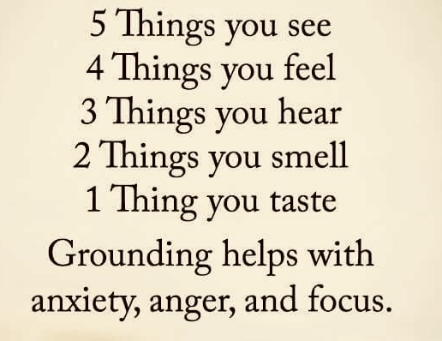

In summary, we all go through turbulent times and we become absorbed in negative thoughts or situations we normally are overwhelmed by. We got used to living in a survival mode that causes physical and psychological disorders. Stress management techniques teach us to shift out of unhealthy spirals.
Stress is not a dangerous mechanism; we just must learn how to activate it for the right reasons, for the right time at the right intensity.
The problem, therefore, begins when this mechanism is activated regularly; and the problem increases since it is activated very easily but we fail to deactivate it.
It is vital to learn to calm down, to manage our emotions. Life confronts us with many difficult and painful situations.
Knowing the root cause of our distress is imperative: is it wondering if you matter in this huge world? Is it repressed anger? low self-esteem (Harris, 2007) raises our awareness by learning mechanisms to better cope with stressful situations, and practice them consistently because we must feel, let in, and embrace our emotions to heal our worries, fears, anger, and shame to fix whatever needs our attention.
Acceptance is the essential step, assuming we must face difficulties, and that will require us to seek within us the necessary resources to solve the problem and face it with the conviction and certainty that we will be able to solve whatever it may come.
It is not about avoiding or denying them because that only perpetuates the problem, but about having the tools to face adversity.
There is no one-size-fits-all prescription for how you may best benefit from stress management techniques
That’s the difference between being resistant and becoming resilient. Gaining resilience means being strengthened in the face of adversity.
it’s not about to be living our lives pursuing happiness but being attuned and self-aware of our feelings giving room to all our emotions even if it is shame, anxiety, sadness, stress, or anger, we need to be heard and validated.
I can affirm that learning strategies and implementing them to better deal with current times are a long-term remedy

Bibliography

- Harris, R. (2007). The Happiness Trap. Wollombi: Exile Publishing Ltd.

- Hanson, R., Mendius, R., Lei, S., & Hanson, R. (2011). Chapter seven. Buddha's brain: The practical neuroscience of happiness, love & wisdom.

- Bradberry, T., Greaves, J., & Bradberry, T. (2009). Chapter 4 "Feel your emotions physically". In Emotional intelligence 2.0 (pp. 70–71)., TalentSmart.

- Atlantic International University. (2019). Models’ techniques deepening, meditation, and Stress management. Mainstream – the concept of motivation 02. Retrieved August 26, 2022, from https://videos.i.edu.mx/default.aspx?action=play&conferenceGUID=4a6aa6ad-bf31-4678-ad9f-04e0b6f939f9.
- Puig, M. A. (2021, January 10). ᐈ Mecanismos de Supervivencia |  Dr. Mario Alonso Puig. YouTube. Retrieved August 31, 2022, from https://www.youtube.com/watch?v=LDLV0N20zS0

- Puig, M. A. (2018). ¡Tómate un respiro! Mindfulness. YouTube. Retrieved August 26, 2022, from https://www.youtube.com/watch?v=yRPHsp5K-Zk

