SHADRACH KABU MASI
UN75566SEL84746

COURSE NAME:
(MSc ELECTRICAL ENGINEERING)

Assignment Title:
(BIG OPPORTUN FOR SOFTWARE ENGINEERING)

ATLANTIC INTERNATIONAL UNIVERSITY
MAY/2022

ABSTRACT

Researchers in software engineering work on a variety of issues. They must provide a variety of findings in order to do just that, and that they must create an acceptable proof to verify these outcomes. They frequently publish their findings in journal articles. I examined all descriptions of scientific articles presented to ICSE 2002 in order to ascertain the sorts of studies published in the proposed and approved articles, as well as the programming commission's deliberations over which articles to approve. The scientific theories of the articles are included in this document, as well as the programming commission's possible issues and data on performance. These knowledge will aid researchers in developing stronger scientific research and writing articles that effectively explain the findings.

INTRODUCTION

Journal publications are the traditional media for sharing discoveries to the scientific world in the subject of software engineering. In a literature review, the author explains what he or she accomplished, how he or she did it, and why the audience should care in order to stimulate the audience's attention. A good research article should be able to respond to these research questions:

So, what precisely did we bring to the table?

What was the issue you responded to?

Why must the audience be interested?

What is the greater question that the above answers?

♦ What is the outcome of your latest experiment?

What fresh information has you provided that perhaps the viewer may apply somewhere else?

Which past works (own or somebody else's) would I depend on for inspiration? Which do you offer as a good option?

What makes your solution unique & superior to past efforts?

What does your latest outcome, specifically and in specifics?

♦ Why must the audience trust your conclusion?

What criteria will you use to assess your claim?

What proof do you even have that your finding supports your claim?

If you can locate the answers clearly, you'll most likely be able to articulate the conclusion properly. If the conclusion also provides fascinating, credible, and important insights into the If you write on the dynamism of software development, you'll have a better chance of getting it accepted for publishing at a symposium or journal. Outstanding researchers are found in other fields of science and engineering. Research mindsets. The empirical model of physicists, for example, and double-blind drug testing are both acknowledged by scientific authorities and the general public, albeit in broad strokes. Through a sociopolitical practice known as "boundary setting," these viewpoints influence the extent of scientific topics [5]. They also offer guidance on a subject's research process. Software engineering, on the other hand, has yet to produce such a well-defined guideline. Early attempts to get this knowledge have been described before [19, 20], including a model of how software engineering approaches evolve [17, 18] and criticisms of the absence of critical thinking in exploratory systems engineering [1, 22, 23, 24, 25]. The findings of trans-disciplinary research are compared and contrasted with study approaches in these arguments. This topic is unusual in that it focuses on the types of papers that are considered legitimate scientific presentations. Another continuing project is the Relevance Experiment [7], which tries to track the impact of software engineering academics on practice. The focus of this dispute is on the frameworks rather than the content of the study. This research focuses on the investigation development's design and study structure, as well as how software developers respond to the challenges listed above. Other sites (such as [4]) concentrate on particular elements of scientific communication. All of the examples in this section are drawn from documents given at ICSE 2002 and the program commission's review of them. The findings of software engineering research are presented in these situations. Workshops often feature other sorts of presentations, such as experience reports, resources on software engineering education, and opinion articles.

RELATED WORK

Observing rookie engineers rather than seasoned ones taught us a lot about software engineering. For example, Hewner and Guzdial's [2] research of what recruiters at look for in fresh grads at a small gaming firm is the most similar to ours. The writers questioned and surveyed around 30 technicians, executives, and artists on their freshly graduated credentials. The authors cited both programming and human talents, such as the capacity to "work together and leave your ego at the door," among others. The authors noticed that new and senior employees had differing perspectives, in addition to biases peculiar to the gaming industry. Begel and Simon monitored 8 new employees at Microsoft for four weeks in a 2008 ICER report, examining their daily tasks. Beginners must locate 'tasks which have an impression,' be 'tenacious' (prevent loss of self), and uncover 'tasks that have an impact,' according to the study, in order to operate well in a 'big technology team setting.' However, it was uncertain whether senior engineers had similar issues.

Some works are descriptive, offering suggestions but not elaborating on why certain topics are significant (or not). For example, Lethbridge [10] surveyed 168 software engineers to see how important ACM Computerized Pedagogical skills [6] machine learning training subjects were. Kelley's work with high performers, such as software developers at HP and Bell Labs [11], is noteworthy. Blazing trails, recognizing who knows, assertive ego, getting the big picture, this same correct sorta base of supporters, collaboration as jointly owned of a venture, smallI governance, smartness, and demonstrate and explain are among the nine practices and strategies recommended by the scholars and characterized as leading to increased efficiency. Previous articles have looked into careers like "Information Technology" [8] and "Systems Engineering" [12]. Many of the criteria, such as "supporting an investment domain of services" and "analyze business difficulties and is a remedy," were intended to encourage people to choose rather than produce software. Luminaries have provided useful information about software engineering abilities. At OOPSLA 2003 [13], Brechner, a Ms general manager of training programs, discussed the importance of design and analysis in leading to substantial (e.g., ethnic backgrounds), multidisciplinary project cooperation, massive production, and activity. Dijkstra underlined that software experts deliver clear and elegant solutions that are constructed with verifiable accuracy in his Nobel Prize presentation [14]. These attributes are undeniably important, despite the fact that the celebrities are unlikely to have looked for them exhaustively or deliberately. The issue has also been addressed in popular media and best-practice standards. Bock, Google's chief operating officer, stated in a Wall Street Journal question and answer session [15] that a programming engineer's capacity to gain experience is crucial. or that decision-making, inventiveness, and imagination were more essential than real competence. In addition to mechanical expertise, McConnell [16] stated that excellent programmers have a number of psychological traits, including humility about their abilities, excitement, and intellectual rigor. According to novices and experts' views [3][17][18], specialists are significantly more efficient, meticulous, and well-versed than beginners. Sackman et al. observed in 1968 [5] that the end lengths of programming and debugging operations might differ by The gap between both the best and worst engineers might be as large as 29:1. in one of the early studies of information flow facilitation.

According to the experts, there are also qualitative and contextual differences. Useful designers, according to Robillard et al. [19], are more vigilant and better at detecting needed details. The myth that 10,000 hours of focused practice is necessary to obtain expert knowledge was created by Ericsson et al. [20], who found that mastery required time, equipment, educators, and facilities. As a consequence of research into diverse fields of collaboration, other key qualities have emerged. Setting, engaging, and aligning goals among team members are all crucial, according to Simon's examination of effective technique [21]. Productive efforts, according to Gobeli et al. [22], demand constructive conflict governance (e.g., faced opposition and giving and taking). Code ownership, the technical domain, and [24] are all things that expert software engineers are familiar with. [25][26] [27] [28] [29] [30] [31] [32] [33] [34] [36] Despite the fact that this sector has seen a lot of study, there aren't many papers that particularly target software engineering skills. Those that do so concentrate on a small number of variables. In comparison to the results of a comprehensive investigation, we use a bigger, richer, and more rigorous knowledge of software engineering skill in our study.

METHOD

For academic proof of software engineering abilities, a representative sample of software enterprises, software platforms, and organizational cultures would be desirable. To begin, we spoke with seasoned engineers at Microsoft, a massive corporation with a wide range of software technologies and expertise, in order to get a sense of the ideal. Face-to-face semi-structured interviews were utilized to compile a complete list of features, as well as a thorough understanding of their importance and relevance in various circumstances.

Choosing whose personal judgments of software engineering talents could be trusted was one of the most crucial considerations in our procedure. Engineers are still exempt from licensing and accreditation requirements. Software engineers, according to the ACM, are "those who create software for computers." significant use" [6]. As a result, we followed the path of human competence specialists [20], defining competence as those who have achieved some level of recognition as software engineering experts. Professionals having a Software Design Engineer Level 2 (SDEII) or above title were selected. During the recruiting and progression processes, several engineers certified these engineers as experts.

We wanted to get a representative sampling of experts from two key industries aspects: product identification (10 major segments at Microsoft plus one for everything else, Voip, Datacentre Operations, and Logistics, for example) and amount of competence (novels at or above SDEII—'experienced'). —as well as'very experienced'—positions at or above Professional Developer Supervisor with 15+ decades work experience) based on previous job. The original author had access to the corporate address book as a full-time Microsoft employee, which we used. We chose engineers in the 22 strata at random in a round-robin strategy with three workers each round, Ideally, each layer should have at least one or two eyewitnesses. We went to 59 (or 39%) of the 152 engineers we contacted (see Table 1).

The interviews lasted around 1 hour and were moderately. We starts by discussing our research, stating how we found the subject, requesting written consent the conversation, and notifying him that all individually identifying information will be removed from the discussion.

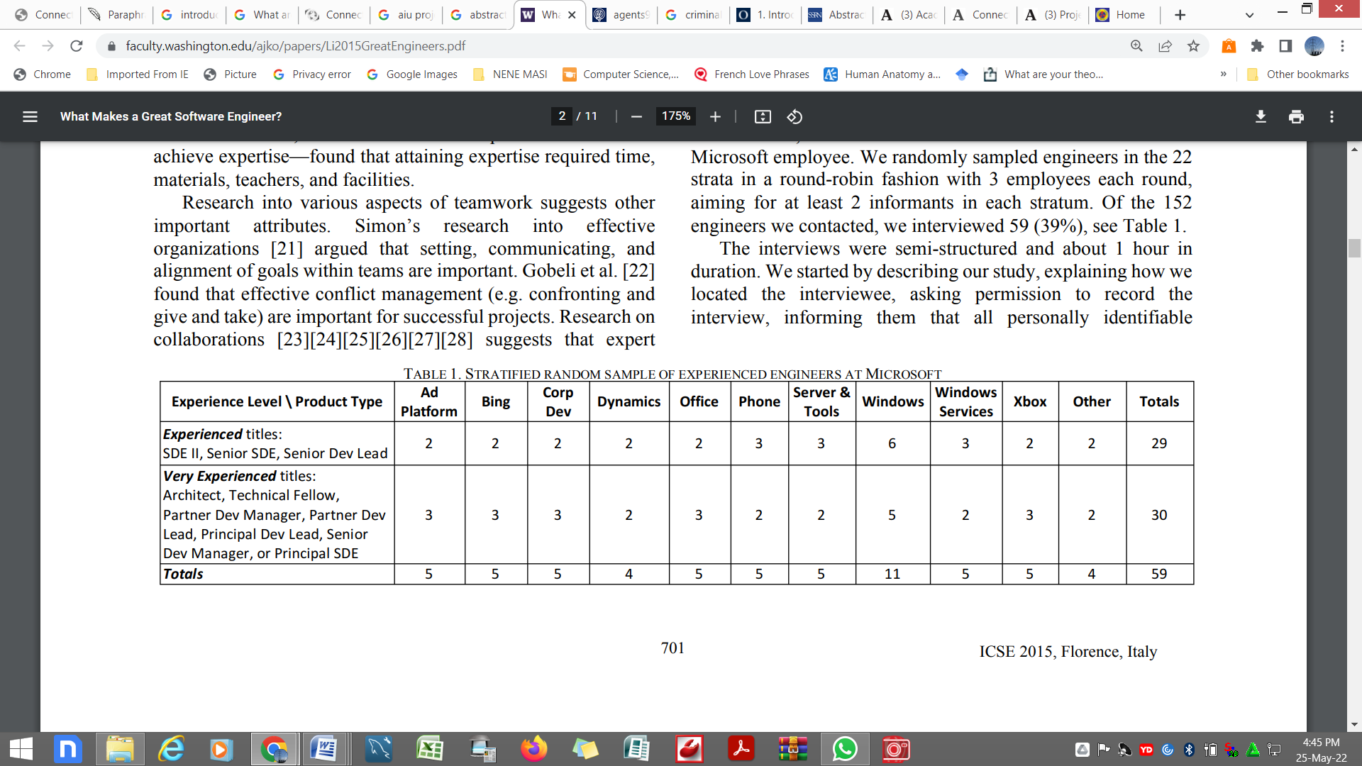

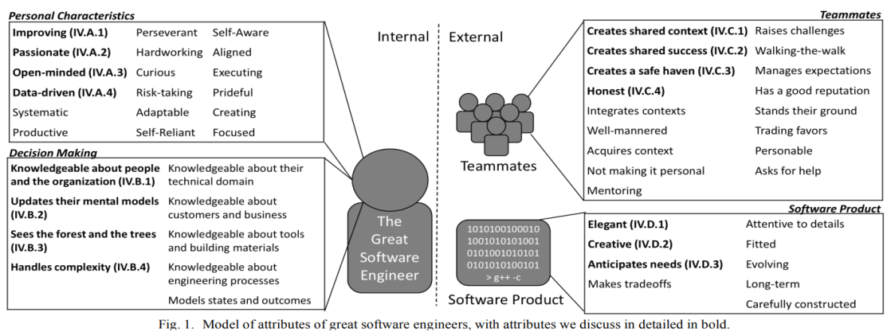

Data would be erased, along with a notice informing users they are within their obligations to decline to respond to queries. and have their responses removed. "I'd like to start by knowing a little bit more about you," we said at the start of the conversation. What software projects have you collaborated on with others, both inside and outside of Microsoft?" The previous backdrop was then removed while the transcript was being transcribed in order to conceal the sources' identities; this helped us build rapport with the spies and made it easier for them to contemplate. "Think of someone you've worked with before who you believed was a great software engineer," we said. What qualities did you think made the person 'exceptional' in your eyes?" We used the words "notable" to describe features that we considered were noteworthy. In the second portion of the interview, we questioned about features that were either vague or may be interpreted differently. As we learned more about the qualities from respondents, we altered the list of traits we questioned about about every 10 interviews. Due to time limits, I focused our attention on five crucial qualities. I concluded the discussion by restating the research's purpose and asking if the interviewees had anything more to contribute.

They over 60 hours of conversations and 389,000 words of recordings were evaluated using a logical technique [29]. We began by going over free code, looking for and examining any areas that highlighted outstanding computer scientist features. Once we had our first characteristics, descriptions, and categories, we did a gene-by-gene analysis of our data to compress the feature set. We then enlisted the help of a Senior Software Design Engineer (3rd author) to go over around a third of the lectures, creating her own traits, classifications, and categories, and comparing them to the first set of talks to corroborate our findings. To come up with the final set of characteristics, we went over all of the translations one last time.

FINDINGS

During our investigation, we discovered a total of 53 qualities that distinguish excellent software engineers. Great engineers, according to our sources, were persons who are enthusiastic with what they do and are constantly improving; people promote the capacity to generate beautiful, innovative, and anticipatory code; who analyze choices at numerous levels of biological organization, spanning low technological specifics to types of project; someone and colleagues respect and like collaborating alongside

We propose a model of the 53 qualities in Fig 1 to give readers an idea of how they relate. Internal aspects of the engineer's character and capacity to make good judgments, as well as outward characteristics of the influence that outstanding engineers have on people and products, are divided into two categories. Making good judgments necessitated an understanding of conditions as well as different courses of action, likely outcomes, and result values. Brilliant Engineers use psychological empowerment and evaluation methods to enhance the technology, themselves coworkers, and the world around them. possibly millions of customers they serve through their computer programming efforts, according to the outside qualities.

Several of the characteristics may be applicable to a wide range of professions, and some can even be related to simply being a nice person. Our objective was to identify the set of characteristics that professional software engineers thought were most important for software engineering. More importantly, we sought to explain why these features are important in real-world settings.

In the rest of this work, we present a summary of each attribute as well as remarks from sources (with their title and division if this data may reveal their identity) that express emotion in dialogues. We centered detailed explanations on traits that we considered were particularly noteworthy based on past research due to capacity limits.

PERSONAL CHARACTERISTICS

18 personality traits of engineers were identified by interviewees (see Table 2). These qualities, such as enthusiasm and curiosity, were preoccupied with who brilliant scientists were as individuals. Most respondents believed that the inventor's characteristics were innate to him or her—formed by their family background that changing them was hard (if not unattainable).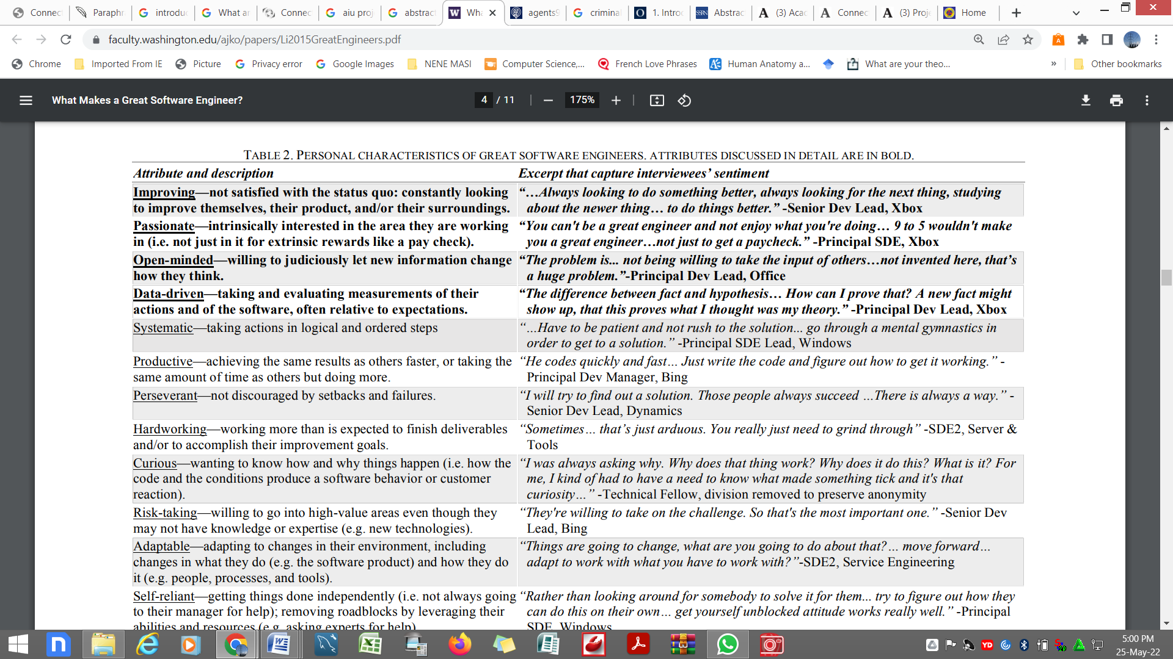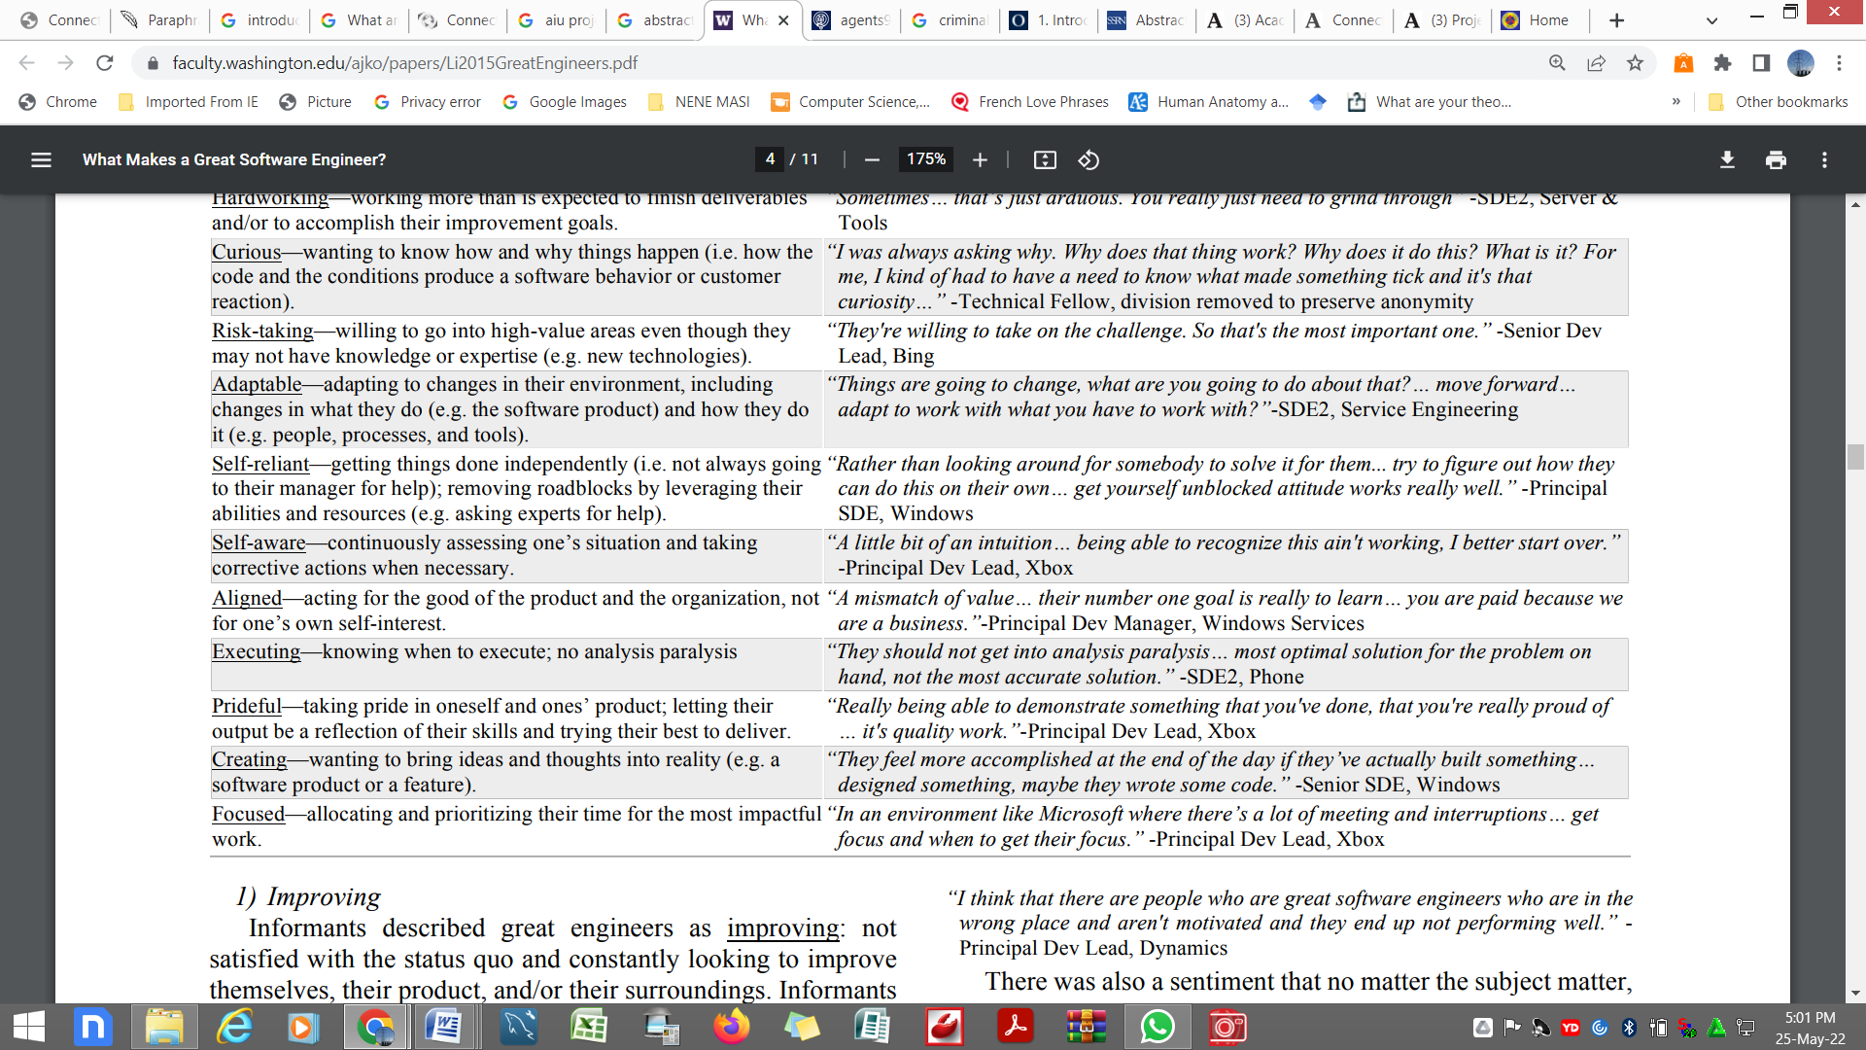

IMPROVING

Skilled machinists, according to studies, are never happy with the status quo and are always seeking for ways to improve themselves, their product, and/or their workplace. Engineers did not start their professions as extraordinary, according to accounts, and professional developers needed to study and progress. Designers never became or stayed brilliant software engineers, according to reports, unless they continued to learn since the software business was continually evolving and growing. Some of the responders expressed interest in jogging up an endless stairwell: "Computer technology is relatively new in comparison to other sciences or technologies. Every year, new technology and ideas emerge. Unless you're solely pleased with what you've previously learned, you'll likely learn that you're out of date in a few years... He's a competent software engineer [sic], and he's always researching and investing. [sic]” -SDE2, Corp Dev

PASSIONATE

According to experts, great engineers are frequently truly enthusiastic: they appear to be genuinely interested in the subject they are working on, not only for the purpose of monetary gain. Respondents stated that high-quality software required a close match between a user's motivation and the task at hand: "I believe there seem to be outstanding software engineers who are in the wrong position or aren't driven, and as a result, they don't function effectively."- Dynamics' Principal Developer

There was a belief that no matter what the subject, everyone would have a natural affinity for it:"I learned that there is always someone excited about something; all we have to do now is find the right people... I was in the wrong job for seven months. It was unbearably uncomfortable. People in my immediate area were proud of their work."- Principal Dev Lead, Phone

BE OPEN TO NEW IDEAS.

So according to an eyewitnesses, brilliant engineers are open-minded, willing to enable new facts to influence the advantages of this strategy rather than adopting their present view asrue. "You should be open... whatever you believe should not be the proper thing today... like the Facebook boom, which burst despite the fact that Napster was still there..." stated one source. No one anticipated Facebook to become so successful when it first began."- Senior SDE, Windows Services



Because software systems were large, sophisticated, and frequently updated, undercover operatives assumed that no one could have a complete understanding of them. As a result, even the most accomplished engineers had to be open to changing their ideas.

"There are so many different industries... regardless of how much you know about the software industry... If that person says something I haven't thought of, I'll put it on pause and say, "OK, explain this." "Could you just tell me what you saw that I didn't see?"-Senior SDE, Office

INFORMATION

According to several sources, great engineers are data-driven, collecting and evaluating measurements of their operations and products, as well as developing behavioral feedback loops for program and method execution. When possible, participants indicated that data should be used instead of gut or reasoning to make decisions. This strategy was commended by some as a way to counteract groupthink, but it wasn't without flaws:

"Another issue that boggles my mind is if, despite our claims to the contrary, we are data-driven... Certain data is being presented to us. We devise a number of methods to avoid it. So, while everyone claims to be data-driven, I've seen people come up with excuses as to why the data won't apply to him. "I've seen that a million times." -Where did you go that I didn't?" enquires Senior SDE. Senior SDE, Office

DECISION MAKING

Interviewees indicated nine attributes of engineers' decision-making abilities (see Table 3): integrating the current circumstances, choice possibilities, probability ramifications, and outcome values. Leakers believed that mere education was insufficient; exceptional architects understood how decisions were made in difficult real-world settings. Not only did brilliant engineers understand what should happen, but also what could and most likely would.

Engineers, according to our interviewees, must be able to comprehend the specifics at various levels—clients and companies, tools and construction equipment, and engineering practices—in order to make sound decisions. We concentrate on one area of knowledge, people and organizations, since it gives information about relationship communication that is rarely studied.

We also discuss how to improve scientists' mental models, how to see the forest for the trees, and how to deal with complexity. According to sources' insights into these traits Brilliant engineers have judgment frameworks that really are complicated and inter are regularly updated. This reflected the difficult decisions that exceptional technologists had to make on a daily basis.

KNOWLEDGEABLE ABOUT PEOPLE AND THE ORGANIZATION

According to whistleblowers, brilliant engineers are well-versed in people and the organization. This requires learning about their employees' jobs, knowledge, and routines. Great designers, for example, can identify important partners for decisions and interact with the right people to coordinate their efforts because they know who owns what. Despite the fact that eyewitnesses occasionally described significant links between the two (for example, other components of a product line), this synchronization usually related to their command chain: "Step is to understand overall wider picture, where you fit in, and how you engage with each other to get use of what you're doing." - Principal Dev Lead, Ad Platform

Understanding who possessed experience helped good engineers to seek advice from the proper people—often domain experts—and for great engineers in leadership roles to take remedial action to close information gap. (e.g. assigning a more senior person):

"[This brilliant engineer] can go through his company and check at the jobs which were allocated, if individuals had the correct level of experience and expertise, and if there didn't, what their superior was or how that individual did, and request code analysis..."-Software Architect (division removed to preserve anonymity)

By knowing people's dispositions, brilliant engineers were able to change their engagement techniques to achieve objectives: "In order to convince or influence people, you must first understand them... That's something you'll have to do both down and up, as well as outside." -Principal Dev Lead, Phone

OBSERVES THE TREES AND THE FOREST

According to experts, brilliant engineers see the forest and the trees, taking into consideration a variety of factors such as technological specifics, industry advancements, business vision, and customer wants. Sources claim that mind maps can have several levels, and that outstanding designer’s think quickly and efficiently at all stages:

"Whatever set [this brilliant designer] apart from other leaders... He could hone in on the details, and he wasn't just an elevated guy...knowing the truth of the stack or the reality of the software..."-Senior Dev Lead, Ad Platform

"The dilemma is gaining the capability to look at these things from many different points of view, at many different levels of abstraction or specifics," said leakers, adding that this capability enabled brilliant engineers to make optimal solution choices while avoiding local optimization techniques: "The dilemma is gaining the capability to look at these things from many different points of view, at many different levels of complexity or detail." Then having the flexibility to organize things whatever you like... making a series of judgments." -Associate in Technology (division removed to preserve anonymity)

REFRESH THEIR MENTAL MODELS

According to eyewitnesses, brilliant engineers are continually altering their mental models at all levels of abstraction—from technological details to industrial trends immediately assessing changes in their environment. This attribute, related to openness, entailed the process of updating mental processes, at times ignoring new ways in favor of superior ones:

"You can never say too much... It has previously worked, but conditions have changed. With each of your tasks, you must always look for opportunities to take risks. If you are not, you will be unable to determine what is realistic." -Principal Dev Lead, Office

Major environmental changes were frequently reported as proof of adjustments in long-held program assumptions by undercover operatives. According to reports, great architects must be able to adapt to three major trends, each with its own set of consequences:

"Every now and again, a second or third order effect takes over." So, back in the day, if you wanted to speed it up your being, you issued orders. Processors were faster, but storage accesses were not. Identifying as being made far more sense than counting instructions at one point. If you know where these objects will collide, you’ll feel dissatisfied because you'll be on the losing side of things." -Technical Associate (division removed to preserve anonymity)

DEALING WITH DIFFICULTIES

According to multiple eyewitnesses, brilliant engineers can handle complexity with ease, grasping and thinking about complex and intertwining concepts with quickness. Whistleblowers claim that some computer issues are inherently tough. This might have been especially crucial at Ms, because products are often developed on top of several layers of technology and interact with a variety of other factors. The development of a clear conceptual framework of relationships was thought necessary:

"[Brilliant engineers] must be able to connect everything in order to fix the issue... You're always debugging many levels of code... You need to rectify the issues but have no idea what is going on since this layer communicates with another layer in the horizontal... you need to fix the problem but have no idea what's going on."-Senior SDE, Windows Services

Some sources said that dealing with complexity was second nature to them. Many advocates thought that skilled engineers might utilize tools and approaches to augment their natural abilities (for example, recording down aggressive behavior information): "That way to obtain... and replicate the architecture in their heads..." There's undoubtedly some natural talent and cognitive ability... That said, just because you lack that talent will not really rule out the possibility of alternative, more ruthlessness methods... Putting the brute force time into understanding an issue involves taking notes and reviewing the structure you've laid down very thoroughly."-Partner Dev Lead, Windows

FELLOW PLAYERS

According to informants, engineers' interactions with their coworkers may be defined in 17 different ways (see Table 4). According to whistleblowers, excellent engineers are expected to have a positive effect on their coworkers. As leaders or supervisors, this was an important element of numerous whistleblowers' work.

Being a reasonable person, being a good leader, communicating effectively, and creating trust were the four themes that dominated the traits in this area. We look through attributes related to communicating effectively and building trust in depth, because these subjects are frequently mentioned in literature yet are sometimes misinterpreted.

ESTABLISHES A CALLED THE EQUIVALENCE POINT

Whistleblowers claim that shared identifying perspective, which requires changing another man's perception of a circumstance, is a far more important aspect of "interacting successfully." This involved tailoring the communication to another person's point of view:

"Simply detect who you're speaking with and are able to assess them on such levels, or you just ask basic question." Are you aware of this? Then you either assess the array of data supplied to them or simplify the problem to the level that they're operating in."-Senior SDE, Windows

This notion is strongly similar to Clarke and O'neill's idea of "earthing," whereby forming groups to "synchronize the content and methods" of communications when done correctly [30]. Because computer science includes a large number of individuals, achieving a shared understanding was viewed as necessary for success:"A single individual can only go so far, therefore you must constantly operate as part of a larger team." Individuals that are unable to interact will only be somewhat successful..."-Principal Dev Lead, Corp Dev

Excellent engineers, particularly those at elevated amounts, are often required to communicate with people who may not have a comprehensive (or same) grasp of the problem but are important to success, according to sources (e.g. partner teams, customers, or management). As a result, it was critical to write the message in such a way that others could understand the issue:

"When talking to corporate stakeholders and customers... in our areas where things are naturally difficult to talk about... When talking to customers outside, people think about things differently, so you have to shift gears in some ways... why you should care about it, and how you will think about it."-Principal Dev Lead, Corp Dev

CREATES SHARED SUCCESS

Great engineers, according to sources, create a common success for all relevant parties, which may include huge sacrifices. Computer science, according to insiders, is a communal activity involving many individuals, many of whom have various underlying motives and corporate goals. Great engineers required to organize all decision-makers around a same goal:

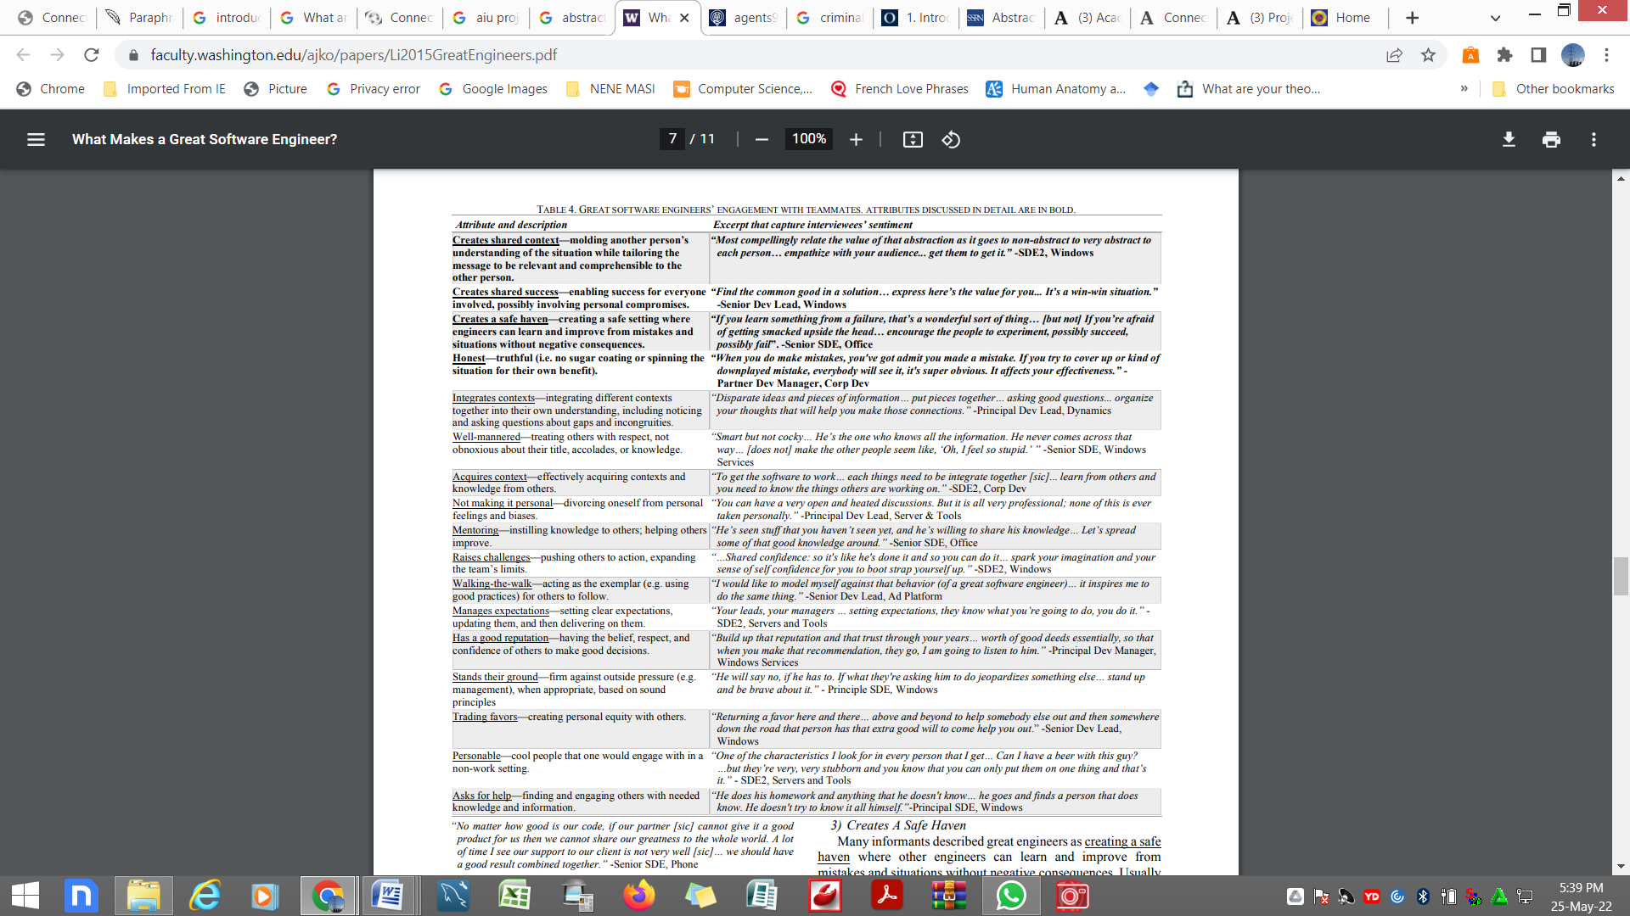

"Regardless of how excellent our code is, if our partner [sic] can't deliver a nice product for us, we won't be able to share our brilliance with the rest of the world." I frequently see that our customer care is inadequate... We ought to be able to achieve a great outcome by combining our efforts."-Senior SDE, Phone

Great engineers, according to multiple assessments, made shared success bidirectional between management and key stakeholders. Administrators needed to place designers in settings where they could succeed, and scientists needed to collaborate with management to achieve mutual success. Brilliant engineers had a greater grasp of the complexity, whereas management had a broader view: "It's a multiple conversation..." That anything is likely to go wrong with this piece of code or this functionality down the street, and you need to notify your boss." Phone: -SDE2, -SDE2, -SDE2, -

This trait most likely assisted in avoiding problematic 'temporal hunger' scenarios, as described by Perlow [31], in which teams experience crises owing to a lack of common knowledge of position and goals.

CREATES A SAFE HAVEN

Brilliant engineers, according to several sources, providing a secure sanctuary where other engineers may learn and progress from mistakes and situations without fear of repercussions. Informed sources believed that if engineers are fearful of making errors, their progress will be slowed:

"Whether you're pursuing a job route or anything else, if you're not insecure, you'll provide your greatest result... Because there is so many turnovers these days, one of the issues that managers confront is maintaining personnel." -Ad Platform Senior Dev Lead

The lack of this trait was also cited by sources as a key cause in talent loss. Informants did not want to operate in unsafe conditions and frequently skipped such workgroups:"If I make a single mistake or don't comprehend something, I'll hit you on the wrist... And you'll only be judged if you pretend that everything is perfect, even if it isn't... And then there's this extremely strange, perhaps unhealthy environment where anyone says something."- Principal Dev Manager, Windows Services

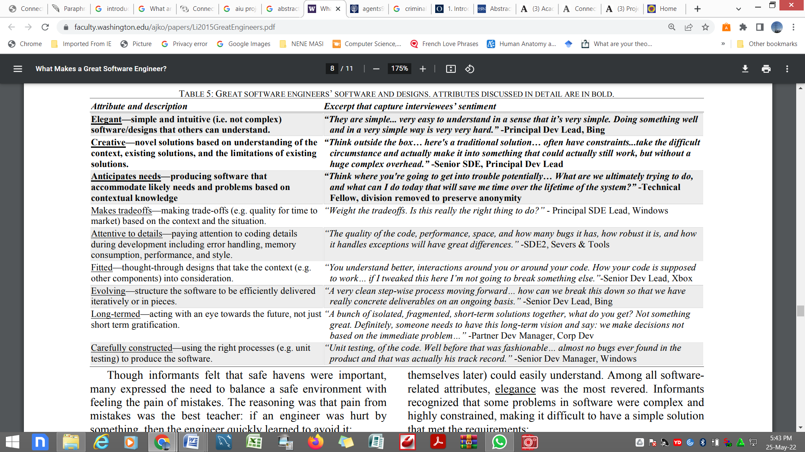

Despite the importance of safe places, several whistleblowers stressed the need to walk the fine line between a secure setting and suffering the agony of errors. The idea was that the greatest lesson was agony through missteps: if an engineer was wounded by anything, he or she rapidly learnt how to prevent it:

"I think that making individuals suffer the consequences of their own errors... I suppose the greatest thing to study is to cope with the consequences of the actions who are being committed."-Principal Dev Lead, Office Honest

According to studies, honesty was significantly more crucial than 'assurance.' It all comes down to smart scientists producing reliable data. Engineers who provided a version of reality that fit his objectives were distrusted. "Wealth comes from someone else believing in you, and part of that belief is that they ask, 'How much do users do?'" "I know this individual normally tells it like it is," Leakers reasoned, "so I'll believe them when they say something is fantastic because they're not trying to deceive me or make themselves seem good or whatever." -Windows Services Principal Dev Manager

Leakers also disliked wasting time blaming others for their difficulties. They believed that exceptional designers would commit their time and resources to solve the issue:"Rather than focusing on how to solve the problem at hand, [other scientists] were more concerned with "How can I make absolutely sure that nobody comes back and thinks that maybe it occurred because of anything I did?" It really doesn't matter... [This excellent engineer] has a way of stating it. What important is the present moment. "How are we going to get over it?"- Senior SDE, Windows Software Product

Nine qualities of the technology that outstanding programmers produced were mentioned by intelligence officials (see Table 5). Our sources, many of whom are outstanding engineers themselves, noted elegance in the code written by other brilliant engineers, much as painters admire the work of other artists.

ELEGANT

The technology of smart engineers was praised by leakers as appealing, with simple and intuitive ideas that everyone (even themselves) could understand. The most crucial of all program characteristics is beauty. Several computer issues were technical and limited, making it difficult to come up with a simple strategy that met all of the requirements, according to Leakers: “"The aesthetic... there was always a sense, everything was neat... extremely short," the author recalls. "OK, this gentleman, he understood what he was talking about," it was obvious simply by looking at it.... There are no extras included in the package. Everything is how it should be: only the required and adequate items are there. It's safe in terms of money."-Windows, Senior SDE

It was also important to avoid complexity, according to the informants. Bugs were more likely to appear in complicated ones, and repair costs were higher (if problems were fixable at all). When the design was brittle to change, it was also more expensive to evolve the system: "Don't make things too difficult for yourself... When you make things simple for yourself and your customers, they become easier to manage in the long run... Customer complaints are fewer in your area."-Senior Dev Lead, Dynamics

CREATIVE

Several authors regarded extraordinary engineers' designs as "innovative," containing "new conceptions based on an understanding of the context's boundaries, existing ideas, and present answers' limits." According to reports, there must have been two key components to developing new solutions. First and foremost, outstanding designers were conscious of the restrictions and requirements of the particular situation:"If you're seeking for something truly innovative...or merely a solution that goes above and beyond the present standard," says the author, "consider the challenges that are now being forced on the environment." ability to perform According to the Principal SDE Lead, outstanding designers were aware of current technology and knew how to use it (and not be creative). This is significant when well-known solutions are preferred because they are less costly and hence less fallible: "Right now, you're focusing all of your creative energy on reinventing already existing concepts, which is a waste of time."-Principal Dev Manager, Windows Services

Despite this, the majority of respondents indicated that unique obstacles arise often in software development, necessitating the hiring of great engineers capable of solving problems: "When there isn't an obvious pattern, finding commonalities and learning how to leverage them is crucial so you don't have to repeat cycles all the time..." Functional capacity of the Principal Project Manager

PREDICTS REQUIREMENTS

Several authors praised exceptional architects' preparations for predicting and reacting to weather forecasts that were unknown at the time of its construction. Size (e.g., more customers), pragmatism (e.g., development progressing to the point that new goods were feasible), and connectivity (e.g., collaborating with various computer products) were all stated frequently by secret services: "QQ is a texting app in China. It is used by hundreds of millions of individuals on a regular basis. This method was devised fifteen years ago, when QQ had only a few million monthly active users. It continues even now, which really is fantastic. It's fantastic to have a system that scales so effectively and predicts all of the issues it'll face."SDE2, Severs & Tools

More than any other characteristic, Leakers admitted to having a tendency to overstate demands in the face of hardship, squandering money on unnecessary flexibility. Some people believed that anticipating the future was hopeless, therefore they instead opted to prepare for immediate needs while leaving room for improvement:"Are you able to develop something that will survive the next two decades?" No one is so bright as to be competent to foretell the future with such accuracy; instead, I will regularly change to satisfy various requirements."”-Senior SDE, Office

TRUTHFULNESS VULNERABILITIES

Our findings, like those of any other empirical study, are vulnerable to a number of validity issues. The lack of a precise and widely accepted concept of "software engineer" jeopardizes the construct's credibility. Sources were typically aware that we'll be discussing writers who wrote code for customers to use, and we clarified any ambiguities. For our interview and analytic techniques, content validity dependability is a concern. When questioned, most informants could only come up with a few essential qualities; given more time to think, they may have come up with a lot more.

Although our research was comprehensive, other researchers may come up with different features, classifications, or models than we did. Validation is also a problem with our sample method. Despite the fact that our 59 interviews generated a wealth of information, even for Microsoft, which employs tens of thousands of engineers, it was a small sample. As a result, a number of prejudices evolved, such as a lack of female participation (they had maybe three among our 59 respondents). Furthermore, they gathered data just from scientists in Seattle, Washington. The findings, particularly those related to management, might not even apply to other situations nations. When it comes to persons and groups, the size of the organization might have an impact on generalization.

Despite the fact that Ms has a well-established approach, tools, and answers, the conclusions may not be relevant to a wide range of situations (e.g. start-ups). Despite the fact that Microsoft is a software corporation, Leakers highlighted bad conditions in industries other than computing, including such banking and retail. It's unknown whether all people have the same characteristics (or criteria). Because Microsoft is a successful corporation that provides product that is utilized by millions of people, the findings are remarkable and intriguing.

DISCUSSION

Almost all of the attributes we observed in good computer developers have been documented in earlier studies to a certain degree, including such [1][3][27], and the bulk of them are comparable to traits important in other occupations, such as [11][21]. On the other hand, our findings are the first to characterize and categorize a wide range of documentation. There are a slew of major ramifications as well. To begin with, our findings indicate that productivity is simply one component of success. Leadership (e.g., defining targets), colleagues (e.g., building a sanctuary), colleagues (e.g., asking for help), alliances (e.g., attaining improvement districts), and sometimes even oneself (e.g., perseverant) all have a role in how the notion is put into practice. This supports the idea that software development is both a social and a technological endeavor. Sending the code alone is sometimes inadequate. According to our findings, excellent software engineering necessitates designers making wise, contextual decisions that are appealing, imaginative, long-term, and consider the forest and the trees.

Second, despite the fact that it is rarely highlighted in the machine learning profession, the findings imply that effective decision-making is critical. Insiders claim that there are a myriad of options though I'm not sure what to do or how to accomplish it. that not all of them are good. Engineers are increasingly tasked with making decisions in more complex and perplexing situations as their careers grow, often with far-reaching effects. Designers must have the capacity to make sound decisions, which encompasses the characteristics stated in Section IV.B and elsewhere finally, data shows that the capacity to learn new skills is more important than any specific core knowledge. Resources used a variety of approaches, including creating software, even within the same department (For example, Stardust, a Ms version is Hadoop). Apparently used to be a lot of argument over which was more important: technical concerns (such as construction) or commercial challenges (such as marketing). Rather, the great majority of responses underlined the need of always acquiring new skills (i.e., continuous development), with many seeing it as a key characteristic of exceptional scientists.

The traits we've identified and outlined might help researchers, novice architects, managers, and instructors. In the remaining sections of this article, we'll discuss the implications of our results and how we may build on them. And Scientists

These findings raise fundamental doubts about our present understanding of the elements that determine software development effectiveness. Procedures [32], preliminary costs (e.g., COCOMO [33]), collaboration [34], and a workable idea [35] have all gotten a lot of press. Many of the underlying characteristics we uncovered, such as fostering consistency and painstakingly manufactured, have yet to be researched, while others, such as coordinated, provides a safe refuge, and matches, have. Individualism, institutions, and, in the vast majority of situations, a substantial component are likely to be at the foundation of these issues.

These studies found a few potential questionnaire design themes. We aren't aware of any tools that help engineers, for example, be more courteous in emails, analyze choices, or see the forest through the trees while making decisions. Engineers, especially those who are new to the discipline, may benefit from research that focuses on supporting and teaching these abilities.

FOR INEXPERIENCED ENGINEERS

Amateur software developers frequently doubt their ability to progress to the level of exceptional engineers [1]. Based on our findings, they should strive towards a set of characteristics. Workshops, entrepreneurship, coaching, and ego are all possible ways to improve things (e.g. for personality traits). Researchers may also explore into drugs that might help certain qualities grow more rapidly and easily.

Our data may also be used by trained personnel to assess their suitability with potential employers. The engineer's fit with the design is crucial, as noted in Section IV.A.2 on performance. The qualities that beginner engineer’s value can be utilized to evaluate a potential team's compatibility.

These findings may also aid newcomers in more effectively promoting themselves to organizations. Because these skills are highly appreciated by experts and specialists, application engineers should make a concerted effort to demonstrate that they possess or can acquire them. This entails emphasizing the features in applications and during opening statements at conferences.

For Managers Our respondents highlighted apprenticeship, problem-solving, and walking as crucial abilities for scientists in management and managerial jobs. A new study may look into how to assist engineers in developing their leadership skills. Our findings might help project advisors make better recruiting selections and enhance their own skills. Managers should be able to more readily identify candidates who suit the team's culture and environment. Engineers that aren't aligned (working on their own projects), aren't well-mannered (as many engineers have noted), or refuse to accept assistance should be avoided. Finally, our findings imply that executives should explore honing these skills inside their current organizations. Administrators may need to combine these findings with other research to create a society that attracts, produces, and maintains outstanding designers.

FOR EDUCATORS

These studies also reveal significant curricular issues, educational demands, and educational goals in formal computer science and software engineering degrees. Administrators might want to think about introducing programs to their curriculum that aren't already available. We discovered, for example, that decision making is a critical component of software engineering, despite the fact that the ACM Computational Curriculum [6] does not address it. Students could benefit from a decision-making course (for example, one that covers Simon's model of rational choice [36], Klein's naturalist decision-making technique [37], or case studies of software engineering decisions).These data may be useful to software engineering professors in evaluating their teaching methods. Despite the fact that most software engineering courses stress transmitting knowledge and abilities (the what), such as earlier work on test automation and advanced analytics, the bulk of excellent engineer characteristics focus on how rather than what. Teachers should consider how they may assist students in achieving their software engineering objectives. Existing project-based courses, for example, may use the attributes identified in this study to assist students evaluate each other's conduct, as well as quasi-code characteristics like beauty, predictability, and uniqueness.

Finally, teachers should make it clear what pupils will not learn in the classroom so that they are aware of any potential gaps and may seek out alternatives outside of the classroom (e.g. internships or open-source projects). For example, self-reliance may not be appropriate for academic reasons and may be best learnt through mentoring; yet, professors should teach students that it is an important component of software engineering knowledge.

FUTURE WORK

Though this book is an excellent place to begin learning about computer science, there are a few areas where more research should be conducted. It is feasible to look into uncommon or common pairs of features. Further research may be needed to provide more thorough and complicated descriptions, assessment methods, or effect evaluations on software engineering outputs for each of the features mentioned in this study. When computer engineering skills are compared to attributes in other sectors, it may reveal more about the phenomenon's distinctive properties.

These findings say very little about the relative importance of traits (such grading or singularity) or the impact of situational factors (e.g. gender or background). We did not do an examination of their perspectives for our interview study since it would have been invalid. We didn't ask informants about all of the features, and when asked about attributes from prior interviews, they frequently agreed or altered their thoughts. Future studies might go even further into this intriguing topic. Thanks to experiments like these and the others that our assumptions inspire, our research community can begin to understand software engineering not just as a purely technical discipline of tools and processes, but as a technological constraint, with specific people contributing and their collaborative partnerships stoking operating system advancement.
SUMMERY
Software engineering is an engineering subject focused with the design of organized systems, as the name indicates.
These applications are carried out by software engineers, who use software engineering ideas to design, construct, manage, test, and evaluate computer software. With a few mouse clicks, these freshly built data centers and software can tackle complicated issues. Software engineering is evolving at a quick pace, and its importance in today's world is growing. As the need for vast amounts of programming grows, so does the need for software engineers. The rapid expansion of the internet, for example, has necessitated the development of new methods for ensuring cyber security in software systems.
Programming engineers' needs, duties, and issues have increased considerably as software controls and expand technology in various aspects of today's world.
Moreover, the rapid rise of electronically consumers (e-Comers) in terms of application has necessitated the creation of several ways for achieving security in software systems.
With these advancements, software development has become a very dynamic and busy field. This is projected in a straight line. When it comes to software development, database management is vital.
This can take several different forms, but it fundamentally gives data in the form of a structured assembly that can be formally examined. The notion of Relational Database Administration System (RDBMS) is rapidly growing in today's society, giving rise to the management of papacies management systems.
With the notion of accounting excel software in mind; this also makes accounting operations extremely straightforward. Engineering, athletics, science, medical practices, architecture, and other related disciplines and fields all require software that improves and simplifies labor. In the subject of software engineering, there are several options. Furthermore, current software programs can be upgraded to make them easier to use and access.
Apart from the technical and development aspects of software engineering, it also provides a wide range of work options.
- Software Application Developers
- Game Developers
- Security Analyst (cyber)
- Information System Management
- Multimedia Programmers
- IT Consultants
- Web Development
- Web Designers etc.
Most of these options are highly dependent, and they provide a huge potential for those who possess such information.
Teaching and training of interested persons is in growing market in the academic area.
This applies to both rich and developing nations, and also international bodies throughout the globe. Several specialists are employed to teach and educate people in order to meet the growing competition for jobs.
In Ghana, for example, software has resulted in the creation of apps for mobile banking, money wallets, and products & utility transactions.
Commodities as well as other business items are exchanged electronically utilizing apps designed by computer programmers in the field of agricultural commerce.
The following are examples of some lesson I’ve learnt from topic:
This essay has taught me a lot, and it has improved my comprehension and awareness of how important it is to be able to study easily. It has given me a lot of thoughts about the possibilities for building additional systems and better software for system applications, which will ultimately make it easier to complete jobs. This is a time-saving sector that will boost production in a variety of areas. I've also learnt about the many employment prospects available in software engineering.
Utilizing Information Can Help You Learn More Effectively At Atlantic International University:
Because software engineering is used in so many aspects of our daily lives, knowing it will not only broaden my horizons but also provide me with the core skills I'll need to deal with the problems I've identified in my study plan. This topic has peaked my curiosity in learning more about Information and Communication Technology (I.C.T.) and Relational Database Management Systems (RDBMS):
This is a paradigm which relates to data which may be arranged to give details and then formally analyzed.
The plan is basically a place where data may be safely kept on tablets and communicate with others.

CONCLUSION

This article has developed from the premise that most software development problems can be traced to the uncertainty inherent in such endeavors. The two most direct strategies for achieving more effective management of soft- ware development are to reduce the absolute amount of uncertainty within a project and to facilitate the information flow to decision makers confronted with uncertainty. The developmental context established by adopt- ing an evolutionary development perspective should result in less uncertainty through a conceptual simplification of the software product, and a capability to fully exploit modern software practices. Information flow is correspondingly enhanced through the early reception of feed- back from project sponsors, and an organizational design that matches information processing requirements and capacities throughout the pro- ject life cycle. A further advantage of this management perspec- tive is its flexibility. Regardless of the size, source, or focus of a software development effort, a single management approach suffices with the only variation being the number of versions that compose the software product. All planning and control mechanisms can be applied to all projects resulting in consistent and understandable policies and procedures. While this perspective is advocated for all organizations, existing policies and constraints of particular organizations may preclude full or even partial adoption. A number of organizations have realized success in an area where success is not common by following practices similar to those described. Obviously, success cannot be guaranteed. Any commitment of resources in implementing their practices bears a risk, but this risk must be contrasted with those costs currently traced to late, or otherwise unsatisfactory, soft- ware products.

REFERENCES

1] A. Begel and B. Simon, "Novice software developers all over again," International Computing Education Research Workshop, vol. 1, no. 425, pp. 3–14, 2008. [2] A. Begel and B. Simon, "Novice software developers all over again," International Computing Education Research Workshop, vol. 1, no. 425, pp. 3–14, 2008.

[2] M. Hewner and M. Guzdial, ACM Technical Symposium on Computer Science Education, 2010, "What game developers seek in a new graduate: interviews and surveys at one game company."

[3] L. Gugerty and G. M. Olson, "Debugging by Skilled and Novice Programmers," ACM Conference on Human Factors in Computing Systems, pp. 171–174, 1986.

[4] "A overview of software measurement experiences in the software engineering laboratory," Hawaii International Conference on System Sciences, 1988, pp. 293–301, F. E. McGarry and J. D. Valett.

[5] Communications of the ACM, vol. 11, no. 1, pp. 3–11, 1968, "Exploratory empirical experiments comparing online and offline programmmg efficiency."

SIGCSE Bulletin, vol. 38, no. 1, pp. 456–457, 2006. [6] "Computing curriculum 2005: the overview report," SIGCSE Bulletin, vol. 38, no. 1, pp. 456–457, 2006. "Computer science curriculum 2005: the summary report," SIGC, R. Shackelford, Andrew McGettrick, Robert Sloan, H. Topi, G. Davies, R. Kamali, J. Cross, J. Impagliazzo, R. LeBlanc, and B. Lunt.

[7] IEEE Software, vol. 23, no. 6, pp. 19–25, 2006. "SE2004: suggestions for undergraduate software engineering programs." "SE2004: suggestions for undergrad computer science curriculum content," IEEE Software, vol. 23, no. 6, pp. 19–25, 2006. T. C. Lethbridge, R.J. LeBlanc, A. E. Kelley-Sobel, T. B. Hilburn, and J. L. Diaz-Herrera, "SE2004: suggestions for undergrad computer science curriculum content," IEEE Software, vol. 23, no. 6, pp. 19–25, 2006.

