SHADRACH KABU MASI
UN75566SEL84746

COURSE NAME:
(MSc Electrical Engineering)

Assignment Title:
(Climate Change)

ATLANTIC INTERNATIONAL UNIVERSITY
MAY/2022
Abstract
Global warming is a subject that has been studied extensively for many years. According to the fossil record, humanity already knew a lot about Earth's ecosystem before we arrived. We are currently living in a unique era in which scientific advances have enabled us to determine not just the age of the earth, but also the age of the entire cosmos. However, there are several unknowns, some of which may have a significant impact on the future quality of our lives. The nature of this change continues to be a matter of controversy among specialists and the general public as our modern civilization experiences an undeniable phase of rising temperatures. Yes, you are correct. As a result, it is critical for those of us in the learning institution to assist our graduates in obtaining the most up-to-date knowledge with which to guide their own thinking and actions in a fast-evolving environment. This work examines global warming academic materials and adapts themes from these resources to a research-based higher education sector.
1. Introduction
The world community has recently dedicated a great deal of thought to the topic of global warming. This concern stems from the negative effects of global warming on humanity's living situations. Even though some economic issues, such as inequality, have traditionally been discussed in emerging regions such as Sub-Saharan Africa, Latin America, and some Asian countries, global warming has taken center stage in worldwide development discussions. Because poorer countries, particularly those in Africa, are more exposed to climate change, they are becoming increasingly concerned.
Africa's long-term prosperity and expansion are jeopardized by global warming. As a result, unless the negative consequences of global warming are addressed, African countries' efforts At first glance, obtaining the Mdg Targets may appear to be a foolish concept dream. Africa is the least responsible for global warming among some of the countries; nonetheless, Geographical position, the continent is especially exposed to the impacts of global warming. over-reliance on rain-fed agriculture, as well as features such as vast unemployment and insufficient capability.
Changing weather patterns, which have an impact on agricultural production while lowering food security, decreased water security, fisheries resource availability in large lakes due to high temperatures, and migratory scalar infections are just a few of the major quality-of-life consequences of global warming. Furthermore, environmental regulations increase the likelihood of conflicts over limited groundwater resources in low-lying coastal areas with dense populations. Because agriculture accounts for a larger share of many of these African countries' GDP, the negative environmental issue of declining crop output stymies economic progress. Furthermore, for the majority of Africans, subsistence farming is their primary source of income (i.e., work).
After the Agreement was founded on May 9, 1992 [1], Ghana signed the United Nations Framework Convention on Climate Change (UNFCCC) in June 1992 at the Rio de Janeiro General Assembly to cope with climate change. Three significant physiological consequences on the environment reported in Ghana [2] are a warming trend, altering rainfall patterns, and rising sea levels.
According to Owusu et al. [3,], Ghana's rainfall pattern is evolving toward a longer dry period and the disappearance of the rainy season. Despite signing the pact, Ghana continues to suffer from the severe effects of climate change, including health problems, agricultural system disruptions, and other problems. Reduced rainfall has resulted in coastal flooding and a low working water level at the country's lone hydroelectric plant (which generates 80 percent of the country's power) [4]. Ghana's economy is suffering from the negative consequences of global warming due to a lack of capacity to implement adaptive measures to address environmental concerns and the socio-economic ramifications of global warming.
The expansion of the environment has created a torrent of uncertainty for rural places whose livelihoods are highly dependent on temperature and precipitation ([5,6]). According to [7], global warming harms basic food supply chain components such as soil, water, and biodiversity. According to the World Bank [2,], a combination of factors such as sexual choice, cultural norms, succession systems, and home commitments make women particularly sensitive to the effects of global warming.
Because Ghana's economy is Farming, electricity, and forests are all industries which are heavily reliant on each other. very vulnerable to climate change and fluctuation, previous research on adaptation measures is critical. The research is summarized in this report by;
- Global warming variations and projections in agricultural output are being investigated.
- Evaluating the unpredictability and projections of global warming in the energy sector.
- Examining the effects of global warming variations and projections on people's wellbeing.
- Addressing the warming of the planet on unemployment, sexuality, and wellbeing.
2. An Overview of Ghana's Global Warming Trends
Ghana is Ghana lies in West Africa, bordered to the north by Burkina Faso, Togo to the east, Cote d'Ivoire to the west, and the Gulf of Guinea to the south by the Gulf of Guinea. It's located within 4.50°N and 11.50°N latitudes, and 3.50°W and 1.30°E longitudes. The nation covers 239,460 square kilometers of land and 8520 people per square kilometer of water.
Since roughly 2010, the country's population has been estimated to be around 25 million, with a 3.5 percent annual growth rate [8]. The bulk of the people in this group is teenagers. The main exports include cocoa, gold, hardwood, diamonds, alumina, manganese, and thermal plant hydropower. Only recently has the country begun to export crude oil. Ghana's poverty rate peaked at 52.7 percent in 1992/1993 and then dropped to 40.5 percent in 1998/1999, 28.5 percent in 2006/07, and 25.2 percent in 2013/14.
The country's average annual temperature is between 20 and 40 degrees Celsius. Despite this average annual temperature, temperatures in Ghana's southern and northern areas can reach 17 and 39 degrees Celsius, respectively, on rare occasions. As one moves north to south in Ghana, the number of rainfalls. The wettest part of Ghana is the far southwest, which receives about 2500 mm of rain per year.
The annual rainfall in Ghana's extreme north, on the other hand, is less than 1200 millimeters. Many peaks and single rainfall depth regimens are the two predominant rainfall patterns in the country. According to the twofold maxima regimes, the two maximum seasons in Southern Ghana are April to July and September to November. Northern Ghana experiences a single maximum regime from May to October, with a protracted dry season from November to May. Temperatures in all of Ghana's ecoregions have risen over time, while rainfall levels have decreased and patterns have become more irregular [1].
CO2 (Carbon Dioxide)
In 2000, Ghana's total direct pollution was estimated to be 13.2 million tonnes of CO2e. (using carbon dioxide, methane, nitrous oxide, and perfluorocarbons as examples). This figure is 174% greater than the -17.8 MtCO2e figure from 1990 and 97% lower than the 23.9 MtCO2e figure from 2006. Carbon dioxide emissions increased by 107% between 1990 and 2007. According to the Representative theory, as a company grows and expands its growth frontiers, the number of fossil fuels burned increases.
Figure 1 shows the elements of carbon dioxide in the atmosphere for the years 2000 and 2006. Methane was the most common greenhouse gas in 2000, accounting for around 46% of total emissions, followed by nitrous oxide (34%), and carbon dioxide (3%). (19 percent). For the year 2000, methane, nitrous oxide, and carbon dioxide emissions are anticipated to be 6.2 MtCO2e, 4.5 MtCO2e, and 2.6 MtCO2e, correspondingly. However, in 2006, carbon dioxide overtook methane as the most important element of greenhouse gas emissions, accounting for around 46 percent of total emissions. Methane (34 percent) and nitrogen oxides (14 percent) came in second and third, respectively (20 percent ).
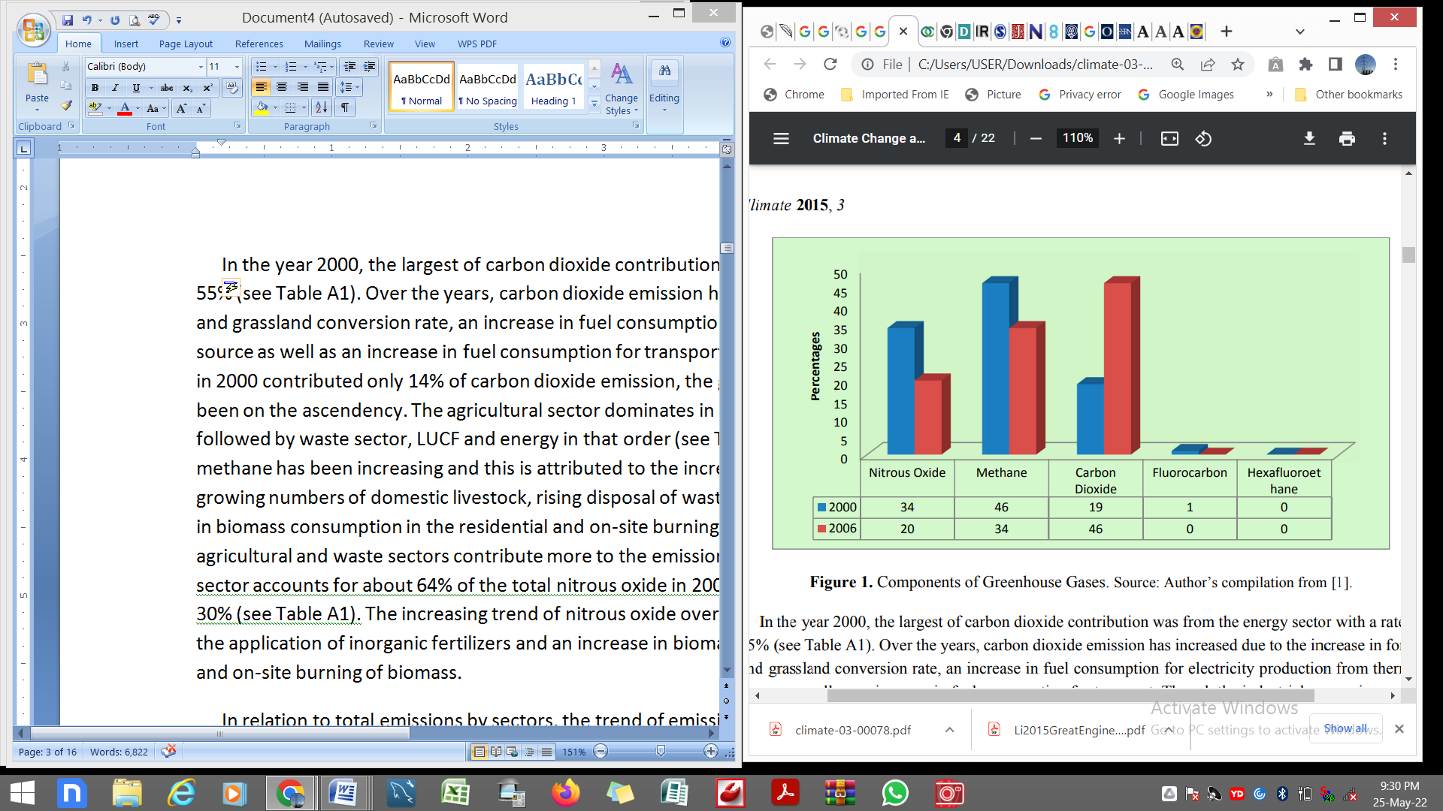
In 2000, the energy industry was the major source of carbon dioxide, accounting for 55% of total emissions (see Table A1). Carbon dioxide emissions have risen over time as a result of increasing forest and grasslands marketing strategies, additional fuel usage for generating electricity, and increased fuel consumption for transportation. Although the industrial processing sector contributed just 14% of CO2 emissions in 2000, it has steadily expanded since then.
Agriculture dominates in terms of methane emissions, followed by the recycling industry, LUCF, and electricity in that order (see Table A1). Methane emissions have risen in recent years as a result of increased biogas from more domesticated animals, increased waste disposal in deep landfills, and increased biomass consumption in residential and on-site biomass burning.
These reasons contribute to the agriculture and garbage industries being the largest methane emitters. Similarly, in 2000, agriculture accounted for almost 65 percent of total n2o emissions, with LUCF accounting for 31 percent. (See Table A1) The rise in n2o levels over time might be associated with increases in the use of inorganic fertilizers, in addition to a rise in bio-fuel combustion in residential areas and on-site biomass combustion.
The trajectory of carbon output by sector fluctuated from 1991 through 2007; the energy sector had the lowest CO2e emissions, with 3265.58 GgCO2e computed in 1991. (20.5 percent of total emissions, including LUCF). However, the sector assumed a high radiation rate in 2000, with an estimated emission of roughly 5862.31 GgCO2e (about 48 percent of total emissions). The energy sector's contribution to overall emissions dropped in 2003, but climbed somewhat in 2006. Regardless, emissions from the energy industry have been constantly increasing (see Table A2).
Figure 1 shows how pollution from manufacturing applications has decreased over time. Carbon dioxide emissions have decreased as a result of technological advances that have the potential to reduce pollution in the atmosphere. LUCF concentrations, on the other hand, have been steadily rising over time. While industry emissions were negative 150 percent of the total pollution in 1990, they quickly climbed, reaching around 35 percent in 2003 before falling to 23.4 percent in 2006. The loss of ecosystems as a result of urbanization and poor agricultural methods is causing a sharp increase in LUCF contamination.
From 1991 to 2007, the agricultural sector's carbon trend has been indecisive. In 2001, the agriculture sector had the greatest energy output as a percentage of total emissions, hitting 45.9%. Pollution dropped dramatically in 2005, then climbed marginally in 2007. Over the decades, the agricultural sector's pollutants have grown slowly (see Table A2). From 2001 to 2007, the proportionate emission of greenhouse gases by the garbage industry has been growing, with the exception of 1991. This rise in waste-related pollutants can be ascribed to growing populations and ineffective waste disposal..
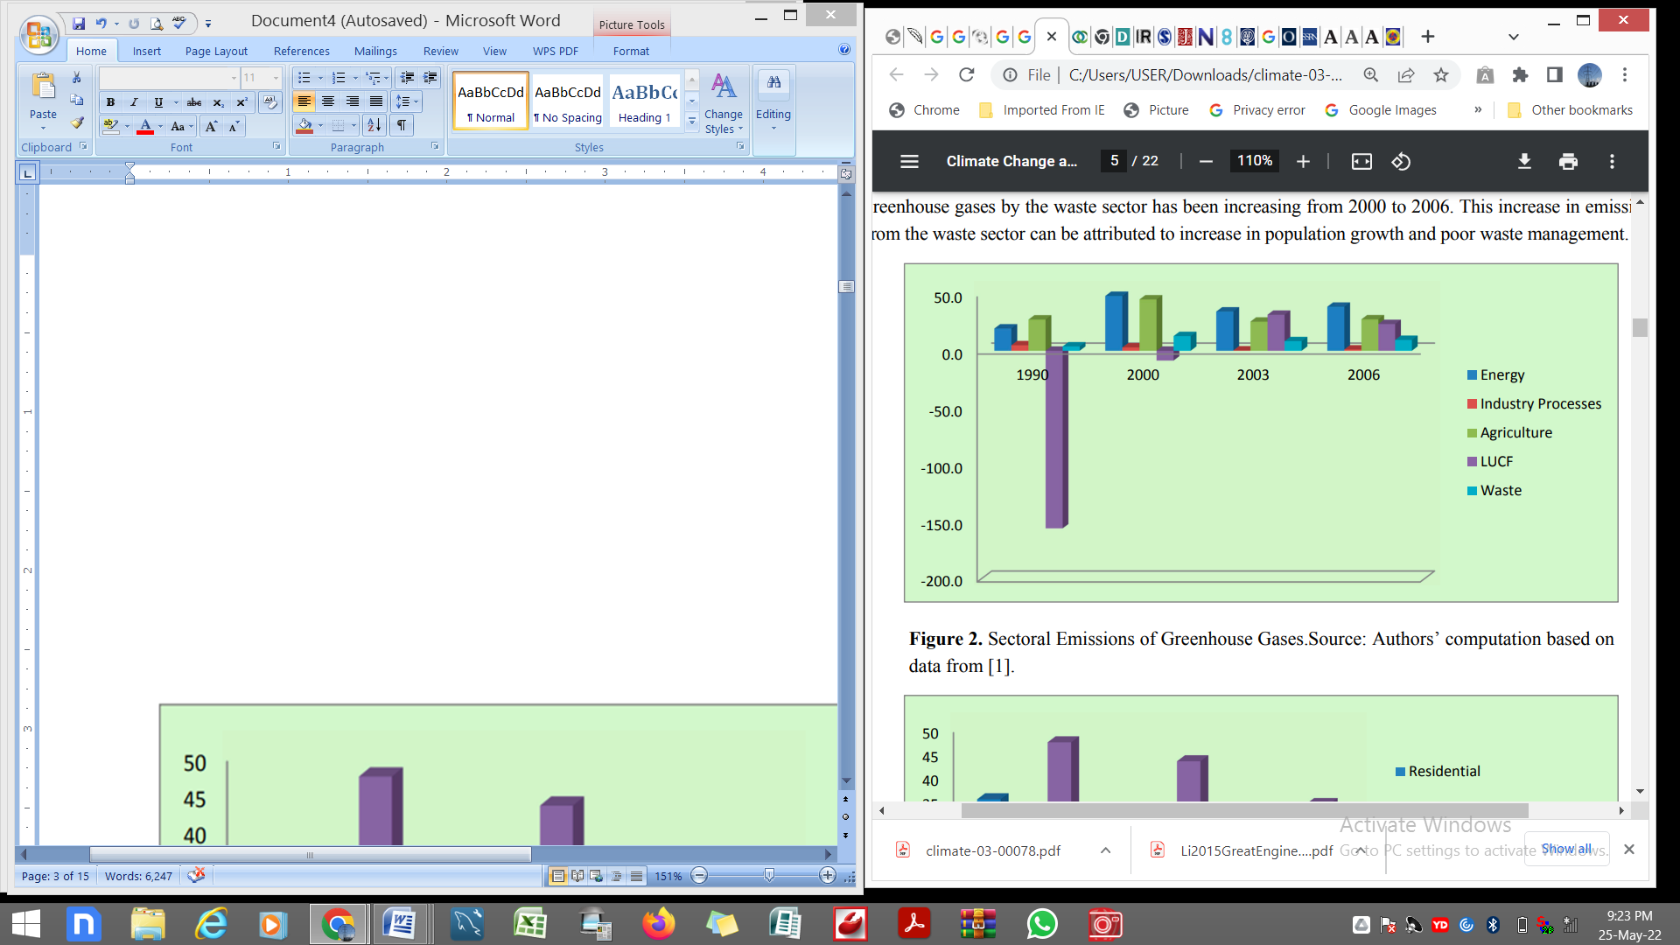
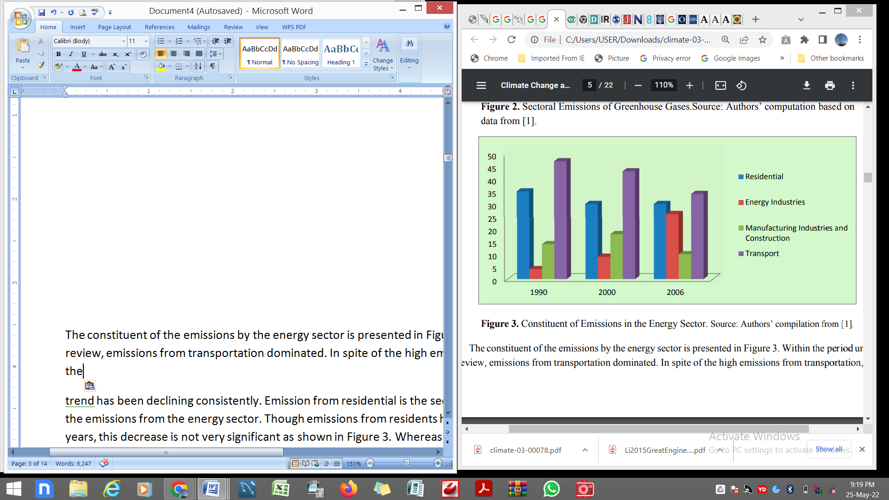
Fig 3 depicts the energy sector's contribution to total emissions. Transportation emissions dominated over the period under investigation. Despite considerable transportation-related emissions, the trend has been downward. Residential emissions account for the second-largest share of total energy-related emissions. Although resident emissions have decreased over time, as shown in Figure 3, the decline has not been considered. While the trend in manufacturing and construction emissions fluctuated from 1990 to 2006, the trend in energy industries increased steadily.
3. Literature Review
In the last few decades, anthropogenic global warming has become a globally hot topic. This is because recent temperature increases are already affecting the health and biomedical applications of all regions.
Humans are the principal cause of global warming, according to overwhelming scientific evidence and consensus ([9, 10]). Before the Industrial Revolution, the number of hydrocarbons in the atmosphere was 279 parts per million, but by 2008, it had risen to 389 parts per million [11]. Periodic changes in CO2 levels have occurred since the industrial revolution, but the overall trend, according to [12], suggests a rise in intensity. Over the previous two decades, greenhouse gas emissions have risen significantly. Carbon output climbed at a rate of 3.3 percent per year between 2000 and 2006 [13], up from 1.3 percent per year in the 1990s.
It is undeniable that human-caused global warming is occurring. According to the IPCC, global temperatures have risen by 0.7 degrees Celsius on average during the last century. Over the previous 26 years, the rate of warming has been remarkable, with eleven of the twelve hottest years happening between 1996 and 2015 [14]. As evidenced by persistent droughts in the African Sahel and the expansion of the disease transmission zone in tropical Africa [10], climate change is beginning to influence governments. The frequency of confirmed weather-related natural disasters is constantly rising around the world. The number of big disaster reports has roughly tripled since the mid-1950s. Floods, diseases, and cyclones accounted for thirteen (13) of the fifteen (15) "flash screams" for immediate global assistance. [15] It was five times higher than the year before. In Ghana, the greenhouse effect is showing itself as high heat and erratic rainfall across all vegetation types [16].
As the globe heats, changes in weather events, acidity, and moisture content are also expected [17]. Environmental change's total influence on the world’s largest ecosystems is yet uncertain in light of this. Flooding is caused by rainstorms in some locations, whereas drought is caused by a lack of rainfall in others, such as the Mediterranean [17]. According to the IPCC [17], by the end of the twenty-first century, weather events are predicted to warm by 1.5 to 5.9 degrees Celsius, culminating in coastal floods as mountains melt. the most recent findings on the other hand, reveal that many global warming projections are approaching the IPCC's upper bound. Sea levels, for example, have increased by 30 cm, far above the IPCC's predictions [18].
3.1. Ghana's Global Warming and Variability
Most countries in Sub-Saharan Africa, including Ghana, are threatened by climate change and global warming. According to a study conducted by [19], about 35% of Ghana's entire landmass has been transformed into the desert. Desertification is predicted to occur at a rate of 20,000 hectares per year, which explains why the LUCF sector has recently increased its contribution to greenhouse gas emissions. The continued activity of mankind in the form of primitive farming methods and the ongoing activity of mankind in the form of primitive farming methods The birth rate in Ghana has contributed to desertification as humans convert woodland and agricultural areas into crowded neighborhoods.
The World Bank [20] validated Ghana's remarkable unpredictability in seasonal rainfall within both years. Rainfall was usually high throughout the 1960s, but it fell too low levels in the late 1970s and early 1980s, according to historical statistics. This loss in seasonal rainfall has continued in recent years, as [21] showed using 20-year data that temperatures are rising in all zones of Ghana, and rainfall is decreasing while becoming extremely irregular.
Global warming is expected to have a significant impact on Ghana, notwithstanding seasonal weather and climatic changes. The trend for warmth during the period 2010 to 2050, according to the World Bank, predicts rising in all regions of the country, The Northern, Upper East, and Upper West areas have the highest weather.
On the other hand, the Brong Ahafo region is the coolest. These are contingent on the results of [20]'s numerous weather forecasts. According to the model, temperatures in the three northern regions will rise by 2.1–2.4 degrees Celsius by 2050. Regions of Ashanti, Western, Eastern, Central, and Volta on the other hand, are projected to warm by 1.7–2.0 degrees Celsius, while the Brong Ahafo region is expected to warm by 1.3–1.6 degrees Celsius.
Ghana's agriculture sector is extremely vulnerable to climate change and fluctuation because it relies heavily on rain. As a result, low productivity levels characterize the sector [20]. Climate change and fluctuation have different impacts on Ghanaian households. The livelihood group and asset holding level of the households, as well as the ecological zone in which the household is located, may explain these discrepancies [20].
Expansion of cultivated land, dry season gardening, women taking on additional agricultural chores, Expansion into livestock husbandry, cultivation of early yielding and high-value crops, and increased fertilizer use are among the adaptation strategies used by households in the northern savannah zone.
According to [22], the following are some of the climate variations that have occurred in Ghana, along with their associated periods:
(a) January 1976–July 1976: Extremely hot temperatures,
(b) 1983–1984: Rainfall year following wildfires
(c) October–December 1989: Extremely hot temperatures,
(d) 1991: During the year, there was a significant rainfall.
g) 1995: Nearly 50 days of heavy precipitation,
(f) 2004: Sub-freezing weather was encountered in March–April (Easter) and November–January.
(g) 2005: Livestock mortality sensitive to winter spells,
(h) August 2006: 1 week of intensive rains, and
(i) There was just a large amount of rain in August and September of 2007.
There was also catastrophic flooding in several regions of Ghana's metropolis (Accra) in 2012 and 2013, which left certain people homeless and resulted in the loss of souls. In this research, Stanturf et al. [23] simulated several global warming and climatic variability situations in Ghana's separate areas. These forecasts were based on the information obtained from the numerous meteorological sensors adopted in this research. The following are the weather forecasts:
(a) Accra (Maritime Savannah Area): Researchers calculated that by 2080, variations in rains will vary from 52% drops to 44% increases in rainy season rainfall, depending on their prediction.
(b) Kumasi (Woodland Rainforest Territory): By 2080, weather reforms are likely to vary from 48 percent declines to 45 percent rises in the rainy season. The least increase in wet season rainfall, 1.13 percent, is predicted under their A2 scenario, which normally has the greatest anthropogenic GHG (GHG) effect.
(c) Tarkwa (Tropical Rainforest Territory): Rainfall data fluctuations are expected to vary from 45 percent reductions to 31 percent rises during the rainy season.
(d) Techiman (Vegetation Transition Zone): Rainfall impacts are needed to vary from 46% drops to 36% increases in the rainy season. The A2 forecast, which has the greatest overall GHG impact, anticipates a 2.94 percent decrease in wet season precipitation.
(e) Tamale (Tropical Savanna Area): Rain fluctuations are expected to vary from 36% decreases to 32% increases in the rainy season. The Northern Region, which includes Tamale, is Ghana's northernmost geographic area, with a steady pattern of declining precipitation.
(f) Walembelle (northern Guinea Savanna Zone): Heavy rainfall fluctuations are expected to vary from 25% drops to 24% rises in the rainy season.
(g) Bawku (Sudan Savannah Zone): Weather fluctuations are expected to vary from a 28 percent drop to a 30 percent rise during the rainy season.
The water level in Ghana's seas will similarly rise, according to Stanturf et al. [23]. It could have important implications for both the ongoing and essential interaction between the length and severity of coastal air masses and fisheries yield. Depending on the situations specifically studied, this will be affected by the rise in the earth's crust, which is predicted to climb from 0.13 m to 0.60 m by the late twenty-first century. Using different meteorological factors and three pollution scenarios, [23] calculated the following warming estimates in various weather sensors:
(a) Accra (Maritime Savannah Areas): During the rainy season, temperatures will rise to 1.68 0.38 °C by 2050 and 2.54 0.75 °C by 2080; during the drought, temperatures will rise to 1.74 0.60 °C by 2050 and 2.71 0.91 °C by 2080.
(b) Kumasi (Woodland Rainforest Areas): Annual Rainfall will be 1.71 0.39 °C by 2050 and 2.60 0.77 °C by 2080; the Dry Season will be 1.81 0.68 °C by 2050 and 2.83 1.04 °C by 2080.
(c) Tarkwa (Tropical Forest Areas): Rainy Season will be 1.69 0.37 °C by 2050 and 2.56 0.75 °C by 2080; the Dry Season will be 1.76 0.67 °C by 2050 and 2.76 1.01 °C by 2080.
(d) Techiman (Wilderness Transition Zone): Rainy Season will be 1.77 0.43 °C by 2050 and 2.71 0.85 °C by 2080; the Dry Season will be 1.95 0.79 °C by 2050 and 3.05 1.20 °C by 2080.
(e) Tamale (Tropical Savannah Zone): Wet Season, 1.84 0.46 °C by 2050 and 2.83 0.91 °C by 2080; Drought Season, 2.05 0.75 °C by 2050 and 3.18 1.18 °C by 2080.
(f) Wallembelle (northernmost Guinea Savannah Zone): Wet Season: 1.92 0.52 °C by 2050; Dry Season: 2.10 0.71 °C by 2050; 3.27 1.11 °C by 2080.
(g) Bawku (Sudan Savannah Areas): Wet Season, 1.92 0.53 °C by 2050, and 2.97 0.98 °C by 2080: Dry Season, 2.11 0.68 °C by 2050, and 3.25 1.08 °C by 2080
3.2. Global Warming Variation and Agricultural Predictions
The agricultural sector has been critical in reducing poverty in most developing nations since it provides a living for the majority of rural households. Rural families in Ghana farm 1–2 hectares of land and produce 90% of the country's agricultural output. Despite its importance, the agricultural industry is the most vulnerable sector in poor countries when it comes to global warming since it relies significantly on rain to carry out its operations.
As a result, changes in Africa's crop productivity and food security may be jeopardized ([24,25]). Given that West Africa accounts for around 28% of Africa's population and 17% of its people are malnourished [26], the impact of global warming might exacerbate the region's already low food yield and quality. Ghana's crop-growing practices are diverse, showing dynamic responses to rising population pressures, land insecurity, climatic instability, and new trade opportunities or markets [23]. As a result, most Ghanaian smallholder farmers use several methods to meet their food and working cash needs.
Physically inactive and shift cropping systems, as well as intercropping and rotational cropping, are examples of agricultural approaches that these farmers might use [23]. Growers of cash crops, such as cocoa and coffee, have been known to set aside areas of their property to raise food crops to support their families. The majority of Ghanaian farmers employ intercropping to mitigate the risk of crop loss due to drought or flooding (see Appendix 1). Using the intercropping strategy, farmers may spread their risk across many crops, and subsistence farmers can benefit from a longer growing season during a year with above-average rainfall [23]. The principal limits to agricultural output in Ghana are low soil organic waste and restricted fertility of the soil (in the form of phosphates and nitrates).
Significant topsoil losses owing to wind and river movement in the northern savannah regions have pushed the boundaries further. Ghana is a significant exporter of cocoa and other products, and the industry has played an important role in the country's economic development, accounting for around 3.5 percent of GDP [27]. Cocoa farmers in Ghana give 70–100% of their annual income to cocoa planters [28]. Because of the importance of this sub-sector, any effects of greenhouse gas emissions on Ghana's suitability for cocoa production would have an influence not just on farmers' lives and incomes, but also on the country's total economic growth.
According to [29], over half of Ghana's cocoa is cultivated under moderate shade, which is a type of sustainable land use that helps the environment, nutrition, and profitability. The appropriateness of current cocoa-growing regions in Ghana by 2050 will be considerably reduced due to expected global warming [30]. The evapotranspiration of cocoa plants will rise as the atmosphere warms. According to the Research Centre for Tropical Agriculture [30], by 2050, the peak temperature of the best weather and the yearly temperature range will have a detrimental influence on cocoa-growing countries. According to CIAT forecasts, appropriate cocoa-growing regions will begin to shift around 2030, mostly affecting Brong Ahafo's southern region.
Furthermore, only the areas between the Central, Ashanti, and Eastern regions would see temperatures similar to the current hot weather. Nonetheless, the remaining cocoa-growing areas will continue to really be appropriate for cocoa production, but to a smaller degree than they are now. According to CIAT [30], "by 2050, cocoa production will be concentrated in two areas in Ghana: the Kwahu Plateau mountain ranges between the Eastern and Ashanti regions, and the Central and Ashanti regions." Similarly, using a General Circulation Model (GCM) and a Simple Climate Model, [19] predicted a drop in precipitation for the years 2020, 2050, and 2080. (SCM). Because of the reduction in rains, the cocoa output is expected to decline from 2020 to 2080.
Irrigation accounts for 16% of agricultural production and 45% of total land used for cereal crop yields in Ghana [23]. Rice is grown primarily by irrigation, rain-fed lowland farming, and rain-fed upland farming. As a result, rice yield in the country would be low during years of severe drought. Rice yield in the years 2020, 2050, and 2080 is expected to be low due to anticipated high temperatures and insufficient precipitation. According to [31], agricultural output in West Africa is unlikely to change much by 2030.
Rice is the crop with the most range of diversity (around 8 percent ). Furthermore, West Africa's agricultural output is anticipated to plummet by 99 percent by 2080. Maize, on the other hand, will be less affected by global warming, with yield decreases ranging from 1% to 8% [31]. [23] suggests that existing subsistence farmers be turned into giant corporations to increase rice and other commodity output, which will necessitate larger land holdings. Farmers could also replace conventional grassland idle with short green manure crop fallow, as well as increasing automation, to reduce the amount of personnel needed to cultivate larger acreages [23].
Root crops are also affected by environmental factors, as seen by higher yields during droughts and less apparent productivity fluctuations from year to year. Drought caused crop yields to diminish or be reduced in Ghana in 1990, indicating that global warming had an impact on agricultural production [19]. Climate variables such as rainfall and mean average temperature are linked to root crop yield variability [19]. Total rainfall and root crop yield in Ghana have a substantial positive association, according to the findings of a test. Despite the fact that there is a positive association between root crops output and warmth indices, it is just a minor one.
Based on a variety of climatic scenarios, [19] predicted that tapioca and cocoyam yields would decline over time, with the rate of decline rising as solar radiation intensity rose. According to the forecast, cassava yields would drop by 3%, 14.5 percent, and 54 percent in the years 2020, 2050, and 2080, respectively. Fish populations and habitats are severely impacted by the fishing industry. Warmer weather has an impact on wild fish populations, bird flocks, and death rates, as well as whether or not particular species may be farmed in certain areas [32]. Families that rely on fish culture for a living are in danger of socioeconomic consequences as a result of these fish-related climate changes.
As a result, everyone suffers as a result of these ramifications, from fisheries workers to fishing villages to fish consumers. In research by [33], Ghana was placed 25th out of 33 nations in terms of how sensitive their economies are to the projected effects of global warming on their catch fisheries. The deterioration of Ghana's fishing industry is entirely attributable to environmental causes, reducing the country's capacity to supply local demand and jeopardizing many Ghanaians' financial and living conditions.
"Ghanaian fisherman generates 80%–90% of Ghana's seafood consumption and give jobs for fish market and numerous dealers," according to the tragedy [33]. In addition, fish accounts for 50–70 percent of the protein in the Ghanaian diet, and the fishery contributes roughly 4.5 percent of the country's GDP. The output of fish stocks is tightly linked to global weather conditions, according to Artificial Neural Network [32]. Thus, lower round sardinella capture rates corresponded to years of greater sea surface temperature (SST); while, the opposite is true for anchovies. Precipitation has a significant impact on the productivity and total yearly catchability of species such as tilapia, catfish, and flat sardine.
3.3. Variance in Biodiversity, Land Usage, and Global Warming
From coastal mangroves and rainforests to savannah in the north, Ghana features a broad range of microclimatic zones. Topsoil erosion in northern Ghana might be harmed by natural disasters as well as human-caused damage related to land use. Large inhabitants and rapid land use have resulted in a deterioration trend in land use / cover. This is made worse by a decline in precipitation mixed with rising temperatures, which would be particularly prominent in northern Ghana, making that region more prone to drought.
The vulnerability has grown in northern Ghana due to a variety of thermodynamic and sentient variables, including erosive rainfall, poor soil quality, and fertility, repeated droughts, insufficient inputs, decreased dry-season agriculture, deterioration, frequent and intense wildfires, and overgrazing. Whether climate changes are beneficial or harmful, Ghana's current rate of rapid urbanization, over-exploitation of natural resources, and overall severe land degradation in desertification-prone zones are unsustainable. The northern savanna zone's resilience and productivity will diminish with time. Ghana presently lacks a thorough forest inventory in terms of forest cover [23]. In the early 1900s, forest cover was believed to cover 33% of the nation.
However, by the 1980s, this ratio had dropped by 78% (to 1.8 million hectares), and rain forests were becoming extinct. Given the current rate of tropical forest erosion, 65.5 percent of the land area is predicted to be eroded by 2050, posing a major risk of drought [23]. There were significant changes in the Peatland Buffer Zone. Gyasi et al. [34] revealed that there is still a tight relationship between yearly climatic factors and crop rotation calendars in Ghana's Upper East Region, as well as irrigation demand conditions and overall plant adaptability. Furthermore, [34] found that the average agricultural field area has increased considerably, although the number of signaling plants has remained relatively constant.
The extensive usage of land is exacerbated by the continual and intense grazing of large flocks of animals. Due to the region's current low rainfall, land degradation is a potential. Prolonged grazing, intensive cropping, and climate unpredictability are all contributors to the loss of greenery in Ghana's Upper East Region, according to these data. The variable frequency of precipitation in the Upper East Region is to blame for the diminishing water depth. Furthermore, seed planting with flame harms groundwater [34]. Hydrological predictions for 2020 and 2050 in the Upper East Region suggest a loss of between 5% and 22% and between 30% and 40%, respectively.
[35] employs the stressed life technique to estimate the financial warming of the world on the road network in the case of global warming and building. They anticipate that between 2020 and 2100, Ghana would spend US$473 million on maintaining and repairing its road network as a result of global warming. (I'm using the no-adapt situation.) If the government adjusts the development and introduction of a new road network projected to arise throughout the stock's lifetime, the entire cumulative expenses rise to US$678.47 million (adapt option). This demonstrates how global warming may degrade natural and cultural resources.
3.4. Power Sector Global Warming Sensitivity and Projections
Energy is vital to humanity's survival, and its value to civilization cannot be emphasized. As a result, electricity may be seen as a vital component of economic growth, and energy consumption per capita as a key indicator of human progress. While energy consumption is necessary for growth (as a catalyst), it also contributes to pollution. As a result, numerous energy conversion processes contribute to GHG emissions [36]. In reality, as technology advances, energy consumption grows, but CO2 emissions do not have to climb in lockstep, since energy efficiency and utilization may be improved. The effective use of power is dependent on an effective evaluation of energy requirements and knowledge of the variables that influence energy needs. Consequently, most governments have disregarded the efficiency of electricity assessment, and Ghana is no exception.
In Ghana, the domestic sector consumes a higher share of total annual energy consumption, around 72 percent in 2008. Sustainability inside the shape of oak fuel and carbon combustion) for cooking accounts for the majority of this energy consumption in the domestic segment (76%) [37], trailed by petroleum products for mobility and preparing food (17%) and electricity for lighting systems (7%). When there is no restoration, wood fuel consumption might result in net pollution, even if wood fuel products are renewable and hence carbon neutral.[37] claims that biological woods provide 90% of fuel and charcoal, with an annual deforestation rate of 3%. At this rate, a decade's worth of devastation will be about 30%. The remaining ten percent of firewood and charcoal comes from waste from sawmills and timber mills, as well as new forests.
The consumption of electricity has increased as a result of the Ghanaian government's recent rural electrification program. In the context of sustainable development, the possibility of sectarian conflict, and national electricity strategy, hydroelectric is a source of worry [23]. The prospective generation of electricity from the Akosombo project is complicated, but it's not only about possible global warming because there are questions of transboundary ramifications. One of the primary issues is Ghana's and Burkina Faso's competing interests in the Volta River Basin. Unlike Burkina Faso, which has focused its efforts in the Basin on improving water usage and storage for agriculture, Ghana's major goal is to keep Lake Volta at peak efficiency for generating electricity.
Furthermore, previous meteorological data and hydrological models show that the water level in the Volta Lake is extremely sensitive to modest fluctuations in rainfall. The water table of the Lakes is unpredictable due to the present varied precipitation projections in terms of global weather models. Nonetheless, historical data shows that precipitation has decreased dramatically from long-term norms, resulting in a reduced water level in the Lake. Furthermore, the Akosombo dam was built during one of the rainy times on record, impeding ideal power generation. This shows that hydroelectric energy output is extremely vulnerable to weather conditions.
The recent flaring of gas from Ghana's Jubilee Oil output has alarmed the public and caused debate among contributing nations. The Jubilee Oil Field's huge supply of gas presents difficulties in storage, distribution, and burning. Long-term frocking at the Jubilee natural gas field emits around 1.5 million tons of CO2 per year or about 7% of Ghana's total national pollution [23]. If indeed the gasoline is utilized to generate electricity, it will save over 13,000 barrels of oil each day, resulting in a carbon dioxide reduction of 0.9 million metric tons. Using the gas for power generation rather than flaring might save 2.4 million tons of CO2 equivalents [23].
3.5. Human Health Impacts of Anthropogenic Global warming Uncertainty and Projection
Several studies have shown a link between human health and anthropogenic global warming variability. According to [38], environmental factors, such as high and low temperatures, are likely to affect prevalence and death rates. On the impact of air temperature on a person's quality of life, several studies have come to similar results. According to Woodward [39], humans can cope well with temperatures in the middle of the range, but 'uncommonly' high or low temperatures disturb them. In addition, [40] estimates that people can sustain a body temperature of around 37 degrees Celsius. The body's thermostat and metabolism functioning could be negatively affected by a significant thermal gradients. Global warming models project that in the twenty-first century, increasing temperatures will become more frequent, stronger, and stay longer [41]. This disease is likely to develop not just in Mediterranean regions, but also in temperate locations where heat waves are not currently occurring [42]. High temperatures cause a reduction in physical and mental work capability; Burnout and over hydration are the next symptoms [43]. This has a unique design. direct impact on output ([17,44]).
According to [45], a projected warming trend and lower precipitation in Ghana would result in a greater prevalence of rubella, while there appears to be a temporary but persistent drop under present climate circumstances. Furthermore, due to the reduction in rainfall and an elevation in the average atmospheric temperature, the odds ratio of diarrheal cases has increased. Furthermore, Ghana is vulnerable to hookworm invasion due to the present high temperatures and declining rainfall patterns. Furthermore, [46] asserts that malaria (vector-borne infections) is on the rise, based on a recent assessment. They claim that in the face of inadequate drainage, malaria will grow as temperatures rise. Cholera, cerebrospinal meningitis, and other water-borne illnesses are also on the rise.
Poverty is a multifaceted concept that impacts most developing nations. Earnings patterns, as well as health, education, and people's lives, are among the themes and sub-concepts discussed. The poor's sensitivity to the negative effects of environmental situations such as depletion of natural resources, environmental instability, and lack of access to drinkable water and sanitation is highlighted by this multi-faceted nature of misery [46]. Figure 4 shows the connections between several aspects of poverty and climate change as a result of environmental circumstances.
This shows how natural resources and ecosystem services affect livelihoods, whereas pollution and access to better water and sanitation have an impact on the healthcare element of poverty. Finally, environmental instability and the likelihood of natural disasters have an impact on impoverished people's vulnerability. Even though there are several causal links between the ecosystem and poverty, the focus is on how environmental elements, whether created by nature or human action, influence man's impoverished state. Changes in the climate are expected to occur as long as man interacts with the environment.
Man is affected by these changes. A man adjusts to environmental circumstances as part of his effort to live. Hardwood fuel is mostly used by rural people and, on rare occasions, underprivileged people in urban areas [46] since it is difficult for them to get environmentally friendly renewable resources. Natural factors have been cited as one of the primary reasons for poverty's persistence. Contamination from mining operations, for example, might be a major source of sickness if this water is used as a drinking water supply. Poor sanitation and sanitary There is a lack of long-term access to high-quality drinkable water, as well as other challenges. Which is factored or contribute to the spread of infections? Natural catastrophes such as floods, landslides, and other natural catastrophes have a greater impact on the poor than on the wealthy, since the poor are much more susceptible.
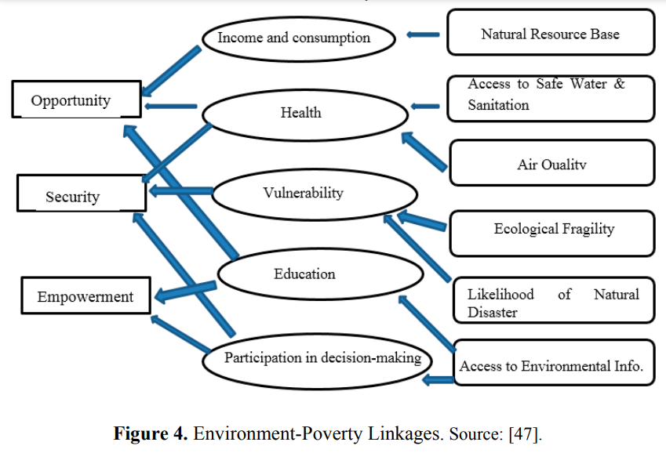

In Ghana, Abbey and Nelson [46] discovered a substantial correlation between global warming and climate warming. According to their findings, environmental zones with high temperatures and limited rainfall, such as the Sudan Savannah, Guinea Savanna, and transition phase zone, have high poverty rates. Furthermore, they discovered that the majority of Municipal assemblies with adverse climatic conditions have extremely high poverty rates. This shows that adverse weather has a propensity to exacerbate impoverishment in these areas, as well as the country as a whole.
Because of Ghana's sensitivity to the effects of harsh weather, the poor (crop farmers, fishermen, and others) who rely on their nearby environment for a living are likely to suffer considerably. In addition, In Northern Ghana, a variety of configurations groundwater system is being used. [48] offers a micro-level simulation to assess the likely influence of farm-level adaptation techniques. They discovered that climatic variability had a significant influence on farm households' poverty and food security. The authors of [49] use a computerized general equilibrium model to look at the effects of climate change on the economy under four different scenarios. They conclude that climate change invariably reduces national welfare, with the poor and urban families, as well as the northern Savannah zone, being the worst hit.
The magnitude of weather occurrences and the proportionate significance of sectoral effect paths, on the other hand, differ dramatically among options. Due to a sexual division of labor within households and society in general, women and men in Ghana maintain different responsibilities in terms of gender. Women's unpaid labor is vital to their livelihoods and the stability of their houses and children. Firewood collection, freshwater collection, childcare, cleaning, sewer systems, and cuisine are examples of unpaid labor duties, as are the preservation of personal bonds among family. According to [50], Ghanaian women spend more than twice as much time as men on home activities.
The majority of women in Ghana's remote regions are active in food crop production and small-scale agricultural commerce, whereas their male equivalents are interested in both sustenance and profitable crop farming (mostly on a relatively larger scale). Women grow about 40% of all farmland during production in Ghana, according to Nelson and Abbey [46]. In metropolitan regions, women are predominantly found in the self-employed shadow sector, primarily in retailing and other service activities, whereas their male equivalents hold the bulk of wage positions in the public and commercial non - agricultural employment [51].
Given current global warming trends and Ghanaian women's precarious economic status, any calamity (flooding, famine, earthquake, or another natural disaster) is likely to disproportionately affect women. Plant variety and density have been reduced by wildfires in the savannah and harvesting in the forest zones. These operations have several negative consequences, including extensive degradation, reduced agricultural yield, and desertification [1]. The negative impact on women in agriculture is accentuated by the fact that they account for a bigger share of the workforce. Furthermore, Ghana's culture and land tenure traditions limit women's access to productive land, and global warming activities disproportionately impact their plots.
Water is frequently given by women and girls in most Ghanaian households. Every day, women spend countless hours going long distances in search of water, gathering and lifting massive volumes of water. Droughts and resource depletion exacerbate women's plight, since they must travel for hours in quest of water. As a result of climate change, cholera, diarrhea, malaria, malnutrition, and heat-related mortality may all be on the rise. According to [52], leishmania is especially dangerous to pregnant women and children, and it has been associated with perinatal death, premature birth, and postnatal anemia.
4. Conclusions
Temperatures in Ghana are rising across the board, according to the last discussion, but rainfall is diminishing and becoming more unpredictable. Ghana is at risk due to global warming and volatility, as well as the country's economic dependency on agriculture, oil, and forestry. Agriculture is suffering as a result of global warming, with cocoa, rice, and root vegetable crops all declining. Climate change and global warming are also having a detrimental influence on the fishing industry, since weather conditions are reducing the amount of catch. Furthermore, power generation via hydroelectric systems, which has been dominant in the past, is at risk owing to the high temperature and low rainfall.
This threat is heightened by open burning in the Jubilee oilfield, which contributes to greenhouse gas emissions, hastening global warming and increasing unpredictability. The potential benefits of the predicted warming effect and precipitation reduction are concerning, as an increase in the incidence rate of influenza, watery stool illnesses, guinea worm infestation, malaria, cholera, cerebrospinal encephalopathy, and other liquid illnesses is expected. The impact of global warming and fluctuation on the poor, who are mostly women and children, is exacerbated...
Policymakers and residents in Ghana have taken several initiatives to mitigate the effects of climate change. These measures, however, are insufficient, and institutional flaws make it difficult to enforce migration and adaptation plans. As shown in Table A3, the Environmental Protection Agency [19] examined the effects of global warming on several sectors of the economy and proposed adaptation measures customized to each sector. These recommended adaptation strategies are useful in resolving ecological challenges; but, institutional flaws and a lack of conviction prevent them from being implemented.
Stakeholders and policymakers should improve existing institutions and build new ones when necessary to carry out the adaptation and mitigation activities outlined in Table A3. Furthermore, adherence to established policies is vital to their effectiveness. Due to the huge differences Climatic consistency's financial influence on many businesses, multi-sector techniques that account for climate uncertainty are also necessary. According to [49], investing in agricultural research and extension, as well as improved road surfaces, might be a cost-effective strategy for reducing the bulk of the damages caused by climate change in Ghana.
References
1. Environmental Protection Agency is a federal agency that is responsible for protecting the environment United Nations International Programme, New York, NY, USA, 2011. Ghana's Second National Communication (GSNC) to the UNFCCC
2. The Costs of Adapting to Climate Change for Developing Countries: New Methods and Estimates, World Bank. http://www.worldbank.org/eacc is a website where you can learn more about the EACC (accessed on 25th January 2014).
3. Changing rainfall inputs in the Volta basin: implications for water sharing in Ghana, K. Owusu, P. Waylen, and Y. Qiu. GeoJournal, vol. 71, no. 2, pp. 201–210, 2008.
4. Climate Change Intergovernmental Panel. World Meteorological Organization and United Nations Environment Programme, Geneva, Switzerland, 2003, Integrating Sustainable Development and Climate Change in the IPCC Fourth Assessment Report (AR4).
5. Al-Hassan, R.; Poulton, C. Agriculture and Social Protection in Ghana; FAC Working Paper No. SP04; Future Agricultures Consortium: Sussex, UK, 2009.
6. S. Athula and H. Scarborough Rain-fed farmers in the arid zone are dealing with climate unpredictability. Towards Understanding Adaptation to Climate Change, Proceedings of the 55th Sri Lankan Conference, Melbourne, Australia, 8–11 February 2011.

