**MBIYDZENYUY YVONNE FOLA**

**ID: UM75019BAC84196**

**MASTERS IN ACCOUNTING**

**Name of Advisor**

Arturo Romero

COURSE NAME:

**(Strategic Planning and Marketing)**

Assignment Tittle:

**(Tools and Technics involved in Planning and Marketing Strategies and its importance)**

**Introduction………………………………………………………….Page 1**

**Planning and Marketing Strategies tools………………………Page 2-9**

**Importance of Planning and Marketing Strategies…………...Page 10-11**

**Conclusion…………………………………………………………...Page 12**

**References……………………………………………………………Page 13**

**Introduction**

Strategic planning is critical for the effective success of an organization's development and sustainability. An organization must observe the critical steps of a proper planning and marketing strategy. A strategic plan is critical in ensuring that an organization follows a set path to achieving the goals and objectives they have set for its company. An organization that lacks a strategic plan is likely to fall into different barriers when trying to implement the majority of its decisions. It allows for an organization to prepare proper resources and opportunities to improve the performance of each sector of the organization. Strategic planning and marketing in organizations can be carried out differently and for different reasons. However, the world today has evolved, and the business world is moving at a rapid speed. It is critical to identify how there is a significant increase in competition across different organizations. New firms are entering the market with proper planning and strategy models that allow them to access their risks and opportunities before concluding.

The adoption of strategic planning in several companies will help them maintain their competitive advantage over other organizations. Companies often go through several issues, and it requires a proper strategy to align all duties and requirements effectively, allowing for ease in sustaining high business returns. Different elements are associated with the specific topic when discussing proper strategic planning and marketing. Elements of the strategy include the different factors that must be included in a strategy to facilitate easy continuation. Strategic planning mainly includes the elements that allow the business to develop and grow internally and externally while meeting set goals and objectives. Marketing, on the contrary, solely deals with the strategies incorporated within any organization to improve its marketing abilities and customer reach. Marketing strategies are often included in an organization's overall strategic plan. The main content of this study includes a deep dive into the tools that are utilized when creating and implementing critical planning and marketing planning.

**Planning and marketing strategies tools**

The tools utilized for proper strategic planning vary and are utilized according to what the organization is targeting or after. The tools serve different purposes and deliver enough information about the organization's future business outcomes and a framework to make the most accurate decisions. These tools include SWOT analysis, a common and most used strategic tool for different organizations. The SWOT analysis includes a compilation of different factors that affect the success of an organization in developing and marketing its products. The SWOT analysis tool allows organizations to understand their strengths, weaknesses, opportunities, and possible threats to their business goals and objectives (Chernev, 2020). It is the leading framework that allows different organizations to create their competitive stand through effective strategic planning and implementation. Technology has improved how SWOT analysis is carried out and has provided extensive access to an organization's future and present outcomes. SWOT has four distinct features that allow the study to meet all the successful business and marketing requirements. With technology, there is a huge emphasis on using real data and facts to make critical decisions. Organizations that operate with regular SWOT analysis allow for flexible business with ease in securing and rectifying potential marketing threats. SWOT tool provides a model that eases the assessment of the business.

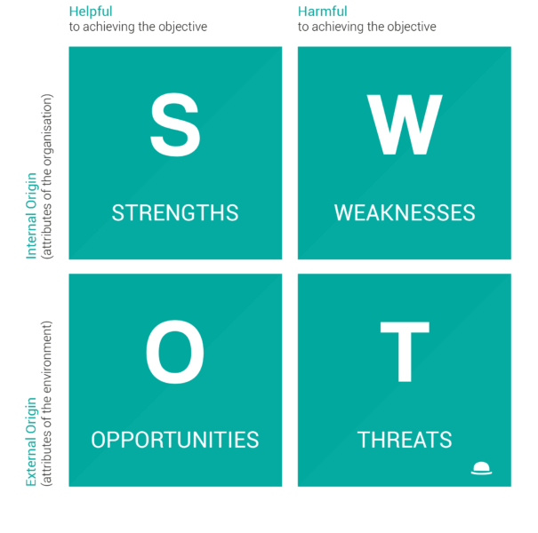

1. SWOT analysis

Marketing also benefits greatly from an effective and clear SWOT analysis. The tool will allow an organization to access its market properly and identify other businesses around the area. It is flexible and allows using both external and internal data to provide the fact-based data that can help an organization develop its business practices according to set goals and decisions (Chernev, 2020). SWOT is utilized in marketing practices by understanding the strengths that the organization possesses to reach a wider market. It provides key details that allow a firm to exploit its strengths, including having loyal customers, good quality and unique products, etc. An organization could also assess its weaknesses which could help them prepare proper strategies to mitigate them. It provides them with the areas they need to improve, including weak brands, inadequate supply chains, and poor promotion techniques that facilitate wide market reach. Through accessing an organization's weaknesses, they can prepare effective mitigation techniques that help prevent or reduce the impact of the identified weaknesses.

Opportunities included external factors that also play a huge role in the progress and success of an organization. External factors include different things, including laws

and policies that govern business practices in a certain location. They also include the tariffs and trade barriers available when setting up marketing strategies (Hanlon, 2021). Tariffs and barriers are key to identifying the best marketing locations and areas. Areas with fewer limitations and taxes are often the best when looking for the most profits. Lastly is the threat section, which includes all potential hazards in any organization or its marketing plan. Threats in the marketing sector include the risk of losing loyal customers. This can be attributed to different things, including high production costs and poor company reputation. Threats usually allow an organization to anticipate marketing issues and barriers so they can set up mitigation or counter practices and improve marketing performance. SWOT analysis is a great tool and model to effectively utilize facts from an organization to make the best decisions possible.

On the other hand, Google and Microsoft had strategic planning and marketing tools that allowed accessing the objectives and key results (Hanlon, 2021). Objectives and key results is a tool or model that allows an organization to set what could be a difficult objective so they can compare it with its key results. Objectives and results provide the organization with a competitive edge over most organizations, including a few principles. The idea to include a limit of 70% key success rate is to ensure that organizations that utilize the tool create the most ambitious objectives harder to beat (Hanlon, 2021). It is a collaborative goal-setting tool that will allow the organization to set measurable goals that are extremely difficult to complete.

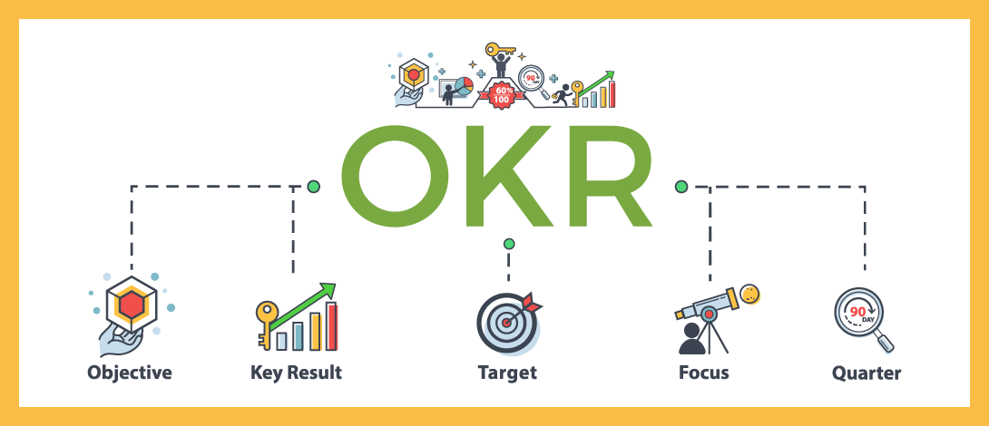

2. OKR tool

This is extremely critical in creating a clear alignment and attention to the set goals and objectives, allowing for better business outcomes and performance. The objectives can be set to provide a direction for marketing campaigns and promotion. It also provides space to edit and set better objectives when previously set goals are achieved. This tool is useful in strategic and marketing planning. This is due to its ability to align an organization with its main set goals and objectives, thus providing a proper pathway to developing the best marketing decisions (Hanlon, 2021). It includes setting marketing objectives that set the role and the necessary processes required to meet the set objectives. Another critical tool utilized is the PESTLE analysis tool. This tool has similarities to conducting a perfect SWOT analysis. It, however, has extensive features that serve a different purpose than that of SWOT tools.

PESTLE analysis includes a clear and concise study of the environment in which a business operates. PESTLE analysis is the perfect tool to understand to what extent its environment affects its business practices and performance. Accessing the environment is a very critical process in marketing and planning. Marketing strategies revolve around creating the best image and reputation for an organization to thrive in. Through proper and effective PESTLE analysis, six environmental factors can be addressed and measured against the success and output of the organization. PESTLE analysis tool

includes studying and keeping track of six key environmental factors. They include political, economic, social, technological, legal, and environmental issues affecting the business (Yudakova, 2021). Marketing heavily relies on stable political environments to operate in, and utilizing this tool can help identify perfect business locations. A business has to access all political factors, including studying present tariffs, restrictions, price control, etc. This is critical in deciding marketing requirements and proper prices to avoid facing various legal factors that limit business success. It also ensures the marketing plans are aligned with areas' political requirements.

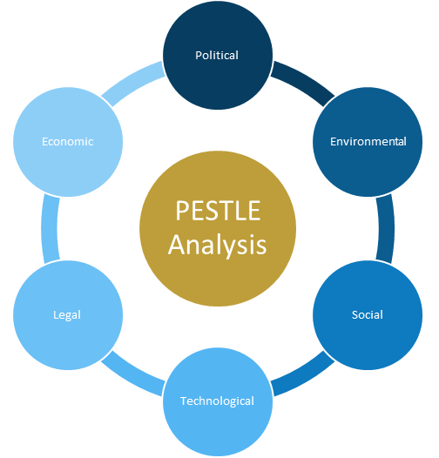

3. PESTLE tool

It provides a key analysis of the area's economy to understand how effective and strong a business can grow. Economic analysis is a key planning phase in marketing that facilitates key financial decisions and improved flexibility to economic factors, including inflation and increased taxation levels (Yudakova, 2021). Furthermore, setting up a proper market for a firm's products requires social approval. This tool provides a way to identify the cultural norms and consumer attitudes toward the product they produce. It is critical to be aware of the loyal customers a firm has and understand the area public's attitude

toward the product they produce. It dives deep into understanding consumer preferences, age, and sex to provide the best products customized to meet the consumer's needs.

Technology is critical, and its ability to provide key tech analysis is essential for understanding the opportunities in that spectrum. A firm can access measure how technology impacts their marketing practices, so they can develop ways to exploit and benefit from it. It also accesses and aligns marketing practices with legal requirements. Products that a company markets must comply and be accepted by the market. Therefore, it provides a clear path to managing legal factors that impact the organization's marketing strategies. Lastly is the overall environment that the business operates in. The

tool provides a clear analysis of the legibility of the product marketed by an organization and its implications. PESTLE is a critical management and planning tool that aligns an organization's practices with the external factors that affect set goals and objectives (Yudakova, 2021).

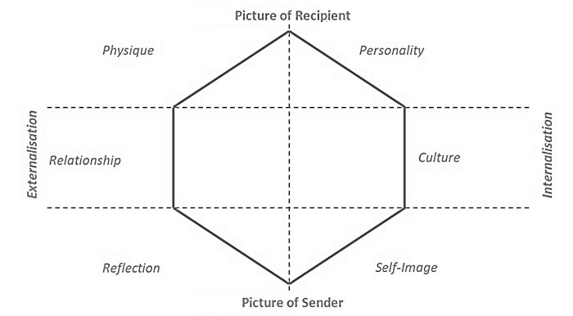

4. Brand Identity Prism

A brand identity prism is a tool that majorly focuses on an organization's brand identity and recognition. It aligns the organization's brand image with its goals and

objectives. Utilizing this model includes measuring a company's brand identity using six important facets. These facets include the organization's physique, relationship, reflection, personality, culture, and self-image. Another tool is the Ansoff matrix, an essential strategic marketing tool that allows an organization to plan for and identify the best possible ways to get the most outcome. It helps an organization scan and studies its market to identify the best practices that will generate the most revenue and increase the organization's sales significantly. It includes different factors and phases, including market penetration and development. It allows the organization to understand and grow its existing market by improving products and developing and entering new markets to increase revenue (McDonalds, 2016). The tool also includes product development which is developing new products for existing markets and diverse products to meet customer needs and exceed expectations. Through the Ansoff matrix tool, an organization can understand its current market and learn how to develop into newer areas.

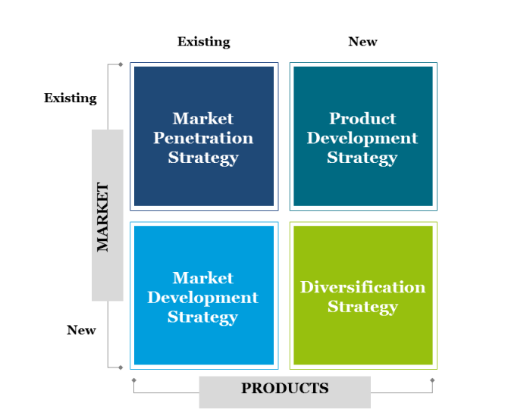

5. Ansoff matrix tool

Lastly, marketing data dashboards and balanced scorecards include the last of the most effective tools for proper planning and marketing. The data dashboards provide an organization with information about their marketing practices and provide key analysis of the key performance indicators available, allowing the business to prepare and plan for more marketing outcomes. They mostly include visually presented data that is utilized to quickly access key metrics and act on the conclusions to improve business outcomes. It greatly paves the way for effective strategic decisions while allowing the suggestion of the best campaign adjustments set to improve business performance.

**Importance of planning and marketing strategies**

Planning and marketing strategies play a key role in the overall outcome. As we have identified earlier, it is difficult to make the right decisions without critically studying and understanding the situation. These tools facilitate effective planning and marketing, which is important in aligning the organization's practices with its set goals and objectives. This is critical in preventing straying away from the main goal over time and therefore sticking to set tasks that facilitate constant growth and sustainability (McDonalds, 2016). It provides focus and thus ensures that a high productivity rate is constantly maintained, facilitating improved business performance. It also enables the proper planning and allocation of resources for every process included. Proper planning and marketing strategies prevent losses which mainly contribute to poor business performance. All processes can be provided through proper planning to maintain productivity rate and business success. It allows an organization to properly set up its budget in alignment with the processes they are to carry out.

These planning and marketing strategies are set up for transparent management of an organization's practices. It provides measurable metrics that can be used to access and

track an organization's success and progress. Furthermore, these practices maintain or foster business consistency. Consistency is key, and without planning, an organization cannot address issues that occur. Planning maintains productivity with different factors, including prevention measures, mitigation strategies, etc. Therefore, proper planning is

critical in avoiding inappropriate resource use and consumption and other improper business practices that allow for business continuity (McDonalds, 2016). Clarity is needed when making marketing plans and decisions. These planning and management tools creates and maintain control within the organizations involved. It helps remove uncertainty by planning and preparing for future business outcomes.

Uncertainties mainly occur when there is no proper plan to address possible business barriers and setbacks. It helps clear the uncertainties and allows a firm to anticipate the future. This helps understand consumer behavior and needs, which helps significantly. It also plays a key role in coordinating the different activities carried out and minimizing the risk of business failure.

Conclusion

The tools we have studied above are critical and play a huge role in an organization's proper and effective progress. An organization must implement the analysis tools and models identified above to pave the way for better business outcomes and performance. It is important that planning and proper strategies are created to foster better business outcomes. Planning and marketing are essential tools for avoiding possible business failure and losses. With technology improving by the day, more tools are expected to get better at providing the needed data to make the necessary changes and improvements for better business outcomes. Technology has changed how different activities are carried out, and marketing strategies have joined in with several tech tools being implemented.

In conclusion, planning and marketing is critical for business success and must be adhered to and implemented effectively. Planning provides the necessary pathway for an organization to follow when trying to meet the objectives they have set for their organization. The advantages of planning and marketing strategies are clear to see and identify with. Risks and uncertainties are often part of business, and the work of planning and using these tools is to minimize the chances of risks by removing various uncertainties. It helps organizations prepare for future outcomes, which is a key business feature and is heavily behind the success of several large enterprises today.

**References**

Chernev, A. (2020). The marketing plan handbook. Cerebellum Press.

Hanlon, A. (2021). Digital marketing: strategic planning & integration. Sage.

McDonalds, M. A. L. C. O. L. M. (2016). Strategic marketing planning: theory and practice. The marketing book, 87.

Yudakova, O. V. (2021, April). Digital Technologies for Planning Marketing Tools for Managing Customer Loyalty. In International Scientific Conference “Digital Transformation of the Economy: Challenges, Trends, New Opportunities” (pp. 505-511). Springer, Cham.