|  |  |
| --- | --- |
| Unraveling the mystery Behind Nutrition | ELVIRA ANTHEA ADJEI    Major: Masters in Nutrition  Student ID: UM74503SNU83673 |

We know what nutrition is but in the same we don’t know what it is. Pretty confusing, but it isn’t. In this course we will be discovering the foundation and building blocks applied to nutrition. Now let’s dive into it.

NUTRITION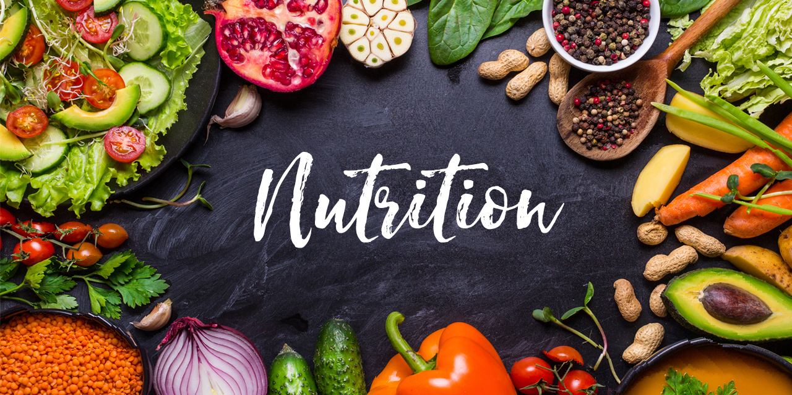

Welcome to the world of nutrition, many people’s opinion on nutrition are the study of food and how it works in your body.

Cambridge dictionary simply defines Nutrition as any substances that you take into your body as food and the way that they influence your health.

Nutrition is also the study of nutrients in food, how the body uses them, and the relationship between diet, health, and disease.

Nutrition also focuses on how dietary choices can be used to reduce the risk of diseases and the effects of malnutrition and undernutrition.

Maintaining a healthy body is something we have to be serious about it daily and also eating the right proportion of food is the key to maintain a healthier body. Balance diet is a diet with all the right proportion of food ingredient. For a healthy life and dieting, eating the right amount of calories for the day is very important. There should be a proportion to balance the energy you burn or your activity level.

Food is the basic thing in life and every living organism need food to stay healthy, strong and active. For us to stay healthy, strong, active and help the body to function well, we need to have a good quality food that has all the correct amount of nutrients.

Food provides our bodies with what they need to:

* Stay alive, be active, move and work;
* Build new cells and tissues for growth;
* Stay healthy and heal themselves;
* Prevent and fight infections.
* Muscles and Bones development
* Energy
* For good brains and heathy organ

Food is comprised of macronutrients and micronutrient

Macronutrients includes;

* Protein,
* Carbohydrate
* Fat and oil

Food also supplies micronutrients

* Vitamins
* Minerals

Nutrients provide nourishment. A plate or a bowl of food must have all the food nutrients. If we do not have the right balance of nutrients in our diet, their risk of developing certain health conditions increases.

To sum it up of the its definition, Nutrition study is all about the relationship between nutrients in food and human health.

NUTRIENTS AND HOW THEY AFFECT OUR BODY

Food like plantains, avocado, pineapple, yam, banana, beans, meat are all food made of different amounts of protein, carbohydrates, fats and oils, minerals, vitamins and water.

All these are call the 6 nutrients that are essential for the health of our body. Each essential nutrients has a different function and purpose a particular purpose for the body functioning.

Let’s us now delve into each of these 6 food nutrients; 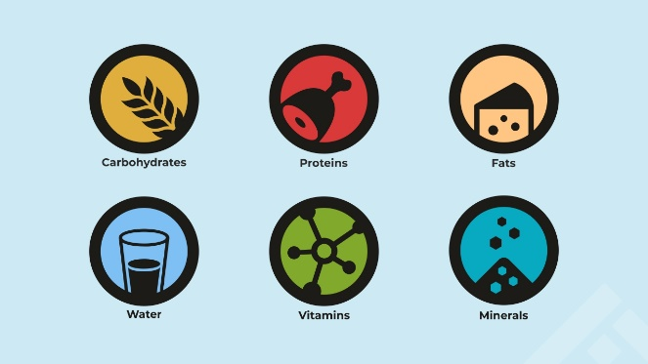

1. Carbohydrates - this is an energy food source to the body. The energy activities we need daily for our day to day work and activities. Together Glucose molecules and its storage form glycogen provides energy for all the brain use and energy for muscles and other body tissues use, example the brain needs carbohydrates for it’s activities, muscles needs it to fuel their work like moving, climbing, carrying, racing etc.

Carbohydrates are found in a wide array of both healthy and unhealthy foods. All plants food like tuber, vegetables, legumes, fruits and more provide ample carbohydrates. Milk also contains carbohydrates and they come in a variety of forms like sugars, fibers, and starches.

The dietary carbohydrates includes:

1. The simple carbohydrates;

•Monosaccharides

•Disaccharides

1. The complex carbohydrate;

* Polysaccharide

Carbohydrates are fuller and healthier and therefore it’s important to include healthy carbohydrates to the diet.

It is necessary to choose from a healthy source when it’s comes to carbohydrates , unprocessed or minimally processed like whole grains, vegetables, fruits and beans—promote good health by providing vitamins, minerals, fiber, and other nutrients.

PROTEIN

* The main function is for growth. Protein is a great nutrient needed to maintain the body’s health. Proteins served as building blocks for bones, muscles, cartilage, skin, and blood. Protein is also a building blocks for enzymes, hormones, and vitamins. Nutrients provided by various protein foods can differ, protein provide your body with a variety of nutrients which help to keep your body functioning well. Mostly vitamins and minerals for example Vitamin B groups help build tissue and aid in forming red blood cells, Iron can prevent anemia, Magnesium helps build bones and supports muscle function and Zinc can support your immune systems.

Proteins are mostly from animal source and includes all seafood, meat, poultry and its products; eggs. Plant base protein includes beans, mushrooms, peas, and lentils; and nuts, seeds, and soy.

Proteins are composed of carbon, hydrogen, oxygen and nitrogen atom. The nitrogen atom in protein gives the name amino (nitrogen containing) to the amino acids.

Meat and poultry choices should be lean or low-fat, like 93% lean ground beef, pork loin, and skinless chicken breasts. Choose seafood options that are higher in beneficial fatty acids (omega-3s) and lower in methylmercury, such as salmon, anchovies, and trout

LIPIDS

Fats are solids in room temperature. Oils are liquids in room temperature. Fats and oils are great sources of energy and functions as protection, insulation, lubrication.

Lipids are a family of compounds and they includes triglycerides, phospholipids and sterols. Thought these lipids family differ in many respects they have one common characteristics which is they are all insoluble in water.

Just like carbohydrates, fatty acids and triglycerides are composed of carbon, hydrogen and oxygen. Hence they also supply energy to the body.

Some sources of oils are olive oil, palm oil, sun flower oil, coconut oil and peanut oils

Some fats are butter, suet (beef fat), lard (pork fat), and fish oils.

Fats can also be in a form of fatty meat and in a processed meat products such as sausages, bacon, salami and canned meat.

Mostly Fats and oils provide more calories than any other food, they contain no protein and very few micronutrients. Only butter and fish-liver oils contain vitamin A and D. Palm nut oil which contain carotene, is converted to vitamin A.

VITAMINS AND MINERALS

Vitamins and minerals plays very important role in our body, these micronutrient are needed in small amounts.

Vitamins are grouped into 2.

* Fats soluble vitamins;

Vitamins A, D, E, K

These are found in vegetables fats, animal fat, fish fat etc.

* Water soluble vitamins;

Vitamins C and B are water soluble vitamins found in the body, it is therefore important to have it frequently. Their food source are mostly from fruit and vegetables, dairy food and fruit.

ROLES OF VITAMINS

* Support immunity-

Vitamins like vitamin C gives support to the overall health, it’s an antioxidant that protects your cells from damage caused by oxidative stress

* Vitamins also play an essential roles in metabolism-

Some vitamins like thiamin, vitamin B6 and B12 support a healthy metabolism cell neurological functions.

* Vitamins helps in energy production, healing of wound, bone formation, eye and skin health.

MINERALS

Two groups of Minerals are macro and micro minerals.

Macro-minerals is what the body needs in large amounts like calcium, potassium, sodium etc.

Micro-minerals are needed in small amounts and they are equally important to the body, for example iron, copper, fluoride, selenium, zinc, chromium, molybdenum, iodine, and manganese.

A good source is nuts and seeds, organ meats, avocado, berries, yoghurt, cheese, leafy greens vegetables etc.

Eating a balance diet can get you all the required nutrients that one’s need for heathy living.

ROLES OF MINERALS

Minerals play a role in the body, such as;

* Heart and brain functioning, as well as the production of hormones and enzyme
* Help maintain cardiovascular
* Health and provide structure to the skeleton.

DIGESTION AND METABOLISM

We eat food to gain energy for activities such as dancing, swimming, and learning. The food we eat powers the activities we do every day. The cells of our body transforms these food nutrients into energy.

Metabolism is a term that used to describe all chemical reactions involved in maintaining the living state of the cells and the organism.

During digestion the body breaks down these energy giving food; carbohydrates, proteins and lipids into a basic units for the body to be absorbed into the blood.

* Glucose from carbohydrates
* Glycerol and fatty acids from fats
* Amino acids from protein

Foods supply carbohydrates in three forms: starch, sugar, and fiber. Starches and sugars form major and essential sources of energy for humans. Fibers contribute to bulk in diet. Carbohydrates digestion gives glucose and the body uses energy as it primarily fuel.

The body releases enzymes that breaks down larger carbohydrates molecules into smaller units of molecules. Some enzymes like saliva amylase, pancreatic amylase, microvilli also contain enzymes that breaks down digestion for carbohydrates into glucose, fructose, and galactose.

Proteins are the main tissue builders in the body. Enzymes needed for protein breakdown are pepsin and pancreatic enzymes breaks down into smaller chains of amino acids release in the blood to build muscle proteins and also energy especially in times of starvation. The nitrogen containing amino group is removed through deamination.

Basically fatty acids and carbohydrates are the primary fuel of energy. The enzymes for lipid digestion is called lipase (lingual lipase, gastric lipase and pancreatic lipase)

HEALTHY CHOICE OF FOOD AND FOOD PREPARATION METHODS

1. Incorporating Plant base diet

Healthy plant base diet include;

Legumes

Whole grains

Fruits and vegetables

Nuts

Coffee

Tea

Research proofs that plant base diet have a lots of benefits and reduce the risk of cardiovascular disease, cardiovascular disease mortality and all-cause mortality.

1. Choose whole grain bread and pasta instead of refined

Whole grains diet have a lots of fiber B vitamins minerals like zinc, iron, magnesium, and manganese.

Examples are;

Oat

Brand rice

Quinoa

1. Drink enough water

It is recommended that 8 glasses of water a day will keep you hydrated.

Most importantly drinking water instead of other beverages helps to reduce intake of sugar and calories. There by decreasing weight loss and promoting weight management.

4. Fish, including an oily fish

5. Method of cooking

Choosing the right method in cooking is very important to maintaining ones health. How we cook food can have both positive and negative effects on one’s health. For example

Grilling and roasting is preferable than frying.

The 3 regular cooking methods we use in Ghana are boiling, stewing and charcoal grilling or smoking used especially with fish. There is a release of toxic compounds that are formed during these kind of cooking especially grilling and high amounts of oil used in stewing methods within our homes and among street food venders in our most favorites and popular food like Waakye

and Jollof rice causing the rise of cancer and other cardiovascular diseases in the country lately.

Some healthy ways of cooking are;

Boiling

Slow cooking and slow simmering

Poaching

Stewing

6. Prebiotic and probiotics

The food we eat can give us a heathy guts, it is important to build our digestive system with a proper use of probiotic and prebiotic foods.

According to WHO, probiotic are live microorganism that can provide benefits to human health when administered in adequate amounts, which confer a beneficial effect on the host.

Probiotics are good bacteria and are living microorganism while prebiotics are non-living organism and they are guts friendly foods like that nourish us and fills us up in other words fibers that are food for probiotics.

It’s important to incorporate these food in the diet: Flax seeds, okra, artichoke, yoghurt, sauerkraut, leeks.

1. Using unsaturated fats instead of saturated. For a healthier choice unsaturated fats such as vegetable oils, oily fish and avocados are healthier than saturated fats that are found in food like lard, sausages, cheese. Healthier alternatives oil include, coconut oil, olive oil and avocado oil. When you're having meat, choose lean cuts and cut off any visible fat. All types of fat are high in energy, so they should only be eaten in small amounts.

**WHY FOOD LABELING?**

It’s a legal responsibility that every food producer must label all food items to help consumers to make the right choice of food when purchasing.

Food labeling is the all-important information about a particular food product that food producers placed on food packaging to inform customers about the product and help them to make the right choice.

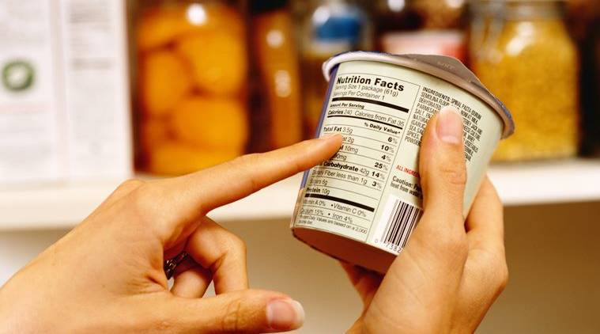

Below are certain important information when food labeling.

* Food name
* Nutritional information
* Ingredients
* Production date and expired date
* Products weights
* Directions for use and storage
* Country of origin
* Allergens and additives
* Calories content
* Any nutrition and health claims
* Indications from producers like Halal Kosher or Organic is also important.

These information help customers to make right choice of food especially food to keep healthy especially that might develop health conditions like high blood pressure, diabetes, obesity and allergies.

Food labeling keeps one safe on the right method of cooking food and also the storage and temperature level. It also protects you from food that can be harmful especially allergies.

WHY NUTRITION?

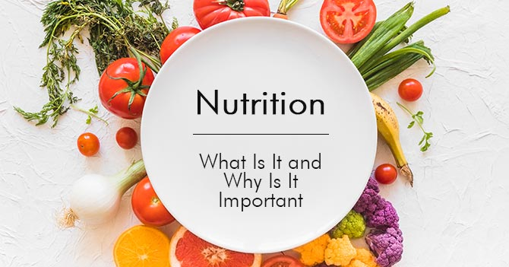

The study of Nutrition helps one to have an in-depth knowledge about the sciences behind each food and food groups as this helps to know the dietary patterns and its effects on human health. This information helps one to make healthy choices for lives also help in shaping institutional menus, educating people and the general public about food we eat and its positive and negative effects as a results of poor nutrition.

Taking into consideration individual needs, age and special circumstances and health issues such as pregnancy, diabetes, hypertension and many more illnesses, some special conditions and cases.

Public education is important as educating the public about health issues helps to create an awareness about the important of eating well as a nation and its effects in the economy due to the rising health conditions that the nations face because of the rise of modern society,

When it comes to prevention, diagnosis and treatment of diseases, nutrition plays a major role especially in the health centers.

It also help in research on diet and mood swings, the results of these research shows better quality diet therapy to reduce depression risk or other health related diseases.

Bibliography:

<https://www.hsph.harvard.edu/nutritionsource/carbohydrates/>

<https://www.myplate.gov/eat-healthy/protein-foods>

<https://www.healthline.com/nutrition/foods-with-m>.

<https://www.foodmag.com.au/six-reasons-why-food-labelling-is-important/>

<https://www.highspeedtraining.co.uk/hub/importance-of-food-labels/>

Book: Understanding Nutrition Tenth Edition by Ellie Whitney/Sharon Rady Rolfes

Chapter 1: page 3, page 6

Chapter 4: page 104, page 105, page 106

Chapter 5: page 142, page 143,

Chapter 6: page 181, page 182, page 183

Chapter 7: page 215, page 216