|  |  |
| --- | --- |
| PUBLIC HEALTH NUTRITION  By Elvira Anthea Adjei | Major: Masters in Nutrition Student ID: UM74503SNU83673 |

DESCRIPTION

This course will help show the importance of alerting the public on nutrition as well as the need to manage the food we consume to prevent health challenges and promote physical activities.

OBJECTIVES

* To promote nutrition education especially among school children
* To contribute to the promotion of health and nutrition
* To support the public health in their effort in promoting a healthy lifestyle in the nation.
* To know the importance of educating the public on nutrition

PUBLIC HEALTH NUTRITION

It is a general concern for every country to have a healthy nation and to be aware about good nutrition.  
The UK Nutrition Society defines public health nutrition as the application of nutrition and physical activity to the promotion of good health, the primary prevention of diet-related illness of groups, communities, and populations (not individuals).  
In Ghana lots of concerns have been raised concerning the inadequate nutritional food served to public schools.

The government policy on free school feeding program was implemented to diminish short-term hunger and malnutrition among elementary school children, to increase school enrolment, attendance, and retention in primary schools and to boost domestic food production through patronizing locals. This policy was made to help public school children to get proper nutritional diet which parents can’t afford especially among the deprived communities and low level income earners.

Earlier this year around 7:00am, I saw a school boy around the age of 15 years vomiting around, I stopped in other to offer some help to this young man, after engaging him in a conversation about his health and the food he ate this morning. He told me he ate fried rice without protein and vegetables, just rice and soya sauce mixed together with oil.

This caught my attention studying this course that the least I can do is to offer some form of education to this school and engage them and help them to know about what they eat and why it is important for them to eat well, to know every bit of food intake and also their right to question the school feeding authorities if food does not have the required amount of nutrients and also not served at the right temperature.  
Interviewing and personal observations were held at Redco W/A J.H.S 1 and 2 added to the public concern about inadequate nutritional food being served to these children in the public school.

THE ENVIRONMENT AND HOW IT INFLUENCES WHAT WE CONSUME

In Ghana because of the proclamation of the Year of Return (An initiative by government of Ghana to encourage Africans living in the diaspora to return to their root (Africa specifically Ghana) and also to settle and INVEST in the country). Because of this, there is an emergence of restaurants from the western country investors being it fast food, Caribbean dishes, Italian, Chinese and so on. In view of this there is a rapid development and lifestyle change particularly fast food restaurants which have spread rapidly in Accra the capital of Ghana. This has caused the rise in health challenges and conditions like diabetes, hypertension, obesity, and other diet related diseases and recently the rise of cancer in Ghana.  
  
What goes into our body is very important and we need to maintain a healthy life as well as a healthy nation.  
That is why this cause will throw a light on and why there is need to educate the public about nutrition and how our choice of food affects our health and why it should be made known as a nation.

EDUCATIONAL INITIATIVE

Nutritional education is the key to gain knowledge about what to eat, what is important to eat and what we eat affect the body in a positive way. Nutritional initiative is being adopted to promote healthy eating practices. This is to help increase the knowledge about healthy eating, promoting a traditional meal or home food, buying food from farmers or local food producers and the importance of having a community food gardening or a back yard gardening if possible.

Nutrients are important for health development and having a good nutrition gives the vulnerable people including infants, children, pregnant and nursing mothers stronger immune systems, safer pregnancy and childbirth and reduce the risk of non-communicable diseases like diabetes and cardiovascular disease.  
Being mindful of what to eat and what goes into the body is very important and nutritional. Workshops help schools, institutions and organizations about the nutritional value of food, what each food nutrients contain, reading the labels on food packaging to know the calories each food contains before consumption and ordering food on the menu which are healthy by taking into consideration the following that can affect ones health;

* Processed foods.
* Refined foods, like sugars, white flour and processed oils.
* High sodium food etc

On special occasions, choose your foods as wisely as you would on any other day. Also, it’s important to package your own food during snack break to avoid eating unhealthy meals.  
Packing low-calorie snacks like fresh fruits, vegetables, whole grains as well as nuts help keep hunger controlled throughout the day.  
People who implement adequate nutrition knowledge in their diet are more productive at their work places and can create opportunities to gradually break the cycles of poor nutrition, poverty and hunger and help children learn better.

Some Nutrition Workshop classes;

* Cooking classes that are healthy
* Back yard gardening
* Training pregnant women and maternal mothers
* Community training
* Organizational or institutional training
* Local food and knowledge on nutrition
* Health and fitness

WORKSHOP CLASS ORGANIZED FOR ‘REDCO W/A J.H.S 1 and 2’

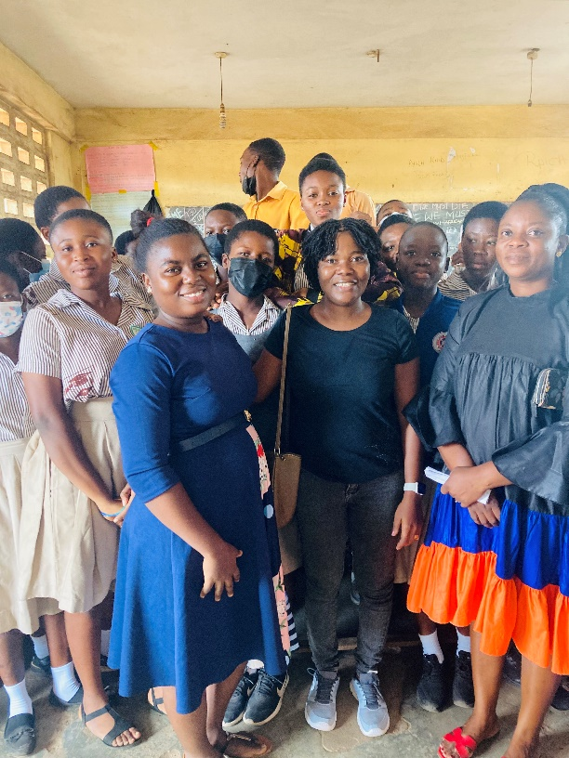

One major problem about ‘Redco W/A J.H.S 1and 2’ is under nutrition and this is a major challenge especially children in the public school in Ghana. Their age compared to their body mass index is questionable. Why? Because they don’t buy the right food, parents don’t give them food that contains all nutrients and right amount for their glowing and developmental need. The environment in which they are don’t sell well nutritious food. Mostly food that are processed are always available and these processed food are packed with calories (sugar and salt to enhance flavor), they are low in nutrients and increase the risk of many disease.

These children also don’t have any knowledge on the calories consumed.

I educated them about the need to cut down processed food and use it as a treat occasionally which will save them a lot from bad calorie intake which can lead to early childhood chronic diseases.  
One randomized studies at work place indicated that people who ate a processed diet consumed 500 additional calories per day, compared with people eating an unprocessed diet.

HEALTH CHALLENGES OF POOR NUTRITION

Malnutrition is a general and worldwide problem. Malnutrition occurs when the body doesn't absorb enough nutrients. Causes include a poor diet, digestive conditions and other diseases that bring a significant threat to human health.  
Two types of malnutrition that the world faces is undernutrition and over nutrition (overweight or obesity), especially in Ghana.  
The World Health Organization is providing scientific advice and decision-making tools that will help countries like Ghana take action to address all forms of malnutrition to support health and wellbeing to the public and all ages.

WEIGHT LOSS AND WEIGHT GAIN

Improper diet as well as over eating can accumulate calories in a short period of time and hence takes longer time to shed weight if one is willing. It is therefore important to be conscious on what we eat or what goes into the body. Weight gain can cause the underling diseases

Good nutrition and dieting in addition to physical activities is the key solution of weight control and good health. Health benefits, include;

* Reducing the chances of developing heart disease, some types of cancer, and other chronic diseases.
* Control your blood pressure
* Possibly improve or maintain some aspects of cognitive function, such as your ability to shift quickly between tasks or plan an activity

Heart Disease-  
Because whole foods are packed with antioxidants and nutrients that support heart health, including magnesium and healthy fats, consuming a diet rich in nutritious, quality and unprocessed foods may also help reduce inflammation, which is considered one of the major drivers of heart disease and hence heart disease prevention .  
  
Adopting and making dietary and lifestyle changes with whole food diet has a great benefit of weight loss and have a lasting impact on health which help to lower your risk and reduce symptoms of certain chronic diseases and because whole food diet is packed full of nutrients and natural taste, they have high levels of vitamins, minerals, fiber and antioxidants which keep us healthy and make us feel good.

Below are some benefits of whole foods diet or incorporating whole food and plant base diet.  
A large study in over 200,000 people found that those who followed a healthy plant-based diet rich in vegetables, fruits, whole-grains, legumes and nuts had a significantly lower risk of developing heart disease than those following a non-plant-based diets. Following a whole food diet helps to maintain the heart and prevent cardiovascular disease.  
  
Chronic Disease-   
Whole food and plant base diet is a great way to help manage or treat conditions such as type 2 diabetes, heart disease, chronic kidney disease, and autoimmune disease. These food is a great source of natural nutrients including vitamins, minerals, and antioxidants.

EDUCATION ON PHYSICAL ACTVITIES AND WELLNESS.

Everyone wants to have a healthy life but doesn’t want the pain that is associated with physical activities. It is wealth when one invest in his or her time to do some exercises.

Physical wellness consists of one recognizing why there is a need and importance for physical activity, to eat healthy foods, and sleep, as well as preventing sicknesses and injury or managing chronic health conditions.

To be active, is to reduce the risk of disease and death. Studies show that regular physical activities or active people increase their life expectancy by two years compared to those who are inactive. Sedentary people experience a twenty percent (20%) to two-fold increase in early death compared to other working people.  
In Ghana, there is an increased risk of premature death in most institutions and organizations, studies shows that, it’s mostly lack of physical activity and improper eating habit. This is due to roadside or street food which these worker buy from. Roadsides food are less costly, ready to serve food and they contain lots and lots of additives and food enhancers like mono sodium glutamine (popularly known in Ghana as Maggie salt). These food enhancers make food taste and looks attractive but has slowly killing chemicals which is bad for human consumption. Educating organizations and institution helps them understand the important and consequences of it and why one needs to engaged in some health fitness. Physical activity is a preventive measure and helps a person being diagnosed with a chronic disease and also decrease the risk of premature death. For instance staying physically active decreases risk of future cardiac events for those with cardiovascular disease. Additionally, physical wellness is listening to and taking care of your body for optimal health and functioning.

Some facts to consider when giving training or education;  
• Understanding and listening to your body, how it works and taking care of it for optimal health function and also help you to feel comfortable with your physical appearance.  
• Feel competent at physical activities  
• Develop well-balanced diet and healthy eating habits  
• Become a responsible drinker or quit drinking  
• The need to sleep and being aware of how a lack of sleep, stress, and non-activity affect your body

• Become aware about the effects of bad food choices, beverages, drugs, chemicals, additives, and caffeine.  
• Engage in regular movement to improve flexibility, strength, aerobic, and cardiovascular health.  
• Develop and cultivate leisure activities  
• Seek medical care when needed for illness, injury and preventative care.

Having an Interview with the Redco school and La Nkwantanan school concerning physical education indicated that most public school have the Physical Education lessons (PE) which they do physical activity recommended for all ages but most private schools do it for both students and teachers including non-teaching staffs. This was good news and at the end of the day helps children and adults participate in the recommended 150 minutes weekly aerobic activities.  
Despite the above health benefits, most students and teachers gave a feedback that physical activities helps them to be active and some suggested that they focus more and become attentive in class lessons.

WHY DO WE NEED TO ENGAGE IN PHYSICAL ACTIVITIES?

1. Keep and improve your strength and endurance-

Strength training can provide great benefits and improvement in overall health and well-being. This training helps one to build muscle, tendon, ligament, bone strength and toughness and helps the joint to function well, reduce potential injury, increase bone density and increase metabolism.

One interesting aspect of this kind of training is it can be done with minimal or without equipment, and one can create any type of equipment especially when doing weights lifting. For example body squatting can be done without any equipment.

There are many methods of strength training. Examples include weight training, flywheel training, circuit training, calisthenics, isometric exercise, gymnastics, plyometric, parkour, yoga, Pilates, Super Slow.

Some equipment for Strength training are:

Barbells and dumbbells, weight machines and other exercise machines, weighted clothing, resistance bands, gymnastics apparatus, Swiss balls, wobble boards, Indian clubs, pneumatic exercise equipment, hydraulic exercise equipment and many more.  
  
2. Increase your energy level to do the work-

Energy is the ability to do work. According to Harvard health publishing, exercising boosts oxygen circulation inside your body. This increase in oxygen not only supports the mitochondria’s energy production, it allows your body to function better and to use its energy more efficiently. Plus, your body gets a boost from an exercise-induced increase in hormone levels that makes you feel more energized.

3. Improves your balance and lower risk of falls and injuries from falls-   
When a person is less active, they become weaker and thereby increase their chances of falling. Falls may or may not cause injury. The risk of falling and getting injured especially among adults can be dangerous and usually relate to some factors like;  
Balancing and instability  
Leg problems  
When blood pressure drops  
Medications  
Some hazards like dim light  
Vision problems

Falling can result in injury, fracture and even more serious ones.

Some causes of fall;   
broken bones like wrist, arm, ankle, and more dangerous ones like hip fractures and skull.  
  
Exercising can help prevent falls because it can:   
• Make your muscles stronger and more flexible  
• Improve your balance  
• Increase how long you can be active  
Exercising at least 150 minutes a week goes a long way to strengthen and prevent falls. Health provider or physical educational coach help to make sure you are doing the right type of exercises.

4. Sleep better- Studies have shown that exercise help you fall asleep more quickly and improves sleep quality and leads to a longer sleeping time. According to Johns Hopkins Medicine, aerobic exercise triggers feel-good chemicals called endorphins and increases the amount of deep sleep you get. Vigorous exercise may also decrease the risk of developing anxiety or depression.  
  
5.Reduce levels of stress and anxiety-  
Exercising and following a healthy diet by minimizing the intake of highly processed foods and beverages, taking all artificial sweeteners and sugar and replacing with natural sugar like honey, eating more whole foods such as vegetables, fruits, beans, fish, nuts, and seeds can help ensure that your body is properly nourished. Whole foods may increase your risk of deficiencies in nutrients that are essential for regulating stress and mood, such as magnesium and B vitamins. Exercising relaxes and provide stimulation and calm, to counter depression and remove stress.  
The long term gain of physical activity is wellness and it has proven to be a low-cost alternative for the treatment and prevention of disease.

Health and wellness advocates are all over the media especially social media like Meta, Instagram, WhatsApp groups etc. all with aim of helping one to stay healthy by eating well and becoming physically active which studies have shown that making time for exercise and diet adjustment prevents certain diseases and improve our mental health.

BIBLIOGRAPHY

<https://www.thelancet.com/journals/lancet/article/PIIS0140-6736(07)61145-3/fulltext>  
<https://www.researchgate.net/publication/350278629_School_Feeding_and_the_Challenge_of_Supporting_Nutritional_Needs_of_Pupils_in_Ghana>