|  |  |
| --- | --- |
| How black chefs still have to fight for representation | The Independent |  The Independent  SAFETY AND iNDUTSRIAL HYGIENE | Elvira Anthea Adjei  Major: Masters in Nutrition Student ID: UM74503SNU83673 |

Description of course

This course will give me an eye opening about safety and hygiene. It will help me protect not only my customers but also my employee’s health from food borne illnesses and food poisoning. It will also give me insight on how to create a productive workforce, thereby helping employees follow practices and organizational work place procedures to give safety to all.

Objectives

Research shows that workers are more productive when the working environment is committed to health and safety. This shows are safer workplace is a happier work place.

* This course will help me reduce risks that are likely to cause incidents in the industry.
* This course will help me improve efficiency.
* This course will also help me avoid damages and insurance costs.
* It will also provide long term benefits to my business and community.

SAFETY AND INDUSTRIAL HYGIENE

One may ask why safety and hygiene? Is it really important to study this course?

The number one asset of a company or any organization is its employees. Employees are the back bone of many organizations and most contributors to the profit of the organization. Employees run the organization with their strength, effort, skills, commitment, dedication, knowledge and wisdom and they are very important in any organization and valuable contributors at workplace

No matter what size the business is, success is the result of continuous hard and smart efforts put in by happy, healthy employees.

Therefore, Employees matter most to many organizations and it is the job of an organization to invest in its employees by providing safe and hygienic environments for its workers to protect them from injuries and illnesses.

Before we go further, first let’s understand the meaning of safety and hygiene itself.

WHAT IS INDUSTRIAL SAFETY?

Safety is the condition of being protected from anything likely to cause danger, risk or injury to one’s life. There is the need for employers to look into the safety in their organization to ensure the removing, reducing and controlling of hazardous substances from the work place.

Demand and increase in production has led to the advancement of technology. These technological equipment has led to the increase in injuries, financial loss, property damage, insignificant products, cooperate reputation, danger in one’s health and in some cases a threat to life of these vulnerable employees.

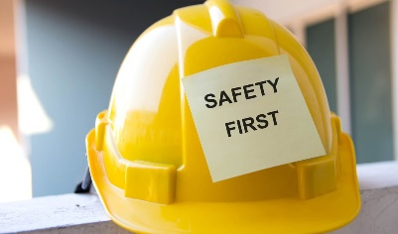The ILO estimates that some 2.3 million women and men around the world succumb to work-related accidents or diseases every year; this corresponds to over 6000 deaths every single day. Worldwide, there are around 340 million occupational accidents and 160 million victims of work-related illnesses annually.

The first organized effort to boost occupational health and practice for the Africans among the Africans, and involving mainly Africans, came in the 1960s with the first African Conference on Occupational health in Africa in Lagos, Nigeria in 1968.

The Labor Act, 2003 and the Factories, Offices and Shop (Amendment) Act are the two main acts containing provisions in relation to occupation safety and health in Ghana.

WHAT IS INDUSTRIAL HYGIENE?

Hygiene are the practices we ensure to maintain health and preventing disease through cleanliness, these practices are employed in the work place to help reduce diseases and illnesses through cross contamination. In the hospitality industry and medical field, it is important to be conscious about it, in that it is a place prone to infection by bacteria, viruses and other germs. The main transferors of infection especially in these industries are employees. Employees can easily cross contaminate by movement from place to place to infect both coworkers and customers.

Industrial hygiene is the art of controlling pressures that arise in or from the workplace and may cause sickness, decreased health and well-being or substantial discomfort among employees and members of the community.

According to Safeopedia, Occupational health and safety (OHS) is a branch of public health aimed at improving workplace health and safety standards. It studies injury and illness trends in the worker population and offers suggestions for mitigating the risks and hazards they encounter on the job.

To explain safety and hygiene I want to showcase my perspective of safety and hygiene in the hospitality industry. In the industry, organization is very important and it helps to avoid, food spillages, slips, burns, falls, blocked hall ways, muscles strains and many more as these are the most common and leading causes of hazards that brings accident.

Cross contamination is another challenge in the industry. Easier transfer of bacterial or microorganism unintentionally transferred from one person to the other or from one place to the other, in this case almost all departments in the establishments are at risk e.g. front office (money handling), bar(intoxicated employee), housekeeping, kitchen, maintenance etc.

Taking into account of Personal Hygiene, Food Hygiene and Environmental Hygiene is crucial to help reduce and prevented these occurrences, for example food must be stored and cooked using the right temperature and prepared hygienically, organization of work, practices of hygiene, correct legislation of pools, safety and hygiene signs placement various location prone to accidents, training etc.

To really understand it let’s look into some examples of some work place hazards.

# MECHANICAL HAZARDS

Mechanical hazards are hazards created by the use of or exposure to either powered or manually operated equipment, machinery or plant.

Some major injuries cause by machines are amputations, fractures, crushing injuries. Machines can also cause minor injuries such as bruises, abrasions, sprains, strains, burns or cuts.

Mechanical hazards may occurs in the following areas; point of operation where work is performed, Power transmission apparatus, Components of the mechanical system that transmit energy to the part of the machine performing the work and part of the machine that moves while work is in progress.

Safeguarding forms barriers and help to minimize or eliminate the risk of accidents from machine by protecting the operator or other persons from the equipment hazards point or danger area.

It is therefore important to practice all requirements and proper supervision and checks been made to protect all employees.

ELECTRIC HAZARDS

According to OSHA, electrocution is one of the most common hazards. Electrical hazards may cause death or personal injury from:   
Electric shock and burns from live wire contact, fires from faulty wiring, overloading circuits, leaving electrical parts exposed, explosions and fires from explosive and flammable substances, contact with overhead power lines, electrical exposure to water etc.

Once I had decided to take a leave of work and relax. I was in the kitchen supervising an order of fruit juice for a client, while one of my trusted housekeepers was cleaning the kitchen wall tiles with a wet cloth but because 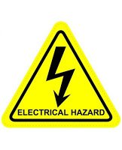 there was an exposed wire on the surface and he didn’t really follow the correct and right-hand procedures, a drop of water must have fallen onto the exposed wire causing him to suffer from an electric shock and it even caused a spark, which could have turned out for the worse.

To prevent electrical hazards like this or even worse, I have to make sure that all electrical sockets where safe, workers are adequately trained, guidelines follow to mitigate electrical hazards and prevent its dangerous effects in case of an incident.

CHEMICAL HAZARDS

A chemical hazard in food terms occurs when food becomes contaminated with germs or harmful chemicals, rendering it unfit to eat. At high concentrations, several food additives, such as chemical preservatives, can be dangerous.

Information regarding the identities and hazards of chemicals must be available and understandable to workers in order to ensure chemical safety in the workplace.

All firms who have harmful chemicals in their workplaces must provide labels and safety precautions to their exposed employees, as well as training on how to properly handle the chemicals.

PRINCIPLES OF INDUSTRIAL HYGIENE

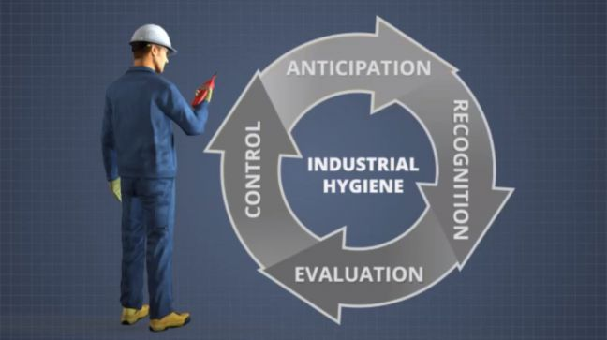

* Anticipate Hazards- The first step in keeping employees safe is to anticipate workplace health problems. Any potential exposure risks relating to the work environment should also be identified during this phase. Employees, for example, may be more exposed if they operate in places with little ventilation or if a procedure produces a lot of dust.
* Recognize Hazards- Potential chemical and physical dangers at a plant can be discovered through understanding procedures. Employees should be questioned about how they finish their task.
* Evaluate Hazards- After anticipating and recognizing hazards, evaluation takes place. Usually evaluation means workplace monitoring. This decides who will be monitored, what will be monitored, where will it be monitored, when will it be monitored, and how will it be monitored. Monitoring should only be done by a qualified professional, such as an industrial or occupational hygienist, due to the complexity of the work environment and the measurement tools.
* Evaluate Results- In the workplace, industrial hygienists utilize qualitative and quantitative analyses to evaluate if exposure levels are acceptable, unacceptable, or uncertain in the industry.
* Control Hazards- Controls are implemented when exposures are determined to be unacceptable. Before using PPE to protect employees from exposure, consider removing or replacing the hazard, separating workers from the danger, or modifying the way workers do their tasks.

WHO IS AN INDUSTRIAL HYGIENIST?

An industrial hygienist is a professional who is capable of assessing and controlling hazards present in the workplace or public space that could cause injury or illness. Every industry needs a hygienist as they play a great role in the work place to ensure safe and healthier environment. Industrial hygienists are experts and professionals in their work field. They are certified and have a broad knowledge in their work field to offer solutions and solve problems in the industry there by delivering advice on ways to reduce or eliminate worker exposure to hazardous materials and circumstances.

WHEN DID HEALTH AND SAFTY CAME TO REALIZATION

The early industry didn’t have machinery and equipment we have today. No smart phones, computer and internet as well. Companies relied on human power for efficiency.

During the industrial revolution with new technological development of machinery and manufacturing processes, most countries ventured into mass production to meet the peoples need. Employees basically cheap labor and employers didn’t have much knowledge on machinery, care and safety.

As employees were brought inside factories, new risks emerged. Working in a factory at the time meant long hours and insufficient ventilation, and potentially hazardous machinery.

Coal miners were physically harmed by the conditions in their homes and workplaces. This was due to pollution from coal-fired power plants as well as several enterprises. Miners frequently died of black lung and other diseases. Spinning machines in textile mills were often left unguarded and posed a serious risk.

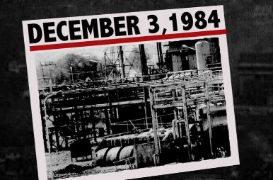The worst industrial accident in history occurred on December 3, 1984, when some 45 tons of the dangerous gas methyl isocyanate escaped from the Union Carbide plant in Bhopal, India. It was a tragic accident indeed.

On January 10, 1860, a five-story mill on the Lawrence River collapsed in the middle of the work day. This is known as the Pemberton Mill Collapse.

Safety and hygiene is very crucial in the hospitality industry; hotel, restaurants, cafes, and catering outlets. Food poisoning was 1st identified as a public health issue in 1880. Globally there are a number of cases about food poisoning, this led to economic loss in terms of working days lost as most employees would absent themselves at work.

The Labor Act, it is obligatory on the employer to ensure health, safety and welfare of persons at the workplace by minimizing the causes of hazards inherent in the working environment.

In my country, Ghana. There is no national policy on occupational health services, but a draft policy jointly developed by the Ministries of Labor, Health, and Mines and Energy as far back as 2000 is yet to be adopted.

COMMON CAUSES OF INDUSTRIAL ACCIDENT AND INCIDENTS

1. Unsafe Conditions-

This may occur when there is a failure to control identify and train people against work place hazard. Some of these unsafe conditions are failure to see liquids on plain surfaces like tiles or floors, injury may occur if attention is not being paid or failure to put warning signs to prohibit passage.

2. Unsafe Acts-

Unsafe acts include not doing job in its rightful manner, failing to see hazards, unnecessary risks, unprotecting or using improper protective equipment, drinking whiles driving, throwing boxes around etc.

3. Equipment and Machine-

Most machinery accident are cause by poor training, inadequate safety equipment, poor maintenance, machine design and assembly defects, and so on.

4. Electrical Hazards- An electrical mishap can occur when equipment is not used appropriately. Exposed or loosened wires can cause electrical shocks if extension and flexible cords are used incorrectly. Low voltage can also lead to electrical shock as well as wet hands.

5. Nature of the Job -Poor Lighting condition, Hazardous Materials, Acts of Workplace Violence, Trips and Falls and others may lead to injury, stress, fatigue and dehydration.

ACCIDENT AND INCIDENT PREVENTION

# Accidents are unexpected occurrence that happened in the work places. These occurrences can lead to injuries, illness and loss of property and production and in some cases death.

# Incident and accident indicate the level of damage that result from a workplace occurrence.

# Incident is any unexpected event that does not result in serious losses or injury and an accident is an unexpected event that causes damage, injury, or harm.

What they have in common is that both events are unplanned and can cause damage to places or things. It is only accidents, however, that cause serious injury or illness to people. So, all accidents are incidents, but not all incidents are accidents.

# Industries cannot completely eliminate accidents in their establishment but there are certain plans, preparations, and actions that can be taken to reduce and avoid them.

1. Communication of safety rules-

Industry should be able to give interactive, informative and positive information about rules and regulations on safety and hygiene. Industry that tells employees what they need to know to work safely under all conditions bring security and protection to its workers.

2. Review Policies and Procedures-

Industry should review their policies and procedures about periodically to remind employees workplace about safety and hygiene in other not to their life and others at risk. During that time employees should be able to express their concerns and issues that bothers them at the use of machine and equipment, in case changes has to be done on the way to use equipment or a tool or moved to a new place or department. Communication of any change should be made know and reason being stated why certain changes has been made.

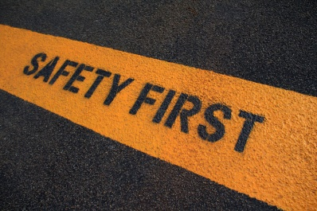

1. Provide Training-

Training gives a good opportunity for employees to gain knowledge about industrial equipment and tools, the risk involved, how to maintain. Appropriate training must be done by a hygienist who can give proper training to employees and most importantly periodic training, periodic checks, reflecting training and on the job training to know that employees comply with safety rules and guidelines and how they can go about their work. The benefits of training employees is to protect them from injuries, reduce waste, better work environment and gain knowledge about new tools and equipment.

1. Clothing and protective rooms-

Rooms like changing room and cloak room should be always cleans to reduce or eliminate contamination. Clothing acts as a particulate barrier that helps prevent contaminants from entering the work environment. While surfaces and equipment can be sterilized. But employees who use the rooms are carriers of bacteria and viruses. We constantly shed skin flakes, microbes, hair, textile fibers, dust, and cosmetic particles, as we move around, talking, and coughing carrying these bacteria and viruses from one place to the other without noticing it. This can cause serious problems in especially where food can easily be contaminated.

1. Post information-

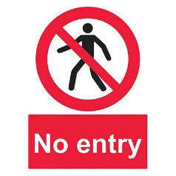One great way to protect employees are safety signs and they must be put at its appropriate place. A signboard is a sign that provides information or instruction using a combination of shape, color and symbols to give information about an unsafe place or a location. Some of these work place safety signs are Prohibition Signs, Mandatory Signs, Warning Signs, Safe Condition Signs, Fire Equipment Signs E.g. caution on wet floor, danger, no smoking, fire alarm control panel, danger, fire exit signs and so on.

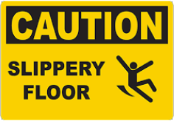 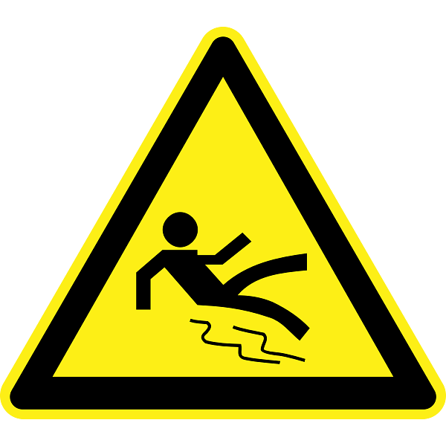

1. Create a Safe Working condition-

Poor housekeeping can be a great risk for injuries, it is therefore important to keep an orderly work place condition. Steps and procedures to follow especially during cleaning should not be taken for granted.

WHY MUST WE INVESTIGATE?

To show the root cause of both incident and accident, a proper investigation must be ensure so to find out errors that caused it so additional measures can be put in place to avoid a recurrence. It’s is the responsibility of management to protect the health and safety of its employees and that means doing everything to reduce and the likelihood of accident occurring.

There are steps and procedures to be taken into consideration. First a team of professionals called the Accident Investigation Team.

This is a group of employees at the company who come together to investigate incidents and determine the root cause and contributing causes. Reports are made to management and based on that, recommendations are made and decisions are taken to bring solutions to the problem.

Therefore accident investigations team must examine all underlying factors that led to happening at the incident

Factors that should be looked at the cause include; task, material, environment, physical evidence, eye witness reports and interviewing. For example making sure to follow all instructions when mopping floors at hotels to prevent slips, using the right knives to do the right job, taking into consideration spills and hot plates and items.

SAFETY OF OPERATION

Safety operation provides ways and instructions and procedures on how to safely perform a task or activity which involves some risk to health and safety.

Consideration and some factors must be looked for as certain businesses, industries and certain departments may be riskier than others. Manufacturing or production, energy, construction and warehousing and some departments represent a few examples of industries that safety must focus.

# In conclusion health and safety doesn’t only focus on the physical needs and overall well-being of employees but also the economy at large. One will ask how come its affects the economy?

If productivity drops due to accidents, sick leave follows and employers have to pay cost to cover medical expenses, ware & tare, and train new employee replacements sick and hence less taxes are paid to government which affects the economy of a country at large.

Bibliography:

<https://hsewatch.com/mechanical-hazards>

<https://ehs.osu.edu/accident-prevention-workplace>

<https://www.safeopedia.com/8-key-cleanroom-protective-clothing-options-to-consider/18/7371>

<https://www.reliableplant.com>

<https://www.safeopedia.com/definition/439/occupational-health-and-safety-ohs>

<https://www.osha.gov/sites/default/files/training-library_industrial_hygiene.pdf>

<https://en.wikipedia.org/wiki/Hygiene>

<https://pubmed.ncbi.nlm.nih.gov/8652439/>

<https://www.ilo.org/moscow/areas-of-work/occupational-safety-and-health/WCMS_249278/lang--en/index.htm#:~:text>

[www.safeopedia.com](http://www.safeopedia.com)

<https://neworleans.legalexaminer.com/legal/what-are-the-top-workplace-electrical-hazards/#:~:text=The%20exposed%20power%20line's%20wires,which%20can%20cause%20electrical%20shocks>.

<https://www.recyclingtoday.com/article/5-principles-of-industrial-hygiene-recycling-facilities/#:~:text=Industrial%20hygiene%20has%20five%20main,evaluate%20results%20and%20control%20hazards>.

<https://www.osha.gov/chemical-hazards>