
History of Architecture
Name: Beverley Gustaff
ID #: UM73939SAR83104
1/21/2022
TABLE OF CONTENTS

INTRODUCTION………………………………………………………………………...…..…..3
ANCIENT ARHITECTURE………………………………………………………………..…….4
PREHISTORIC ARCHITECTURE……………………………………………………….......….5
EGYPTIAN ARCHITECTURE………………………………………………………………….6
MESOPATAMIA ARCHITECTURE…………………………………………………………….7
CLASSICAL ARCHITECTURE………………………………………………………………....8
BYZANTINE ARCHITECTURE…………………………………………………………..……9
ROMANESQUE ARCHITECURE……………………………………………………………..10
GOTHIC ARCHITECTURE…………………………………………………………………....11
RENAISSANCE ARCHITECTURE…………………………………………………….….......12
BAROQUE ARCHITECTURE………………………………………………………….……....13
ROCOCO ARCHITECTURE…………………………………………………………………...14
NEW CLASSICISM ARCHITECTURE……………………………………………………......15
ART NOUVEAX………………………………………………………………………………...16
BEAUX ARCHITECTURE……………………………………………………………………..17
NEOGOTHIC ARCHITECTURE………………………………………………….……………18
ART DECO…………………………………………………...……………………………….....19
MODERN ARCHITECTURE……………………………………………………………...……20
POST MODERN ARCHITECTURE……………………………………………………………21
THE GALLERY…………………………………………………………………………………22
CONCLUSION…………………………………………………………………………………..31
BIBLIOGRAPHY………………………………………………………………………..………32

INTRODUCTION
Architecture can be described as symmetrical plans and eclectic use of architectural features to create a finished design. The history of Architecture is study of how architecture has evolved throughout the centuries and the many different cultures and landscapes identified over time.
The history of architecture highlights the history and evolution of human divination and civilization throughout the centuries to present day architecture. The main artifacts of architecture include structure and buildings such as commercial, residential buildings and industrial buildings as well as other structural construction include roads; bridges, railways, etc. Human civilization has certainly evolved with the history and modernization of architecture. The history of architecture follows the patterns of the changes in architecture with a variety of traditions in the various regions, the dates and the over arching stylistic trends. Originally the tradition of developing and designing architecture was based on the satisfying of the need for basically shelter and protection from elements such as wind and rain, snow, etc.
The drawings in architecture must be accurate, precise and complete with all relevant details and information required for the builder or engineer to have a full understanding of the work to be carried out. It is very important that the standards of architecture are followed in order that they will be understood universally in the proper context and at the anticipated professional level of preparing the drawings.
Architecture is a language in itself and therefore architects use the drawings to express this language which can be observed as a second language. The effective communication of ideas for the implementation of a project throughout the entirety must be clearly understood by all parties involved. This includes the clients; builders; contractors, engineers; and all other professional who must read the finished designs and drawings in every stage of the project. There should be no confusion or questionable situation on the drawings.
It is essential that architects learn different techniques that can be used in residential; commercial and industrial buildings and projects. Scope of works, Specifications, Dimensioning of drawings; Building Codes and Architectural Standards must be essentially involved in the drawings and finally learning to appreciate and creation of presentation drawings or 3D drawing and modern technologies as architecture evolves throughout the centuries to where we are today.
ANCIENT ARCHITECTURE
Throughout history the designing of architecture has been developed to tell stories in a variety of ways. Architects create and design drawings to communicate the intention effectively.
Ancient architecture dates back to prehistoric architecture and the architects of the stone edge era. It can be said that the exact origin of architecture dates back to the Neolithic period that is around 10000 BC. People simply stopped living in caves and decided to handle their own building in regards to how they wanted their houses to look like and feel like. Ancient architecture existed in the days when straw houses and mud huts were the norm and an accepted way of living. Architecture is a method of protection from weather; wind; rain; snow
The timeline of ancient architecture ranges from prehistoric architecture to Egyptian architecture to Mesopotamia to Classical architecture to Byzantine architecture to Romanesque architecture to Gothic architecture to Renaissance to Baroque to Rococo to Neo Classicism to Art Neouveaux to Beaux Arts to Neo gothic to Art Deco to Modern Stylist architecture to Post modernist architecture.
Throughout the evolvement of ancient architecture it is safe to say that architecture has seen its fair share of evolution. Although there have been significant changes over time, many original architectural patterns and designs remains intact. The centuries old architecture even influenced the later forms and styles of architectural designs.
The Roman column designs consisted of arches and entablatures giving permission to even greater spatial freedom in architectural designs which are still significantly used in modern day architecture. The discovery of concrete construction greatly facilitated the use of the building of arches, vaults and domes as in the Pantheon and other public building such as basilicas, baths, amphitheatres and triumphal arches and arch works.
Roman columns carried arches which were introduced as an architectural technique during the Classical era of architectural history.

PRE-HISTORIC ARCHITECTURE
This is the era of the Stonehenge when the earthen mouding and mud huts were the architecture of the day .Huts were made of variety of materials. Huts were even made of mammoth bones around the time of about 11000 BC to 15000 BC. People would build stone circles and mud brick houses and large stone tombs. The Stonehenge architecture is visible in the United Kingdom in the prehistoric architecture. Then came the pyramids of Egypt following the United Kingdom buildings. This era was also called the Neolithic Age.
During the Mesolithic and Neolithic era architecture began to take shape as human beings tried to create settlements and homes. The majority of structures were made of timber using the “post and lintel” system. Others ctructures were constructed using animal bones such as mammoth.
Bottom of Form
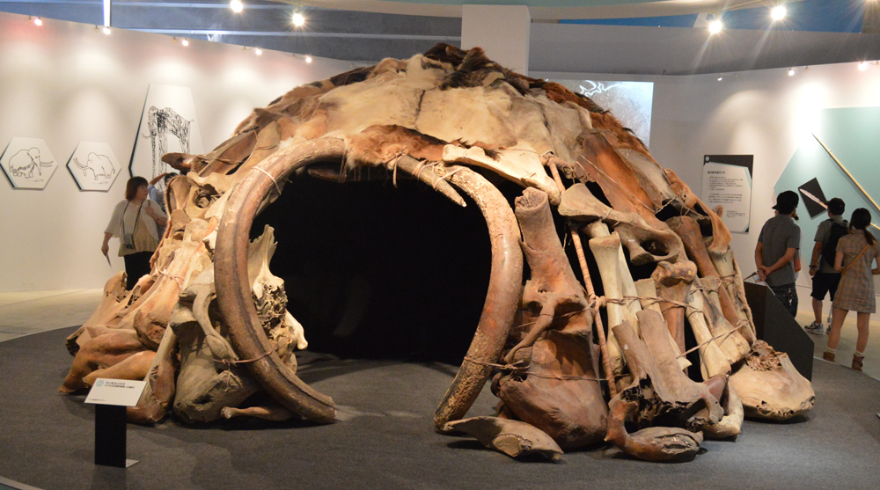
Image of Prehistoric architecture
EGYPTIAN ARCHITECTURE
The pyramid of Egypt is a remarkable example of Egyptian architecture and although pyramids are no longer built the ones great works of architecture that is recognized as outstanding to this day.
The pyramids ot the form of construction in Egypt still stand as the reminder of the architecture of that era. Dating as far back as 3050BC to 900BCthe Egyptians constructed shrines and temples which still can be seen in modern day. These include very enormous structures that are called Pyramid of Giza. These structures are monumental and are great works of architecture that is recognized as outstanding to this day. The pyramid of Egypt weight was more than five million tons and it is said that each pyramid took twenty three years to complete. Pyramids were constructed to serve as tombs for Pharaohs and their consorts. It is believed that due to their height. The pyramids were constructed by giants during that era as giants were known to exist.
Image showing the great Sphinx of Giza in front of a Pyramid – Egyptian architecture
MESOPOTAMIA ARCHITECTURE
The architecture of Mesopotamia is ancient architecture of the region of the Tigris–Euphrates river system, encompassing several distinct cultures and spanning a period from the 10th millennium BC to the 6th century BC. Wikipedia
This type of architecture originated in Assyria and influenced by the Babylonian style is a western Asiatic architecture. Mesopotamia relates namely to Persia; Assyria and Babylon. West Asian architecture bridge in the twin Euphrates known as Mesopotamia (the Neolithic Age), people would make stone circles, mud-brick houses, and big stone-slab tombs. Stonehenge in the United Kingdom is also an example of a famous prehistoric structure. The pyramids of ancient Egypt would follow in the centuries to come, as would architecture in the Byzantine empire (such as Italy’s Basilica of San Vitale). In the next centuries, the Gothic era during Medieval Ages would lead to other iconic works, such as Paris’ Notre-Dame Cathedral.
It is the belief of the Mesopotamians they viewed architecture as an art of construction or the “craft of building”. They believed that this craft was taught to men by gods. Sun baked bricks and stones became the building materials of choice which were made from a paucity of stones in the region. The Babylonians made frescoes and tiles. They also featured pilasters and columns which were lined with colored stone slabs that were not painted and were carefully sculptured by humans. The Mesopotamian families had the responsibility of building their own homes and the use of mud and wooden doors .were the norm although reeds were used in construction. In the houses the only openings were doorways as houses were constructed as load bearing structures.
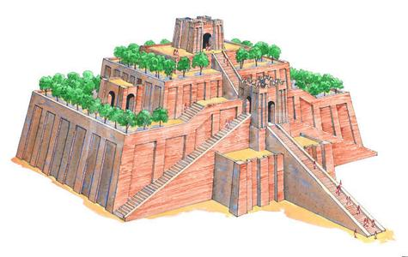
Image showing the reconstruction of a ziggurat suing sun baked bricks as the building material.
CLASSICAL ARCHITECTURE
Classical Orders Architecture began in the era of 850 AD and 476 AD. The classical orders include the Roman and Greek type architecture. Many great buildings and structure were constructed according to the classical orders. The classical orders were generally column styles and tablatures. Classical architecture is the architecture of Greece and Rome. This form of architecture emphasizes the construction and use of columns and pediment. The Greek architecture was mainly based upon the peam and post system whereby the columns would bear the load of the structure. The construction of timber or wooden columns was superseded by the introduction of building using marbles and stones. The designs were done Greek Doric ionic and Corinthian using post and lintel frames to build structure. The composite were mainly Romans and Tuscan.

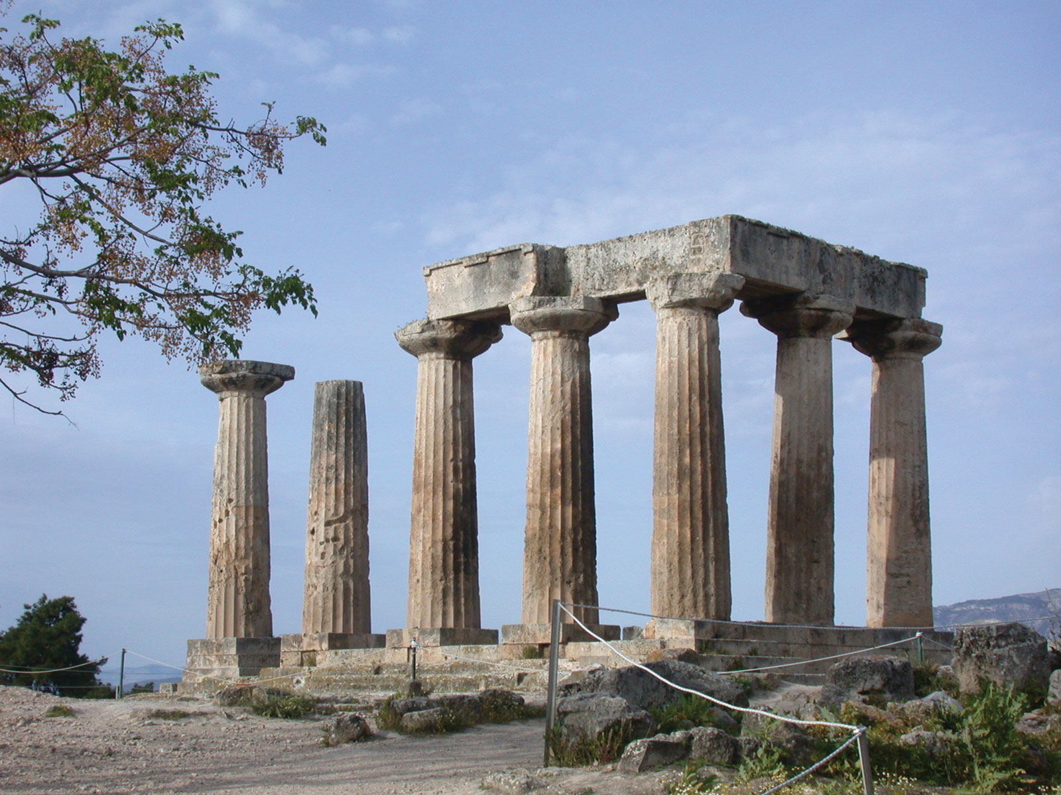
An example of Classical Architecture showing thre ruins of the Temple of Apollo, Greece
BYZANTINE ARCHITECTURE
Byzantine Architecture - This was the era between 527 AD and 565 AD. Byzantine was renamed Constantine now as Istanbul and also New Rome. The Istanbul and New Rome evolved and was an inspired style classically that used bricks for the structures and buildings.\ Byzantine architects were eclectic and they drew on the styles of Roman architecture they combined the bsailistic and symmetrical features
The Byzantine was shifted from the early Christians and lasted till the end of the 5th (fifth) century AD under the rule of Emperor Justinian where the style evolved. The attributes of the Byzantine Church included a centralized plan with surrounding isles and extended wings .
The church is finished with a Dome sitting on the Penderline which serves as the roof.
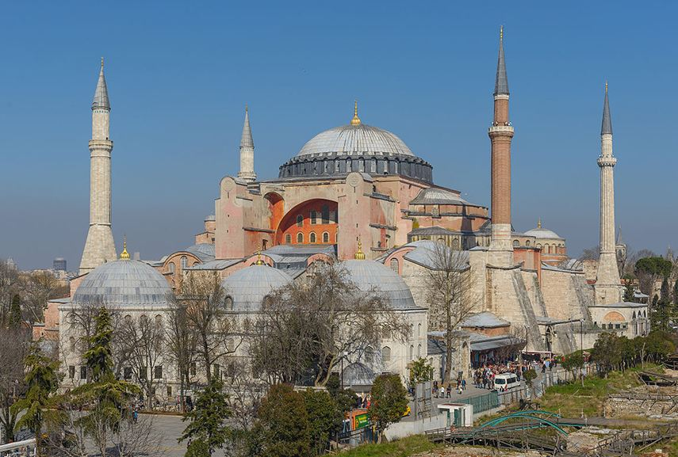
An example of Byzantine Architecture displaying Hagia Sophia, Istanbul
ROMANESQUE ARCHITECTURE
This is an era during the period of time between 800 AD to 200 AD The Romanesque Architecture, as the name suggests, is derived from the Roman Classical architecture and the emergence of Romanesque architecture with rounded arches being displayed. The churches gradually took on the shape of having cross shaped formation which are framed by wings known as transepts’ and the choir. It is viewed the revival of Roman elements of architecture. In Britain the Romanesque architecture was known as Norman architecture The Normans were the descendants of Vikings or North men called Norse. In the period of 1066 when William the Conqueror from Normandy invaded Britain in sighted the building schemes during that time.
The roof structure of the buildings was made of wood and the columns were made solid of carved stones. The building itself was a heavy weight due to the structural elements. The outward thrust and stress were the result in the spanning of the sides of the building. Simple semi-circular roof vaults known as barrel vaulting to cross vaulting was the more adventurous form of architecture and construction and ornate into Gothic Architecture. The arches that define the naves of the churches are well modulated and geometrically logical and are repeated as built.
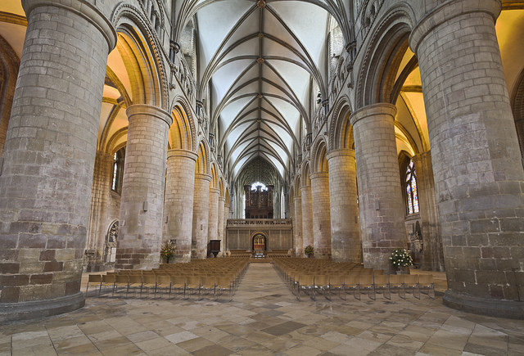
Gloucester Cathedral, nave, begun 1089 (ceiling later), photo: Michael D. Beckwith (CC BY 2.0)
GOTHIC ARCHITECTURE
Gothic Architecture era was between the period of 1100 AD and lasted from the middle of the twelfth century to around the sixteenth century.. This was the era that saw the heightening and lightening of the buildings and structures. This era also saw the use of pointed arches being aa part of structures. Then there came the invention of ribbed vaulting and flying buttresses during Germanythe twelfth to the thirteenth century. The ribbed vaults are still in use and with very valuable impacts of the usage in modern day architecture..
Gothic architecture saw a form of masonry buildings that are comprised of cavernous spaces with the expanse of walls broken up by overlaid tracery. The gothic arches were built to solve the problem of constructing tall structures while permitting as much natural light as possible into the building. The use of stained glass panels reduce the sirect entry of sunlight into the interior of the building while at the same time rendering sun dappled interior effects. Gothic architecture was very common in France, Britain, Spain and Germany.
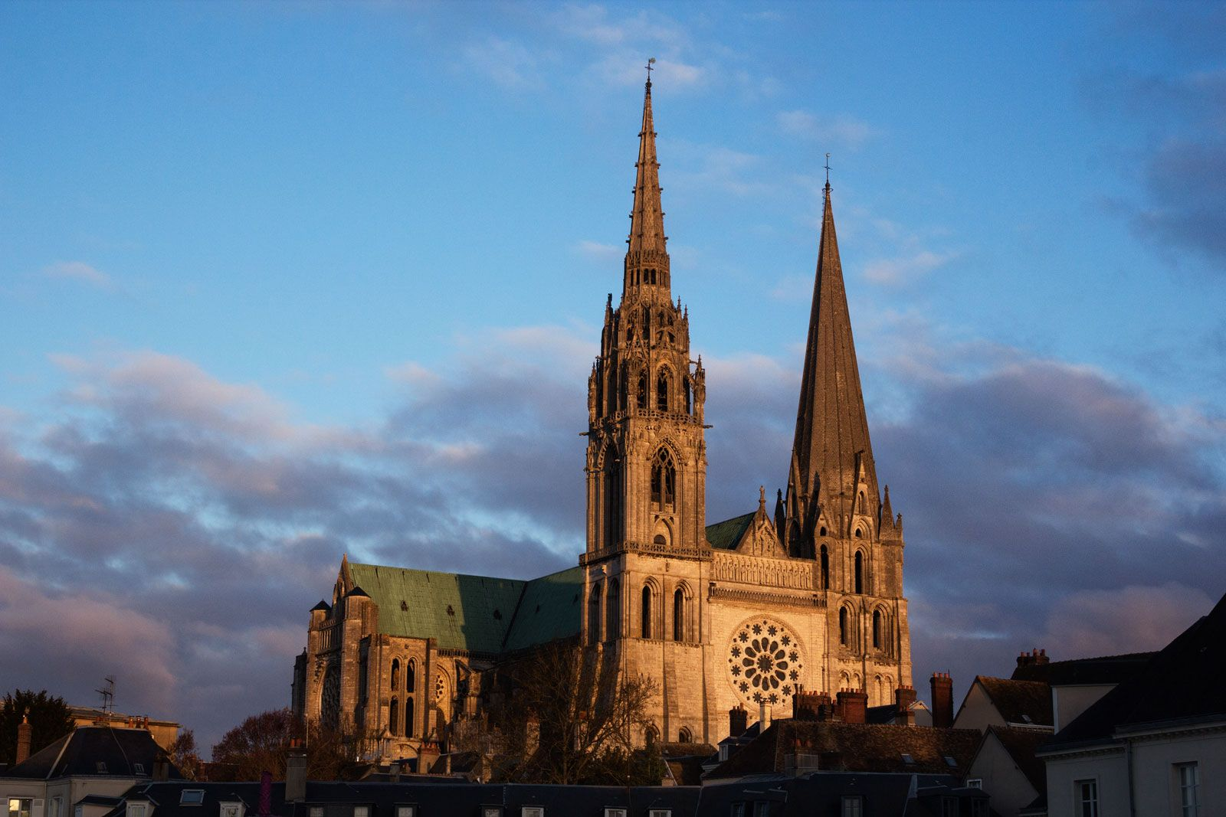
Image shows the Gothic design of the Chartres Cathedral in France which was completed in mid 13th century
RENAISSANCE ARCHITECTURE
Renaissance Architecture is the era between the period of 1400 AD to 1600 AD. Renaissance architecture spans over a period of two hundred years. The renaissance architecture is known as the rebirth of or the revival of the Greek and Roman Classical Arts combined with Gothic architecture. This form of architecture was based on regular order of building such as round arches and symmetrical masonry and proportions in establishing a structure or a building. This style of architecture emerged in Florence Italy during the sixteenth century. The focus of the early renaissance buildings was to allow as much air and light as possible to enter the building The Roman Classical Arts made used of rusticated masonry to include masonry parapets with balusters and the Dome in a drum.
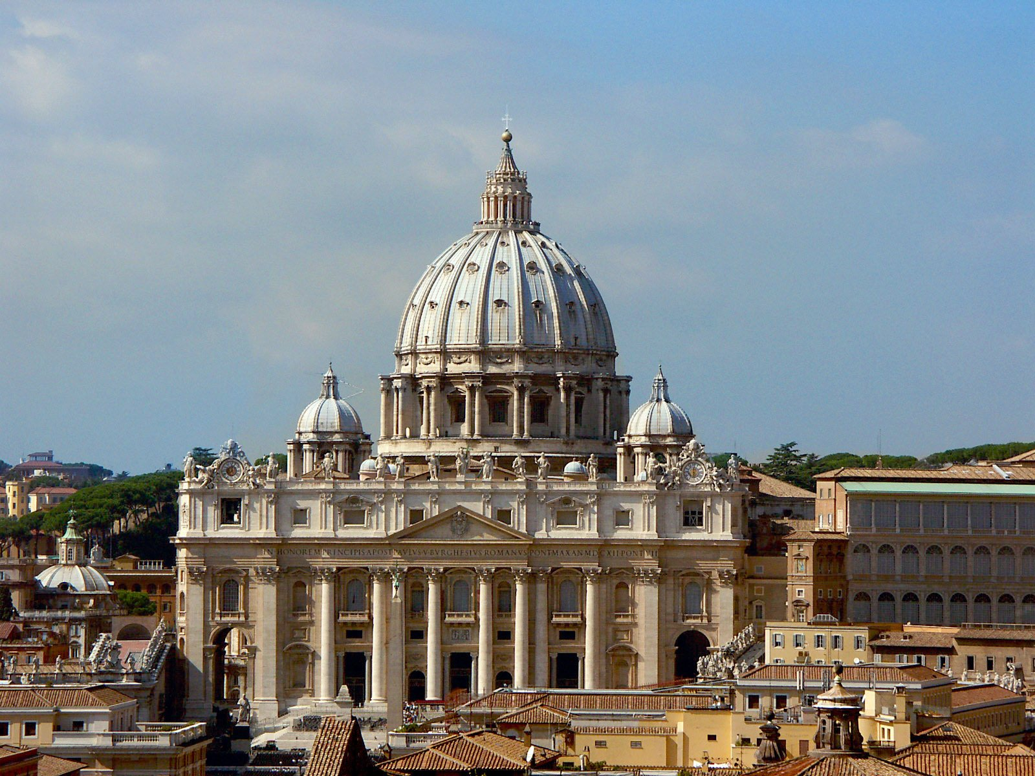
Image shows the Saint Peters Church in Rome - Renaissance architecture. The dome was completed in the 1500s
BAROQUE ARCHITECTURE
Baroque Architecture was the phase of architecture during the period of1600 to 1800 AD. The style of architecture included irregular shaped buildings and extra vagrant ornamentations. Some elements of this are still found in Europe and South America. This style of architecture is a very decorative, theatrical form of architecture. These decorative styles were not used on residential or personal houses. The Baroque styles of architecture were extremely dramatic during the sixteenth century to the eighteenth century. One of the characteristic of this form of architecture is that the final building may appear distorted. This is as a result of parts of the structure may appear to be broken, elongated or showing some sort of manipulation to the building. There is also repeated decorations to the structure, which makes this architecture style stands out.
The Baroque architecture emerged after the Renaissance architecture was established in Italy and other parts of Europe. The Renaissance architecture was characterized mainly by its symmetrical plans and facades, pillars and pilasters while on the other hand Baroque architecture promoted a more diversified and free approach to architectural designs.
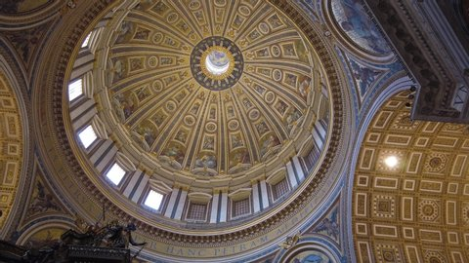
Image showing the Baroque architecture with interior decorations
​​​​​​ROCOCO ARCHITECTURE
Rococo Architecture ranged between 1650 Ad and 1790 AD. The phase of this era appeared to be the final of the Baroque style of architecture. It is the “Final Phase of the Baroque”. Builders used to construct buildings that gracefully finish with sweeping curves and a most beautiful finish.
Rococo architecture has seen many forms of interior designs with gracious and fabulous finish. Rococo architecture follows directly behind the design of Baroque architecture.

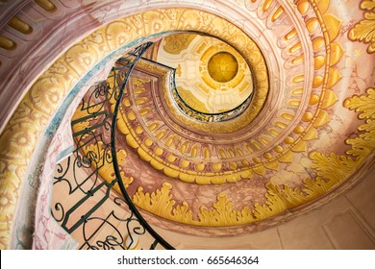
Image showing an example of Rococo Architecture

NEO-CLASSICISM ARCHITECTURE
Neo Classicism Architecture is the form of architecture that saw the return of classical form of architecture with classical shapes in Europe; Great Britain and the United States. The revival of the use of Greek and Roman Orders as decorative motifs were a great part of this form of architecture. This era ranged from the period between 1730 AD and 1925 AD. Neo classicism is the revival of Classical architecture during the period of the eighteenth to the nineteenth century.
The Neo-Classicism architecture is characterized by its grandeur of scale and simplicity of geometric forms and styles. Neo-classical architecture has many characters. Some of the characters include a) massive scale; b) symmetrical floor plans; c) simplicity of form; d) built to achieve classical perfection (Greek and Romans); e) Uncluttered appearance with minimum decorations; f) Domed flat roofs g) Doric or Ionic columns supported with tall columns h) gardens around buildings follow geometric patterns

Neoclassicism architecture with flat roof centered dome
ART NOUVEAU
Art Nouveau is the era of the period between 1890 and 1914 this form of architecture is known as the new style of architecture. .This form of architecture was expressed in art and fabric as well as graphic designs. The buildings often appear to be symmetrical shapes and arches. The finish design appeared with decorative surfaces.
When Art Nouveau was introduced into architecture in the late nineteenth century, it brought a new regression for a new style of architecture. The possibility of mass production of iron was introduced as a result of the Industrial Revolution. This revolutionized the process of construction and general building processes. While most décor styles are generally straight forward, incorporating art nouveau style can prove to be quite a task without the proper guidance of a design professional. According to Paris born designer, Robert Couturier”Art Nouveau is inspired by the fluid forms of nature.” One famous Art Nouveau and designer was Hector Guimard.
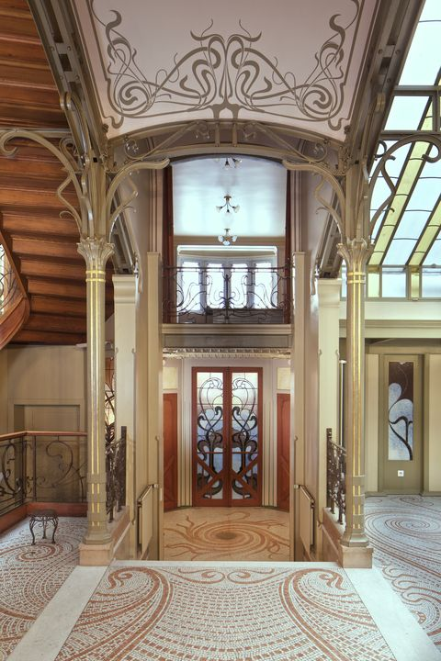
The image shown above is an example of Art Nouveau Architecture

BEAUX ARCHITECTURE
Beaux Architecture was in the era of 1895 AD and 1925 AD and is known as the Beaux Arts in Academics or Classical Revival Beaux Arts Architecture with symmetrical plans and eclectic features of architectural uses. This style of architecture was a subset of the Greek revival and Neoclassical forms of architecture. It became very dominant architectural style in the gilded age.
Beaux arts architecture became part of the American Renaissance Movement. The Beaux Arts architecture is characterized by symmetry, order, formal design, and grandiosity and elaborate ornamentations. This form of architecture is known to be found on balustrades; pilasters, columns, cornices and triangular pediments. The exterior was stone built in grandiosity with their symmetry and the interior were lavishly decorated and painted with sculptures, swags, medallion, flowers and shields. The interiors will always be built with opulent ballrooms and grand stairs ways ancient. Large arches rival the Roman arches.
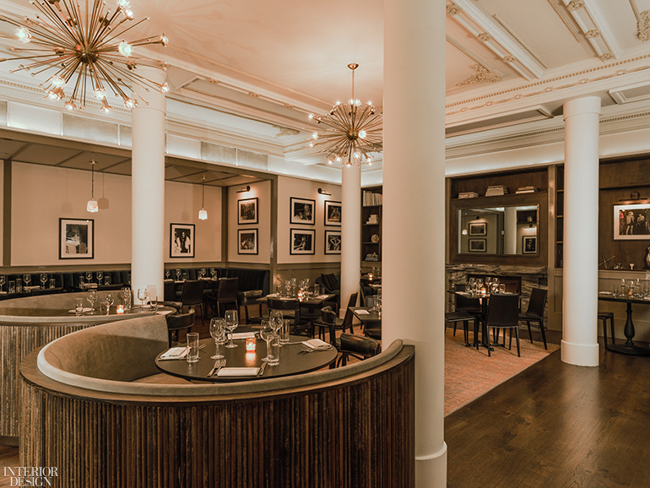
The structural columns and intricate Beaux-Arts plasterwork are both original to the building, which dates back to 1903. Photography by Sasha Maslov.
NEO GOTHIC ARCHITECTURE
Neo Gothic Architecture was in the era of the period during 1905 AD to 1930 AD. The ideas of gothic architecture influenced and were applied to the modern architecture within that era. The idea brought out the gothic appearance to modern buildings. Gorgoyles arched windows with other medieval designs and details brought out t grandiosity and rhe gothic
The neo gothic style of architecure was a new style of architecture that emerged in England during the mid eighteenth century. The parliament of England is an example of neo gothic architecture. The birth of Gothic architecture brought elegance, new life and new meaning to architecture. The Gothic Revival architecture was used in many types of building including religious buildings. Medieval elements were incorporated into facades of ordinary buildings. Gothic architecture was not used as much as the neo gothic architecture.
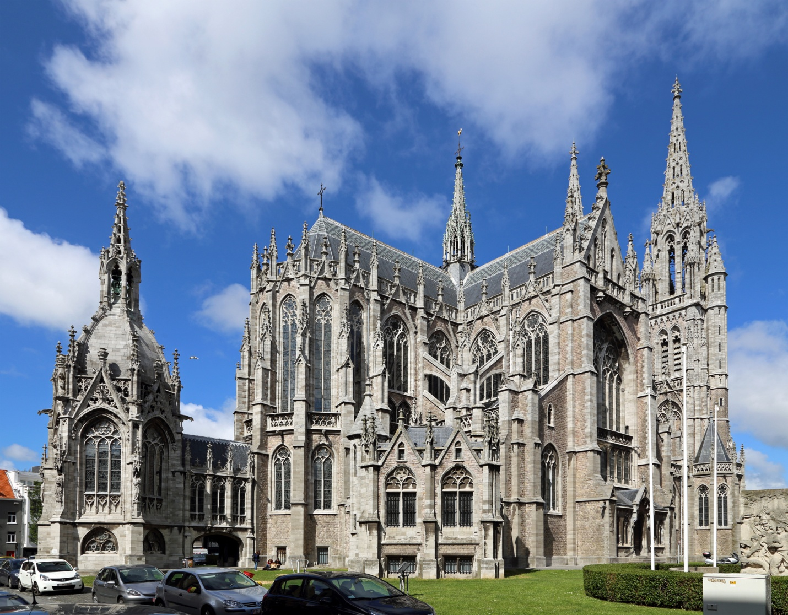
The image displays an example of Gothic Architecture
ART DECO ARCHITECTURE
Art Deco - This was the period between 1920 and 1930 AD. The introduction of zigzag lines as well as vertical to create dramatic effects on the Jazz age buildings. Many Art Deco monolithic inspire by the architecture of the Egyptian architecture. Art Deco is a style that refers to visual arts, architecture and desining. Art Deco was first discovered in France in the era of world war 1.
Art Deco style of architecture became popular in the United States and United Kingdom. Though it was short lived, Art Deco influenced fashion, art, buildings and home wares. This was during the period of the great depression in the 1920s. The architects of that time were very inventive and creative in their approach to designing architecture. The buildings that were constructed represented a sleek style of building. The creation of the Art Deco created buildings that were fresh, modern and unlike the revivalist styles of architecture. Art Deco style of buildings are remarkably unmistakable and represent the era of the times that was at the center of the machine age though this era was also during the time of the great depression in the 1920s.

Alice Morgan for House of Beutiful
The image above shows an example of Art Deco style of architecture.
MODERN ARCHITECTURE
Modern Stylist Architecture is the style of architecture that very modern day designs and plans. Modern architecture refers to the technological and engineering development of designs and projects. Although modern architecture may sometimes refers as contemporary architecture. Contemporary architecture means current while modern architecture. Modern architecture focuses mainly on materials such as metals, concrete and glass in the construction industry. Modern architecture can be defined as clean lines with minimalist interiors that can speak for themselves of the architectural styles.
Modern architecture is a unique form of architecture. The bold, angular roof lines are very prominent and unique. Architects of this era created some of the most unique designs in architecture. From vaulted ceiling to structural element to unusual linear elements are all very unique and amazing. One of the most famous modern architects is Frank Lloyd Wright who stands out with his unique style of architectural designs. In Jamaica a modern architect with whom his design speaks of his eloquent and outstanding workmanship is Herbert Repole. His buildings and designs actually stand out in a most symbolic manner. He is known for the design and construction of the Atrium and many other outstanding. Another great architect in Jamaica is Wilson Chong. He is most famous for the designing of the only National Stadium in the island.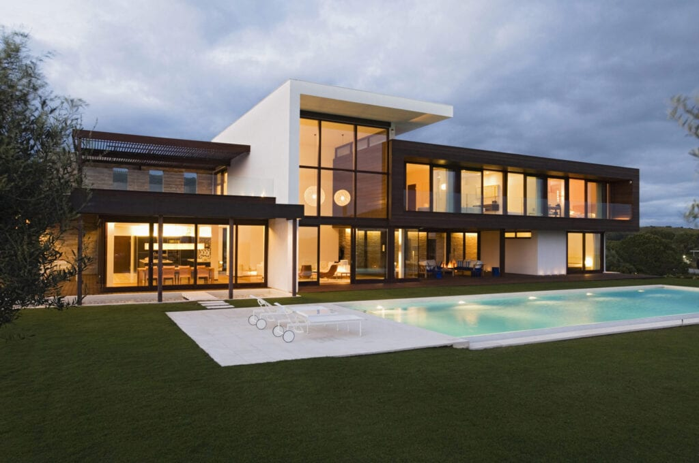The image above shows an example of modern architecture - Peter Cade/ Getty Images
POST MODERN ARCHITECTURE
Post modern Architecture is the current era that we are living in. The era of post modern architecture dates back to the beginning of 1972 to where we are today in architectural technologies. The modern day trends and de-constructivism formalize the modernism and structuralism of the present mode of architecture. The invention of new type of architecture and new buildings are based upon the historic values of ancient architecture. The re invention of historical details and familiar motifs dates back to classical and ancient architecture details.
It is said that post modern architecture was first introduced ton the field of architecture by Robert Venturi. Therefore he is called the “father of post modern architecture”. This new era of architecture is far advanced with modern technologies and computer designs. This style of architecture came about in the 1960s with a “bang” with its variety of “striking” colors, shapes and designs it made reference to classical and gothic architecture in some shape or form. Post modernism structures are easily identified by the “signature characteristics “and their “stringent forms” that are displayed.
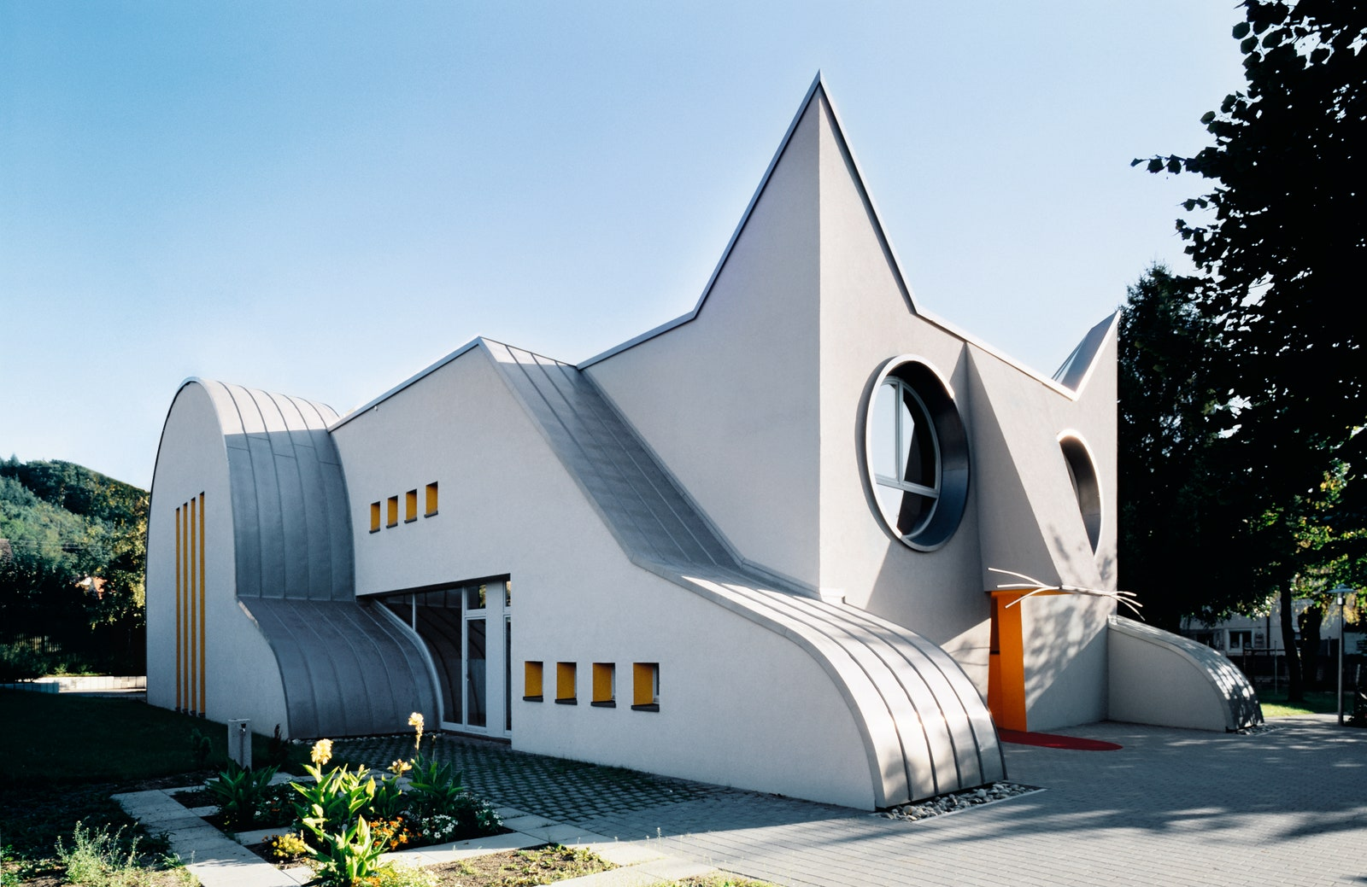
Photo by Dirk Altenkirch. Image courtesy of Phaidon.
Museum Garage by Jurgen Mayer H, Workac, Clavel Arquitectos, Nicolas Buffe,
The image above is an example of Post modern Architecture

THE GALLERY
Photos of timeline architecture
BYZANTINE ARCHITECTURE - Hagia Sophia famous dome (532-537).
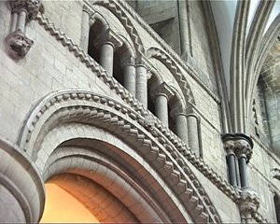
Gloucester Cathedral, decorative carving on the nave arcade

CLASSICAL ARCHITECTURE
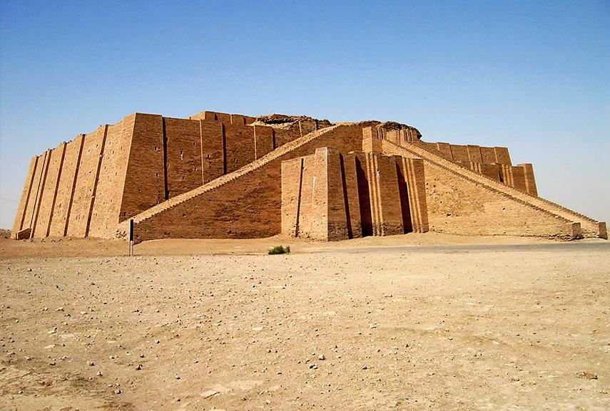
EGYPTIAN ARCHITECTURE

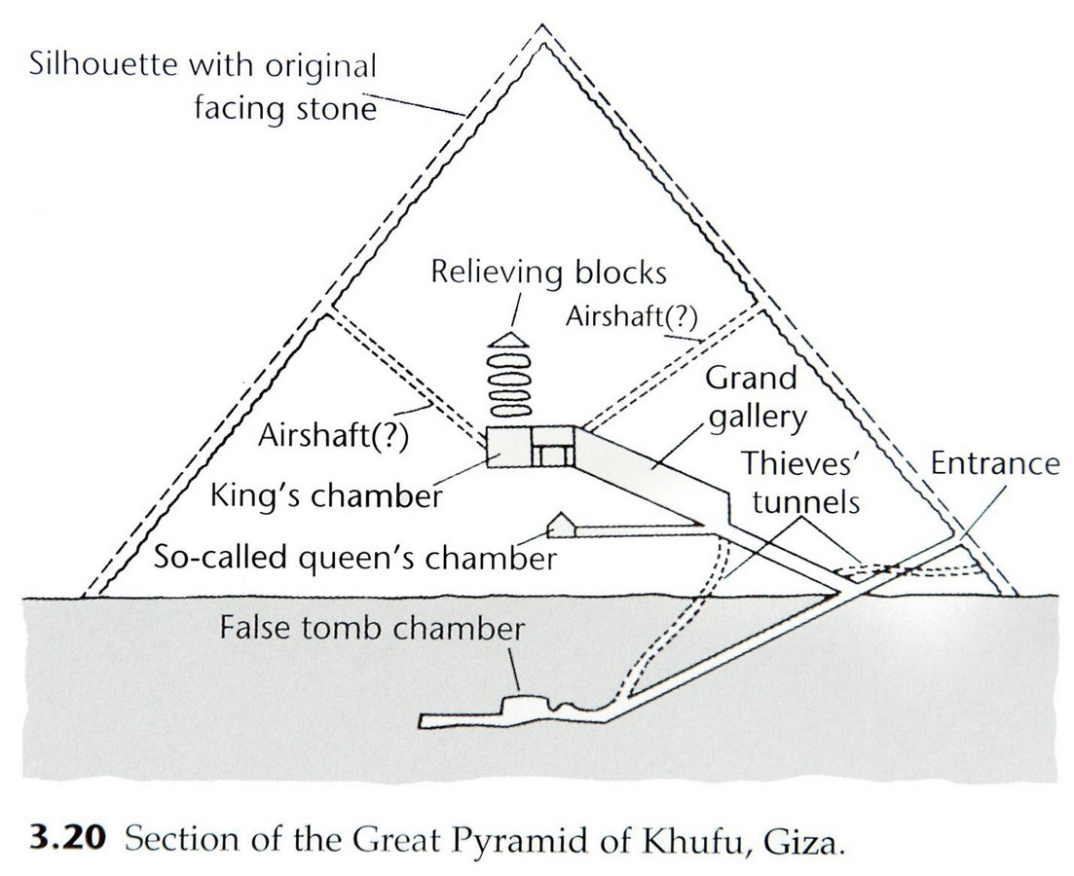
EGYPTIAN ARCHITECTURE PYRAMID DESIGNS

ROMAN ARCHITECTURE
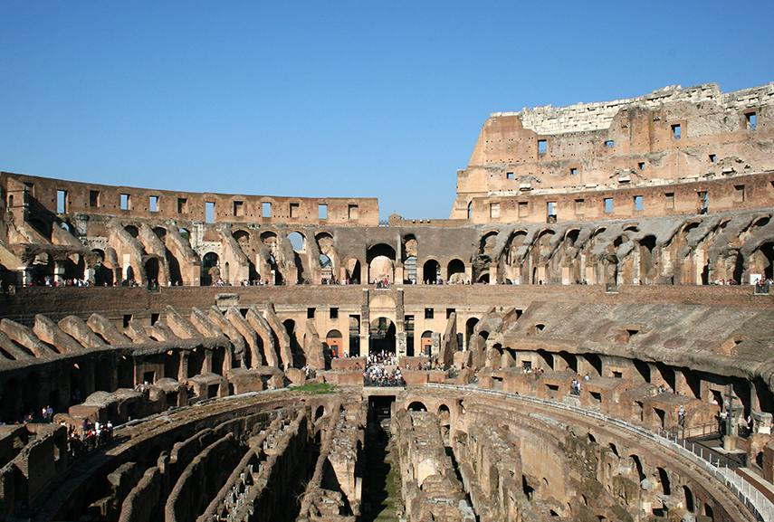
BYZANTINE ARCHITECTURE

ROCOCO RCHITECTURE

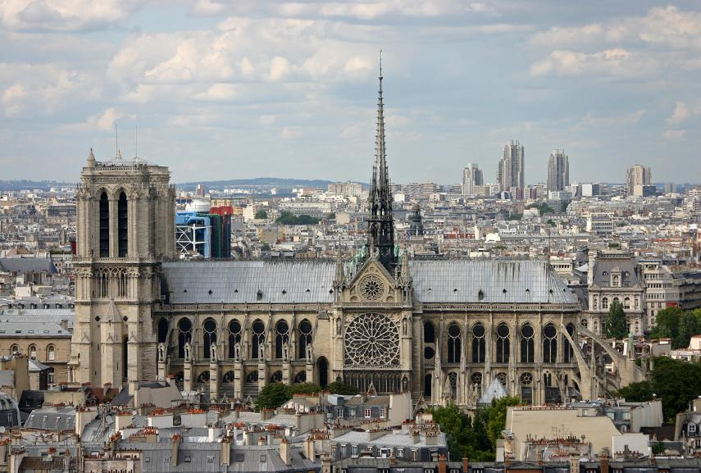
GOTHIC ARCHITECTURE
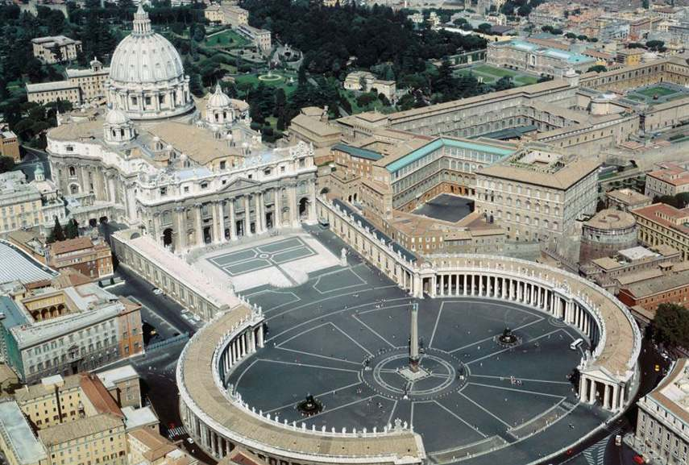
RENAISSANCE ARCHITECTURE
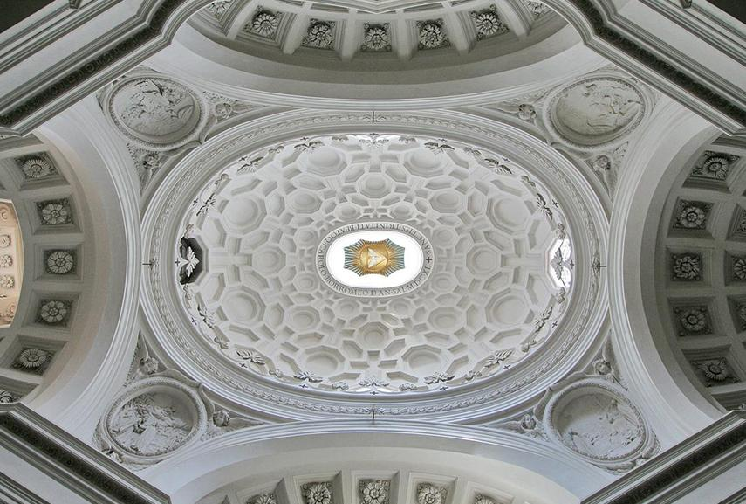
BAROQUE ARCHITECTURE
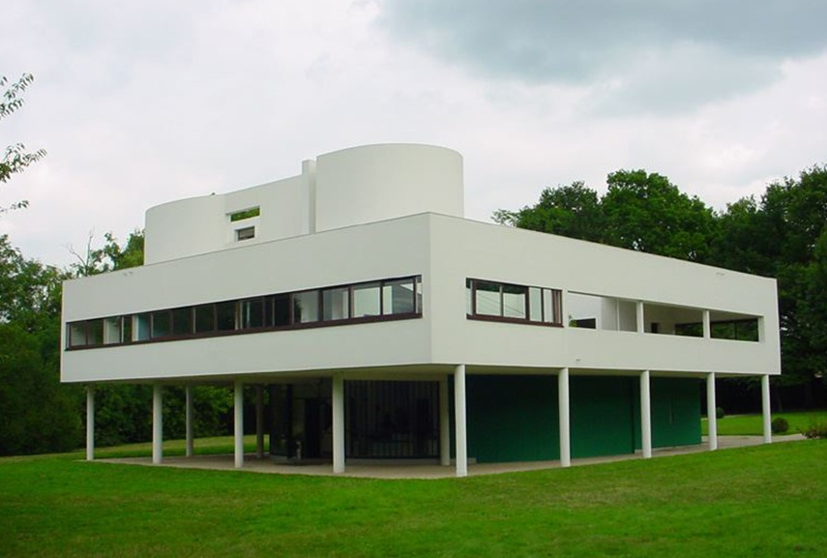
MODERN ARCHITECTURE
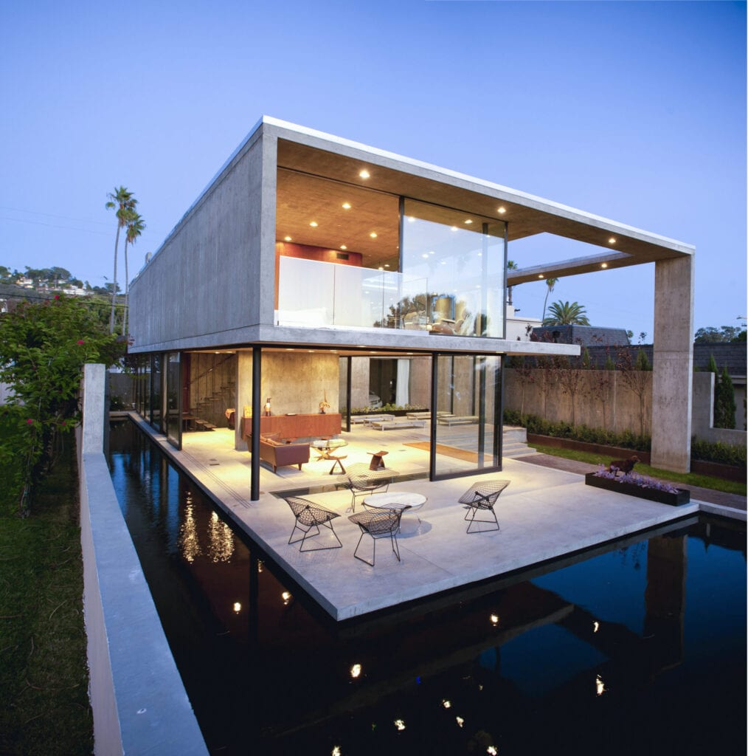
The image above displays examples of MODERN ARCHITECTURE Stephen Simpson/ Getty Image
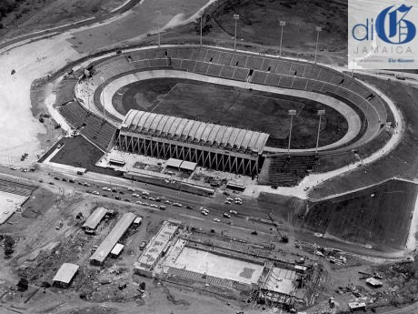
The National Stadium designed by Wilson Chong (Jamaican Architect)

The Atrium designed by Herbert “Denny” Repole (Jamaican Architect)
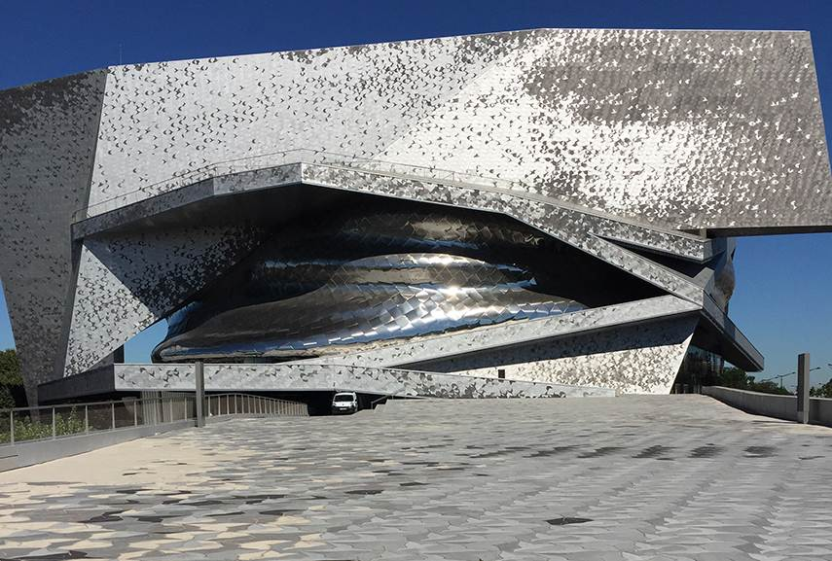POST MODERN ARCHITECTURE (By Jean Nouvel - Paris 2015 - 2016)
Post Modern architecture of 2022
Rockefeller Center joined forces with Art Production Fund to prepare the 2022 -Max Colby.

POST MODERN ARCHITECTURE
CONCLUSION
The history of architecture traces the changes in architecture through various traditions, regions, overarching stylistic trends, and dates. The beginning of all these traditions is thought to be humans satisfying the very basic need of shelter and protection. Wikipedia
The architect of the day does well to avail himself or herself of the knowledge and understanding of the history of architecture. The history of architecture traces the various changes through traditions, cultures, religions, the different regions styles, dates and trends to where we are today.
Architecture is such a grand field of work . There are so many variancies and dusciplianries to learn from and develop ones very own form of architectural concepts.
The evolution of architecture throughout the centuries has seen many different cultures. It is important to note that although every era differs significantly, the evolution has made architecture one step greater than its predecessor. Architecture has grown but has never lost its main function and objective which is to provide protection and shelter.
Architects throughout the centuries have made great impact on communities, societies and the world at large. Architects have made significant changes to the the methods of construction and development designs. Architecture will continue to evolve as the world continues to see more sustainable designs and greater architectural works.
In Jamaica there are some very outstanding architects. These include Wilson Chong; Vayden McMorris, Verma Panton; Herbert Denham (“Denny”) Repole and Gordon Gill.
I have had the personal pleasure and opportunity to work with Mr. Repole and I have to say that he was and has always been my inspiration in the field of architecture.

BIBLIOGRAPHY
https://www.widewalls.ch/magazine/the-history-of-architecture#:~:text=The%20exact%20origin%20of%20architecture,to%20look%20and%20feel%20like.
https://www.re-thinkingthefuture.com/architectural-facts/a2475
https://www.widewalls.ch/magazine/rockefeller-center-public-arts-program
https://www.britannica.com/art/Gothic-architecture
https://www.shutterstock.com/editor/image/baroque-dome-side-chapel-san-pietro-551795416
https://www.elledecor.com/design-decorate/room-ideas/a26967479/art-nouveau-interior-design
https://www.mymove.com/home-inspiration/decoration-design-ideas/why-people-love-modern-architecture/

