1/26/2022

UM73216HPS82376

ADEKEMI AYOOLA ADEBAMIJI

**Essay On Self Esteem and Human Relationship**

SHE 045

Content.

1. Introduction ……………………………………………………………. Page 02
2. Definition of Self Esteem…………....…………………………………. Page 03-04
3. Classification of Self Esteem.……………………………....................... Page 05-07
4. Definition of Self Confidence…………………………….…................... Page 08- 14
5. Conclusion………………………………………………………………. Page 15
6. References………………………………………………………………. Page 16

**Introduction.**

A self-esteem is an individual personal opinion about themself, this can either be positively or negatively, this could be due to their abilities, position, values worth and so on. Self-esteem can also be how an individual rates himself, or what he thinks about himself. Moreso, what you feel about yourself will determine how you carry yourself.

Also, the feeling of self-esteem can either be high or low. However, people with good self-esteem mostly think well of themselves, they are mostly satisfied with their personality or achievement which makes them more confident while people with low self-esteem seem to have negative thoughts or place little or no value on themselves and sometimes feeling unworthy which later leads to serious conditions like depression.

Many factors contribute to our self-esteem these includes our background. For example, from research, children from rich family background tends to do and feel better about their self-esteem than children from poor background. Also, individuals’ personality determines how they will act in certain ways and also determines how they will react to certain situations, their feelings towards others. Also, experiences people have had while growing up contributes to their self-esteem example is a child that is always bullied due to obesity will likely have a low self-esteem while growing up except, he/she gets help.

Although, low self-esteem seems to be more pronounced in the female gender than the male, however, its start in childhood but doesn’t really get noticeable until around adulthood. This can be frustrating or straining for people around these individuals due to the effect of low self-esteem. Also, early diagnoses will bring about help and change to them so as to live a better and fulfilled life.

Furthermore, self-esteem is like the foundation to our success. Parents have a lot do by being sensitive to know when a child needs help, so as to get help early to avoid it escalating terrible behavioral problems for them in future.

**Essay.**

The self-esteem is a personal opinion of one self, it explains how you feel about yourself as an individual, this feeling describes your potentials or strength which can either make you feel comfortable about yourself or show your weakness which can make you feel unfulfilled as a person.

Similarly, the way you feel about yourself goes along way; this is what radiates to your outside. Moreso, when you have a healthy self esteem you re more likely to live a balanced life both mentally, emotionally and in all aspects of your life (Cherry, 2021).

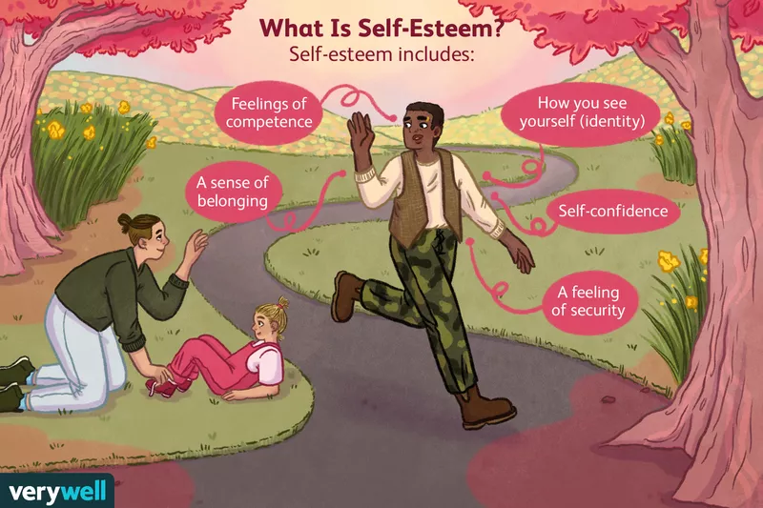

In other words, self-esteem gives you a picture of how you see yourself even before the world sees you, even though everyone wants to be seen and appreciated, it’s a personal feeling that starts from the inside of us as human and so the world will only give back what you have portrayed. This means the opinion you create in your mind about yourself is what will be displayed.

However, the self-esteem is not a feeling that suddenly appears but builds from childhood through adulthood which later becomes a habit. Moreso, many factors influence our self-esteem some of these includes:

* Past or childhood experiences: While growing up, a lot of experiences occurs this can be a positive or negative one, this either builds a child’s self-esteem or breaks it, for example a child that grows with an abusive or violent parent/guardian is most likely to grow up with a low self-esteem. More examples include, a child that is obese which is probably due to excessive eating or a result of a health condition might be body shamed by peers leading to a lower self-esteem, or young children who have been abused sexually mostly by close relatives or trusted friends causes so much pain to them both physically and emotionally overtime, if these feelings are unresolved it lingers on as they develop into adulthood.
* Parents / Caregivers: Raising kids is not just about sending them to the best of school or wearing the best dress, parenting must be balanced by supporting kids emotionally, for example a child that gets low grades in chemistry or mathematics, instead of helping them get better by finding solutions the kids get thrashed or abused or make him feel dejected over time, this decreases the child’s self-esteem even as they grow older by making them feel they’re worthless.

Other factors include the social media where people try to compare themselves with the global world where they do not belong and when they cannot fit in, they feel depressed which affects their self-esteem. Another factor is peer pressure who are bad influences and so on.

**Classification of Self Esteem**

Moving forward, our self-esteem is divided into two major categories which are:

**Low self-esteem**

This is characterized by people with feelings of unworthiness or people feeling they are not up to the standard of the people around them, such people practically pull themselves down before others even do, they practically write themselves off as being inferior or less human of others.



However, this feeling makes the individual kind of over conscious most times for example when they enter into a room, they feel others are talking or waiting for their fault or mistake, with little or no expression from an audience they can criticize themselves even before others do, they mostly get judgmental and easily feel rejected. (Firestone, 2012)

Similarly, most time this feeling is always a disturbing one as it comes from your inner thought. However, it can sometimes be destructive due to the fact that it takes over every aspect of your life from the physique, to emotional, including how we relate or keep relationship most importantly professional relationships. The feeling starts as tiny voice by creeping into your mind and creating an awareness of how unworthy or incompetent you are at all you do as a person overtime it continues into adulthood which becomes part of you.

Additionally, since people living with low self-esteem have a weak personality, they mostly need help and coping strategies to overcome this feeling some of the ways includes:

* Finding the triggers: The individuals need to point out what and what causes the feelings like when or where its likely to occur.
* Another way to overcome this is to stop comparing oneself to others, instead challenge yourself.
* Maintaining good physical fitness is another way of having a healthy self-esteem, because you feel confident from within.
* Also, everyone is good at one thing or the other, so identify your strength and work on it, this will make you a better feel confident of yourself. Others includes building or keeping the right relationship/ friend who will encourage and motivate you (AntsyAna, 2020).

**High Self Esteem**

High self-esteem is simply believing in yourself, having a good opinion or seeing yourself as someone who can achieve anything. This set of people are not easily influenced by what people do or what happens around them especially when its negative, also it is absolutely different from pride. Frankly speaking, it is just an expression of confidence and success, people with high self-esteem practically feel good and confident about themselves with or without any one’s validation. Moreso, instead of wallowing in self-pity an individual with high self-esteem gives in for improvement by accepting their weaknesses and learning new things.



Moreso, individuals with high self-esteem make their own decisions and are not afraid to air their opinions, they do not mind if others do not feel comfortable about it. They tend to create their own path in life without minding criticism, practically it’s difficult to intimidate people with this frame of mind because they have a mind of their own. Other characteristics of high self-esteemed individuals includes:

* Ability to make constructive change where ever they find themselves.
* Also, they grow and learn from others irrespective of their success or achievements.
* They are always eager to meet new people and ready to explore.
* They always mostly trust their judgement and make their own decisions in life because they know what they want and know how to achieve their goals. (Thomas, 2020 ).

**Self Confidence**

Self-Confidence is a state of mind where you are sure of your abilities or have assurance in yourself. You can’t be confident except you have certain level of trust in your skills or ability, the knowledge of this strength gives you confidence about yourself or gives you the ability to believe in yourself to accomplish any task despite any difficulty (Joseph, 2012).

Even though, we all have one fear or the other, staying positive and working on your strength helps you to believe in yourself. On the other hand, research shows that your thought influences most of your actions. A self-confidence is like the foundation of all success so without believing in yourself you might find yourself failing and not being confident enough to persist to be able to achieve your goal, you simply give up on yourself.

However, when you work on your confidence it gives you an internal energy to try again or gives you the motivation you need, in all aspects of your life from work either as a leader or a team member, also in human relationships you need this to be able to make the right choices for yourself this in turns gives you success.

Even though, a low self-confidence can be frustrating or depressing for people, if not taken care of it can be detrimental. Also, we need to understand that we were not born with self confidence instead we pick it while growing. Moreover, the same way low self-confidence started it can also be relearned. With proper help it can be worked on, some of the ways to boost self-confidence individually includes:

* You need to know or identify that negative inner thought about yourself and face it to be able to move on.
* Say no comparison, you need to realize everyone has his own imperfections but your ability to work on your own is what matters. However, research shows people who compared themselves to others mostly experience envy and the more envy they experience the worse they feel about themselves (Morin, 2021).
* Learn to focus on your strength.
* Work on your yourself physically for example, you can start by eating healthy and exercising this gives you self-confidence, also learning or picking up new skills or hobby boost your confidence and so on.
* Stop seeking validation from people as this can ruin your confidence again.
* It’s important you Stay positive and keep friends with a positive spirit who will inspire you instead of putting you down.

Although, self-confidence and self-esteem seem close however, you can have self confidence in you due to your abilities, for example you can be very good at acting and still not have a good self-esteem. Even though they are both important to our emotions, working hard to get better at all you do will give you that confidence you need as an individual. However, having a high esteem is important to our health so loving yourself totally, believing in yourself, feeding your soul mind and body with positivity all around you.

**Consequences of Low Self Esteem**

Furthermore, when people continue to live with these feelings without getting help it tends to deteriorate into bigger problems causing lots of damages to their life and the people close to them. However, some of the problems can be emotional, physiological and so on. Below are some of the problems that can be encountered:

1. **Emotional Dependency.**

Everyone wants to be love and be loved back in return, we all want somebody to listen, comfort and count on, in times of troubles or when we’re facing life difficulties. We want someone who can understand us and give us all the support we need in our moments of trials.



However, emotional dependency is a psychological state of mind with an excessive bond between group of people, could be between family members or between spouses. It’s more of psychological attachment where the partner feels obsessive over the other one. However, the attachment is most times more obvious in one party than the other. Also, people with this state of mind can be obsessive in their relationship in order to achieve personal feelings of satisfaction either due to the fear of being alone or taking decisions alone. (Soussi, 2021).

Similarly, emotional dependence mostly stems from low self-esteem or insecurities also, the individuals mostly rely on the other one for almost all their emotional help, for example in taking decisions, for validation and feel they cannot do without the other. In most cases in an emotional dependent relationship, you find out the person is not even happy or being treated right but they mostly find it hard leaving their spouse due to the fear of loneliness or feel they are not good enough for others. Its mostly traumatic because even though they seem too dependent they tend to get hurt more in the relationship mostly when their needs cannot be met

Furthermore, People with this state of mind most times do not realize they act that way more so. They just want to feel in charge, more over research emotional dependency is more predominant in female than male and

some of the characteristics includes:

* They feel their life is going to crumble without the other person.
* They feel they’re not good enough due to their low self-esteem.
* Their happiness is centered on just one person example is their spouse.

1. **Unresolved Feelings.**

Emotions are feelings that are inevitable, love, hate, anger and so on, some of our emotions is just a reaction to what we experience be it anger or happiness. However, there are people who let out their emotions immediately when the need arises, and some just suppress it, perhaps believing it will resolve or they will get over it as time goes on. For example, a girl was molested by her caregiver and refused to speak out either because she is helpless and can’t fight back might just bear the pain silently especially if she feels she won’t be listened to. As the child transitions into adulthood, she may find it hard trusting anyone around her especially the opposite sex. Subconsciously her thoughts will be that she’s going to be taken advantaged of again. This unresolved pain mostly becomes a fear simply because the pain was not expressed at that moment.

On the other hand, having unresolved feelings doesn’t just stay within, at one time or the other it gets outs and it’s expressed as an outburst of aggression, depression or anger which can sometimes generates into more serious health problems like inability to sleep or high blood pressure, this constricts the blood vessels which can also degenerate into a heart attack.

Also, unresolved feelings can also lead to some behavioral problems, a lot of people especially children who grew up in broken home or rough families are bound to have a lot of suppressed emotional feelings rather than confronting their issues they tend to move on with this leading to more behavioral problems as they grow into adulthood or move into relationship with more disturbing characters. For example, a child that grows up with all of bully or fighting within their families might grow up being so defensive, aggressive to avoid the same pattern he/she went through while growing up.

Additionally, this feeling always come back at one time or the other in our lives also, while some continue to repress or cling to these emotions without releasing the energy, they mostly unhealthy for us, physically, emotionally. However, you can release these emotions by:

* Allow yourself to release the accumulated unhealthy emotions, sometimes you just need to let it out, cry it out, don’t beat yourself up by feeling bad and you will feel better.
* Also, seek for a professional help to get better coping skills in dealing with your emotion
* Address the overall emotions to avoid repeating the same pattern or transferring the emotions to others.

1. **False Self Esteem**

A false esteemed person is an individual who sees themselves as the stars of the moments in front of the whole world and others at their feet, their ego is mainly based on what is visible to the world not their real person. An individual with a false self esteem wants others to see just him and no other person, their ego is based on what they want you to see.

However, this can be few of their physical achievements which they show to the world, you can hardly get into their real self because there is nothing worth to be seen. Individuals like this never see themselves making mistakes or accepting mistakes, neither to they like to be criticized instead they will rather use others as an excuse. A false esteemed individual makes others feel they can achieve a height even when they cannot do that, the main idea is to look down on them.

Although, they know within themselves they do not have a good self-esteem, more reason why they have to build a wall of defense around themselves to avoid people looking down on them for the fear of being put down. Most of these attitudes prevent them from having a good relationship.

**Low Self-Esteem in Children & Adolescents**

The growing stage of children to adolescence is rapid and in between a lot of physical, emotional transformation happens, a lot of factors determines the kind of personality they are most likely to pick up, or their confidence as an individual. Some of these includes: The families where they come for example, families that have good relationship among themselves, their children tend to do better emotionally which also means they would have a better self-esteem.

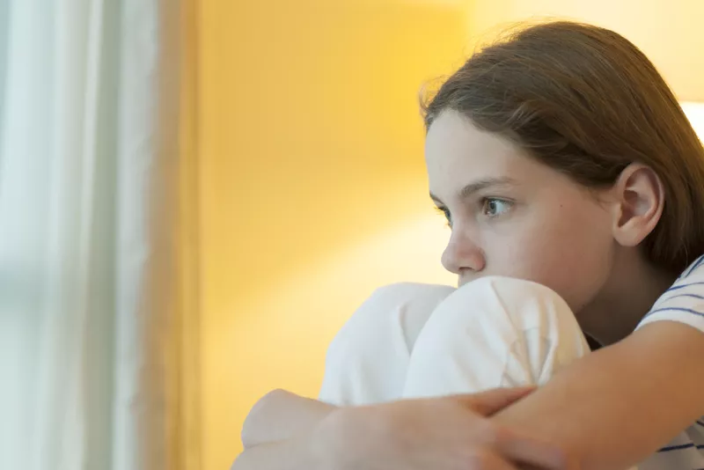

However, these changes are more obvious during toddlers to young teenage years. Most children start when they start seeing differences between them and others, for example a child that is overweight might compare herself with others and feel like (we all eating almost the same food or we are of the same age but I am the only overweight one.) (Fraser-Thill, 2022)

Similarly, is the feeling of incompetence among them, example is a child that is not academically sound he might feel he’s not good or smart enough like others is at a big risk of developing a low self-esteem. Research shows, at this stage children tend to criticize or put all the weight of blame on themselves making them get more depressed.

**Self-Esteem And Adhd**

Moving forward, Attention- deficit /hyperactivity disorder is a mental disorder affecting majorly children and mostly continues to adulthood. Also, this disorder becomes noticeable in some children as early as 3-5, till around 12 years of age. However, it can be more pronounced in boys than girls because they are more agile or tend to be more playful. For some children, this disorder is not easily noticeable by some parents until they start mixing up with friends or start school. Recently ADHD has also been found in older adults even though some symptoms must have been there but was not diagnosed on time.

However, children with this problem are seen having problems with paying attention, they are hyperactive, are easily distracted, have problems with organizational skills, and so on. This is one major reason why some of these kids have issues with their teachers/ minders especially if they are not aware. For example, a child with ADHD might be seen talking excessively without being asked to or seen fond of interrupting others while doing their task, they may also find it hard sitting in a particular space for too long due to their hyperactive nature.

Even though, the cure of ADHD has not been fully found, early diagnoses and management has been helpful in making patients deal with it better. Management of this disorder also depends on factors like age or how serious their symptoms are. Also, management of this disorder includes the use of medications and behavioral therapies and this always done by a professional child psychologist. However, some of the causes of the ADHD has been linked to: Genetics, Exposure to toxin during pregnancy, **Significant head injuries, certain drugs used by mother during pregnancy and so on.**



Moving forward, children living with ADHD has lots of challenges which can affect their self esteem as they grow to understand they are different from others. Most of the children living with ADHD are spotted in public places easily, especially in schools or other social gatherings. For example, a child with ADHD can get easily distracted during class work, another example is during mental drill most of these kids have problems with reasoning. Such behaviors can make teachers or minders get frustrated by criticizing them, also some of them also have problems relating with their peers resulting into loneliness, thereby making them feel bad or developing a negative self-image about themselves, this overtime leads to low self-esteem or low self confidence in the child and can be at risk of not fulfilling their potentials.

On the other hand, parenting has a lot to do with a child’s self-esteem both in cases of ADHD or children generally. Also, inculcating a good self-esteem into children gives them the mental balancing they need as they grow into adulthood. Moreso, how they personally feel about them selves goes along way, a child that feels good about himself will most likely be able to relate with people and live a fulfilled life. Some of the ways we can help children have a healthy self-esteem are:

* Expressing your love to them unconditionally, this gives them a sense of security and strength to face their challenges
* What you speak and how you speak will become their inner voice later one. creating a good environment to grow.
* Encourage positive thinking and talks for children for example teach children to say positivity to themselves like I am different and I am smart.
* Build up on your child’s strength. for instance, if your child is not good in chemistry but is very sound in tennis, create time to let work on her strength.

In conclusion, having confidence in yourself or building a good self-esteem is an action which cannot be hidden, it mostly reflects in the way you relate with people around you, what you feel about yourself, how you deal with every situation that comes your way and mostly how you take decisions in your life. Without a good self-esteem you are not going to believe in yourself or take any positive action. Moreso, it will be difficult to survive or thrive in every aspect of our lives either in marriage, work or the world at large.

Moving forward, having a more knowledge on self-confidence and a good self-esteem has helped me figure out personally some of my unresolved feelings which I need to let go. Moreso, I have also been able to learn better techniques on how to deal with my feelings and others at large without being emotionally dependent on them.

Finally, parent have a lot to do in raising children’s self-esteem, we need to keep in mind that, every child starts their life first from the family, if you raise your child with full love, positive mindset, spend more time with them, build on their strength, give them all the support they need as children while growing they are most likely to grow up as confident children. Especially, children with special needs. Also, early diagnoses help us know and deal better with their needs so they can develop and maintain positive self-image so they can reach their full potential as they grow into adulthood.

**References**

AntsyAna. (2020, May 6). Retrieved from bing,com: https://www.bing.com/videos/search?q=overcoming+low+self+esteem&ru=%2fvideos%2fsearch%3fq%3dovercoming%2520low%2520self%2520esteem%26form%3dSWAUA2&view=detail&mid=8648DF7EA888EEB5DD3D8648DF7EA888EEB5DD3D&&FORM=VDRVSR

Cherry, K. (2021, April 24). *Very Wellmind*. Retrieved from https://www.verywellmind.com/what-is-self-esteem-2795868

Firestone, L. (2012, August 23). *PSYCALIVE* . Retrieved from https://www.psychalive.org/low-self-esteem/

Fraser-Thill, R. (2022, January 12). *verywellfamily*. Retrieved from https://www.verywellfamily.com/causes-of-low-self-esteem-in-kids-3288009

Joseph, I. (2012, January 13). *TEDxTalks*. Retrieved from https://www.youtube.com/watch?v=w-HYZv6HzAs

Morin, A. (2021, November 27). *Verywellmind*. Retrieved from https://www.verywellmind.com/how-to-boost-your-self-confidence-4163098

Soussi, F. (2021, June 4). *Illumination*. Retrieved from https://medium.com/illumination/emotional-dependency-symptoms-causes-and-treatment-44267bfc1a45

Thomas, P. (2020 , January 9). *Self Help for Life*. Retrieved from https://www.youtube.com/watch?v=JfIUUaalX74