**SAVANA THOMPSON-PAUL**

**EDUCATIONAL LEADERSHIP**

**STRATEGIC SCHOOL MANAGEMENT**

**ATLANTIC INTERNATIONAL UNIVERSITY**

**HONOLULU, HAWAII**

**SPRING 2021**

**MAY 31, 2022**

**TABLE OF CONTENT**

INTRODUCTION …………………………………………………….. 3

LITERATURE REVIEW ……………………………………………...4

HOW STRATEGIC MANAGEMENT

CONTRIBUTE TO SCHOOL

DEVELOPMENT? ……………………………………………………. 5

THE FUNCTIONS OF LEADERSHIP

IN CREATING STRATEGIES …………………………………….... 7

CASE STUDY …………………………………………………………9

ANALYSIS …………………………………………………………….10

CONCLUSION ………………………………………………………..11

BIBLIOGRAPHY ……………………………………………………..12

**INTRODUCTION**

A basic quality of strategy is planning and following a course of action which meets certain objectives of a school with taking account of the future (Fidler, 2002). Every organization needs to plan for the future. There has to be a set of goals that the organization needs to achieve. So therefore, planning is very critical. If the organization does not plan then it will plan to fail. Organizations such as schools plan on a regular basis in order to run the day to day activities of the institution. While planning is important schools also need to organize activities and actions that will be taken on a daily basis. A school needs to organize its resources to achieve the goals set by the institution. An organize school will have a step by step approach to get things done. When schools practice to organize its actions or resources it experiences a higher degree of achievement. Although, planning and organizing is vital for the running of a school, the school needs to set a time scale as well. A time scale would give the school a suggested time of when to get things done. It makes no sense the school leader plan and organize the school’s resources but don’t have any time line. The time line will force the actions of individuals to achieve certain goals by a certain time.

Additionally, team work plays an essential role in the management of a school. Every stakeholder of a school needs to practice and accept team work. Everyone has to have the same agenda or objectives. It cannot be the case where some persons have a totally different agenda from others and they are working with the same institution that will bring forth confusion. Also, the institution will remain in a stagnant position for a long time until everyone decides to work together as a team. For strategic management to work in schools all these elements (organizing, planning, time scale and team work) have to be accepted and practiced by the school leader and the stakeholders of the school. This essay will examine strategic management in schools by focusing on the influence of strategic management on school development and the functions of leadership in creating strategies.

**LITERATURE REVIEW**

During World War II in a military area is where the notion of strategic management was created. At Harvard Business School, strategic management was then matured in a business syllabus. At first, strategic management was known as ‘business policy’ and later viewed as a successful management approach. It was also embraced by many organizations in the business sector.

Strategic management is considered to be an art as well as science. The basic components of strategic management are creating, executing and assessing strategies. The processes of strategic management are assessing the internal and external environments, planning strategies, executing strategies and managing strategies (Manketvit, Srisa-ard, & Setsaengsri, 2016).

It is found that in many areas the use of strategic management has expand the competence of institutions and centers. Strategic management plays an efficacious function in the achievements of institutions and centers. A lot of research has been done on the spread of strategic management at educational institutions; because in the field of education, one of the most important topic is education (Amoli & Aghashahi, 2016).

**How strategic management contribute to school development?**

Strategic management plays an essential role in school development. School leaders have to plan strategically to develop a school’s performance. The type of plan must be suitable to the timescale. Long term plans must lack detail but should adequately state a way to contour decisions. The path needs to be pointed out instead of stating the precise path (Fidler, 2002). Strategic planning is something that takes time. School leaders cannot just get up one day and say this is what I am going to do, expecting to accomplish the goal right away. They have to think about the objectives or the goals of the school, whether or not the decisions they are about to make will affect the goals of the school in a negative way or positive way. Strategic management is not just about having a critical plan of action which directs the way forward for achieving the goals of the institution. It should also entails the length of time the plan of action will take to accomplish the mission.   
  
A strategic plan has to be done in order to accomplish the goals set by the school. Strategic implementation tends to be analogous. As soon as a strategic aim has been determined, a strategic plan is created to move from the present to the strategic aim (Fidler, 2002).

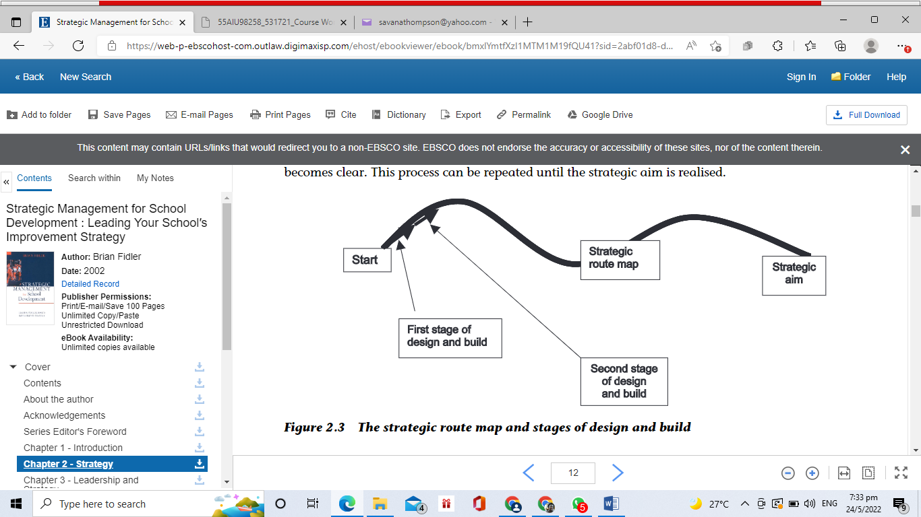

The strategic plan of the school should clearly states the steps that are to be implemented in order to attain the aims of the institution. Once the school administration decides on the aims of the institution, automatically, a strategic plan should follow.

Additionally, both an official process of strategic management and strategic thinking should be in the minds of senior officials so as to have a successful strategy (Fidler, 2002). The administration of a school needs to constantly have in mind the aims of the institution. They also need to follow the plans that are put in place to achieve the goals of the school. Any new idea or policy that the school will embark upon needs to be in correlation with the strategic plans and aims of the institution. Any decision that the school administration is going to take should tie-in with the plans of the school. It makes no sense that the school administration makes decisions that has no connection with the strategic aims of the school.

In addition, strategic management contributes to giving schools a competitive edge over other schools that is if the strategies of these schools are managed wisely. Once the school administration sensibly manages the measures to be taken in order to attain the future goals that are desired by the institution it will have an advantage over other schools. In the education system there are many schools that have students performing better than others. The reason for this is that the schools that are doing exceptionally well are the schools that practices strategic management. These schools have strategic aims and plans. They manage these aims and plans wisely which result in physical development of the institutions and high academic performance.

**The functions of leadership in creating strategies**

The functions of leadership are recognizing new opportunities, influencing others to perform, act for the organization and give clear meaning of what the organization represent (Fidler, 2002). School leaders and head-teachers should be alert and quickly identify problems the school population is encountering and propose solutions for these issues. You cannot be a school leader or head-teacher and you are oblivious of what is happening in the school’s surrounding. This is why a school leader should communicate with the staff, not just the academic staff but also the ancillary and administrative staff. When the school leader communicates with the staff he or she becomes aware of the needs of the institution. Once the school leader is aware of the difficulties is the school is experiencing, the leader will be able to develop strategies that will eradicate these difficulties.

Also persons in management positions at a school should have the expertise to convince others to do what is required of them. A principal should be able to motivate the staff to perform the daily operations of the school. When the staff is motivated they contribute greatly to the success of the school. The staff will become committed to their duties. They also will have the drive and energy to perform on the job. This will most definitely result in the school having a competitive edge over other schools. If the staff is not motivated to do their task they become disengage, communicate poorly and the overall productivity of the school diminishes.

Likewise school leaders and head-teachers should be ambassadors for the school. Leaders of schools should represent the institution anywhere they go. They should be speak and live the beliefs of the institution. They should also give clear meaning of the school’s mission and vision. The leaders should have in their minds constantly the mission and vision of the school and any decision that they will take should be in correlation with the mission of the school, as well as the vision of the school.

It is evident that strategy needs leadership, not someone who has been designated for the position of leadership but someone who has leadership qualities. Anyone can be designated for a leadership position but they don’t have the qualities of a leader. A strategy consist of the plans and actions that will be taken in order to attain a future goal or objective. In order for a strategy to be created and also be successful in the future the person or persons who have created and implemented the strategy needs to possess the qualities of a leader.

This course has contributed to my educational development in a huge way. I have learnt the importance of planning for the future. As a leader, I should not have only long term plans but also short terms plans. These short term plans should be in connection with the long term plans. It is essential that when I become a principal I practice strategic management in my institution because it will contribute to the development of my institution. It is critical that the goals that I set for the school should be in agreement with the strategies that are created to achieve these goals. I realize that if I have the qualities have a leader it will be evident that my staff will be willing to follow the direction given to them by me. Strategies and leadership goes hand in hand for the development of a school.

# **Case Study:** The Level of Implementation of the Strategic Management in Primary Schools (Yenipinar & Akgun, 2017)

This study is about views of principals and teachers on the degree of applying strategic management in primary schools. The research was done in the province of Istanbul, Turkey, in Atasehir, Kadikoy, Kartol, Maltape and the townships Sultanbeyli. The study was done in 2011-2012. The study entails 192 primary schools and 400 teachers.

**Analysis**:

The study shows that teachers disagree with principals on the view that strategic implementation and evaluation is utilized to a great length. The reason for this difference is that teachers are impartial while assessing the principals for the procedure of strategic management. There is not any difference in the participants’ views based on gender as it relates to the degree of implementation of strategic management. School leaders who are of the age 36-40 have a greater strategic analysis, guidance and forming strategy than those who are of the age 26-30. The rationale for this dissimilarity is the changes in the appointment of principals. However, there is a remarkable dissimilarity between teachers’ strategic analysis, guidance and forming strategies which may result from the new ways of appointment.

Schools and principals need to accept strategic management. Strategic management should be implemented in order to allow schools to live and perform their duties (Yenipinar & Akgun, 2017).

**Conclusion**:

To conclude, strategic management is essential to the development of any school. School leaders should use strategic management to run their schools if they want a competitive edge. Strategic management also makes schools successful in their attempt to achieve their goals. In order for schools to achieve success they need to have strategic plans that are suitable to the time line that are set for accomplishing their goals. These strategic plans must be implemented to accomplish the goals of the institution. Additionally, it is paramount that the process of strategic management and strategic thinking is in the minds of all the stakeholders of the schools at all time. This will lead to the success of schools.

School leaders have roles to play in creating strategies for their schools. School leaders’ roles should be innovative, enthusiastic and ambassadorial. When principals possess these roles they will establish strategies that will contribute to the successful development of the schools.

# Bibliography

Amoli, S. J., & Aghashahi, F. (2016). An Investigation on Strategic Management Success Factors in an Educational Complex. *Procedia - Social and Behavioral Sciences*, 447-454.

Fidler, B. (2002). *Strategic Management For School Development: Leading Your School's Improvement Strategy.* London: Sage Publishing.

Manketvit, S., Srisa-ard, B., & Setsaengsri, C. (2016). Development of a Participatory Strategic Management Model for Collaborative Educational Provision Schools. *International Journal of Behavioural Science*, 19-30.

Yenipinar, S., & Akgun, N. (2017). The level of Implementation of Strategic Management in Primary Schools. *Universal Journal of Educational Research*, 791-798.