**IRWIN ABRAHAM**

**ID: UM70923BHU80076**

**MASTERS IN HUMAN RESOURCES MANAGEMENT**

**REWARD SYSTEMS MANAGEMENT**

**ATLANTIC INTERNATIONAL UNIVERSITY**

**HONOLULU, HAWAII**

**SPRING 2022**

**DATE: 31 MAY 2022**

**TABLE OF CONTENTS**

Introduction 3

Why Reward 3

How to Reward 4

Creating Equity Procedurally 5

Other Methods to Determine Base Salary 10

Other Financial and Non-Financial Rewards 11

Conclusion 12

Works Cited 13

Introduction

Chapter 1 of the Grenada Constitution of 1973 is titled, “Protection of Fundamental Rights and Freedoms”. One of the fundamental rights and freedoms enshrined in Section 1 of the said chapter is the right to work. Indeed, additional protection is guaranteed to all citizens in Section 4 (1) and (2) of the Constitution in that, “no person shall be held in slavery or servitude” and “no person shall be required to perform forced labour” respectively. Given the long history of the use of enslaved labor until the passing of the Slavery Abolition Act in 1833, followed a period of continued colonization until ‘independence’ in 1973, the issue of a just reward for work done continues to be a very sensitive one in a Grenadian context. This paper seeks to examine principles governing the awarding of rewards to employees for their work and to analyze their application within my institution of employment and Grenada, without straying into the sociological ramifications of same.

Why Reward?

StudyVids argues that all enterprises, whether public or private, need people, in some way or the other, to be successful in achieving their goals. People are needed to devise a corporate strategy and implement the required activities and tasks to allow the entity to survive, thrive and flourish. This outcome is best achieved when the human resources team is established, trained, motivated and committed. In return, the employees expect to be rewarded in a manner that is commensurate with their work, such that they will be incentivize to remain with the enterprise, build a career, and be successful in their lives - financially, emotionally and otherwise.

How to Reward?

Trost explains that one of the central concerns in determining reward is the question of equity. To this end, one of the frames in which equity can be considered is to find the balance between the contribution an employee makes to the company’s success and the reward received. I appreciate the objectivity of this line of thinking as there are Procedural Equity methods that can be employed to reach to a satisfactory balance between performance and reward. Using the graphical representation presented in Figure 1, Trost highlights a grey band to represent that range where a reasonable medium is achieved.

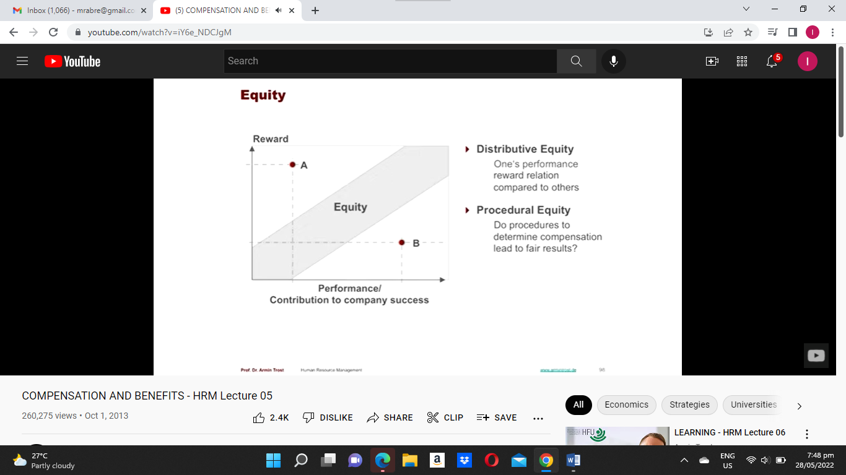

Figure 1: showing the quest to achieve equity between reward and performance as presented by Trost.

By contrast, Figure 1 also demonstrates another, and in my view, subjective manner to discuss rewards. Referred to as Distributive Equity, it compares one employee’s performance/reward ratio with that of another employee. For example, the point on the graph represented by A, illustrates an employee receiving high reward for relatively little effort. In comparison, a colleague whose reward/performance is at point B, would feel aggrieved for two reasons. Not only are they receiving a reward for their performance below the equity band, but their reward is also substantially lower than employee A, while their effort is significantly higher. This I perceive to be a recipe for conflict. In this regard, this essay will pursue a Procedural approach to finding equity.

Creating Equity Procedurally

Trost outlines nine factors to be considered in the quest to find equity and these are illustrated in Figure 2. These factors are:

* Responsibility: the greater responsibility an employee has including the management of people, the greater to anticipated rewards.
* Strategic Relevance: employees who perform strategic functions that have a direct impact on the long-term sustainability of the company will attract a greater reward.
* Performance: simply put, people who perform better should be rewarded better!
* Qualifications: generally, persons with higher qualifications are paid better because qualification indicate a greater capacity for a greater output. Notwithstanding, in my institution, rewards are tied to demonstrated competence at the job function and not to qualifications per se although at the time of recruitment, a minimum qualification for the post is advertised.
* Market: compensation is influenced by the remuneration packages offered by competitors to allow the company to attract and retain employees.
* Company Success: the more successful a company is, the more employees should benefit from that success.
* Cost of Living: the cost of living in the area where the company is located should be taken into account when determining pay.
* Civil Status: in some instances, civil status influence pay. For example, these is heated debate about equal pay for male and female athletes in sports such as soccer and lawn tennis.
* Tenure: longevity of service should be rewarded with increased remuneration.

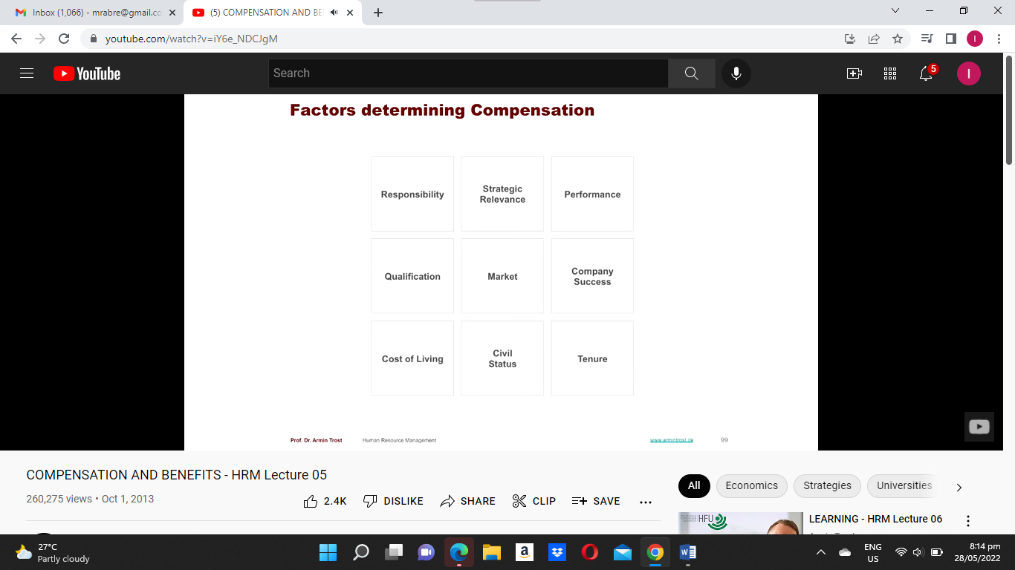

Figure 2: showing the factors that affect equity of rewards as presented by Trost.

The importance of these factors cannot be underestimated, however, there needs to be a mechanism to quantify them. Based on Trost’s advice, the first step in creating equity is to establish a base salary and the Hay evaluation method of job evaluation provides such an instrument. Upon this base salary, other forms of rewards can be built and these will be considered further in this essay.

The Hay system, according to the University of Waterloo, analyses four factors in evaluating a job and combines them to give an overall score. These factors are Knowledge, Problem Solving, Accountability and Working Conditions.

Knowledge is the cumulative sum of every form of knowledge and skill needed to adequately perform on the job and it is further sub-divided into Functional Expertise, Managerial Skills and Human Relations.

Function Expertise include the practical procedures, specialized techniques and knowledge within occupational fields, commercial functions, and professional and scientific disciplines needed to do the job. The Managerial Skills needed are planning, organizing, coordinating, integrating, staffing, directing and or controlling the activities and resources associated with the function of the unit, position, or section. Human Relations envisions the face-to-face skills needed for various relationships with other people.

The second factor of Problem Solving captures the amount and nature of the thinking required in the job in the form of analyzing, reasoning, evaluating, creating, using judgment, forming hypotheses, drawing inferences, arriving at conclusions and so on. The two sub-parameters in problem solving are the environment in which the thinking takes place and the novelty and complexity of the thinking required.

Accountability denotes the answerability for action and its consequences. The measured effect of the job on end results in the organization. There are three dimensions in accountability: Freedom to Act - which is the extent of personal, procedural or systematic guidance and control on the job; Job Impact on End Results - is the degree to which the job affects or brings about the results expected of the unit or function being considered; and the Magnitude or the size of the function or unit measured in the most appropriate fashion.

Working conditions assess the environment in which the job is performed and it is made up of four divisions. In each division is measured according to duration, intensity and frequency. Physical Effort evaluates the level of physical activity the job requires particularly if they produce physical exertion, stress or fatigue. The Physical Environment may include possible exposure to unavoidable physical and environmental factors that may increase the risk of accident, ill health or discomfort to the employee. Sensory Attention – some jobs require concentrated levels of sensory attention such as seeing, hearing, smelling, tasting, touching during the work process. Mental Stress - refers to exposure to factors inherent in the work process or environment, which increase the risk of such things as tension or anxiety.

Figure 3 illustrates how the Hay system is applied using three of the four factors to compute a score after analyzing all the dimensions.

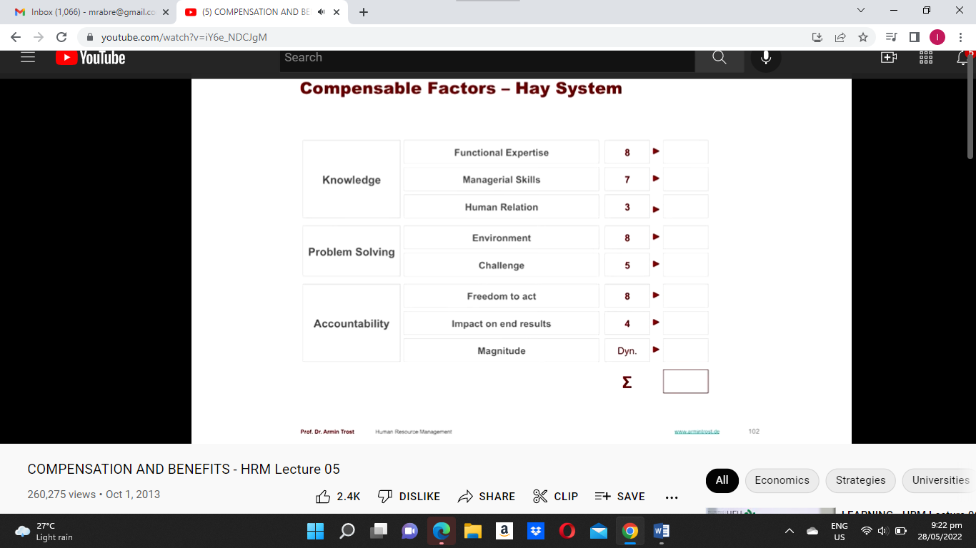

Figure 3: showing how three of the four factors in the Hay System are computed to determine an overall score for that job as presented by Trost.

Once the job evaluation is completed, the second step of the job analysis, as outlined by Trost, is to conduct a pay survey. This is done comparing jobs with similar duties in many companies to establish benchmarks. Using statistical regression analysis, a market line is drawn that most closely represents the relationship between job value and market pay. The process is illustrated in figure 4.

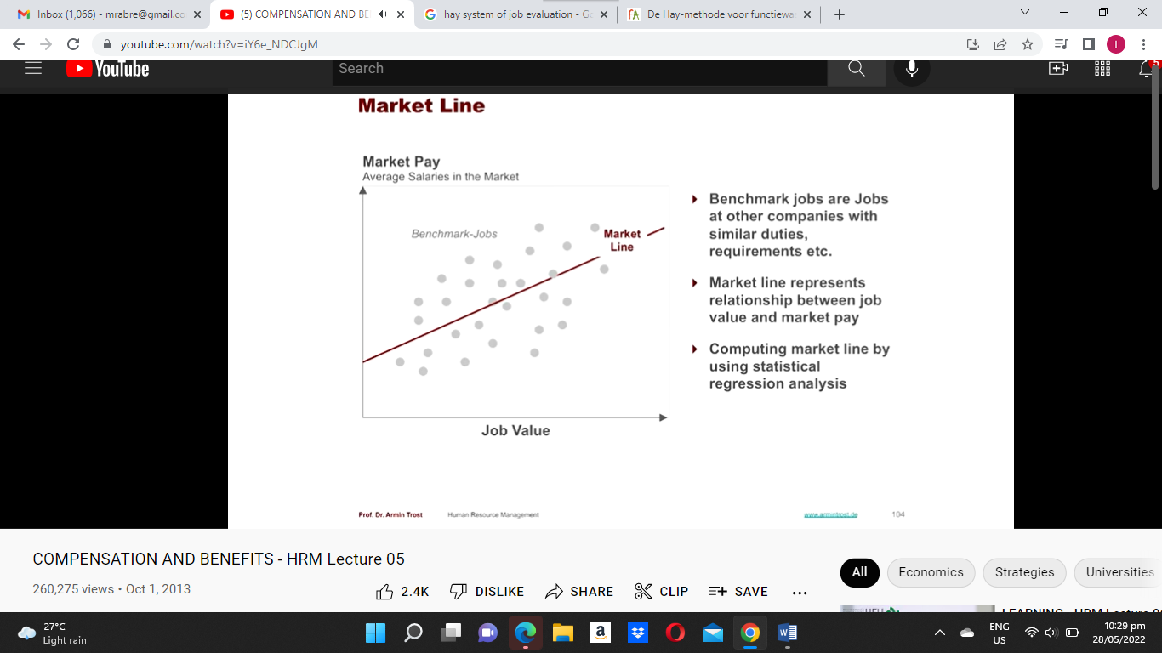

Figure 4: showing a market line derived using benchmark jobs as presented by Trost.

In Grenada, the Employers’ Federation in collaboration with the International Labour Organization Office for the Caribbean, produced its latest Compensation and Benefits Survey Report in 2018. This report lists over 40 common positions across a range is private sector business including the job title, a summary the job description, qualifications needed, the lowest, highest, median and average of the base salaries offered and the benefits offered by various companies. The data provided therein will be used by local companies to develop a market line to guide the base salary.

According to Trost, the final step of establishing base salaries for all positions in the company is to create bands of job grades with their corresponding pay. Furthermore, the company will have to decide whether to reward employees above, at, or under market value. Figure 5 demonstrates the bands and the pay offered.

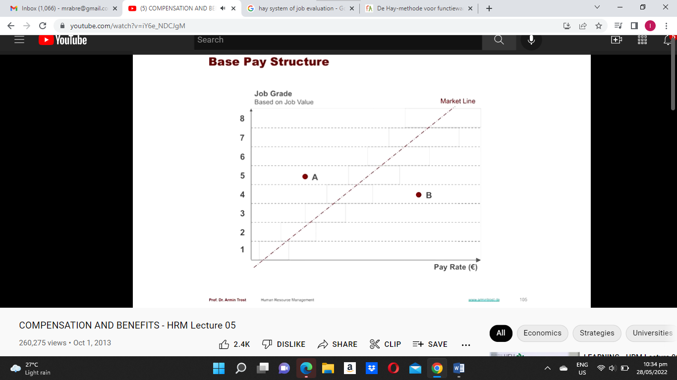

Figure 5: showing the creation of eight job grades and the range of salary that can apply as presented by Trost.

At the Community College where I work, employees are categorized as executives, managers, faculty, professional, non-managerial and ancillary. The base salary for employees of the College presented in the College’s Pay and Grade Scales has Grades ranging from A to M. Each Grade has a number of incremental points to reflect annual changes of salary. Persons are also hired on terms and conditions spelt out in their contract as well as adjunct faculty on an hourly basis.

Other Methods to Determine Base Salary

It is to be noted that the method previously explained is used to determine salaries paid bi-monthly or monthly and it allows all employees working the same job to be paid in the same band, notwithstanding their productivity. StudyVids lists other schemes may be employed such as Payment by Results, whereby employees are remunerated by production unit, or performance related pay where rewards are dependent on the achievement of targets set by management and employees. Another option for payment is Profit Related Pay where employees receive a bonus when the company makes a profit. These alternatives are applicable in specific settings when, for example, there is an unambiguous way to determine the unit output of a single employee in the case of the Payment by Results scheme. In Grenada, by and large, the time rate approach is vastly used because it is easier for organizations to administer when their staff perform general roles and it makes labor costs predictable.

Other Financial and Non-Financial Rewards

Once the base salary has been established, then the emphasis is turned to what other financial and non-financial rewards that can be offered to employees to compensate for their contribution to the organization. Information from the previously referenced Compensation and Benefits Survey Report (Grenada Employers’ Federation, 9), indicate that some of the additional benefits offered to employees of an appropriate rank include the use of a company vehicle, club subscription, housing or rental allowance, laundry, clothing, payment of utilities, use of a company cellular telephone, meal allowance, entertainment allowance, profit sharing, bonuses and gratuity.

At the College where I work, benefits include: overtime, pension and medical insurance, a waiver in tuition fees for courses taken in the College, leave of absence with pay, sick leave, maternity leave, paternity leave, compassionate leave, vacation leave, special leave and study leave. Of course, there are qualifying criteria to be met for these benefits.

StudyVids notes that non-financial rewards aim to satisfy employees psychological needs such as job satisfaction, recognition, career opportunities, trust, responsibility, skill development opportunities. In Grenada, there are a host of activities to show appreciation to workers. For example, there are employee of the month schemes where a picture of the winning employee is posted in a conspicuous position, there are staff parties to celebrate special occasions such as Christmas and New Year holidays, sporting teams made up of employees are sponsored to participate in amateur leagues, and the children of employees are given varying levels of sponsorships when they complete some level of education and are entering into the next.

Conclusion

There ought to be a symbiotic relationship between capital and labor in that employees are needed to develop and execute the strategic objectives of business ensuring their success. In return, employees expect to receive a just reward for their effort, not only financially, but fulfilment for their life’s work. This symbiotic relationship is best achieved when there is equity or a balance between performance and reward as well as a sense that there is equal pay for equal work among the employees. This paper presented a method to achieve procedural equity in ascertaining a reasonable base pay and looked at options for additional reward to the base salary, both financial and non-financial. Given the historical and sociological issues from slavery to colonialization to independence, the Community College where I work has a clear mandate to improve the wellbeing of citizens to relieve incidences of unemployment, underemployment, minimum wage, living wage, the working poor, exploitation of vulnerable citizens. These are issues not covered in this paper but ultimately are part of the agenda when discussing reward system management at the macro level.

Works Cited

“Compensation and Benefits – HRM Lecture 05.” *YouTube*, uploaded by Armin Trost, 1 October 2013, https://www.youtube.com/watch?v=iY6e_NDCJgM.

Grenada Employers’ Federation. *Compensation and Benefits Survey Report.* 2018*.*

*Hay Evaluation Method.* University of Waterloo. <https://uwaterloo.ca/human-resources/support-managers/compensation/hay-evaluation-method>. Accessed 31 May 2022.

“Reward Management.” *YouTube,* uploaded by StudyVids, 16 June 2017, <https://www.youtube.com/watch?v=wwb0tGdEvAY&t=1093s>.

*Slavery Abolition Act.* Britannica.com, <https://www.britannica.com/topic/Slavery-Abolition-Act>. Accessed 31 May 2022.

*The Grenada Constitution Order, 1973.* OAS.org, <https://www.oas.org/dil/grenada_constitution_order_1973.pdf>. Accessed 31 May 2022.