**LINDA WALTER ANDEM**

**UM69997BBU79131**



**LINDA WALTER ANDEM**

**UM69997BBU79131**

COURSE NAME:

**MARKETING AND SALES**

**MKS 058**

A PHASE 11 COURSE

PREREQUISITE FOR MASTERS IN BUSINESS ADMINISTRATION

PRESENTED TO THE DEPARTMENT

1.0 Introduction……………………………………………………………………. 3

1.1 Concept of marketing…………………………………………………... 3

2.0 Market research…………………………………………………………...…. 4

2.1 Types of market research……………………………………………… 5

2.2 Characteristics of good market research………………………… …. 7

2.3 Importance of market research……………………………………….… 8

3.0 Marketing environment………………………………………………………… 8

4.0 Market segmentation…………………………………………………………… 11

4.1 Methods for segmenting consumer markets……………………………. 12

4.2 Characteristics of market segmentation………………………………… 13

5.0 Market mix……………………………………………………………………… 14

5.1 Market brand…………………………………………………………… 17

6.0 Concept of sale………………………………………………………………… 18

6.1 Marketing vs sales……………………………………………………… 20

6.2 Differences between marketing and sales……………………………… 21

6.3 Skills in selling and their training………………………………………. 22

7.0 Recommendations………………………………………………………………. 24

8.0 References……………………………………………………………………...... 26

**1.0 Introduction**

Finding the best technique to get sales teams and marketing managers on the same page is one of the most difficult tasks facing any firm (Justin, 2021). While this may appear to be a straightforward process involving organizational and reporting structures, it is far from straightforward.

Marketing and sales are like two sides of a coin, with each face with its uniqueness and peculiarity representing the coin value, solidifying the coin existence as a token or valid means of transaction and separating the coin from the common nickel, copper or zinc. Each face complements each other and one cannot function without the other, sadly this kind of cooperation and coexistence is not prominent as seen in some emerging and established organizations leading to unhealthy competition among the two departments leading to disoriented and disjointed organization.

As an administrator, it is cogent for its business to be able to arouse and capture its target audience for a business to survive and thrive in the ever-growing competitive market and this centres on the marketing and sales team. Therefore, A business needs to understand the synergy of marketing and sales.

**1.1 Concept of Marketing**

Marketing is the process of communicating the value of a product or service to customers to sell it. Marketing can be seen as an organizational function and a collection of procedures for producing, delivering, and communicating value to customers, as well as customer relationship management.

Marketing is the science of identifying target audiences through market research and segmentation, as well as analyzing consumer behaviour. Marketing, from a societal perspective, is the link between a society's material needs and its economic reaction patterns, as well as offering superior consumer value. (Johnson, 2018). Marketing addresses these desires and requirements through facilitating exchanges and fostering long-term partnerships.

Marketing can alternatively be defined as "the activity of directing the flow of commodities from producers to consumers or users." All activities that affect changes in the ownership and possession of products and services can be classified as marketing. (Engelen, 2011).

Marketing aids in the creation of employment chances for a large number of people. Because the marketing process encompasses a variety of operations such as buying, selling, warehousing, shipping, finance, risk-taking, and so on, it provides opportunities for many people to increase their income.



A marketer trying to capture the interest of his prospect (Linda Andem, 2021).

**2.0 Market Research**

According to American Marketing Association, “Marketing Research is the function that links the consumer, customer and public to the marketer through information-information used to identify and define marketing opportunities and problems, generate, refine and evaluate marketing actions; monitor marketing performance; and improve understanding of marketing as a process.”

Marketing research is the process of systematically analyzing problems, constructing models, and gathering data to make critical decisions and control the marketing of goods and services. (Groenross, 2013)

Marketing research is a well-organized, systematic process that necessitates planning at every level. It employs a scientific approach. It is a methodical process that aims to generate accurate and reliable data. Marketing research is also characterized as the use of scientific methodology to solve marketing problems.

Marketing research entails researching to support marketing activities as well as statistically interpreting data to produce information. Managers then use this information to plan marketing activities, assess the nature of a firm's marketing environment, and obtain information from suppliers.

The marketing research process consists of several stages, including the formulation of a problem, the creation of a research plan, the collection and interpretation of data, and the formal dissemination of information in the form of a report. The goal of marketing research is to provide management with information that is relevant, accurate, reliable, valid, and up to date. (Jochen, 2014)

Marketing researchers interpret their findings and convert data into information using statistical methods such as quantitative research, qualitative research, hypothesis tests, Chi-squared tests, linear regression, correlations, frequency distributions, Poisson, binomial distributions, and so on.

There should be a distinction between marketing research and market research. Market research is research conducted in a specific market. As an example, after deciding on a suitable market segment, a company may research that market. Marketing research, on the other hand, refers to all marketing-related research. Market research is therefore a subset of marketing research.

**2.1 Types of market research**

Gummeson et. al. (2013) categorized Market research, as a sub-set aspect of marketing activities, dividing it into the following parts:

1. Primary research (field research), which involves the conduction and compilation of research for a specific purpose.

2. Secondary research (desk research), initially conducted for one purpose but often used to support another purpose or end goal.

Market research into health foods, which is done only to determine the needs/wants of the target market for health foods, is an example of primary research, according to these definitions. In this scenario, secondary research would be studying healthy foods that were employed by a company that wanted to manufacture a completely different product.

Preparing, collecting, and interpreting primary research from data to information can be costly. Even though secondary research is very inexpensive, it is frequently outdated and antiquated when it is used for a purpose other than that for which it was designed. Primary research can also be divided into quantitative and qualitative research, which, as the names suggest, refer to numerical and non-numerical research methodologies and procedures. Whether data can be quantified (quantitative research) or subjective, non-numeric, or abstract notions must be explored determines the applicability of each form of study (qualitative research). (Gummeson, 2013)

There also exist additional modes of marketing research, which are:

1. Exploratory research, is about research that investigates an assumption.
2. Descriptive research, which, as the term suggests, describes "what is".
3. Predictive research, meaning research conducted to predict a future occurrence.
4. Conclusive research, to derive a conclusion via a research process.

**2.2 Characteristics of Good Marketing Research**

Jochen 2014, Gave the characteristics of good marketing research as follows:

**1 Scientific method:** Effective marketing research follows the scientific method's principles of careful observation, hypotheses formation, prediction, and testing. Investigate the concept of creativity. Marketing research at its best creates novel solutions to problems.

**2. Multiple methods:** Competent marketing researchers avoid over-reliance on a single method, preferring to tailor the method to the problem rather than vice versa. They also appreciate the importance of obtaining information from a variety of sources to boost confidence. Models and data are interdependent. Competent marketing researchers understand that the facts are derived from problem models. These models should be made as transparent as possible because they dictate the type of information sought.

**3. Value and cost of information:** Competent marketing researchers are concerned about valuing information vs its cost. The marketing research department uses value/cost evaluation to choose which research projects to do, which research designs to deploy, and whether or not to acquire further data after the initial results are in. The cost of research is usually easy to calculate, but the value is more difficult to predict. The value is determined by the research results' dependability and validity, as well as management's readiness to accept and act on them. In general, the most important information costs the most because it necessitates more intensive methodologies, yet it is simple to waste a lot of money on poorly designed research.

**4. Healthy scepticism:** Competent marketing researchers will approach assumptions made by managers about how the market operates with a fair amount of scepticism.

**5. Ethical marketing:** The majority of marketing research is profitable for both the sponsoring company and its customers. Companies gain a better understanding of their customers' demands through marketing research, allowing them to provide more gratifying products and services. Misuse of marketing research, on the other hand, can cause harm or annoyance to customers. The correct conduct of research is guided by professional ethical norms.

**2.3 Importance of Marketing Strategy**

Jochen 2014, Gave the importance of marketing strategy as follows:

1. A marketing strategy gives a business an advantage over its competition.

2. Strategy aids in the development of goods and services with the greatest profit potential.

3. Marketing strategy aids in the discovery of areas impacted by organizational growth and, as a result, aids in the development of an organizational plan to meet customer expectations.

4. It assists in determining the appropriate price for an organization's goods and services based on market research data.

5. Effective departmental coordination is ensured by strategy.

6. It enables a business to make the best use of its resources to communicate a sales message to its target market.

7. A marketing strategy aids in the pre-determination of the advertising budget, as well as the development of a system for determining the scope of the plan, i.e., the revenue generated by the advertising plan.

In a nutshell, a marketing strategy outlines how a company achieves its set goals.

**3.0 Marketing environment**

Understanding the "marketing environment" is critical for Businesses in comprehending consumer concerns and motivations, as well as tailoring the product to meet those demands. Marketers employ marketing environmental scans, which collect data about events occurring outside the organization regularly to discover trends, opportunities, and risks to a company and to stay one step ahead of the customer

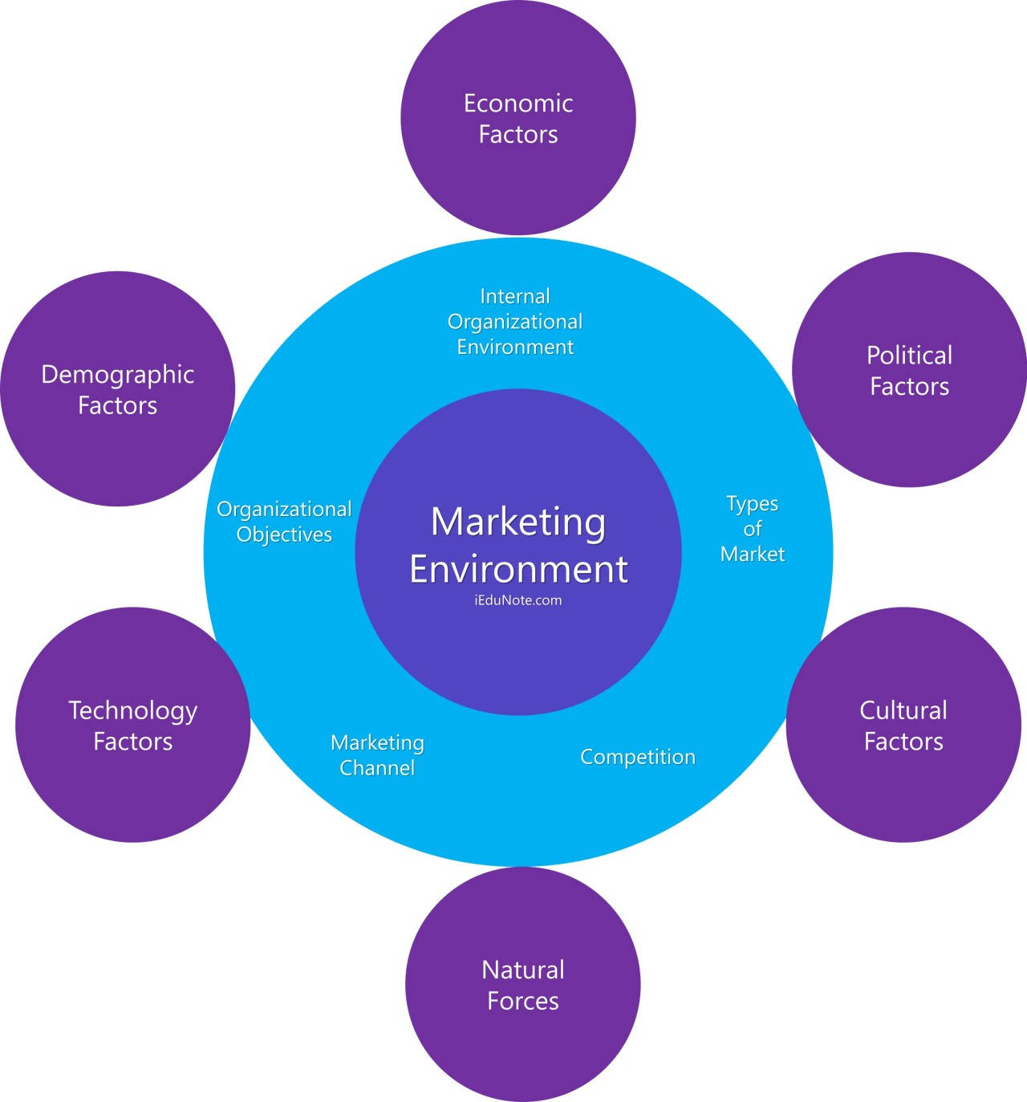

Elements of Marketing Environment

Hair et al. (2012), postulated that the six key elements of a marketing scan include: demographic forces, socio-cultural forces, economic forces, natural forces, political forces, and technological forces. Therefore, Marketers must look at where the threats and opportunities stem from in the world around the consumer to maintain a productive and profitable business.

The market environment is a marketing term that refers to the factors and forces that influence a company's ability to build and maintain successful customer relationships. The environment is divided into three levels: Micro (internal) environment - forces within the company that impact the company's ability to serve its customers. Meso environment – the industry in which a company operates, as well as the market for that industry (s). The macroenvironment (national) consists of larger societal forces that influence the microenvironment. Johnson (2019).

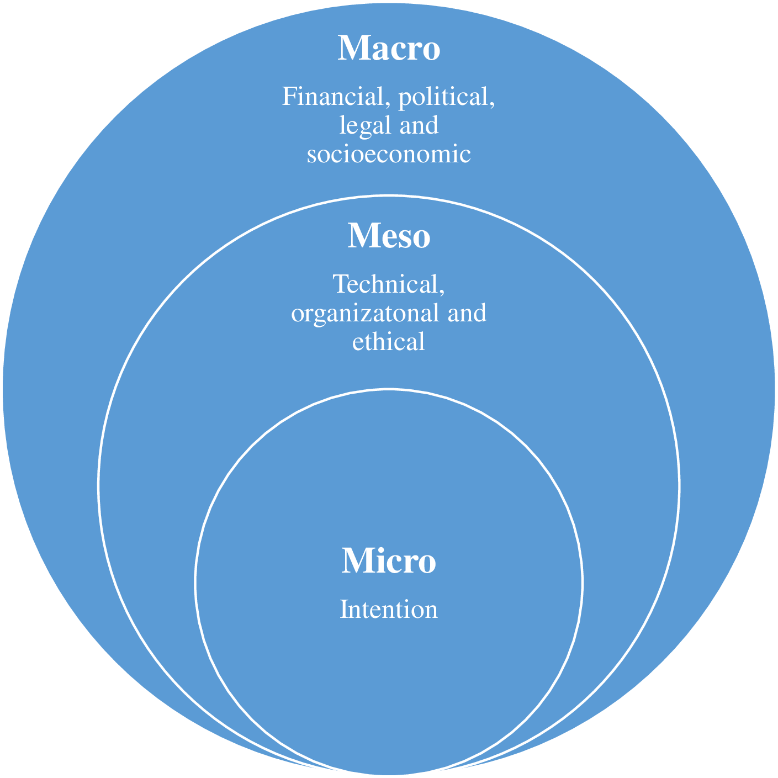

Google Images

**1. Microenvironment:** The microenvironment (near environment) refers to the business itself as well as all of the challenges that arise within the business. As a result, businesses can exert control over all of the challenges and influences in the microenvironment. The internal environment is another name for the microenvironment. The microenvironment refers to external forces that affect the company's ability to serve its customers. It consists of the company, its suppliers, marketing intermediaries, customer markets, and the general public.

**2. Meso environment:** The meso environment exists between macro and micro-opportunities. Policies, standard operating procedures, rules, and guidelines form the framework of a business or organization and can be considered its infrastructure.

**3. Macro environment of marketing:** The macro-environment refers to all forces that are part of a larger society and affect the micro-environment. It encompasses concepts such as Political, Economic, Social, Technological, Environmental, and Legal factors (PESTEL) affecting organizations in the macro-environment.

**4.0 Market Segmentation**

Vaid (2020), Define Market segmentation as a marketing strategy that entails dividing a large target market into subsets of consumers with similar needs and priorities, then designing and implementing strategies to target them. Market segmentation strategies can be used to identify target customers and provide supporting data for positioning to meet the goals of a marketing plan. Businesses may develop product differentiation strategies or an undifferentiated approach involving specific products or product lines based on the target segment's specific demand and attributes.

The goal of segmenting a market is to allow a business marketing/sales program to focus on the subset of prospects who are "most likely" to purchase the business offering and services. If done correctly, this will help to ensure the highest return on your marketing/sales expenditures. There are significant differences in what to consider when defining market segments depending on whether you are selling to individual consumers or businesses.

Market segmentation refers to the division of a consumer market into people who have similar needs and desires. For example, Kellogg's cereals and Frosties are marketed to children. Crunchy Nut Cornflakes are marketed to adults. Both goods refer to two products that are marketed to two distinct groups of people, each with similar needs, characteristics, and desires.

**4.1 Methods for Segmenting Consumer Markets**

It is critical to have a clear understanding of what customers require to succeed in business. However, not all customers are the same. They may be of different ages or genders, or they may have very different values and interests. They may also use the products to meet a variety of needs. To effectively appeal to customers, it is prudent to segment the business target market to customize how to engage with them. The 4 general bases of segmenting market are as follows:

**1. Geographic Segmentation:** Marketers can segment based on geographic criteria such as nations, states, regions, countries, languages, cities, neighbourhoods, or postal codes. The geo-cluster approach combines demographic and geographic data to create a more accurate or specific profile. In rainy areas, merchants can sell raincoats, umbrellas, and gumboots. Summer clothing can be sold in hot regions. A small business commodity store may only target customers in the local neighbourhood, whereas a larger department store may target several neighbourhoods in a larger city or area while ignoring customers on other continents.

**2. Demographic Segmentation:** Demographic segmentation divides markets into different groups based on their age, gender, income level, ethnicity or religion, and family life cycle. The United States Census Bureau employs demographic segmentation to document and segment the people who live in the United States.

**4. Psychographic Segmentation:** Psychographic segmentation, also known as Lifestyle segmentation. This is determined by examining customers' activities, interests, and opinions (AIOs). It considers how people spend their leisure time, as well as what they are most responsive to and influenced by. Psychographic information is critical for segmentation because it identifies the target subject's activities and targeted lifestyle, as well as the image they are attempting to project. The mass media has a significant impact and influence on psychographic segmentation. Lifestyle products can refer to high-involvement products and purchases, as well as speciality or luxury products and purchases. Lifestyle segmentation reflects how the target subject identifies themselves or wishes to be identified in society. Businesses can develop promotional mixes and product lines that are tailored to the needs of their customers by identifying and understanding their lifestyles and the external influences that influence them.

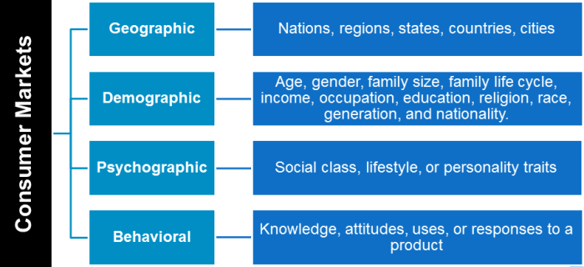 Market Segmentation

Segmentation based on occasions is based on the unique wants and wishes of customers on specific occasions, such as for products to be used in conjunction with a specific vacation. Decorations and lamps, for example, are virtually solely sold in the weeks preceding up to the celebration and are not often accessible all year. People preparing for a wedding or a funeral are another form of occasional market group. These are events that happen just a few times in a person's lifetime but occur so frequently in a big population that continued general demand makes it a valuable market segment.

**4.2 Characteristics of the Market Segmentation**Marketing is all about meeting the needs and desires of customers. Consumers have the money and are willing to spend it to meet their needs by purchasing goods and services. Marketing strategies are essential for a company to meet the needs of its customers. The target market is made up of individuals or organizations for whom the company intends to implement its marketing strategies. The company then divides the target market into groups of buyers who have similar needs, characteristics, or behaviours; these groups are known as market segments. Market segments are thus subsets of target markets, and their characteristics highlight target market characteristics.

**Requirements for Effective Segmentation**

A marketer should choose a segment that meets the following criteria:

1. The segment must be measurable: This means that the segment chosen must be measurable. It implies that the information should be accessible. The number of females in a country, for example, can be counted, but the number of people who enjoy partying cannot.

2. The segment should be accessible: This means that the segment should be within reach and easily approachable.

3. The segment should be substantial: The segment chosen should be large enough to support production.

4. The segment must be practicable and cost-effective.

5. Each segment chosen should be unique: Each segment chosen should be unique. Any type of segment overlapping can cause confusion and chaos.

**5.0 Marketing Mix**

All of the processes involved in getting things from the maker to the consumer are best defined as marketing. Some businesses also sell to other businesses, and some corporations also promote services. Whatever the case may be, marketing is concerned with what you're selling, to whom you're selling, and where you're selling. Companies, on the other hand, frequently conduct focus groups and marketing research surveys to better determine whether or not what they are offering would be successful in the marketplace. E. Jerome McCarthy, a marketer, created the four Ps classification in 1960, which has since been adopted by marketers all over the world.

Product, pricing, promotion, and place are the four Ps of marketing. Booms and Bitner created a 7-point model for services marketing in 1981, which included the basic four Ps plus process, people, and physical evidence.

**1. Product:** This is a product or service. The product is either a tangible good or an intangible service that appears to satisfy certain customer demands. All goods have a logical product life cycle, and marketers must be aware of and prepare for the many stages and their associated obstacles. Understanding the problems that the product is seeking to tackle is critical. The product's benefits and all of its features must be comprehended, and the product's unique selling proposition must be investigated. In addition, the product's potential purchasers must be identified and comprehended.

**2. Price:** The price refers to the amount a customer is expected to pay for a product. How a product is priced has a direct impact on how well it sells. This is related to the customer's perception of the product's worth, rather than an objective costing of the thing on sale. A product will not sell if its price is higher or lower than its perceived worth. This is why it's critical to comprehend how a buyer perceives what you're selling. A product can be successfully priced higher than its objective monetary value if the customer value is positive. If a product offers minimal value from the perspective of the customer, it may need to be underpriced to sell. Distribution strategy, value chain costs and markups, and how rivals price a rival product can all affect the price.

**3. Promotion:** Promotion encompasses an organization's marketing communication strategy and practices. Advertising, sales promotions, public relations, direct mail, personal selling, and online promotion are just a few examples. All of these topics have been briefly covered. Whatever channel is chosen, it must be appropriate for the product, the pricing, and the target audience. It's crucial to distinguish between marketing and promotion. Promotion is merely the communication part of the marketing function as a whole.

**4. Place/Distribution:** Place encompasses distribution networks, market coverage, inventory management, transportation, and logistics. The availability of a product to customers at the right time, in the right place, and in the correct quantity are all important considerations in product placement. The location or placement of the product has to do with how it will be delivered to or reach the client.

**5. People:** Great customer service not only converts to sales but can also help the business grow its client base through referrals. Getting these referrals from people who love your business is a terrific illustration of how your marketing efforts may help your sales process. It's critical that everyone who represents your brand or interacts with consumers – including non-human chatbots! – be a properly trained sales expert who understands your product and how it will improve your customers' lives or solve their problems.

**6. Process:** The process of getting your product to the customer should be designed for optimal efficiency and reliability, but it should also incorporate elements that are consistent with your brand, such as being environmentally or sustainably oriented. Digital alliances and logistics have become an important part of the marketing mix as online shopping has grown in popularity.

**7. Physical evidence:** Physical evidence includes elements that demonstrate your brand's existence and that a transaction occurred. A real store or office for your business, a website if your firm functions entirely online, and printed business cards that you exchange when meeting people are all examples of proof that your brand exists. Physical or digital receipts, invoices, or follow-up email newsletters sent to customers as a retention exercise are all examples of proof of purchases.

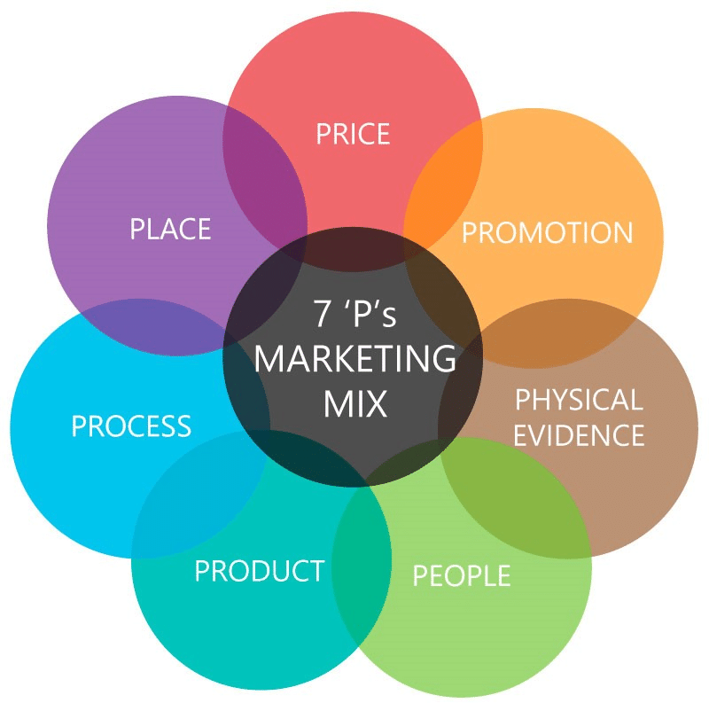

The 7p’s of Marketing

All of the elements’ customers see hear, and sometimes even smells about a product or service must be considered in the marketing mix. This, of course, involves packaging and branding, but it should also encompass how products are presented in stores, where they are positioned, and in what context they are placed, as well as digital placement, such as on the business website and social media.

**5.1 Marketing Brand**

"A brand" is defined as "any name, term, design, symbol, or another attribute that distinguishes one seller's product from that of other sellers." Business, marketing, and advertising all employ brands.

Originally, livestock branding was used to distinguish one person's cattle from another's by burning a distinguishing mark into the skin of the animal with a hot branding iron. Coca-Cola, which is owned by the Coca-Cola Company, is an example of a modern brand.

A brand, which is considered an intangible asset in accounting, is frequently the most valuable asset on a company's balance sheet (Day, 2020). To optimize shareholder value, brand owners carefully manage their brands, and brand valuation is an important management approach that assigns a monetary value to a brand and allows marketing spend to be managed (e.g., prioritized across a portfolio of brands) to maximize shareholder value. Putting a value on a brand compels marketing leaders to focus on long-term stewardship and managing for value, even if only purchased brands appear on a company's balance sheet.

Therefore, Branding can well increase sales of not only one product, but also other products connected with that brand. If a customer enjoys Pillsbury biscuits and believes in the brand, he or she is more inclined to try other Pillsbury items, such as chocolate chip cookies. A brand's personality (name, word, sign, symbol, or design, or a mix of them) identifies a product, service, or organization, as well as how it interacts with important stakeholders such as customers, employees, partners, and investors.

**6.0 Concept of Sale**

A sale is a transaction in which goods or services are transferred for money or other assets between two or more persons, usually a buyer and a seller. A sale in the financial markets is an agreement between a buyer and seller on the price of a security, as well as the delivery of the security to the buyer in exchange for the agreed-upon compensation. (Micevski et.al., 2019)



A salesman closing a sale.

The transaction is not regarded as a sale if the item or service in question is transferred without pay from one party to the other. Instead, it is termed a gift or a donation.

A sale occurs when a seller gives a good or service to a buyer in return for a defined quantity of money or specific assets. Both the buyer and the seller must agree on the exact parameters of the transaction, such as the price, amount of the good sold, and delivery logistics, to complete the transaction.



Furthermore, the offered object or service must be available for purchase, and the seller must have the authority to transfer the item or service to the buyer.

Countless sales transactions are conducted every day by millions of people all over the world. This maintains a steady flow of assets and serves as the foundation for the economies involved. The selling of products and services in a retail market is a more prevalent type of transaction; the sale of investment vehicles in financial markets is a more refined value exchange.

A sale can be made as part of a business's operations, such as in a grocery store or a clothes store, or between people. Items acquired during a yard sale are considered individual sales, however, purchasing a personal automobile from a car dealership is considered a business-to-business transaction.

Sales can also take place between companies, such as when a raw materials provider sells available materials to a company that uses them to make consumer items.

**6.1 Marketing Vs. Sales**

Although many individuals group sales and marketing together, the two operations are generally independent of one another. In its most basic form, marketing is the process of increasing potential customers' awareness of your company and brand. By converting those potential customers into real customers, sales convert that viewing into profit. Here are some key points to help in the understanding of the distinction between sales and marketing as Highlighted by Le Meunier-Fitzhugh (2019).

**1. Process:** The marketing process focuses on introducing the brand and goods to new customers or reminding existing customers about it. Organizations that are developing new marketing strategies must clearly describe what their product or service is, how it addresses a problem for the user, and how much it costs. The marketing team must then determine who is most likely to be interested in this product or service, as well as where they might find them.

A strategy that describes an organization's actions, tools, resources, and overall sales goals is part of the sales process. To make a profit, a sales force is particularly interested in turning those who are familiar with the brand into consumers. Customers are interacted with and questions are answered to give relevant product or service information.

**2. Goals:** The marketing objectives of a firm are to communicate clearly about its product, company, or brand. The main goal is to look at the large picture and properly describe how the product or service benefits as many people as possible to generate new leads. However, management must make both teams aware of their market position.

**3. Strategies:** Marketing tactics are usually built on acquiring data about their target audience to see what works and what doesn't. The marketing team can test out strategies once they know whom they're trying to reach with a particular campaign. Internet marketing, print marketing, blog marketing, and focus groups are among the most prominent marketing tactics.

Connecting with potential consumers, communicating and listening to them, and then converting them into paying customers are the cornerstones of sales techniques. Typically, a salesperson will contact a prospect by phone, at a networking event, or online. Then, depending on the extent of the product or service, they will make a pitch to them in the hopes of making a sale.

**4. Prospects:** Marketing has a better chance of succeeding than sales because it is attempting to identify a target demographic and raise awareness. Marketing tries to find new prospects, while sales want to capitalize on existing relationships with established prospects and clients.

**6.2 The Differences Between Sales and Marketing**

Vaid (2020), However, differentiated marketing and sales as similar as marketing and sales maybe, that they differ in that a salesman without marketing will have no prospects or leads to follow up with, while a salesperson without a competent sales method and strategy will have a low closing rate. Marketing and sales should work together, but in most businesses, they are two separate departments that don't even communicate with one another.



marketing is everything done to contact and influence prospects, whereas the sales process is everything done to close the deal and obtain a signed agreement or contract. Both are necessary for a company's success. A company cannot function without one or the other of these processes. To achieve a successful level of business growth, it is critical to combine both efforts. On the other hand, if efforts are imbalanced or departments do not communicate, corporate growth might be hampered.

Marketing should include tactics for determining the business reach and persuading prospects that you are the right firm for them. The messaging is what gets the prospect ready for the sale. Advertising, public relations, social media, relationship marketing, brand marketing, viral marketing, and direct mail are all possible components.

Interpersonal engagement is a key component of the sales process. A one-on-one meeting, cold calls, and networking are common methods. It's anything that brings you closer to a prospect or customer rather than keeping them at a distance. Most of the time, marketing activities have brought the prospect or potential consumer to the business. If you market effectively, you can start to convert that prospect from a cold lead to a warm lead. It is significantly easier for the sales professional or sales department to close the sale once the prospect has reached the "warm" stage.

When it comes down to the basic purposes of sales and marketing teams, marketing is responsible for developing strategy, while salespeople are responsible for implementing strategy. To use more marketing-friendly terminology, marketing creates the value proposition, while salespeople are its stewards. Without clear lines of communication, understanding, and buy-in, even the best-laid plans can fail due to poor execution. It can cause conflict and frustration in some cases.

**6.3 Skills in Selling and their training**

Salespeople sell a company's products and services to customers such as individuals, businesses, and government agencies. Salesmen must have certain skills when approaching potential customers to win new business; and if they lack those skills, they will fail. There is a requirement for a sales training program. A sales training program instructs salespeople how to sell the company's products, which must be taught to a salesperson before sending in the order field. It should also focus on increasing salesperson motivation and morale.

To be successful in his job, a salesman must possess the following abilities.

**1. People skills:** Traditional selling techniques are rapidly evolving these days. Personal grooming and etiquette are required for effective salesmanship. Because first impressions are crucial, a salesperson should have a pleasant personality. He ought to be good at Hard skills, such as talking and presenting, as well as soft skills, such as attentive listening, are required. He may present the product or service after patiently listening to the customer's requirements positively in a professional manner This is beneficial in providing satisfactory answers to the Prospects' objections and questions are overcome, and they are persuaded to purchase the product.

**2. Communication skills:** Being responsive to customers' needs is essential for building a relationship with the customer. To do so, the salesperson must be an effective communicator. He should have abilities to communicate and convince the prospects. He should be skilful enough to ask questions that uncover the problems and needs of the prospects and then should make a response to persuade them into buying.

**3. Company information:** When selling goods and services, the salesperson must be knowledgeable about the company, its products, and services to confidently discuss them with current and prospective buyers.

(a) He should be familiar with a variety of product assortments, as well as the number of variants in each. each product line's physical characteristics and sizes, as well as specific features advantages and advantages.

(b) He should be familiar with the products' operations and applications, as well as their level of quality control to persuade his buyers about the superiority of his company's products and services In comparison to his competitors.

(c) Understanding of pricing policies, cash discounts, and credit policies, as well as the ability to negotiate and finalize the transaction.

(d) Understanding of exchange policies, transportation costs, and free shipping options.

e) Understanding of customer service policies and procedures. Depending on the type of product or service provided, it can be pre-sales, during-sales, or after-sales service. He should also be clear about the warranty or guarantee policy that has been decided using the organization

**4. Market knowledge:** Understanding both urban and rural markets are critical for a good salesperson He should investigate various market segments, both existing and prospective. While prospecting for sales, consider prospective buyers' needs and preferences, purchasing power, and purchasing behaviour.

**5. Information and technology skills:** The Internet has ushered in a new era of selling by putting complete purchasing and decision-making power in the hands of potential buyers. If one company's website doesn't provide what prospects are looking for, they can go to another's.

The website could be able to suit the expectations of today's tech-savvy clients. Today's sales force isn't what it used to be. Prospecting for products and services is no longer necessary; instead, prospects look for sellers online. (Le Meunier-Fitzhugh, 2019) Because the website has become the primary point of contact for salespeople, they must have one.

Today, web marketing must be integrated. A good salesman must be able to negotiate. Identify and connect with leads generated by the Internet to outperform the competition. The fundamentals of Web marketing should be learned by current salespeople.

**6. Self-management skills:** A salesman has to take up so many tasks like gathering market information and customer information; feeding future buying trends back to the company, preparing reports, attending team meetings; representing the company at trade exhibitions, events and demonstrations etc. He also has to follow general selling practices like taking up several sales calls per day; handling payments made by customers etc. He requires self-management skills to perform his tasks efficiently and to develop confidence.

**7.0 Recommendations**

In today's competitive environment, the efficiency with which marketing operations are managed determines the success or failure of most businesses. When an Administrator understands the distinction between sales and marketing, then the Administrator will know how they can support each other to create a successful business. Therefore, it is paramount for an administrator to be knowledgeable about Marketing and Sales to understand the synergy and how to properly utilize them in achieving the organization’s goals and objectives.

While their primary aims are distinct, sales and marketing are in many ways intertwined and should work together. They can align their interests by forming a partnership and sharing any resources that overlap. One option for larger companies is to create a service-level agreement (SLA). This is a contract between two departments that details the deliverables that each will supply to the other. It assists in the establishment of team partnerships by explicitly defining what both sides are expected to do. For small firms, this may not be necessary. Management, on the other hand, must inform both teams of their distinct market situations.

In addition, as a business administrator, it is cogent that Salespeople should be involved in the strategic planning process. It ensures that their opinions are heard, but more significantly, salespeople have a deeper contact with customers and can notice things that marketing may not be able to see from the office, Salespeople can be excellent sources of market intelligence because they are intimately familiar with local markets, competitors, and customers. Not only does this enhance the strategy, but it also aids implementation by gaining buy-in from the sales staff by letting them know they were involved in the process.

Furthermore, Marketing people should, at least once a year, visit with some salespeople and ride around making customer calls in an attempt to better understand salespeople and glean observations from the local markets. Likewise, its essentials the sales team understands marketing strategy. As a result, it’s imperative that salespeople not only understand selling skills but also develop a conceptual understanding of marketing. By having a better understanding of the theories, tools, terminology and tactics used in a marketing strategy, salespeople can better understand why they are being asked to do certain things. With this understanding comes better execution and a more cohesive sales/marketing effort.

**8.0 References**

Atlantic International University. Marketing and Sales.https://students.aiu.edu/Dashboard/OpenCourse?lang=1&fileName=Marketing%20and%20Sales.html

Day, G. S., & Schoemaker, P. J. (2020). How Vigilant Companies Gain an Edge in Turbulent

Times. MIT Sloan Management Review, 61, 2, 56-64

Day, G.S. (2011), “Closing the marketing capabilities gap”, Journal of Marketing, Vol. 75(July), pp. 183-195.

Engelen, A. and Brettel, M. (2011), “A Cross-Cultural Perspective of Marketing Departments'Influence Tactics”, Journal of International Marketing, Vol. 19 No. 2, pp. 73-94

Groenross, C., Strandvik, T. and Holmlund, M. (2013, forthcoming), “How companies can

offer something customers will buy”, Journal of Service Management.

Gummesson, E, Kuusela, H. and Närvänen, E. (2013, forthcoming), “Reinventing marketing

strategy by recasting supplier/customer roles”, Journal of Service Management.

Hair, J.F., Sarstedt, M., Ringle, C.M. and Mena, J.A. (2012), “An assessment of the use of

partial least squares structural equation modelling in marketing research”, Journal of the

Academy of Marketing Science, Vol. 40 No. 3, pp. 414-433.

Jochen W. , Sven T. and Volker K., (2014). The Role of Marketing in Todays’ Enterprises, 2014, [Journal of Service Management](https://www.researchgate.net/journal/Journal-of-Service-Management-1757-5818) 25(2):171-194 DOI:[10.1108/JOSM-01-201 0037](http://dx.doi.org/10.1108/JOSM-01-2014-0037)

Johnson, J. S., & Matthes, J. M. (2018). Sales-to-Marketing job transitions. Journal of

Marketing, 82, 4, 32-48.

Johnson, J. S., Matthes, J. M., & Friend, S. B. (2019). Interfacing and customer-facing: Sales

and marketing selling centres. Industrial Marketing Management, 77, 41-56.

# Justin F. 2021. The relationship between sales and marketingHttps://agribusiness.purdue.edu/the-relationship-between-sales-and-marketing/

Le Meunier-Fitzhugh, K., & Massey, G. R. (2019). Improving relationships between sales and

marketing: the relative effectiveness of cross-functional coordination mechanisms. Journal of Marketing Management, 35, 13-14, 1267-1290.

Micevski, M., Dewsnap, B., Cadogan, J.W., Kadic-Maglajlic, S., & Boso, N. (2019). Sales intra-functional flexibility: Its relationship to performance and moderating effects on role stressors. Journal of Business Research, 104, 552-562.

Vaid, S. S., Ahearne, M., & Krause, R. (2020). Joint marketing and sales appointment:

Uncertainty from the intertwining of marketing and sales in one position. Industrial Marketing Management, 85, 221-239.