**STUDENT NAME: JOY O. AKINOLA**

**STUDENT ID: UM69844SFO78978**

**ADVANCED FOOD PRODUCT DEVELOPMENT**

**COURSE: Advanced Food Product Development**

**COURSE CODE: AFO 412**

**ATLANTIC INTERNATIONAL UNIVERSITY**

Contents

Contents 2

**INTRODUCTION** 3

**THE IDEA GENERATION** 5

**PRODUCT** **DEFINITION** 8

**IDEA DEVELOPMENT AND TESTING** 10

**BUSINESS ANALYTICS AND FINANCIAL ANALYSIS** 12

**PRODUCT DEVELOPMENT** 15

**MARKETING TESTING** 16

**COMMERCIALIZATION** 16

**CONCLUSION** 13

**BIBLIOGRAPHY** 14

# **INTRODUCTION**

**UNDERSTANDING ADVANCED/ NEW PRODUCT DEVELOPMENT**

New product development is the synthesis and conceptualization of an idea or combination of ideas. New product development entails the ideation, layout (design), validation (authentication), and launch (introduction and unveiling) of a brand-new product to the world or a significant improvement in an already existing product.

The concept of New Product Development relies greatly on an organization’s ability to appoint an innovative and creative team in the selection of product concepts.

Ample financing is essential to drive these brand-new prospects to a fully established project.

The process of New Product Development involves an intensive screening and evaluation for choosing the most excellent concepts, and for the release of the new concepts to bring about a winning product.

Innovation and creativity are the brain behind any new product conceptualization; however, the prototype may differ representing various brands. According to Carter, 2022, the Market Led and Technology Led approaches are some of the effective prototypes for New Product Development models applied by various organizations.

Methodology is understood and applicable in the maintenance, innovative advancement and implementation of strategies.

According to Corp 2022, Advanced Product Development (APD) is the forward-facing lines of production for the developing next generation processes, raw materials and product solutions. These are a group of innovative thinkers that combines experiences from the previous, existing knowledge and potential requirements in the quest for originality, modernization and joint development of projects.

Through regular coordinated, new development assessment, customer relationships, technology and structures, the new product development team can identify unresolved challenges and needs in the specific markets. The team provides and generate forefront solutions that causes the company to continue staying pertinent and creating cutting-edge values for the consumer.

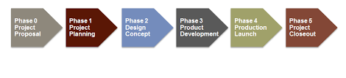

**Figure 1.1. New Product Development Process.**

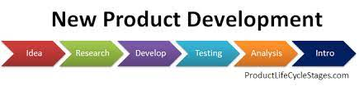

**Figure 1.2. New Product Development Stages.**

Historically, the essence of a company is understood to be its ability to develop new products, this is even more true today than ever with the accessibility of information and resources. Organizations are no longer just existing, but they are becoming more dynamic and developing new products to improve their stance and advance their growth because new product development is one way an organization can grow. Growth is an important component of a flourishing company.

New Product Development is the procedure of creating a new idea and bringing it to life, with the aim of providing solution to the challenges of the focused group. Since the effect of the pandemic COVID-19 on various businesses, the need for Research and Development across the world for the generation of new product development or an improvement on existing products have greatly intensified. While several organizations concentrate on introducing new products, others improved the existing products.

When it comes to successful new product development, productivity is essential. Industrialists looking to stay significant, effective and worthwhile should incessantly create and expand new products ideas that are successful in the marketplace, by delivering excellent benefit to the purchasers by adequately comprehending the interest of the consumers. It is crucial to identify existing products and finding exceptional ways to improve on and develop a more advanced product.

Every New Product Development approach ought to be universal, consumer-focused and transactional. The new product development group cooperates on creating a new product by adhering to certain rules and regulations guiding the various stages of new product development.

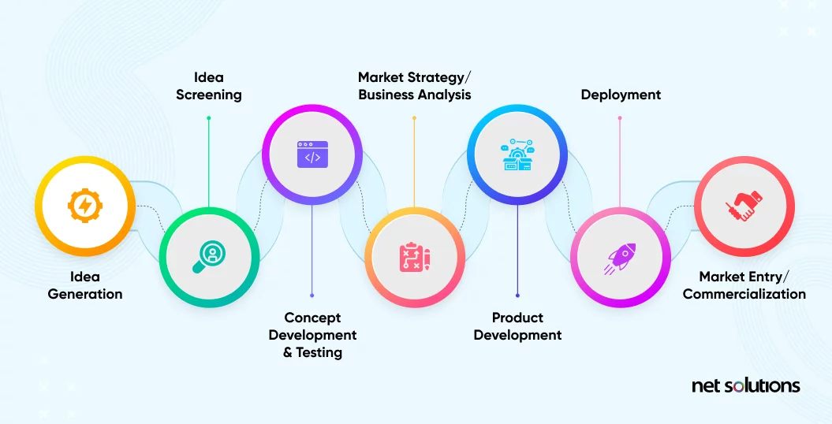

**Figure 2. Different Stages of New Product Development Process**

**Step 1: Idea Generation (Ideation) or Concept creation**

This is the initial phase of new product development where ideas are generated, created and concept are developed. Concept creation is an endless, thorough quest for innovative, sustainable invention improvement prospects. Habitually, corporations utilize fundamental core and peripheral analysis such as the strengths, weaknesses, opportunities and threats analysis to examine the assets, limitations, prospect and risks in the marketplace developments to create several, possible merchandise concepts.

Core concepts can be obtained by means of research and development (R&D). Concept creation can also be established through member of staff brainstorming about ideas. Additionally, peripheral concepts are generated from exploring the market by connecting and communicating with suppliers, wholesalers, consumers and rivals.

Furthermore, New product development and product innovation processes ought to be an ongoing process that lingers although the various phases of the product life cycle, from idea generation, product modeling, idea validation, prototype, Minimal Viable Product (MVP) improvement, initial-unveiling and final official launch.

The objectives of these new product development phases are to create several worthwhile ideas and concepts that can shape the groundwork for the New Product Development plans, policies and strategies. The foremost emphasis for phase 1 should be to organize free-associating and suggestion meetings were providing solutions and resolving consumer challenges are priority.

This stage is not majorly about creating guaranteed ideas that are set for completion. However, as an alternative, unprocessed and unverified ideas that can be nominated to be debated and considered for further advancement and development.

There are several stages of the initial phase of the New Product Development which may include and may not be limited to the following:

**Dimensional assessment**– identifying the basic attributes of the generated ideas and invention concept and requesting significant inquiries to evaluate its possibility for success.

**Scenario assessment**– during this assessment, the New Product Development process is involved with distinguishing marketplace progression to take advantage of the expected customer requirements.

**Problem assessment**– preparing a directory of current customer difficulties and demands to provide a starting point for invention improvement concepts.

**Structure assessment**– recognizing product advantages and characteristics that are consumers friendly and meeting the need of the consumer would be a great product to have, ascertaining defects in current manufactured goods and offering the marketplace with an improved, or completely new products.

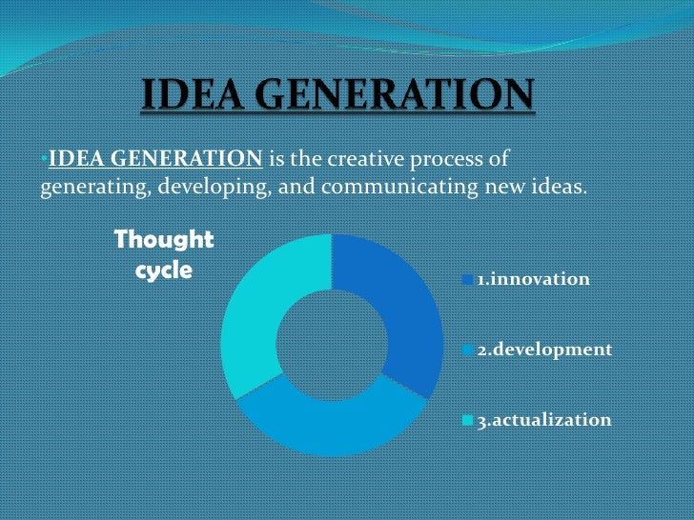

**Figure 2.1. Idea Generation Thought Cycle by Cityraven.com**

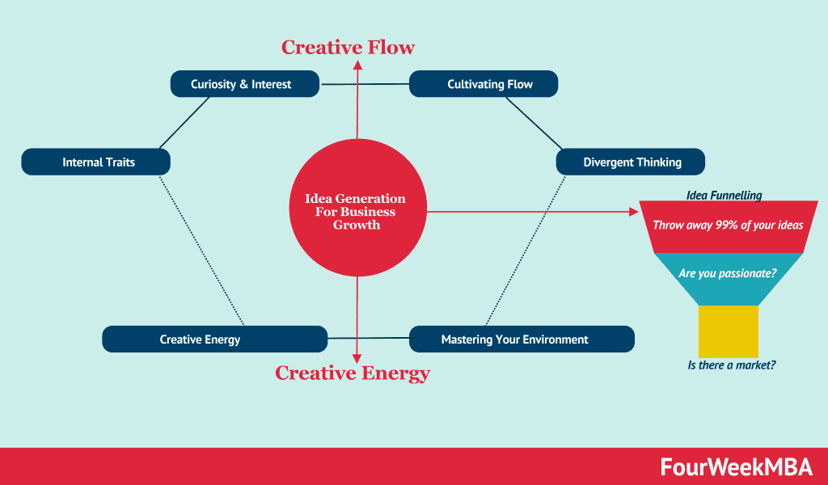



**Figure 3 How to Enhance Creativity- Creative Flow and Creative Energy by fourweekmba.com**

**Step 2: Product Definition**

This is the phase where the product definition is done through various idea screening methodologies. Multiple ideas are conceived; however, brainstorming is carried out to carefully and effectively select a few product concepts that can provide the required solution for the target market.

The product executive crew develops several new product development concepts and designs; however, it is important to note that not all these ideas and concepts will be great, or even achievable. This next phase of new product development is the third phases and involves examining the entire recently created concepts and ideas to scrutinize the excellent ones from the rest. Irrelevant concepts are abandoned as the team takes into consideration various areas of interest of the organization such as the organization’s strong point, limitations, availability, recent marketplace developments, consumer’s requirements, rival products, profitability etc.

Qualities of new product concepts are assessed based on these considerations, a consistent specification to clear out inadequate, unacceptable or less appealing concepts designs that could have progressed beyond the initial phases of new product development.

As much as, the concept generation phase of the New Product Development procedure existed to generate a catalogue and record of several new concepts, the concept screening phase is to decrease the number of irrelevant ideas and concepts based on the interest of the organization to guarantee that the final product is as desired and profitable to the organization as well as meeting the need of the consumer.

The organization’s product administration group can possibly generate several new product development ideas, however, just a few of these ideas will be viable and achievable. During this stage the ideas are screened based on different characteristics such the need of the customers, the trends in the marketplace, profitability and expected Return on Investment (ROI), as well as the strength and weaknesses of the company for such a task. Concepts and ideas that are not good enough are not further considered for production.

New product idea qualities are evaluated based on the factors mentioned above using a regulated specification. While the initial phase of the New Product Development is to generate ideas, inappropriate or less desirable ideas that may have advanced through the stages of new product development continue to be evaluated until a single desirable product is achieved.

Additionally, the Strengths, Weaknesses, Opportunities, and Threats (SWOT) analysis is a great exercise for identifying and selecting excellent New Product Development ideas. The Strengths, Weaknesses, Opportunities, and Threats (SWOT) analysis distinguishes and showcases the areas in which the idea’s strengths and opportunities overshadows its threats and weaknesses.

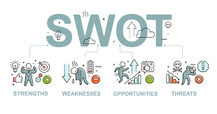

**Figure 3. Figurative display of the different Stages (SWOT) Analysis for a New Product Development Process**

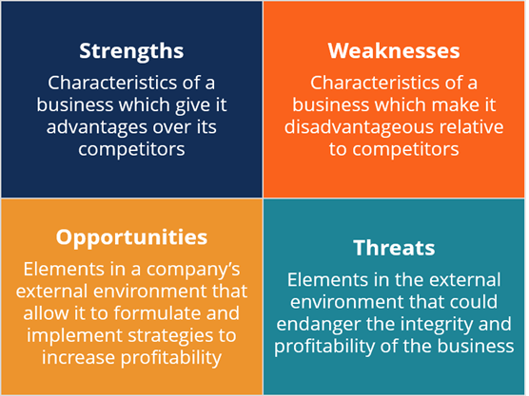

**Figure 4. Different Stages of (SWOT) Analysis for New Product Development Process by searchenginejournal.com**

**Stage 3: Idea development & testing**

The next phase of the new product development is a critical stage which includes the testing and the actual development of the successfully screened idea/concept.

**Concept development**

At the end of each idea scrutiny and evaluation phase of the new product development, ideas that are productively profitable are recognized and taken further into the next phase of development.

New products suggestions that are subsequently evaluated for profitability are the complete explanation and strategy of new product development simulation, generated mainly into important and appropriate consumer product that is standard and acceptable. From each feasible new product development concepts, several complementary models can be generated for the organization to choose the most appropriate one based on the quality, cost, suitability, expediency and the need of the target market locally and globally as the case may be.

A product creation model is a comprehensive description and design of the new product development ideation, put together significantly, and in the best possible way satisfactory and relevant to customer.

**Concept testing**

During concept testing, detailed information about the product concept is shared among a group of interested individuals in the target market. Every established concept is tested with model focus on the market groups to generate responses based on the physical and other attributes of the concept. Questions may be asked in specific areas to unravel the concept and the purpose of the concept.

Testing can be done repeatedly, if necessary, in order to achieve an excellent finished product. The concept testing procedure consequently allows your company to swiftly and efficiently measures the attributes of the new product concept early enough before major financial, labor and time investments are largely made, and original final product is created.

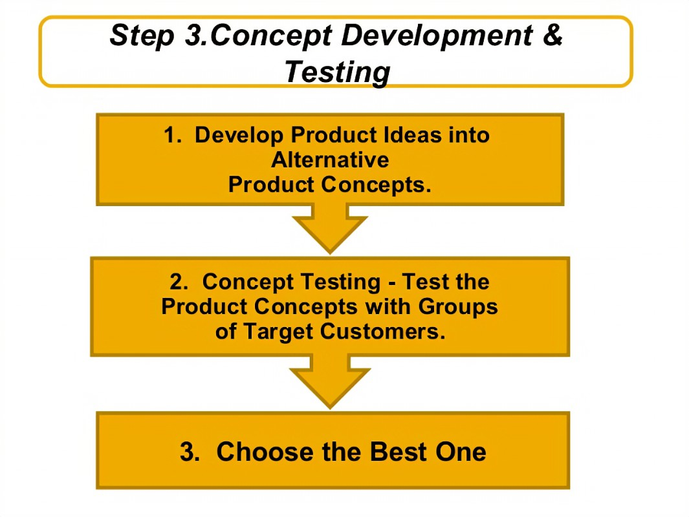

**Figure 5. New Product Development –** **Concept Development and Testing & Product Life-Cycle by Sonu Choudhary**

**Step 4: *Business Analytics* & financial analysis**

For the duration of the New Product Development procedure, each product concept that survives the assessment phases is further taking into a more complex and comprehensive business analysis and assessment stage. This process is important to establish a system of measurement to track the advancement of the New Product Development process. The system of measurement will include various parameters such as an input and output metrics to determine the standard processing time of each development phase, and the output time that quantifies the worth of products, fraction of new product sold and providing detailed feedback.

Business assessment will assist the new product developer to ascertain the necessary costs involved in the anticipated New Product Development, and the predicted profits that may be generated from the product in imminent economic years. The cost of a New Product Development is very significant.

Your business assessment /analysis is a great way to identify and eradicate inappropriate concepts and prevent excessive expenses during New Product Development.

The following maybe considered during business analysis:

* Evaluate the industry’s market and rival. Investigate, get reviews and feedback from consumers to ascertain the most suitable price for your product, and the profit generated.
* Assess the market and the sales performance of current products within the scope. Utilize existing sales information within your industry in order to discover and understand the existing degree of interest customers have in the same commodity line with your product in the marketplace.
* Assess the amount of the sales according to your prediction during the initial business assessment exploration, integrate this into the needs of the customers, the number of active customers, the reach of the business within the industry and globally as the case may be.
* It is important to evaluate your break-even point, assess the productivity of your products, and intentionally generate sales. Plan your profits based on your projected promotional product price to detect and manage your lowest sales amount on each product.
* Marketing strategy is essence in the positioning of your business and new product in the marketplace. It provides the insight and knowledge required to position your products in the right places that ensures the right target is reached. However, it is essential to utilize the data generated during marketing research and business analysis to structure the marketing strategy approach, methodologies that are crucial in the product advertising and, recognizing important marketing and merchandise news that is relevant for the business.

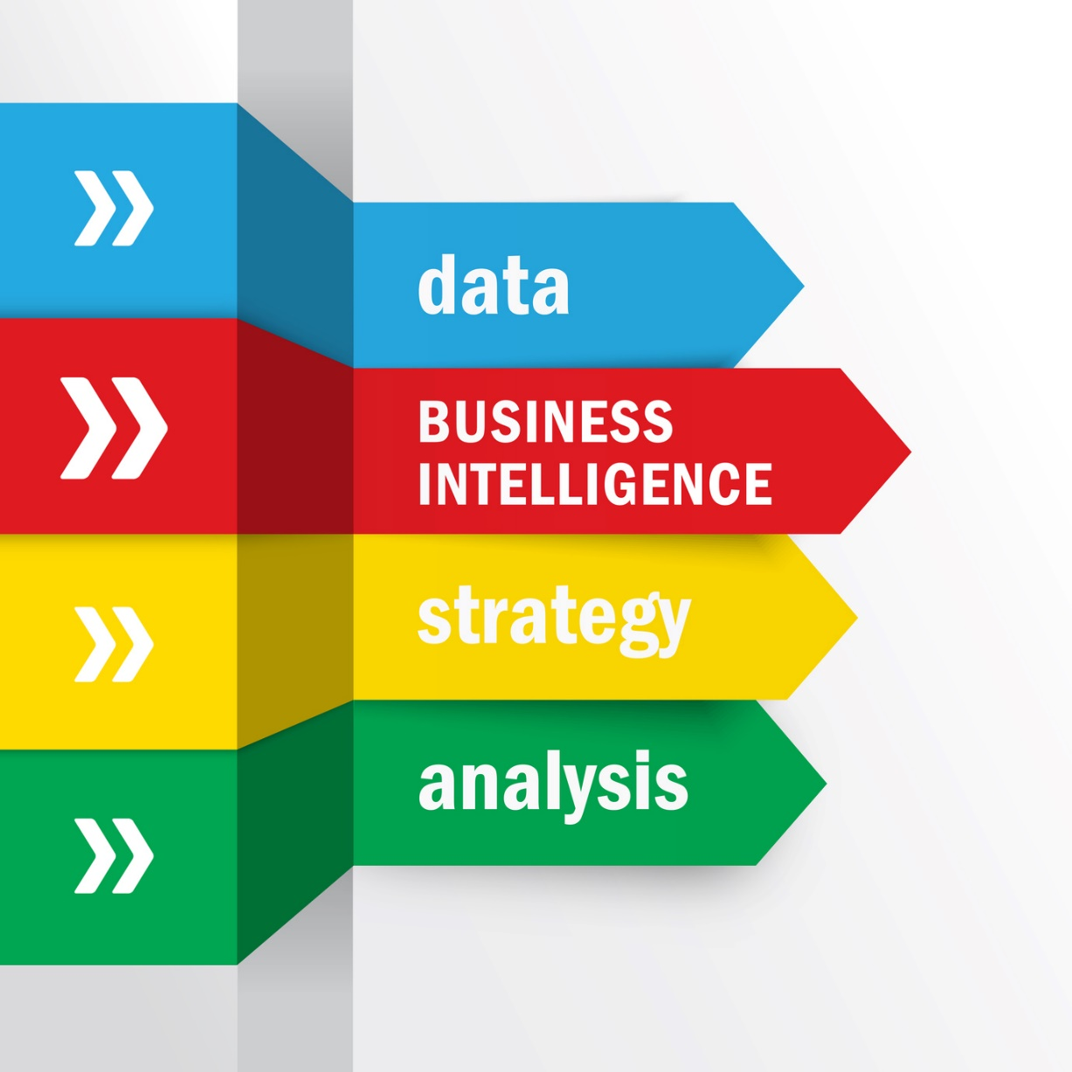

**Figure 6. Business Analytic and BI Concept by businessimpactinc.com**

Prior to the advancement of a new product, it is essential to evaluate the feasible idea of the new product concepts for commercial and economical possibility and its consequences. Organizations will have to ensure that they can have enough financial capital to execute the necessary strategies they have identified. Both business and financial strategies are significant and necessary during the new product development process. Every New Product Development strategy should include the lowest mandatory investment, demand estimation, budget plans, appropriate competitors, productivity and profitability. Examination structure must be in place to examine the progress of each process, metrics to observe productivity output of each input such as quality of the final product to be launched, time management during each stage and more.

It is advised to analyze the sales record of comparable products and examine the recent and existing market to verify the current developments and facts and calculate the scope of risk that may affect your new product’s development.

An accurate and comprehensive examination procedures make the new product development process easier. However, it is the responsibility of the organization to determine the most suitable concepts, branding, business, and marketing strategies to employ.

**Stage 5: Product development**

Subsequently the endorsement of all appropriate corporate, marketing, monetary and product development strategies, the new product development concept is grown into an authentic product in the final stage of new product development.

From the early stages of product idea and concept construction, assessment and testing, packaging, product branding and product positioning. An actual model or limited manufacturer prototype is developed, and other strategies are analyzed and employed to guarantee that the product concept can be trusted enough to function as a secure, efficient and effective marketplace product. At this stage, the expertise of your Research and Development (R&D) department team, or an external examination authority is employed. Depending on the product and prototype techniques applied the stages involving the R&D team takes an ample time that sometimes runs into years.

**Stage 6: Marketing Testing**

Marketing test entails putting out an authentic final product for sale in one or several testing market locations and studying in what manner it retails under the pre-established advertising strategy. The objective of the marketing testing phase of the New Product Development procedure is to authenticate the complete idea and process development involved in the new product prior to the when full financing is done, and preparation made for the product before its forthcoming commercial unveiling.

As earlier mentioned, consumer response, opinion and suggestions are important depending upon genuine perceived consumer actions, rather than just request for information about concerns in a suggested product. The factual extent of marketing testing required may differ very significantly in conjunction with each organization and the new product.

**Stage 7: Commercialization**

During this stage of new product development, celebrations are in order, and satisfactory. Teams are welcome to celebrate the success of the New Product Development process and the launch and commercialization of the product.

The new product, and all related testing, financial and marketing strategies are all set for release into the market. At this point, the implementation of a complete production process and marketing plan is necessary.

At this point, the new product developments are ready to go conventional, customers are buying your products and professional assistance is constantly examining more development.

Maintaining your supply and delivery channels packed with products is a fundamental component of this process. Invigorating adverts and commercials throughout this phase will ensure that the products resolutely planted into the thoughts of the consumers resulting in purchases.

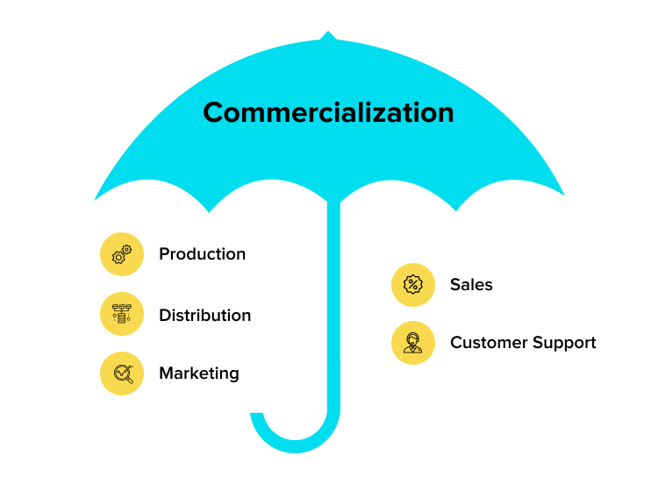

**Figure 7: Commercialization**

# **CONCLUSION**

Our world is a universal marketplace with swift and unstable changes in the fundamental and industrial phases of science and technology. Business developments are transforming daily, and conventional businesses and job sets are turn out to be computer-generated, electronically driven, and in some cases even mobile. This height of transformation generates the necessity to assembly the business so that individuals can establish new products beforehand to prevent agitation from consumers, the general market, or rivalry. The establishing and manufacturing of new product by company is now faster and more affordable, thereby making product launching easily achievable.

Every successful New Product Development project is a combination of several strategic planning and processes. After the concept development and concept testing phase, and a favorable model has been carefully chosen, a preliminary business and advertising approach is put in place for sales and promotional purposes.

This involves a complex evaluation of the entire techniques of the project managing such as the target market, value proposition of the product, budgeting as well as advertising and promotional aspect, sales crews, sales locations and so many more. These evaluations are essential to ensure that the final product successfully gets across to the target audience.

Finally, New product development is about transforming a new concepts/ idea into practical, innovative and effective products. This product could be a company’s invention, that is able to give them a competitive benefit, advantage and dominate the marketplace.

The 7 phases of New Product Development according to this research by Joy Akinola:

1. Idea Generation (Ideation) or Concept creation
2. Product Definition
3. Idea development & testing
4. Business Analytics & financial analysis
5. Product development
6. Marketing Testing
7. Commercialization

However, organizations have been able to uniquely combine various stages of New Product Development to fit their structure.

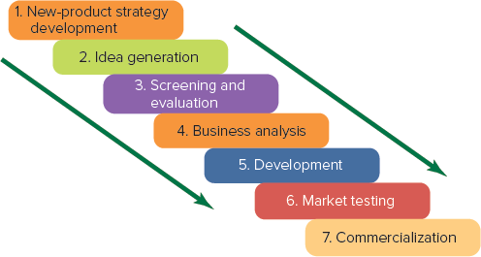

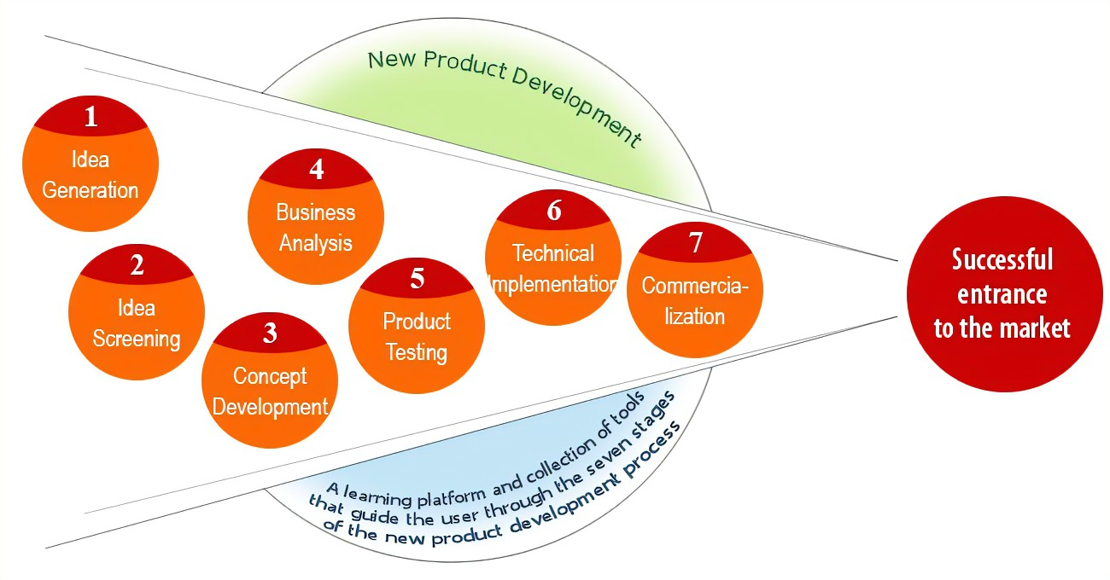

**Figure 8: 7 Stages of New Product Development**

# **BIBLIOGRAPHY**

BI & Business Analytics: Are They the Same?” *Business Impact*, 21 May 2015, businessimpactinc.com/blog/bi-business-analytics-are-they-the-same/.

Cuofano, Gennaro. “Idea Generation: How to Enhance Your Creativity Flow for Business Growth.” *FourWeekMBA*, 29 July 2019, fourweekmba.com/idea-generation/. Accessed 8 June 2022.

Carter, J. (2022). *New product development [NPD] | 2022 examples | tcgen*. Https://Www.tcgen.com/; TCGen. <https://www.tcgen.com/product-development/new/#intro>

Corp, S. (2022). *ABOUT | shape corp.* Shape Corp. <https://www.shapecorp.com/about/>

Singh, S. (2022, January 21). *What are the seven stages in new product development process*. Https://Www.netsolutions.com/Insights/Everything-About-New-Product-Development/. <https://www.netsolutions.com/insights/everything-about-new-product-development/>

Vidyarthi, S. K., & Evans, M. E. (2019). *Tomato Chemistry, Industrial Processing and Product*. Ebscohost.com; Sebastiano Porretta. <https://web.p.ebscohost.com/ehost/ebookviewer/ebook/bmxlYmtfXzIwMjU0NThfX0FO0?sid=59050f3f-ac54-4bda-9c31-bc33f00d251a@redis&vid=10&format=EB&rid=1>

Maam, Ms. Samreen, and Sonu Choudhary. “New Product Development and Product Life-Cycle Strategies.” *Https://Www.slideshare.net/SonuChoudhary2/New-Product-Development-Plc-By-Sonu-Choudhary*, Slideshare - a scribd company, [www.slideshare.net/SonuChoudhary2/new-product-development-plc-by-sonu-choudhary. Accessed 2022](http://www.slideshare.net/SonuChoudhary2/new-product-development-plc-by-sonu-choudhary.%20Accessed%202022).

Queensland, Government. “Business Analysis of New Products | Business Queensland.” *Qld.gov.au*, 2018, www.business.qld.gov.au/running-business/growing-business/becoming-innovative/developing-products/new-products/analysis. Accessed 20 Dec. 2021.

Satinder, Singh. “What Are the Seven Stages in the New Product Development Process?” *Net Solutions*, Net Solutions, 21 Jan. 2022, www.netsolutions.com/insights/everything-about-new-product-development/. Accessed 15 May 2022.