**Your name: Joseph Konda Kodi**

**Your student ID number: UAM6126HPU75183**

**Your major: added course**

COURSE NAME:

**(Public Health)**

Assignment Title:

**(UNESCO Sustainable Development Goals)**

ATLANTIC INTERNATIONAL UNIVERSITY

**20/Month 3/year 2022**

1-

**Table of contents**

1. **Dignity**
2. **Equality**
3. **Liberty**
4. **Solidarity**

**Introduction**

Write 2 to 6 paragraphs introducing the topics of the assignment or essay.

The terms mentioned above in the table of contents are terms that supposed to be applied in the societies so that people can be feel eased within their societies and practice their activities by expressing their skills with moral without hindrance or anything which mat hampers their freedom. The feeling with dignity, means that the human being feels worthy of whatever position he deserves in his location whether being in the government or practicing his daily life in full freedom and respected, that where the government rules and regulations that gives right to every citizen to handle the position he/she deserves. And people feel with patriotism whereby they prepare themselves to defend their countries and die for it.

The dignity results in quality distribution of the limited resources being positions or development in the state regardless of race or ethnicity or gender. The equality is the scale used so that everybody receives his right without discrimination, averting nepotism, tribalism, egoism, greediness and begrudge in the societies. The liberty, Abraham Lincoln said every man is created equal, so people have right to feel free to do whatever they want to do without control or suppressed or repressed within their domain of authority. with dignity, equality, liberty the societies can unit in solidarity to build and develop their countries, without solid solidarity the development can be hampered and devastating discrimination take place which later lead to ethnic war, destruction and instability of the countries creating smoky environment whereby people be affected with many ill-health. Because this can lead emigration or immigration of the people creating unnecessary congested and over population in host countries.

**Write essay or multiple choice questions.**

Divide the assignment into sections. The sections can correspond to separate ideas, separate issues or even separate chapters in a book.

2-

General view

1. Dignity

The dignity is sometimes taken for granted, it is difficult to feel with dignity where the minds of some people assumes superior on others. In some countries after independence, ethnic group get opportunity in the government and snatch it as their own property as a result, they suppress, repress, exploit and humiliate the other groups in the state. Therefore, the other group feels unhappy because they are considered inferior and always proletariat in the country.

Not only proletariat group but to be abused and mocked on not different than slaves.

In relation to Sudan the black people are molested even worst the slaves.

For example:

1. Collection of the bucked faeces from arab homes
2. Work as house-servants
3. Cleaners of the streets to collect rubbish/garbage
4. Recruit them and use them in army to fight and kill their own people in name of the Allah of the arab.
5. So our people Nuba were used in wars to kill South Sudanese people during Anyanya one blindly without knowing the reason why they kill them.
6. In second war in South and Nuba mountains they were used blindly to kill their people thinking they were killing non-muslim pagan as they were inspired. That Allah said kill pagans and he take you and 70 from your relatives to heaven.
7. Muhammad Ahmad Almahdi and slave trade in Nuba mountains

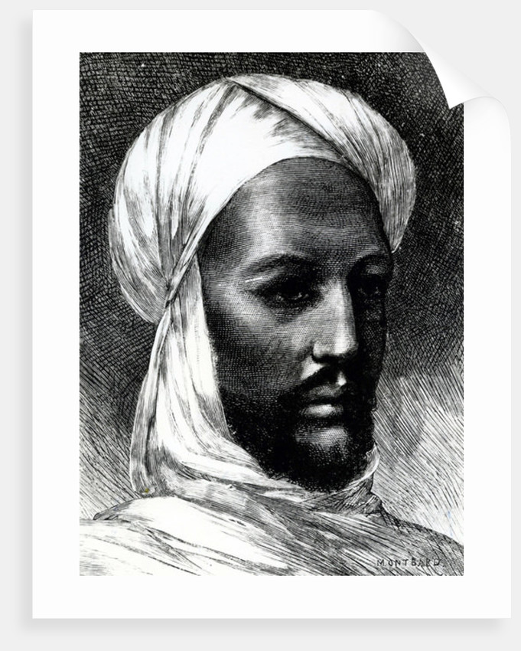

The Muslim man who exported hundreds of thousands of the Nuba people, he had covenant with Islamic shieks in Nuba mountain to contribute human beings as annual taxes forhim to export.

3-

Equality

Means equal distribution of the resources, positions, but now rather used as

propaganda by the politician to cunning people in rallies of the campaign trail, it should be reality, but now a days this golden term is taken by mistake by the politicians to be used for their political interests.

The true pronunciation is justice and equality, people are crying around the globe accusing their leaders from injustice and inequality. If this term was applied genuinely as it is pronounced, there would never ever be political problems or disparity in the world but because misused, there are many deaths, riots and coups and snatching power from civil system by point of the gun. Equality means balancing distribution of resources, positions for all regardless of race, ethnicity, religion or gender based attitude. Especial in the African continent people have believed it as natural injustice and inequality. No change from injustice to justice.

liberty

The condition of being free from control or restriction. The dictatorship uses power over people restricting them to practice their skills and express their options as free citizens of the independent country; despite of the independent country, people still face difficult control stances with intimidation to their freedom. In Sudan I remember president Omar Hassan basheer said, no any language again to be pronounced in Sudan apart from Arabic language, because it is the language of the Allah. That was in Gadarif region during his visit after cessation of South Sudan in 2011, and intending to intimidate Nuba mountains and immediately started war bombarding and killing civilians indiscriminately.

Denying the right of the people to express their will as citizens of the country. And his successor Abdulfatah Alburhan is continuing the same thing, people say we don’t want you, but still killings continue against innocent civilians.

Solidarity

Solid standing together around a common goal. People around the globe in many countries are standing together to reject dictatorship, injustice, freedom restrictions. Saying freedom must surmount. Solid solidarity with determinant can achieve very important goal of which all human beings can benefit, for example solidified movement against injustice can achieve freedom, in spite many live can be lost but still freedom through the blood of martyrs can still be achieved. Solidarity towards development of the state or a country with determinant can bring change.

4-

Analysis

There are real intellectuals in the world who are struggling for peaceful globe and initiatives to manufacture conducive political environment for human beings to live in harmony, despite of their endeavors exerted, still some leaders could not understand to adjust themselves to change.

Dignity:

since the people are already free from colonization, what again is called suppression and repression of the people within their independent countries and denying their right as free people living in their independent countries. The obvious greediness on the universal resources is the cause of all these. The greedy individual who gain upper hand over the others in the country, practice nepotism, tribalism, egoism and begrudge, denying the right people in the right positions to apply their positive experiences acquired from the true theories for the benefit of all. As a result the African countries continued and still continuously resversing backward from the development spectate on Europeans or USA going ahead with development. Africa is still continuing to sell crude minerals instead of using them to manufacture and export ready made goods.

Equality:

The price of the word equality is most expensive than vivid coloured diamond, it is very expensive word, it is easy to be said but very hard to apply, equality the symbol of the true government, it is applied by those who want their legacy evoked positively, it is applied by the patriotic people who love their countries and their people. It cannot be applied by the thieves and corrupt people who have in the objectives to expropriate and devour the universal properties of the people. And it cannot be applied by those who want to employ their inexperienced relatives whose minds exempted from the true knowledge in the field they are employed they are only nominated to close the doors of the development for their own interests and interests of their relatives and deny the interest for the reform of all.

Liberty:

The patriotic leaders understand why people brought him or her to the position he is holding. It is because they trust him according to his genuine characteristics. And since he knows that his people trust him, he opens the door for all to welcome every citizen, that means he opens his ears to listen to the people because he was ready since to serve people as their servant and people serve him and worship to give them food as leaders do. They like people to praise them

5-

for survival. The true leader does not restrict freedom of the people but he is rather ready to confront and flex with all types of challenges. When people enjoy liberty, they produce for the country as much as possible and ready to defend it with their own blood because they love it,

Solidarity:

Standing together in solidarity provides positive development result for the country. To unite strategic plan towards achieving clearly marked and targeted objective, is possible to achieve, because all the group determine towards one goal, solidified armed forces can dislodge the enemy from their fortresses. Despite losses and prices they pay their solidarity is to dislodge their enemy. Thus determinant solidarity based on very clear vision, the objective can be achieved with no doubt.

Actualization:

Dignity

The people of Nuba mountains never feel as having dignity or having equal rights in Sudan but rather inferiority, with no full rights according to the Sudanese system. Currently, because of war, some rights are now achieved, for example some students are now allowed to be enrolled in colleges like, military science, law, technical colleges. But the other problem is that they have no chance of studying English language, the English language studied is very weak; the arab students, because they sent them to strengthen their English language abroad, they speak better English by far than Nuba students.

In the liberated areas, many students are English pattern, and many are currently university graduates in different fields, because they got chance to study in east Africa as refugees. And the different between government controlled areas and Sudan people’s liberated areas, is that within Sudan people’s liberated areas, people feel with full dignity; because thinking, planning and decision making is in their hands and not controlled by the colonists of arab.

So dignity is not for charity or granted it is very expensive price to be paid to feel dignified.

Equality

Equality in Sudan is sincerely false and I don’t it will be applied practically may by mere words narrated by the politicians, nothing can be done pragmatically at the grass-root as expected.

Because domination of the arab ethnic group has permanently established foundation. They are wealthy, they have highly educated cadres, with long experiences therefore they continue to dominate Sudan and deny others equal distribution of the limited resources and positions because they are categorized as first class, and first have always upper-hand even financially and they can always be able to send their children into higher education quality for example in USA, China, Russia and different European and Asian countries to study in technical schools.

6-

Liberty

Freedom is not for granted or it cannot be given easily unless some people are ready to pay their lives as price for freedom. To be free many people die and later those who remain be free and start development of their state. Even in independent countries, some group organize themselves as first class and start to dominate but later people will say no, no one is better than the other all of us should have equal rights within our government, and if thing don’t change,; this can incur war or outrages and unrest in the country. So freedom must surmount so that everybody feels happy with services.

Solidarity

Tightens to achieve the targeted goal, for example after comprehensive peace agreement, CDR Abdulaziz Adam Alhelu, the Chairman in Chief of the Sudan People’s Liberation Army/North and Chairman of the Sudan Liberation Movement established a decree all the armed forces must contribute some money so that we build bank in South Sudan in Juba; because of the solid solidarity, the armed forces contributed and were able to build huge bank in Juba. So solidarity is standing together to achieve certain important and necessary goal. Even to defend the country people stand firm in solidarity to die for the sake of their country for example in Ukraine, despite Russia is one most advanced countries being weapon, tanks, air-crafts, submarines or missiles, the people of Ukraine are saying no! Russia can only conquer Ukraine when all Ukrainians die including their president.

People can also stand in solidarity to use their limited resources to develop their country with depending on external resources.

Recommendation

I think in 1905 the renounced slave trade and considered it crime against humanity. People should try to change bad practiced attitudes to better so that they live in harmony amongst each other.

I thank UNESCO so much for important initiative trying its best to bring human being into the wise standard. These terms if they are applied wisely, the violence can be mitigated around the globe.

Dignity, Equality, Liberty and solidarity.

Let human being renounce his greed and emancipate his mind from nepotism and tribalism. Let people respect each other’s positions, ethnicity and values. Everybody has value that should be considered.

To apply these terms wisely, the people need to be aware of what is in his portfolio, back ground and recommendations about his activities in former field of responsibilities. Level of

7-

the theories and experiences of candidate to be elected, was he successful in former position or not that is to be careful from electing criminal and corrupt candidates and vilify talented candidates.

That is where we create errors. We should elect candidate who pronounces how is he going to apply the terms mentioned above, this terms were engineered by the true expert and are the routes to safety. To form the true government, we make sure we put in our constitution the importance of the Dignity, Equality, Liberty and solidarity as very important in our strategies .

Changing bad habits of the bias to the ethnicity or tribe and ignore genius intellectuals who can really lead people through the right process, should be deplored drastically. If country to succeed, let it apply the rules of dignity, equality, liberty and solidify itself tightly for the sake of the development of the country for the benefit of all and benefit of the groups.

**Conclusion**

Write 2 paragraphs summarizing the key ideas of the assignment.

United nations has always successful plans but most of them become theories narrated without implementation. There are many human right articles that should be executed so that people can live in harmony but do not take place the way it should. That is because of the right of vetoes.

Liberty, the freedom of the people is restricted by the dictators as well as autocratic systems; I think United nation should continue with its human right initiatives in order to mitigate violence in world, all human beings deserve dignity to feel happy within their countries and in their departments, equality is very important pillar that hold balanced umbrella in the sky in which everybody feels balanced participation in planning and decision making based on shared vision and equal distribution of the limited resources for the development of all. So that all people within the same geographical area feels satisfied, and this brings peace, stability and development for all.

**Bibliography**

Put the bibliography of the books and other sources used to write the assignment.

UNESCO development go 20-30