**Your name: Joseph Konda Kodi**

**Your student ID number: UAM6126HPU75183**

**Your major: AIU Course**

COURSE NAME:

**(Article 28: Human Right to Free and Fair World)**

Assignment Title:

**(the universal declaration of human right)**

ATLANTIC INTERNATIONAL UNIVERSITY

**17/Month 3/year 2022**

1-

The Universal Declaration of Human Rights was drafted in a period, 1946-1948,

Table of contents: from the Cassin envision article 1 and 2.

Comprising fundamental principle of:

1. Dignity
2. Equality
3. Liberty
4. Solidarity

**Introduction**

Write 2 to 6 paragraphs introducing the topics of the assignment or essay.

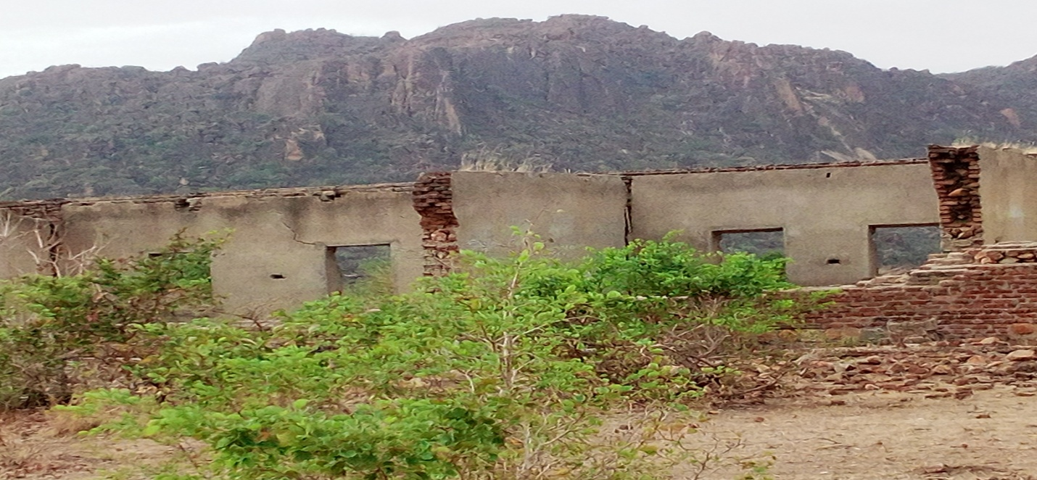

In 1898 when the British government came in to Sudan, they found the black people including Nuba people in herd in Egypt for sell as income commodities of Mahdi. They recruited the slaves and used them in war and conquered Sudan and killed the Mahdi’s successor Khalifa Abdulahi Altaashi.

When the British government left Sudan in 1956, they reversed slavery, and handed the government to the Arab ethnic group who used to export and castrate black people in Sudan and in Arab world. Good-luck to the slaves who were exported to USA specifically Mexico and Brazil, despite being exploited, but they were kept alive. But unlucky ones in arab world vanished because no off-springs due to the castration.

2-

But before the British government left Sudan, they signed consortium relationship with the arab colonial system. Of course even before they leave Sudan war broke-out in south Sudan.

In 1960s

Bishop Philip Abass Gabush from Nuba ethnicity left Church and joined the parliament and Butros Tia Shokai succeeded him as Bishop. In 1969, Jaafar Nimiry ousted the civilian government, killed president and became president by toppling civilian government, as a result the military didn’t reconcile with the Bishop Philip Abass and they embroiled in political disagreement and he escaped to Uganda.

But what happened to Nuba people after departure of the British government?

**Write essay or multiple choice questions.**

Divide the assignment into sections. The sections can correspond to separate ideas, separate issues or even separate chapters in a book.

General view

Dignity of Nuba

The people of Nuba denied dignity as indigenous people of Sudan, they humiliated by the following:

1. Work as collectors of faeces in bucket latrines and cleaners of latrines for arab.
2. Work as house servants
3. Women of Nuba had no option rather than to work as brewers and sellers of local alcohol all these was done so that could be able to educate their kids.
4. The lucky got chance to be recruited in the army and police
5. Cleaners of the rubbish and collectors of the garbage in streets.
6. They were called slaves
7. Any Nuba moving in street can a rested by the arab police and taken to custodies without reasons convicting them with theft without any evidences and fine them to pay money.

Equality

Nuba people did not know that there was something called equality, they did not know that they were part of the indigenous people of Sudan, they saw themselves as valueless people who just go to Khartoum to get jobs and ,money without knowing that they were part of Sudan.

In Nuba mountains region, there were very few schools to educate their kids, they did not know the benefits of education, most of the parents only knew that when child is educated, he can be clerk in the office, or teacher this is what they knew all about education. Most of them after senior level they take them to study Quran and know only about Islam. Chances was only for

3-

boys with no equal chances to the girls. But in this world as whole something equality is just rhetoric propaganda narrated by the politicians to gain common ground from the communities so that he can be elected to the constitutional position, either president or member of parliament; in reality there is nothing called justice and equality. But it should be applied if possible so that people see equal parallel distribution of the limited resources and be happy with service

Where is Human right to fair and free world?

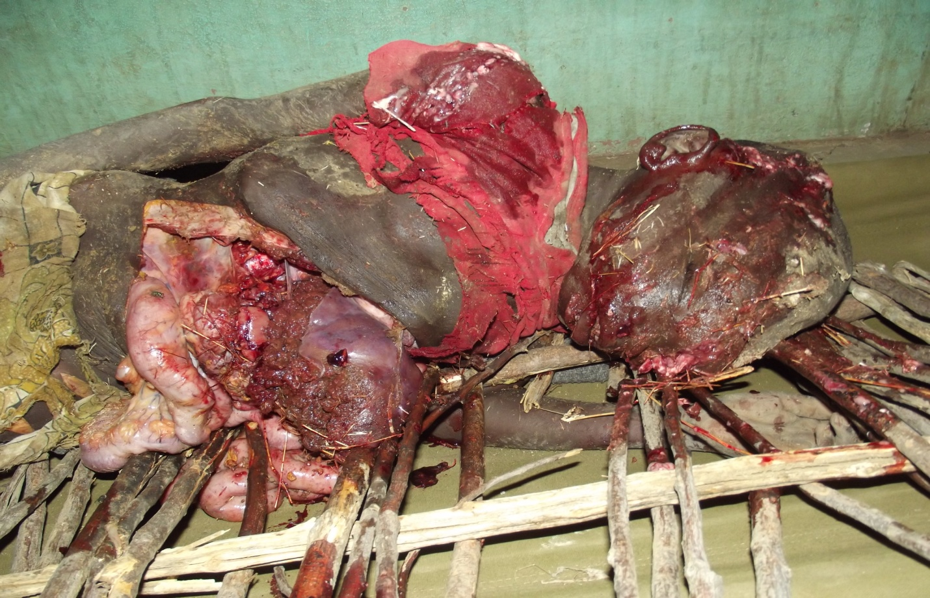

4-

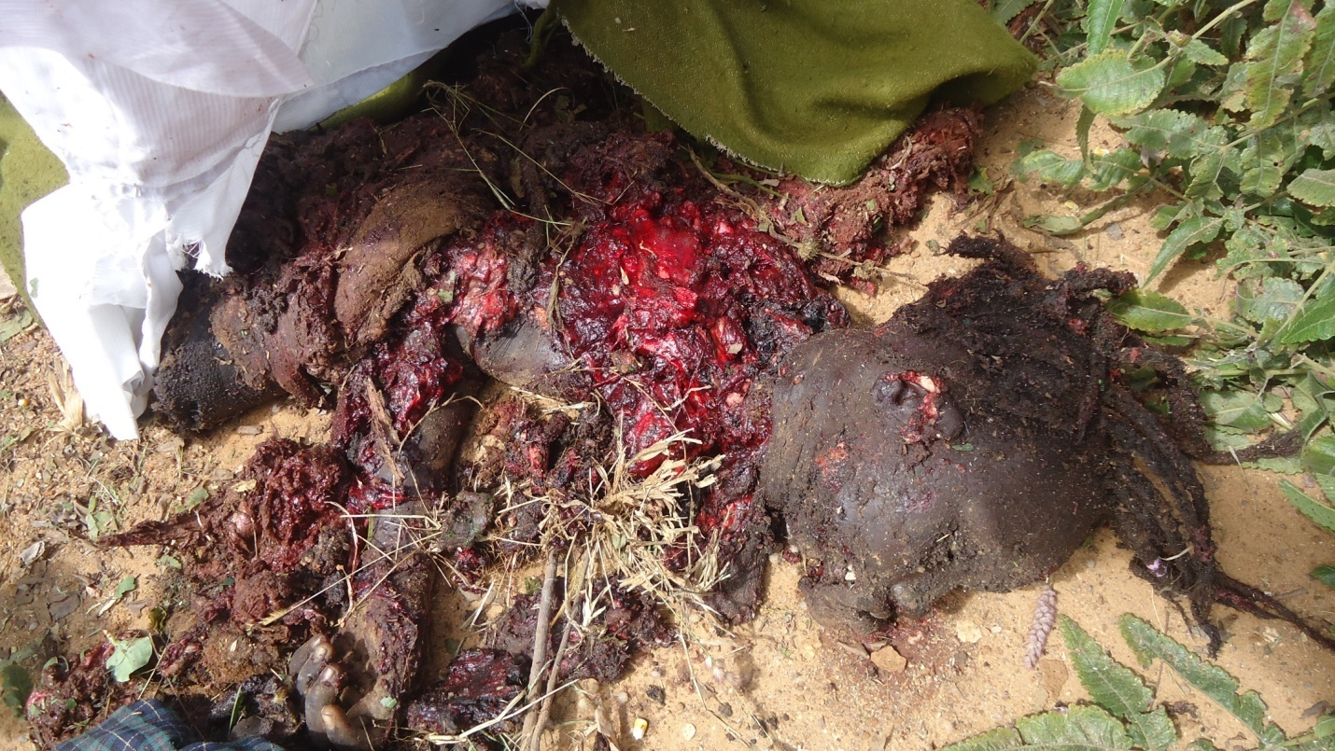

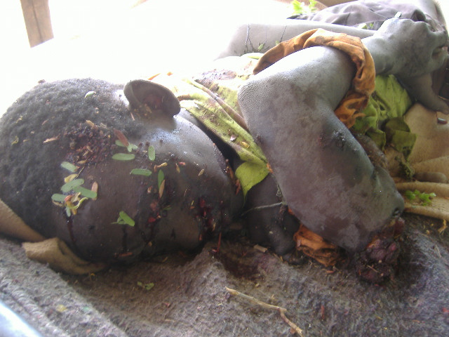

5-

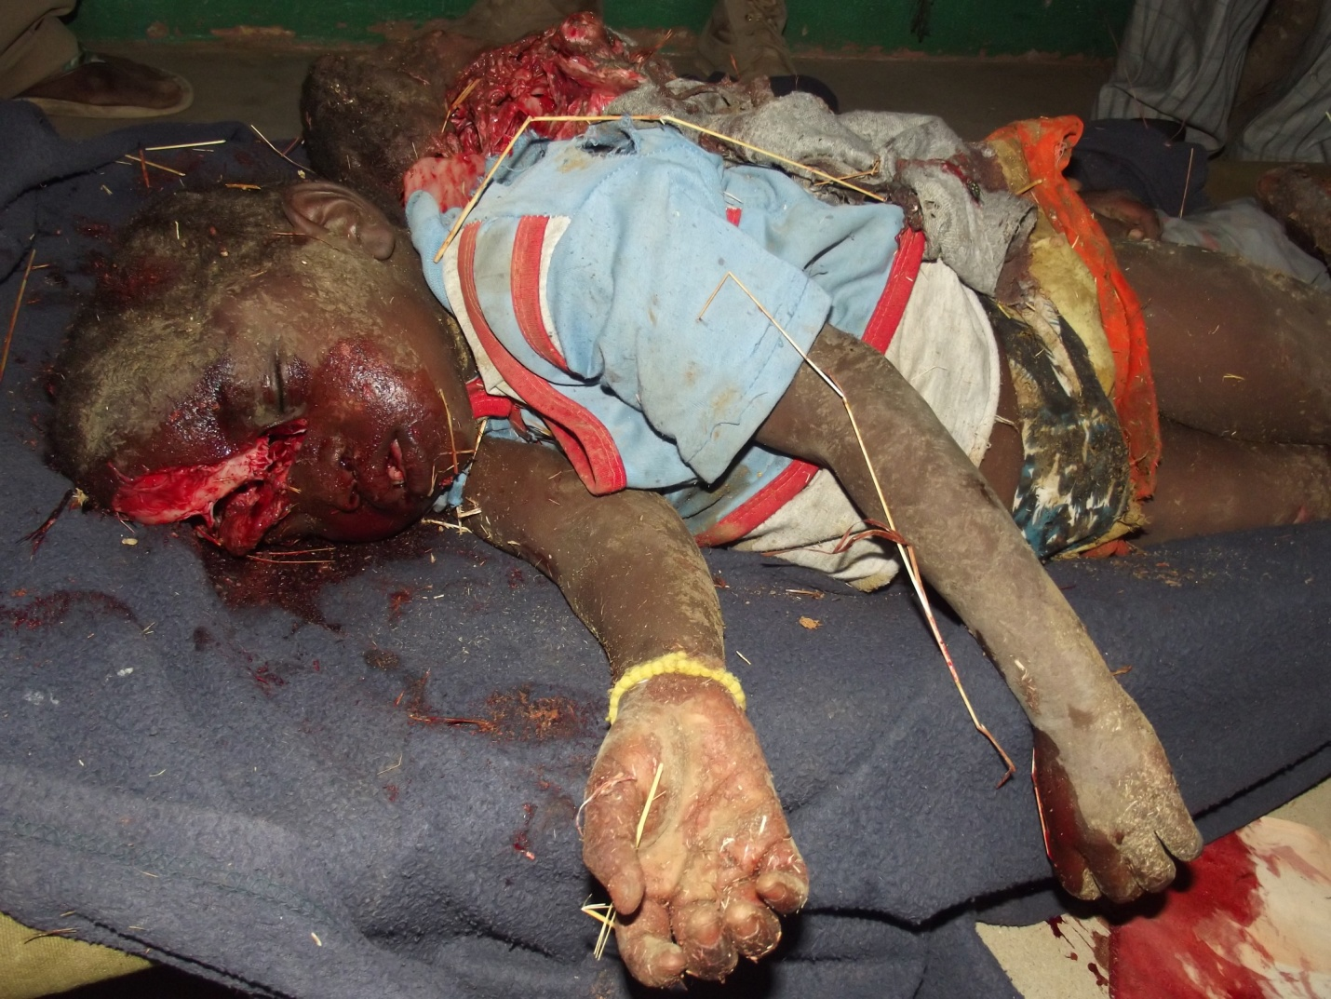

Liberty

There was no freedom for the people of Nuba to work as people with right to enjoy the independence enjoyed by the arab ethnic group, the independence was assumed right given for them only without involvement of the Nuba people. The people pay taxes but denied equal

development because they were considered nothing rather than slaves to be suppressed, repressed humiliated and exploited in war in South Sudan.

Liberty is it to get rid of all inhumanity and nurture freedom in the hearts of the people to psychologically be free from any injustice and enjoy true life in their states.

Causes of war

In 1982 war in South Sudan, CDR Yousif Kua Macki the graduate of the economic and finance in University of Khartoum and Daniel Kodi the member of parliament were encouraged by Dr. John Garang De mabior to join him in the bush to fight for liberty of the African indigenous people in Sudan.

6-

People were mobilized from Nuba mountains to Ethiopia. The first group spent 3 months to reach Ethiopia but the other groups managed to reach Ethiopia after 45 days all of them went by footing. Some them got sick in the way and were left for the wild animals and some them drowned in the rivers when the canoes turnover in the river. They drowned because no one of them knew how to swim.

The theme of Yousif Kua was we must fight because we were

1. Suppressed
2. Repressed
3. Exploited
4. Humiliated

So we must fight to free ourselves from such bitter colonization.

In 2004 in Maridi Health Intitute in South, I was about to graduate from the institute; the college had granted us privilege to be introduced to the international laws by one of the South Sudanese Dr. who achieved his academy in International laws and was awarded PhD on international laws.

He said in short, I just want to introduce you to the International laws, but according to my theories or lessons I learnt and experiences I acquired, the International laws are not based on reality.

He said International laws will be applied to all people in Globe as the way it is written, because by the end of the day, it will say no interference in the country’s affairs because of the country’s sovereignty and its territorial integrity. Which means the government has right to kill its civilians as much as possible no country can jump in and say the international law of human right said you should not slay innocent civilians but it will rather be narrated negotiations while the government continuously kill innocent people; that was why international community was spectated on war in South Sudan and Nuba mountains and about 2.5 million South Sudanese and hundreds of thousands of Nuba people were slain by the arab colonial government without mercy.

1. Fundamental right of the individual.

In Sudan before war, there was no right Christian person to go to the restaurant and eat during Ramadan, all people should stay hungry whether Christian or muslim no restaurant is allowed to open for non-muslims. During Islamic legislative rules in Sudan, people were harassed when speaking native dialects or practicing their cultures and were obliged to study Arabic and speak as the fundamental language of the Allah of arab, as well as practice Islamic prayers in Arabic language because Allah will not understand any other language apart from his language Arabic.

7-

1. Civil and Political rights.

In Sudan, there are some vacancies/government institutions specified for arab colonial government

According to the sovereignty classes in Sudan, arab first and their females second class and then black person who is muslim and political proponent of the certain arab party third class and may be other black groups will be number 4.

3-Spiritual, public and political freedom

Christianity worship was restricted, no public political rights for the black people in Sudan was allowed, even the free movement in Khartoum was restricted. Because there was emergency rules to arrest black people if they are found to be sitting together in any gatherings. So the black man was always worried when he is sitting or moving anywhere because he can be arrested at any time and taken to prison and fine without investigation. A few educated Nuba individuals were threatened not to involve in any political arguments because it is not their right.

Analysis of war between Russia and Ukraine

According to my analysis. I think Russia did not intend to invade Ukraine with some Ukrainian elements within their own country. I think some Ukrainians are interested to reverse and rejoin Russia, that is why Russian government utilized that golden chance to revert Ukraine. Russia’s strategic plan, specifically Putin and his vice Dmitri, want to revert former Russian states of the soviet union, but this time not as communists but with religion freedom and some states or individuals in the states may think they better rejoin Russia since their regions don’t have resources for their development. That is why Russian President Putin is asking President Zelensky to step down from the government as a solution.

But this should be through other political means and not on account of the innocent people of Ukraine for example, children, women, elderly and other non-political innocent civilians of Ukraine. In reality it is unnecessary war on country with its full independence and territorial sovereignty.

* This is the current situation, the former genius intellectuals have vanished and we are now with premature people handling governments as well as security council.

Children targeted in school but fortunately the children were not in the classes.

It is already stated by the human right expert Cassin that

in recent years, however, belief in multilateralism has started to fray, as some countries overtly assert their national self-interests over the welfare of humankind in general.

8-

What happened in Nuba mountains in front of the international community was terrible.

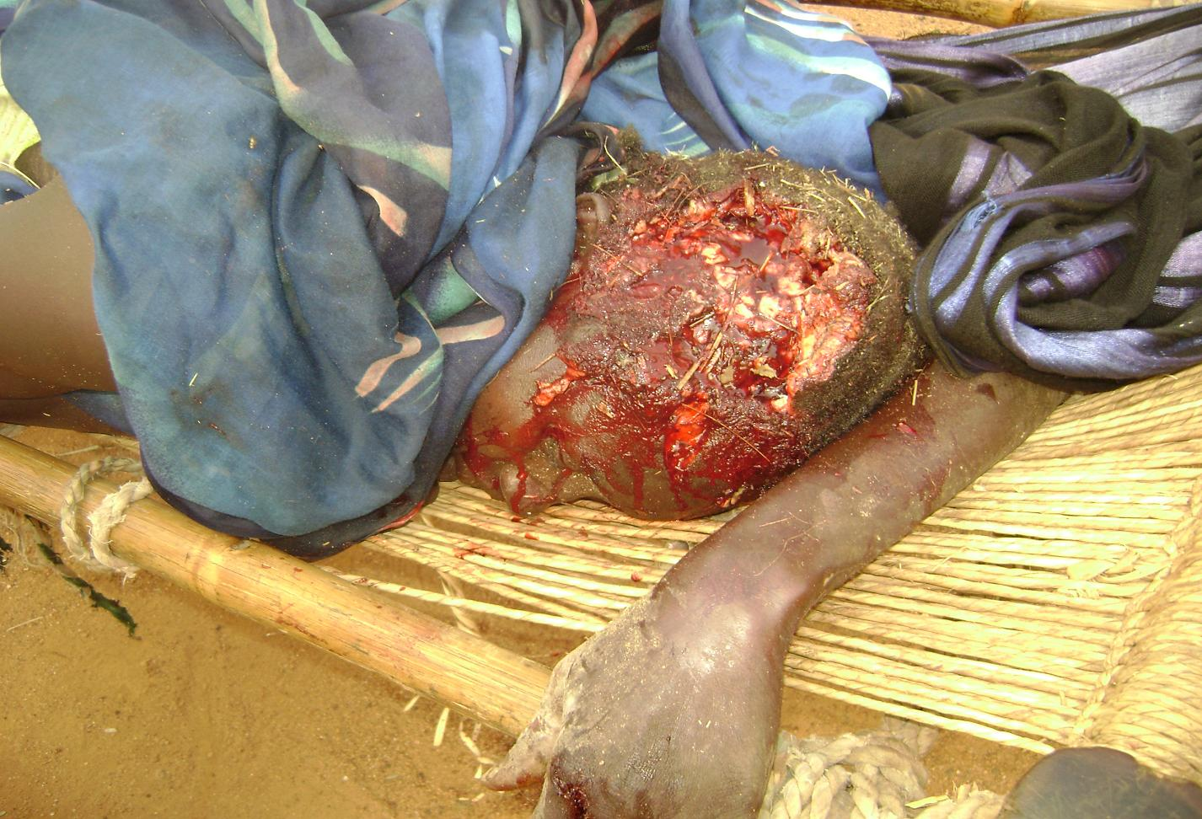

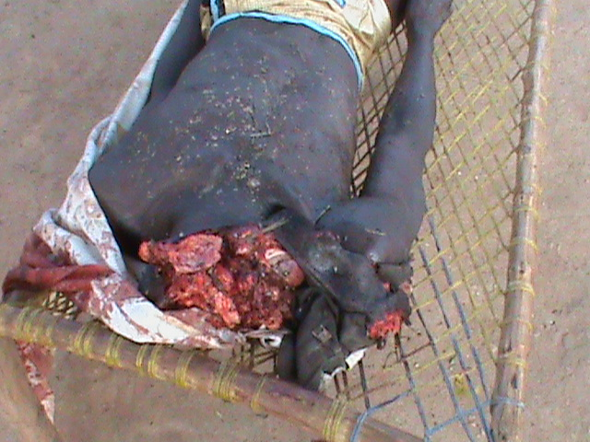

9-

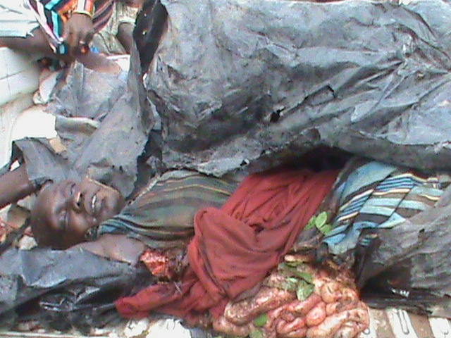

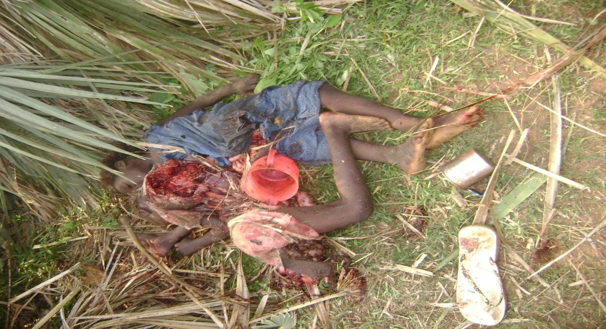

10-

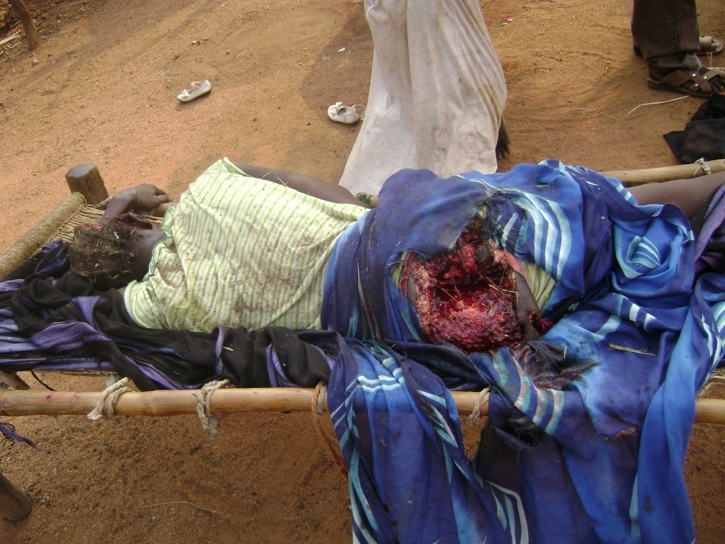

These are just very few pictures I selected other it can be magazine of the pictures of the bombardment casualties

There are real human right expertise who cry for the right of the mankind in the universe, but where is the power that can support them to do their work. The human right experts pondered properly about human beings as well as all living things living in the unique biosphere should be maintained. But how can they manage without support of the great powers (security council) the human right experts are now looked and heard at like just merely bell hanging and ringing in the wilderness nobody takes care about who is killed and why is he killed, for example, why child is being, he knows nothing about politics.

What was purpose of the United nations and International Christian Red Cross.

I thought Red cross’s mandate is to do into war Zone and be respected by the rivals to create secure buffer zone for injured and sick, United nations respected to go in and save lives by giving food and medicine without harm.

But who will protect them? Nobody, those who should protect them are the war disaster

11-

instigators for their business and they prefer war rather than peace to boost their business income.

For example:

United nations vote to impose sanctions on Russia as pressure to stop killing innocent people in Ukraine; China, India abstained. They abstained intentionally because it is their chance in such crisis to continue their business with Russia, and they understand that at this stage, Russia is in very high need they can sell their goods to them for high prices and Russia will have no option rather than to accept, and they also know that Russia can sell its goods for them at very low price.

So that is how the game if being played.

They security council never voted as united to solve the problems, one or two of them must assert its right of veto against the other for its business interest.

China and Russia the people these two countries survive on bloodshed of the innocent people around the globe.

These countries never have humanitarian organization as charity organization to supply needs to the needy people suffering in disasters especially man-made disasters. For example; food, water, shelters and medicine.

The worst countries that supply for boosting ma-made disasters

1. Saudi Arabia
2. Qatar
3. Arab united emirates
4. Turkey

These are the main sources of supplying Khartoum with money and then Khartoum buys from China and Russia they are the worst evil countries in the universe.

African countries will never ever extend their hands to donate a cup of maize for any African suffering from hunger, but they rather happy with man-made disasters in Africa so that a white brings dollars and they get jobs.

The arab countries can help each other in case of natural or man-made disasters.

Sincerely

United States of America and some European countries are the only states that maintain humanitarian spirit as they reach needy people in disasters as quickly as possible, with basic needs eg. Food and non-food items, water, shelter and medicine..

Actualization:

The human right laws have undoubtedly been neglected, United nations including Un agencies are not given stronger power to even defend themselves and defend the innocent people in war zones, they are not mandated to engage direct in war but once they are sent in war hazardous areas, they are supposed to be able to defend themselves and innocent people within their domain since they are armed. We witness them in Darfur/Sudan, the arab militias

12-

kill people in front of them because they had no suitable weapons and stronger mandate in their rules and regulations. ICRC is not very active to reach casualties very early in order to apply first aid as recommended because, they have no protection to ensure their safety, ICRC do not reach casualties anywhere in the world but they only go to few places with restricted mandate.

Security is not united to ensure global security and up to date application of the UN charters as possible, but they are rather engaged in segregation and neglected their mandate as security council. Russia is member of the security council, but Russia is the one killing innocent people in Ukraine defying the rules and regulations they signed in the security council.

This state clearly the globe is not secure anymore.

The only human right is someone who has stronger weapons and more money.

The president of Sudan Omar Basheer, said many time just give me three months I will wipe Nuba people out of the map but he failed otherwise Nuba people were subjected to be wiped out of the map.

Recommendations:

1. It is very difficult to recommend anything for such international intellectuals about how to handle the globe. Especially when someone sees his/her viable interests in front of him on calculations predicted huge income of trillions on credit of innocent people.
2. Security council revise its mandate and covenant on UN charters evaluate whether there is commitment to execute it or abolish them and meditate another ways of handling the globe.
3. Ensure safe buffer zones for UNHCR/ICRC to receive internally displaced people during conflict and avail all the necessary basic needs for the displaced within the country of conflict for example: water, food, medicine and shelter instead of emigration to create unnecessary narrowing and overcrowding in other countries, better keep people within their countries of conflict and then launch aid to them while negotiations go on; even plan to produce food for them locally within their country instead of importing it from far away.
4. Late security council ponder twice about the security on the globe.
5. United nation should ensure solid solidarity as stated in its charter

13-

**Conclusion**

Write 2 paragraphs summarizing the key ideas of the assignment.

United Nations human right charters need to be revised to ensure that all the countries are committed to the rules and regulations adapted, ratified and signed by the united nations general assembly.

United nations security council according to my view need to be revised especially right of the veto that dictate continuation of the killing of the innocent people.

In war that amount to the killing of the innocent people it is important to oblige opponents to maintain buffer zone for internal displaced people to be served by United nations agencies, to supply basic needs.

Broker early as possible and declare cease-fire and open negotiation threshold to find solution through compromise.

The United nations should seriously at right of the veto that deny possible ways of solutions and encourage violence for business

In Ukraine issue, United nations really stood firm, but Russia was really adamant to defy, attack and kill innocent civilians.

**Bibliography**

Put the bibliography of the books and other sources used to write the assignment.

The Universal Declaration of Human Rights was drafted in a period, 1946-1948,

Thanks so much

Joseph Konda Kodi

AIU student from Nuba mountains South West of Sudan

14